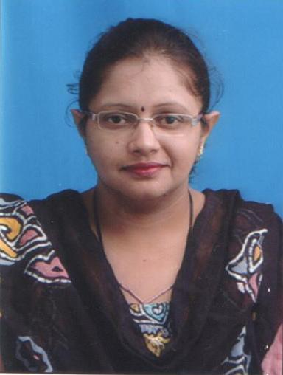
Residential Address :

Saya Park- 3, 6th floor,
Pakhadi, Kharegaon,
Kalwa (W),
Thane – 400605

Mobile No:- 8692872377/9082603865

Email: sampadamkr@gmail.com
DOB :- 27 Nov 1977

Mrs. Sampada Mayekar
__________________________________________________________________

Current Salary | 30000/-
Expected Salary | 35000/-
Notice period | 15 days

Summary Total 17 yrs of experience on Receptionist cum
Computer Operator.

Expertise includes Drafting & Typing of letters &
Reports, Handling entire Reception, Data-Entry,
Handling Incoming & Outgoing Calls, Handling
Couriers, Maintaining Attendance Register,
Maintaining Guest Relations.
Education 1994 S.S.C, Bangalore University
Percentage 65%

1996 H.S.C, St, Ann’s College, Bangalore.
Percentage 55%

2000 B. Com, B. M. S. College for Women
Percentage 50%
Skills Operating Systems –Basic Ms. Office & Excel

Summary :

- A determined performer, with excellent comunication skills, who believes in hard work and has ability to excel in a team or individual environment.
- Open to new ideas and realize that every day is a learning experience.
- Eagernes to learn.
- Organized way of working.

Strength :

- Strong work ethics
- High degree of flexibility and adaptability
Experience : Currently working with NEUMEC GROUP as Receptionist
Cum Computer Operator since March 2008 till Date .

Job Responsibility :

Working as a Receptionist cum Computer Operator.
Expertise includes Drafting & Typing of letters & Reports,
Handling entire Reception, Data-Entry, Handling Incoming &
Outgoing Calls, Handling Couriers, Maintaining Attendance Register,
Maintaining Guest Relations.

Experience : April 2003 – June 2007
Worked with PROCEDURAL CONSULTANTS as
Receptionist cum Computer Operator.

Job Responsibility :

Working as a Computer Operator cum Receptionist.
Expertise includes Drafting & Typing of letters & Reports,
Handling entire Reception, Data-Entry, Handling Incoming &
Outgoing Calls, Handling Couriers, Maintaining Attendance Register,
Maintaining Guest Relations.

Experience : April 2002 – October 2002
Worked with FEEDBACK INFRASTRUCTURE PVT. LTD as
Receptionist.

Job Responsibility :

Expertise in Handling Incoming & Outgoing calls of Clients,
Drafting & Typing of letters, Data-Entry,
Preparation of day to day work and uploading of the same
to the Directors and our Senior Colleagues.

Computer Skills
- MS- Office
- Proficient in Internet.
- Data-entry.

Languages Known | To Read | To Write | To Speak
English | Proficient | Proficient | Proficient
Hindi | Fluent | Fluent | Fluent
Marathi | Fluent | Fluent | Fluent
Kannada | Fluent | Fluent | Fluent

Hobbies & Interests
- Listening Music
- Reading Books
- Managing & Interacting with People

( Sampada Mayekar )

