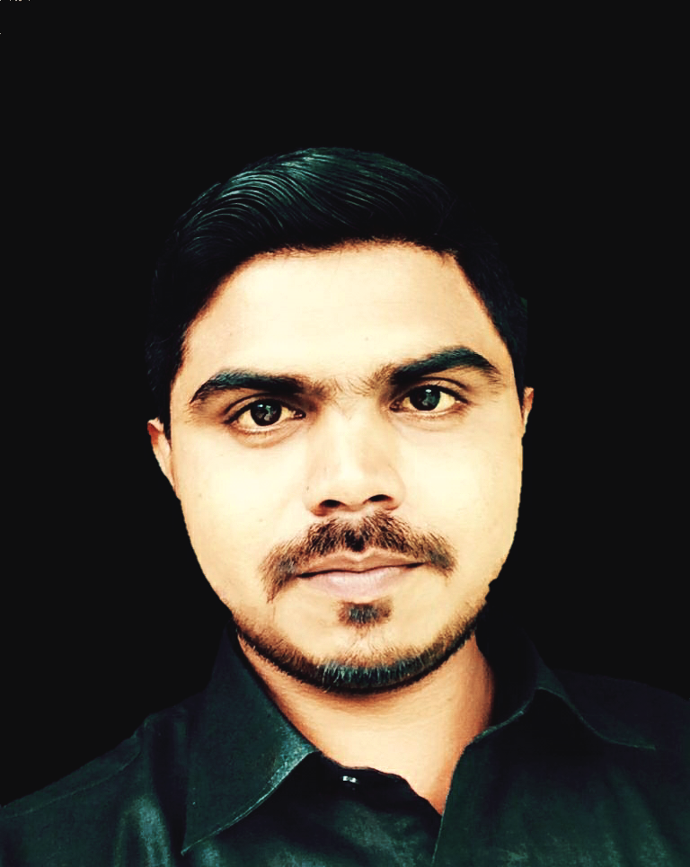
PHOTO
Job Application

To,

Personal/HR- Manager

------------------------------

-------------------------------

-------------------------------

Subject: Application for the suitable Post –

Respected Sir/Madam,

I am highly motivated candidate willing to fulfill a challenging job,I wish to apply, in your esteemed organization for the suitable post in respective department. I am enclosing herewith my RESUME for your kind perusal and consideration.

I request you to give me an opportunity to serve for your well-known organization. I assure you that, I will serve for the company to the best of my abilities and also to the satisfaction of my senior. I am waiting for your favorable reply.

I consider myself to be a quick learner, open minded and responsible. I am also proud of myself on being creative, eager to learn, motivated, versatile & flexible. With my attention to detail and being driven to work hard, I can offer support to your team.

If, you need further information, please do not hesitate to contact me.

Thanking you in anticipation.

Yours faithfully
Hitesh T Keni

9021532002

CURRICULAM VITAE

HITESH TULSHIDAS KENI

Present Address:

77/02 Mahim fisherman

Coloney near s.l raheja hospital

Mahim mum 400016.

CAREER OBJECTIVE: -

I desire to work in a company that uses my knowledge talent hard work dedication and sincerity in a well manner. I am looking for the great opportunity as OFFICER –HOSPITAL ADMINISTRATION that offers me challenging assignments, professional development and career growth.

Seeking a position to utilize my abilities in the “Hospital Administration” that offers a professional growth while being resourceful, innovative & flexible.

PROFILE:

A pleasing personality with an open mind to learning and skills enhancement and able to perform under diverse and demanding business conditions. Fast learner and highly articulate, confident and able to motivate and communicate to achieve the organizational goals and personal goals.

- Achievement oriented, hardworking and dedicated.
- Quick learner, highly energetic and motivated aspiring to become a sound and successful professional in the areas of my interest.
- Goal – oriented and dynamic individual with an intrinsic desire to succeed in every task undertaken.
- Endowed with good analytical, problem solving abilities; possess a flexible and a detail oriented attitude.
- To get elevated in the field assigned to me by exploring my skill sets, and work to the best of my ability for the benefit of the organization.
SALIENT PERSONALITY TRAITS:
- Good Communication Skill
- Ability to co-ordinate and work well in team work
- Ability to learn quickly
- Positive attitude /Communicate by nature
EDUCATIONAL QUALIFICATION:
Education Qualification | Board / University | Year of Passing | Marks Obtained
S.S.C. | Mumbai Board | 2004 | Pass Class
H.S.C. | Mumbai Board | 2009 | Pass Class
B.Com. | Nashik University | 2013 | Pass Class
OTHER / EXTRA QUALIFICATION:
Education Qualification | Institute | Year of Passing | Marks Obtained
MS-CIT | Comp-u- Learn Computer Institute- Chinchani | 2017 | A-Grade
Tally-9 | Comp-u- Learn Computer Institute- Chinchani | 2017 | A-Grade
ITI-Electrician | Govt Institute - Chinchani | 2006 | A-Grade

WORK (PROFESSIONAL) EXPERIENCE:-HAVING 6+ YEARS SOUND PRACTICALS EXPERIENCE:-
- Worked with BARC-Tarapur- Maharashtra As a Typist cum Office Assistant. From August-2013 to March-2017.
- Worked with Mep Infrastructures Development (Toll Naka) Sea Link- Worli- Mumbai- Maharashtra. As a Admin Executive from October-2017 to November-2018.
- Worked with INDIRA IVF HOSPITAL As Receptionist/Admin/ Maintenance/ Mis/ Mrd Executive from Feb -2019 to June – 2020.
- Worked with Aarthi scans & labs As assistant floor manager. From October 2020 to Apr-2021.
- Worked with D. Y.PATIL Hospital As Night operation executive.. From July 2020 to Oct – 2022.
- Worked with Kokilaben hospital as Officer in Admin dept... From Nov 2022 to Present.

AREA OF EXPOSURE:-
Hospital Administrator
- Supervise administrative activities of 500+ medical, nursing, technical, and maintenance Staff in a 500+ bed hospital
- Compliance & process streamlining and vendor relation management.
- Supervised daily administrative operations; attendance, cleaning related issues in hospital, Equipment issues, Patient related issues.
- Conduct routine service evaluations, tracking feedback from service users and collaborating with stakeholders to develop continuous process improvement strategies.
- Resolved potential issues with patients; stayed up-to-date with healthcare regulations.

CASHIER -KEY RESPONSIBILITIES:
- Maintaining all Record & Files
- Drafted in Tender copy of all clients
- On client request will process Bills / Process monthly payments
- Day to Day Cash & Bank Transaction
- Maintain cash transaction & Petty cash book preparing cash voucher
- Bank reconciliation statement
- Monthly/ quarterly/ half yearly/ bank reconciliation statement
- RTGS / NEFT Transaction / Maintain salary & wages register
- Day to day data entry update in computer
- Cheque deposit in bank / Cash deposit in bank
- Maintain Daily attendance record /DATA Entry in Excel
- Correspondence to relevant dept. i.e. labors contractor / causal worker / pay roll worker.
Hospitality management
- In Hospital handling all that related works like “Reception executive, Mrd executive, hospital maintenance and floor coordinator.
- In Reception area admission and pre consult form filled work and enquiry.
- When patient do further his treatment then handling his medical records.
- Every day hospital report email and WhatsApp reporting and handling mobile related patient’s enquiries.
- In Hospital all I do electronic and electrical related works.
- Communicating with upper management to develop strategic operations goals.
- Monitoring operational performance of both internal and external service providers.
- Providing a workplace setting that is conducive to productive work.
- Receiving and responding to approvals and notifications.
- Monitoring RMO,CMO,INTENSIVIST,DOCTORS, STAFF NURSES,PHARMACIST,BILLING,SECURITY AND WARDBOY
- Maintain Cencus of the all over hospital.and report to clinical authority.
- Handling any issue about hospital related admission, dama, refusal,discharge.
RESPONSIBILITIES IN SCANS & LABS:
- Handling all dept in likes Mri, Ct scan, Blood collection, X-ray, Sonography.
- On patient any queries about prescription and cost related.
- Maintain all day cash, card transaction.
- Maintain Daily attendance record /DATA Entry in Excel.
- Day to day data entry update in computer.
- Maintain flim & cases count in record sheet.
LANGUAGE KNOWN:
Marathi, Hindi & English
HOBBIES:-
- Hardworking /Adaptability /Honest / Flexibility
- Optimistic /Group Discussion /Listing Music & TV Programmer & Decoration
PERSONAL INFORMATON:
Date of Birth | 24/04/1988
Sex | Male
Nationality | Indian
Marital Status | Unmarried
Color | Fair
Father’s / Husband Name | Mr. TulshidasHarichandraKeni
Permanent Address | 77/02 Mahim fisherman  Colony near s.l raheja hospital  Mahim mum 400016.
Contact No. | +91 9021532002
Mail id | Kenihitesh1@gmail.com

SALARY EXPECTION:
- Current Salary:-3 to 4 Lakh P.A.
- Expected Salary:- As per company policy
DECLARATION:
I hereby declare that all the statement made by me is true and complete to the best of my knowledge and belief and nothing has been suppressed.
PLACE: Mahim. DATE:

