CURRICULUM VITAE 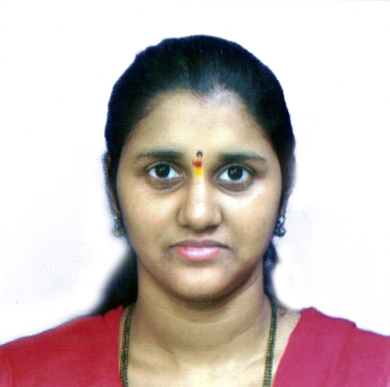

SAURAVI DEEPAK WADAM
Add : 3/59, Sabusiddhik Road,
BMC Chawl, Crawford Market,
Mumbai : 400 001.

Mobile: 8082760718.

Email: sauraviwadam@gmail.com

Total Worked EXPERIENCE : 7+ Years

Career Objective

To be a part of a dynamic organization where I can prove myself and create good name for using my knowledge and skills.

Educational Qualification

- B.Com.
Appeared in 2009.

- H.S.C.
Bai Kabi Bai Junior College, University of Mumbai, March 2005, Grade = First Class.

- S.S.C.
Young Ladies high school, Maharashtra Board, March 2003, Grade = Second Class.

Technical knowledge

- MS-CIT

Work Experience

- Currently working with CFM Chartered Finance Management Pvt Ltd (CFM) from October 2022.
- Worked with Sai Computers as Office assistance from Sept 2017 to Feb 2020.
- Worked with AMI India Logistics as Tel. Operator & Receptionist for 6 Months. (Jan 2015 - July 2015)
- Worked with Tulsidas Khimji Pvt Ltd for 1yr & 6 months as FOE & admin staff. (July 2012 - April 2014)

- Worked with Shah Bros as admin staff for 2 years. (Feb 2009 - July 2011)

WORK PROFILE

- Attending EPBX system.
- Data Entry work.
- Co- ordinate with clients by phone & mail.
- Handling day to day courier.
- Surfing Internet for Clients Details.
- Handling office Boys for day to day & housekeeping work.
- Updating attendance Register.
- Handling Billing & Stationery work.

Strengths

- Hard working
- Goal oriented

Hobbies

- Listening Music
- Reading Books

Personal Data

Husband Name : Deepak Yashwant Wadam
Date of Birth : 18th May 1987.
Marital Status : Married
Nationality : Indian
Language Known : English, Hindi & Marathi.

DECLARATION

I hereby declare that information provided above is to the best of my knowledge.

Sauravi Deepak Wadam

SIGNATURE

