Innovation Initiative Management
Application Test Plan
User-Acceptance & Functional Test Coverage
Document version | 1.0
Application version | Step 1–14 implementation (post-redesign)
Test plan date | 2026-04-29
Tester name
Test environment
Browser / OS
Build / commit

1. Introduction
This document is the comprehensive test plan for the Innovation Initiative Management (IIM) application. It covers every functional area implemented in the current build: authentication, the project repository, task manager, roadmap module (Timeline, Kanban, Bubble, Now/Next/Later, Capacity), PPTX export, project dependencies, decision log, document links, notifications, project health scoring, the velocity dashboard, resources insights, the public idea submission portal and admin review, the admin console (users, roles, custom fields, templates, thresholds, project values), security and access control, data persistence, and UX/visual conformance.
The plan is structured for manual user-acceptance testing. Each test scenario provides concise steps and an expected outcome. The tester records the result in the Pass / Fail / Blocked columns and writes any observed issues in the Comments column. Tests should be executed top-to-bottom in each section, but most sections can be exercised independently provided the seed data is in place.

2. Scope
In scope:
- All UI surfaces accessible from the application shell.
- All HTTP API routes that back those surfaces.
- Authentication, authorization, and the role-permission matrix.
- Notifications, scheduled jobs, and email delivery (when configured).
- Visual conformance to the NICE Polaris-style design system.
- JSON-store data persistence behavior.

Out of scope:
- Database migration (Phase 2) — no database is connected at this build.
- GitHub Projects / Jira integration (Phase 3) — webhook stubs are present but not wired.
- Production deployment hardening, hosting platform configuration, and TLS.
- Load and stress testing — covered separately.

3. How to use this document
For each test:
- Read the scenario and steps.
- Execute the steps against the running application.
- Mark Pass, Fail, or Blocked by ticking the corresponding ☐ in the row.
- Record any deviation, defect, or environmental note in the Comments column.
- If a test depends on data from a prior section (e.g. a created project), execute prerequisite tests first.

Result legend:
- Pass — actual behavior matches the expected outcome with no issues.
- Fail — actual behavior deviates from the expected outcome; record the deviation.
- Blkd (Blocked) — the test cannot be executed (missing dependency, environment issue, blocked by another defect); explain in Comments.

Defects observed during testing should also be logged in the team's issue tracker. Reference the Test ID (e.g. AUTH-03) in the issue title for traceability.

4. Test environment & prerequisites
Tests assume a freshly seeded development environment with the default admin account, plus at least one user per role (Project Lead, Team Member, Viewer) created through the invite flow. Some tests require RESEND_API_KEY for email delivery; others have a dev-mode fallback that surfaces the URL in the response. Where AI features are referenced (overlap detection, priority recommendation, complexity estimation), tests assume the AI advisor is wired or document the expected fallback when it is not.

4.1 Environment setup tests
These should pass before any other section is exercised.

ID | Test Scenario | Steps / Expected Result | Pass | Fail | Blkd | Comments / Issues
ENV-01 | Spreadsheet source file is at the expected path | 1. Locate the source spreadsheet for the seed.  2. Confirm the filename is exactly `Tiger_Team_Projects.xlsx` (underscores, not spaces; case-sensitive on some shells).  3. Confirm it lives at the repo root — i.e. the same folder as package.json — NOT inside /data, /scripts, or any subfolder.  4. If the file lives elsewhere, set the IIM_SEED_SOURCE environment variable to the absolute path before running seed (e.g. `set IIM_SEED_SOURCE=C:\Users\me\IIMApplication\files\iim-app\Tiger_Team_Projects.xlsx` on Windows).  Expected: The spreadsheet is at <repo-root>/Tiger_Team_Projects.xlsx with the exact filename, OR IIM_SEED_SOURCE points to its absolute path. | ☒ |  |  | - Npm run seed results in error: Spreadsheet not found — falling back to snapshot under C:\Users\tness\IIMApplication\files\iim-app\data\seed/. Spreadsheet exists in root folder and data folder  - If using an open version of Edge, the application automatically loads as the admin user. I had to open an in-private window to get the login page.
ENV-02 | Run seed against the spreadsheet (primary path) | 1. From the repo root, run `npm run seed`.  2. Watch the console output for the source-file resolution message.  Expected: Console reports the spreadsheet was found at the resolved path; data/projects.json, data/tasks.json, and data/users.json are populated. NOTE: If the console shows 'Spreadsheet not found — falling back to snapshot under data/seed/', mark this test FAIL and note which path was attempted; the snapshot fallback is itself valid behavior but not the primary path being tested here. | ☒
ENV-03 | Snapshot fallback produces a working data folder (when primary path fails) | 1. If the previous test failed because the spreadsheet wasn't found, confirm the snapshot fallback ran without errors.  2. Verify data/projects.json and data/tasks.json contain records (non-empty arrays).  3. Verify data/users.json contains the default admin account.  Expected: Snapshot fallback completes without errors; data folder is populated with seeded records and a default admin user. This is documented, valid behavior — record PASS even if the primary path failed. | ☒
ENV-04 | Default admin user is created in users.json | 1. Open data/users.json in a text editor.  2. Confirm one user record exists with role=Admin and a bcrypt password_hash.  3. Note the email — it is admin@example.com unless IIM_ADMIN_EMAIL was set during seed.  Expected: Default admin record is present with a bcrypt hash (string starting with $2 — never plaintext). | ☒
ENV-05 | App boots without environment errors | 1. Confirm .env contains NEXTAUTH_SECRET and NEXTAUTH_URL.  2. Optionally set RESEND_API_KEY for transactional email.  3. Run `npm run dev`.  4. Inspect the terminal for any startup errors or red console output.  Expected: App boots cleanly. Warnings about missing optional variables (e.g. RESEND_API_KEY) are acceptable; required-variable errors are not. | ☒
ENV-06 | Unauthenticated user is redirected to /login | 1. Open a fresh browser session: a private/incognito window, OR clear cookies for the app's host first. Do NOT use a window where you may already be signed in.  2. Navigate to the app's root URL (e.g. http://localhost:3000/).  Expected: App redirects to /login. NOTE: If you skip the private/clear-cookies step and a previous session exists, the app will load straight to the dashboard — that is correct behavior, not a defect, but it does not validate the redirect. Always test in a clean session. | ☒ |  | ☐
ENV-07 | Sign in with default admin credentials | 1. From the /login page, enter the admin email (admin@example.com unless overridden) and the password (default 'ChangeMe!2026' unless IIM_ADMIN_PASSWORD was set).  2. Click Sign in.  Expected: User is redirected to home (/) and the global header shows the admin's name/avatar. | ☒
ENV-08 | Project and task data is loaded into the app | 1. After signing in, navigate to /projects.  2. Confirm project records appear with IDs in YYYY-NNN format (or, if the snapshot fallback was used, that any seeded records appear at all).  3. Navigate to /tasks and confirm task records appear with IDs in YY-NNNN format.  4. If the spreadsheet was the source: spot-check that names, statuses, target dates, and stakeholders match the source spreadsheet. If the snapshot was the source: confirm only that records load — the snapshot may not match the latest spreadsheet.  Expected: Projects and tasks load and display. ID formats are correct. (Spot-checks against the spreadsheet only meaningful when the spreadsheet — not the snapshot — was the seed source.) | ☒

5. Authentication & access

5.1 Test scenarios
Login, logout, session protection, password reset, and the rate-limiting and anti-enumeration behaviors documented in the access-control changelog.

ID | Test Scenario | Steps / Expected Result | Pass | Fail | Blkd | Comments / Issues
AUTH-01 | Successful login with valid credentials | 1. Ensure you are NOT already signed in. Use a private/incognito window, OR sign out first, OR clear cookies for the app host.  2. Open /login.  3. Enter a valid email and password for an active user.  4. Click Sign in.  Expected: User is redirected to home (/) and the global header shows the user's name/avatar. | ☒ | ☐ |  | 5/5 – Passed after updated code applied. Correct username and role displayed at login. Access restricted as expected.  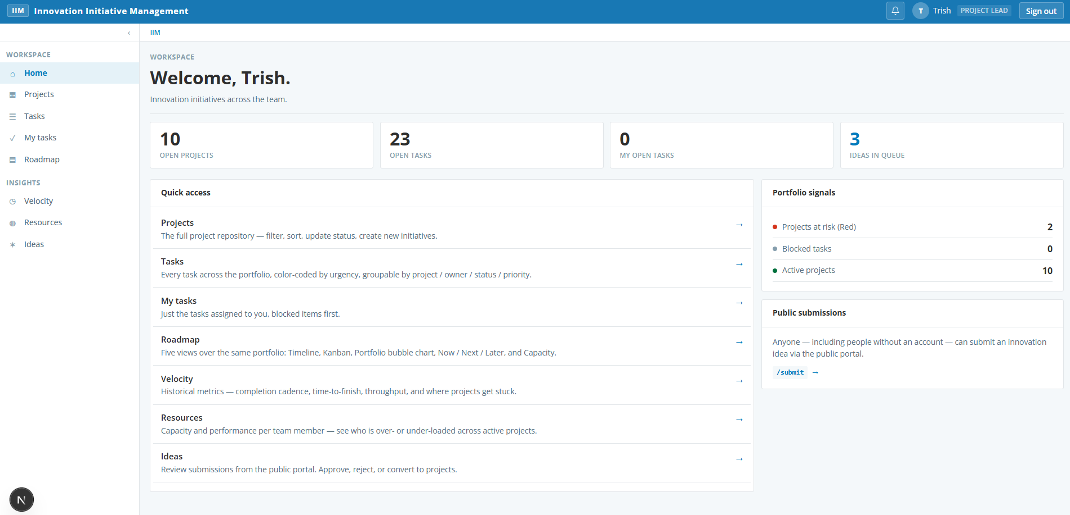  4/30 - Signed in as user with a project lead role and as a user with a team member role. Application still shows default Admin screen and name; access is not restricted according to the user profile restrictions. Subsequent sign out and sign back in resulted in the expected behavior with restricted access.  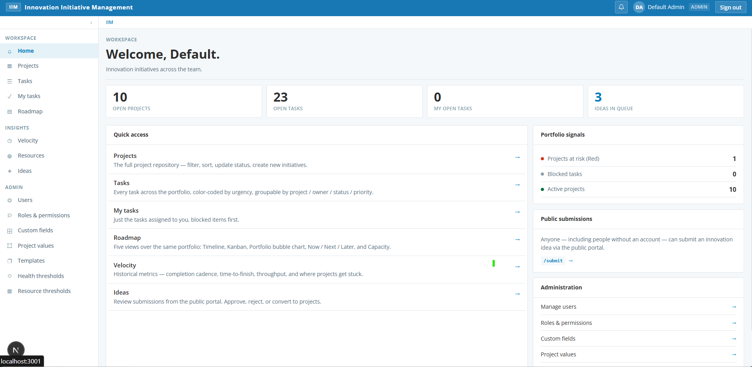  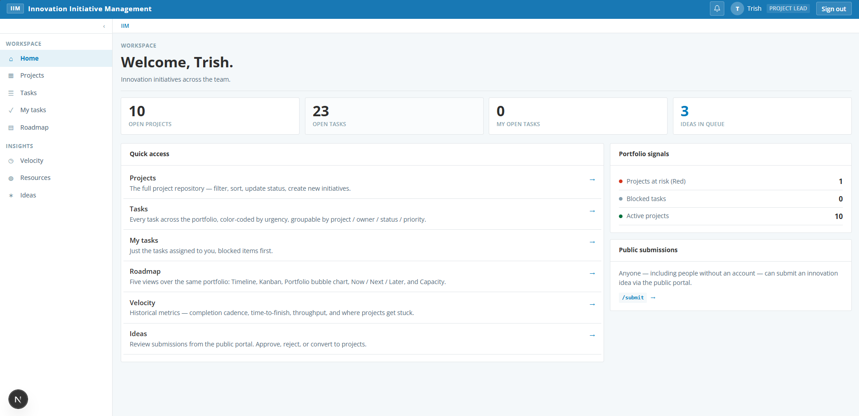
AUTH-02 | Failed login with wrong password | 1. Open /login.  2. Enter a valid email and an incorrect password.  3. Submit the form.  Expected: Generic error message appears; no indication whether email or password was wrong. | ☒ |  |  | Failure message displays:  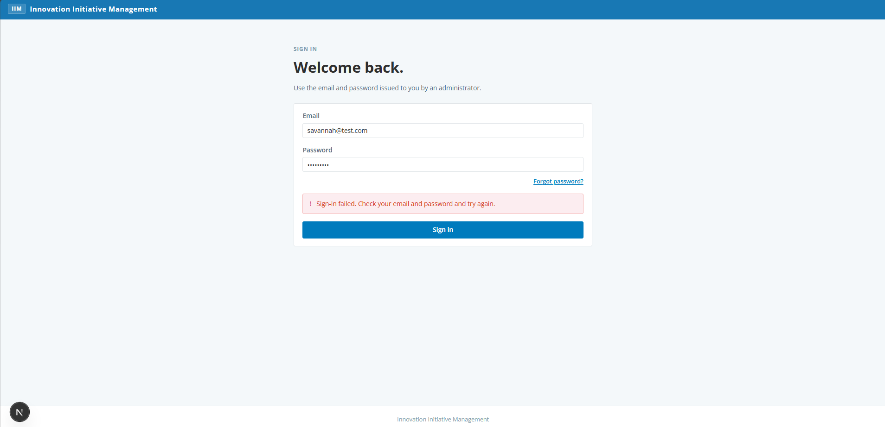
AUTH-03 | Failed login with unknown email | 1. Open /login.  2. Enter a non-existent email address with any password.  3. Submit the form.  Expected: Same generic error message as wrong password (anti-enumeration). | ☒ |  |  | Same error message as previous use case
AUTH-04 | Login with deactivated user is blocked | 1. As Admin, deactivate a user from /admin/users.  2. Sign out and attempt to log in as that user.  Expected: Login fails with a generic error; deactivated user cannot enter the app. | ☒ | ☐ |  | Displays same error message for sign in failure
AUTH-05 | Protected routes require authentication | 1. Sign out.  2. Attempt to navigate directly to /projects, /tasks, /roadmap, /admin/users.  Expected: Each redirects to /login with a callbackUrl preserved. | ☒ |  |  | Each direct navigation is redirected back to the callback URL
AUTH-06 | Public routes are accessible without auth | 1. Sign out.  2. Navigate to /submit, /forgot-password, and an /invite/[token] URL.  Expected: Public pages render without redirect; no leakage of authenticated content. | ☒ |  |  | /submit navigates appropriately to the submit page  /forgot-password redirects to forgot password page  /invite[token] results in message to request a fresh invite  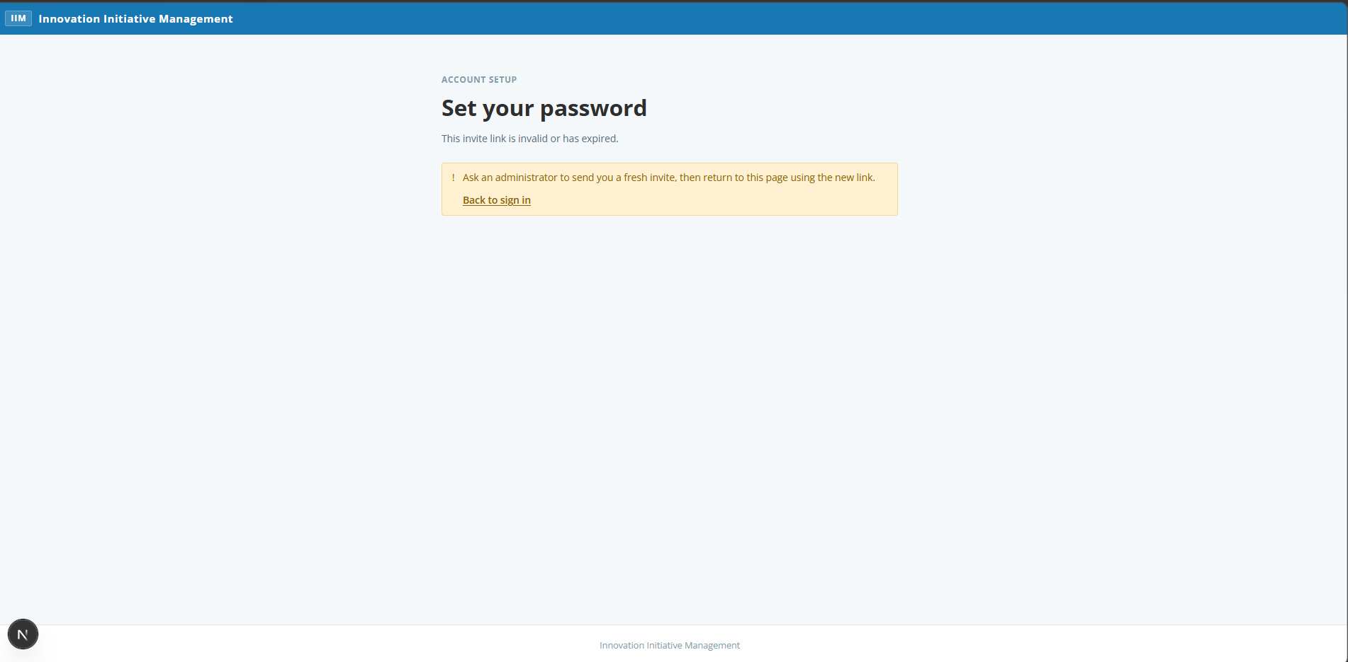
AUTH-07 | Sign out terminates the session | 1. From any authenticated page, click the user menu and choose Sign out.  2. Attempt to navigate to /projects via Back button.  Expected: User is returned to /login; Back navigation does not restore authenticated content. | ☒ |  |  | Clicking back button redirects to the sign in page.
AUTH-08 | Forgot-password request — existing email | 1. Navigate to /forgot-password.  2. Enter the email of an existing user.  3. Submit the form.  Expected: Generic confirmation message displayed. In dev mode without RESEND_API_KEY, a reset URL is returned in the response for testing. | ☒ |  |  | Functions as expected:  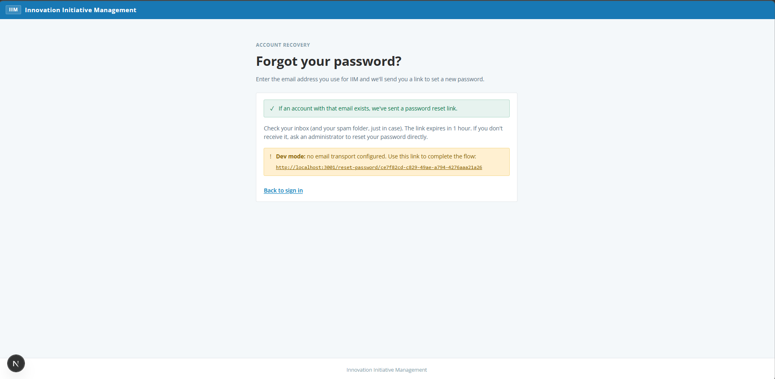
AUTH-09 | Forgot-password request — unknown email | 1. Navigate to /forgot-password.  2. Enter an email that does not exist.  3. Submit the form.  Expected: Identical generic confirmation message; response timing comparable to the existing-email path. | ☒ | ☐ |  | 5/1 – passed on retest. Dev mode notification displayed as expected.  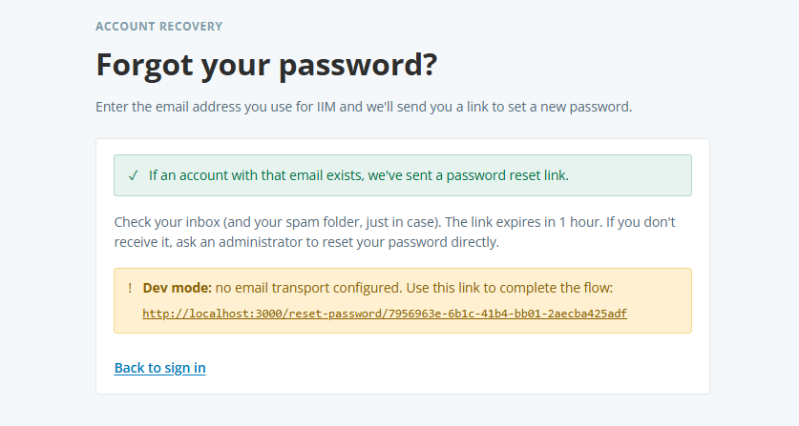  4/30 - Received appropriate notification on screen. As dev environment, expected to see similar message that no email would be sent.  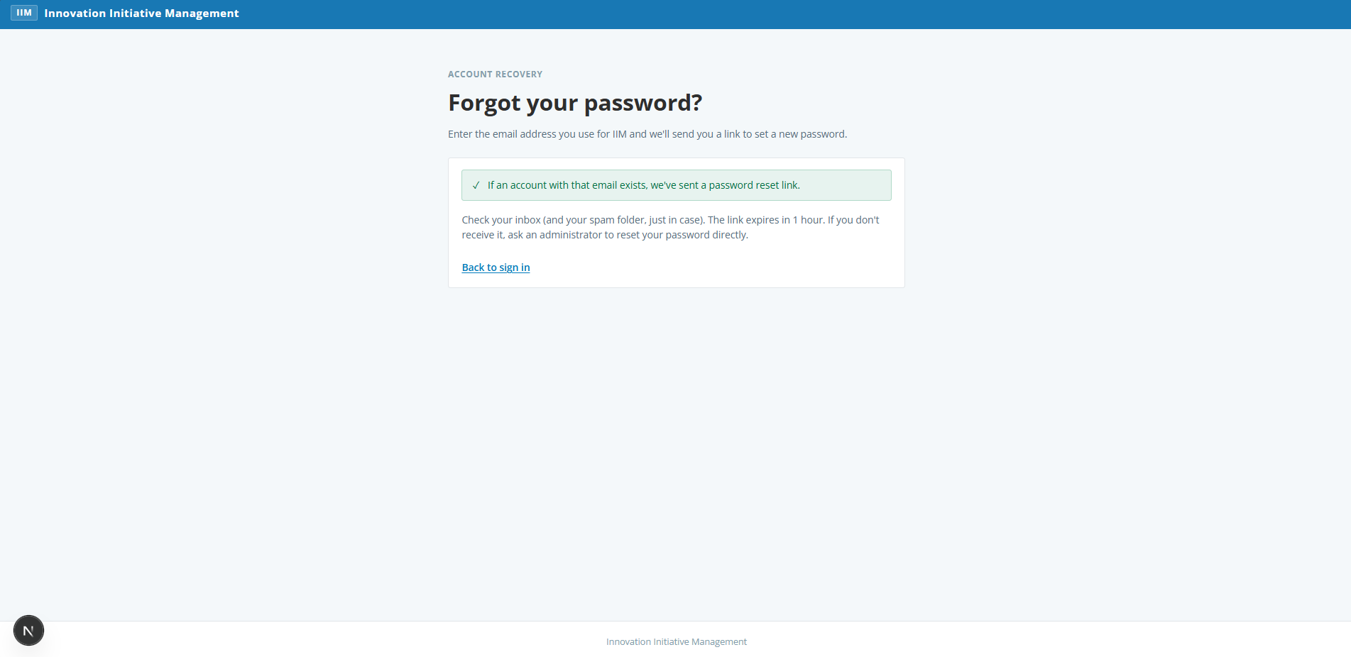
AUTH-10 | Reset-password flow with valid token | 1. Trigger forgot-password and capture the reset URL.  2. Open the URL within the 1-hour TTL.  3. Enter and confirm a new strong password.  4. Submit the form.  Expected: Password is reset; user is redirected to /login?reset=1; user can sign in with the new password. | ☒ | ☐ |  | 5/1 – passed on retest with updated code. Strong password is enforced  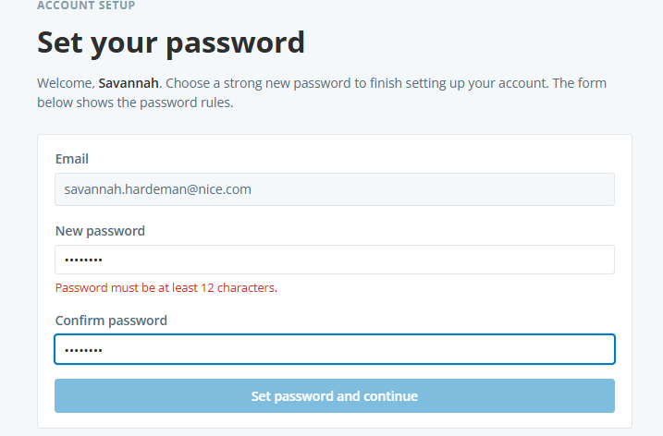  4/30 - Did not force a strong password; only requirement is 8 characters.
AUTH-11 | Reset-password flow with expired/unknown token | 1. Open /reset-password/<invalid-token> directly in the browser.  Expected: Generic error displayed; the form does not allow setting a password. | ☒ |  |  | 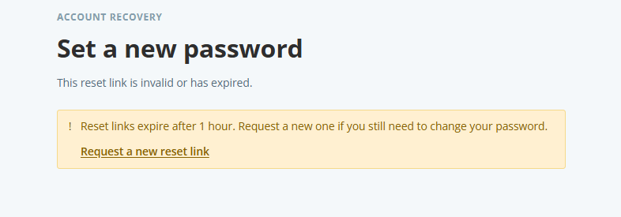
AUTH-12 | Rate limit on public reset-request endpoint | 1. From the same IP, submit 6 forgot-password requests within an hour.  Expected: After 5 attempts the 6th is rejected with a rate-limit response. | ☒ | ☐ |  | 5/1 – Passed after updated code. Attempts at 7:30am, 7:33am, 7:34am, 7:35am, 7:36am, 7:38am. Final attempt #6 resulted in the error message.  4/30 - Attempts at 5:23am, 5:36am, 5:42am, 5:46am, 5:49am, 5:51am, 5:53am, 5:56am (in private window)  Attempts at 5:57am, 5:59am finally received message in regular window after 10 attempts.  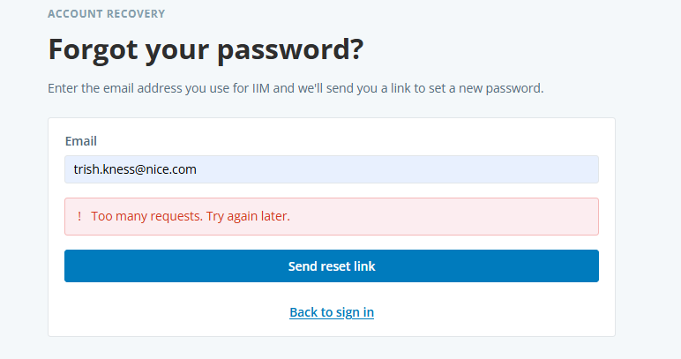
AUTH-13 | Admin-triggered password reset | 1. Navigate to /admin/users.  2. Click Reset password on a user row.  3. Confirm the modal.  Expected: A reset URL is shown to the admin (and emailed if RESEND_API_KEY is configured). | ☒ |  |  | Functioned as expected

6. Home dashboard

6.1 Test scenarios
The permission-aware home page introduced in the access-control alignment.

ID | Test Scenario | Steps / Expected Result | Pass | Fail | Blkd | Comments / Issues
HOME-01 | Home page renders KPI tiles per permission | 1. Sign in as Admin.  2. Land on / and confirm KPI tiles for Open Projects, Open Tasks, My Tasks, Ideas in Queue.  Expected: All four KPI tiles render with non-zero counts (assuming seeded data). | ☒ |  |  | All tiles display with expected counts from the spreadsheet. Admin does not have Open Tasks so this populates as a zero count  Application Update Needed: Resources does not exist in the Quick Access section; this should be added.
HOME-02 | Home page hides tiles when permissions are missing | 1. Sign in as a Viewer.  2. Confirm tiles for which the user lacks view permission appear as dashed-border placeholders.  Expected: Layout stays four-column; missing tiles show as placeholders rather than shifting tiles around. | ☒ | ☐ |  | 5/5 – past after updated code. Home page count now shows appropriate number of tasks.  5/1 – not resolved after testing. Logged in as user with 3 open tasks but home page count shows 0.  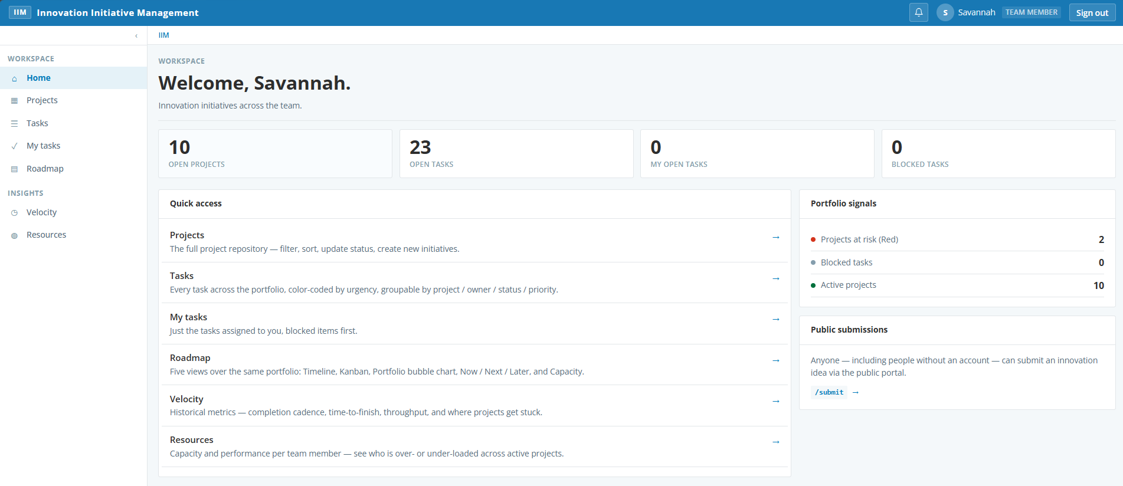  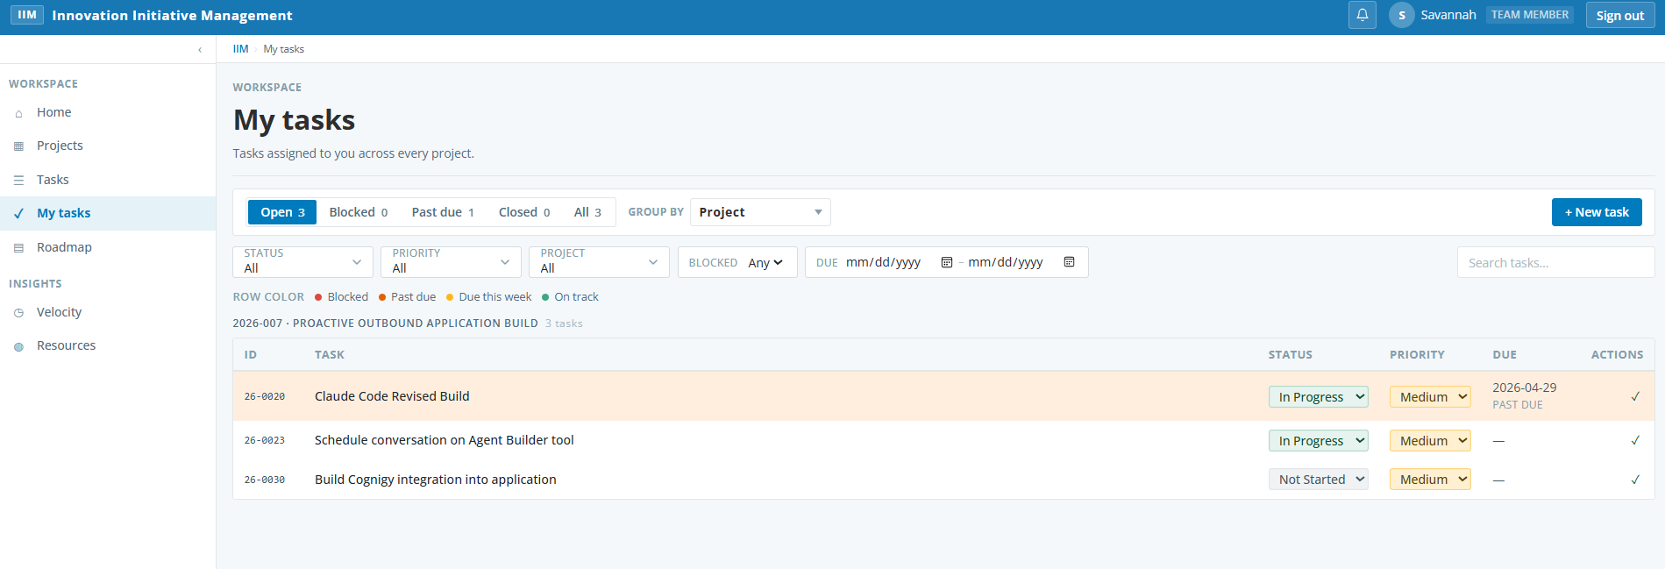  4/30 - Logged in as project lead; Admin functions not displayed as expected.  Logged in as team member; Admin functions not displayed as expected. Open tasks KPI shows zero when user has 3 tasks assigned that are in progress. May be due to status change from Open to In Progress. Expected behavior is for the KPI to show the user the number of tasks that are assigned to them that do not have a status of Complete or Canceled. This behavior is the same for all roles when user has assigned tasks; they do not display.
HOME-03 | Quick-access links filter by permission | 1. Sign in as a user with limited permissions (e.g. Project Lead without ideas.review).  2. Inspect the Quick Access section.  Expected: Only links the user has permission to use are present. | ☒ |  |  | Team member role shows links appropriately based on defined guidelines.  Validated for all roles  Application Update Needed: Need to add Resources page to the default configuration so that only Admins and Project Leads can see the resource allocation
HOME-04 | Administration card hides for users without any admin permission | 1. Sign in as a Team Member with no admin permissions.  2. Scroll through the home page.  Expected: No Administration card is displayed. | ☒ |  |  | Team member role – validated admin card does not display  Project lead role – validated admin card does not display  Viewer role – validated admin card does not display

7. Projects repository

7.1 Test scenarios
Section 5.1 of the design document. Covers the projects table, filters, inline edits, quick view, project create/edit, status updates, custom fields, and permission gating.

ID | Test Scenario | Steps / Expected Result | Pass | Fail | Blkd | Comments / Issues
PROJ-01 | Default Projects page filters to open statuses | 1. Navigate to /projects.  2. Inspect the Status filter and the row counts.  Expected: Default view excludes Completed and Canceled projects (shows In Progress, In Planning, Not Started, Blocked, On Hold, Delayed). | ☒ |  |  | 10 of 11 rows show as expected
PROJ-02 | Status toggle reveals completed/canceled | 1. On /projects, switch the status filter to All or Completed.  Expected: Completed and/or Canceled rows now appear; counts update accordingly. | ☒ |  |  | Completed shows 1 row, all shows 11 rows as expected
PROJ-03 | Filter by Phase, Priority, Project Type, Lead, Application/Product | 1. Apply each filter individually and in combination.  2. Verify the filtered row set.  Expected: Each filter narrows results correctly; clearing returns to default view. | ☒ |  |  | Validated each filter displays the values as expected and clear returns to default view. Tested various combinations and all worked correctly. Clear all function appropriately cleared all fiters.
PROJ-04 | Sort by any column | 1. Click the Name column header to sort ascending; click again to sort descending.  2. Repeat with Priority, Status, Target Date, Lead.  Expected: Sort indicator toggles direction; rows reorder as expected, including null target dates handled gracefully. | ☒ |  |  | Validated all filters sorted appropriately.
PROJ-05 | Inline status update without opening the project | 1. Click the inline Status control on a project row.  2. Change the value and confirm.  Expected: Status updates immediately; row health score recalculates if relevant. | ☒ | ☐ |  | 5/5 – passed after code updated. Status changed after a few seconds when project updated to Blocked status  4/30 - Validated change was accepted and status changed. Navigated to another page and returned and verified the status was still as I changed it.  Changed project status to blocked; project health did not update until I navigated to a different page and came back.
PROJ-06 | Quick view side panel | 1. Click on a project row.  2. Confirm the quick-view panel opens with summary fields, document links, and tabs.  Expected: Quick view shows summary, dependencies, decision log, document links without navigating away. | ☒ |  |  | Validated that quick view panel opened appropriately
PROJ-07 | Bulk actions on multiple projects | 1. Select 2–3 project checkboxes.  2. Use the bulk action toast to update Status, reassign Lead, or change Priority.  Expected: All selected projects are updated; toast disappears after action completes. |  | ☒ |  | 5/5 – Test case removed.  Bulk action functionality was removed from the page in a previous build. Test case is invalid
PROJ-08 | Export filtered view to CSV/Excel | 1. Apply one or more filters.  2. Click Export.  Expected: A CSV/XLSX file downloads containing only the filtered rows with all visible columns. | ☒ |  |  | Report exported as expected with only the filtered data and all columns. Tested both CSV and XLSX
PROJ-09 | Health score badge appears on every row | 1. Visually scan the Projects table.  2. Hover the badge for tooltip.  Expected: Each row shows a Red/Yellow/Green badge; tooltip explains the contributing factors. | ☒ | ☐ |  | 5/5 – passed after updated code. Tooltip displays as expected.  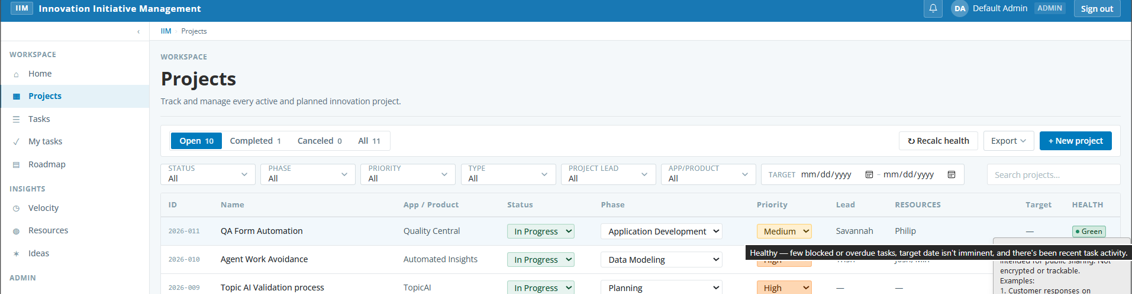  4/30 - No tooltip displayed on hover
PROJ-10 | Recalc Health button forces portfolio refresh | 1. Click Recalc Health in the toolbar.  Expected: Toast confirms recalculation; badges may change for affected projects. | ☒ |  |  | Changed status of a project to move it from red to yellow and recalculated. Updated status showed as expected.
PROJ-11 | Create new project — happy path | 1. Click + New Project.  2. Fill required fields: Name, Description, Application/Product, Project Type, Priority, Phase, Lead.  3. Save.  Expected: Project is created with auto-generated ID in YYYY-NNN format; it appears in the table. | ☒ |  |  | Tested creation of new project. Project created with appropriate numbering and displayed in the table.  Application Update Needed: the Project Lead selector is using the default Edge selector instead of the list displayed in the other drop down features on this page.
PROJ-12 | Project ID auto-increments within the year | 1. Create a new project.  2. Note the ID.  3. Create another and compare.  Expected: Second project's numeric suffix is the previous + 1 (within the same year). | ☒ |  |  | Validated that new project IDs are incrementing appropriately within the year.
PROJ-13 | Validation blocks creation when required fields missing | 1. Open the New Project modal.  2. Leave required fields blank and submit.  Expected: Inline validation messages appear; project is not created. |  | ☒ |  | 5/5 – Test case removed  Invalid test case. The Create Project function does not enable until all mandatory fields contain a valid value.
PROJ-14 | Edit existing project | 1. Open a project's edit form.  2. Modify several fields including Description and Target Date.  3. Save.  Expected: Changes persist; updated_at refreshes; quick view reflects the new values. | ☒ |  |  | Made several changes to one project. Validated that both the quick view and the projects page reflected the updates appropriately.
PROJ-15 | Status-tab summary-only update (note added without status change) | 1. Open a project's Status tab.  2. Without changing status, type a note in the Summary field.  3. Click the button (which should label 'Add note').  Expected: An entry is appended to status history labeled 'Note added'; status field is unchanged. | ☒ |  |  | Entered note. Validated note appeared in the history labeled note added without a status change. Documented which user and date and time of change.
PROJ-16 | Status change with a summary | 1. On the Status tab, change the status to a new value AND enter a summary note.  2. Click 'Update status'.  Expected: Status flips and history entry shows 'Old → New' with the summary archived. | ☒ |  |  | Tested status change with note. Validated status is updated in both the quick view and the projects page. Note is saved in the history along with the status change and date/timestamped with user information
PROJ-17 | Empty status tab submission is blocked | 1. Open Status tab.  2. Don't change status; leave summary blank.  Expected: Submit button is disabled; no orphan entries added. | ☒ |  |  | Validated that the button (both Add note and Update Status) are disabled until there is either a new status, a note, or both.
PROJ-18 | Custom fields appear on the project form | 1. As Admin, add a custom field via Admin Console.  2. Open the project form (new or edit).  Expected: The custom field appears with the configured type and is editable. | ☒ | ☐ |  | 5/5 – passed after updated code. Custom field displays on both the quick view and new project page and is editable.  4/30 - Added new project field via Admin Console and saved. New field does not display on Edit Project form or the New Project form. Since it is not available for a project, unable to confirm if it exists on the projects page.
PROJ-19 | Custom fields are filterable on the Projects page | 1. Add a custom field of an enum type.  2. Set values on a few projects.  3. Use the custom-field filter on /projects.  Expected: Filter narrows to the selected value(s). | ☒ | ☐ |  | 5/5 – passed after code update. Can create a custom number field and search for range.  4/30 - Invalid test case. There is no ability to set a type on a custom field.  Added a new Application/Product. Validated it appeared in the drop down list for both a new project and editing an existing project. Displayed on the Projects page and appeared in the filter for application/product
PROJ-20 | Delete project (Admin only) | 1. As Admin, open a non-critical project's detail.  2. Use the Delete action and confirm.  Expected: Project is removed; downstream tasks/dependencies are handled per design. |  | ☒ |  | 5/5 – Removed test case.  Invalid test case. There is no delete action available on the project quick view, the edit project page or the Projects page (this was previously there for the admin role). Verified that Delete Projects is an Admin function according to the roles and permissions.
PROJ-21 | Permission gating on edit/create | 1. Sign in as a Viewer.  2. Inspect the Projects toolbar and any project row.  Expected: + New Project and edit affordances are hidden; API calls return 403 if attempted directly. | ☒ |  |  | Validated that the New Project button is not displayed. In the Quick View pane, there is no edit button. Validated that nothing is editable on the project rows but that filtering works appropriately.

8. Tasks & My Tasks

8.1 Test scenarios
Sections 5.2 and 5.3. Task table, callouts, filters, grouping, create/edit, templates, and personal scope.

ID | Test Scenario | Steps / Expected Result | Pass | Fail | Blkd | Comments / Issues
TASK-01 | Tasks page default view shows open tasks | 1. Navigate to /tasks.  2. Inspect the default filter set.  Expected: Open tasks across all projects shown; closed tasks excluded by default. | ☒ |  |  | Validated default view is Open tasks and number of tasks displayed is consistent with the value shown
TASK-02 | Visual callouts on task rows | 1. Identify rows that are Blocked, Past Due, or Due This Week (from seed data or after creating).  Expected: Blocked rows display in red; past-due in orange; due-this-week in yellow; on-track in green. | ☒ | ☐ |  | 5/5 – passed after new code update. Lines now show as green for tasks as expected.  5/5 – not resolved after code update. Tasks in progress or not started are not highlighted in green on the screen until the mouse is run over that row.  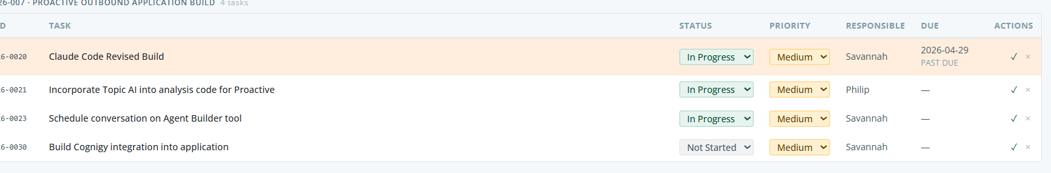  4/30 - Validated that rows that are blocked, past due or due this week are highlighted. On track tasks are not highlighted as noted in the Expected results
TASK-03 | Filter by Status, Priority, Project, Responsible, Blocked flag, Date range | 1. Apply each filter and combinations.  Expected: Filters narrow results correctly and combine logically. | ☒ |  |  | Validated all filters working as expected and in combination. Validated that clear all function becomes available as soon as any filter is applied and clears all filters appropriately.
TASK-04 | Group by toggle | 1. Switch grouping between Project, Responsible, Status, Priority.  Expected: Rows reorganize under the selected grouping; group counts are accurate. | ☒ |  |  | Validated that switching the grouping results in the values being displayed as expected
TASK-05 | Inline status update for tasks | 1. Change a task's status inline from Open to In Progress, then to Complete.  Expected: Each change persists and the row re-classifies (color callouts may shift). | ☒ |  |  | Validated that the status change persisted as each change was made. Unable to validate color callout changes as none of these statuses currently contain a color callout
TASK-06 | Create task — required fields and project link | 1. Click + New Task.  2. Pick a parent project, enter Task Name, Description, Priority, Responsible.  3. Save.  Expected: Task is created with ID in YY-NNNN format; appears in the project's task list. | ☒ |  |  | Validated task created successfully with correct number format and with the next task ID in sequence.
TASK-07 | Edit task and update assignees | 1. Open an existing task.  2. Update Responsible, add Additional Assignees, set Target Date.  3. Save.  Expected: Changes persist; My Tasks reflects assignee changes for affected users. | ☒ |  |  | Validated changes persist and task color callout updated appropriately. My Task displays appropriately for someone identified in Other Resources
TASK-08 | Block a task and link to blocker description | 1. Open a task.  2. Toggle Blocked = true and fill Blocker Issue/Task.  3. Save.  Expected: Task row shows the Blocked callout; blocker text shown in the row tooltip or quick view. | ☒ |  |  | Validated that a task blocked by a project shows the blocking details on the main tasks page.
TASK-09 | Apply task template on project creation | 1. Create a new project; choose a project type that has a template.  2. Accept the template prompt.  Expected: Tasks from the template are created and linked to the project. | ☒ |  |  | Validated template visible on new project form. Validated once project has been created the link to view tasks for the project navigates correctly to the Tasks page and applies the project ID filter. All tasks displayed as expected.
TASK-10 | My Tasks page scopes to current user | 1. Sign in as User A.  2. Navigate to /my-tasks.  Expected: Only tasks where Responsible = User A appear; same callouts and filters as Tasks page. | ☒ |  |  | Validated that only tasks assigned to the user are displayed. Coloring is correct for blocked and past due tasks; as noted previously there is no color for in progress tasks that are more than one week from due date
TASK-11 | My Tasks shows blocked tasks prominently | 1. Ensure the signed-in user is the Responsible on a Blocked task.  2. Open /my-tasks.  Expected: Blocked tasks render at the top of the page or in a clearly highlighted section. | ☒ |  |  | Validated the blocked task is highlighted and displayed at the top
TASK-12 | Bulk task actions | 1. Select multiple tasks.  2. Use bulk update (status, priority, etc.).  Expected: All selected tasks update; changes are visible immediately. |  | ☒ |  | 5/5 – removed invalid test case  Invalid test case. There is no bulk update capability in the application
TASK-13 | Permission gating on task create/edit/delete | 1. Sign in as Viewer.  2. Verify create/edit/delete affordances are hidden on /tasks and /my-tasks.  Expected: Read-only access; API calls return 403. | ☒ | ☐ |  | 5/5 – passed after updated code. Edit task button no longer displays.  4/30 - Signed in as Viewer role. Create task button is missing. For existing task, Edit task pane opens and is editable but displays error message. While user is prevented from making changes, this is not the expected behavior. Behavior is consistent on both the Tasks page and My Tasks page  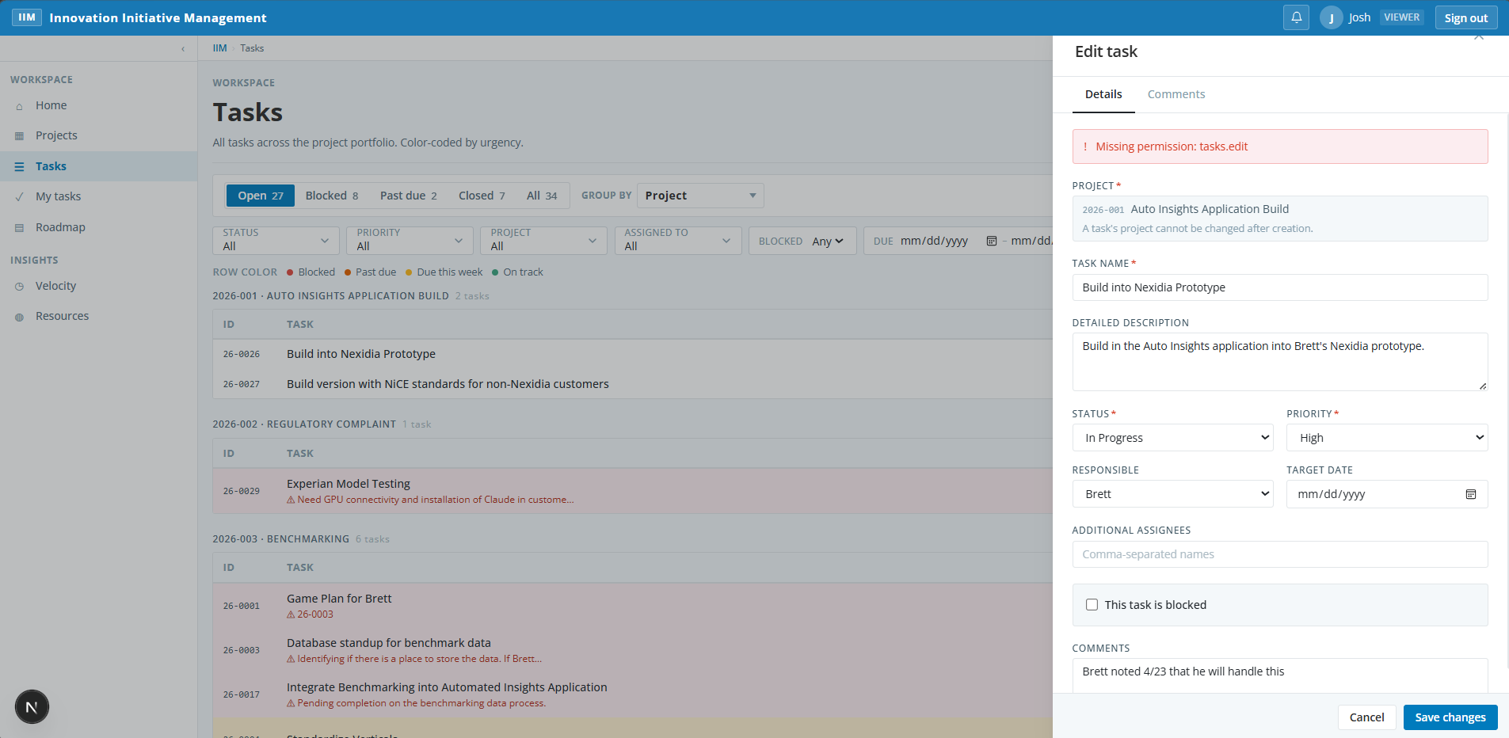

9. Roadmap module

9.1 Test scenarios
Sections 5.4 through 5.8. All five sub-views and dependency rendering.

ID | Test Scenario | Steps / Expected Result | Pass | Fail | Blkd | Comments / Issues
ROAD-01 | Roadmap page tabs render | 1. Navigate to /roadmap.  2. Verify tabs for Timeline, Kanban, Bubble, Now/Next/Later, Capacity exist.  Expected: All five sub-views are accessible from the roadmap shell. | ☒ |  |  | Validated all pages are accessible
ROAD-02 | Timeline (Gantt) view renders projects as bars | 1. Open the Timeline tab.  2. Inspect bar positions vs target dates.  Expected: Each project with a target date appears as a horizontal bar; bars are colored by Status or Priority based on the selected toggle. | ☒ |  |  | Validated that bars appear appropriately on the timeline and are consistent with project dates. Color changes based on the selection of priority vs status
ROAD-03 | Timeline window control changes calendar scale | 1. Switch the time-window selector between months, quarters, years.  Expected: The X-axis scale updates correctly; bars reposition without layout breaks. | ☒ |  |  | Weeks, months and quarters all display appropriately when selected.  Application Update Needed: add the year to the headers for the Weeks view
ROAD-04 | Drag bar end to adjust target date | 1. Drag the right edge of a project bar.  2. Confirm the date change in the prompt.  Expected: Target date is updated on the project; bar redraws to the new position. | ☒ |  |  | Validated project timeline moved appropriately on the timeline and the quick view shows the updated dates.  Application Update Needed: The popup message is a standard edge popup that is not in style with the rest of the application. Update so this looks like it’s a message generated by the application instead of the browser. Should be consistent with application design.  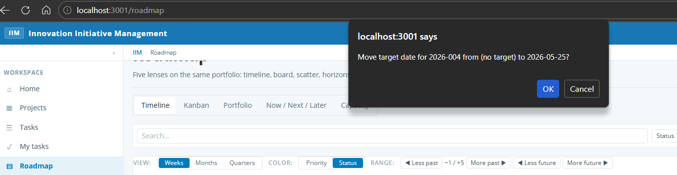
ROAD-05 | Click bar opens project quick view | 1. Click a project bar in Timeline.  Expected: Quick view panel opens with the project's summary. | ☒ |  |  | Validated quick view panel opens and has edit rights for appropriate user. Confirmed that Viewer only user does not have edit rights.
ROAD-06 | Dependency arrows render between linked projects | 1. Set Project A 'Depends On' Project B.  2. Open Timeline view.  Expected: Connector arrow renders from B to A; arrow color reflects upstream status (green/orange/red). | ☒ |  |  | Validated dependency is displayed in the timeline view and colored appropriately.
ROAD-07 | Kanban view shows configurable columns | 1. Open Kanban tab.  2. Switch the column field between Status, Phase, Priority, custom roadmap_bucket.  Expected: Columns redraw based on the selected field's enum values. | ☒ |  |  | Validated that columns redraw appropriately for all column selections
ROAD-08 | Drag-and-drop card between Kanban columns | 1. Drag a card from one column to another.  Expected: The corresponding field on the project is updated; card moves and persists across reload. | ☒ |  |  | Validated that the field on the project quickview is updated appropriately. Validated change persists across projects page and in kanban when returned to the roadmap
ROAD-09 | Kanban swimlanes | 1. Enable swimlanes by Application/Product.  Expected: Cards group into rows by Application/Product within columns. | ☒ |  |  | Validated that swimlane rows created appropriately by application/product within the columns
ROAD-10 | WIP limits display warning when exceeded | 1. Set a WIP limit on a column to a number lower than its current count.  Expected: Column header indicates over-WIP status visually. | ☒ |  |  | Set column and validated that visual indicator displays.
ROAD-11 | Save and reload Kanban configuration | 1. Configure columns and swimlanes.  2. Save as a named view.  3. Reload the page and reapply the saved view.  Expected: Saved configuration is available in the saved-views list and restores the chosen settings. | ☒ |  |  | Validated view is saved and accessible in the drop down list for a different user role.
ROAD-12 | Portfolio Bubble Chart default axes | 1. Open the Bubble tab.  Expected: X = AI Complexity Score (or fallback when AI absent); Y = Priority; bubble size proportional to estimated duration. | ☒ |  |  | 5/5 – still unclear if this is passed or not as the AI capability still doesn’t exist. When changing to Product Type as the X axis, the bubbles that appear seem to be proportional to estimated durations. Only 9 bubbles appear when there are 10 projects. This may be due to bubbles stacking on top of one another – one bubble looks like it is double layered but hovering only produces a single project as the larger bubble is layered on top of the smaller bubble.  4/30 - Unclear if this passed. AI capability does not exist yet, but this appears to be the default for the X Axis. Therefore nothing displayed.  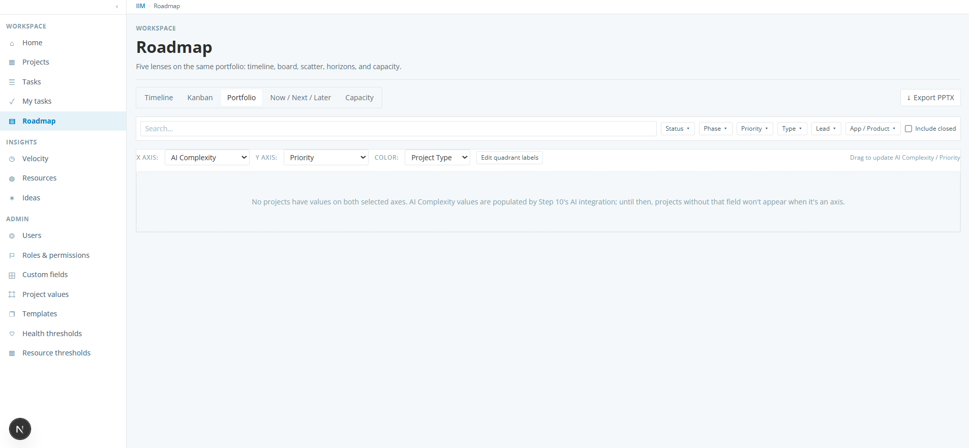
ROAD-13 | Bubble chart configurable axes | 1. Change X-axis to Stakeholder Count and Y-axis to Target Date proximity.  Expected: Bubbles re-plot to the new axes; quadrant labels remain editable. | ☒ | ☐ |  | 5/5 – bubbles replot appropriately. Addressed with bubble changes  Bubbles replot appropriately. However, the graph only shows 6 projects when I have 10 open projects. By default, this should include all projects that do not have a status of Complete or Canceled
ROAD-14 | Bubble chart click opens quick view | 1. Click any bubble.  Expected: Quick view panel opens for that project. | ☒ |  |  | Validated quick view displays with appropriate edit rights for user role.
ROAD-15 | Bubble chart filter integration | 1. Apply filters in the shared filter bar.  Expected: Filtered-out projects are removed from the chart; counts update. | ☒ |  |  | Validated that filters work as expected and Clear all resets the page.
ROAD-16 | Now / Next / Later auto-placement | 1. Open the Now/Next/Later tab.  2. Inspect column placements vs project Status and Target Date.  Expected: Active projects appear in Now; soon-to-start in Next; later-stage in Later. Unplaced lane catches items with no bucket. | ☒ | ☐ |  | 5/5 – Validated that unplaced lane now shows at the bottom. New projects without a start date or target date default to the Later bucket.  4/30 - Unclear if passed. No items are in an unplaced lane. All others appear correct. Added new project with not started status and no target date and it appeared in the Next bucket. There is no visible Unplaced lane
ROAD-17 | Drag card across Now/Next/Later columns | 1. Move a card from Next to Now.  Expected: roadmap_bucket on the project is updated; card persists in new column. | ☒ |  |  | Validated dragging card changes the location on the roadmap and persists. Auto status indicator is removed.
ROAD-18 | Capacity / Resource view renders rows per team member | 1. Open Capacity tab.  Expected: Each Project Lead and Additional Resource appears as a row; bars represent active project assignments over the timeline window. | ☒ |  |  | Tested under the Resources Capacity page since the Roadmap Capacity page is being deprecated. Validated that each resource appears in a row with bars appropriately representing projects over the time window.
ROAD-19 | Overload indicator highlights overcommitted resources | 1. Identify a resource assigned to more than one concurrent project.  Expected: Cells in the overlap window display the configured overload color (e.g. red). | ☒ |  |  | 5/5 - Validated that all resources show a visual indicator showing overload status.  Not tested. Unclear what is meant by the overlap window in the expected behavior
ROAD-20 | Capacity hover tooltip | 1. Hover a bar in Capacity view.  Expected: Tooltip displays project name, role, and start/target date. | ☒ | ☐ |  | 5/5 – Resolved with updated code.  4/30 - Tested under the Resources Capacity page since the Roadmap Capacity page is being deprecated.  Tooltip displays project number and name and role. Start/Target date are not displayed in the tooltip

10. PPTX export

10.1 Test scenarios
Section 5.9. Slide picker, native vs raster slides, branding, filter inheritance.

ID | Test Scenario | Steps / Expected Result | Pass | Fail | Blkd | Comments / Issues
PPTX-01 | Open PPTX export modal | 1. On any roadmap view, click Export Deck.  2. Inspect the slide picker.  Expected: Modal lists Title, Timeline, Kanban, Bubble, Now/Next/Later, Capacity, Status Summary, Blocked/At-Risk, Velocity slides. | ☒ |  |  | Validated all expected Dashboard views area available. Unclear why some are selected by default while others are not
PPTX-02 | Export deck with selected slides | 1. Select 3–4 slide types in the modal.  2. Choose Customer Name and Date Range.  3. Click Generate & Download.  Expected: A .pptx file downloads with filename pattern IIM_Roadmap_YYYY-MM-DD.pptx. |  |  | ☒ | 5/5 – removed test case  Test case is invalid. There is no customer name and date range to be selected; only selection options are which slides to include.  PPTX file generated and downloaded with name IIM_Roadmap_2026-04-30.pptx
PPTX-03 | PPTX content fidelity — Now/Next/Later slide | 1. Open the downloaded deck in PowerPoint.  2. Inspect the Now/Next/Later slide.  Expected: Three columns; cards generated natively (selectable text); colors match branding. | ☒ |  |  | Validated the three columns show as expected. Where there is overflow too large to fit the screen, it indicates there are more projects than listed.
PPTX-04 | PPTX content fidelity — Timeline slide | 1. Inspect the Timeline slide in PowerPoint.  Expected: Image is high resolution (rendered at 2x); date markers and bars readable. | ☒ |  |  | Validated the output matches what’s on the screen. Unclear if the resolution matches as expected but image can be adjusted for better readability
PPTX-05 | PPTX inherits filter context | 1. Apply Application/Product filter in roadmap view.  2. Export deck.  3. Confirm only filtered projects appear in the output slides.  Expected: Output mirrors the on-screen filter selection. | ☒ |  |  | Validated that only the filtered selection is included in the deck
PPTX-06 | Branding configuration applies to PPTX | 1. As Admin, set custom logo, primary, and secondary colors in Admin Console.  2. Export a deck.  Expected: Logo and colors appear on the title slide and section headers. |  |  |  | 5/5 – removed test case  Invalid test case; there is no current capability to set logo and colors.  Application Update Needed: Update the pptx export capability to use slides from the NiCE branded template deck. This needs to be something that can be replaced as brand changes occur.
PPTX-07 | Permission gating on export | 1. Sign in as a user without roadmap.export permission.  Expected: Export Deck button is hidden; direct API call returns 403. | ☒ |  |  | Validated export deck functionality is not available to user

11. Project dependencies

11.1 Test scenarios
Section 5.10. Upstream relationships, dependency types, circular detection, propagation to health and roadmap.

ID | Test Scenario | Steps / Expected Result | Pass | Fail | Blkd | Comments / Issues
DEP-01 | Add an upstream dependency to a project | 1. Open a project's edit form.  2. Add a 'Depends On' selection for an upstream project; choose dependency type.  3. Save.  Expected: Dependency is saved on the dependent project; an arrow appears in the Timeline view. | ☒ |  |  | Validated during the roadmap testing. This functions correctly.
DEP-02 | Circular dependency prevention | 1. Project A depends on B; B depends on C; attempt to make C depend on A.  Expected: Save fails with a clear message; no circular dependency stored. | ☒ |  |  | Validated functions as expected.  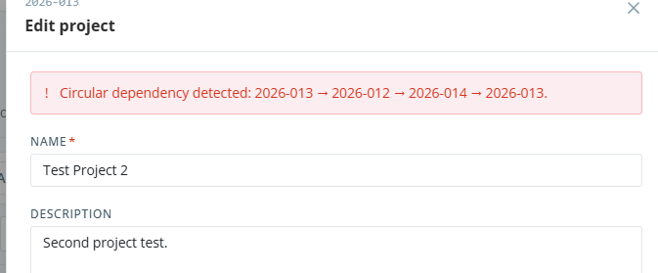
DEP-03 | Dependency warning when upstream is Blocked/Delayed/On Hold | 1. Set an upstream project's status to Blocked.  2. Open the dependent project.  Expected: A warning banner appears on the dependent project record and on the row health indicator. | ☒ |  |  | Validated warning indicator appears on Project page in correct row. Validated quick view shows warning.  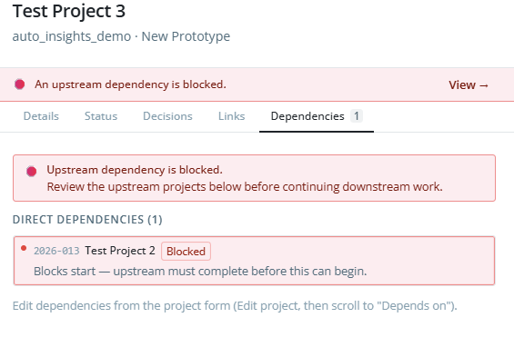
DEP-04 | Dependency chain panel | 1. Open a project that has a multi-level upstream chain.  2. Expand the dependency chain panel.  Expected: All upstream levels are displayed up to the configured depth limit; statuses are color coded. | ☒ |  |  | Validated multiple dependencies are seen in the panel.  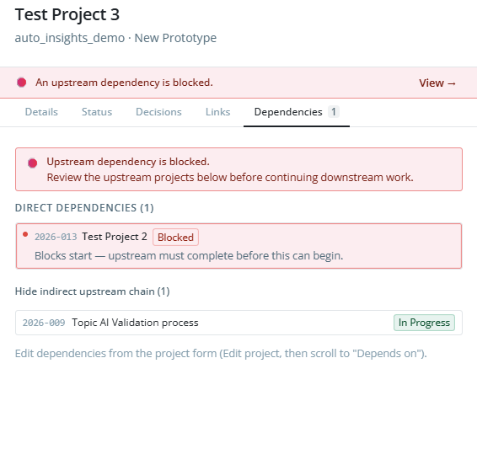
DEP-05 | Dependencies influence priority recommendation (when AI advisor enabled) | 1. When AI advisor is available, run priority review.  Expected: Projects with no upstream blockers rank higher when other factors are equal. |  |  | ☒ | AI Advisor not currently available.

12. Decision & change log

12.1 Test scenarios
Section 5.11. Append-only entries, type filtering, search inclusion.

ID | Test Scenario | Steps / Expected Result | Pass | Fail | Blkd | Comments / Issues
DEC-01 | Add a decision log entry | 1. Open a project's Decision Log tab.  2. Add an entry: Date, Decision Type, Summary, Rationale, Made By.  3. Save.  Expected: Entry appears at the top of the list; type renders as a colored badge. | ☒ |  |  | Added decision and completed all fields. Displays at the top of the list.
DEC-02 | Decision log entries are immutable | 1. Attempt to edit an existing decision log entry.  Expected: No edit affordance is offered; entries are append-only. | ☒ |  |  | validated that an entry can’t be changed once it’s been made.
DEC-03 | Filter decision log by type and date range | 1. Use the type filter and date range controls.  Expected: Visible entries narrow accordingly; clearing restores full list. | ☒ | ☐ |  | 5/5 – validated this displays as expected once a decision has been logged.  4/30 - There are no filter and date range controls visible on the project quick view decisions page.
DEC-04 | Decision log content searchable globally | 1. Use the global search bar with text from a decision rationale.  Expected: Search results include the project that contains the matching decision entry. | ☒ | ☐ |  | 5/5 – validated this is working correctly after code change.  4/30 - There is no search bar visible on the project quick view decisions page.

13. Document & repository links

13.1 Test scenarios
Section 5.14. Link types, auto-detection, task-level links.

ID | Test Scenario | Steps / Expected Result | Pass | Fail | Blkd | Comments / Issues
LINK-01 | Add a document link with auto-detected type | 1. Open a project's Document Links section.  2. Paste a github.com URL with a Label.  3. Save.  Expected: Link saves with link_type = GitHub Repository; icon matches. | ☒ |  |  | Validated this link was selected appropriately.
LINK-02 | Add link types beyond auto-detect | 1. Add Confluence, Figma, Notion, and Other links.  Expected: Each link displays correctly with its icon and is clickable in a new tab. | ☒ |  |  | Validated auto detection of Confluence. Validated link displayed correctly and when clicked takes you to the right place.  Application Update Needed: Edit the list of link types. Remove Google Drive and Notion. Add the ability to link to an internal drive that is not sharepoint.
LINK-03 | Edit and delete links | 1. Open the link editor; rename one and remove another.  Expected: Changes persist; quick view panel reflects updates. | ☒ | ☐ |  | 5/5 – validating there is now edit capability for the link.  4/30 - There is no edit capability for the link. Confirmed deletion worked as expected.
LINK-04 | Task-level links | 1. Open a task and add a PR link.  Expected: Task displays the link; clicking opens the destination in a new tab. | ☒ |  |  | Validating working as expected.
LINK-05 | Links visible in quick view | 1. Open a project's quick view.  Expected: Document links chip row is visible without opening the full record. | ☒ |  |  | 5/5 – validated number of links displayed next to Links header. When tab is selected, links are visible.  4/30 - what is meant in the Expected outcome. Quickview shows the number of links next to the tab header.  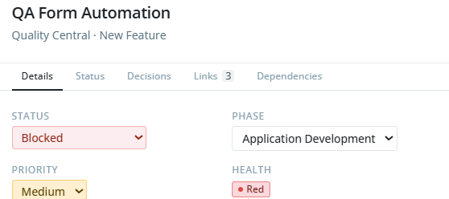

14. Notifications & alerts

14.1 Test scenarios
Section 5.12. In-app and email delivery, scheduled sweeps, preferences, digest mode.

ID | Test Scenario | Steps / Expected Result | Pass | Fail | Blkd | Comments / Issues
NOTIF-01 | Notification bell shows unread count | 1. As an admin, assign a task to User A.  2. Sign in as User A and look at the bell icon.  Expected: Bell shows a badge with the unread count; opening the drawer lists the assignment notification. | ☒ | ☐ |  | 5/5 – validated bell icon showed indicator when new task was assigned.  4/30 - Bell icon does not show any indication of an unread count  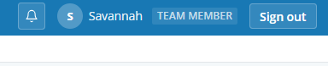
NOTIF-02 | Mark notification as read | 1. Click a notification in the drawer.  Expected: Notification is marked read; unread count decreases. | ☒ | ☐ |  | 5/5 – validated notification shows appropriately to the user.  4/30 - No notifications display even though a new task was assigned to the user  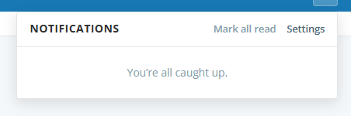
NOTIF-03 | Task Due Soon notification | 1. Set a task target date to 2 days out (within the configured lead time).  2. Trigger the daily sweep (or invoke run-notifications-sweep manually).  Expected: Responsible user receives a TaskDueSoon notification. | ☒ | ☐ |  | 5/6 – validated updated functionality works and notification displays appropriately.  4/30 - There is no functionality to trigger a sweep available in the application
NOTIF-04 | Task Overdue notification | 1. Set a task target date to yesterday with status still Open.  2. Trigger the sweep.  Expected: Responsible user receives a TaskOverdue notification. | ☒ | ☐ |  | 5/6 – validated updated functionally works and notification displays as expected.  4/30 - There is no functionality to trigger a sweep available in the application
NOTIF-05 | Project Blocked notification | 1. As Admin, mark a project as Blocked.  Expected: Project Lead and assignees receive a ProjectBlocked notification. | ☒ | ☐ |  | 5/5 – validated owner receives two notifications; one for project blocked and one for the health score changing  4/30 - No notification displayed to the user
NOTIF-06 | Dependency Blocked notification | 1. Set an upstream project to Blocked.  2. Trigger the sweep.  Expected: Owners of dependent projects receive a DependencyBlocked notification. | ☒ | ☐ |  | 5/6 – validated updated functionality works as expected.  4/30 - There is no functionality to trigger a sweep available in the application
NOTIF-07 | Health Score Degraded notification | 1. Force a project's health score to drop from Green to Yellow (or Yellow to Red).  2. Run the sweep.  Expected: HealthScoreChanged notification fires for affected stakeholders. | ☒ | ☐ |  | 5/6 – validated updated functionality works as expected.  4/30 - There is no functionality to trigger a sweep available in the application
NOTIF-08 | Notification preferences — per-type delivery | 1. Open /profile/notifications.  2. Set Task Assigned = Off; Task Overdue = Email + In-App.  3. Save and trigger relevant events.  Expected: No Task Assigned notification fires; Task Overdue produces email and in-app entries. | ☒ | ☐ |  | 5/6 – validated functionality now existis.  4/30 - No such functionality exists in the application
NOTIF-09 | Daily digest mode | 1. Set notification mode to Daily Digest.  2. Trigger several events through the day.  3. Run the daily sweep.  Expected: User receives a single digest email summarizing the day's events. |  | ☐ |  | No such functionality exists in the application
NOTIF-10 | Email delivery uses configured provider | 1. Configure RESEND_API_KEY.  2. Trigger an event that emits an email.  Expected: Email is sent through Resend with the configured template; delivery logged. |  |  | ☒ | Email is not configured
NOTIF-11 | Idea submitter notified on status change | 1. Submit a public idea with an email address.  2. As Admin, change idea status from New to Approved.  Expected: Submitter receives an IdeaStatusChanged email. |  |  | ☒ | Email is not configured

15. Project health score

15.1 Test scenarios
Section 5.13. Calculation, thresholds, sparkline, propagation through dependencies.

ID | Test Scenario | Steps / Expected Result | Pass | Fail | Blkd | Comments / Issues
HLTH-01 | Health score = Green for a healthy project | 1. Choose a project with <20% blocked/overdue tasks, target date >2 weeks away, recent task activity.  Expected: Badge displays Green. | ☒ |  |  | Validated green status as appropriate
HLTH-02 | Health score = Yellow at risk thresholds | 1. Adjust a project so 30% of tasks are open with target date 10 days out.  Expected: Badge transitions to Yellow. | ☒ | ☐ |  | 5/5 – validated working correctly after code change.  4/30 - Selected project with 3 tasks, all open. One task (33%) set to target date 10 days from today with other tasks set further out. Project status remains at green.
HLTH-03 | Health score = Red on serious issues | 1. Set status = Blocked OR force >40% blocked/overdue tasks.  Expected: Badge displays Red. | ☒ |  |  | Validated project status moves to Red
HLTH-04 | Health propagates from upstream Red projects | 1. Set Project A (upstream) to Red.  2. Confirm Project B (dependent) reflects the rule.  Expected: Per design, dependent project is forced to Red because upstream is Red. | ☒ |  |  | Validated project B is forced to Red with change of Project A to Blocked and Red status.
HLTH-05 | Sparkline shows 30-day history | 1. Open a project's detail page.  Expected: A sparkline of recent health scores renders, capped at 30 entries. | ☒ |  |  | Validated health score history displays and shows trend.  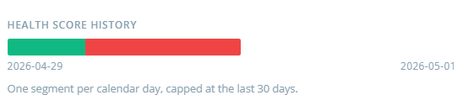
HLTH-06 | Configurable thresholds in Admin Console | 1. Open /admin/health-thresholds.  2. Adjust the Yellow/Red thresholds; save.  3. Trigger Recalc on the Projects page.  Expected: Badges update to reflect new thresholds; saved settings persist after refresh. | ☒ |  |  | Validated badges change and persist after refresh

16. Velocity & throughput dashboard

16.1 Test scenarios
Section 5.15. Charts, time range, filters, individual view, caching.

ID | Test Scenario | Steps / Expected Result | Pass | Fail | Blkd | Comments / Issues
VEL-01 | Velocity dashboard renders all charts | 1. Navigate to /dashboard/velocity.  Expected: Charts render: Projects per Quarter, Avg Time to Completion, Estimated vs Actual, Task Throughput, Phase Cycle Time, Blocked Time, Idea Conversion Rate. | ☒ | ☐ |  | All charts display as expected
VEL-02 | Time range selector | 1. Switch range between 30 days, 90 days, 6 months, 1 year, all time.  Expected: All charts re-render with data within the selected range. | ☒ |  |  | Validate all charts re-render as expected
VEL-03 | Filter by Project Type and Application/Product | 1. Apply each filter and combination.  Expected: Metrics narrow to the filtered subset. | ☒ |  |  | Validated metrics are changing; volumes are relatively low at this point so more difficult to see at the project level. Task level changes as expected
VEL-04 | Individual contributor view | 1. Filter to a specific team member (Admin or self only).  Expected: Metrics show that user's throughput; cross-peer view is restricted as designed. | ☒ |  |  | Validated metrics are limited to the specific user
VEL-05 | Minimum-data warning when sparse history | 1. View a fresh environment with <3 completed projects.  Expected: A warning banner explains data is limited and metrics may be unreliable. | ☒ |  |  | Validated warning banner is present
VEL-06 | Server-side caching of metrics | 1. Open Velocity dashboard, refresh quickly twice.  Expected: Second load is faster (cached); cache invalidates after 1 hour or on data change. | ☒ |  |  | Validated that second load was faster
VEL-07 | Permission gating on velocity view | 1. Sign in as a user lacking velocity.view permission.  Expected: Velocity link is hidden; direct route returns 403/redirect. | ☒ |  |  | Validated link not displayed for user with no permissions

17. Resources insights

17.1 Test scenarios
Resource roster, capacity tab, performance tab, and resources permission gating.

ID | Test Scenario | Steps / Expected Result | Pass | Fail | Blkd | Comments / Issues
RES-01 | Resources insights page renders | 1. Navigate to /insights/resources.  Expected: Resource roster is listed; capacity and performance tabs are visible. | ☒ |  |  | Validated that resource roster shows as expected with capacity and performance tabs visible
RES-02 | Resource detail drilldown | 1. Click a resource name.  Expected: Detail panel shows assignments, capacity, and recent activity. | ☒ |  |  | Validated resource panel shows detailed information per person
RES-03 | Capacity tab shows assignments over time | 1. Open the Capacity tab.  Expected: Same dataset as roadmap Capacity view, scoped to the resource detail. | ☒ |  |  | Validated this shows as expected
RES-04 | Performance tab metrics | 1. Open Performance tab.  Expected: Throughput, completion times, and personal velocity render. | ☒ |  |  | Validated this shows as expected
RES-05 | Permission gating — resources.view vs resources.view_all | 1. Sign in as a user with only resources.view (their own data).  Expected: User sees only their own resource detail; cross-peer detail is blocked. | ☒ | ☐ |  | 5/5 – validated working as expected and tool tip displays appropriately  4/30 - Information displays for the entire team (appears to be anyone who has tasks on the same projects or projects in which they are assigned as lead), not just the individual user.

18. Idea submission & review

18.1 Test scenarios
Sections 5.17 and 5.18. Public submission, rate limiting, review workflow, conversion.

ID | Test Scenario | Steps / Expected Result | Pass | Fail | Blkd | Comments / Issues
IDEA-01 | Public submission portal accepts an idea (no login) | 1. Open /submit while signed out.  2. Fill in Submitter Name, Idea Name, Description, Urgency, Stakeholders.  3. Submit.  Expected: Confirmation page or message appears; idea is added to the queue with status New. | ☒ |  |  | Validated submission displays as expected. Idea is in queue with status New
IDEA-02 | Public submission with optional email | 1. Submit an idea including a valid email address.  Expected: Idea is saved with the submitter email recorded for follow-up notifications. | ☒ |  |  | Validates submission displays as expected. Idea is in queue with email address attached.
IDEA-03 | Rate limit on /submit | 1. From the same IP, submit 6 ideas within an hour.  Expected: After the threshold the next submission is rejected with a friendly message. | ☒ |  |  | Validated the 6th idea was rejected with message.  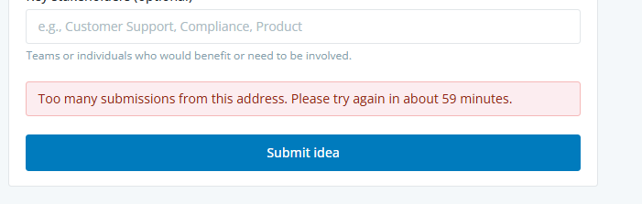
IDEA-04 | Admin Ideas Review queue | 1. Sign in as an admin or reviewer.  2. Navigate to /admin/ideas.  Expected: Ideas list renders with filter by status; click opens the detail view. | ☒ |  |  | Validated idea list with filter. Click on link opens the idea page.  Application Update Needed: update so clicking anywhere on the row opens the idea instead of having a link just on the name
IDEA-05 | Approve idea | 1. Open an idea and click Approve; add an admin comment.  Expected: Status updates to Approved; submitter is notified if email present. | ☒ |  |  | Status updated. No email present
IDEA-06 | Reject idea | 1. Open an idea, click Reject, supply a reason.  Expected: Status updates to Rejected; admin comment is recorded. | ☒ |  |  | Validated rejected status is recorded. Validate note saved after clicking Save Notes function. No specific way to enter a rejection reason other than the notes field
IDEA-07 | Convert idea to project | 1. Open an idea, click Convert to Project.  2. Review the pre-filled project form and save.  Expected: A new project is created (YYYY-NNN ID) and idea is marked Converted with a link to the new project. | ☒ |  |  | New project created and displayed in the projects list as expected  Application Update Needed: Application/Product, Project lead dropdown in the Convert to Project displaying the standard browser selection list instead of a list consistent with the application UI
IDEA-08 | AI overlap check (when configured) | 1. Click AI Overlap Check on an idea.  Expected: Inline analysis appears summarizing matches against existing projects/ideas, or a clear fallback if AI is disabled. |  |  | ☒ | AI not yet configured
IDEA-09 | Permission gating — ideas.review vs ideas.convert | 1. Sign in as a user with only ideas.review.  Expected: User can approve/reject but the Convert action is hidden. | ☒ | ☐ | ☐ | 5/5 – validated  4/30 - Convert to project function is active, not hidden for user without that access. Conversion attempt fails with a “missing permission” message.  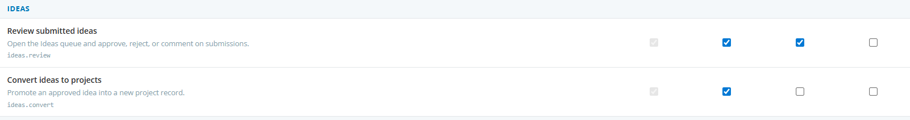

19. Admin console

19.1 Test scenarios
Section 5.19. User management, roles & permissions matrix, custom fields, templates, thresholds, project values.

ID | Test Scenario | Steps / Expected Result | Pass | Fail | Blkd | Comments / Issues
ADM-01 | User Management — invite a new user | 1. Navigate to /admin/users.  2. Invite a user by email; assign a role.  Expected: Invite token is generated; an email is sent if Resend configured; URL is displayed for sharing. | ☒ |  |  | Validated URL displayed since email is not configured.
ADM-02 | Invite acceptance flow | 1. Open the /invite/<token> URL.  2. Set a password and submit.  Expected: User is activated and signed in; appears as Active in /admin/users. | ☒ |  |  | Validated user is active and can sign in. User shows as active in admin panel
ADM-03 | Deactivate and reactivate a user | 1. Toggle the user's active flag in /admin/users.  Expected: Login fails for deactivated users; reactivation restores access. | ☒ |  |  | Validated this works correctly
ADM-04 | Roles & permissions matrix — toggle a permission | 1. Open /admin/role-permissions.  2. Toggle a non-Admin permission and Save.  Expected: Change persists; affected users see updated UI gating immediately. | ☒ |  |  | Validated this functions correctly
ADM-05 | Admin column locked | 1. Inspect the Admin column in the matrix.  Expected: All checkboxes are disabled and pre-checked; Admin always has every permission. | ☒ |  |  | Validated all checkboxes are prechecked and disabled
ADM-06 | Reset to defaults | 1. Click Reset to defaults; click Save.  Expected: Matrix returns to seeded defaults across all non-Admin columns. | ☒ |  |  | Validated return back to defaults.  Application Update Needed: Message displays as standard browser message and not consistent with the application UI
ADM-07 | Discard changes | 1. Toggle a few checkboxes; click Discard changes.  Expected: Changes are reverted without a server round-trip. | ☒ |  |  | Validated changes reverted immediately.
ADM-08 | Soft warning on orphaned admin permissions | 1. Grant a non-Admin role admin.* permission without admin.console.  Expected: Warning appears explaining the route may be unreachable from nav. | ☒ | ☐ |  | 5/5 – validated warning now displays at the top of the page.  4/30 - No warning displayed  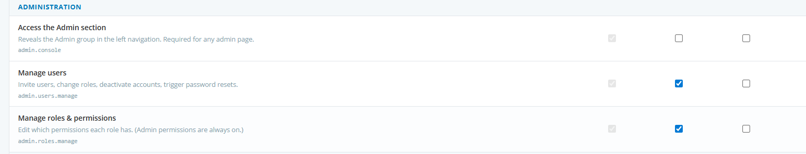
ADM-09 | Custom Fields — add and edit | 1. Open /admin/custom-fields.  2. Add a field with name, type, options.  3. Verify it appears on the project form.  Expected: Field renders correctly on the project form and is filterable. | ☒ |  |  | Displays as custom field on the project page, the project quick view, edit project page and new project page. Filter works as expected showing only projects that match the filter value
ADM-10 | Custom Fields — remove | 1. Remove a custom field; confirm.  Expected: Field disappears from forms; existing records keep stored values per design. | ☒ | ☐ |  | 5/5 – validated stored values for removed custom fields are visible with comments on how to make them appear again.  4/30 - When custom field is removed, project records do not visibly retain the value. It is only visible if the custom field is addedback in
ADM-11 | Task Templates — create | 1. Open /admin/templates.  2. Create a template with several tasks; tie to a project type.  Expected: Template saved; offered when creating a project of that type. | ☒ |  |  | Validated template can be saved. Available to apply when creating a new project. Also validated that on tasks page when using add tasks from template, the correct project type must be selected for the tasks to appear.
ADM-12 | Health Score Thresholds editor | 1. Open /admin/health-thresholds.  2. Adjust thresholds and save.  Expected: Settings persist; portfolio recalculates on the next trigger. | ☒ |  |  | Validated this is functioning as expected
ADM-13 | Resource Thresholds editor | 1. Open /admin/resource-thresholds.  2. Configure overload thresholds.  Expected: Capacity view reflects updated overload colorization. | ☒ |  |  | Validated capacity view reflects overload at changed thresholds
ADM-14 | Project Values editor | 1. Open /admin/project-values.  2. Add or rename enum values for Status, Phase, Priority, Project Type.  Expected: New values are available across project forms and filters; existing references remain intact. | ☒ |  |  | Validated able to add in every location
ADM-15 | Permission gating — admin pages | 1. Sign in as a user lacking the relevant admin.* permission.  Expected: Each admin page is hidden in nav and returns 403/redirect on direct navigation. | ☒ | ☐ |  | 5/5 – validated now displays a graceful access denied page.  4/30 - Admin pages are hidden. 403 error and redirect not displayed; user sees next.js message.  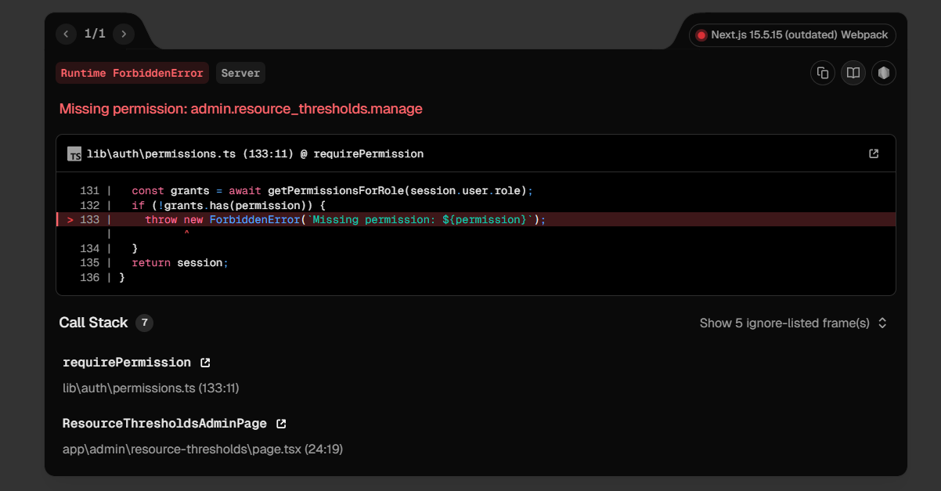

20. Global search

20.1 Test scenarios
Search across projects, tasks, decisions, and link labels.

ID | Test Scenario | Steps / Expected Result | Pass | Fail | Blkd | Comments / Issues
SRCH-01 | Global search finds project by name | 1. Use the global search bar.  2. Enter a partial project name.  Expected: Matching projects appear in results; clicking opens the project. |  | ☒ |  | No global search exists on home page or in the navigation bar; search is available on individual pages only
SRCH-02 | Global search finds tasks by name | 1. Search for a partial task name.  Expected: Matching tasks appear with the parent project link. |  | ☒ |  | No global search exists on home page or in the navigation bar; search is available on individual pages only
SRCH-03 | Search includes decision log content and link labels | 1. Search for text from a decision rationale or document link label.  Expected: Matching projects appear in results. |  | ☒ |  | No global search exists on home page or in the navigation bar; search is available on individual pages only

21. Security & access control

21.1 Test scenarios
API-level enforcement, mid-session permission changes, password storage, write integrity, CSRF.

ID | Test Scenario | Steps / Expected Result | Pass | Fail | Blkd | Comments / Issues
SEC-01 | Unauthenticated API call is rejected | 1. Without a session, call GET /api/projects directly (Postman/curl).  Expected: Returns 401/redirect; no project data leaks. | ☒ |  |  | 5/7 – validated unauthorized error displays
SEC-02 | Authenticated user without permission cannot mutate | 1. As Viewer, attempt POST /api/projects.  Expected: Returns 403; record is not created. | ☒ |  |  | Validated 403 status displayed as expected
SEC-03 | Permission change takes effect mid-session | 1. Revoke a permission via the matrix while a user with that permission is active.  2. Have that user trigger a UI affordance or API call.  Expected: API responds 403; UI gating updates on next render. | ☒ |  |  | Validated button disappeared and appeared as expected. Validated 403 status displayed as expected on API call
SEC-04 | Password hashing uses bcrypt | 1. Inspect data/users.json for a recently set password (in dev).  Expected: Stored value is a bcrypt hash; no plaintext or reversible encoding. | ☒ |  |  | 5/6 – validated password is stored as a hash.
SEC-05 | Concurrent JSON write integrity | 1. Trigger two simultaneous updates to the same record (e.g. two browser tabs).  Expected: Last-write-wins; file is not corrupted; atomic write rename behavior holds. | ☒ |  |  | Validated only one value saved; validated json structure remained intact.
SEC-06 | CSRF protection on mutating endpoints | 1. Attempt cross-origin POST to /api/projects with a valid session cookie but no CSRF token.  Expected: Request is rejected by NextAuth/Next middleware behavior. | ☒ |  |  | Validated functions as expected.

22. Data persistence

22.1 Test scenarios
JSON-store integrity, atomic writes, schema backfill, reseed behavior.

ID | Test Scenario | Steps / Expected Result | Pass | Fail | Blkd | Comments / Issues
DATA-01 | JSON store survives restart | 1. Create a project, restart the dev server, and reload the app.  Expected: New project persists; data/projects.json contains the record. | ☒ |  |  | Validated project displays in UI after restart. Validated project record remains in projects.json
DATA-02 | Atomic write — no corruption on simulated crash | 1. Begin a write operation, then kill the server before completion (best effort in dev).  2. Inspect projects.json on restart.  Expected: File remains valid JSON; no half-written content. | ☒ |  |  | Validated file remains json format. No content from the save was written.
DATA-03 | Backfill of new fields on existing records | 1. After a schema change, load the app against an older data folder (e.g. without password_reset_token fields).  Expected: Backfill helper sets defaults; no errors during load. | ☒ | ☐ |  | Project appears in projects list. Attempting to open it results in error as expected
DATA-04 | Reseed wipes and replaces | 1. Run npm run seed against a populated environment.  Expected: All JSON files are rewritten from the spreadsheet; existing custom data is overwritten as documented. | ☒ |  |  | Validated works as expected

23. UX & visual conformance

23.1 Test scenarios
Polaris design tokens, shell consistency, accessibility, responsiveness.

ID | Test Scenario | Steps / Expected Result | Pass | Fail | Blkd | Comments / Issues
UX-01 | Visual conformance — Polaris tokens | 1. Inspect any page for typography, color, spacing.  Expected: Open Sans font; brand blue (#007bbd) for active controls; #f4f8fa background; thin borders; compact controls (~28px input height). | ☒ |  |  | Pages inspected are as expected
UX-02 | Header, breadcrumb, tab strip render consistently | 1. Navigate between Projects, Tasks, Roadmap, Velocity, Admin pages.  Expected: Global header, breadcrumb strip, and tabs follow the documented heights and styling. | ☒ |  |  | Looks as expected
UX-03 | Left rail collapse | 1. Toggle the left rail collapse control.  Expected: Rail collapses to ~52px; icons remain; labels disappear; expand restores prior state. | ☒ |  |  | Functioning as expected
UX-04 | Loading and empty states | 1. Open pages with empty data sets (e.g. brand-new environment or filtered to no results).  Expected: Empty states render gracefully; no broken zeros, no blank panels. | ☒ |  |  | Validated pages display as expected
UX-05 | Error handling — API failure | 1. Simulate an API error (stop a downstream service or force a 500).  Expected: User sees a clear error toast or banner; UI does not crash; retry is offered where appropriate. | ☒ |  |  | Validated functioning as expected
UX-06 | Keyboard navigation | 1. Tab through main pages; activate buttons via Enter/Space.  Expected: Focus order is sensible; controls are keyboard reachable; focus ring visible. | ☒ |  |  | Validated functions as expected
UX-07 | Accessibility — ARIA labels on icon buttons | 1. Inspect icon-only buttons (notification bell, link icons, kebab menus).  Expected: Each has aria-label or accessible name. | ☒ |  |  | Validated bell has accessible name
UX-08 | Responsive behavior at 1024px width | 1. Resize the viewport to ~1024px wide.  Expected: Layout remains usable; tables scroll horizontally if needed; no critical clipping. | ☒ |  |  | Validated acceptable at 1024px

Test execution summary
Record the count of tests in each result category as testing proceeds. Use this page as the rollup for sign-off.

Section | Area | Tests | Pass | Fail | Blkd
4.1 | Environment setup | 8 | 8 | 0 | 0
5 | Authentication & access | 13 | 13 | 0 | 0
6 | Home dashboard | 4 | 4 | 0 | 0
7 | Projects repository | 18 | 18 | 0 | 0
8 | Tasks & My Tasks | 12 | 12 | 0 | 0
9 | Roadmap module | 20 | 20 | 0 | 0
10 | PPTX export | 5 | 5 | 0 | 0
11 | Project dependencies | 5 | 4 | 0 | 1
12 | Decision & change log | 4 | 4 | 0 | 0
13 | Document & repository links | 5 | 5 | 0 | 0
14 | Notifications & alerts | 11 | 8 | 0 | 2
15 | Project health score | 6 | 6 | 0 | 0
16 | Velocity & throughput dashboard | 7 | 7 | 0 | 0
17 | Resources insights | 5 | 5 | 0 | 0
18 | Idea submission & review | 9 | 8 | 0 | 1
19 | Admin console | 15 | 15 | 0 | 0
20 | Global search | 3 | 0 | 0 | 3
21 | Security & access control | 6 | 6 | 0 | 0
22 | Data persistence | 4 | 4 | 0 | 0
23 | UX & visual conformance | 8 | 8 | 0 | 0
Total |  | 168 | 160 | 0 | 7

Sign-off
On completion of testing, the tester signs and dates this section.

Tester signature |  | Date:
Approver |  | Date:

