SAE 2.04 ENGLISH BDD
ZHANG Dylan
FLAGOTHIER Lorenzo
Group B

1) In a bar or line graph, show the evolution in the numbers of :

a) all applicants between 2006 and 2023

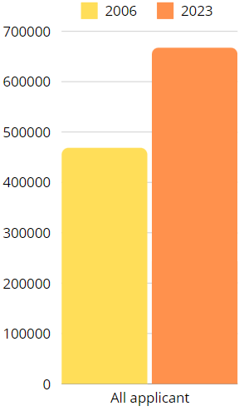
These numbers in this graph represent the total number of applicants to UCAS in 2006 and 2023.
In 2006, there were 468650 applicants, whereas in 2023, there were 667650.
This increase from 2006 to 2023 suggest a signifant growth in the number individuals applying through UCAS.

b) international applicants from the EU (excluding UK) between 2006 and 2023
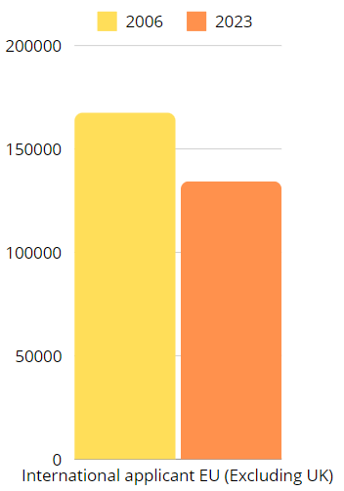

These numbers in this graph represent the total number of international from the European union (excluding UK) who applied through UCAS in 2008 and 2023.
In 2006, there were 167480 applicants, whereas in 2023, there were 134370 .
This data suggest a decrease in the number of EU applicant from 2006 to 2023.

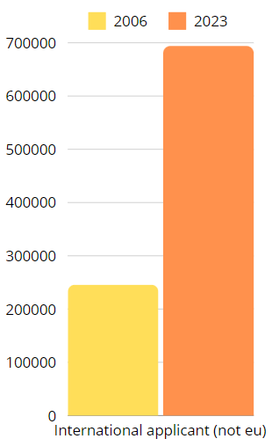
c) international non-EU applicants between 2006 and 2023

These numbers in this graph represent the total number of international from countries outside European who applied through UCAS in 2008 and 2023.
In 2006, there were 245710 applicants, whereas in 2023, there were 693940 .
This data suggest a significant increase the number of international applicants from non-EU countries from 2006 to 2023.

2) Compare the figures for applications between 2021 and 2023 of applicants from England, the EU (excluding UK), Northern Ireland, International not EU, Scotland and Wales.
What can you conclude from these ?

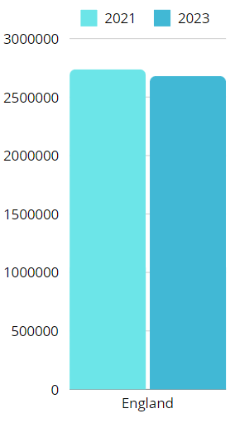
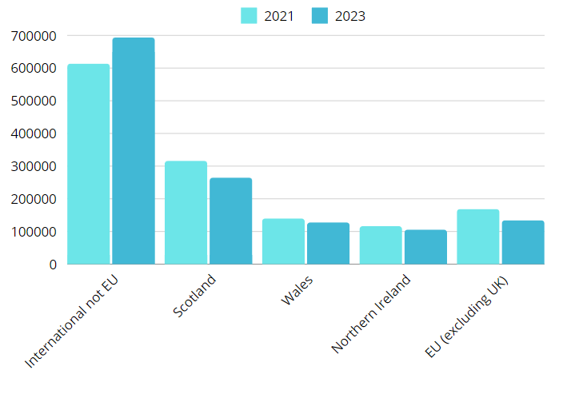

After comparing all these graph, we can conclude that the number of applications for England, Scotland, Wales, Northern Ireland, and the EU (excluding the UK) decreased in 2023 compared to 2021, except for international not EU.

3) Has Brexit had an effect on the number of French applicants to UK universities ? What about other EU countries ? Use bar or line graphs to compare the figures before and after Brexit.

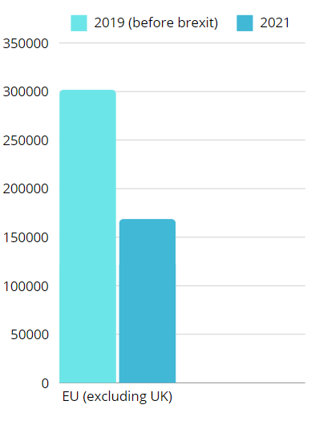
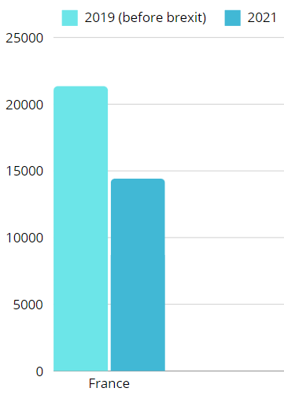
The Brexit had occured the 1st February 2020,
We can see the graph here, by comparing the number of application from EU and France before and after the Brexit made a huge difference.
Almost cut in half the amount of application from EU and France.

4) Which country (excluding the UK) had the highest number of applicants in June 2023 ? Indicate the number to justify your answer.

The country with the highest number of applicants in June 2023 is China with 30700 of applicants.

5) Which country (excluding the UK) had the highest number of female applicants in June 2023 ? Indicate the number to justify your answer.

The country with the highest number of female applicants in June 2023 is China with 15890 of applicants.

6) Show how the number of applicants from Australia has evolved between 2006 and 2023 in a bar or line graph. Compare the figures for all age groups and genders.
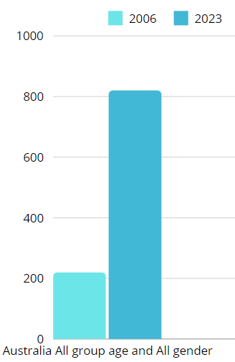

We can see in this graph, the number of Australian applicants from 2006 to 2023 for all age groups and genders.
Their numbers of applicants increased from 220 to 830.

7) Show how the number of applicants from China has evolved between 2006 and 2023 in a bar or line graph. Compare the figures for all age groups and genders.
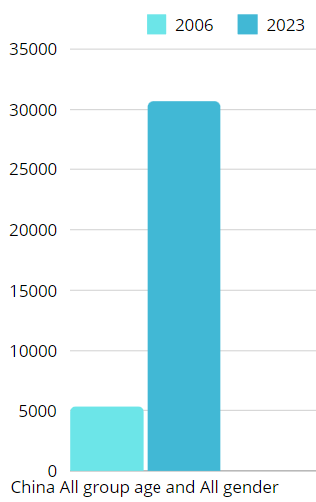

We can see in this graph, the number of chinese applicants from 2006 to 2023 for all age groups and genders.
Their numbers of applicants increased from 5330 to 30700.

