VSAT FAULTY ITEM
RETURN, REPAIR & ACCEPTANCE
Standard Operating Procedure (SOP) and Life-Cycle Support Workflow
Applicable items: complete VSAT terminals, antenna systems, modems, ACUs, BUCs, LNBs/LNAs, motors, drives, power supplies, controllers, cables and replaceable modules
Document No.: VSAT-LCS-SOP-001 | Revision: A (Draft) | Date: 21 October 2026
Purpose
Establish a traceable, repeatable process for receiving field-declared faulty equipment, inspecting and diagnosing it, deciding repair versus replacement, verifying conformity, and returning the item to service while preserving configuration control and life-cycle support.

Document Control
Field | Entry
Document owner | VSAT Engineering / Integrated Logistics Support (ILS)
Process owner | Repair Centre Manager
Quality authority | Quality Assurance (QA) / authorized release signatory
Approval | To be completed by organization
Review cycle | Annual, or following major product/process change
Status | Draft template — not an OEM-approved maintenance manual

1. Purpose and Scope
This procedure defines the controlled workflow for equipment returned from field use with a reported fault. It applies to system-level returns and individual line-replaceable units (LRUs), including antenna/pedestal assemblies, antenna control units (ACUs), modems, BUCs, LNBs/LNAs, RF cables, motors, motor drives, controllers, power supplies, interface modules and associated software/configuration.
The procedure is designed around common production-service practices: RMA control, quarantine, traceability, risk-based inspection, fault reproduction, documented diagnosis, approved repair, independent verification, acceptance testing and controlled dispatch. It does not replace the OEM manual, contractual acceptance criteria, RF exposure rules, electrical safety rules or applicable quality-management system.

2. Normative and Industry Practice References
- ISO 9001 principles: documented information, control of nonconforming outputs, competence, monitoring/measurement, corrective action and traceability where required.
- IPC-A-610 / J-STD-001 may be adopted where applicable to electronic assembly workmanship and soldering; select the revision and class required by contract.
- ESD control should follow the organization’s adopted ESD control programme (for example, ANSI/ESD S20.20 or IEC 61340-5-1 where applicable).
- Use the specific OEM service manual, test procedure, calibration requirements and warranty/RMA terms as the controlling technical authority.
These references are examples of commonly used frameworks, not a declaration that the facility is certified to them. The organization should confirm applicable revisions and contractual obligations before approval.

3. Roles and Responsibilities
Role | Core responsibility
Receiving / stores | Check shipment, match paperwork, assign receipt ID, photograph condition, preserve packaging and route item to quarantine.
Repair coordinator | Validate RMA, create work order, prioritize case, maintain customer communications and records.
Technician / diagnostician | Perform safe inspection, reproduce fault, run approved tests, record evidence and propose repair.
Repair engineer / authority | Approve repair method, deviations, component substitutions and escalation to OEM.
QA / independent tester | Verify process compliance, review results, control nonconformities and authorize release.
Configuration / logistics owner | Maintain BOM, firmware/configuration baseline, serial-number history, spares status and dispatch records.

4. End-to-End Flow Diagram
Use this flow as the master process. A “No” at a decision gate must route to the indicated hold, escalation, customer decision or rejection path; it must not be bypassed informally.
1. FIELD RETURN / RMA
Fault report, serial number, configuration, symptom, operating conditions and accessories
↓
2. RECEIPT & QUARANTINE
Verify identity and paperwork; photograph; inspect packaging; assign unique work order; ESD/safety controls
↓
3. INCOMING INSPECTION
Check damage, tampering, corrosion, moisture, missing parts, seals, connectors and accessories; record as-received condition
↓
4. ACCEPTED FOR DIAGNOSIS?
YES → proceed. NO → hold for missing data, safety risk, transit damage claim, warranty/customer decision or return-unrepaired
↓ YES
5. TRIAGE & FAULT REPRODUCTION
Review history; confirm symptom; classify system/LRU; check configuration and safe power-up conditions
↓
6. DIAGNOSIS & ROOT-CAUSE ANALYSIS
Run approved tests; isolate to module/board/cable/software/installation; capture measurements and evidence
↓
7. REPAIR AUTHORIZED / ECONOMIC?
YES → approved repair. NO → replace with approved unit, seek OEM repair, request customer authorization or declare beyond economical repair
↓
8. REPAIR / REPLACEMENT
Use approved parts and workmanship; record removed/installed P/N, S/N, revision, firmware and repair actions
↓
9. POST-REPAIR VERIFICATION
Repeat failed test first; then full applicable LRU test; independent check where required
↓
10. SYSTEM INTEGRATION & ACCEPTANCE
Reassemble; verify interfaces/configuration; run functional, RF, motion/tracking, environmental or burn-in tests as applicable
↓
11. QA RELEASE GATE
All mandatory tests pass? YES → release. NO → return to diagnosis/repair loop; record nonconformance and retest
↓ YES
12. OUTGOING INSPECTION & DISPATCH
Final visual/configuration check; test report; labels; packing; ESD/moisture protection; shipping record; close work order

5. Process Infographic
The following overview is a visual summary. The detailed procedure and acceptance records in this document remain the controlling workflow.
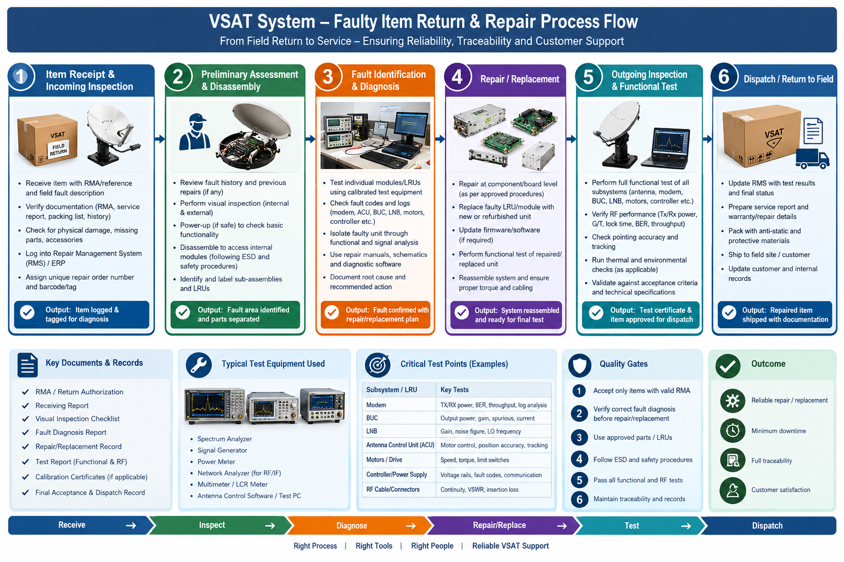

6. Detailed Work Instructions

6.1 Field Return Authorization and Work Order
- Obtain a unique RMA/return authorization or documented internal authorization before shipment where contractually required.
- Require the field report to include: customer/site, system and LRU part number (P/N), serial number (S/N), hardware revision, firmware/software version, fault symptom, date/time, environmental conditions, recent maintenance, configuration, alarms/logs and troubleshooting already performed.
- Assign a unique repair work-order number on receipt. Link the RMA, customer asset ID, P/N, S/N, warranty status and all later actions to this number.
- If the item arrives without sufficient identification or paperwork, place it in controlled hold; do not silently merge it with another asset.

6.2 Receipt, Safety and Incoming Inspection
- Verify package count against the packing list. Photograph the package before opening if damage is visible or a shipping claim may be needed.
- Record date/time, carrier, package condition, seal condition, accessories, cables, mounting hardware and any visible damage.
- Apply ESD controls to electronic LRUs. Isolate equipment with damaged mains wiring, stored energy, liquid ingress, burnt components, exposed conductors or suspected RF hazards until assessed by competent personnel.
- Inspect connectors, RF flanges, waveguides, coaxial interfaces, grounding points, heat sinks, fans, gaskets, motor couplings, antenna structure and evidence of corrosion, moisture, impact, tampering or overheating.
- Do not power up a unit with a suspected short, liquid ingress, damaged RF path or unsafe power interface. Record the reason and obtain engineering disposition.

6.3 Triage and Fault Reproduction
- Review the reported fault, maintenance history, previous repair records, configuration and applicable technical manual.
- Check whether the reported symptom could be caused by installation, power supply, cabling, connector damage, antenna alignment, modem configuration, network settings, software or an external satellite/network condition.
- Reproduce the fault using a controlled test setup and approved limits. Record instrument IDs, calibration status, test setup, ambient conditions, configuration and raw readings/logs.
- Assign a fault category: confirmed hardware fault; configuration/software issue; intermittent fault; installation/environmental issue; no fault found (NFF); transit damage; or indeterminate pending OEM analysis.
- For intermittent faults, define a repeatable stress or soak test based on the OEM procedure. Do not invent thermal, vibration, RF power or duration limits.

6.4 Diagnosis and Root-Cause Analysis
- Use a fault tree or symptom-to-test matrix to narrow the fault to the smallest replaceable assembly without unnecessary disassembly.
- Inspect logs, status LEDs, alarms, built-in test (BIT), event counters and firmware/configuration before opening sealed modules.
- Use known-good substitution only where interfaces, ratings and configuration are compatible; record the reference unit and restore the original configuration after testing.
- Separate confirmed cause from suspected cause. Record evidence, measurements, failed test step, probable root cause, contributing factors and confidence level.
- Escalate to the OEM when repair requires proprietary calibration, sealed RF alignment, high-power RF work, firmware signing, unavailable schematics or safety-critical disposition.

6.5 Repair-versus-Replace Decision
Decision factor | Repair is generally favoured when… | Replacement / escalation is favoured when…
Technical feasibility | Approved repair method exists and post-repair performance can be verified. | No approved method, extensive damage, sealed module or untestable repair.
Availability | Parts, tooling, software and trained staff are available. | Parts obsolete, counterfeit risk, lead time unacceptable or OEM-only repair.
Economics / warranty | Repair cost and turnaround meet contract and warranty conditions. | Repair exceeds agreed threshold or replacement is faster/cheaper over life cycle.
Reliability | Root cause can be corrected and recurrence risk is acceptable. | Repeated failure, latent damage or reliability cannot be demonstrated.
Configuration | Repair preserves approved design and traceability. | Substitution changes form/fit/function, firmware, RF performance or certification.

The repair-versus-replace threshold must be approved by the customer/programme. Do not substitute a different P/N or firmware version without engineering authorization and configuration-control approval.

6.6 Repair and Replacement Controls
- Use approved work instructions, ESD-safe bench practices, calibrated tools and approved replacement parts. Record the parts used, lot/batch where relevant, P/N, S/N, revision and source.
- Record the as-found condition, repair actions, replaced components, rework performed, firmware/configuration changes, technician and date.
- For board-level repair, inspect workmanship and clean/coat only as required by the approved process. For RF modules, preserve torque, connector, waveguide, thermal-interface and grounding requirements from the OEM documentation.
- For BUCs, LNBs/LNAs and RF paths, use suitable rated loads, attenuators, couplers and measurement equipment. Follow RF exposure, high-power and electrical safety controls.
- For ACU/motors/pedestal assemblies, verify wiring, limit switches, encoders/resolvers, brake operation, axis direction, travel limits, tracking and interlocks using the approved test setup.
- For modems/controllers, preserve approved firmware, network parameters, keys/credentials and configuration backups under access control. Do not place sensitive keys or credentials in general repair reports.
- If replacement is selected, verify interchangeability and approved configuration; transfer only authorized settings and update asset records before testing.

6.7 LRU and System-Level Verification
Test the repaired function first, then complete the full applicable acceptance sequence. The exact limits must come from the OEM manual, contract or approved engineering specification.
Item / subsystem | Typical checks (examples; use approved limits)
Modem | Power-on self-test; firmware/configuration; Tx/Rx lock; IF levels; BER/PER; throughput; alarm/log review; network interoperability.
BUC | P/N and band verification; gain; output power; frequency; current draw; alarm/status; spectral emissions/linearity and stability per approved RF test plan.
LNB/LNA | Input band/LO; gain; noise figure or noise temperature where specified; current draw; stability; output level; connector integrity.
Antenna / feed / RF cables | Visual/mechanical inspection; connector torque; cable continuity; insertion loss/return loss or VSWR where applicable; feed polarization and alignment.
ACU / controller | Boot/BIT; command/telemetry; axis direction; position readback; encoder/resolver feedback; limit switches; interlocks; tracking and pointing accuracy.
Motors / drives | Winding/insulation checks where specified; current draw; speed/torque response; direction; brake; thermal behaviour; limits and fault codes.
Power supply / interface | Input range; output rails/ripple; load regulation; protection; grounding; communication/interface checks.
Integrated VSAT terminal | End-to-end Tx/Rx; modem lock; link acquisition; tracking; commanded movement; alarms; configuration baseline; representative traffic test.

6.8 Outgoing Inspection and Release
- Confirm all required tests passed, deviations are approved, and the repair report is complete.
- QA or an authorized independent reviewer verifies the test record, configuration, labels, workmanship, calibration status of test equipment and closure of nonconformities.
- Perform final visual inspection: cleanliness, connectors/caps, fasteners, seals, labels, accessories and absence of loose parts or test leads.
- Restore the approved configuration; record firmware/software versions and configuration checksum or revision where applicable.
- Issue a release status: repaired and accepted; replaced and accepted; NFF with evidence; returned unrepaired by customer/OEM decision; or rejected/scrapped under authorization.
- Pack with appropriate ESD, shock, moisture and RF-connector protection. Include authorized service report, test certificate, warranty/repair statement and return shipping documentation.

7. Quality Gates and Nonconformance Control
Gate | Mandatory evidence | If gate fails
G1 — Receipt accepted | RMA/work order, identity, as-received photos and condition report. | Quarantine; resolve identity/documentation or shipping damage.
G2 — Diagnosis approved | Reproducible evidence or documented NFF/indeterminate outcome; engineering disposition. | Continue diagnosis or escalate to OEM/customer.
G3 — Repair authorized | Approved method, approved parts and documented repair/replace decision. | Hold pending approval; no uncontrolled rework.
G4 — Test passed | Completed test sheet with measured values and pass/fail criteria. | Open nonconformance; return to diagnosis/repair loop.
G5 — QA release | Independent review, closed deviations, correct configuration and release status. | Do not ship; correct record/test/configuration gaps.

A failed outgoing test returns the item to the diagnosis/repair loop. Retest all affected functions and any functions potentially impacted by the repair. Repeated failures should trigger a corrective-action review and trend analysis.

8. Minimum Records and Forms
Record / form | Minimum fields
RMA / Field Fault Report | Customer/site; asset ID; P/N/S/N; symptom; operating conditions; logs; warranty status; requested return date.
Receiving & Incoming Inspection | Work order; package/accessories; photos; damage; identity; safety/ESD status; acceptance/hold decision.
Diagnostic Worksheet | Test setup; instruments/calibration IDs; firmware/config; test steps; readings/logs; reproduced/not reproduced; fault classification.
Repair / Replacement Record | Root cause; approval; repair actions; replaced parts; old/new P/N/S/N; software/config changes; technician/date.
Functional / RF Test Report | Test procedure revision; acceptance limits and source; actual values; pass/fail; retests; tester/reviewer.
Nonconformance / Corrective Action | Failure description; containment; root cause; corrective action; recurrence/trend review; closure authority.
Release & Dispatch Record | QA release; final status; report/certificate; packaging; ship-to; tracking; warranty terms; work-order closure.

9. Test Equipment and Calibration Control
- Typical equipment: calibrated DMM; bench power supply; oscilloscope; spectrum analyzer; signal generator; RF power meter/sensor; rated attenuators/couplers/loads; network analyzer where needed; modem/network test tools; approved antenna-control test software; mechanical tools and ESD workstation.
- Equipment must be suitable for the frequency, power, impedance, connector and measurement uncertainty involved. High-power RF tests require properly rated loads, attenuation and interlocks.
- Record equipment ID and calibration due date on the test record. If out-of-tolerance calibration is discovered, assess the validity of prior results and affected releases.
- Use OEM-specific fixtures, calibration routines and software where required. Do not infer acceptance limits from typical catalogue values.

10. Life-Cycle Support and Fleet-Level Controls
- Maintain an installed-base register linking each system to its configuration baseline and each LRU to P/N, S/N, revision, firmware, installation location and repair history.
- Track failure rate, mean time to repair (MTTR), turnaround time, no-fault-found rate, repeat-failure rate, repair yield, parts consumption and obsolescence risk.
- Classify spares as repairables, consumables and long-lead/obsolete items. Establish minimum/maximum stock from installed base, failure history, lead time and required availability—not from an arbitrary fixed ratio alone.
- Maintain separate serviceability status: serviceable, unserviceable-awaiting-diagnosis, awaiting-parts, awaiting-OEM, awaiting-customer-approval, beyond economical repair and quarantined.
- For technology migration, keep legacy and new LRU configurations separately controlled. Approve interface adapters, firmware, frequency-band variants and replacement cross-references before field deployment.
- Retain legacy repair capability while demand and contractual obligations remain. Use last-time buys, approved repair partners, cannibalization only under authorization, and a documented end-of-support plan.
- For new technology LRUs, qualify them on a pilot terminal first; verify RF, mechanical, power, thermal, control/interface and environmental compatibility before fleet rollout.

11. Suggested Service-Level Targets (Set Contractually)
Metric | Definition | How to establish target
Receipt acknowledgement | Time from delivery to RMA/work-order acknowledgement. | Set by contract and operating hours.
Triage time | Receipt to initial classification and test plan. | Set by complexity tier (system, LRU, RF module).
Repair turnaround | Receipt to QA release, excluding agreed customer/OEM holds. | Use historical data and parts lead times.
First-pass yield | Items passing post-repair verification without rework ÷ repaired items. | Trend by LRU family and failure mode.
Repeat failure | Same/related failure within agreed period after release. | Define time window and matching logic.
NFF rate | No-fault-found returns ÷ total returns. | Trend by site, LRU, symptom and operator.

12. Implementation Checklist
- Approve the procedure owner, revision, safety rules and applicable OEM/contract documents.
- Create controlled forms for RMA, receiving, diagnosis, repair, test, nonconformance and release.
- Define LRU-specific test procedures, acceptance limits and required calibrated equipment.
- Train receiving, repair, QA and logistics staff; authorize personnel for RF/high-voltage/motion work.
- Set up ESD-safe quarantine, diagnostic benches, RF test area, repair area and finished-goods holding area.
- Pilot the procedure on representative modem, BUC, LNB/LNA and ACU/motor returns; revise based on evidence.
- Audit the first cases for record completeness, traceability, independent QA release and correct dispatch status.

Appendix A — Example Work-Order Status Codes
Code | Meaning
REC | Received; awaiting incoming inspection
HOLD | Quarantined / documentation / safety hold
TRI | Triage and fault reproduction
DIAG | Detailed diagnosis
AUTH | Awaiting repair/replacement approval
PART | Awaiting parts or OEM support
REPR | Repair in progress
TEST | Post-repair test and integration
QA | QA review / release gate
DISP | Ready for dispatch
NFF | No fault found; evidence and disposition required
BER | Beyond economical repair; authorized disposition required

Appendix B — Important Technical Caveats
- A VSAT system is not a single generic device. Acceptance limits differ by frequency band, BUC power class, modem waveform, antenna size, tracking architecture, environmental rating and OEM.
- Never transmit a BUC into an unrated or open RF path. Use rated loads and follow OEM RF safety procedures.
- Do not perform live antenna motion tests without checking travel limits, personnel clearance, mechanical restraints and interlocks.
- For warranty-sensitive, sealed or safety-critical items, opening or board-level repair may invalidate warranty or certification; obtain written authorization first.
- The procedure should be approved by the responsible engineering and QA authorities before use as a controlled organizational SOP.

