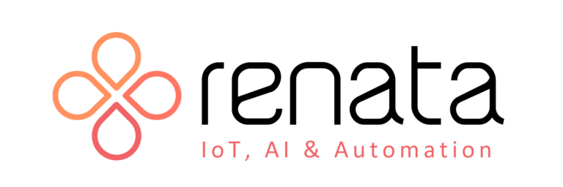
IoT · AI · Automation

DocuVault
Knowledge Management AI Platform
Client Reference Guide

Version | DocuVault v2.0
Date | March 11, 2026
Prepared by | Renata AI
Classification | Confidential – Client Use Only

Renata Envirocom Pvt. Ltd. | renataiot.com

Contents

1. System Overview
2. Key Features
2.1 Document Management
2.2 AI Knowledge Assistant
2.3 Users, Roles & Access Control
2.4 Collaboration & Sharing
2.5 Search & Organisation
2.6 Audit Trail & Notifications
3. Accessing System Features
4. Architecture Overview
4.1 How the System is Structured
4.2 How Documents are Indexed
4.3 How the AI Answers Questions
5. Technical Reference
6. Add-On Features & Integrations
6.1 Annual Maintenance Contract (AMC)
6.2 Email System Integration
6.3 LAN Drive Sync (Google Drive-Style)
6.4 Auto-Indexing on Upload
6.5 Desktop Agent — Web to Desktop
7. Client Q&A Summary
8. Support & Contact

1. System Overview

DocuVault is Renata AI's Knowledge Management Platform. It gives your organisation one place to store, organise, and query all your documents — using plain English, not search keywords.
At its core is an AI assistant that reads your documents and answers questions instantly. No more hunting through folders or opening file after file.
What you can do with DocuVault
- Upload and organise your documents in one secure place.
- Control who can see each document — from fully public to private or role-restricted.
- Ask the AI assistant questions in plain English and get answers drawn from your own documents.
- Collaborate with your team through comments, shared links, and notifications.
- Track every action with a complete audit trail.
- Manage users and roles with fine-grained permission levels.

Item | Details
Platform | DocuVault v2.0 — web-based (browser) + optional desktop agent
Supported Files | PDF, Word, text files, images, and more
Max File Size | 100 MB per upload
AI Knowledge Modes | Hybrid (default) · Strict (documents only) · Indicated
Access Control | Public · Private · Role-Based · Custom (per user)
Web Access | Any modern web browser on desktop, tablet, or mobile
Desktop Access | Optional background desktop agent — auto-connects files, runs in system tray

2. Key Features

2.1 Document Management
Everything you need to manage documents throughout their full lifecycle.
Feature | What it does
Upload | Add documents from your computer. Supported types include PDF, Word, images, and more.
Access Control | Choose who can see each document: Public, Private, Role-Based, or shared with specific people.
Version History | Every time a document is edited, the previous version is saved. You can view or restore any past version.
Document Locking | Lock a document while editing so no one else can make changes at the same time.
Categories & Tags | Organise documents into categories (with sub-categories) and tag them for flexible grouping.
Metadata | Track view count, download count, file size, and upload date automatically.
Soft Delete | Deleted documents can be recovered by an administrator before permanent removal.

2.2 AI Knowledge Assistant
The AI assistant lets you ask questions about your documents in plain English. It reads through all indexed documents, finds the most relevant parts, and writes a clear answer.
Feature | What it does
Ask in Plain English | Type a question naturally — the AI understands context, not just keywords.
Answers from Your Docs | The AI draws from documents stored in DocuVault, so answers are grounded in your data.
Follow-up Questions | Ask follow-up questions in the same conversation. The AI remembers context.
Three Answer Modes | Hybrid (default): Uses your documents first, fills gaps with general knowledge.  Strict: Only answers from your documents — refuses if the answer is not in any document.  Indicated: Labels which parts come from your documents and which from general knowledge.
Permission-Aware | The AI only uses documents the logged-in user is allowed to access.
Source Transparency | Each answer shows which documents and pages were used, so you can verify the information.

2.3 Users, Roles & Access Control
User Type | What they can do
Guest | View documents that are set to Public only. Cannot upload or edit.
Regular User | Upload and manage their own documents. Access documents based on their role level. Comment and collaborate.
Admin | Full access to all documents, all users, and all system settings.

Administrators can create custom roles (e.g. "Team Lead", "Department Head") and assign a numeric level to each. Documents set to Role-Based access are visible only to users whose role level meets or exceeds the requirement.

2.4 Collaboration & Sharing
Feature | What it does
Comments | Add comments to any document. Replies are threaded for easy reading.
Shared Links | Generate a link to share a document. Optionally add a password, set an expiry date, or limit how many times it can be opened.
Direct Sharing | Share a document directly with specific registered users.
Notifications | The system automatically alerts you when a document is shared with you, updated, or commented on.
Favourites | Bookmark documents you use often for quick access from your sidebar.

2.5 Search & Organisation
Feature | What it does
Search Bar | Search by title, description, or content. Results rank the most relevant documents first.
Filters | Narrow results by owner, date, access level, category, tags, or file type.
Sorting | Sort by title, upload date, last updated, view count, or file size.
Categories | Organise documents into a tree of categories. Each category can have a colour and icon.
Tags | Add one or more tags to a document. Search and filter by tag across all categories.

2.6 Audit Trail & Notifications
Every action in DocuVault is automatically recorded. The activity log shows who did what, and when — making it easy to track changes for compliance and accountability.
Recorded Action | When it appears in the log
Upload / Create | A new document is added to the system.
View / Download | A user opens or downloads a document.
Edit / Update | A document or its details are changed.
Delete | A document is removed (soft-deleted).
Share | A document is shared via link or direct user share.
Comment | A comment is added to a document.
Permission Changed | A document's access level or user role is updated.

3. Accessing System Features

The table below shows how to navigate to each feature. All paths are relative to your system's base URL (e.g. https://yourdomain.com).

URL Path | How to access
/register/ | Open the system in your browser and click Register. Enter your name, email, and password.
/login/ | Enter your username and password and click Sign In.
/dashboard/ | Your home screen after login. Shows recent documents, notifications, and quick links.
/documents/ | The full document library. Use the search bar and filter panel to narrow results.
/documents/create/ | Click + New Document. Select a file, fill in the details, set access level, and click Save.
/documents/<id>/ | Click any document title to open it — preview, download, comment, version history, and share.
/documents/<id>/edit/ | Open a document then click Edit. Save changes — the system automatically creates a new version.
/documents/<id>/index/ | Open a document then click Index for AI. The system reads and indexes the content for the AI assistant.
/documents/bulk-index/ | Admins only. From the document list, go to Actions → Bulk Index to index all unprocessed documents.
/chatbot/ | Click AI Assistant in the sidebar. Type your question and press Enter.
/search/ | Use the search bar in the top navigation. Add filters for date, owner, category, tags, and access level.
/categories/ | Navigate to Organise → Categories to create, nest, and colour-code categories.
/favorites/ | Click the star icon on any document. Access bookmarks via Favourites in the sidebar.
/notifications/ | Click the bell icon in the top bar to see all notifications.
/activity/ | Go to Account → Activity Log for a complete history of all actions.
/admin/users/ | Admins only. Go to Admin → Users to view all accounts and update role assignments.
/admin/roles/ | Admins only. Go to Admin → Roles to create, edit, or remove custom roles.
/profile/edit/ | Click your avatar (top right) → Edit Profile to update your details.

4. Architecture Overview

This section gives a plain-English view of how DocuVault is structured — how it stores your documents, how the AI learns from them, and how it answers your questions.

4.1 How the System is Structured
DocuVault has three main layers that work together:

Layer | What it is | What it does for you
Your Browser | The web interface you open on any device. | Where you upload, search, chat with AI, and manage settings.
DocuVault Platform | The server application in the background. | Handles login, stores documents securely, controls access, and connects you to AI.
AI & Storage | The AI engine and databases. | Reads and indexes documents, answers questions, and stores all data.

System Flow
Your Browser  Any device | → | DocuVault  Platform  Application | → | Document  Storage  Files & Data | → | AI Search  Engine  Find content | → | AI Answer  Model  Write response

Figure 1: How the main components of DocuVault connect.

4.2 How Documents are Indexed
Before the AI can answer questions about a document, it must be "indexed" — this means the AI reads it and saves a summary in a way it can search very quickly.

Upload  Document | → | Platform  Validates | → | AI Reads &  Processes | → | Saved to  Search Index | → | Ready for  AI Queries

Figure 2: The five steps from uploading a document to it being ready for AI questions.

Steps in plain English
Step 1 — Upload: You select a file and upload it. DocuVault saves it securely.

Step 2 — Validate: The system checks the file size (must be under 100 MB) and file type.

Step 3 — AI Reads It: The platform reads the document — extracting all text, tables, and if needed, running text recognition on scanned pages.

Step 4 — Save to Index: The content is broken into sections and saved in the AI search index. This lets the AI find relevant parts instantly.

Step 5 — Ready: The document is now available to the AI assistant for any permitted user.

How to index a document
Open any document, then click Index for AI. The status will update to "Indexed" once complete. Admins can also index all documents at once using the Bulk Index option.

4.3 How the AI Answers Questions
When you type a question in the AI assistant, DocuVault goes through these steps to find and write the answer:

User Types  Question | → | Platform  Searches Docs | → | AI Reads  Relevant Parts | → | AI Writes  the Answer | → | User Receives  Answer

Figure 3: How a question becomes an answer.

Steps in plain English
Step 1 — You type a question: Ask anything in plain English, e.g. "What are the leave policy rules?"

Step 2 — Platform searches your documents: DocuVault searches all indexed documents to find the sections most relevant to your question.

Step 3 — AI reads the relevant parts: The AI reads the top matching sections. It only uses documents you have permission to access.

Step 4 — AI writes the answer: Using the content it found, the AI writes a clear, direct answer.

Step 5 — You receive the answer: The answer appears in the chat with the source documents and page numbers used. You can ask follow-up questions.

The three answer modes
Mode | How it behaves | Best for
Hybrid | Uses your documents first. Fills gaps with general knowledge if needed. | General use — recommended for most teams.
Strict | Only answers from your documents. Says so clearly if information is not found. | Compliance, legal, or regulated content.
Indicated | Uses both sources but clearly labels which part comes from where. | Research, auditing, or when traceability matters.

5. Technical Reference

Technology Stack
Category | Technology
Web Framework | Django 5.x (Python 3.10+)
Database | SQLite (development) / PostgreSQL (production)
AI Language Model | Groq API — llama-3.1-8b-instant
AI Search Engine | ChromaDB vector database with all-MiniLM-L6-v2 embeddings
Document Reading | pdfplumber, PyMuPDF, Camelot (tables), Tesseract (OCR for scanned pages)
AI Framework | LangChain, HuggingFace, PyTorch
Max File Upload | 100 MB per file
Search Method | Hybrid — 70% semantic similarity + 30% keyword matching

AI Configuration
Setting | Value
Document chunk size | 512 characters (256 in lightweight mode)
Overlap between chunks | 100 characters
Results per query | 8 chunks (6 in lightweight mode)
Conversation memory | Up to 8 turns per session
Max response length | 512 tokens (~380 words)
Response consistency | Low variability — temperature 0.2 for reliable, repeatable answers

User & Permission Model
Access Level | Who can see the document
Public | Everyone, including guests who are not logged in.
Private | The document owner and admins only.
Role-Based | Users whose role level is equal to or higher than the required level set by the owner.
Custom | Only specific users selected by the document owner, plus admins.

Key Database Records
Record Type | What it stores
Document | The file, title, access level, category, tags, and owner.
Document Version | A snapshot of the document every time it is edited.
Chat Session | A conversation thread between a user and the AI assistant.
Chat Message | Each individual question and AI answer, with source references.
Activity Log | An immutable record of every action in the system.
Notification | Alerts sent to users for shares, comments, and updates.
Shared Link | A temporary link with optional password, expiry, and access count.

6. Add-On Features & Integrations

DocuVault is built to grow with your organisation. The features described in this section are available as add-ons or integrations that can be configured and enabled on top of the standard platform — either during initial deployment or at any later stage.

6.1 Annual Maintenance Contract (AMC)
An AMC can be offered to customers to maintain and upgrade the AI components of DocuVault over time. This ensures the system stays current with the latest AI models and security standards without any disruption to your data.

What the AMC covers
- LLM model upgrades (e.g. upgrading from one AI model to a newer, more capable version)
- Performance optimisations and retrieval improvements
- Security patches and infrastructure monitoring
- UI improvements and new feature rollouts

Important: No retraining needed for LLM upgrades
DocuVault does NOT train the AI on your documents. It uses a method called Retrieval-Augmented Generation (RAG). This means:
- LLM upgrades do NOT require your documents to be reprocessed.
- Your existing indexed documents continue working normally after an upgrade.
- Re-indexing is only needed if the embedding model itself changes (e.g. switching to a different embedding provider). In that case, embeddings are recomputed automatically and can be handled under the AMC.

6.2 Email System Integration
DocuVault can integrate with your organisation's email system. Emails and their attachments are ingested and indexed so they become searchable through the AI assistant — just like any other document.

Supported email systems
- Microsoft Outlook / Exchange
- Microsoft 365
- Gmail
- IMAP servers
- On-premise enterprise mail servers

What gets indexed
Email Content | What is indexed
Email body | The full text of the email message.
Attachments | PDF, Word, Excel, and PowerPoint files attached to emails.
Metadata | Sender, receiver, subject line, and timestamp.

Security & access control
Role-based access ensures that emails are only retrievable by users who are authorised to see them.
- HR emails → accessible to HR users only
- Finance emails → accessible to Finance users only

Once integrated, users can ask the AI assistant questions like: "Show discussions about vendor contracts with ABC company." The system retrieves matching content from documents, attachments, and email conversations together.

Email integration flow
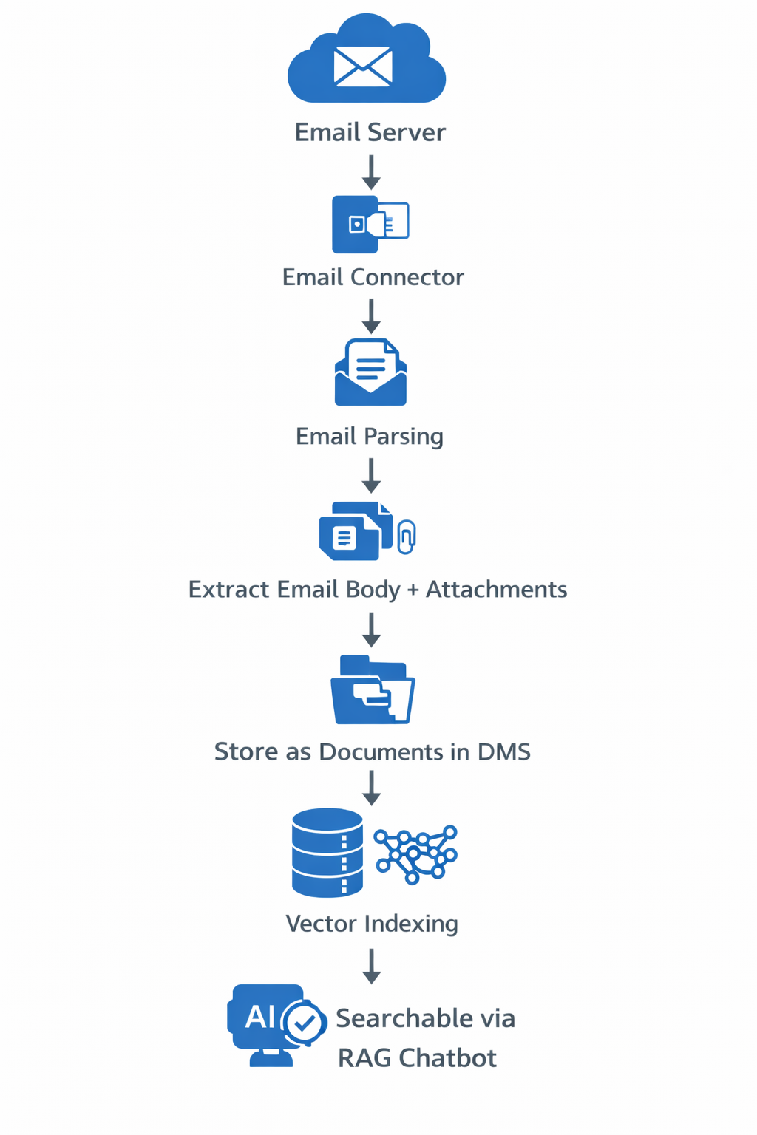
Figure 4: How emails flow from your mail server into DocuVault and become searchable via the AI assistant.

6.3 LAN Drive Sync (Google Drive-Style)
Instead of manually uploading files through the web interface, users can save documents into a synchronised folder on their computer. A background sync agent watches the folder and automatically sends new or updated files to DocuVault.

How it works
User PC  (Sync Folder) | → | Sync  Agent  Background | → | DocuVault  Server | → | Version  Control | → | AI  Indexing

Figure 5: LAN sync pipeline — from a user's folder to DocuVault version control and AI indexing.

Features
- Automatic document synchronisation — no manual uploads required.
- Version tracking — every save creates a new version with timestamp and user.
- Rollback — restore any previous version from DocuVault.
- Instant AI indexing — new documents are indexed automatically as they sync.
- Enterprise-ready — supports multiple PCs on the same LAN.

Implementation options
Option | Description
Desktop sync agent (recommended) | A lightweight background app installed on each user's PC.
Network shared drive monitoring | Monitors a shared network folder without any client install.
Drive-style desktop client | A full Google Drive-like interface with sync status indicators.

6.4 Auto-Indexing on Upload
By default, documents must be manually triggered for AI indexing after upload. The system can be configured to index documents automatically the moment they are uploaded, so they are immediately available to the AI assistant without any extra step.

How indexing works (not AI training)
A common question from clients is whether uploading documents "trains" the AI. The answer is no. DocuVault uses indexing, not training. The distinction is important:
 | AI Training | DocuVault Indexing
What it is | Modifying the AI model's internal weights. | Reading and storing document content in a searchable format.
Time | Hours to days. | Seconds to minutes per document.
Effect | Permanently changes the AI model. | Adds document to the search index only.
Required? | Never required in DocuVault. | Required once per document (or on re-upload).

Indexing pipeline diagram
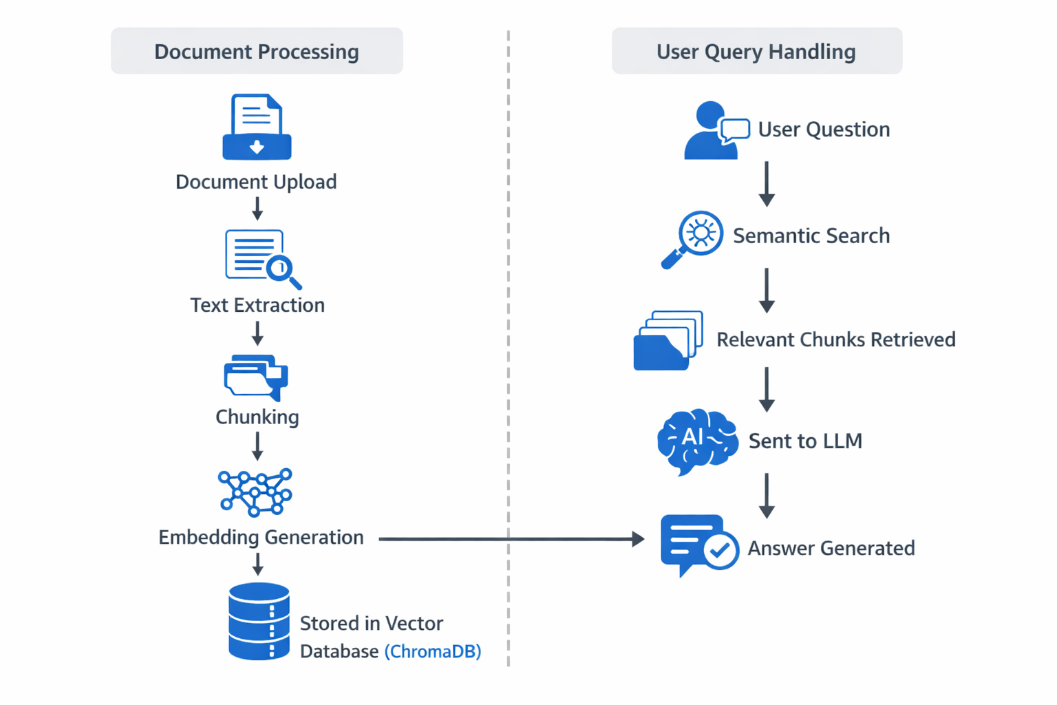
Figure 6: Left — Document processing pipeline (upload to vector database). Right — Query handling (user question to AI answer).

How to enable auto-indexing
Auto-indexing can be enabled by your system administrator in the platform configuration. Once enabled, every document uploaded will be automatically indexed in the background without any action required from the user.

6.5 Desktop Agent — Web to Desktop
By default, DocuVault runs entirely in a web browser — no installation needed. However, for teams who work heavily with local files, a lightweight Desktop Agent can be installed alongside the web platform. The agent runs quietly in the background, bridges your computer's file system directly to DocuVault, and makes accessing the platform feel like a native desktop app.

What the Desktop Agent does
Capability | Description
System tray icon | The agent sits in your Windows/macOS system tray. One click opens DocuVault instantly — no browser URL to remember.
Automatic file watching | Select one or more folders on your computer. Any file saved there is automatically detected and synced to DocuVault.
Background sync | Files are uploaded and indexed in the background without interrupting your work.
Auto-connect on startup | The agent starts with your computer and reconnects to the DocuVault server automatically — no manual login each day.
Local file shortcuts | Right-click any file in Windows Explorer / macOS Finder and choose "Send to DocuVault" directly.
Offline queue | If the server is temporarily unreachable, the agent queues pending files and syncs them automatically once the connection is restored.
Notification alerts | Desktop pop-up notifications for completed uploads, indexing status, shared documents, and AI query replies.
Session persistence | Stay logged in across sessions — the agent maintains your authentication token securely.

Web vs Desktop — side by side
 | Web Browser (Standard) | Desktop Agent (Add-On)
Installation | None — open any browser | One-time lightweight install (~20 MB)
File access | Manual upload via browser | Automatic — watches selected folders
Startup | Open browser and navigate to URL | Starts with computer, always ready
Notifications | In-browser only | Native desktop pop-ups
Right-click upload | Not available | Right-click any file to send to DocuVault
Offline handling | Not available | Queues files and syncs when back online
Best for | Occasional users, mobile, tablet access | Power users who work with many local files daily

How the Desktop Agent connects
File saved  on your PC | → | Agent detects  the change  Background | → | Uploads to  DocuVault  Auto | → | AI indexes  the file  Instant | → | Available  everywhere  Web + Desktop

Figure 7: From saving a file on your computer to it being searchable in DocuVault — fully automatic.

Deployment
Supported OS | Windows 10/11, macOS 12+, Ubuntu 20.04+
Server connection | Connects to DocuVault over LAN or internet (HTTPS)
Authentication | Uses the same username / password as the web platform
Configuration | Admin sets allowed folders, sync rules, and notification preferences via a simple settings panel
Distribution | Installer provided by Renata AI — deployable via Group Policy (Windows) or MDM (macOS)

Who should use the Desktop Agent?
The Desktop Agent is ideal for users who regularly save documents locally (reports, drawings, scanned files, spreadsheets) and want them available in DocuVault without any manual effort. The web platform remains fully functional alongside it — both modes work together.

7. Client Q&A Summary

The following table summarises the most common questions raised by clients during technical discussions about DocuVault.

Client Question | Answer
Can you offer an AMC for LLM upgrades? | Yes. An AMC covers LLM upgrades, performance improvements, security patches, and UI enhancements.
Do you need to retrain the AI when upgrading the LLM? | No. DocuVault uses RAG — the LLM is not trained on documents. Upgrades do not affect indexed data.
When is re-indexing required? | Only if the embedding model itself is changed (e.g. switching providers). This is handled automatically under AMC.
Can DocuVault integrate with our email system (Outlook, Exchange)? | Yes. Emails and attachments are ingested and indexed. Users can query email content through the AI assistant.
Can it work like Google Drive with automatic sync? | Yes. A LAN Sync Connector can be implemented so documents sync automatically from user folders to DocuVault.
Does the AI train automatically when I upload a document? | No. The AI does not train on documents. Uploading triggers indexing, which is fast and does not change the AI model.
How is DocuVault different from BigQuery? | BigQuery is designed for structured data analytics using SQL. DocuVault is designed for semantic search and AI question answering over unstructured documents such as PDFs, emails, and reports.
Do users have to open a browser every time? | No. With the optional Desktop Agent, DocuVault runs in the system tray. Files sync automatically from watched folders, and the platform is accessible with a single click.
Can the Desktop Agent work if the server is offline? | Yes. The agent queues pending files locally and syncs them automatically once the server is reachable again.

Have more questions?
If you have additional technical questions not covered in this document, please contact Renata AI through the channels listed in the Support section.

8. Support & Contact

For assistance, feature requests, or any questions about DocuVault, please reach out through the following channels:

Channel | Details
Website | https://renataiot.com
Company | Renata Envirocom Pvt. Ltd.
Product | DocuVault v2.0 — Knowledge Management AI Platform
Document date | March 2026

Confidentiality Notice
This document is prepared exclusively for authorised DocuVault clients. The system details and architecture described here are proprietary to Renata Envirocom Pvt. Ltd. Please do not share or distribute without written consent.

