GLOBAL DATA PREPARATION PROCESS
BALISE DATA COMPILER: SOFTWARE USER's manual
Reference : |  |  | GDPP_BSI_INST_0300 |  |  |  | Keywords: |  | GDPP
Version : |  |  | C |  |  |  |  |  | Data compiler
Revision Date : |  |  | 21/03/07 |  |  |  | Filename: |  | DPT0029
 | Written by |  |  | reviewed |  |  |  | Approved by
Date
&
Signature
Nom | O.SEBILLEAU |  |  | P.MOULARD |  |  |  | F. DUPIRE
Position | SYSTEREL |  |  | SYSTEREL |  |  |  | ALSTOM

Amendment Record

Version  Date | Author Name | Sections | Modifications
1A  19/11/02 | O.SEBILLEAU | - | First issue of the document
2A  03/12/02 | O.SEBILLEAU | all | After internal review (BR_CDPBALMUL_1A_PM_1A)
A  06/02/03 | O.SEBILLEAU | 3.4.1.1.1.1.2 | After ARB review (GDPP_BSI_INST_0300_V2A_COMT_APB.doc)  Replace “Data is then checked” by “ The data entry is then checked”
B  21/03/07 | O.SEBILLEAU | 5.2.1.1.1.1.1 | command line modified
 |  | 5.2.1.1.1.1.6 | -telformat option added
C  29/03/07 | O.SEBILLEAU |  | Add Filename: DPT0029 in first page
Table of Content

1 Introduction 4
1.1 Subject 4
1.2 Field of Application 4
1.3 Document Description 4
2 Documents & Terminology 5
2.1 Reference Documents 5
2.2 Applicable Documents 5
2.3 Associated Documents 5
2.4 Definitions 5
2.5 Abbreviations 5
3 Overall description 6
3.2 Environment 6
3.3 Software building tools 6
3.4 Context diagram 6
4 Software installation 8
5 Software use 9
5.1 input and output files 9
5.1.2 Telegram file 9
5.1.3 Log file 9
5.1.4 Udf file 9
5.2 Launching the compiler 9

Introduction

Subject

This document explains how to use the Balise data compiler software.

Field of Application

This document concerns the Balise data compiler

Document Description

Chapter 3 gives an overall description of the data compiler

Chapter 4 explains how to install the software

Chapter 5 explains how to use the software.

Documents & Terminology

Reference Documents

Ref.N° Title | Reference | Issue
- GDPP Glossary | GDPP_BSI_PLAN_006

Applicable Documents

Ref.N° Title | Reference | Issue
- Software quality plan | C328_PQPL

Associated Documents

Ref.N° Title | Reference | Issue
- Balise data compiler software specification | GDPP_BSI_DESG_0261
- Balise data compiler software design | GDPP_BSI_DESG_0262
- Software building manual | GDPP_BSI_INST_0296

Definitions

see Gdpp glossary ([Ref. 1]).

Abbreviations

see Gdpp glossary ([Ref. 1]).

Overall description

The Balise data compiler builds a telegram to be downloaded into the Balise.

Environment

The Data compiler is designed to be used on a PC computer under Windows NT or Windows 2000 operating systems.

Software building tools

The Software is written in C and Perl. The complete description of the building procedures can be found in [Assoc 3]).

Context diagram

The following diagram describes the Balise programming process.

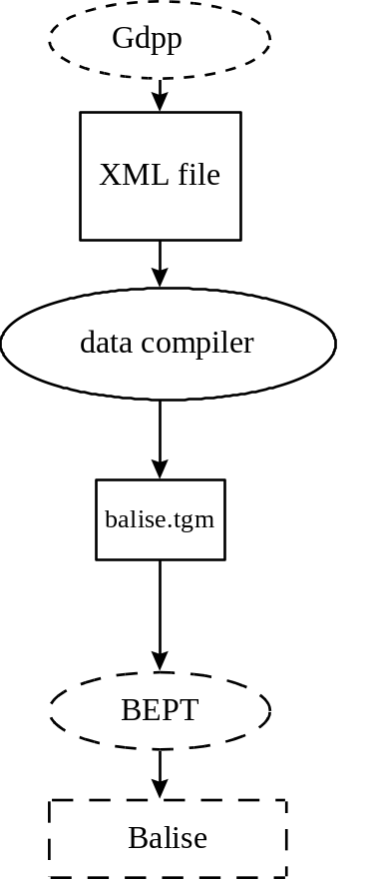

Fig 1: Balise programming process

The Gdpp tool is used for data entry of the telegram data. The data entry is then checked for consistency and precompiled by the Gdpp tool. Finally, configuration data is exported by the Gdpp tool towards the Data Compiler.

The Data Compiler is used to build the telegram that can be downloaded into the Balise by the BEPT tool.

Dotted elements in the diagram are just shown for information and are not described in this document.

Software installation

The Data compiler installer creates all directories and copies all the files needed by the software. The installer can be launched at the DOS command line level, or can be called by another program.

Launch the installer which is located in the "main" directory using the following command:
install <directory>

where <directory> is the name of the directory in which you want to install the software.

Example: "install C:\dir1\dir2\balisedatacompiler" installs the software in the C:\dir1\dir2\lbalisedatacompiler directory.

The installer creates the necessary directories and copies all the files needed by the software.

If no errors are reported, the installation is OK.

In case of errors, take the appropriate action, and launch the installer again.

Software use

input and output files

The data compiler takes as input an xml file holding the encoder parameters to compile (see [Assoc 1]), and outputs several files:
- The Telegram is stored in the “balisename.tgm” file.
- The log file :"compile.log"
- Another file upon request.

balisename is the Gdpp name of the balise (this name is found in the input file).

Another file which is used during the compile process can be saved upon request. This files is:
- "balisename.udf"

The description of this file is given below.

Telegram file

The Telegram file is intended to be downloaded in the Balise by the appropriate tool. Its format is described in the document ([Assoc 1]).

Log file

The log file reports all steps of the compile process, and the errors if any. It is a text file which can be read by any standard text editor. Its name is "compile.log".

Udf file

This file holds the telegram user data (not scrambled). The format of the file is described in the document ([Assoc 2]).

Launching the compiler

The data compiler can be run by typing the following command:
installdir\main\compile <inputxmlfile> -o outputdir [-udf] [-telformat (udf|sacem)]

where installdir is the directory path in which the compiler is installed.

<inputxmlfile> is the xml file holding the telegram data. This file is built by the Gdpp program.

outputdir is the directory path where all the files built by the compiler are stored. This option is mandatory. This directory must exist as it is not created by the compiler.

option: -udf request to copy the udf files in the output directory.

option: -telformat gives type of coding strategy to be used (udf: ERTMS). If option is missing, ERTMS coding strategy is taken as default.

If one error is detected during the compilation, the program exits with code 1, and the corresponding error message is written in the log file.

If the compilation is done without errors, the program exits with code 0.

