green_time red_time main_node_id stage movement_str

15.370311 44.629688 1 2 EBT

44.629688 15.370311 1 1 NBL

18.873627 41.126373 2 1 WBL

41.126373 18.873627 2 2 WBT

27.695925 32.304073 3 1 EBT

32.304073 27.695925 3 2 SBL

32.304073 27.695925 3 2 SBT

Main_node 1:

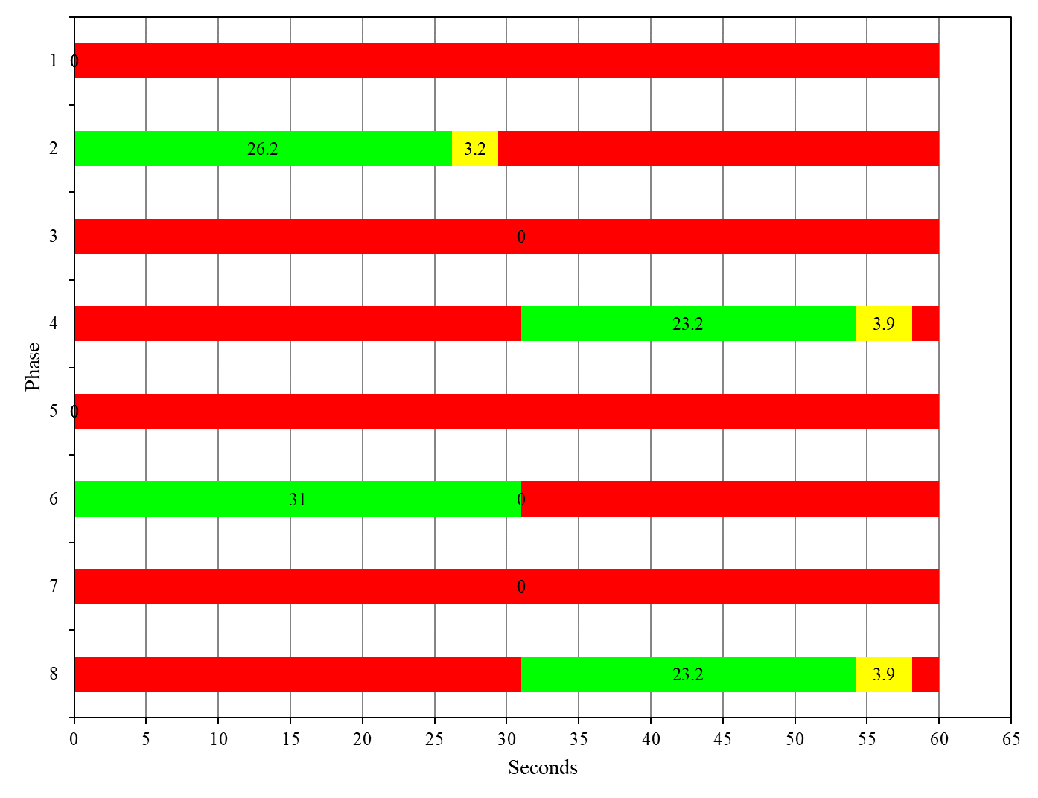

Main node 2:

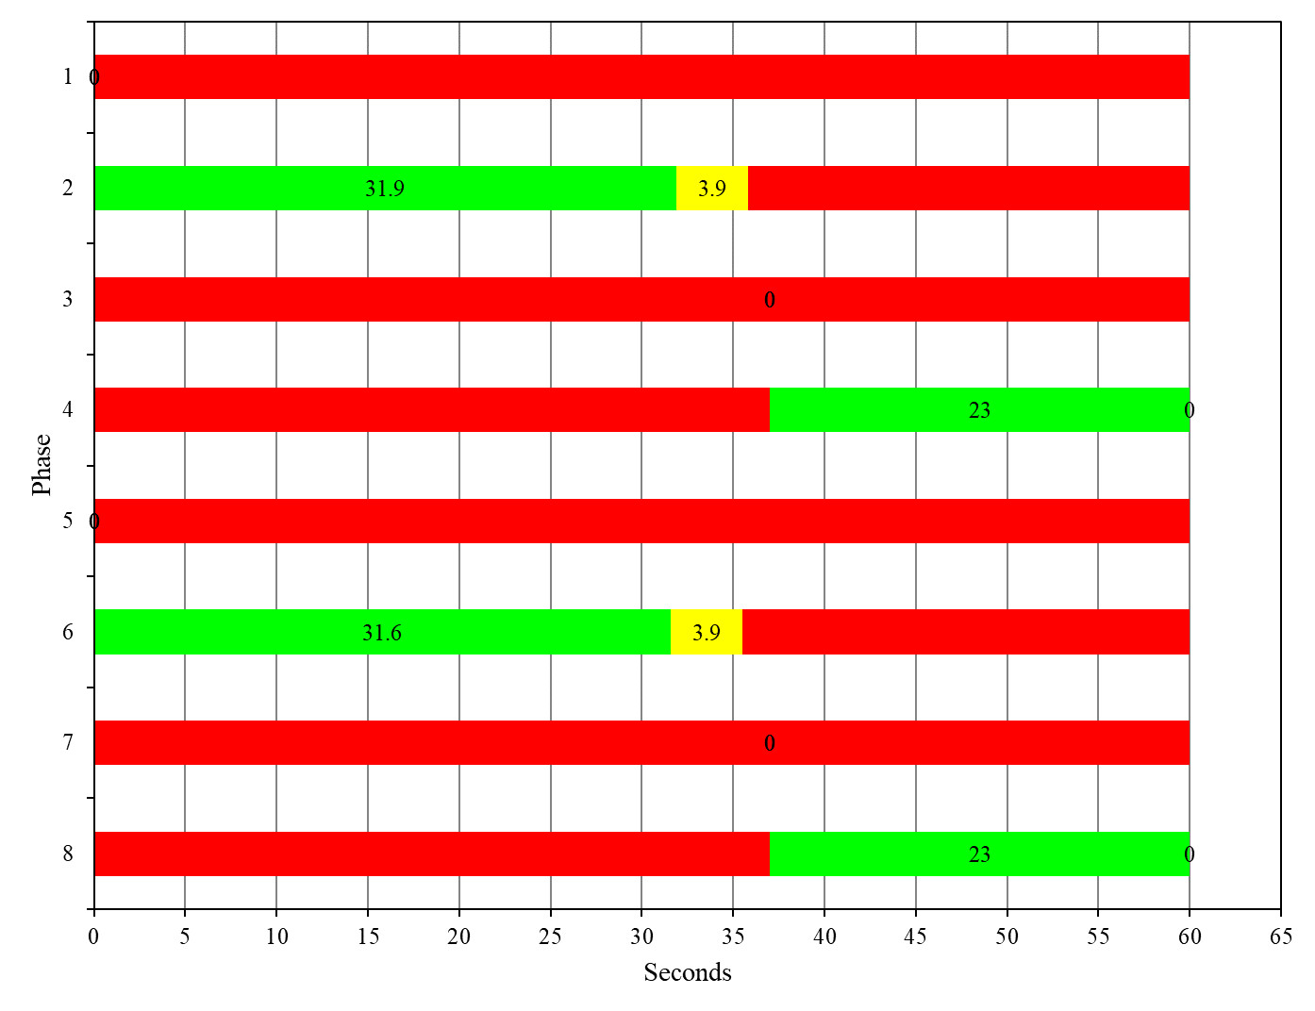

Main node 3:

