STALite Implementation Details
- Flow Chart Overview:
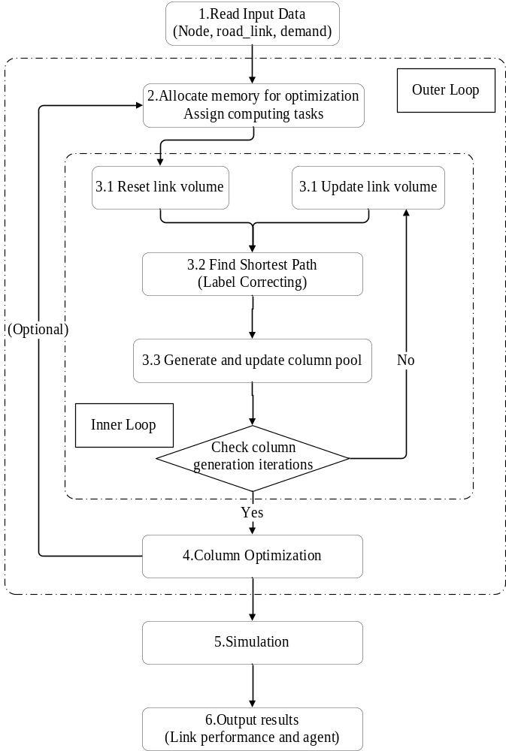
Figure 0.1: Flow chart overview

We will illustrate the whole process of STALite by a specific example two_corridor, and this programming guide will be expanded in the order of figure 0.1. You can find some basic parameter definitions in the user’s guide. Here, we pay more attention to the specific execution process of the program.

- Classes Overview
Here, we do an overall overview of the whole class.
Table 0.1: Classes Overview
Class | Description
class CCSVParser | Class for reading and writing .csv.
class CDemand_Period | Class for demand period /  Calculate starting(ending) time
class CAgent_type | Class for different demand agent type  (including agent’s VOT/PCE/CRU)
class CLinkType | Class for linktype
class CColumnPath | Class for node sequence/link sequence of a column.
class CAgentPath | Path sequence and statistics for each agent
class CColumnVector | Path sequence and statistics for each column
class CAgent_Column
class CAgent_Simu | Class for the agent in the simulation
class Assignment
class CVDF_Period | Calculate Volume Delay Function Period  (using BPR function)
class CLink | Class for roadlink
class CServiceArc | Class for service arc
class CNode | Class for node
class COZone | Class for origin zone
class CAGBMAgent
class NetworkForSP | Class for shortest path calculation
class VehicleScheduleNetworks
class CVSState | Class for vehicle scheduling states
class C_time_indexed_state_vector

Here, we explain some important classes briefly:
- Class Assignment
Class Assignment includes some basic globe parameters or variables for computing assignment, such as number of nodes, number of links, etc.
Initialize the demand array for each zone, agent type, demand period, and total demand array for each zone, period.
- Class NetworkForSP
Class NetworkForSP provides some basic memory space to generate the shortest path tree for each origin zone.
void AllocateMemory(int number_of_nodes, int number_of_links)
Allocate memory and initialize the data for shortest path calculation.
void UpdateGeneralizedLinkCost()
The generalized link cost for each link can be calculated by the following mathematical formula.
genalized_cost= travel_time_per_period + route_choice_cost + toll / m_value_of_time
void BuildNetwork(Assignment* p_assignment)
Build subnetwork in each workbench based on agent type and link-type at iteration 0.
The m_outgoing_link_seq_no_vector and m_to_node_seq_no_vector are defined to store outgoing link for each node and link.

Notes: Forward star method(To be detailed)

1. Read Input Data
Section 1.1~1.5 introduces how to read basic traffic network(node/link) data, and you can find the detailed source code in function void g_ReadInputData(Assignment& assignment).
Section 1.6 introduces how to read the demand file, and you can find the detailed source code in function void g_ReadDemandFileBasedOnDemandFileList(Assignment& assignment).
1.1 Read demand_period.csv
Table 1.1: demand_period.csv
demand_period_id | demand_period | time_period
1 | AM | 0700_0800
We use the class CDemand_Period to store demand_period and time_period, and each demand period message will be stored in vector assignment.g_DemandPeriodVector. For easy searching, we use the map data structure assignment.demand_period_to_seqno_mapping. In this example two_corridor, there is only one piece of demand period information in vector g_DemandPeriodVector.
1.2 Read link_type.csv
Table 1.2: link_type.csv
link_type | link_type_name | type_code
1 | Highway/Expressway | f
2 | Major arterial | a
We use the class CLinkType to store link type name and the abbreviation of link type(“f” means Highway/Expressway, “a” means Major arterial), and each link type message will be stored in array assignment.g_LinkTypeMap.
1.3 Read agent_type.csv
Table 1.3: agent_type.csv
agent_type | name | VOT | flow_type | PCE
p | passenger | 10 | 0 | 1
We use the class CAgent_type to store some attributes of agent type, such as VOT(value of time), flow type(0:flow, 1:fixed path, 2:integer decision variables), and PCE(the vehicle conversion factor). Each agent type message will be stored in vector assignment.g_AgentTypeVector.
1.4 Read node.csv
Table 1.4: node.csv
node_id | zone_id | x_coord | y_coord
1 | 1 | 0.017882 | -0.12518
2 | 2 | 40.25393 | 0.053648
3 |  | 19.77825 | 14.80687
4 |  | 19.68884 | -9.69242
We use the class Cnode to store the node attributes including node_id, zone_id, x_corrd, and y_coord. The difference between node_id and zone_id is that zone_id is prepared for the node with traffic demand or traffic attraction volume.
1.5 Read road_link.csv
We use the class Clink to store the link attributes. Here, we use an example link to illustrate the details. All link messages will be saved into a globe vector g_link_vector. Some attributes are based on BPR function and VDF(Volume delay function) to link a.
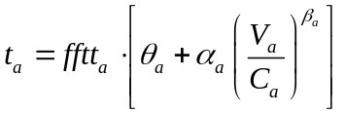
Table 1.5: road_link.csv
Name | Example value | Storage location | Description
road_link_id | 1003 | link.link_id
from_node_id | 1 | link.from_node_seq_no  (after mapping)
to_node_id | 3 | link.to_node_seq_no  (after mapping)
facility_type | Freeway
dir_flag | 1
length | 20 | link.lenth
lanes | 1 | link.number_of_lanes | Roadlink lane numbers
capacity | 4000 | link.link_spatial_capacity
free_speed | 60
link_type | 1 |  | 1: Highway/Expressway  2: Major arterial
cost | 0
VDF_fftt1 | 20 | link.free_flow_travel_time | Free flow travel time in VDF
VDF_cap1 | 4000 | The calculation result  according to BPR function  will be saved in  link.PCE_at and Link.CRU_at. | The capacity parameter in VDF
VDF_alpha1 | 0.15 |  | Parameter α in VDF
VDF_beta1 | 4 |  | Parameter β in VDF
VDF_theta1 | 1 |  | Parameter θ in VDF
VDF_gamma1 | 1 |  | Parameter γ in VDF(Optional)
VDF_mu1 | 100 |  | Parameter μ in VDF(Optional)
*The rest of the parameters in Clink are not read from the file and will be introduced later.
1.6 Read demand_file_list.csv and demand_p.csv
Table 1.6: demand_file_list.csv
scenario_no | file_sequence_no | file_name | format_type | demand_period | agent_type
0 | 1 | demand_p.csv | column | AM | p
Table 1.7: demand_p.csv
from_zone_id | to_zone_id | number_of_passengers
1 | 2 | 7000
The demand_file_list.csv provides document indexes for different types of demand(demand_p means the passenger demand, demand_v means the demand for the vehicle, etc.).
We use 4 different statistics and arrays to save demands,
- total_demand[agent_type_no][demand_period_no]: total demand for each agent type and period
- g_column_pool[from_zone_seq_no][to_zone_seq_no][agent_type_no][demand_period_no].
od_volume: demand for each column(for each OD, agent type and peroid)
- total_demand_volume: total demand
- g_origin_demand_array[from_zone_seq_no][agent_type_no][demand_period_no]: trip generation volume for each origin zone, agent type and period.
For this example:
total_demand[0][0] = 7000;
g_column_pool[0][1][0][0].od_volume = 7000;
total_demand_volume = 7000;
g_origin_demand_array[0][0][0] = 7000;

2.Allocate memory for optimization and assign computing tasks
To achieve parallel computing, we should prepare memory space for calculation tasks and assign each OD into corresponding workbench or thread. You can find the detailed source code in function void g_assign_computing_tasks_to_memory_blocks(Assignment& assignment).
Take 4 threads and 8 od pairs as an example, we divide all OD pairs into 4 parts and realize parallel computing in different workbenches(as shown in figure 2.1). But the two corridor example only has 1 OD, so we can only one thread.
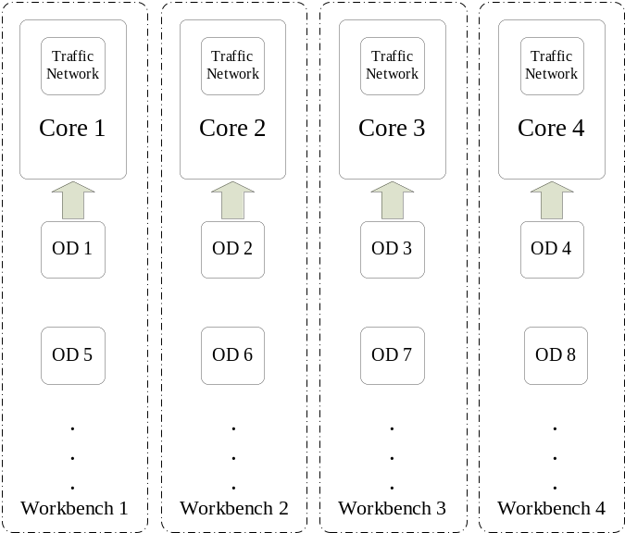
Figure 2.1: Schematic diagram for parallel computing
Here, we use the array NetworkForSP* PointerMatrx to record the corresponding position in different threads for each OD pair. The main purpose of establishing the workbench is to calculate the shortest path for each OD. You can refer class NetworkForSP for details.
For this example:
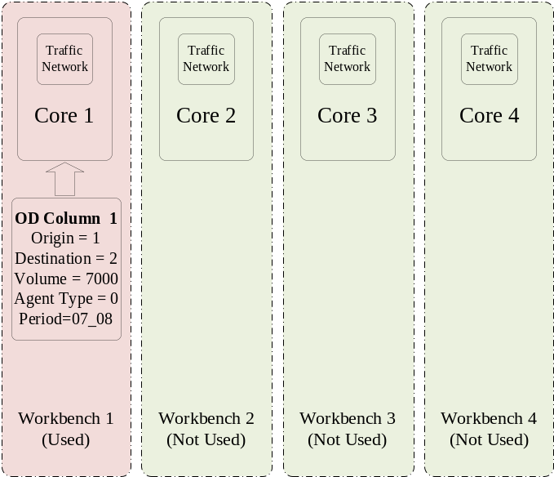
Figure 2.2: Parallel computing for example
Notes:
Outer Loop: Loop for column pool optimization iterations, which are set as the default value(Outer iteration number=1).
Inner Loop: Loop for column generation iterations, which can be set in setting.csv.

3.Column Pool Generation
Find Shortest Path and Update Path Cost in each iteration. Unless otherwise specified, we will take the first iteration as an example to talk about the program execution process in detail.
3.1 Reset and update link volume and cost
There are 4 modes to reset or update link volume based on BPR function, and you can find the detailed source code in the corresponding function.
- void update_link_travel_time_and_cost()
We use the BPR function to update travel time(TT):
Where,
variables t_{a} (variable avg_travel_time in code) represents generalized travel cost (or time) on link a;
variable fftt_{a} (variable FFTT in code) is the free-flow travel time of link a;
variable V_{a} or X_{a} (variable flow_volume_per_period or volume in code) represents flow volume on link a. Typically, V_{a} is used to cover composite flow volume in different applications, while Xa is used to denote nonnegative pure flow or fluid from the network flow modeling perspective.
C_{a} (variable capacity in code) represents the (ultimate) capacity of link a;
θ_{a}, α_{a}, β_{a} are the coefficients of VDF function for link a.

- void g_reset_link_volume_in_master_program_without_columns()
Only for User Equilibrium(UE) mode.
- void g_reset_link_volume_for_all_processors()
Only for User Equilibrium(UE) mode.
- void g_reset_and_update_link_volume_based_on_columns()
Only for System Optimization(SO) and User Equilibrium(UE) with resource constraints.
For this example:
Iteration 1:
Column Pool = { }
Because the pool is empty, this step is skipped.
Iteration 2:
Column Pool = {Column 1}
Column 1 = {Path: 1-3-2; Volume = 7000}
After this step, we can get the travel time for column 1 and global link volume and travel time. As for how to generate a column, you can refer to section 3.2

3.2 Label Correcting Algorithm
According to the road network with updated link cost, we can use the label method to generate the columns. There are 3 steps in generating a path column: build the sub-network for each origin zone, find the shortest path tree in sub-network, and do back-trace by the label.
- void BuildNetwork(Assignment* p_assignment)
Build the network for each O-D pair using the adjacency list.
For this example(sub-network for origin_zone_no=1):
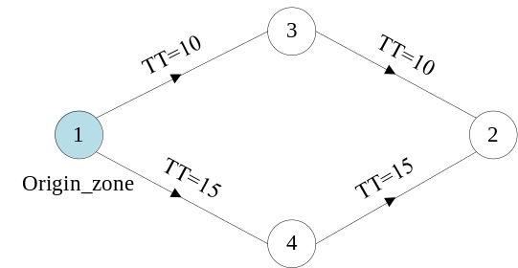
Figure 3.1: Physical network for example
- float optimal_label_correcting(int processor_id, Assignment* p_assignment, int iteration_k, int o_node_index, int d_node_no, bool pure_travel_time_cost)
Label correcting algorithm with double queue implementation.
Generate the shortest path tree.
The pseudo-codes details of Label Correcting are as follows:
Algorithm：Deque Label Correcting Algorithm
begin
//Initialization
m_label_distance_array[from_node] = 0;
m_node_predecessor[from_node] = 0;
m_label_distance_array[j] = ∞ for each node j∈N-{from_node}；

SEList.pushback(from_node);
while SEList ≠ Φ do
begin
remove the first element on the left from SEList;
for each arc (i,j)∈A(i) do: //A(i) means the outgoing link set of node i
if m_label_distance_array[j] > m_label_distance_array[i] + link_cost(i,j) then:
begin
m_label_distance_array[j] = m_label_distance_array[i] + link_cost(i,j);
m_node_predecessor[j] = i;
if node j has not been in SEList earlier then add node j to the right end of SEList;
else add node j to the left end of SEList;
end;
end;
end;
For this example:
Iteration 0:
The current road network is shown in figure 3.1. According to the label correcting method, we can easily find a one to shortest-path tree for each origin zone.
Here are the shortest path tree and node predecessor table for origin_zone_no = 1:
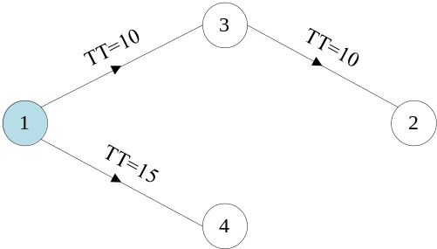
Figure 3.2: Shortest path tree for example
Table 3.1: Node predecessor for SPP tree
 | 1 | 2 | 3 | 4
Shortest path cost | 0 | 20 | 10 | 15
node_predecessor | -1 | 3 | 1 | 1

3.3 Backtrace and generate column pool
- void NetworkForSP::backtrace_shortest_path_tree(Assignment& assignment, int iteration_number_outterloop, int o_node_index)
For each node, find it's the shortest-path tree and backtrace the SPP tree from destination to origin and load flow count at the same time. Using the node-sum method to append a new path(like the hash-table method, as shown in figure 3.3).
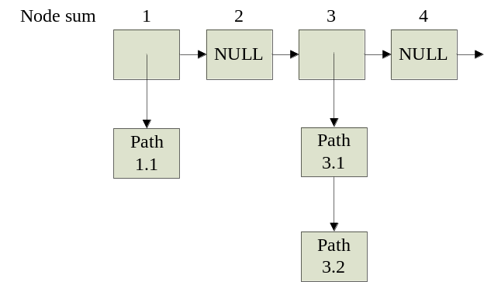
Figure 3.3: Node-sum method
For this example:
Iteration 0:
For origin zone = 1 and destination zone = 2, we can get a feasible column(1-3-2) by the node predecessor table.
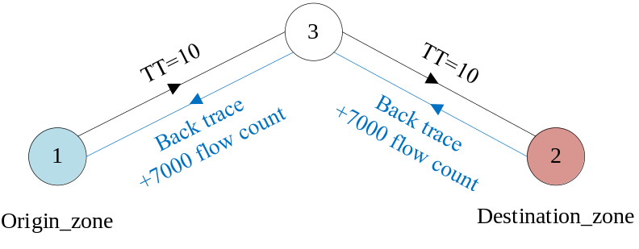
Figure 3.4: Backtrace for shortest path tree

At this point, we get the column pool in iteration 0:
column pool = {column 1};
column 1 = {1,3,2}.
You can use the following standard format to achieve the label correcting algorithm with parallel computing in different workbenches.
*Please refer to Guide into OpenMP: Easy multithreading programming for C++.
*The code template:
#pragma omp parallel for
for (int ProcessID = 0; ProcessID < g_NetworkForSP_vector.size(); ProcessID++)
{
……
//Perform one to all shortest-path tree calculation in each processor
}

4.Column Pool Optimization
Given the generated column pool, we can optimize the column pool by adjusting flow counts between columns.
- void g_column_pool_optimization(Assignment& assignment, int column_updating_iterations)
Call g_update_gradient_cost_and_assigned_flow_in_column_pool for column_updating_iterations times

- void g_update_gradient_cost_and_assigned_flow_in_column_pool(Assignment& assignment, int inner_iteration_number)
Based on the newly calculated path volume and column pool, we update volume-based travel time and update volume-based resource balance using the reduced gradient method. Here, we use this example to illustrate the implementation details.
Algorithm: Column Pool Optimization
Input: Generated Column Pool(after 2 column generation iterations)
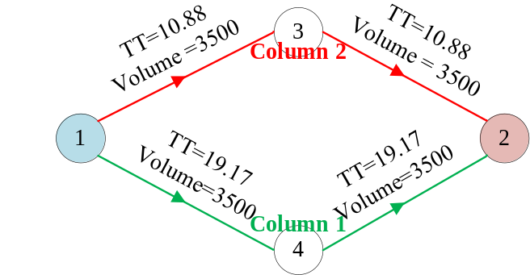
//Step 1: Calculate the gradient cost for each column cost.
Column 1 total cost(path_gradient_cost[1]) = 38.34
Column 2 total cost(path_gradient_cost[2]) = 21.76
least_gradient_cost = min{path_gradient_cost}= 21.76
//Step 2: Calculate gradient cost difference for each column cost.
for each non-shortest path column(only column 1 here):
path_gradient_cost_difference[1] = path_gradient_cost[1] - least_gradient_cost= 16.58
path_gradient_cost_relative_difference[1] = path_gradient_cost_difference / max(0.0001, least_gradient_cost) = 0.7619
//Step 3: Update path flows
step_size = 1.0 / (iteration_number + 2) *od_volume =1/(0 + 2) * 7000 = 3500
//Step 3.1: Shift flow form non-shortest path to shortest path
path_volume[1] = max(0, path_volume[1] - step_size * path_gradient_cost_relative_difference) = max(0, 3500 – 3500 * 0.7619) = 833.35
total_switched_out_path_volume = previous_path_volume[1]- path_volume[1] =
3500 – 833.35 = 2666.65
end for
//Step 3.2: Consider the least-cost path(column 2 here), receive all volume shifted from the non-shortest path.
path_volume[2] = path_volume[2] - total_switched_out_path_volume = 3500 + 2666.65 = 6166.65
//Step 4: Based on newly calculated path flows, update volume, and travel time.
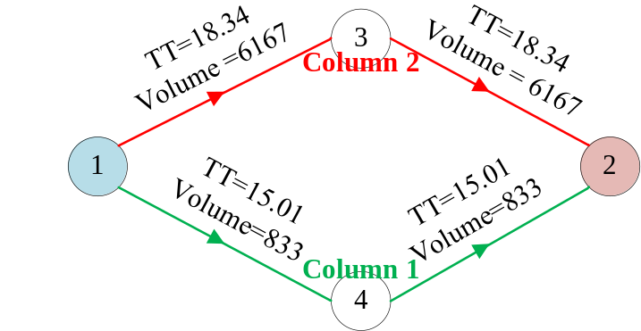

5.Simulation
- void Assignment::STTrafficSimulation()
Given an optimization result, make the simulation, output the specific flow for each link and time, and output the departure time and arrival time for each agent.
For each simulation interval, active the agent, update the entrance queue, and exit queue.
- void Assignment::AllocateLinkMemory4Simulation()
Prepare memory space for the simulation process.
STALite Simulation
//Step 1: Scan the different continuous paths in the column pool and generate a simulation agent for each column(In this example, an agent represents a vehicle).
We use the class CAgent_Simu to store simulation time and simulation route, etc., and each simulation agent will be stored in vector g_agent_simu_vector.
for each simulation_interval:
//Step 2: Simulate traffic conditions at time t(as shown in figure 5.1).
Inherit the CumulativeDeparture and CumulativeArrival value from the previous simulation-interval period for each link.
//Step 2.1: Active simulation agents that are going to depart from the origin node.
//Step 2.2: Push back the simulation agents into the corresponding entrance queue.
//Step 2.3: Pop the simulation agents from the entrance queue and push it back into the exit queue, and update the total travel time at the same time.
//Step 2.4: Check whether the agent has reached the destination node.
//Step 3: Count the departure numbers and arrival numbers for each link at time t.
//Step 4: Check link capacity and termination condition for each activated simulation agent.
t = t->next simulation_interval;
end for
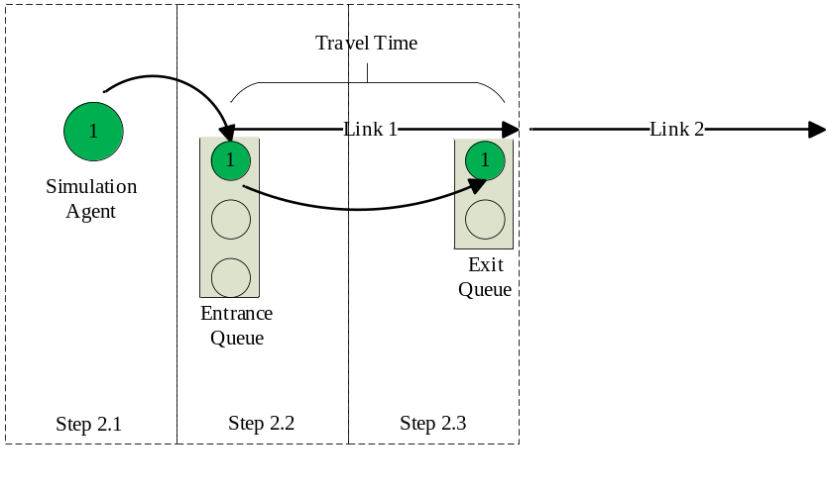
Figure 5.1: Simulation principle
6.Output Results
The output results mainly include two files, link_performance.csv and agent.csv(based on simulation), and you can find the detailed source code in function void g_output_simulation_result (Assignment& assignment).
7. Calculation Process Overview
Table 7.1: Calculation Process Overview
Iteration | Network | Column Generation | Column Pool
0 | 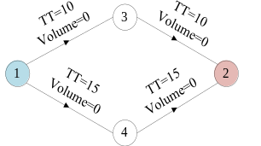 | 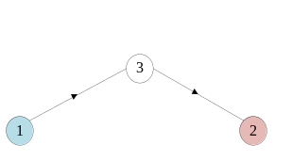 | 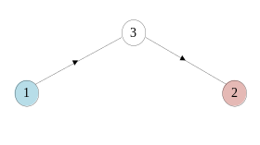
1 | 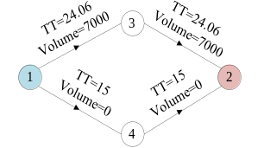 | 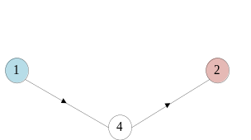 | 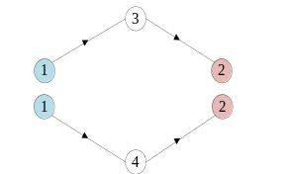
2 | 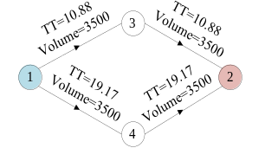
Column Pool Optimization
