STORIA DELLE VERSIONI

|  |  |  |  |  |  |
| --- | --- | --- | --- | --- | --- |
| **Rev** | **Date** | **Document** | **Issued by** | **Checked by** | **Approved by** |
| 1 | 18/06/2023 | Csv Downloader | Ugur Akcelik |  |  |
|  |  |  |  |  |  |
|  |  |  |  |  |  |
|  |  |  |  |  |  |

DOCUMENTI RICEVUTI

|  |  |  |  |  |
| --- | --- | --- | --- | --- |
| Titolo | Descrizione | Rev | Data | Ricevuto Tramite |
|  |  |  |  |  |

DOCUMENTI ALLEGATI

|  |  |  |  |  |
| --- | --- | --- | --- | --- |
| Titolo | Descrizione | Rev | Data | Inviato Tramite |
|  |  |  |  |  |
|  |  |  |  |  |
|  |  |  |  |  |

INDICES

1. Introduction 3

2. Usage 4

# Introduction

The CSV Downloader widget is a user-friendly tool that helps you create CSV files with multiple sensor values and a date range. By following the provided instructions, you can easily generate customized CSV files that meet your specific requirements. The CSV Downloader widget aims to streamline the organization and analysis of sensor data, resulting in time savings and increased productivity.

**Interface**

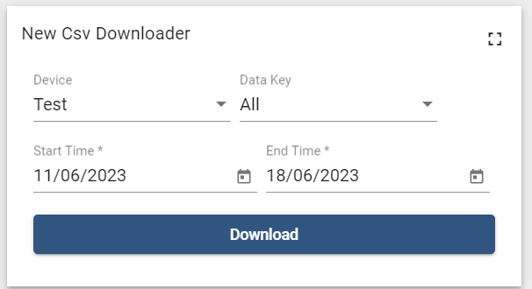

**Format**

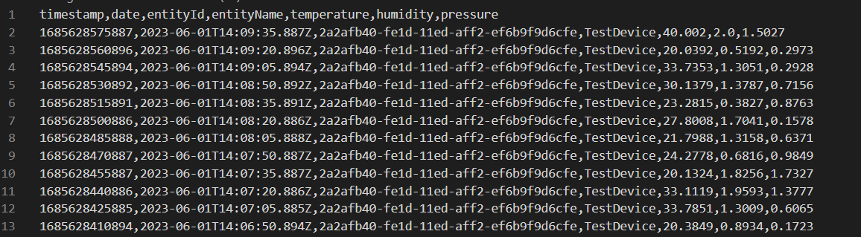

# Usage

**Prepare the .json File**

Before adding a widget to a dashboard, you need to have the widget's .json file ready. Ensure that you have the .json file saved on your computer or accessible through a file-sharing service.

**Access Widget Bundles**

Open the Widgets Library from the user panel. Look for a section labelled "Widget Bundles". This is where you can manage and add new widgets to your dashboard.

**Add .json File to Widget Bundles**

Within the Widget Bundles section, locate the option to add a new widget or upload a widget.

Click on the “Browse file” button to initiate the widget addition process.

A file selection dialog box or a drag-and-drop area will appear. Use this interface to navigate to the location where the .json file is saved on your computer.

Select the .json file and click "Open" or any equivalent option to initiate the upload process.

**Verify Widget Addition**

After the upload is successful, the widget should appear in the list of available widgets within the Widget Bundles section.

Verify that the widget's name or description matches the intended widget you want to add to your dashboard.

**Add Widget to Dashboard**

Navigate to the dashboard where you want to add the widget.

Click on the plus (+) button to enter the dashboard customization mode.

Click on the desired option to add a widget.

A list of available widgets will be presented. Look for the Csv Downloader widget and select it.

The widget allows for the addition of multiple entity aliases and provides the capability to select multiple keys for its functionality.

The widget will now be added to your dashboard, typically in a customizable grid or layout area.

Adjust the position and size of the widget as desired by dragging and resizing it within the dashboard layout.

Once you are satisfied with the widget's placement, save or apply the changes to finalize the addition of the widget to the dashboard.

**Select the Device**

Choose the specific device from a list of available options to focus on gathering data from a particular source.

**Select the Data Key**

Pick the relevant data key from the available options to specify the type of information you want to extract and analyze.

**Select the Start Date**

Set the starting point by selecting the desired date from which the data collection or analysis should commence.

**Select the End Date**

Specify the end date to define the timeframe or duration until which the data collection or analysis should extend.