Hello, and welcome to MVP Connect. Here we will outline how to use your app.

During use, long press on buttons to open a tip holder.
This app will function on any device that has a browser. To use MVP Connect like an app, follow the install instructions on the webpage. This is create a shortcut on your device and when opened, the app will act like an app in full screen mode. It is not installed like an app, it creates a link to the browser.

On first load, there are no albums or images loaded. You have a clean slate to start building albums.

Long-press in the top-left corner to change modes (Play / Editor)

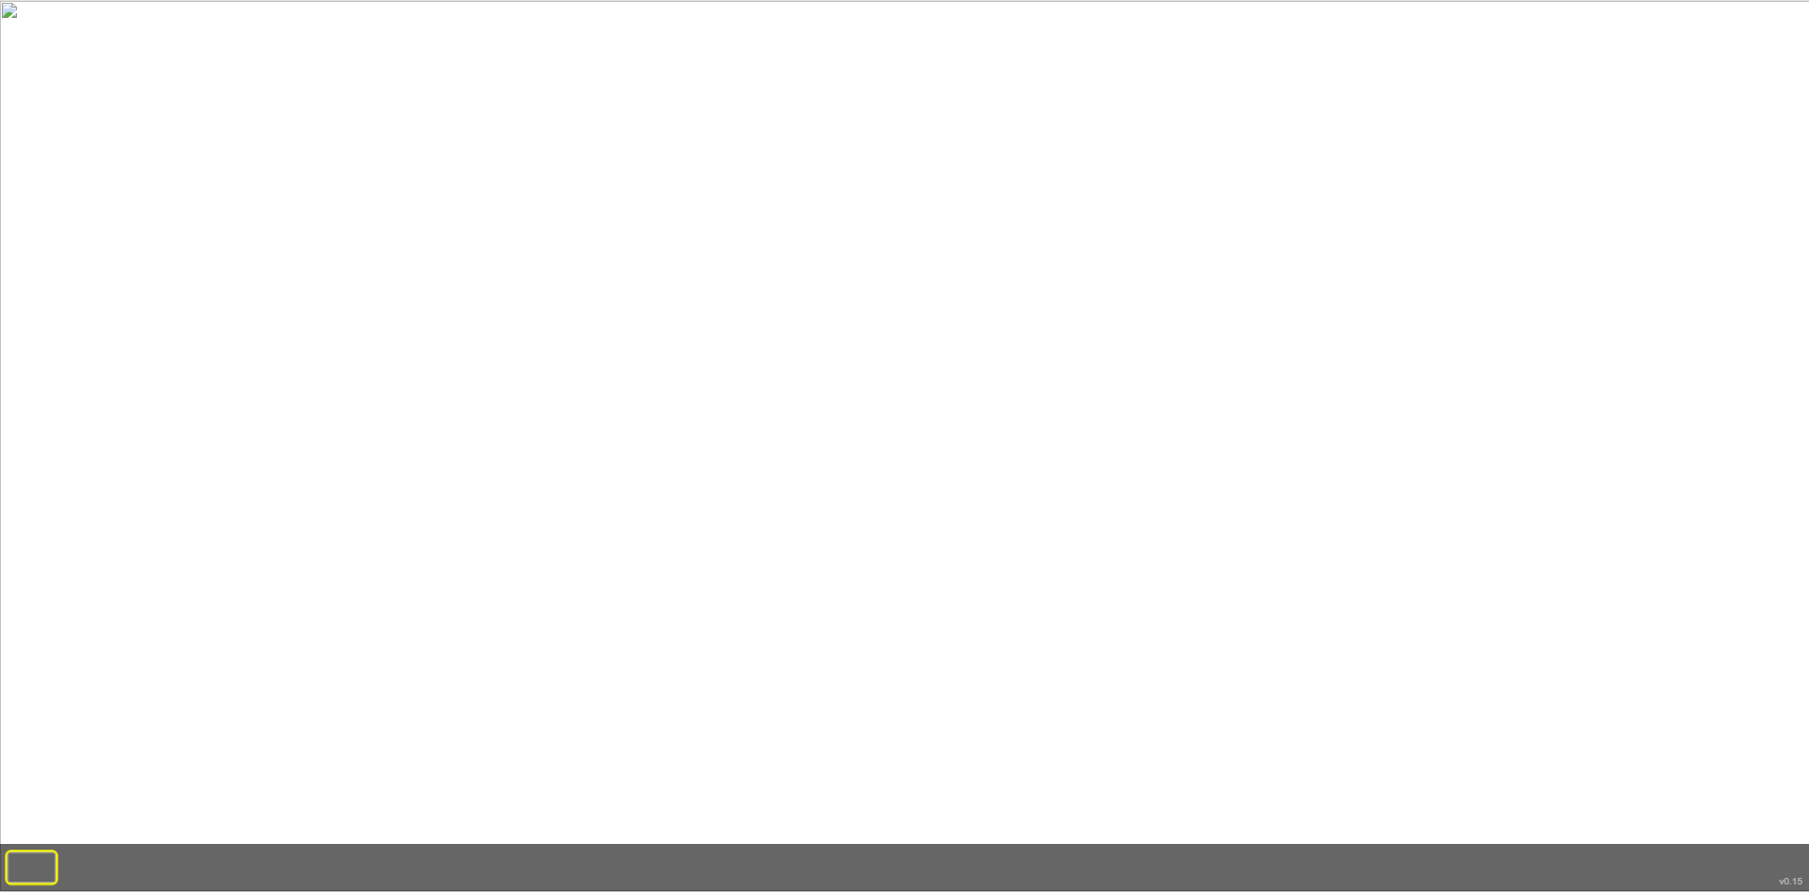

- Modes -

There are two modes, Play mode and Editor mode.

The default mode is Play mode. Users can click on the far-left and far-right of the screen or select the thumbnails to cycle between pages (images). Users can also click on items, play audio clips, and scratch images.

To enter ‘Editor’ mode, long-press in the top-left corner for about 3 seconds. Likewise, to enter ‘Play’ mode, hold for about 3 seconds in the same position.

Editor mode is where the magic takes place. This mode is not for students, patients, or users who should not have access.
In the ‘Editor’ mode, you’ll notice a toolbar on the right-hand side and a button to toggle the toolbar on/off. This can be handy when using mobile devices with smaller screens.

Indicates draw mode, play page audio button, play frames button.
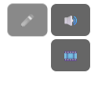
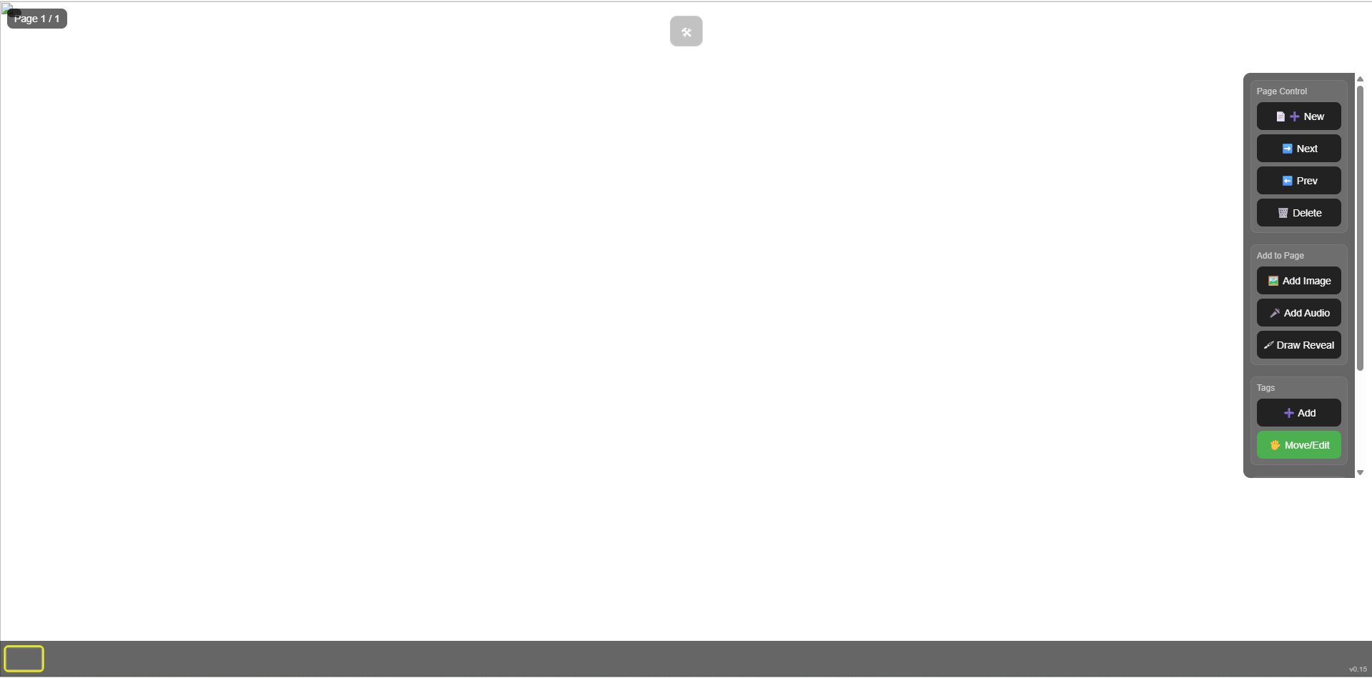
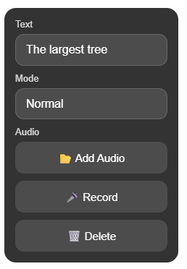
Toggle toolbar button
Toolbar
Tag inspector
When a tag is selected, the inspector will appear. Here you can edit text, change tag modes, load audio from file, record audio, and delete the tag.

- Page Control -

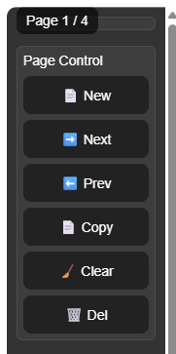
1. The page indicator displays the current page out of the total.
1.

2. add a new blank page (up to 30 per album).
2.
3. & 4. The Next and Previous buttons cycle through the pages that you have created. *Thumbnails
3.
4.
5. ‘Copy’ will duplicate the currently selected page.
5.

6. Clear removes audio clips and tags from the page with the image persisting.
6.
7.
7. Delete removes the page entirely.

These options are your page management.

You can also cycle through pages by clicking / touching the *Thumbnails at the bottom of the screen.

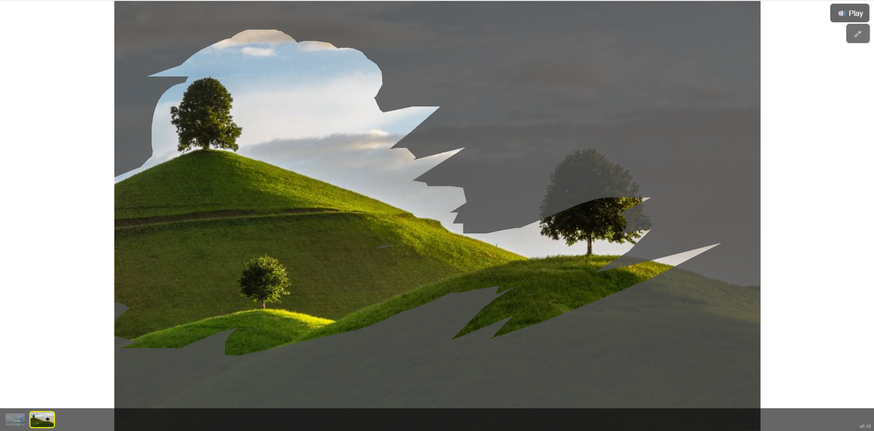

- Add to Page -

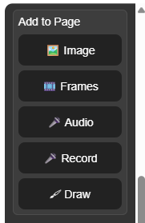
1. Click ‘Image’ to locate the image on your device that you would like to display. Select the image and click ‘OK’ to the message.
1.
2.
2. Click ‘Frames’ to load up to 5 images that act similar to a .gif (quickly cycle through the images)
3.
4.
3. To load an audio clip from your device, click ‘Audio’. *Max clip sized is 500kb.
5.

4. To directly record audio from your device’s microphone, click ‘Record’. *Max clip sized is 500kb. A red dot will appear in the center of the screen when recording, and the device will capture audio for up to 6 seconds. Clicking the red dot will stop the recording.

5. enable / disable draw mode. If enabled, tags on the selected page will be ignored and a gray image will appear over the page image. Users can draw / scratch to reveal the colour image underneath.

Draw Mode indicator
Page audio indicator
Click to play the clip

Page frames indicator
Click to play the frames

- Tags -

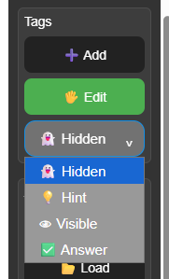
1. To add tags to the page (image), click ‘+ Add’ and then click on the image. After placing the tag, edit mode will be activated to allow editing.
1.
2.

2. ‘Edit’ is selected by default. This allows you to move tags around and resize them.
3.
3. You can change the type of tag for each page.
Hidden – tags are not visible on screen.
Hint – thin box around tags.
Visible – tags can be seen.
Answer – Only the ‘correct’ tag will be visible.

All tags on a page are clickable unless Draw mode has been activated.
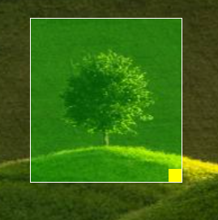
Tags can be moved by clicking / touching them and moving them around the image. They can also be resized using the bottom-right yellow square.

- Tag Inspector -
When selecting a tag, the tag inspector will appear.
This will allow you to add text, select modes, add or record audio clips, or delete the tag.

The three modes are ‘normal’ (blue), ‘correct’ (green), and ‘incorrect’ (red).

Audio clips should not be larger than 500kb or else they will not be loaded.

- Album -

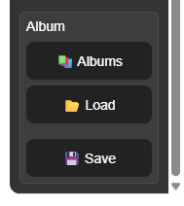
So now we need to talk about albums…
1.

1. To enter the album selection scene, click ‘Albums’.

This will open the album control window.

To create a new album, click ‘Add Album’.

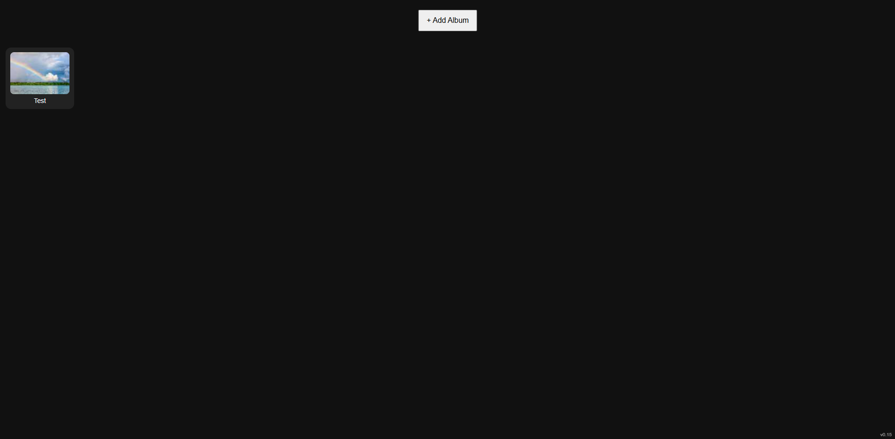
You will be prompted to name the new album. Click ‘OK’ when done.
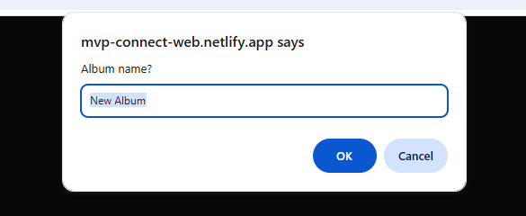

Select an album and an options menu will appear. You can open (enter ‘Editor’ mode), rename, delete, or close the current menu.

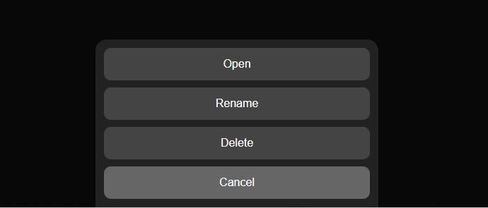

You can have as an unlimited amount of albums, but each album has a maximum of 30 pages.

Important note! – Clearing your browser cache and history will remove all albums. So saving is very important. If you have saved your albums, and do clear the cache or app data, you can load them at any time.
Also, you can share them with family, friends, and students.

2. To load an album, create an empty album and the click ‘Load’. This ensures your current album is not overwritten.
2.

3. Click ‘Save’ to save the current album to your device as a .zip file. It will show as the album name you created. Eg. Test.zip
3.

After selecting save, an export summary will be shown outlining the number of pages, images, frames, audio clips, and the file size. Select ‘Download’.

Below is an example of draw / scratch during play.

