**University of Engineering and Technology, Lahore**

**Department of Computer Sciences**

**Discrete Mathematics**

**Project Report**

**Title: Detailed Analysis of Graph & Number Theory**

**Submitted By:**

Muhammad Jilani (2022 – CS - 192)

Muhammad AbuBakar (2022- CS -188)

**Submitted To:**

Sir Waqas

**Submission Date:**

January 01, 2024

Contents

**Question 1:** 4

**Part A:** 4

**1. Board Representation as a Graph:** 4

**2. Piece Influence and Graph Connectivity:** 5

**3. Pathways of Strategic Moves:** 5

**4. Cycles in** **Checkers Strategies:** 5

**5. Graph Theory in Checkers games:** 5

**6. Checkers Openings: A Graphical Approach:** 5

**7. Algorithmic Insights in Checkers Analysis:** 5

**8. Physics of Checkers Movement:** 5

**9. Strategic Decision-Making Network:** 5

**10. Conclusion:** 5

**Part B:** 6

**1. Level Design as a Graph:** 6

**2. Character Movements and Graph Connectivity:** 6

**3. Navigating Pathways in Super Mario:** 6

**4. Pattern Recognition and Cycles:** 6

**5. Graph Theory in tetris:** 6

**6. Level Transitions: A Graphical Approach:** 6

**7. Algorithmic Insights in tetris:** 6

**8. Physics of tetris Movement:** 6

**9. Graph Theory in Super tetris Education:** 6

**10. Conclusion:** 7

**Part C:** 7

**1. Tic-Tac-Toe as a Graph:** 7

**2. Graph Connectivity in Tic-Tac-Toe:** 7

**3. Path Analysis in Tic-Tac-Toe:** 7

**4. Cycles in Tic-Tac-Toe Strategies:** 7

**5. Tic-Tac-Toe Generalizations and Graph Theory:** 7

**6. Algorithmic Insights in Tic-Tac-Toe:** 7

**7. Strategic Decision-Making Network in Tic-Tac-Toe:** 7

**8. Temporal Dynamics in Tic-Tac-Toe:** 8

**9. Graph Theory in Tic-Tac-Toe Education:** 8

**10. Conclusion:** 8

**Question 2 (Graph Theory):** 8

**Part A:** 8

**Undirected Graph Degrees:** 8

**Source Code:** 8

**Execution:** 8

**Part B:** 9

**Directed Graph Degrees:** 9

**Source Code:** 9

**Execution:** 9

**Part C:** 10

**Bipartite Graph Check:** 10

**Source Code:** 10

**Execution:** 10

**Part D:** 11

**Adjacency Matrix Creation:** 11

**Source Code:** 11

**Execution:** 11

**Part E:** 12

**Edge Listing from Adjacency Matrix:** 12

**Source Code:** 12

**Execution:** 12

**Part F:** 13

**Incidence Matrix Construction:** 13

**Source Code:** 13

**Execution:** 13

**Question 3 (NumberTheory):** 13

**Part A:** 13

**Prime Factorization:** 13

**Source Code:** 13

**Execution:** 14

**Part B:** 14

**Euclidean Algorithm for GCD:** 14

**Source Code:** 14

**Execution:** 14

**Part C:** 15

**LCM Calculation:** 15

**Source Code:** 15

**Execution:** 15

**Part D:** 15

**Bezout Coefficients:** 15

**Source Code:** 15

**Execution:** 16

**Part E:** 16

**Modular Inverse:** 16

**Source Code:** 16

**Execution:** 16

**Part F:** 16

**RSA Encryption:** 16

**Source Code:** 16

**Execution:** 18

**Part G:** 18

**RSA Decryption:** 18

**Source Code:** 18

**Execution:** 19

**Links:**

[**https://www.linkedin.com/posts/abubakar-ilyas-5a5245229_numbertheory-graphtheory-codinginmathematics-activity-7147634995212333056-7rjR?utm_source=share&utm_medium=member_desktop**](https://www.linkedin.com/posts/abubakar-ilyas-5a5245229_numbertheory-graphtheory-codinginmathematics-activity-7147634995212333056-7rjR?utm_source=share&utm_medium=member_desktop)

[**https://www.linkedin.com/posts/muhammad-jilani-804a422a7_presenting-my-discreate-math-project-assigned-activity-7147670856620576768-Or08?utm_source=share&utm_medium=member_desktop**](https://www.linkedin.com/posts/muhammad-jilani-804a422a7_presenting-my-discreate-math-project-assigned-activity-7147670856620576768-Or08?utm_source=share&utm_medium=member_desktop)

# **Question 1:**

## **Part A:**

#### 1. Checkers (Draughts)

**Board Representation as a Graph:**

In Checkers, the game board with its distinct squares can be graphically represented as a network of nodes, where legal moves between squares form the edges. This depiction helps capture the strategic nature of Checkers, offering insights into piece interactions and movement possibilities.

**Piece Influence and Graph Connectivity:**

Analyzing graph connectivity in Checkers provides valuable insights into the influence of pieces on the board. Understanding connected components delineates strategic zones, emphasizing the significance of piece placement and movement in this game.

**Pathways of Strategic Moves:**

Checkers unfolds through strategic moves, and these sequences can be represented as graph paths. Analyzing these pathways aids in understanding specific move sequences and their broader implications for the strategic landscape of the game.

Cycles in Checkers Strategies: Identifying cycles within the graph representing Checkers unveils repetitive patterns and strategic choices. Recognizing these cycles contributes to a deeper understanding of strategic positions and recurring tactics employed by players.

Graph Theory in Checkers Strategies: Applying graph theory principles to Checkers endgames allows for systematic analysis. Nodes represent simplified game positions, and edges denote legal moves, enabling strategic decision-making and scenario analysis.

**Checkers Openings:**

A Graphical Approach: The dynamic nature of Checkers' opening moves finds an expressive representation in graph structures. Conceptualizing opening strategies as evolving graphs provides players with a visual tool to analyze the evolving nature of the game during its initial phases.

**Algorithmic Insights in Checkers Analysis:**

Integrating graph algorithms, such as pathfinding and connectivity analysis, enhances Checkers' strategic analysis. These algorithms aid in exploring various game scenarios, assisting players and analysts in devising effective strategies.

**Physics of Checkers Movement:**

Drawing parallels between Checkers movements and graph theory reveals the physical dynamics inherent in piece interactions. Analyzing piece movements through the lens of graph theory deepens the understanding of Checkers as a strategic battlefield.

**Strategic Decision-Making Network in Checkers:**

Graphically representing strategic decision-making in Checkers creates a network of possibilities. Nodes represent potential moves, while edges illustrate their strategic implications, offering players a visual guide for informed decision-making.

**Conclusion:**

Checkers and Graph Theory have a symbiotic relationship. The application of graph theory not only deepens our understanding of Checkers' complexity but also serves as a powerful tool for strategic analysis and learning.

## **Part B:**

#### . Tetris :

**Level Design as a Graph in Tetris:**

Tetris levels can be envisioned as grids, each cell representing a possible position for falling tetrominoes (blocks). The grid can be seen as a graph, with each cell as a node and the adjacent cell connections forming edges. This structure illustrates the potential movements and placements of tetrominoes within the game.

1. Character Movements and Graph Connectivity in Tetris: Understanding the connectivity of the grid cells demonstrates how the tetrominoes can move and interact within the game. Analyzing the connected areas assists in strategizing block placements, creating solid lines, and clearing rows efficiently.
2. Navigating Pathways in Tetris: Similar to navigating through paths in a graph, players in Tetris aim to create clear pathways within the grid. Visualizing possible movements and pathways aids players in making quick decisions on where to place blocks to achieve optimal outcomes.
3. Pattern Recognition and Cycles in Tetris: Identifying patterns within the grid reveals common sequences of tetrominoes and their placements. Recognizing these patterns assists in planning ahead, optimizing placements, and setting up combos to clear lines more effectively.
4. Graph Theory and Item Acquisition in Tetris: While Tetris doesn't have traditional items, the different tetromino shapes act as unique "pieces" that players strategically position. Viewing these tetrominoes as nodes in a graph highlights their characteristics and impacts on gameplay strategies.
5. Location Transitions: A Graphical Approach in Tetris: In Tetris, the transition from one level to the next can be represented graphically. Moving from a completed level to a new, often faster-paced level mirrors the progression between graph nodes, emphasizing the changing difficulty and pace of the game.
6. Algorithmic Insights in Tetris: Utilizing algorithms related to graphs can aid in determining optimal block placements, predicting potential tetromino sequences, and strategizing to maximize score and create efficient clearings.
7. Physics of Character Movement in Tetris: Analyzing the interactions of falling tetrominoes within the grid using graph theory enhances the understanding of the game's dynamics. It helps players anticipate how different shapes fit together and make informed decisions about placements.
8. Graph Theory for Educational Purposes in Tetris: Visualizing Tetris gameplay through graph theory can serve as an educational tool, helping players grasp spatial reasoning, pattern recognition, and strategic decision-making in a dynamic environment.
9. Conclusion: Applying graph theory concepts to Tetris provides a deeper understanding of its mechanics. Graphical representations offer insights into strategic planning, pattern recognition, and decision-making, enriching the experience of this classic puzzle game.

## **Part C:**

### **1. Tic-Tac-Toe as a Graph:**

Just as in chess and Super Mario, Tic-Tac-Toe can be elegantly represented as a graph. Each possible state of the Tic-Tac-Toe board becomes a node, and the legal moves connecting these states form the edges. This graphical model encapsulates the simplicity of the game's structure.

### **2. Graph Connectivity in Tic-Tac-Toe:**

Examining connectivity within the Tic-Tac-Toe graph provides insights into the relationships between different board states. Analyzing connected components helps understand strategic zones and potential winning or drawing positions.

### **3. Path Analysis in Tic-Tac-Toe:**

The progression of a Tic-Tac-Toe game can be effectively analyzed using paths through the graph. Paths represent sequences of moves, offering a strategic overview of how the game unfolds and how players can achieve victory.

### **4. Cycles in Tic-Tac-Toe Strategies:**

Identifying cycles in the graph unveils repeated patterns in Tic-Tac-Toe strategies. Recognizing these cycles is essential for understanding scenarios leading to a draw and exploring optimal winning strategies.

### **5. Tic-Tac-Toe Generalizations and Graph Theory:**

Beyond the traditional 3x3 Tic-Tac-Toe, graph theory allows for the exploration of generalizations, such as larger boards or different win conditions. The graph structure adapts to accommodate variations, providing a versatile tool for analysis.

### **6. Algorithmic Insights in Tic-Tac-Toe:**

Applying graph algorithms, such as depth-first search or minimax, enhances Tic-Tac-Toe analysis. These algorithms aid in exploring potential moves, predicting opponents' strategies, and determining optimal paths to victory.

### **7. Strategic Decision-Making Network in Tic-Tac-Toe:**

Representing strategic decision-making as a network of nodes and edges provides a visual guide for players. Nodes depict potential moves, while edges illustrate their strategic consequences, aiding players in making informed choices.

### **8. Temporal Dynamics in Tic-Tac-Toe:**

Introducing temporal dynamics through graph theory captures the evolving nature of a Tic-Tac-Toe game. Observing how the graph evolves over time allows players to adapt to changing strategies and make dynamic decisions.

### **9. Graph Theory in Tic-Tac-Toe Education:**

Utilizing graph theory as an educational tool in Tic-Tac-Toe enhances comprehension through visual representation. The graphical framework serves as a pedagogical aid, fostering a deeper understanding of game dynamics for players of all skill levels.

### **10. Conclusion:**

In conclusion, Tic-Tac-Toe, although seemingly simple, can be dissected and analyzed through the lens of graph theory. This analytical approach not only unveils the intricacies of the game but also showcases the adaptability of graph structures in accommodating variations and enhancing strategic decision-making.

# **Question 2 (Graph Theory):**

# **Part A:**

## **Undirected Graph Degrees:**

## **Source Code:**

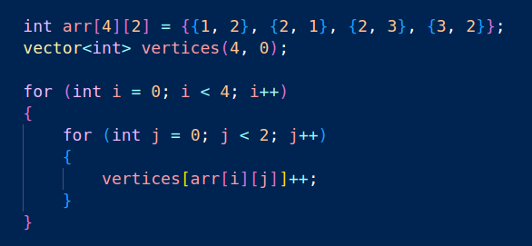

## **Execution:**

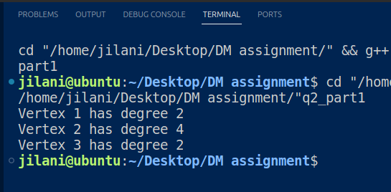

# **Part B:**

## **Directed Graph Degrees:**

## **Source Code:**

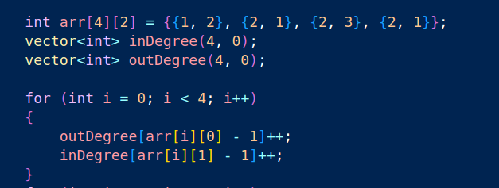

## **Execution:**

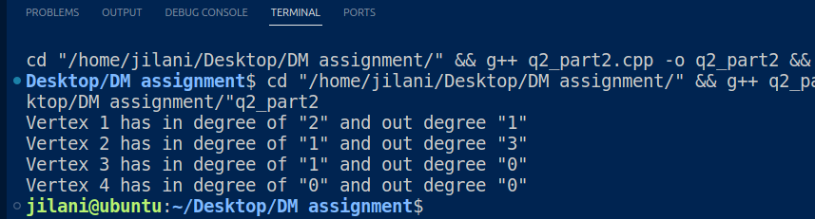

# **Part C:**

## **Bipartite Graph Check:**

## **Source Code:**

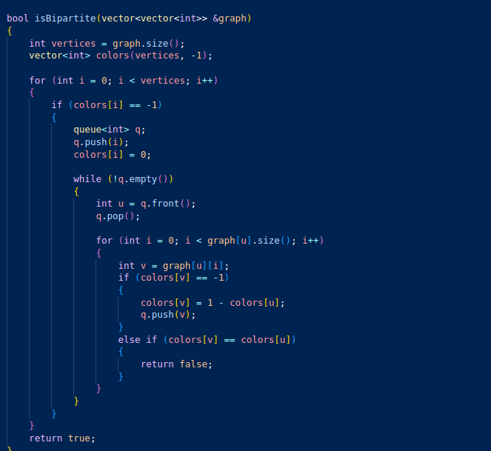

## **Execution:**

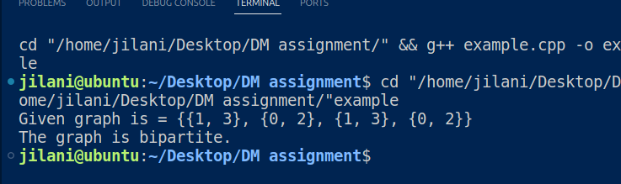

# **Part D:**

## **Adjacency Matrix Creation:**

## **Source Code:**

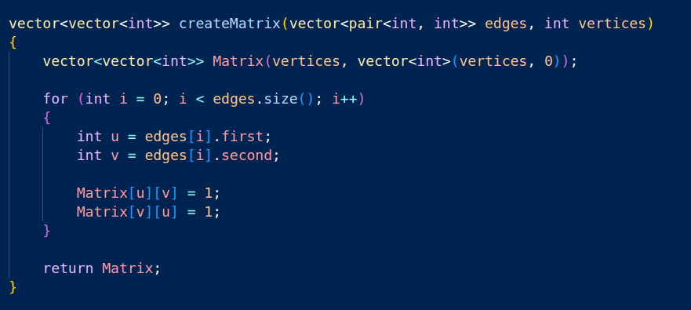

## **Execution:**

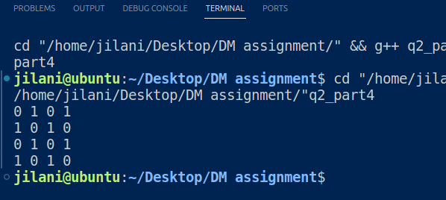

# **Part E:**

## **Edge Listing from Adjacency Matrix:**

## **Source Code:**

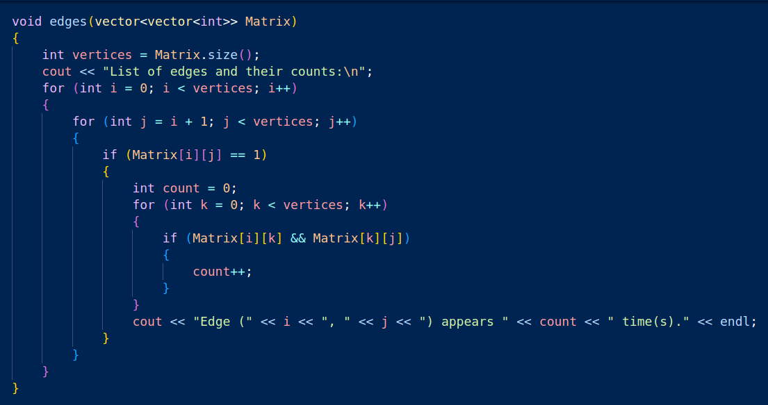

## **Execution:**

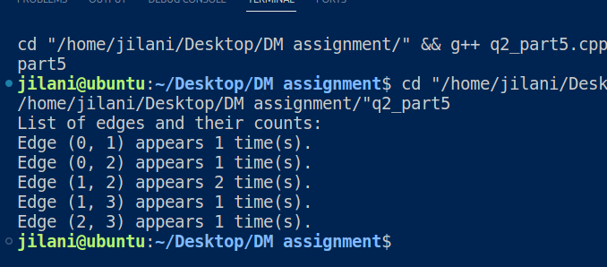

# **Part F:**

## **Incidence Matrix Construction:**

## **Source Code:**

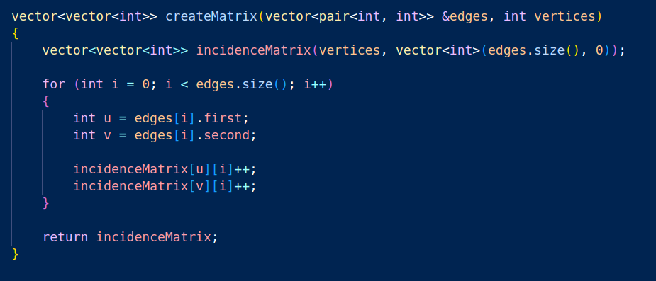

## **Execution:**

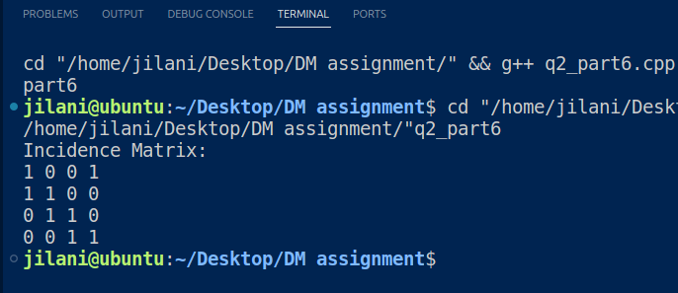

# **Question 3 (NumberTheory):**

# **Part A:**

## **Prime Factorization:**

## **Source Code:**

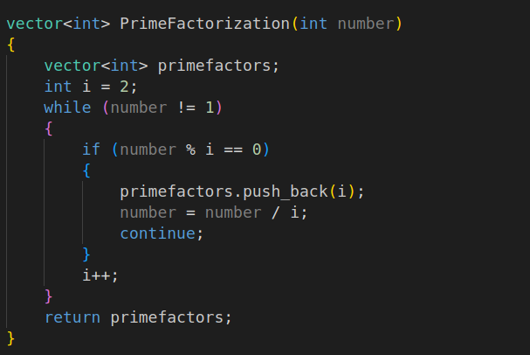

## **Execution:**

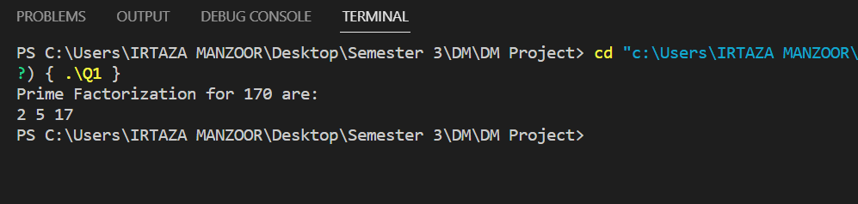

# **Part B:**

## **Euclidean Algorithm for GCD:**

## **Source Code:**

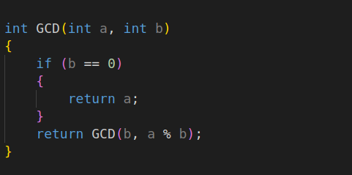

## **Execution:**

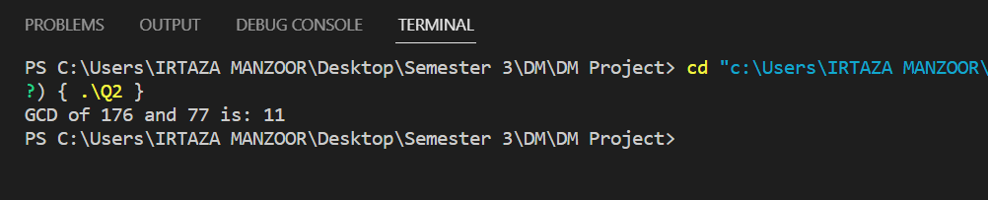

# **Part C:**

## **LCM Calculation:**

## **Source Code:**

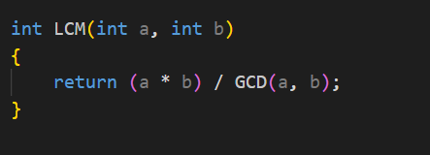

## **Execution:**

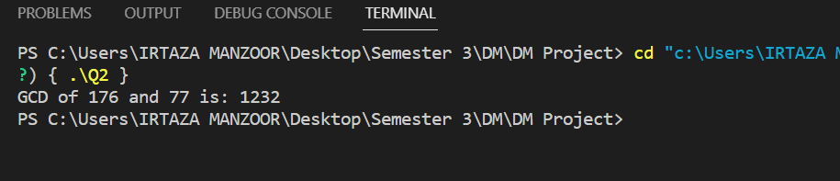

# **Part D:**

## **Bezout Coefficients:**

## **Source Code:**

## **Execution:**

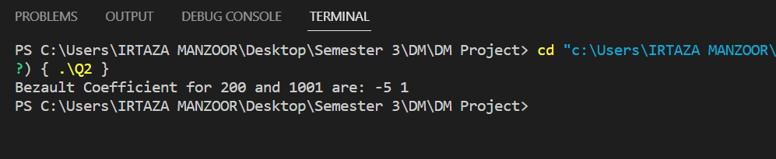

# **Part E:**

## **Modular Inverse:**

## **Source Code:**

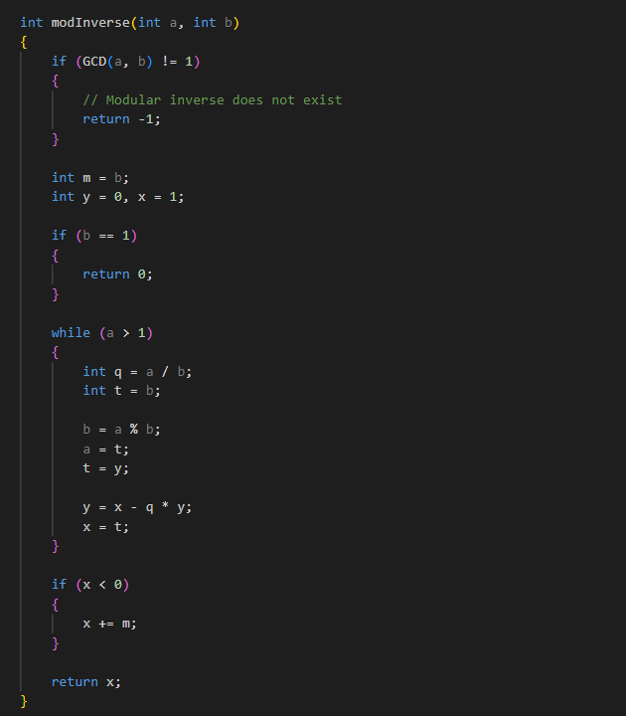

## **Execution:**

# **Part F:**

## **RSA Encryption:**

## **Source Code:**



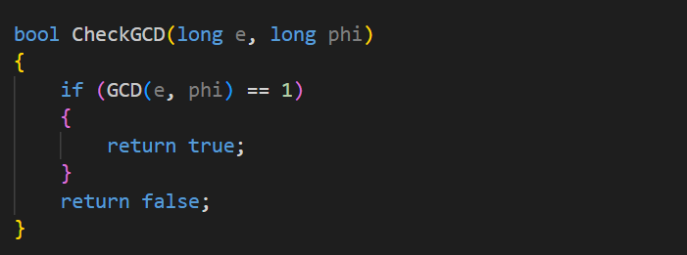

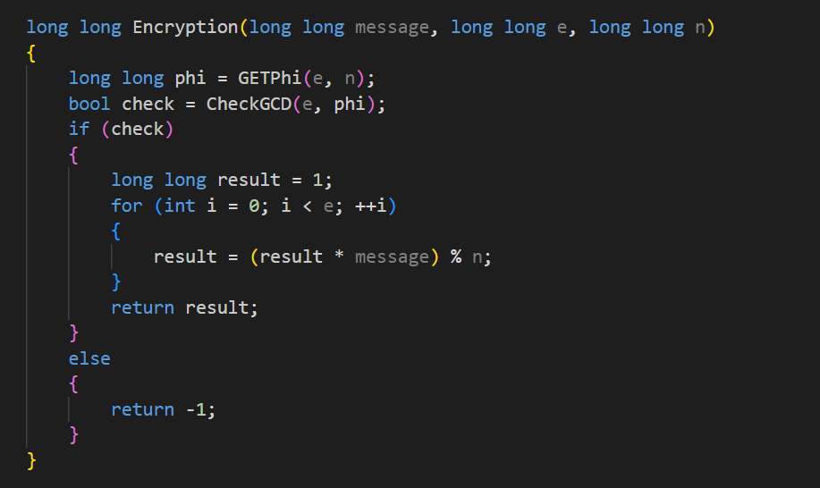

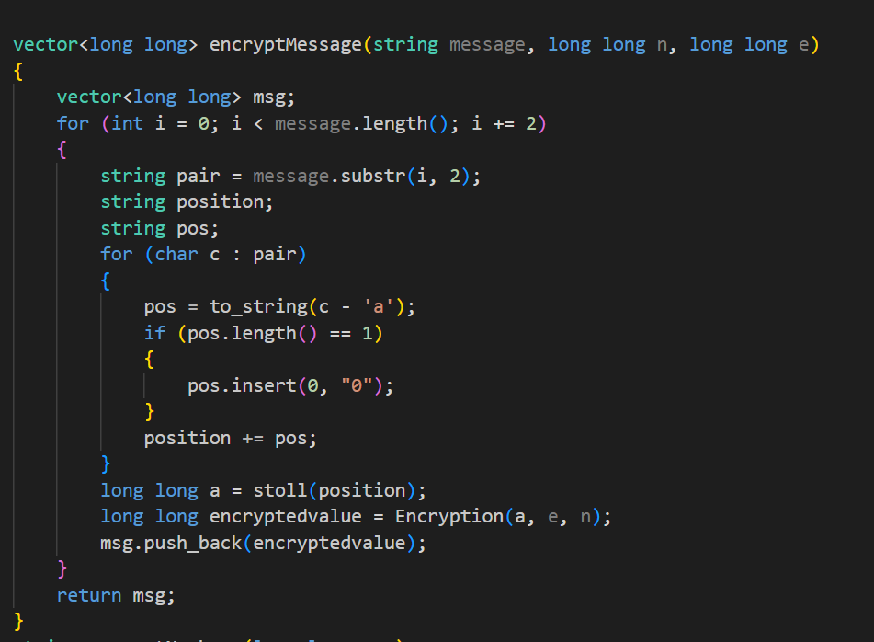

## **Execution:**

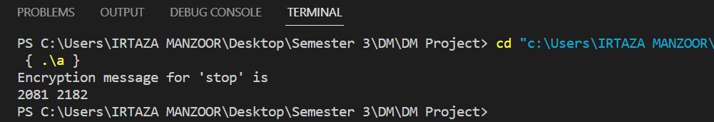

# **Part G:**

## **RSA Decryption:**

## **Source Code:**

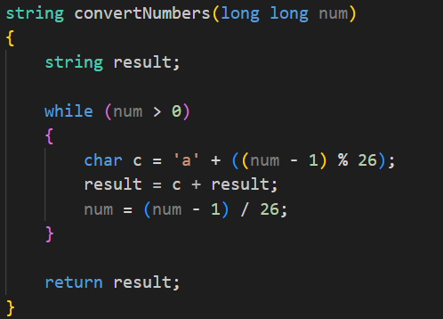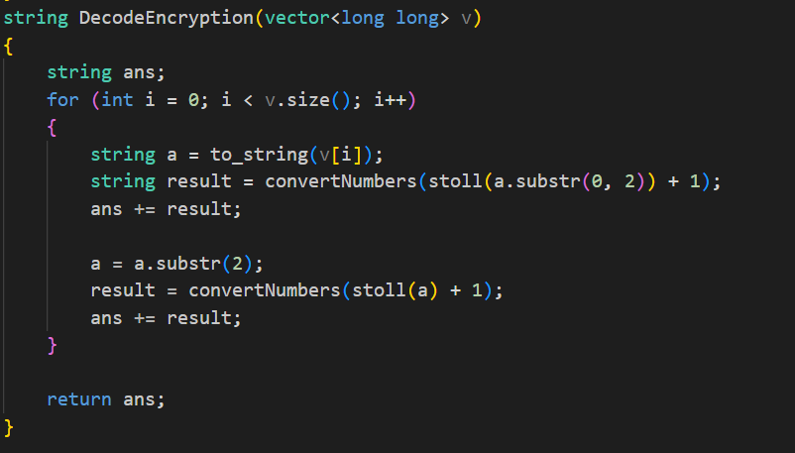

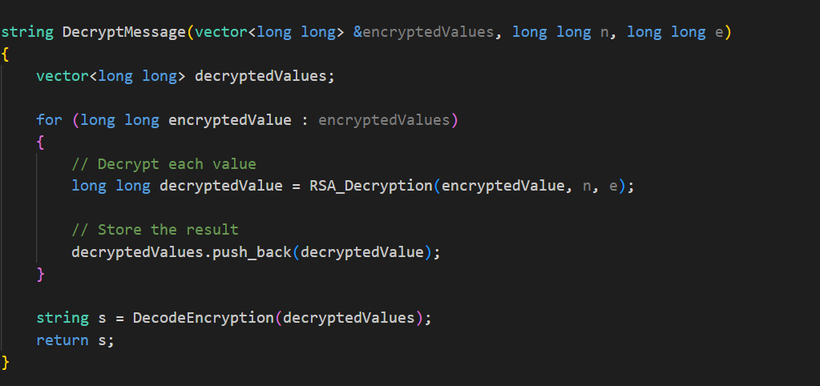

## **Execution:**

