A new year is coming. Everyone wants to meet him cheerfully and brightly. Soundlights I made will help me. Maybe my soundlights will help you to decorate the meeting of the new year and make it brighter.

General view of soundlights:

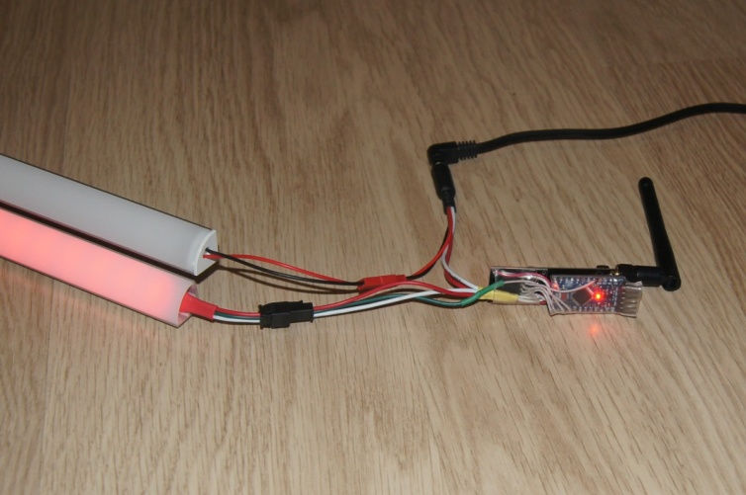

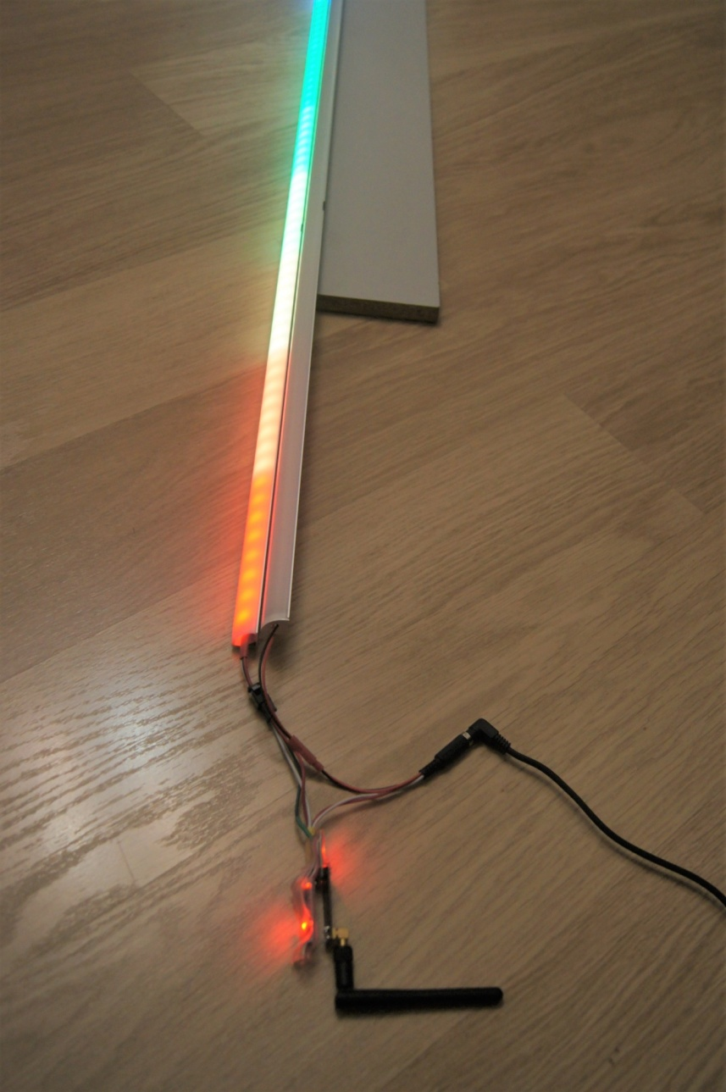

Soundmusic is situated on cupboard:

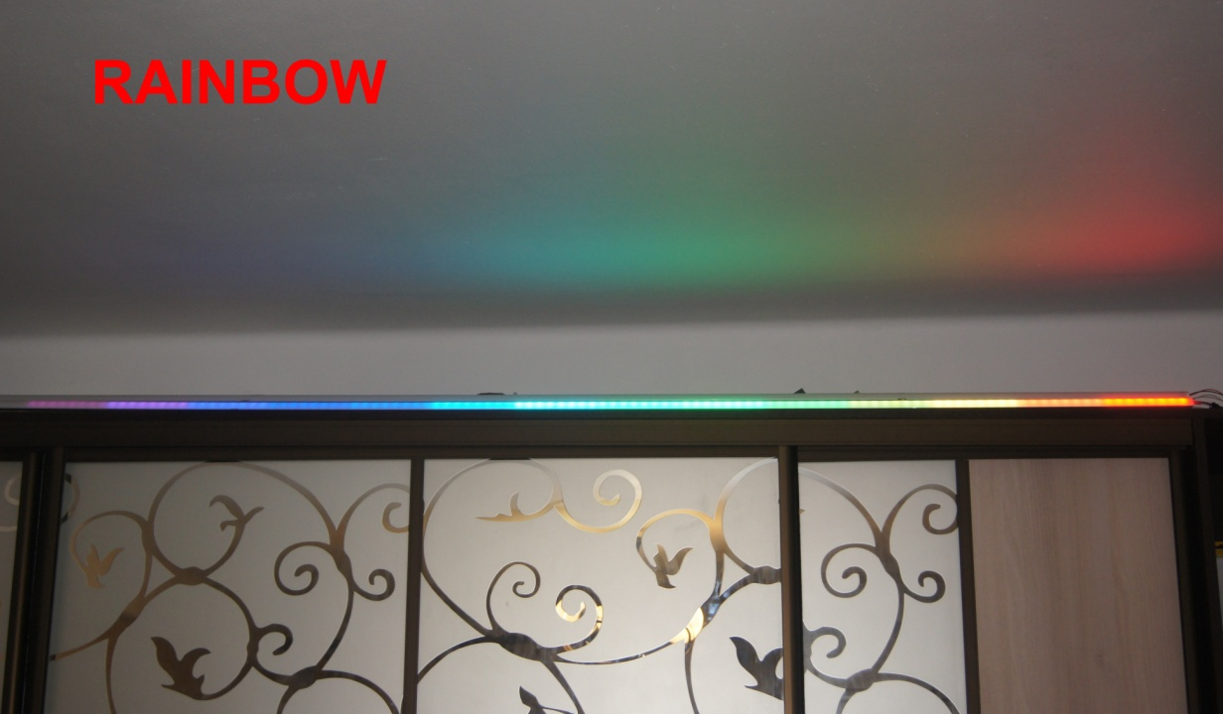

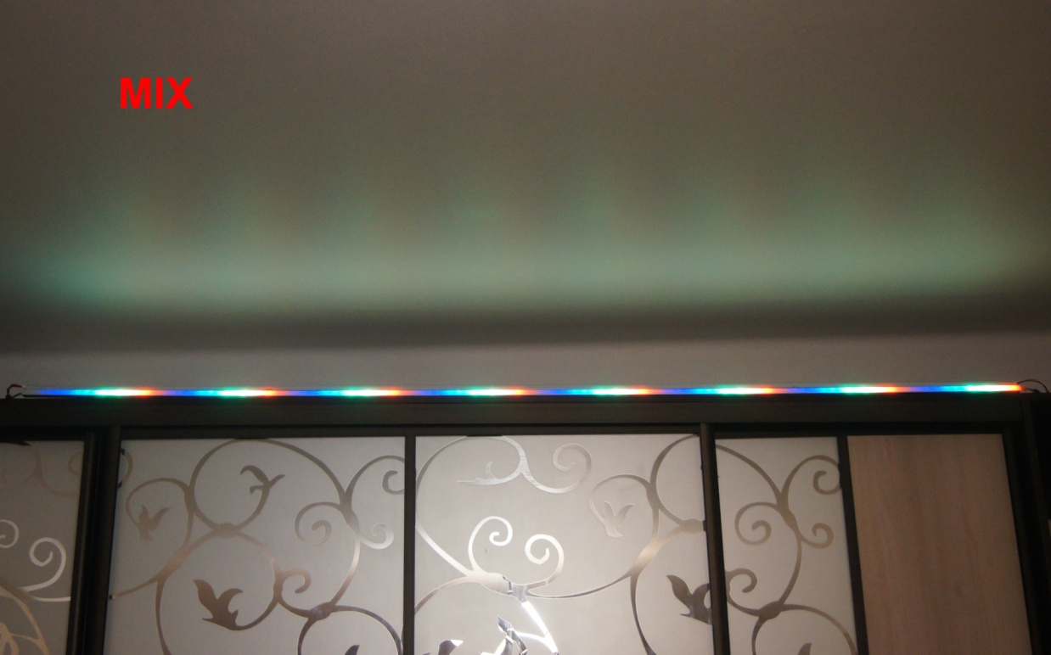

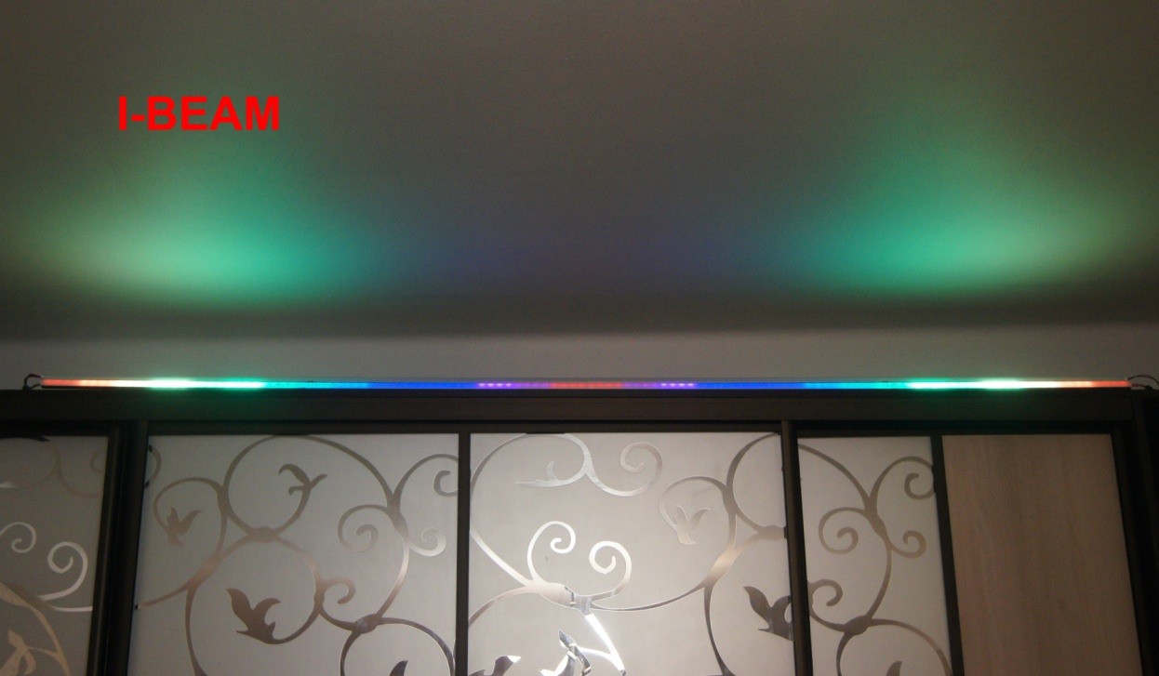

During the time while the LED ribbon and arduino were being delivered I have wrote the soundlight program 'Musical Ligth' for the personal computer and the WS2812 tape control sketch or the similar for Arduino.

The tape can be managed either directly by the Arduino connected to the COM port or via the radio bridge by nRF24L01. In the first case, the sketch COMTOLEF.ino is used, in the second sketch COMtoRF and RFtoLED.

Connection diagrams are presented:

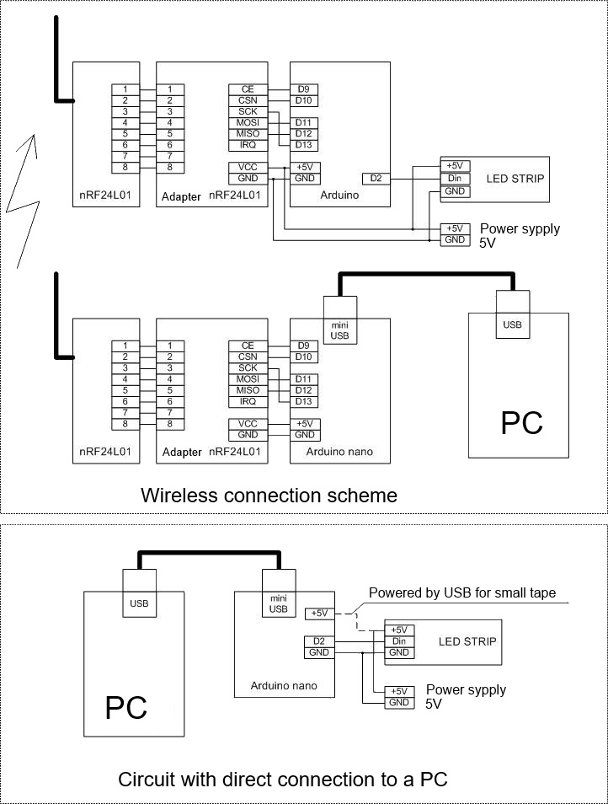

When you directly connect to a USB PC, without using an additional power source, remember about limited load capacity of the USB port. If your ribbon have a large number of diodes, you just need to set the number of LEDs in the sketch less then 20. Like this: #define stripLed 20, there is no need to cut the ribbon. If it is required install a resistor from 33 to 470 Ω between terminals D2 and Din as recommended by the manufacturer. The minimum connection scheme for arduino nano and LED ribbon is shown on the Easy Connection tab of the program.

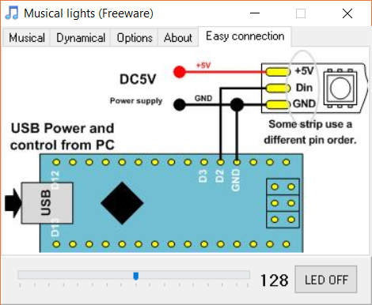

The program supports color and dynamic modes of operation. Connects to any audio device of PC. Digital processing of the audio stream is performed by the PC. Color music programs are formed by arduino cards based on data on the spectral composition of the current fragment of the phonogram received from the PC. In the program you can choose one of three color music programs or one more than 100 dynamic ones. Tri-color music and twenty-four dynamic subroutines Implemented in the attached sketches. The remaining programs are available for developers.

Musical Light program:

Rainbow;  
Mix;  
I-beam;

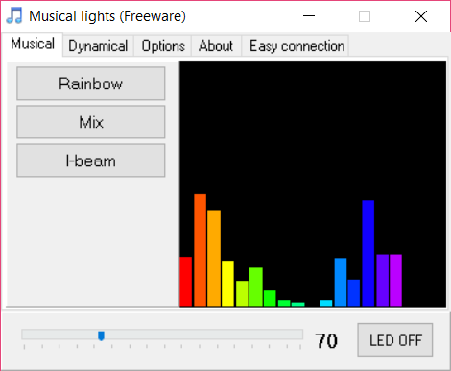

Dynamical programs:

TheaterChaseRainbow - one examples from the Adafruit_NeoPixel library;

RainbowCycle - one examples from the Adafruit_NeoPixel library;

Flaming Fire;

Stroboscope;

Color field for quick selection of color ribbons;

+19 realized variants of dynamic lights;

> 100 programs can be available for developers.

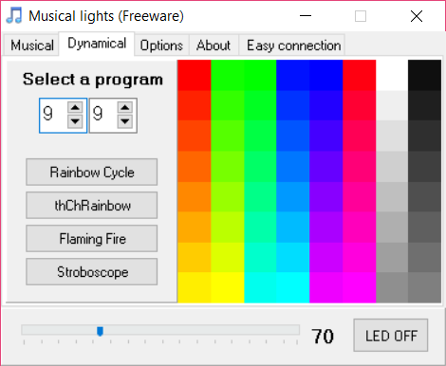

My audio connection option.

I use iTunes to play audio. My audio receiver YAMAHA has airplay support. At the same time iTunes can output audio simultaneously to the audio receiver and PC. On a PC, I use a virtual audio cable to connect to my program as shown below.

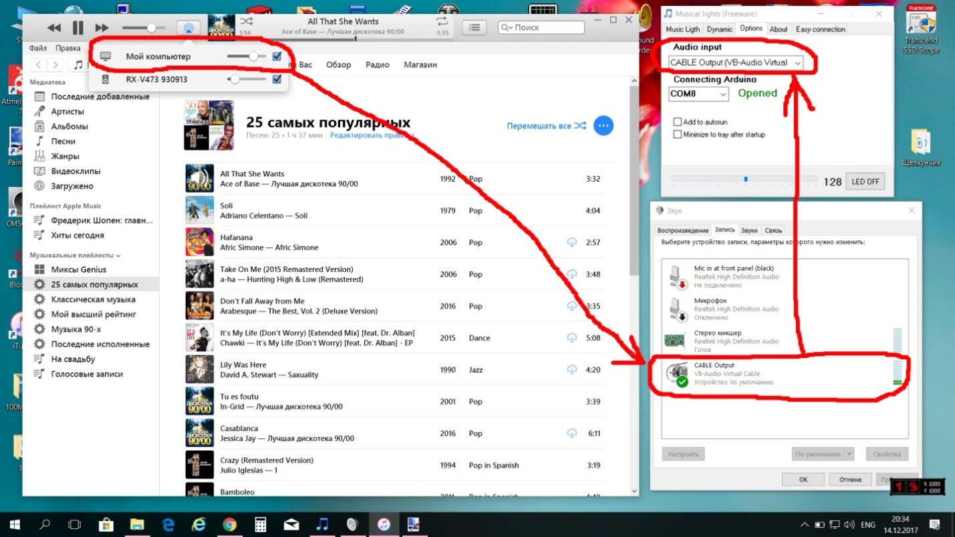

The audio stream coming to the PC gets to the device by default, to the input of the "virtual audio cable", and its output serves as a source of sound in the program of color music. You can also use a mixer, a PC line input and even a PC or laptop microphone to receive the audio stream in my program.

Kind of running program:

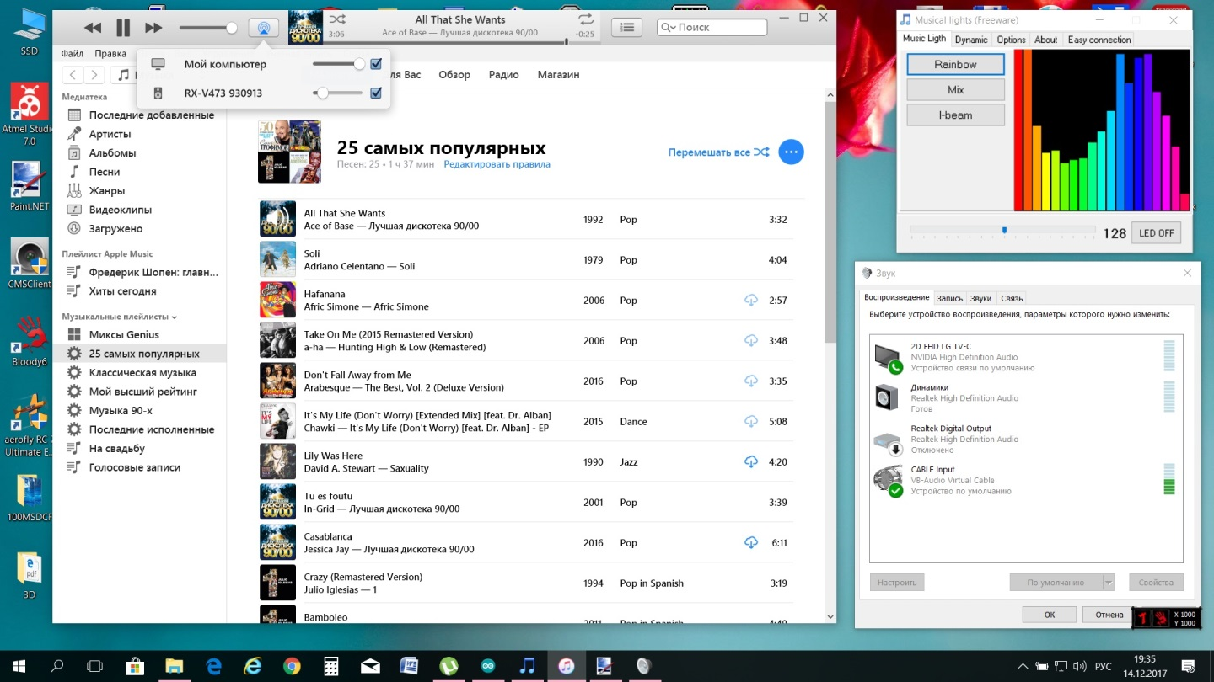

The program can be minimized to the tray, install with startup and minimize to the tray after launch.

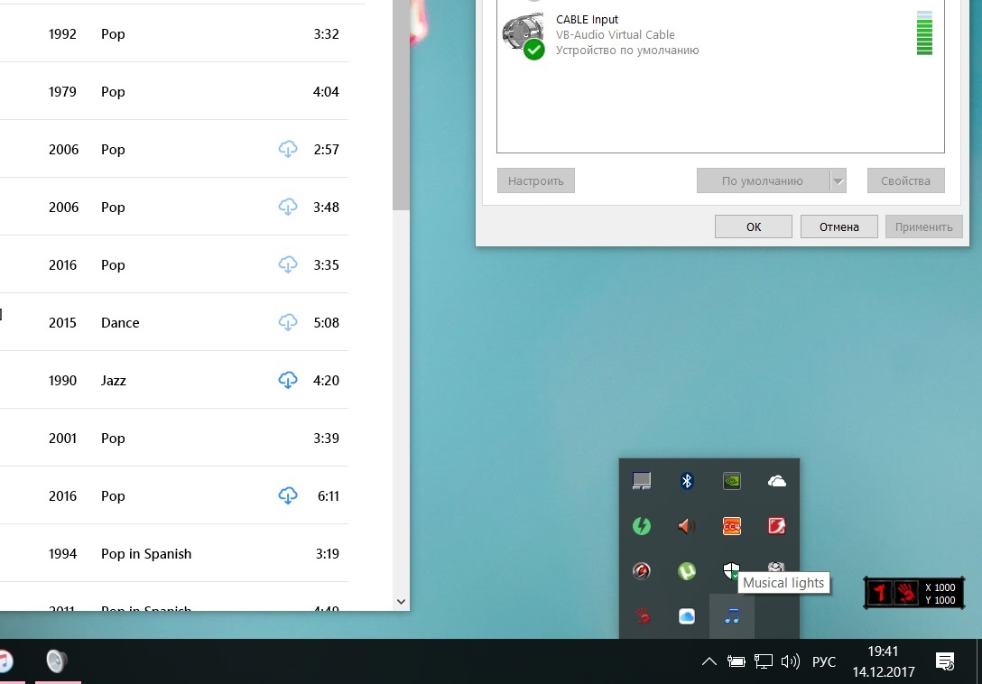

From the pop-up menu in the tray, you can change the color-music program, set one of the three dynamic programs, turn off the ribbon and close the program.

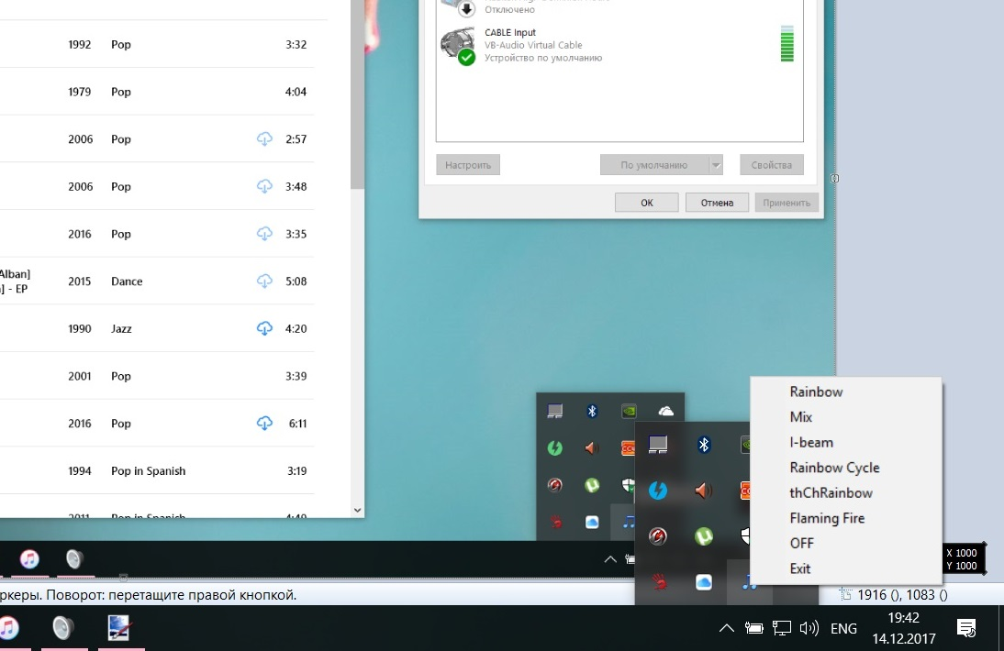

Attention! Before compiling the sketch, set in the sketch in line #define stripLed 120 the number of LEDs corresponding to your ribbon, for example #define stripLed 240.

The program has three color-music and twenty-four dynamic programs. If you have experience writing sketches for arduino, you can increase the number of dynamic programs to 100 or more. If you will support me the software will be developed.

Material for developers and programmers!

In dynamic mode, color programs are formed based on the program number and tempo received from the PC. Dynamic programs can run autonomously, without connecting to a PC. If you want to use the ribbon controller autonomously, you will need to connect one or more digital inputs of the arduino button board, and one potentiometer to one of the analog inputs. Buttons will be used to switch the program number and potentiometer to change the program parameter (tempo, brightness, color). The connection of the buttons and potentiometer with arduino can be found in the standard examples. Write down and enter the code in the ribbon controller's skeleton, which changes the program number of the subroutine and the value of the parameter, depending on the buttons pressed and the position of the potentiometer. You can switch the dynamic programs using the IR receiver and the remote control from the TV. Connecting the IR receiver to arduino can also be found in the standard examples.

In the color music mode, the outputs of the 20 digital bandpass filters obtained from the PC are used to form color programs. The values ​​at the output of digital filters at a constant rate are transmitted by a personal computer and contained in the array readData [].

To implement your color music programs, you can process and combine 19 bandpass filters as you please to get a beautiful color music program.

The maximum number of LEDs in ribbon 252, and it can be increased to the maximum allowable tape manufacturer. To do this, in the sketch, you must change the types of all variables related to the number and position of the LEDs from uint8_t to uint16_t.

Happy New Year and Merry Christmas !!!