Universal Shift Register
Code:
library IEEE;
use IEEE.STD_LOGIC_1164.ALL;
use IEEE.STD_LOGIC_ARITH.ALL;
use IEEE.STD_LOGIC_UNSIGNED.ALL;
entity shiftregister is
Port ( clk : in STD_LOGIC;
reset : in STD_LOGIC;
datain : in STD_LOGIC_VECTOR (3 downto 0);
sel : in STD_LOGIC_VECTOR (1 downto 0);
sl_in : in STD_LOGIC;
sr_in : in STD_LOGIC;
dataout : out STD_LOGIC_VECTOR (3 downto 0));
end shiftregister;

architecture Behavioral of uni is
signal TEMP : STD_LOGIC_VECTOR(3 downto 0) := "0000";
begin

process(reset, clk)
begin
if reset = "1" then
TEMP <= "0000";

elsif rising_edge(clk(0)) then
case sel is

-- 11: Parallel load
when "11" =>
TEMP <= datain;

-- 00: Hold previous data
when "00" =>
null;

-- 01: Left shift
when "01" =>
TEMP <= TEMP(2 downto 0) & sl_in(0);

-- 10: Right shift
when "10" =>
TEMP <= sr_in(0) & TEMP(3 downto 1);

when others =>
null;
end case;
end if;
end process;

dataout <= TEMP;
end Behavioral;

RTL Diagram :

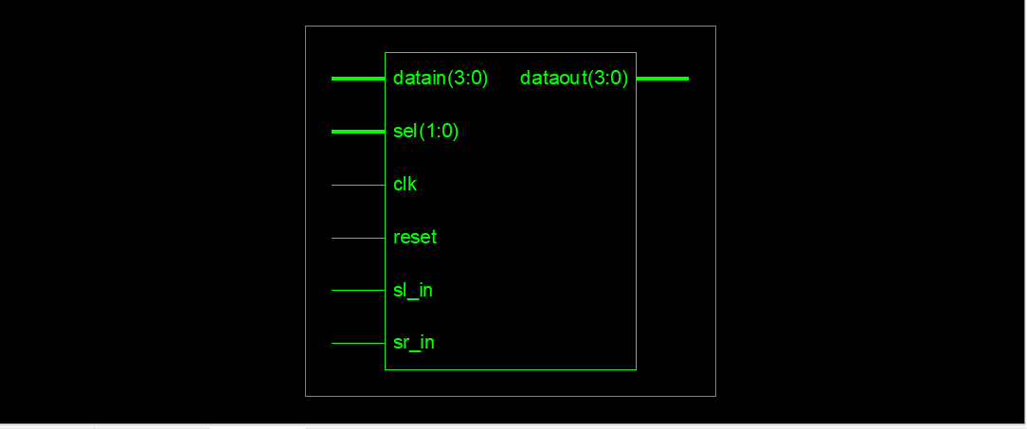
Left Shift :
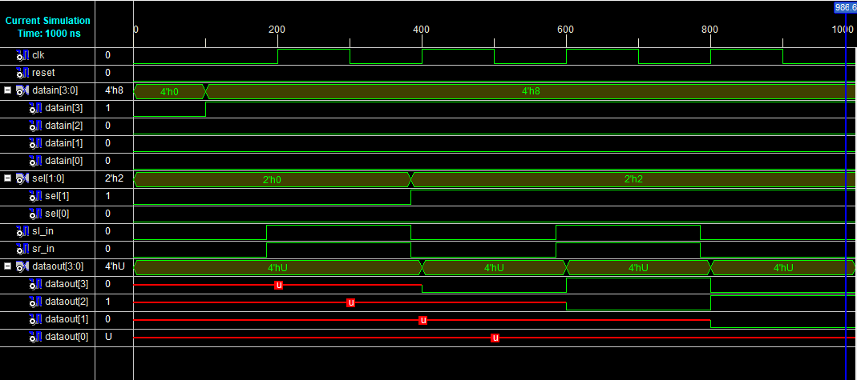

Right Shift :
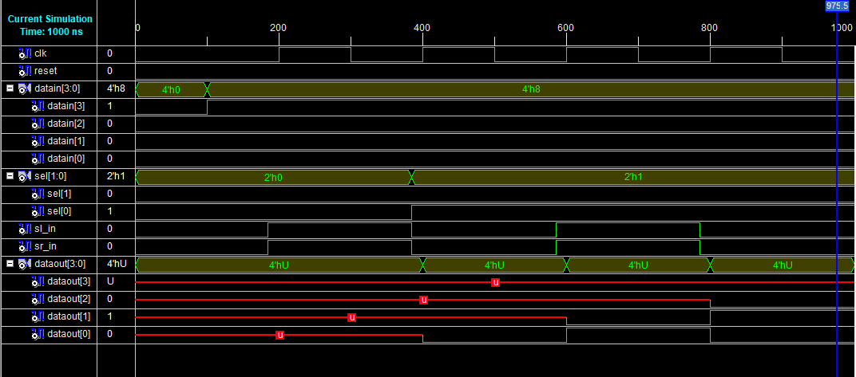

Hardware Outputs:
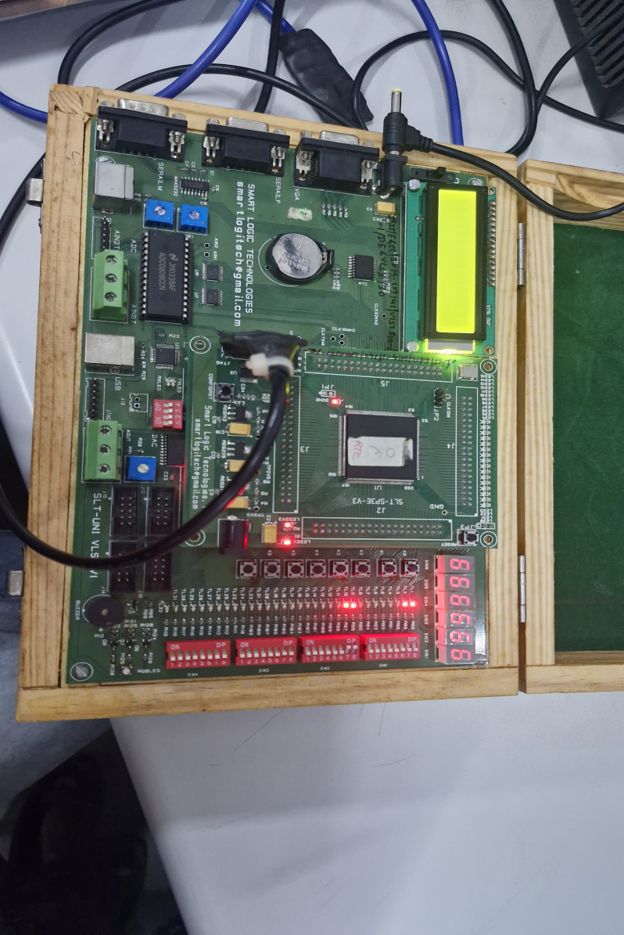

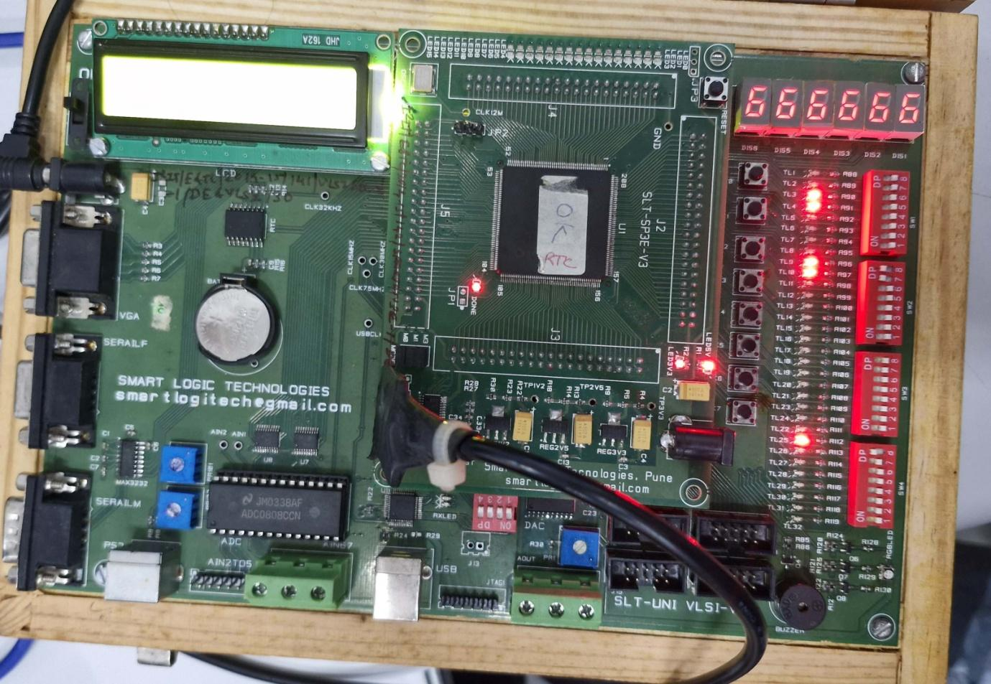

Pin Assignment :
Sr. No. | Signal Name | Pin Designation | Direction | FPGA Pin No.
1 | clk | Clock 555: 1Hz | Input | P132
2 | reset | Key0 | Input | P204
3 | dataout[0] | TL1 | Output | P205
4 | dataout[0] | TL2 | Output | P206
5 | dataout[0] | TL3 | Output | P203
6 | dataout[0] | TL4 | Output | P200
7 | datain[0] | TL9 | Input | P192
8 | datain[1] | TL10 | Input | P193
9 | datain[2] | TL11 | Input | P189
10 | datain[3] | TL12 | Input | P190
11 | SL_in | TL17 | Input | P179
12 | SR_in | TL18 | Input | P180
13 | sel[0] | TL25 | Input | P165
14 | sel[1] | TL26 | Input | P167

