EXPERIMENT NO: 7

TITLE: To prepare CMOS layout for 2:1 MUX using logic gate and transmission gate and compare the performance in terms of speed, space and power

LAYOUT:

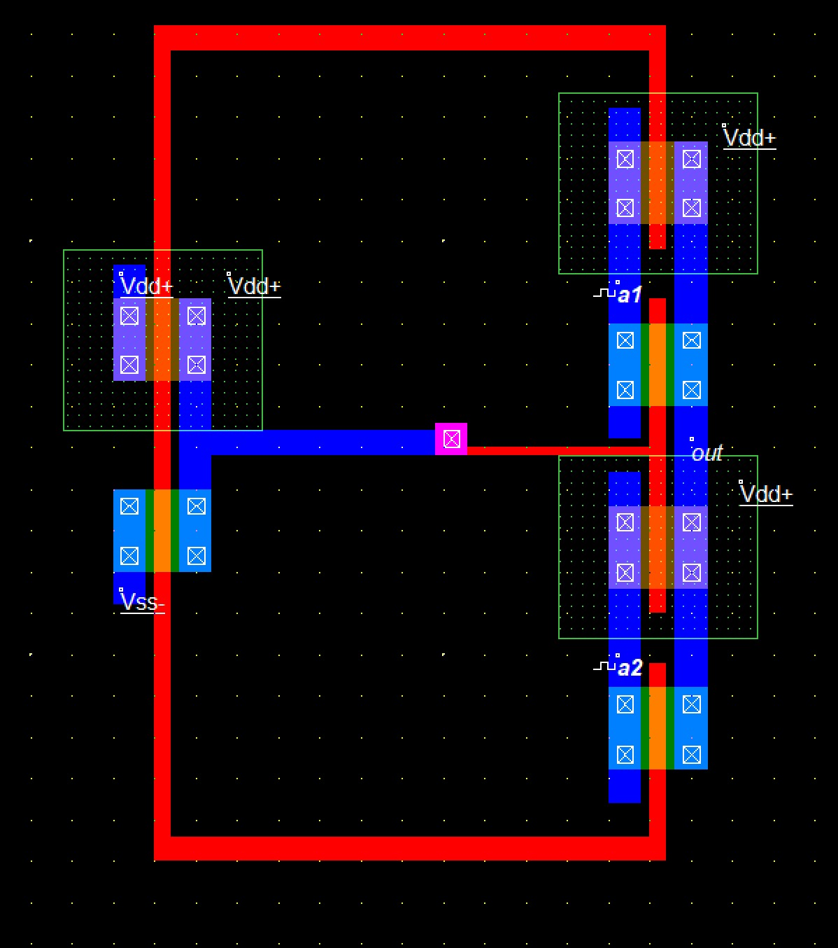

OUTPUT:


