EXPERIMENT NO: 8

TITLE: Design a layout for signal bit SRAM cell using CMOS technology

LAYOUT:

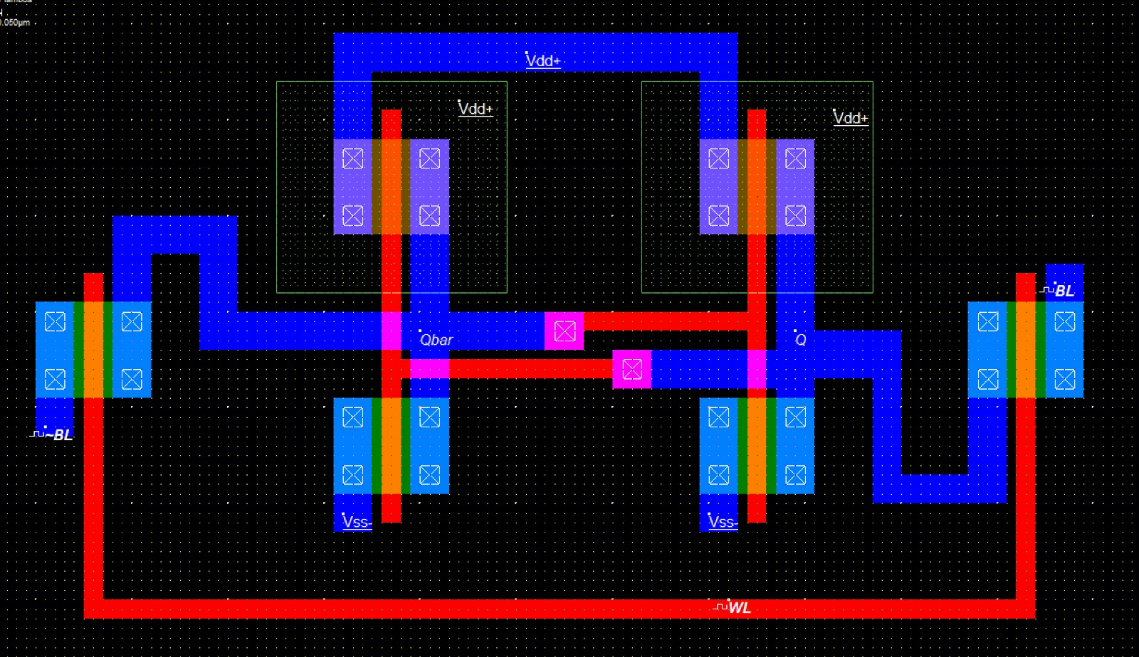

OUTPUT:



