Introduction
The coursework instructed to develop some specific features of a selected university’s website. Our group chose to develop the website of University of Bristol. The Analyst analyzed the system and came up with some diagrams. This document contains the assumptions that had to be made, user stories, use case diagram, Initial class diagram, Entity Relationship Diagram (ERD) and activity diagram.
Assumption
- As we are instructed to develop a page to show the courses it can be assume that there are one or more subject/module under each course.
- The project involves developing a feature called deal with enquiries. So, there may have one or more staff of the university to reply to the enquiries of the users.
- Previous success stories of the university may have a relation with the faculties or one or more individual student of a specific school/faculty.
- As we are about to develop a website for a university so the features of the website may not be too complex.
- As most of the university follow a simple design so the design of the website may be simple easy to use.
- As this is a website for a university so some feature and functionality may involve with future students.
User stories
- As a future student I want to see all the courses offered by the university to see if the course that I’m looking for is available or not.
- As a visitor I want the website to show all the latest academic news in the website to get informed about different session and seminars and other notices.
- As a future student I want to see the success stories of the previous students in the website to get a clear idea about the teaching efficiency of the university.
- As a staff of the university I want to deal with the enquiries made by others to remove doubts and dilemmas about different courses, payment and other issues.
- As a staff of the university I want provide and update the contact details of the university so that others can contact with us if any problem or issue arise.
- As a staff of the university I want provide and update information about the school/college so that others can know more about us and our history.
- As a future student I want to see the detail of all the courses in order to get a clear and detailed information about them such as- duration, course fee, last date of registration etc.
- As a future user I want to see all the research done by the university to check if I can a contribute in the research or learn from the researches as well as do a research by myself under the university’s supervision.
- As a user I want to see all the details of the events so I can join them if necessary.
- As a visitor I want to see a picture gallery to see the latest events and shows done by the university.

Use case diagram
The use case diagram with the users for the proposed system of University of Bristol is given below:
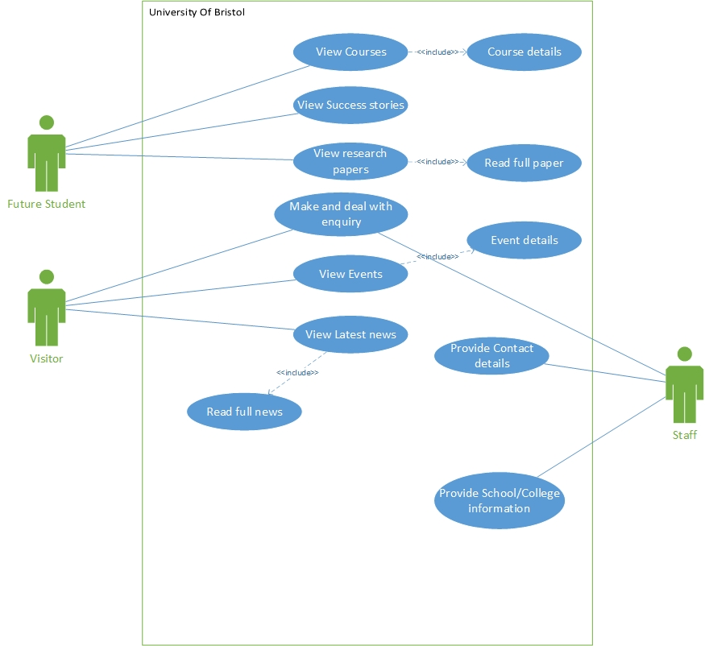
Figure 1: Use cage diagram.

Initial class diagram
The Initial class diagram for the proposed system of University of Bristol is given below:
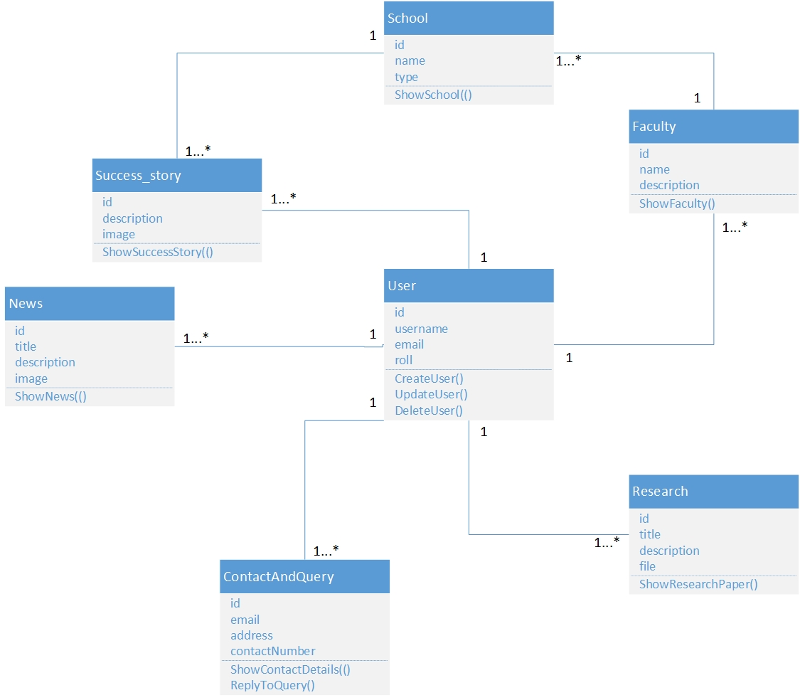
Figure 2: Initial class diagram.

Entity Relationship Diagram
The Entity Relationship diagram for the proposed system of University of Bristol is given below:
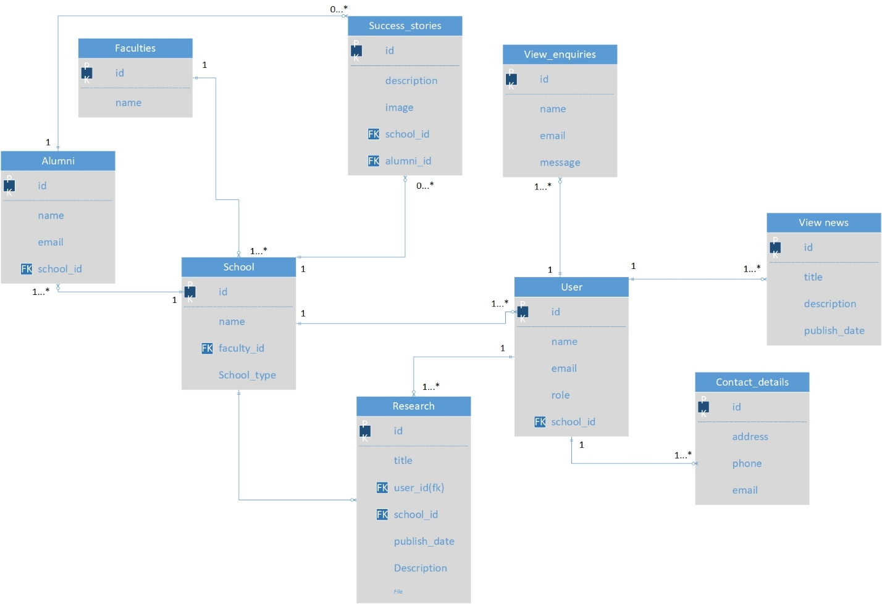
Figure 3:Entity Relationship Diagram.

Activity diagram
The Activity diagram for the proposed system of University of Bristol is given below:
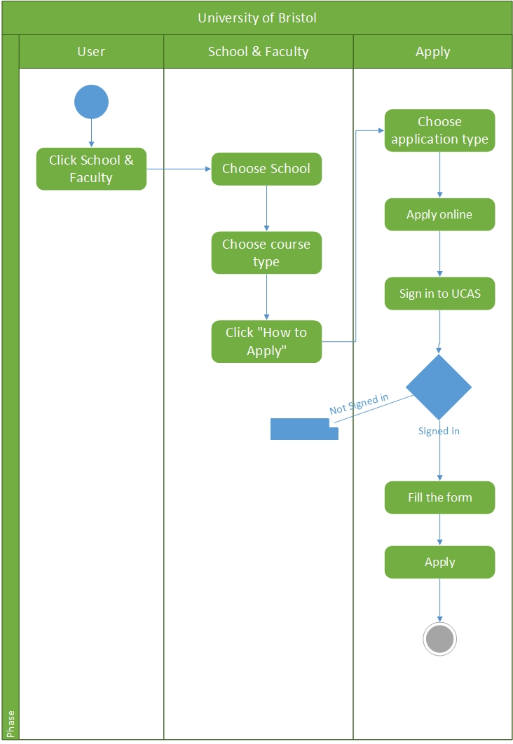
Courses

Alumni
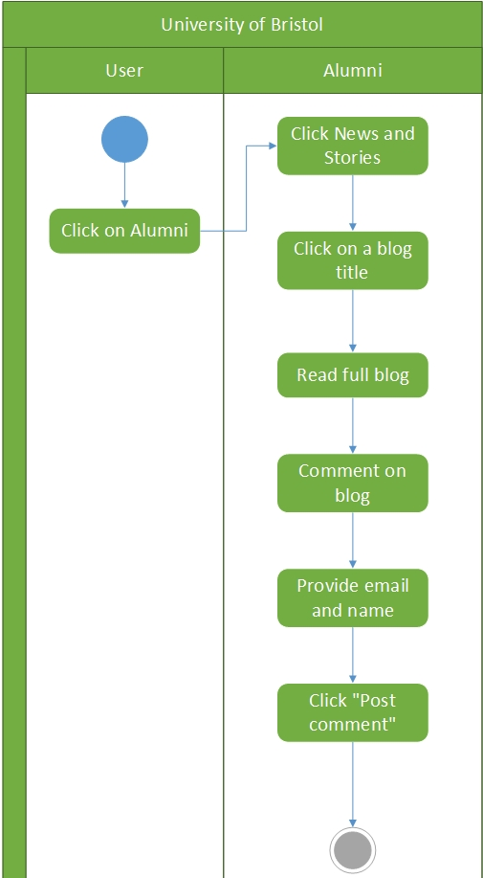

Query
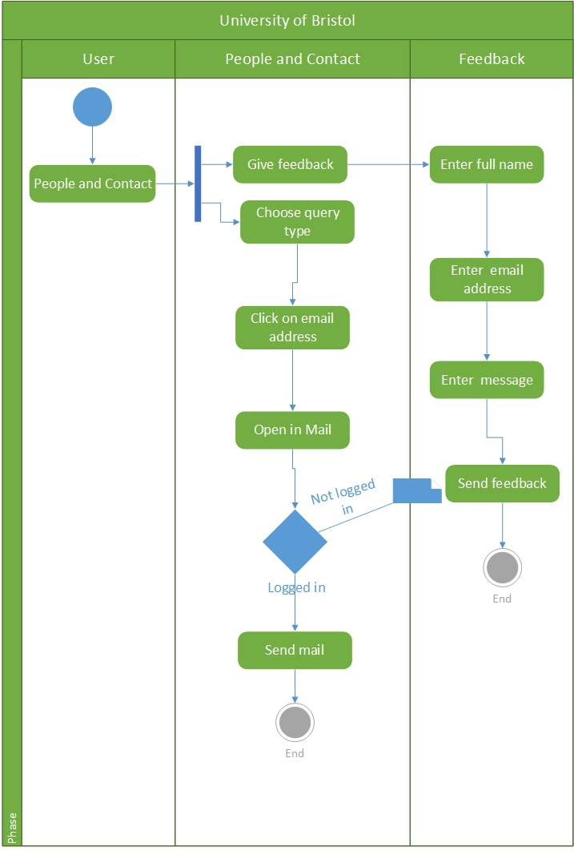

News
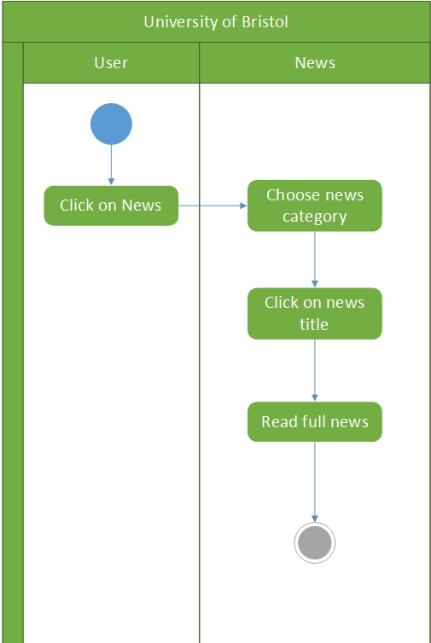

Research
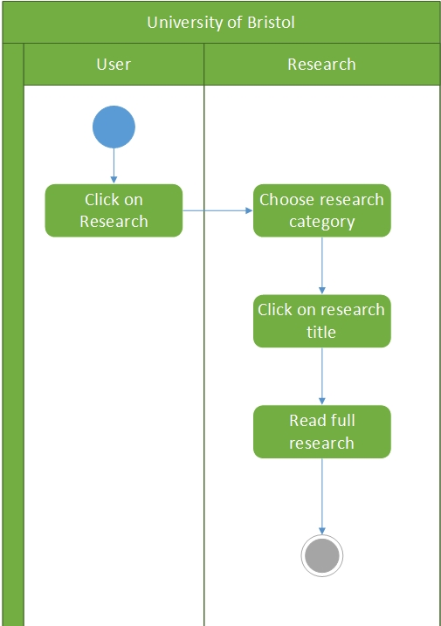

About
