Module Introduction: Cryptography
Cryptography is the foundation of modern digital security. In a world where personal information, financial transactions, and sensitive communications constantly flow across networks, the ability to protect data has become essential. This module provides a deep understanding of how information is secured, transformed, authenticated, and verified through mathematical processes and cryptographic mechanisms. It begins by exploring the fundamental principles that govern how plaintext becomes ciphertext and how keys act as the core drivers of secure communication. From there, the lessons move through the evolution of encryption—from historical classical ciphers to sophisticated modern algorithms that protect today’s digital systems.
The module also introduces essential concepts such as hashing, digital signatures, and the mechanisms used to verify data integrity and authenticity. Finally, learners will see how cryptography is applied in real-world environments, including secure web connections, blockchain systems, password protection, and data storage. By understanding these concepts not only from a theoretical perspective but through practical applications, students gain the foundational knowledge needed for cybersecurity, network defense, and secure system design.
This module does not simply teach how encryption works—it teaches how trust is built inside digital systems. As cyber threats grow more advanced, a strong grasp of cryptography becomes crucial for any future cybersecurity professional, developer, or IT practitioner. This module prepares learners to analyze, evaluate, and apply cryptographic solutions in real-world environments where security cannot be compromised.

Module Objectives
By the end of this module, the student should be able to:
- Understand and explain the core concepts of cryptography, including plaintext, ciphertext, keys, encryption, and decryption.
- Distinguish between symmetric and asymmetric encryption and describe how each model secures digital communication.
- Describe classical encryption methods and analyze why they became insecure, leading to the development of modern algorithms.
- Explain how modern encryption algorithms such as AES, RSA, and ECC function and where they are used in practice.
- Understand the purpose and characteristics of hashing, including integrity verification and the concept of collision resistance.
- Describe how digital signatures work and explain the security properties they provide: integrity, authentication, and non-repudiation.
- Identify real-world applications of cryptography such as HTTPS/TLS, blockchain, password hashing, and full-disk encryption.
- Apply cryptographic concepts to real-world cybersecurity scenarios and evaluate which techniques are appropriate for specific security needs.
- Recognize the role of cryptography in building trust, securing communication, and protecting sensitive data across digital systems.

1.Fundamentals of Cryptography
Cryptography begins with a simple goal: to allow two parties to communicate securely even if someone else is listening. But behind that simple idea lies a complex mix of mathematics, logic, computer science, and security principles that ensure information stays private, authentic, and unaltered. At its core, cryptography is the science of transforming readable data into something meaningless to anyone except the intended recipient. This transformation is not random; it is governed by precise mathematical rules known as algorithms, which rely on secret values called keys. Without these keys, no attacker—no matter how skilled—should be able to uncover the original message.
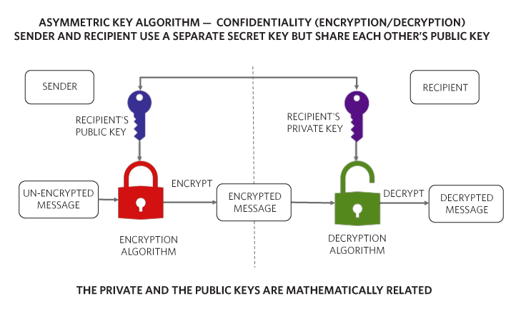
Cryptography: Fundamentals of the Modern Approach | Analog Devices
Every cryptographic system starts with plaintext, which is the original message exactly as it is meant to be read. This could be a password, a bank transaction, a personal message, or even a whole file. When plaintext is encrypted, it becomes ciphertext, a scrambled form that appears random and unreadable. Ciphertext should reveal nothing about the original message, even if an attacker studies it carefully. The ability to scramble and unscramble this data relies entirely on the key, a unique piece of information that dictates how encryption and decryption are performed. If the key is wrong—or missing—the ciphertext remains meaningless.
The process of transforming plaintext into ciphertext is called encryption, while reversing it back to readable form is called decryption. Both processes depend on an algorithm, which is a specific mathematical procedure that explains exactly how to mix the plaintext and the key together. What makes cryptography powerful is not that the algorithm itself is secret—most modern algorithms are published openly for experts to study—but that the key is secret. Even if the algorithm is known, without the right key, the ciphertext should be impossible to decode.
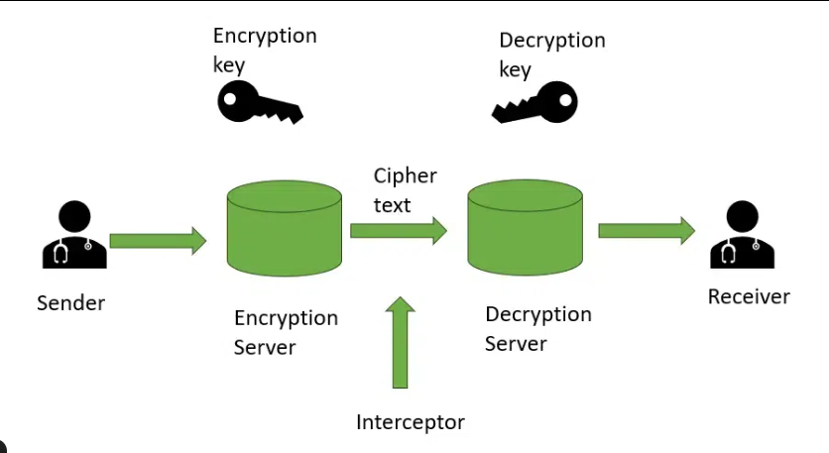
What is Cipher? - GeeksforGeeks
A major foundational concept in cryptography is the difference between symmetric and asymmetric encryption. Symmetric encryption uses the same key to encrypt and decrypt. It is extremely fast, efficient, and ideal for encrypting large amounts of data. However, it faces a major challenge: the key must be shared between the communicating parties, and sharing that key securely can be difficult. If the key is intercepted while being transmitted, security is instantly compromised.
Asymmetric encryption solves this by introducing a pair of keys: a public key, which can be shared with anyone, and a private key, which must be kept secret. The public key encrypts messages, but it cannot decrypt them; only the matching private key can. This brilliant structure allows secure communication without needing to share a secret key beforehand. Anyone can send you an encrypted message, but only you can read it. This system also supports digital signatures, which allow you to prove a message genuinely came from you.
Together, these concepts—plaintext, ciphertext, keys, algorithms, symmetric and asymmetric encryption—form the true foundation of cryptography. Before any modern system like HTTPS, digital wallets, blockchains, VPNs, or secure messaging apps can function, this basic framework must exist. Cryptography is not just about hiding information; it is about creating trust in a digital world where people communicate, store information, and perform transactions without ever physically meeting. It ensures that messages stay private, identities are real, and data cannot be changed without detection. It is, in many ways, the invisible shield that protects nearly everything we do online.

2. Classical and Modern Encryption Algorithms
The evolution of cryptography is best understood by examining how encryption algorithms have transformed over centuries. Classical encryption began as simple, manual techniques used to hide messages in ancient civilizations, while modern encryption relies on advanced mathematics, computational complexity, and digital processing. Although modern systems are far more powerful and secure, classical algorithms remain important because they reveal the roots of cryptographic thinking and why today's techniques were created.
Classical encryption algorithms were primarily substitution and transposition ciphers. One of the most famous examples is the Caesar cipher, named after Julius Caesar, who used it to protect military communication. It works by shifting each letter in the alphabet by a fixed number of positions, producing a ciphertext that looks altered but still preserves the structure of the language. If the shift is three positions, for example, “HELLO” becomes “KHOOR.” This technique was clever for its time, but it is extremely weak by modern standards because the pattern is predictable. A modern attacker can break it almost instantly using brute force, simply trying all possible shifts, or using frequency analysis to identify common letters. This weakness highlights why cryptography had to evolve; languages have patterns, and predictable substitutions are easy to exploit.
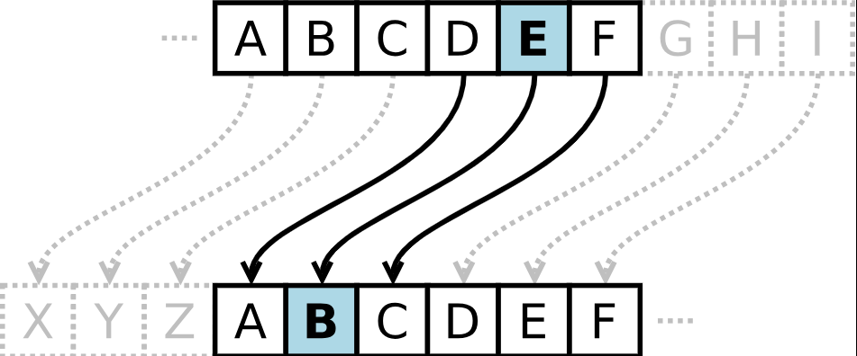

As cryptography progressed, more complex classical ciphers emerged, such as the Vigenère cipher, which introduced multiple shifting values rather than just one. For centuries, these ciphers were considered unbreakable, but as mathematical techniques and analytical methods improved, even these more advanced classical systems were eventually defeated. Their downfall demonstrated a deeper truth: any cipher based on predictable patterns or small keyspaces can be broken. That truth became the foundation of modern cryptography, which shifted from linguistic tricks to mathematical hardness—problems that computers cannot solve easily even with immense processing power.
Modern encryption algorithms fall mainly into two categories: symmetric and asymmetric systems. The most important modern symmetric cipher is the Advanced Encryption Standard (AES), which has become the global standard for securing digital data. Unlike classical ciphers that operated on letters, AES works on binary data, treating plaintext in fixed-size blocks of 128 bits. It uses complex mathematical transformations, including substitution, permutation, mixing, and key expansion. These operations occur in multiple rounds, depending on the key length, which can be 128, 192, or 256 bits. AES is considered extraordinarily secure because its keyspace is astronomically large. Even with the fastest supercomputers, trying all possible keys through brute force would take longer than the age of the universe. This level of security is essential today, as AES protects everything from encrypted messaging apps and VPNs to financial transactions and government data.
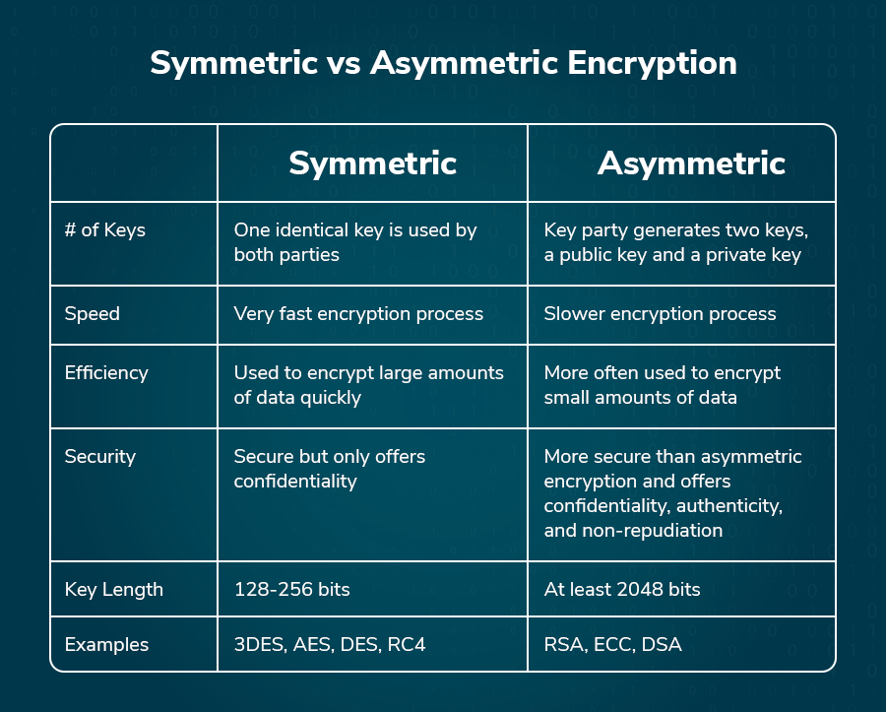
Symmetric vs Asymmetric Encryption (Made Super Simple)
While symmetric algorithms like AES are fast and powerful, they require both parties to share the same secret key, which can be difficult when communicating over the internet. This challenge led to the creation of asymmetric encryption, also known as public-key cryptography. One of the first and most influential asymmetric algorithms is RSA, named after Rivest, Shamir, and Adleman. RSA relies on the mathematical difficulty of factoring large composite numbers. The public key is used to encrypt, while the private key is used to decrypt. RSA transformed digital communication because it allowed secure key exchange without needing to meet physically. However, RSA requires very large keys—commonly 2048 or 4096 bits—because the mathematical problem it relies on is easier than the brute-force difficulty of AES.
To solve the need for smaller, more efficient keys, modern cryptography introduced Elliptic Curve Cryptography (ECC). ECC is based on the properties of elliptic curves over finite fields and relies on the hardness of the Elliptic Curve Discrete Logarithm Problem. The same security offered by RSA with a 3072-bit key can be achieved with ECC using only a 256-bit key. This huge efficiency boost makes ECC ideal for smartphones, IoT devices, cryptocurrencies, and anywhere low power consumption or high speed is required. Digital signatures used in Bitcoin and other blockchains, for example, rely heavily on ECC.
The contrast between classical and modern algorithms shows a profound shift in cryptographic design. Classical ciphers relied on simplicity and secrecy of method, which often failed once the method became known. Modern ciphers rely on mathematical strength and computational difficulty, openly publishing their algorithms while keeping only the keys secret. This transparency allows experts worldwide to analyze and strengthen the systems, creating standards robust enough to secure global digital infrastructure.
In summary, classical algorithms represent the foundation—simple, historical, and now easily broken—while modern encryption algorithms represent the present and future, built on complex mathematics, fast computation, and rigorous security models. Without the lessons learned from classical ciphers, the powerful and reliable systems we use today would never have existed.

3. Hashing and Digital Signatures
In modern cryptography, secrecy is only one part of the picture. While encryption protects data from being read, it does not automatically guarantee that the data is authentic, unchanged, or sent by the right person. That is where hashing and digital signatures come in. These two concepts focus not on confidentiality, but on integrity, authenticity, and non-repudiation—three pillars of trust in digital communication.

Hashing: The Guardian of Integrity
A hash function is a mathematical process that takes any amount of data—whether a single word or an entire file—and transforms it into a fixed-length string of characters. This output is called a hash, digest, or fingerprint. What makes hashing extraordinary is that the output is completely different even if the input changes by just one character. Changing “hello” to “hallo” produces a completely unrelated hash. This sensitivity makes hashing the perfect tool for detecting tampering.
Hashing is designed to be one-way. There is no reversal. Once data is hashed, there is no computational method to retrieve the original message from the digest. This is why it is used for things like password storage. Instead of storing plaintext passwords, systems store their hash values. When a user logs in, the system hashes the password input and compares it with the stored hash. Even if a database is stolen, attackers cannot reverse the hashes to discover the original passwords.
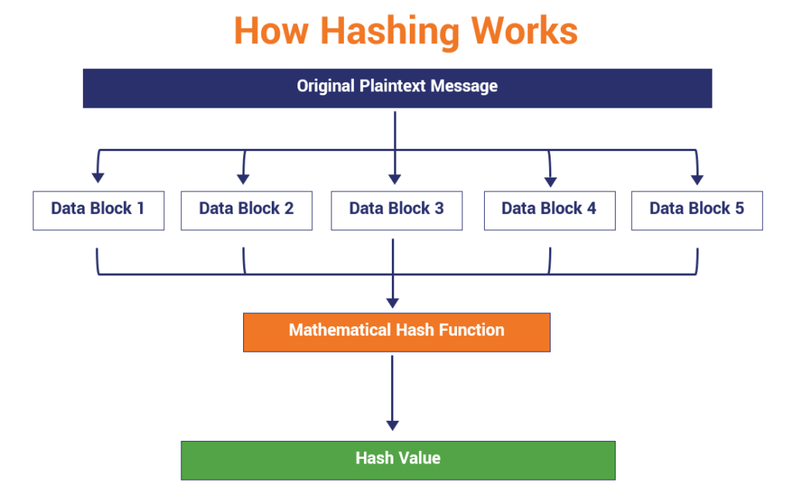
What Is a Hash Function in Cryptography? A Beginner’s Guide - Hashed Out by The SSL Store™
A secure hash function must also be collision-resistant. This means it should be virtually impossible to find two different messages that produce the same hash. If collisions were easy to find, attackers could exploit them to forge data, pretending corrupted information was still valid. Algorithms like SHA-256 and SHA-3 are widely used because they maintain strong collision resistance even under intense cryptographic analysis.
Hashing forms the backbone of integrity verification in countless systems. When you download software, the website often provides a hash value. You can compute the hash of your downloaded file, and if it matches, you know the file has not been tampered with. In blockchain technology, hashing links blocks together, making it nearly impossible to alter past transactions. In everyday communication, hashing silently protects you from data corruption and undetected modifications.

Digital Signatures: Authenticity, Integrity, and Non-Repudiation
While hashing alone can tell you whether data has been altered, it cannot tell you who created or sent the data. To achieve this, cryptography combines hashing with asymmetric encryption, creating what is known as a digital signature. A digital signature is the modern equivalent of signing a contract or stamping an official seal, but it goes far beyond traditional signatures in both security and reliability.
The process begins by hashing the message. Hashing reduces the size of the data, ensuring the signature remains small and efficient while maintaining a precise fingerprint of the content. The sender then encrypts this hash using their private key. The encrypted hash becomes the digital signature. When the message and the signature arrive at the recipient, the recipient uses the sender’s public key to decrypt the signature. This reveals the original hash. The recipient then hashes the received message independently. If the two hashes match, it proves two things: the message has not been altered, and the signature could only have been created by the owner of the private key.

sectigo.com/resource-library/how-digital-signatures-work
This system provides powerful security guarantees. It ensures integrity, because any modification—even a single character—would change the hash and invalidate the signature. It ensures authentication, because only the owner of the private key can create a valid signature. Most importantly, it ensures non-repudiation, meaning the sender cannot deny creating or sending the message. In legal and financial contexts, this is crucial. Digital signatures prove authorship more reliably than any handwritten signature ever could.
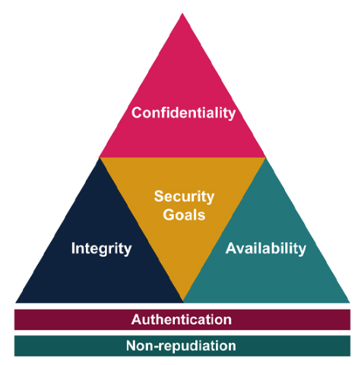
Gamified Intelligent Cyber Aptitude and Skills Training (GICAST): Week 1: 1.1 | OpenLearn - Open University
Digital signatures are used everywhere in the digital world. Every time you visit an HTTPS website, digital certificates—signed by trusted Certificate Authorities—verify that you are communicating with the real server, not an impostor. In blockchain networks like Bitcoin and Ethereum, digital signatures authorize transactions, proving that a user owns the private key tied to their wallet. In secure email, digital signatures ensure that messages are genuine and safe. Even software updates are digitally signed so users can confirm they are installing authentic, unaltered code.
Together, hashing and digital signatures create a powerful framework for trust. Hashing guarantees that data remains unchanged, and digital signatures guarantee that the sender is legitimate. They work silently beneath the surface of the internet, allowing billions of transactions, messages, and files to flow securely every day. In a world where communication is instant and global, these mechanisms ensure that authenticity and integrity never become casualties of speed and convenience.

4. Cryptography in Real-World Applications — Expanded Explanation
Cryptography is no longer a theoretical discipline practiced only by mathematicians or intelligence agencies. It has become the invisible infrastructure that protects nearly every digital action people perform—from sending a message, making a bank transaction, logging into an account, or even simply connecting to a Wi-Fi network. In a world where information moves freely and instantly across borders, cryptography acts as the silent guardian, ensuring that privacy, identity, trust, and security are preserved regardless of how open the internet may seem. Without cryptography, the modern digital world would collapse into chaos, because every message, every account, and every system would be exposed.
One of the clearest examples of cryptography’s importance is found in securing web traffic. When you see “https://” in your browser, that seemingly simple letter “s” signals that cryptography is actively protecting your connection. Behind the scenes, protocols known as SSL and TLS establish a secure channel between your device and the website you are visiting. This process ensures that no one between you and the server—not your internet provider, not hackers, not governments monitoring traffic—can read or alter your data. The TLS handshake, a remarkable cryptographic dance, uses asymmetric encryption to exchange a secret key, then switches to symmetric encryption like AES to protect all communication. This hybrid approach provides both strong security and fast performance. Every time you log in to your bank account, submit a form, or enter your credit card details, cryptography guarantees that your information reaches the correct destination safely and unchanged.
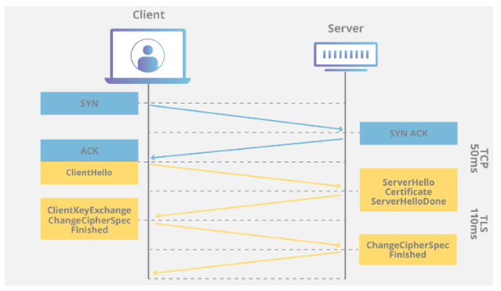
What happens in a TLS handshake? | SSL handshake | Cloudflare
Another powerful real-world application is blockchain technology. While often associated with cryptocurrencies, the blockchain is fundamentally a cryptographic system designed to achieve two goals: to prevent tampering, and to prove ownership or authenticity without relying on a central authority. At the core of every blockchain is hashing. Each block contains not only its own data, but also the hash of the previous block, forming an unbreakable chain. If anyone attempts to modify a single transaction—even changing one character—the hash changes, and the chain breaks instantly. This property creates immutability, a key feature that makes blockchain trustworthy. Digital signatures further strengthen the system by ensuring that only the legitimate private key holder can authorize a transaction. No bank or administrator is needed to confirm ownership; cryptography itself becomes the authority. Whether used for cryptocurrencies, digital identities, supply chain tracking, or secure voting systems, blockchain relies entirely on cryptographic principles to maintain trust in a decentralized world.
Cryptography also plays a critical role in protecting stored data. Sensitive information such as passwords, personal records, government data, and private files cannot simply be stored as plaintext. If databases are hacked, plaintext data would give attackers immediate access to everything. To prevent this, systems use hashing with salting to store passwords securely. When someone creates a password, it is transformed into a hash, and a random salt is added to prevent attackers from using precomputed tables to reverse-engineer the hash. Even if attackers steal the entire database, they still cannot reconstruct the passwords due to the one-way nature of hashing. For files and drives, full-disk encryption systems like BitLocker and FileVault rely on symmetric encryption, usually AES, to lock all stored information. The encryption happens automatically at the hardware or operating system level. If the device is lost or stolen, the data remains useless because the decryption key is not accessible. This approach transforms physical theft from a catastrophic event into a minor inconvenience.
Beyond these major applications, cryptography quietly powers countless everyday technologies. Secure messaging apps like WhatsApp and Signal use end-to-end encryption so that only the sender and the recipient—not even the company hosting the service—can read the messages. Virtual Private Networks use cryptography to secure data across untrusted networks. Digital certificates authenticate identities on the internet, allowing you to know that a website is real and not a fraudulent clone. Even small actions, such as using Apple Pay, unlocking a smartphone with biometrics, syncing cloud backups, or verifying a software update, all involve cryptographic operations happening silently in the background.
Cryptography has become a universal language—an invisible shield woven into every layer of modern digital life. It maintains privacy, protects identities, verifies authenticity, and ensures that information can move freely without becoming vulnerable. The real power of cryptography lies not only in its mathematics but in its reliability. People use cryptographic systems billions of times per day without ever seeing them, yet their trust in digital technology depends entirely on the strength of these hidden defenses. The modern world functions because cryptography ensures that even in an environment full of risks, communication remains safe, systems remain trustworthy, and data remains secure.

