Introduction
Network Defense is a vital component of cybersecurity focused on protecting computer networks from unauthorized access, misuse, disruption, and cyberattacks. As organizations rely heavily on interconnected systems and online communication, securing network infrastructures has become more critical than ever. This module provides students with a foundational understanding of how data travels across a network, the threats that endanger network security, and the tools and techniques used to safeguard digital environments. By learning essential concepts such as the OSI Model, common network attack methods, firewall technologies, intrusion detection and prevention systems, and incident response strategies, learners gain the knowledge necessary to detect, prevent, and respond to cyber threats. The goal of this module is to build strong analytical and technical skills, preparing students to defend modern networks in both academic and real-world cybersecurity environments

Learning Objectives
By the end of this module, students are expected to:
- Understand and explain how the OSI Model structures network communication and why each layer plays a critical role in security.
- Identify and describe common network threats, including how attackers exploit network protocols and trust mechanisms to intercept, disrupt, or manipulate communication.
- Demonstrate knowledge of firewall technologies, intrusion detection systems, and intrusion prevention systems, including how these tools work together to protect networks.
- Apply monitoring techniques using tools such as Wireshark, Nmap, and Snort to analyze traffic, identify suspicious activity, and support network security operations.
- Understand and follow the phases of incident response, including preparation, detection, containment, eradication, recovery, and lessons learned, to effectively manage and resolve cybersecurity incidents.
1. The OSI Model
The OSI Model, or Open Systems Interconnection Model, is a conceptual framework that explains how data travels across a network. Think of it as a layered blueprint that breaks communication into seven stages, starting from the physical signals moving through wires up to the actual applications you interact with, like your web browser or email. When a device sends data, it begins at the top layer, where applications format and prepare information, then works its way down through the layers. Each layer adds its own specific instructions and structure to ensure the data moves correctly, safely, and efficiently. Once transmitted over the physical medium—whether cables, radio waves, or fiber—the data then climbs back up the layers on the receiving device, reversing the process until it reaches the user in a readable form.
At the top is the Application layer, where users and programs interact with network services such as emails or web browsing. Beneath that, the Presentation layer handles formatting, encryption, and compression, so devices understand each other’s data even if they run different systems. The Session layer manages and maintains the communication sessions between devices, like keeping your connection stable during a video call. Moving deeper, the Transport layer ensures reliable data delivery through protocols such as TCP or fast delivery through UDP, deciding whether to guarantee every packet arrives or prioritize speed instead. The Network layer handles logical addressing and routing, deciding which path the data should take across networks, using IP addresses as guides. The Data Link layer takes charge of physical addressing through MAC addresses and ensures data frames move smoothly across a local network segment. Finally, the Physical layer is responsible for converting the data into electrical or radio signals and delivering it across cables or wireless transmissions as raw bits.
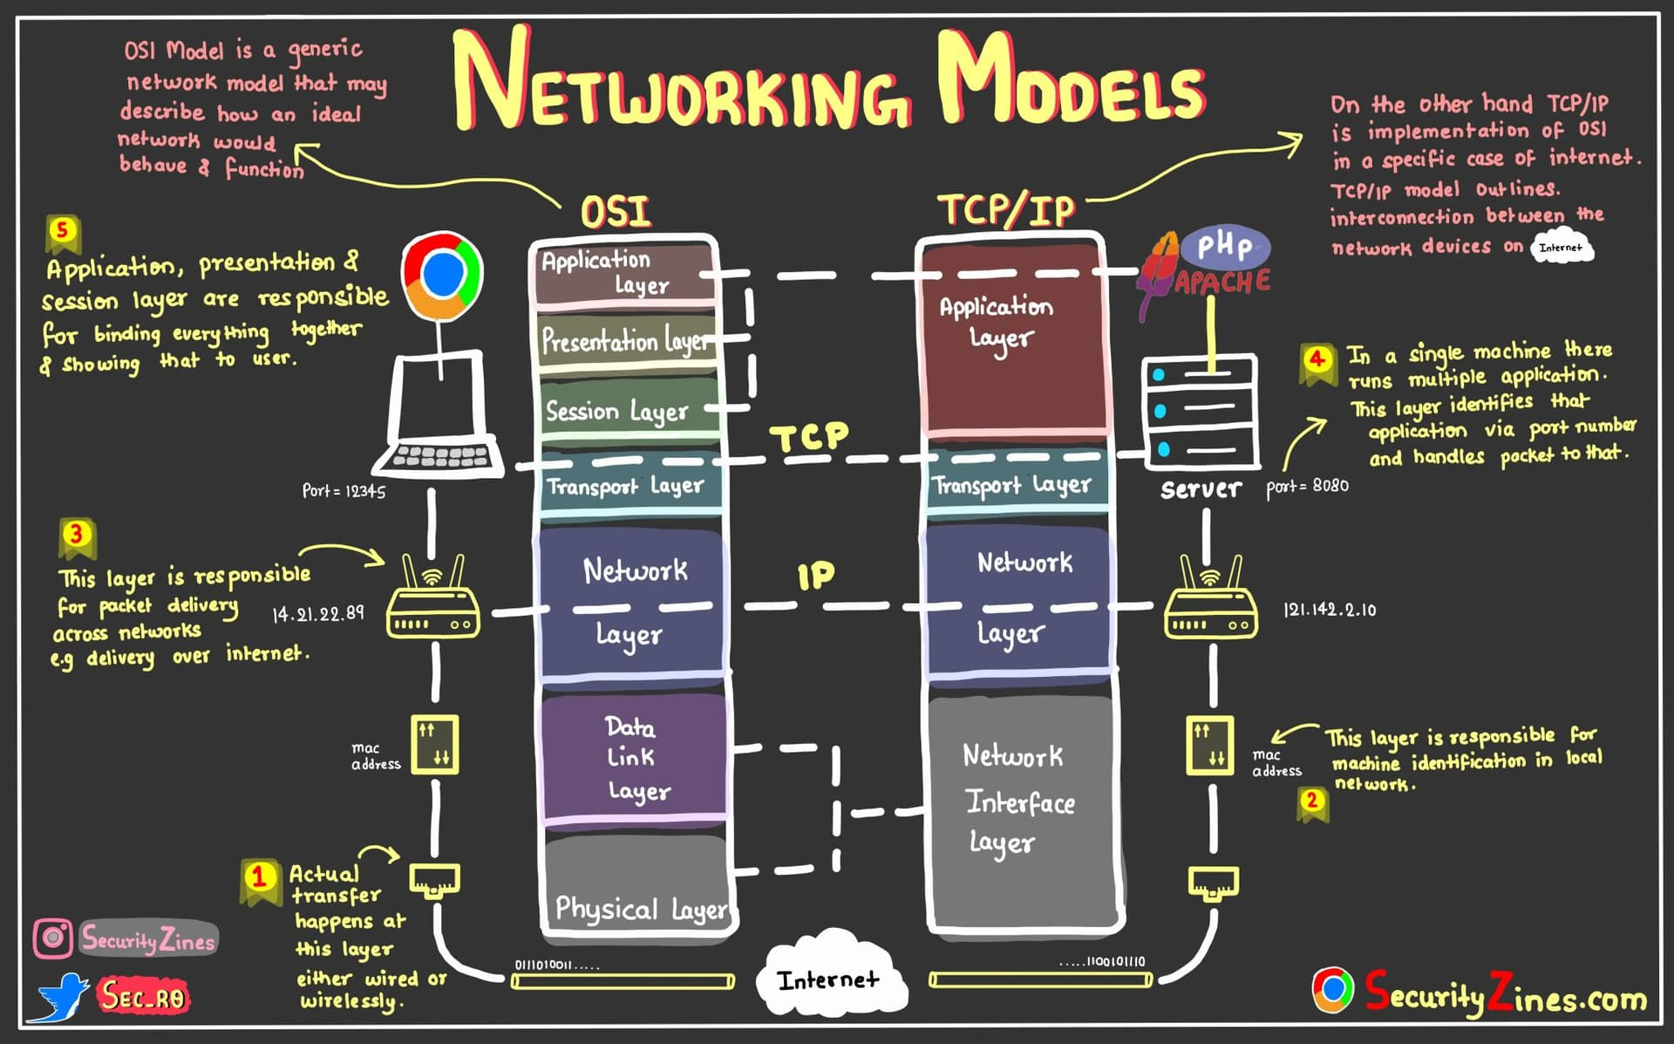
OSI 7 Layers Model - Computer Networking - telecomHall Forum
This layered approach matters deeply in network defense because security controls often target specific layers. Firewalls typically monitor traffic at the Network and Transport layers by filtering based on IP addresses and ports, while application firewalls work at the Application layer to inspect the content of web traffic. By understanding the OSI Model, security professionals can pinpoint where vulnerabilities exist and apply defenses at the correct stage, ensuring each layer contributes to a secure and reliable communication process
2. Common Network Threats
Before you can defend a network, you must understand the threats that target it. Common network threats aim to disrupt communication, steal information, or silently manipulate data as it travels across systems. These attacks often blend technical strategy with deception, making them difficult to detect unless you understand how they operate at the network level. The most widely encountered threats include attacks that overwhelm systems, trick devices into trusting malicious machines, secretly capture data flowing through the network, and quietly position an attacker between two communicating devices.
One of the best-known threats is the Distributed Denial of Service attack, where an attacker uses a network of compromised systems—known as a botnet—to bombard a server or service with overwhelming traffic. Instead of a single attacker, hundreds or thousands of devices flood a victim system with connection attempts or data packets until it slows, crashes, or becomes unable to serve legitimate users. This threat focuses on exhaustion rather than stealth, aiming to disrupt availability and paralyze online services. 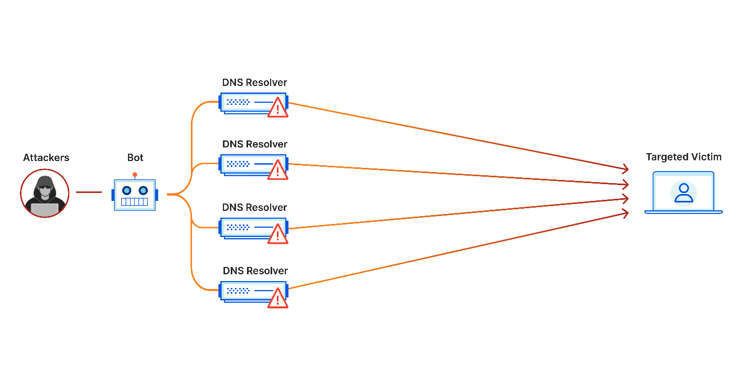
What is a distributed denial-of-service (DDoS) attack? | Cloudflare
Another threat is ARP spoofing, which takes advantage of how devices inside a local network learn each other’s MAC addresses. The attacker sends fake ARP messages to devices on the same network, convincing them that the attacker’s machine is the router or another trusted device. Once that deception succeeds, all traffic meant for the real gateway is silently diverted to the attacker first. This allows the attacker to intercept traffic, modify data, or launch additional attacks without the victim realizing their communication path has been corrupted.
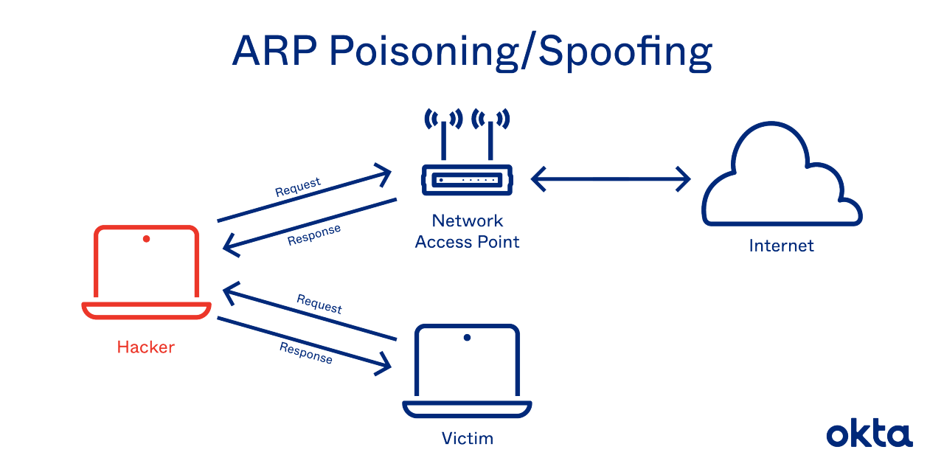
ARP Poisoning: Definition, Techniques, Defense & Prevention | Okta
Packet sniffing represents a quieter but equally dangerous threat. By putting a network interface into promiscuous mode, an attacker can capture data traveling over the network. If the network traffic isn’t encrypted, sensitive information like passwords, session cookies, and private communications becomes exposed. Even on switched networks, attackers may pair sniffing with ARP spoofing to gain access to traffic that isn’t meant for them. This attack highlights why encryption is a foundational security requirement in any network, especially in environments with shared access.
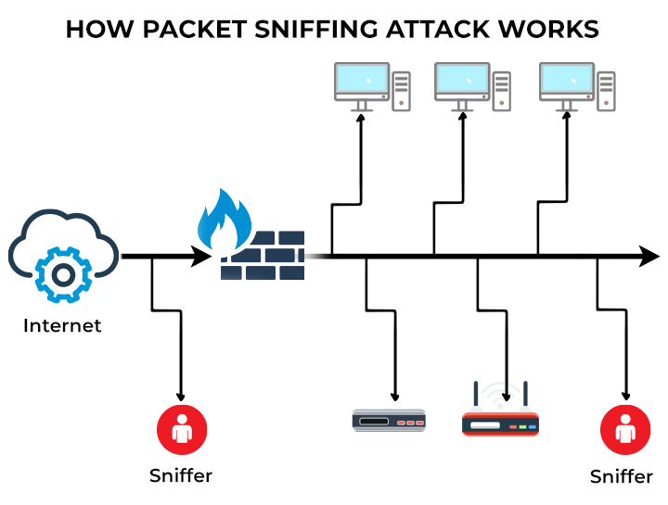
Packet Sniffing Meaning, Methods, Examples and Best Practices
Finally, there are Man-in-the-Middle attacks—broader, more flexible versions of ARP spoofing—where an attacker secretly inserts themselves between two communicating parties. Instead of just intercepting data, the attacker can modify it, impersonate legitimate systems, and alter transactions or messages without alerting the users. In secure environments, attackers sometimes attempt to bypass encrypted communications through methods like fake certificates, tricking devices into trusting their disguised presence. The threat here is not just theft of information, but also manipulation and trust damage within the communication chain.
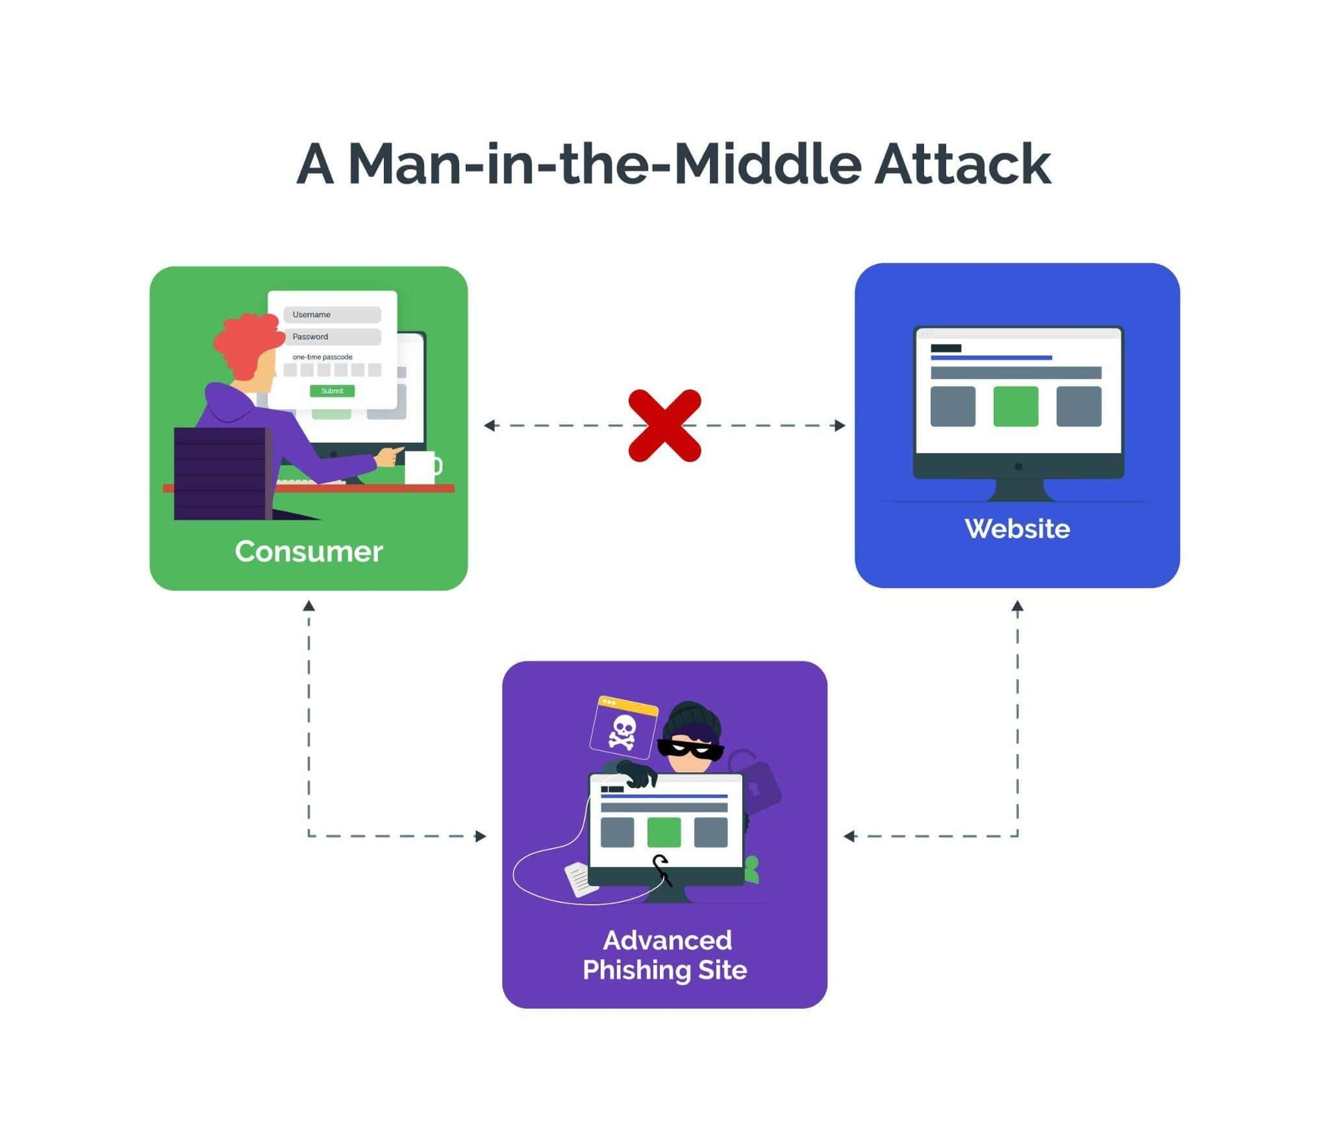
Man-in-the-Middle Attack: Definition, Examples | Arkose Labs
Together, these threats demonstrate that network attacks do not rely solely on brute force or malware; they often exploit trust mechanisms, communication protocols, and the lack of encryption. Understanding how these attacks work prepares defenders to implement proper countermeasures such as segmentation, encryption, certificate validation, intrusion detection, and secure device configuration so that malicious activity is recognized and stopped before real damage occurs.

3. Firewalls, IDS, and IPS: Network Defense Essentials
To understand modern network security, you must first grasp the three core technologies that stand as digital guardians at the edge of the network and within it: firewalls, intrusion detection systems (IDS), and intrusion prevention systems (IPS). Together, they form a layered defense that filters, monitors, and reacts to suspicious activity, each playing a different but complementary role. Without them, networks would be constantly exposed to malicious traffic, automated scanners, and attackers attempting to slip inside undetected.
The firewall is the first and most fundamental line of defense. Think of it as a gatekeeper positioned between trusted internal systems and the outside world, examining every packet of data trying to enter or leave. It makes decisions based on predefined rules—allowing legitimate communication while rejecting anything unauthorized. Early firewalls simply checked the source and destination IP addresses and port numbers, but modern ones are far more advanced, capable of inspecting not only connection information but also the actual content of traffic. A stateful firewall tracks ongoing conversations between devices, ensuring that only returning traffic from legitimate requests is allowed back inside. Meanwhile, application-layer firewalls can deeply analyze web requests, block malicious behavior like SQL injection, and enforce strict control over what applications are allowed to communicate. In short, firewalls serve as the main perimeter shield, filtering traffic at multiple layers to reduce risk before threats even enter the network.
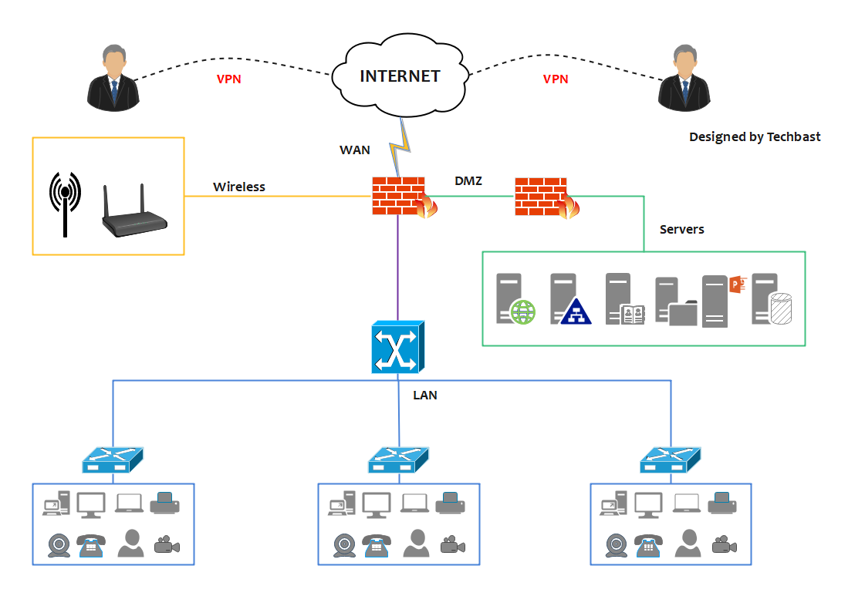
Firewall Network Diagram Examples
If firewalls are the guards at the door, intrusion detection systems are the surveillance cameras and alarm systems inside the building. An IDS does not block traffic—it watches, analyzes, and alerts. It studies patterns in traffic and system behavior, searching for signs of attacks, unusual activity, or violations of security policies. Some IDS tools work by comparing network traffic against known attack signatures, much like how antivirus software recognizes malicious files. Others use anomaly detection, learning what “normal” traffic looks like and flagging deviations that might signal attacks like data exfiltration or lateral movement. Although an IDS cannot stop an attack directly, it provides critical visibility. It tells security teams where suspicious activity is happening and gives them the information needed to respond quickly and effectively.
An intrusion prevention system takes the monitoring ability of IDS and combines it with active defense. Instead of simply alerting administrators, an IPS sits in-line with traffic and can immediately block malicious behavior the moment it is detected. This means it must operate with precision and low latency—too slow, and legitimate traffic is disrupted; too aggressive, and normal operations might be incorrectly blocked. IPS solutions examine packet contents, detect exploit attempts, stop suspicious connections, and terminate harmful sessions before they impact systems. In many networks today, firewalls and IPS capabilities are combined into what we call next-generation firewalls, which integrate filtering, monitoring, and real-time response in one platform.
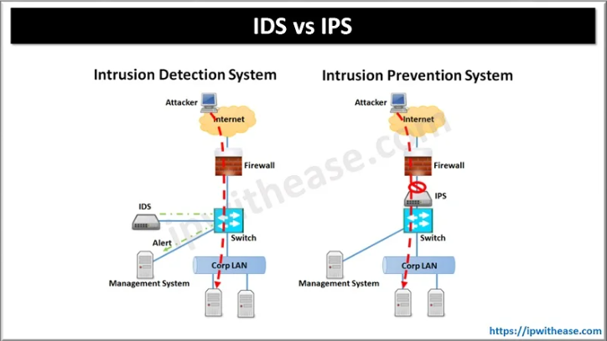
Difference between IPS and IDS - IP With Ease

Ultimately, these three technologies operate as a coordinated defense system: the firewall decides what can enter, the IDS watches for anything suspicious that gets through or happens internally, and the IPS acts instantly to stop malicious activity when necessary. Together, they build a secure barrier and monitoring environment, ensuring that even if attackers test the gates or breach the perimeter, they are quickly detected, contained, and denied the ability to cause damage.
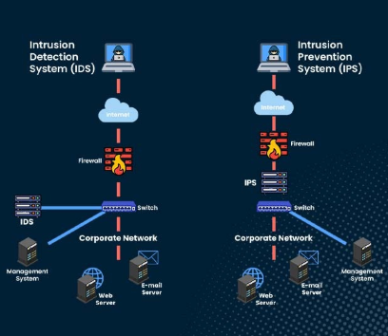
What is the Difference between IDS and IPS? - PyNet Labs

4. Network Monitoring and Incident Response
Defending a network is not only about preventing attacks; it is equally about detecting suspicious behavior and responding quickly when threats slip through. Even the most advanced firewalls and security systems cannot guarantee total protection, which is why monitoring and incident response play a critical role in cybersecurity. Network monitoring gives security teams visibility into what is happening across systems, allowing them to observe patterns, detect anomalies, and identify early warning signs of compromise. Incident response provides the structured process that organizations follow when a threat becomes real, ensuring they contain attacks efficiently, remove intruders, and restore normal operations without panic or confusion.
Effective monitoring requires specialized tools designed to inspect and understand the massive flow of data moving across the network. One of the foundational tools is Wireshark, a powerful packet analyzer that allows analysts to capture and inspect network traffic at every level of the OSI model. With it, a cybersecurity professional can trace suspicious activity down to the individual packet, examine protocols, view payloads, and reconstruct the path of an attack. Next is Nmap, a widely used network scanning tool that identifies active devices, open ports, running services, and potential vulnerabilities. Nmap isn't just for attackers—defenders use it to discover weaknesses before someone else does. Finally, tools like Snort apply intrusion detection logic, scanning traffic in real time and generating alerts when patterns resemble known attacks or abnormal behavior. Together, these tools turn raw network activity into actionable intelligence, allowing security teams to see what others might miss.
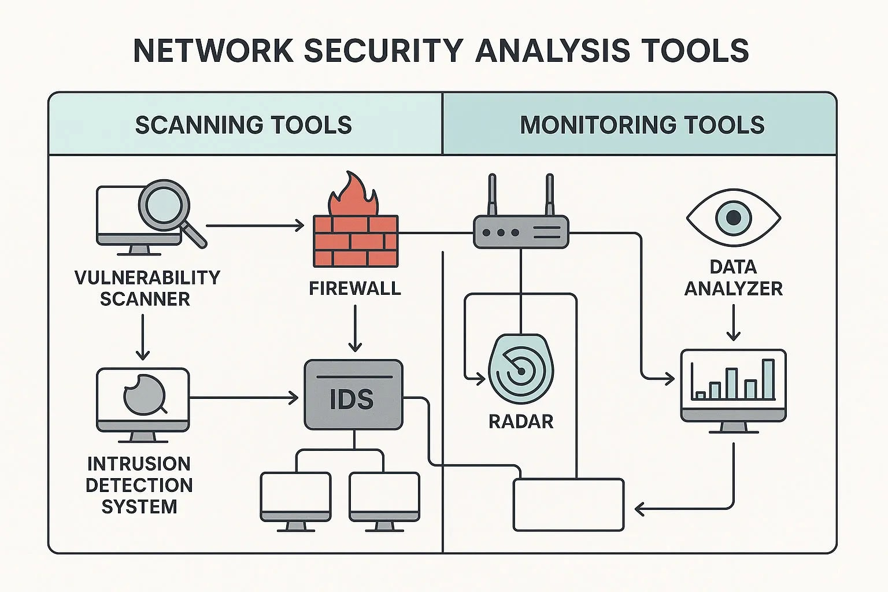
Nmap vs. Wireshark: Choosing the Right Tool for Network Penetration Testing
But seeing the threat is only half the battle. When an attack succeeds or suspicious activity is confirmed, incident response begins. The first step is preparation—ensuring monitoring systems are in place, employees are trained, backups are ready, and procedures are documented long before a breach occurs. When an incident is detected, the team must identify the scope and severity: determining which systems are affected, what type of threat is present, and whether data or services are at risk. Once the situation is understood, rapid containment measures follow. This may involve isolating compromised devices, blocking malicious connections, or applying emergency firewall rules to prevent further spread. After containment comes eradication—the careful removal of malware, the closing of exploited vulnerabilities, and the elimination of any hidden backdoors left by the attacker. When the threat is eliminated, systems can be safely restored and monitored closely to ensure normal operations resume without re-infection.
The final and often overlooked phase is reflection and improvement. After a security incident, organizations conduct a post-incident review to analyze what happened, what worked, and what failed. This stage leads to policy improvements, better monitoring setups, staff training updates, and sometimes restructuring of the security architecture. It is also where proper documentation matters most, especially when the incident involves sensitive data, legal obligations, or potential law enforcement involvement. Maintaining a proper chain of custody for logs and evidence ensures that the organization can take legal action if necessary and that the investigation remains credible.
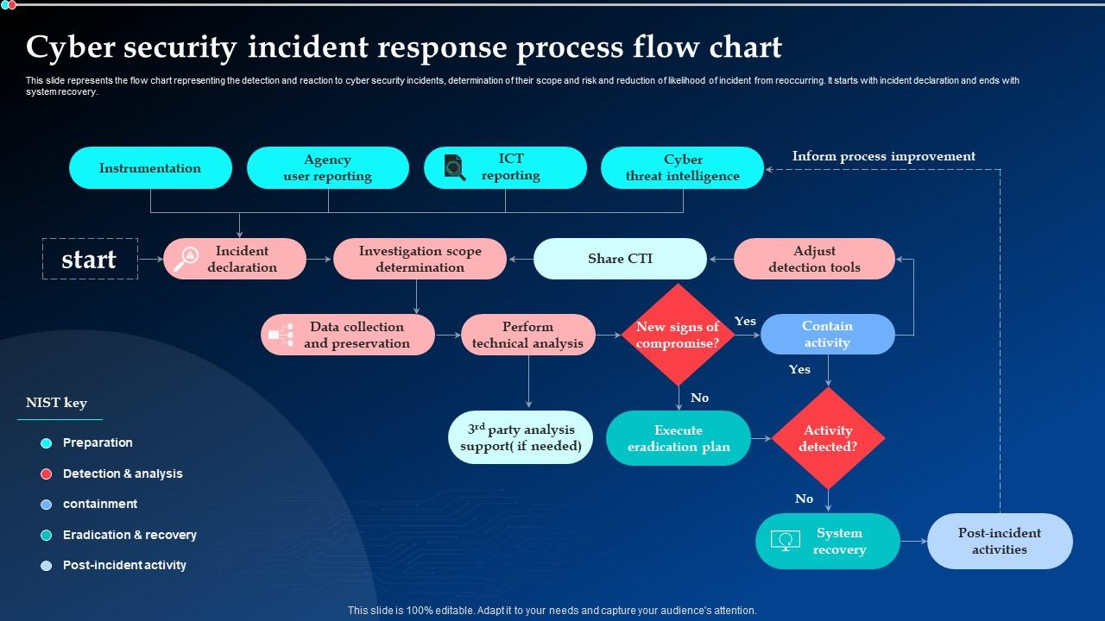
Cyber Security Incident Response Process Flow Chart Ppt Powerpoint Presentation Model File Formats PPT Template
In essence, network monitoring and incident response transform security from a passive barrier into an active, intelligent defense system. Instead of merely trying to stop attacks, organizations anticipate threats, watch for subtle signs of compromise, and react decisively when danger emerges. This mindset acknowledges a critical truth in cybersecurity: prevention is essential, but visibility and response are what truly protect an organization when the unexpected happens.

