Introduction
Web security is a critical foundation of the digital world, ensuring that websites, applications, and online systems remain safe, trustworthy, and resilient against cyber threats. As organizations and individuals increasingly rely on the internet for communication, banking, education, business operations, and personal activities, the protection of online platforms has become more important than ever. Every interaction on the web involves data being shared, stored, and processed, making security essential not only for safeguarding information but also for maintaining confidence in the systems we use every day. This topic explores the essential principles of web application security, including the core security concepts, the fundamental components of secure application design, and the most common risks identified by global security standards. By understanding these principles, learners will develop a strong awareness of threats, how they arise, and the techniques used to prevent them, ultimately preparing them to contribute to secure and trustworthy digital environments.

Objectives
- Understand the importance of web security in modern digital environments.
- Recognize and explain the core security principles: confidentiality, integrity, availability, and accountability.
- Identify and describe key components of application security, including threat agents, vulnerabilities, attacks, controls, and impacts.
- Develop awareness of how security breaches occur and the factors that contribute to them.
- Gain foundational knowledge of the OWASP Top 10 and the most critical web application risks.
- Learn to think from an attacker’s perspective to better anticipate and prevent threats.
- Apply security awareness and best practices in web development and testing tasks.
- Build a proactive security mindset to help create secure and reliable applications.

1. Introduction to Web Application Security and Core Concepts
Web application security is the discipline of protecting websites and online systems from unauthorized access, abuse, or damage. As the world increasingly depends on digital platforms for banking, communication, education, and business, securing these web systems has become essential. Every time someone logs into a website, sends data, or performs an online transaction, there is potential for an attacker to intercept, steal, or manipulate information. This is why understanding web security is not just a technical requirement but a critical foundation for trust in modern online services.
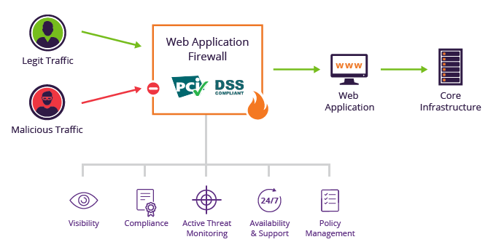
Web Application Security | What do You Need to Know? | Imperva
At the core of web security is the concept of safeguarding data and services so that only the right people can access them, information remains accurate, and systems stay available whenever users need them. These three principles are known as confidentiality, integrity, and availability. Confidentiality means information must remain private and accessible only to authorized individuals. It prevents identity theft, leaks of personal information, and unauthorized viewing of business data. Integrity ensures that information is trustworthy and unaltered unless approved. For instance, financial records, grades, and medical data must remain accurate because a single unauthorized change can have serious consequences. Availability guarantees that users can always reach the service when they need it. An online banking site that goes down during payday, or a government portal crashing during a deadline, shows how essential availability is. Alongside these principles, accountability plays an important role because systems must be able to trace actions to responsible users; this enables auditing, investigation, and enforcement of security policies.
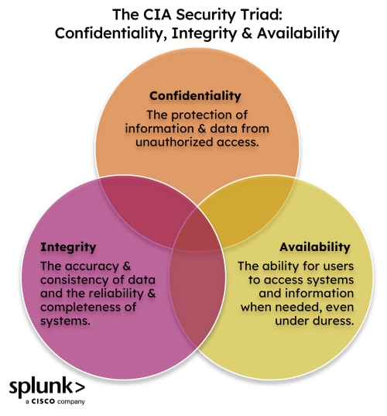
What's The CIA Triad? Confidentiality, Integrity, & Availability, Explained | Splunk
Web security stretches across different levels. Physical security protects the equipment that runs applications, such as servers inside data centers. Network security defends the communication pathways that data travels through, using technologies like firewalls and secure connections to block intruders. Application security focuses specifically on the software itself—ensuring that code, configurations, and user interactions do not create openings for attackers. This layer is especially important because even if the building and network are fully protected, a single vulnerable web application can become the doorway attackers use to break in.
Every security incident follows a certain pattern. There is always a threat agent, which may be a hacker, a disgruntled employee, or even an automated bot searching the internet for weak sites. The attacker uses an attack technique, such as injecting malicious code into a website. This technique works only if there is a vulnerability or weakness in the system, like a poorly coded login form or an unprotected database query. If there are no effective security controls—such as input validation, encryption, or access checks—the attack succeeds. The immediate outcome is known as the technical impact, which could involve stolen data, corrupted records, or a crashed server. This then leads to a broader business impact such as financial loss, reputation damage, legal consequences, or disruption of services for customers and users. Understanding this chain helps organizations predict and stop attacks before they happen.
In everyday practice, web application security is not limited to cybersecurity professionals. Developers must write secure code from the beginning to avoid introducing weaknesses. Testers must learn to identify security flaws while checking functionality. System administrators must ensure that configurations, servers, and databases remain hardened against attacks. Even regular users play a part by following secure practices, such as choosing strong passwords and recognizing suspicious emails or links.
In summary, web application security is the continuous process of protecting digital systems and data against threats. It requires awareness, discipline, and proper implementation of safeguards at every level of technology. As the digital world continues to evolve, mastering these core security concepts becomes essential for anyone working with web systems, whether they are building them, testing them, or simply using them responsibly.

2. Understanding Application Security Components
Understanding application security components means learning how an attack happens, what weaknesses make it possible, and what defenses can stop it. Every security incident is not random; it follows a logical pattern, and knowing each part of that pattern helps developers and security professionals identify risks early and protect systems more effectively.
Everything begins with a threat agent, the individual or entity attempting to harm or gain unauthorized access to a system. This could be a cybercriminal, an inside employee who misuses access, a competing business, or even automated bots constantly scanning the internet for weaknesses. Each threat agent has motives such as financial gain, curiosity, revenge, espionage, or simply wanting to exploit systems for fun or recognition. By identifying who might want to attack a system and why, organizations can better predict and prepare for potential threats.
Threat Agent Categories | Download Scientific Diagram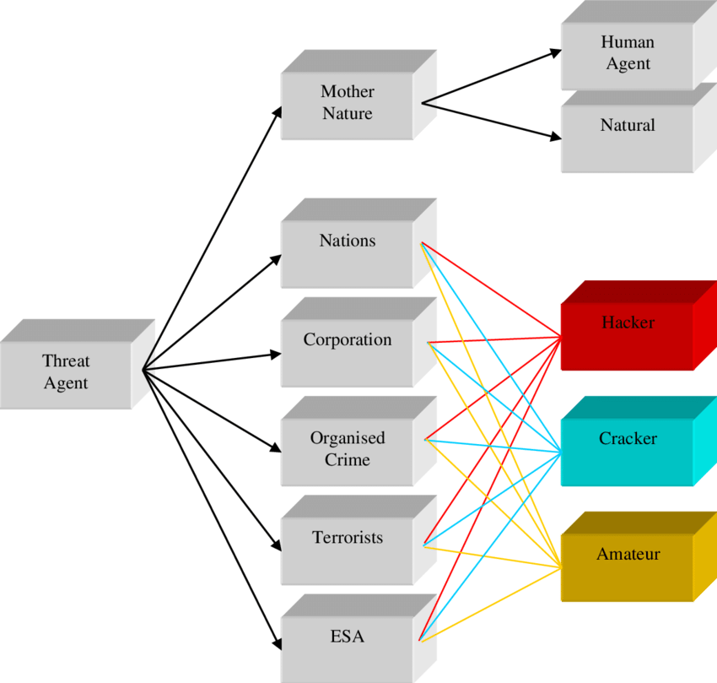
Threat Agent Categories | Download Scientific Diagram
Once a threat agent exists, they need a method to execute the attack, which is simply called an attack. An attack is the specific technique used to exploit weaknesses in an application. Common examples include injecting malicious code into database queries, tricking users into clicking harmful links, stealing session tokens, or guessing weak passwords. These attacks succeed only when the system being targeted has a flaw that can be taken advantage of.
That flaw is known as a vulnerability, which is any weakness in a system, code, configuration, or design that an attacker can exploit. Vulnerabilities can arise from poor coding practices, lack of proper data validation, missing access controls, weak authentication systems, or insecure configurations. Even a small oversight, such as failing to sanitize user input or leaving error messages visible, can create an opening for attackers. A vulnerability is not harmful by itself, but it becomes dangerous when an attacker discovers and uses it.
To prevent vulnerabilities from being exploited, systems implement security controls. These are defensive mechanisms designed to block, detect, or minimize attacks. Controls can include encryption, authentication mechanisms, firewalls, validation checks, user access restrictions, and logging systems. When controls are properly designed and implemented, they greatly reduce the chance that vulnerabilities can cause real damage. However, if a control is poorly implemented or missing entirely, it becomes a serious risk and may lead to a successful attack.

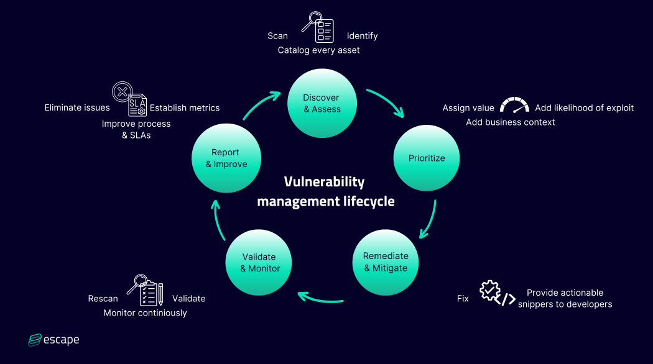
Vulnerability Management Lifecycle: A Comprehensive Guide
If an attack succeeds, it produces a technical impact, which refers to the direct consequences on the system itself. This might include data being stolen, modified, or deleted, servers crashing, applications being defaced, or unauthorized access being granted. While the technical impact is the immediate result, it leads to the more serious consequence: the business impact. Business impact involves real-world effects such as financial loss, legal penalties, loss of customer trust, operational downtime, and brand damage. Even a single breach can cost an organization millions or destroy its reputation permanently. This is why companies prioritize fixing vulnerabilities and strengthening controls — to avoid losses far greater than the cost of prevention.
Ultimately, understanding these components builds a security mindset. Instead of viewing security as optional or something handled only by specialists, developers and teams begin to see the full lifecycle of risks and take responsibility for preventing them. Every system has potential weaknesses, and attackers are constantly searching for them. By recognizing the roles of threat agents, attacks, vulnerabilities, controls, and impacts, organizations can defend themselves more effectively and ensure that applications remain safe, reliable, and trustworthy.

3. OWASP Top 10 Risks - Part 1 (A1 - A5)
The OWASP Top 10 represents the most critical security risks found in web applications, and understanding the first five of these threats is essential for anyone involved in building or maintaining online systems. These risks are based on real-world attack data and highlight the most common and dangerous ways that cybercriminals compromise web applications. Rather than being a checklist of technical mistakes, the OWASP Top 10 serves as a framework to help developers and security testers think like attackers, anticipate weaknesses, and create more resilient applications. At its core, this model emphasizes that security is about balancing the likelihood of an attack with the impact it can cause — meaning the most dangerous weaknesses are those that are both easy to exploit and capable of causing severe damage.
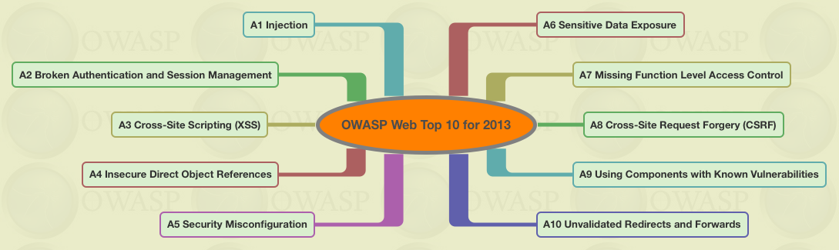
OWASP top 10 web app vulnerabilities over time | by Seralahthan | Medium
The first risk is Injection, a type of attack that occurs when an application processes untrusted or improperly validated input. When an attacker sends malicious data to an interpreter — for example, a database query, a system command, or a directory search — the system may mistakenly execute it as legitimate instructions. SQL injection remains one of the most known forms of this attack, allowing hackers to manipulate or steal database content simply by inserting crafted input into vulnerable application fields. This risk persists mainly because some systems fail to properly filter and sanitize user input, treating everything entered by a user as trustworthy.
The second major risk is Broken Authentication and Session Management. Web applications rely on systems for verifying identity and preserving user sessions, such as login credentials and session tokens. When these mechanisms are poorly designed or implemented — for example, using weak password storage, predictable session IDs, or failing to properly terminate sessions — attackers can impersonate users. This often leads to account takeover, unauthorized access to personal data, or administrative system control. The consequences are severe because authentication is the foundation of trust in any online platform.
Next is Cross-Site Scripting, or XSS. This vulnerability emerges when applications allow the delivery of untrusted data to users’ browsers without proper validation or escaping. Instead of attacking the system directly, the attacker injects a malicious script into a site, causing it to run inside another user’s browser. Through XSS, attackers can steal cookies, hijack sessions, manipulate website content, or redirect victims to malicious sites. The threat is powerful because it abuses the trust that users place in the website, and it spreads through simple user interactions such as clicking links or loading pages.
The fourth risk, Insecure Direct Object References, occurs when developers expose internal identifiers such as database keys, file paths, or record IDs to users without adding access control checks. In this scenario, an attacker can manipulate these references — such as changing a number in a URL — to access or modify data that does not belong to them. This issue arises when developers assume that users will only access objects or records they are meant to see, forgetting that malicious users deliberately test for hidden access points.
The fifth major risk is Security Misconfiguration, a broad problem that results from improper setup or incomplete hardening of applications, servers, and entire technology stacks. Systems often run with default credentials, overly permissive settings, outdated software, or unused features that leave hidden entry points for attackers. This vulnerability is dangerously common because even a perfectly written application can be compromised if the environment hosting it is not secured. Many breaches happen not because software code is flawed, but because systems are deployed without proper security settings.
Taken together, these first five OWASP risks reveal a recurring pattern: attacks succeed not simply due to advanced hacking techniques, but because systems trust user input too easily, fail to guard identity and access mechanisms, expose internal objects, or operate in insecure environments. As a result, developers, administrators, and security professionals must work as a team to enforce strict input validation, secure authentication processes, robust access controls, and thorough configuration practices. By understanding these threats and building defensive habits early, organizations can drastically reduce their risk of exploitation and create safer digital environments for users and data.

4. OWASP Top 10 Risks - Part 2 (A6 - A10)|
The remaining five risks in the OWASP Top 10 continue to highlight how modern web applications can be compromised when sensitive data is not properly protected, access controls are incomplete, and outdated or insecure components are used. Understanding these threats reinforces the idea that even a single weak point in a system can open the door for significant attacks. These risks do not only apply to large companies — any system that stores information, interacts with users, or connects to third-party services can fall victim to these vulnerabilities. Developers and security teams must treat these risks not simply as technical flaws, but as business risks that can affect trust, reputation, and continuity of service.

One of the most serious risks is Sensitive Data Exposure. Many applications fail to properly secure information such as credit card numbers, personal identity data, passwords, and confidential business assets. If data is transmitted without encryption, stored in plain text, or inadequately protected, attackers can easily steal or manipulate it. Sensitive data exposure is dangerous because once leaked, personal and financial information cannot be taken back. People may suffer identity theft, financial fraud, and long-term privacy damage. For organizations, this often means legal consequences, loss of customer trust, and high recovery costs. Protecting sensitive data requires strong encryption, careful handling, and strict security practices at every stage of data storage and transmission.
The next major risk is Missing Function-Level Access Control, which arises when applications fail to properly enforce who is allowed to perform certain actions. Even if a site protects its main features, attackers may still access restricted functions simply by guessing or modifying URLs, using hidden API routes, or calling backend operations directly. This vulnerability exists when developers rely solely on user-interface controls to hide features, instead of verifying permissions at the system level. As a result, unauthorized users may gain administrative privileges, change important settings, or access private information. Proper authorization checks at every system function are essential to preventing this silent but dangerous form of attack.
Another common and powerful attack method is Cross-Site Request Forgery (CSRF). In this scenario, the attacker tricks a logged-in user into performing an unintended action in a vulnerable application. Because the user is already authenticated, the system believes the malicious request is legitimate. This can allow attackers to change account details, transfer funds, or perform administrative actions on behalf of the victim. CSRF demonstrates how attackers can weaponize trust — not by hacking a system directly, but by manipulating users to unknowingly trigger harmful actions. Strong token systems, proper session validation, and security controls help defend against this type of attack.
The ninth OWASP risk, Using Components with Known Vulnerabilities, highlights the danger of relying on outdated libraries, plugins, frameworks, or third-party tools. Modern applications are built using many external components, and if even one of them has a known security flaw, attackers can exploit it easily — especially since these weaknesses are often publicly documented. Teams that fail to track and update software components introduce risk without realizing it. This problem persists because development speed often takes priority, and many teams lack visibility into what third-party dependencies their systems use. Regular updates, vulnerability scanning, and dependency management are crucial to maintaining secure systems.
Finally, Unvalidated Redirects and Forwards occur when an application allows users to be redirected to a different page without verifying the destination. Attackers can exploit this behavior to send users to malicious sites, launch phishing attachments, or bypass access controls within a system. While this may seem like a minor issue, it is powerful because it leverages user trust in a legitimate website to carry out deception. If a trustworthy site redirects to a harmful location, users may not realize they are being targeted until it is too late.
Together, these last five risks remind us that security is not only about defending against direct attacks — it involves protecting user data, enforcing proper access at every level, managing dependencies responsibly, and guarding against manipulation of users and system behavior. A single oversight in handling data, managing access, updating software, or controlling user navigation can compromise an entire platform. By understanding and addressing these vulnerabilities, developers and security practitioners can build more resilient applications that truly protect users and business assets.
The Open Universe: Web Application Security Top 10

