Freight Rate Prediction — Validation Report
Reproducible submission based only on supplied development labels.

1. Data and quality checks
The labeled development data contains 48,000 loads dated January 1–October 31, 2025. The unlabeled prediction data contains 12,000 loads dated November 1–December 31, 2025. All development targets are present and positive. No duplicate IDs or complete development feature-and-target rows were found.
Development data has 300 missing weights, 292 nonpositive weights and 374 missing market indices. The prediction data has 165 missing weights, 145 nonpositive weights and 249 missing market indices. Nonpositive weights are marked missing, not converted to their absolute values. A weight-invalid flag distinguishes affected rows. Numeric missingness is encoded as -999, a sentinel outside the observed positive weight/market-index ranges; categorical missingness is encoded as Unknown.
There are 8 new cities at prediction time: Allentown, Charlotte, Chicago, Jackson, Knoxville, Laredo, Norfolk, San Diego. CatBoost handles unseen category values; supplied latitude/longitude features give the main model a geographic representation without needing those city names to have appeared during training. Coordinates were used as supplied, with no unsupported geocoding corrections.
340 development rates exceed $4/mile. These are possible anomalies, not proven labeling errors. They are retained in training and every validation metric. MAE-loss candidates reduce their leverage. No target trimming or outlier exclusion was used to improve reported scores.
The quote signal is not temporally stable: its monthly correlation with observed rate/mile changes sign and is approximately zero in August. This may indicate regime-dependent behavior, contamination or unreliable availability; its provenance is unknown. Both inclusion and exclusion were tested on future-month tuning data. It is not assumed to be a trustworthy direct quote of the target.

2. Temporal split and leakage prevention
Training: January–July (33,718 loads). Tuning/early stopping: August (4,759 loads). Locked test: September–October (9,523 loads). This forward split mirrors predicting later months. A shuffled random split would mix time regimes and overstate reliability.
Selection is based only on August dollar MAE. Each candidate is trained with up to 1,400 trees and early stopping after 130 unimproved iterations on its own loss. After selection, the selected tree count is fixed, the model is refit on January–August, and September–October is evaluated once without selecting another candidate. The final model is then refit on all January–October labeled loads. The 12,000 final-validation labels are not available and are never used. load_id is used only for output matching, not as a model feature. Feature transforms are row-local and do not use target means or test statistics.

3. Models and results
Baseline: median development dollars/mile multiplied by distance. Candidates: CatBoost with core features or core plus quote signal, MAE or RMSE loss, and either dollar rate or rate/mile targets. Rate/mile predictions are converted to dollars using the row's distance. The chart model is selected independently among reduced-schema candidates. All candidates use depth 7, learning rate 0.055, L2 regularization 5, seed 42 and four CPU threads.
Features include origin, destination, directed lane, equipment, distance, log distance, cleaned weight, weight/distance, missing-weight flag, elapsed days, weekday, weekend, day-of-month, month and annual sine/cosine terms. The main schema adds coordinates, latitude/longitude differences and market index. Categories are learned by CatBoost within the fitted training data.
Selected main model: core_rpm_mae (292 trees). Selected chart model: chart_rpm_mae (707 trees).
Model / split | MAE ($) | RMSE ($) | R² | MAPE
median_rpm_baseline  August tuning | 260.52 | 673.96 | 0.7912 | 11.46%
core_rpm_mae  August tuning | 85.03 | 613.78 | 0.8268 | 3.95%
core_rate_rmse  August tuning | 133.79 | 617.24 | 0.8248 | 6.79%
core_rpm_rmse  August tuning | 114.33 | 614.60 | 0.8263 | 5.20%
quote_rpm_mae  August tuning | 147.42 | 623.35 | 0.8214 | 6.89%
quote_rate_rmse  August tuning | 138.48 | 619.13 | 0.8238 | 7.19%
chart_rpm_mae  August tuning | 93.18 | 612.79 | 0.8274 | 4.25%
chart_rate_rmse  August tuning | 138.45 | 619.10 | 0.8238 | 6.53%
median_rpm_baseline  September-October locked test | 256.95 | 684.25 | 0.7990 | 11.63%
core_rpm_mae  September-October locked test | 117.41 | 636.91 | 0.8258 | 5.04%
core_rpm_mae  2025-09 locked test | 114.79 | 620.16 | 0.8343 | 4.63%
core_rpm_mae  2025-10 locked test | 119.93 | 652.62 | 0.8177 | 5.43%
chart_rpm_mae  September-October locked test | 107.59 | 633.55 | 0.8276 | 4.75%
chart_rpm_mae  2025-09 locked test | 103.54 | 615.99 | 0.8365 | 4.26%
chart_rpm_mae  2025-10 locked test | 111.49 | 650.00 | 0.8192 | 5.22%
MAE is the primary selection metric because no official accuracy metric was provided. RMSE highlights sensitivity to rare high-rate loads. MAPE is diagnostic and can overweight small actual rates. These are internal temporal validation results, not the organizer's hidden final-validation score.
Top final-main-model feature importances: weight_per_mile (25.2), equipment (23.8), distance (13.6), log_distance (12.7), market_index (4.3), day_index (3.1). CatBoost importances are model-specific and are not evidence of causal effects.

4. Fixed December chart
The chart inputs contain only pickup, delivery, distance, equipment, weight and date. They do not contain coordinates, market index or quote signal. Rather than inventing those values or silently applying a different feature schema, a dedicated model is trained using only features available in that input. Its locked temporal test score is shown above. This is a separate reduced-information forecast, not the full model's prediction at unspecified values of the omitted features.
For every day in December 2025 the fixed scenario is Lexington → Fort Wayne, 360 miles, Dry Van, 32,000 lb. Only date changes. The following image was generated by the supplied scorer, copied byte-for-byte to score.py without modifying its plotting or validation logic.
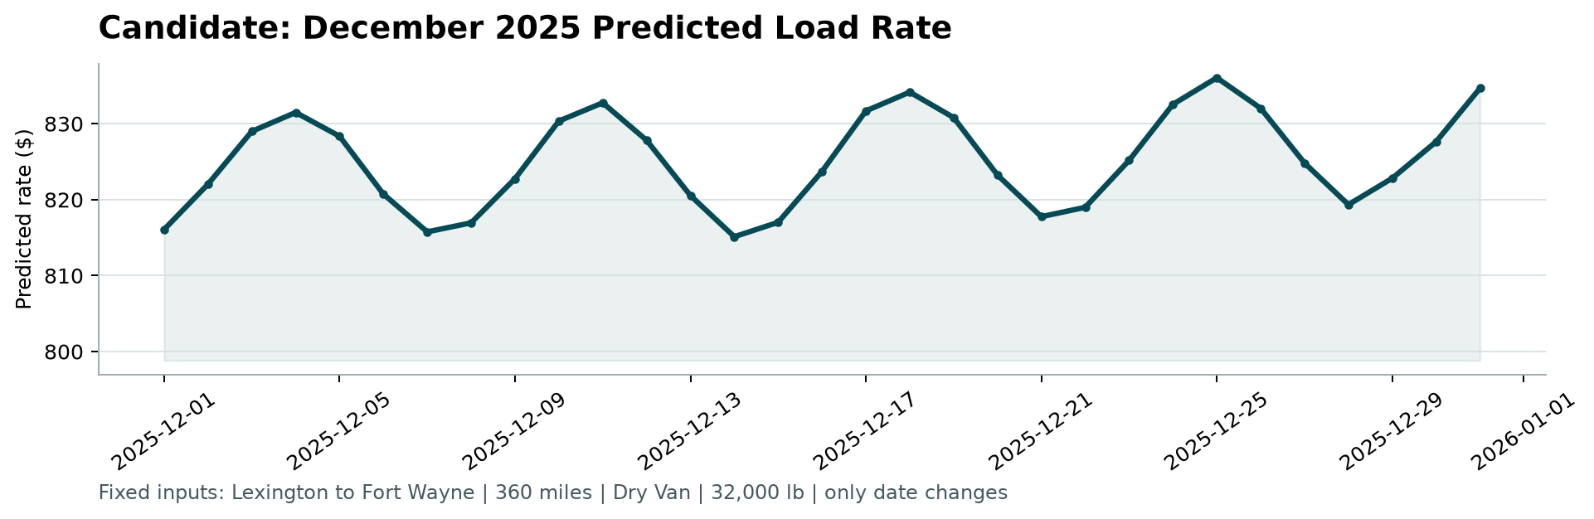
Scorer execution: python score.py --predictions validation_predictions.csv --december-predictions data/december_chart_inputs.csv. The scorer confirmed 12,000 valid final predictions and 31 valid fixed-scenario December predictions. It does not calculate prediction-accuracy metrics; those are calculated by the organizer after submission.

5. Reproducibility and limitations
Run train.py, score.py, test_solution.py and make_report.py in that order. The final CSV is filled by joining on load_id in template order, not by assuming the validation rows and template rows are aligned. Positive finite outputs are required by the scorer; predictions are floored at $1 and written to cents. artifacts/audit.json, results.json, metrics.csv and locked_test_predictions.csv record the data checks, configuration and internal holdout results.
Only ten months from one year are available. Annual seasonality and holiday effects are therefore weakly identified, and CatBoost does not extrapolate numerical trends beyond training support reliably. The locked test covers September–October, not November–December; it cannot prove performance during winter or on the eight unseen cities. No spatial holdout experiment was used. Future work should use multiple years, rolling-origin validation and a geographic holdout, and verify quote-signal provenance before relying on it. No holiday-specific coefficients were invented.

