

LAB ASSIGHMENT 3
WEB DEVELOPMENT
DR. ARIFFIN

NEZAR AHMED (AI230264)
- Your codes for the biodata, hobbies and campus life pages.
Index:

- Biodata:
- <!DOCTYPE html>
- <html lang="en">

- <head>
- <meta charset="UTF-8">
- <meta name="viewport" content="width=device-width, initial-scale=1.0">
- <title>table</title>
- </head>

- <body>
- <table border="1" style="border-collapse: collapse;">
- <tr>
- <th>Name</th>
- <td>Nezar</td>
- <th rowspan="4"><img src="my_pic.png" width="150px"></th>
- </tr>
- <tr>
- <th>Date of Birth</th>
- <td>7th/May/2001</td>
- </tr>
- <tr>
- <th>Religion</th>
- <td>Islam</td>
- </tr>
- <tr>
- <th>Race</th>
- <td>Arab</td>
- </tr>

- <tr>
- <th rowspan="4">Address</th>
- <th>Street</th>
- <td colspan="2">Taman U</td>
- </tr>
- <tr>
- <th>Town</th>
- <td colspan="2">Parit Raja</td>
- </tr>
- <tr>
- <th>District</th>
- <td colspan="2">Batu Pahat</td>
- </tr>
- <tr>
- <th>State</th>
- <td colspan="2">Johor</td>
- </tr>

- <tr>
- <th rowspan="3">Contact</th>
- <th>Phone Number</th>
- <td colspan="2">123456789</td>
- </tr>
- <tr>
- <th>Social Media</th>
- <td colspan="2">@nezar57</td>
- </tr>
- <tr>
- <th>Website</th>
- <td colspan="2"><a href="https://www.noonativity.com">www.noonativity.com</a></td>
- </tr>

- <tr>
- <th>Course and Institution</th>
- <td colspan="3">web development @UTHM</td>
- </tr>
- <tr>
- <th>Programming Skills</th>
- <td colspan="3">C++, HTML and CSS</td>
- </tr>
- <tr>
- <th>Hobbies</th>
- <td colspan="3">Painting</td>
- </tr>
- <tr>
- <th>2025 Wishlist</th>
- <td colspan="3">develop games</td>
- </tr>
- </table>
- </body>

- </html>

- Hobbies:
- <!DOCTYPE html>
- <html lang="en">

- <head>
- <meta charset="UTF-8">
- <meta name="viewport" content="width=device-width, initial-scale=1.0">
- <title>hobbies</title>
- <style>
- body {
- display: flex;
- align-items: center;
- justify-content: center;
- background-color: rgb(24, 33, 50);
- }

- .header {
- padding: 10px;
- background-color: rgb(39, 59, 95);
- border-radius: 50px;
- }

- p {
- text-align: center;
- color: aliceblue;
- margin: 0px;
- }

- h1 {
- margin: 0px;
- text-align: center;
- color: rgb(212, 251, 173);
- }

- .media {
- align-items: center;
- display: flex;
- }

- .ink,
- .pencil,
- .oil,
- .digital,
- .animation {
- background-color: rgb(39, 59, 95);
- height: 150px;
- display: flex;
- padding: 10px;
- margin: 20px;
- border-radius: 15px;
- }
- </style>
- </head>

- <body>
- <div class="container">
- <div class="header">
- <h1>My hobbies</h1>
- </div>
- <br>
- <p>All the following art pieces are made by me,Nezar Ahmed</p>
- <p>My hobby is to draw with various mediums and types.</p>
- <div class="media">
- <div class="pencil">
- <img src="hobbies/pencil.jpg" alt="pencil artwork">

- <p>pencils on canson papers</p>
- </div>

- <div class="ink">
- <img src="hobbies/ink.jpg" alt="pencil artwork">
- <p>Ink on canson papers</p>
- </div>

- <div class="oil">
- <img src="hobbies/oil.jpg" alt="pencil artwork">
- <p>Oil colors on Canvas</p>
- </div>

- <div class="digital">
- <img src="hobbies/digital.jpg" alt="pencil artwork">
- <p>Digital art</p>
- </div>

- <div class="animation">
- <video src="hobbies/animation.mp4" type="video/mp4" controls>video</video>
- <p>Animations, also a digital art</p>
- </div>
- </div>
- </div>
- </body>

- </html>

- Campus life:
- <!DOCTYPE html>
- <html lang="en">

- <head>
- <meta charset="UTF-8">
- <meta name="viewport" content="width=device-width, initial-scale=1.0">
- <title>campus life</title>
- <style>
- body {
- display: flex;
- align-items: center;
- justify-content: center;
- background-color: rgb(24, 33, 50);
- }

- .header {
- padding: 10px;
- background-color: rgb(39, 59, 95);
- border-radius: 50px;
- }

- p {
- text-align: center;
- color: aliceblue;
- margin: 0px;
- }

- h1 {
- margin: 0px;
- text-align: center;
- color: rgb(212, 251, 173);
- }

- .media {
- align-items: center;
- display: flex;
- }

- .U,
- .T,
- .H,
- .M {
- background-color: rgb(39, 59, 95);
- height: 150px;
- display: flex;
- padding: 10px;
- margin: 20px;
- border-radius: 15px;
- }
- </style>
- </head>

- <body>
- <div class="container">
- <div class="header">
- <h1>Campus Life</h1>
- </div>
- <br>
- <p>Moments of campus life at UTHM</p>
- <div class="media">
- <div class="U">
- <img src="CL/U.jpg" alt="pencil artwork">

- </div>

- <div class="T">
- <img src="CL/T.jpg" alt="pencil artwork">
- </div>

- <div class="H">
- <img src="CL/H.jpg" alt="pencil artwork">
- </div>

- <div class="M">
- <img src="CL/M.jpg" alt="pencil artwork">
- </div>

- </div>
- </div>
- </body>

- </html>

- b. The screenshot of your personal website.
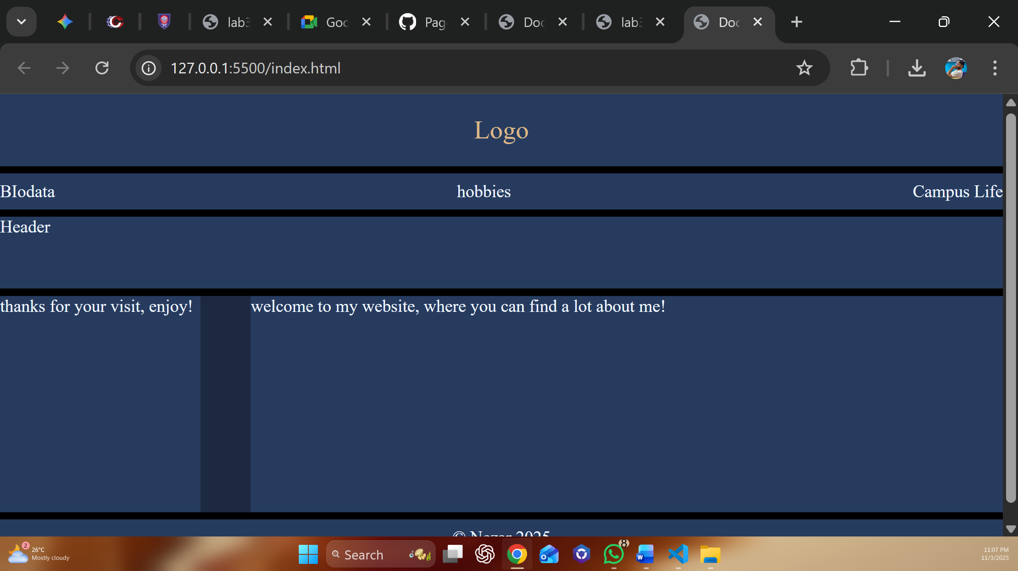
- c. GitHub Pages link.

