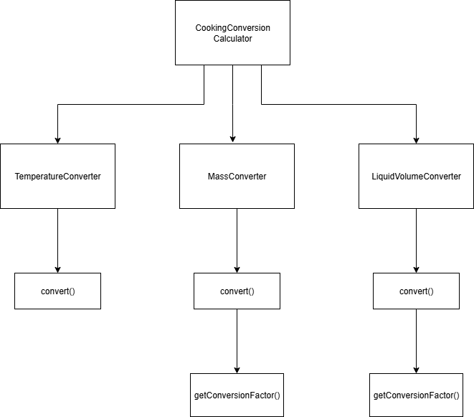**Program Structure**

**Top-down Integration**

|  |  |  |  |  |  |  |
| --- | --- | --- | --- | --- | --- | --- |
| Unit under test | List of Stubs/Drivers | result | Stub’s return value | Expected results | Actual results | Pass/Fail/No run |
| CookingConversionCalculator | Stubs: TemperatureConverter | ทดสอบการเรียก TemperatureConverter  เมื่อแปลง F -> °C  320.0 F -> 160.0 °C | (tempValue - 32) / 1.8; | 160.0 | 160.0 | Pass |
| CookingConversionCalculator | Stubs: MassConverter | ทดสอบการเรียก MassConverter  เมื่อแปลง cup -> gram  5 cup -> 625.0 gram | Multiplier = 125 | 625.0 | 625.0 | Pass |
| CookingConversionCalculator | Stubs: LiquidVolumeConverter | ทดสอบการเรียก LiquidVolumeConverter  เมื่อแปลง teaspoon -> ml  2.0 teaspoon -> 10.0 ml | Multiplier = 5 | 10.0 | 10.0 | Pass |
| TemperatureConverter | - | F -> °C  320.0 F -> 160.0 °C | - | 160 | 0.0 | Fail |
| MassConverter.convert() | Stubs: getConversionFactor() | ทดสอบการเรียก getConversionFactor()  เมื่อแปลง cup -> gram  10 cup -> 1250.0 gram | 125 | 1250.0 | 1250.0 | Pass |
| MassConverter.getConversionFactor() | - | cup -> gram  10 cup -> 1250.0 gram | - | 1250.0 | 1250.0 | Pass |
| LiquidVolumeConverter.convert() | Stubs: getConversionFactor() | ทดสอบการเรียก getConversionFactor()  เมื่อแปลง oz -> ml  10 oz -> 295.74 ml | 29.574 | 295.74 | 295.74 | Pass |
| LiquidVolumeConverter.getConversionFactor() | - | oz -> ml  10 oz -> 295.74 ml | 29.574 | 295.74 | 295.74 | Pass |
|  |  |  |  |  |  |  |
|  |  |  |  |  |  |  |

**Bottom-up Integration**

|  |  |  |  |  |  |  |
| --- | --- | --- | --- | --- | --- | --- |
| Unit under test | List of Stubs/Drivers | result | Stub’s return value | Expected results | Actual results | Pass/Fail/No run |
| TemperatureConverter | Drivers: CookingConversionCalculator | °C -> F  20.0 °C -> 68.0 F | - | 68.0 | 52.0 | Fail |
| MassConverter.getConversionFactor() | Drivers: MassConverter.convert() | gram -> oz  100.0 gram -> 3.5 oz | - | 3.5 | 3.5 | Pass |
| MassConverter.getConversionFactor() + MassConverter.convert() | Drivers: CookingConversionCalculator | gram -> oz  200.0 gram -> 7.0 oz | - | 7.0 | 7.0 | Pass |
| LiquidVolumeConverter.getConversionFactor() | Drivers: LiquidVolumeConverter.convert() | pint -> ml  3.0 pint -> 1419.528 ml | - | 1419.528 | 1419.528 | Pass |
| LiquidVolumeConverter.getConversionFactor() + LiquidVolumeConverter.convert() | Drivers: CookingConversionCalculator | pint -> ml  10.0 pint -> 4731.76 ml | - | 4731.76 | 4731.76 | Pass |
|  |  |  |  |  |  |  |
|  |  |  |  |  |  |  |
|  |  |  |  |  |  |  |
|  |  |  |  |  |  |  |
|  |  |  |  |  |  |  |