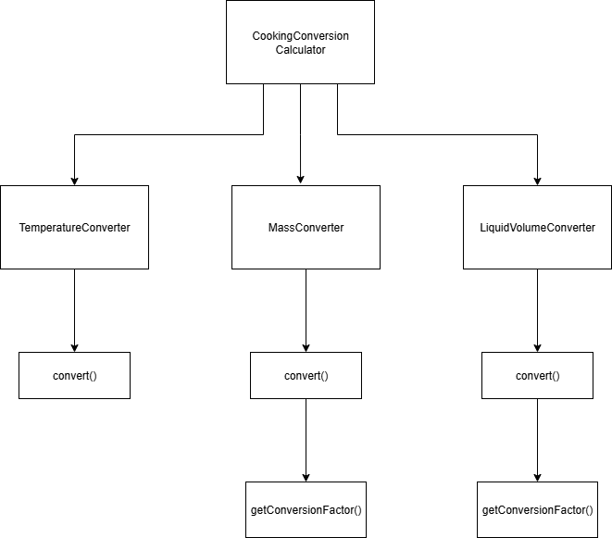**Program Structure**

**Top-down Integration**

|  |  |  |  |  |  |  |
| --- | --- | --- | --- | --- | --- | --- |
| Unit under test | List of Stubs/Drivers | result(ต้องการทดสอบฟังก์ชันการทำงานอะไร) | Stub’s return value | Expected results | Actual results | Pass/Fail/No run |
| CookingConversionCalculator, TemperatureConverter | Stubs: convert() |  |  |  |  |  |
|  |  | *ตัวอย่าง*  1 km -> 1000m | 1000 | 5000 |  |  |
|  |  |  |  |  |  |  |
|  |  |  |  |  |  |  |
|  |  |  |  |  |  |  |
|  |  |  |  |  |  |  |
|  |  |  |  |  |  |  |
|  |  |  |  |  |  |  |
|  |  |  |  |  |  |  |
|  |  |  |  |  |  |  |

**Bottom-up Integration**

|  |  |  |  |  |  |  |
| --- | --- | --- | --- | --- | --- | --- |
| Unit under test | List of Stubs/Drivers | result | Stub’s return value | Expected results | Actual results | Pass/Fail/No run |
|  |  |  |  |  |  |  |
|  |  |  |  |  |  |  |
|  |  |  |  |  |  |  |
|  |  |  |  |  |  |  |
|  |  |  |  |  |  |  |
|  |  |  |  |  |  |  |
|  |  |  |  |  |  |  |
|  |  |  |  |  |  |  |
|  |  |  |  |  |  |  |
|  |  |  |  |  |  |  |