**Cracking the Code: How Machine Learning Transforms Bank Marketing Strategies**

**1.0 Introduction**

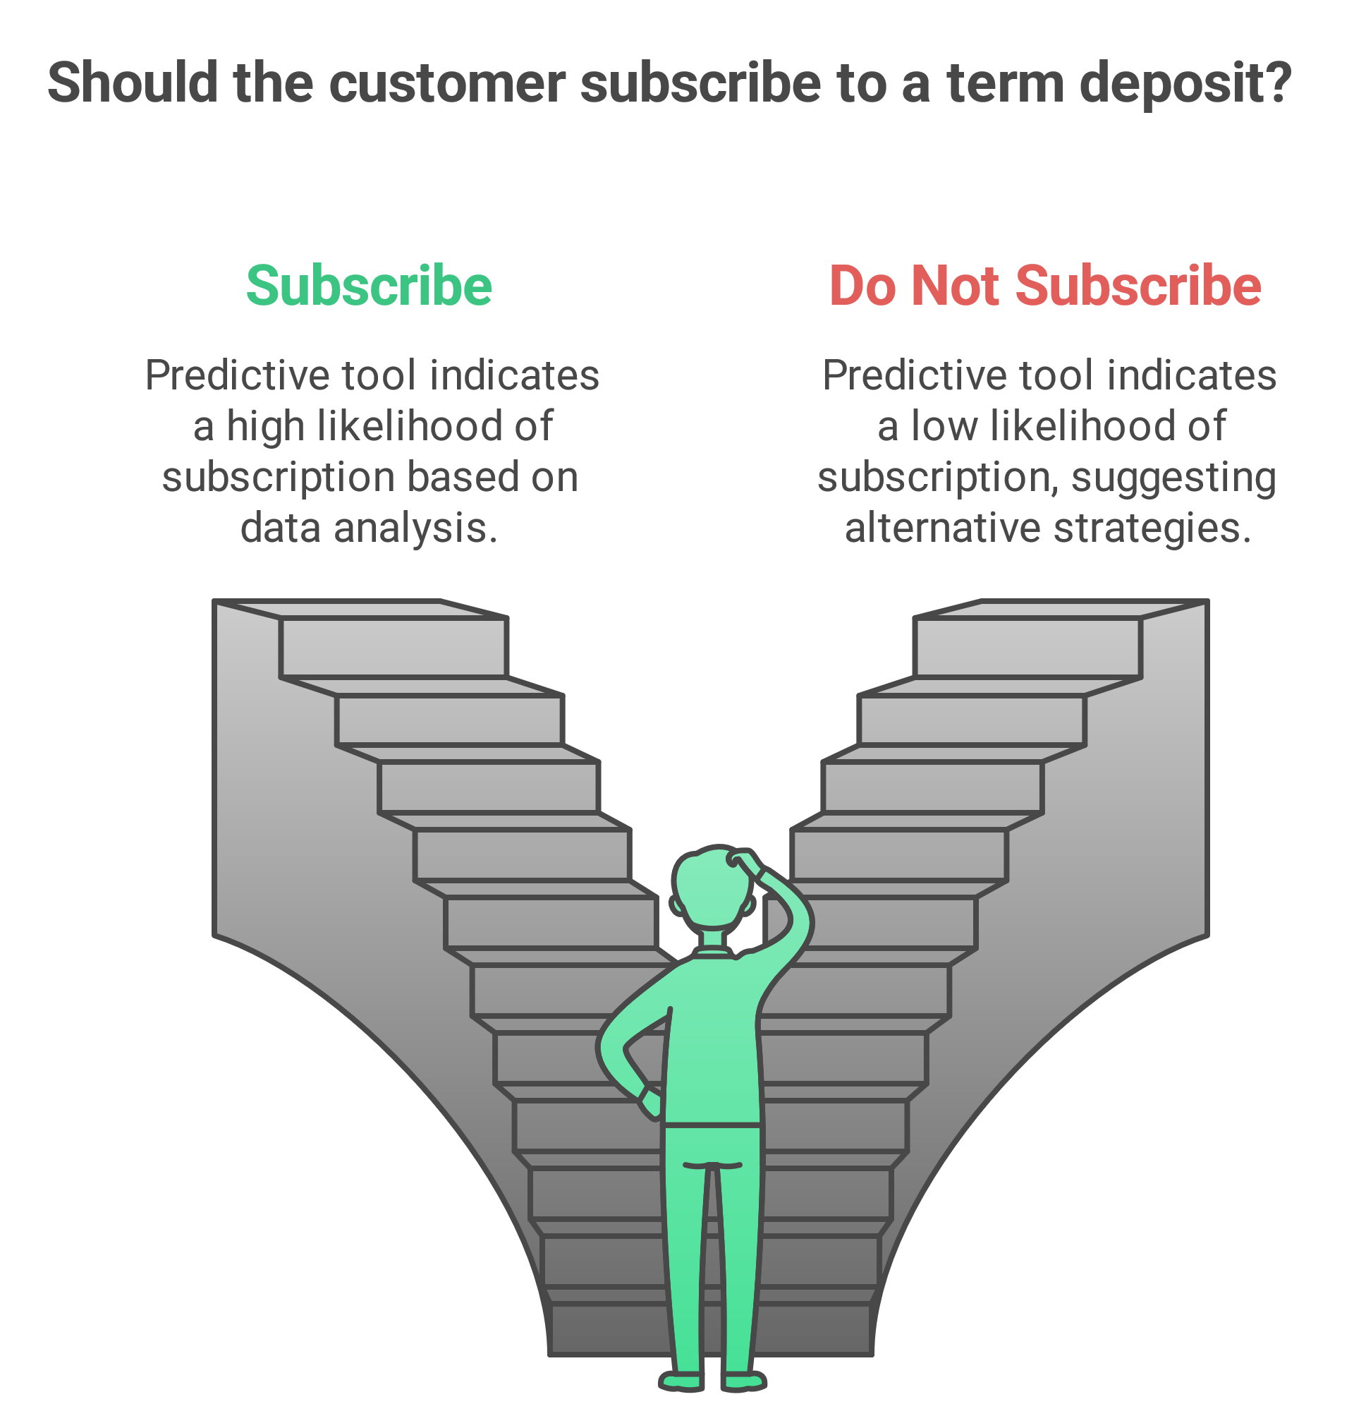

**Figure 1. A diagram to illustrate the goal of the bank term deposit prediction tool.**

**1.1 Background Information**

In the highly competitive banking sector, direct marketing campaigns are pivotal in attracting term deposit subscriptions. This project leverages machine learning to predict the likelihood of clients subscribing, using customer demographics, financial data, and past interactions. By uncovering patterns in customer behaviour and campaign performance, banks can optimize strategies to drive higher conversion rates.

The economic context from May 2008 to November 2010 adds significant relevance to this initiative. During this period, Europe grappled with the global financial crisis. This was characterized by severe economic contraction, rising unemployment, and diminished consumer confidence. The crisis led to sovereign debt issues in countries such as Greece, Portugal, and Ireland, necessitating bailouts and austerity measures ([Economics Observatory](https://www.economicsobservatory.com/why-did-the-global-financial-crisis-of-2007-09-happen)). For banks, this period was marked by tighter liquidity, heightened scrutiny, and a need for innovative strategies to maintain customer engagement.

The project’s primary objective is to build a predictive model that forecasts subscription outcomes, with a secondary goal of offering actionable insights into the factors influencing client decisions. These insights are expected to empower marketing and sales teams, campaign managers, and data analysts to create refined, data-driven strategies that resonate with target audiences. By situating this effort in the context of economic volatility, the project also ensures that banks can sustain meaningful client relationships and achieve long-term growth, even amid financial uncertainty.

**1.2 Key Predictors of Term Deposit Subscription**

The analysis identifies several critical categories of features that influence a client’s likelihood to subscribe to a term deposit:

* **Customer Demographics**: Variables such as age, job type, marital status, education level, and credit or loan history are pivotal in capturing socio-economic factors and financial stability that impact subscription decisions.
* **Financial Details**: A client’s average yearly balance serves as a strong indicator of financial capacity and investment behaviour.
* **Campaign Interaction**: Metrics like contact type, duration of the last interaction, frequency of contacts, and the outcome of previous campaigns provide insights into customer engagement and the effectiveness of past outreach efforts.
* **Temporal Patterns**: Features such as the day, month, and year of contact reveal seasonal or temporal trends in customer responsiveness.
* **Economic Indicators**: Broader economic factors, including employment variation rates, consumer price and confidence indices, market interest rates, and employment levels, shape the external context influencing client decisions.
* **Engineered Features**: The Economic Sentiment Index (ESI), aggregating key economic indicators, captures the macroeconomic environment’s impact on customer behaviour, offering a holistic perspective.

**1.3 Hypothesis**

To build a robust foundation for the analysis and subsequent development of the prediction tool, the following hypotheses were formulated:

* **Null Hypothesis (H₀)**: There is no significant effect of the Economic Sentiment Index (ESI) on the likelihood of a customer subscribing to a term deposit, and this effect does not vary significantly across the year span.
* **Alternative Hypothesis (H₁)**: There is a significant effect of the Economic Sentiment Index (ESI) on the likelihood of a customer subscribing to a term deposit, and this effect varies significantly across the year span.

By addressing these hypotheses, the analysis aims to determine whether a comprehensive indicator of the broader economic environment (ESI) plays a crucial role in influencing subscription decisions. The findings are expected to provide strategic insights into tailoring campaigns for varying economic conditions.

**1.4 Key Business Questions**

The analysis progresses through a series of carefully curated business questions, designed to assess the null hypothesis and guide the flow of insights:

1. **What is the distribution of term deposit subscriptions (yes/no)?**

**Purpose**: Provides context by identifying the balance between subscription outcomes, ensuring model evaluation metrics align with the data.

1. **How does client demographics (e.g., age, job, marital status) relate to subscription rates?**

**Purpose**: Highlights target demographic groups more likely to subscribe, enabling focused marketing strategies.

1. **What financial indicators (e.g., balance, loan status) influence subscription likelihood?**

**Purpose**: Explores the impact of financial capacity and behaviour on subscription decisions, refining data-driven insights.

1. **What is the role of previous campaign outcomes (e.g., pdays, previous, poutcome) in predicting current subscriptions?**

**Purpose**: Leverages historical data to enhance predictions and optimize future campaign design.

1. **Which features are the most significant predictors of term deposit subscriptions?**

**Purpose**: Helps prioritize impactful data for collection and analysis, streamlining resource allocation.

1. **Is there a significant temporal variation in the impact of ESI on subscription rates?**

**Purpose**: Directly evaluates the core hypothesis, revealing whether ESI’s effect varies over time and providing actionable insights into seasonal or temporal adjustments.

By structuring the analysis around these questions, the project builds a logical progression toward validating or rejecting the null hypothesis. Each step contributes to uncovering critical insights, ultimately linking individual customer attributes and external economic factors to subscription likelihood. This cohesive flow ensures the findings not only enhance predictive accuracy but also deliver actionable recommendations to optimise marketing strategies in alignment with the bank's objectives.

**2.0 Methodology**

A structured approach is adopted for the analysis, ensuring that each step is both reproducible and aligned with the project’s goal of building an accurate prediction tool for term deposit subscriptions. The approach is designed to comprehensively explore the data, evaluate key metrics, and implement predictive modelling with rigorous validation protocols.

**2.1 Exploratory Data Analysis (EDA) and Data Cleaning**

This involved understanding the dataset, identifying potential issues, and preparing the data for modelling.

**2.1.1 Data Quality Assessment & Exploration**

* **Assess Data Structure**: Used methods like .info(), .head(), and .describe() to explore the dataset’s dimensions, data types, and summary statistics.
* **Check Duplicates**: Removed duplicate records to ensure the dataset’s integrity.
* **Validate Data Consistency**: Confirmed variable values aligned with expected ranges (e.g., ensuring all months in the month column are valid).
* **Identify Missing Values**: Verified the absence of missing values as indicated in the data description.

**2.1.2 Univariate Analysis**

Individual features were analysed through visualizations such as histograms, bar charts, and box plots to understand their distributions.

**Example**: Examined the age distribution of clients and the proportion of different job categories.

**2.1.3 Bivariate Analysis**

Relationships between pairs of features were explored using bar charts, and box plots.

**Example**: Investigated how average yearly balance (balance) varied across job types or marital statuses.

**2.1.4 Multivariate Analysis**

Complex interactions between multiple variables were analysed through advanced visualizations, such as heatmaps and pair plots.

Example: Evaluated how variables economic indicators collectively influenced the target variable (y).

**2.1.5 Handling Missing Values and Feature Engineering**

* **Verify Completeness**: Confirmed no missing values were present in the dataset.
* **Feature Transformation**: Encoded categorical variables and normalized numerical variables to improve model performance.
* **Feature Creation**: Generated new variables to capture additional insights, such as segmenting customers based on age or creating an economic sentiment index (ESI) by aggregating key economic indicators.

**2.1.6 Key Insights & Integration into Applications**

* **Hypothesis Validation**: Applied statistical tests (e.g., correlation analysis, Chi-square tests) to confirm assumptions about customer behaviour.
* **Extract Insights**: Highlighted significant factors influencing subscription outcomes, such as correlations between call duration and successful subscriptions.
* **Interactive Dashboards**: Developed dynamic visualizations using Plotly and Streamlit for effective stakeholder engagement and interactive exploration of findings.

**2.2 Key Metrics and Success Criteria for Modelling and Evaluation**

The following metrics and benchmarks were established to measure success and guide the model development process:

* **Model Accuracy**: A minimum accuracy of 85% on balanced data to ensure the model performs well overall.
* **F1 Score**: A target F1 score of > 80% to maintain a balance between precision and recall, crucial for subscription prediction.
* **ROC-AUC Score**: An ideal score of 80% to evaluate the model's ability to generalize across various thresholds.
* **Baseline Models**: At least four baseline models are implemented for performance comparison.
* **Hyperparameter Tuning**: Conducted only for baseline models that exceed their F1 score expectations to avoid unnecessary computation.

**2.3 Application Development Workflow**

**2.3.1 Local Development**

* Develop and test Streamlit app locally.
* Ensure that all features work as expected.
* Fix any bugs or issues that arise during development.

**2.3.2 Containerization**

* Create a `Dockerfile` to define app’s environment and dependencies.
* Build the Docker image and test it locally to ensure that it works in the containerized environment.
* Use Docker Compose if needed to manage complex setups with multiple services.

**2.3.3 Deployment**

* Push the Docker image to a container registry (e.g., Docker Hub).
* Deploy the containerized app to a production environment or cloud service.

**2.3.4 Testing**

* Test the containerized app in staging or a test environment to ensure it behaves as expected before production deployment.

**2.4 Protocol for Replication**

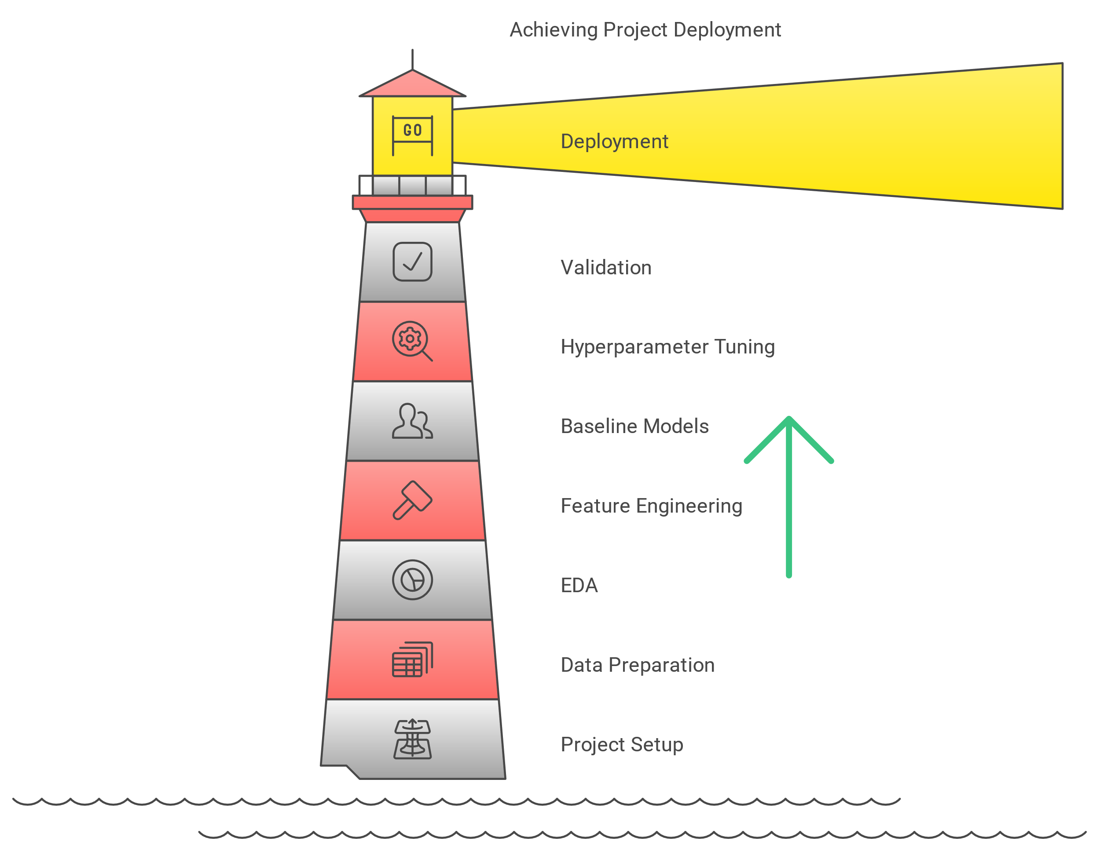

**Figure 2. Project Workflow for Bank Term Deposit Analysis and Development of Prediction Tool**

* **Project Setup**: Establish a reproducible environment and import essential libraries.
* **Data Preparation**: Collect and validate the dataset, ensuring no duplicates or missing values.
* **EDA**: Perform univariate, bivariate, and multivariate analyses to uncover key insights and relationships between features.
* **Feature Engineering**: Transform and create variables to enhance model performance.
* **Baseline Models**: Implement at least four baseline models and evaluate them against predefined metrics.
* **Hyperparameter Tuning**: Fine-tune only models that meet or exceed the F1 score target for optimization.
* **Validation**: Measure model performance using accuracy, F1 score, and ROC-AUC to ensure generalizability.
* **Deployment**: Integrate insights and predictive capabilities into actionable tools for marketing optimization.