Hidden Cost of Your Dinner Plate: Which Foods Are Destroying the Planet?
1.0 Introduction
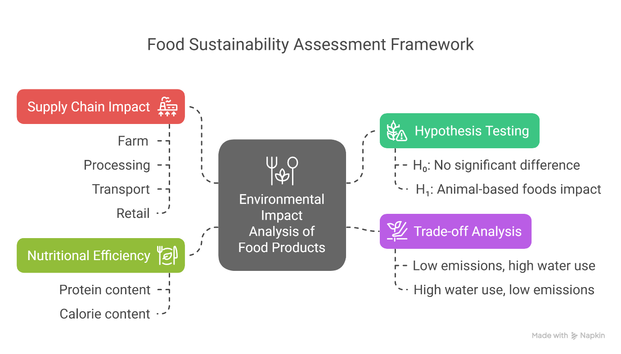
Figure 1. Conceptual framework illustrating the primary objectives and hypothesis of the food sustainability assessment. The diagram outlines how environmental impacts of animal-based and plant-based foods are evaluated across critical supply chain stages, trade-off considerations, and nutritional efficiency considering emissions, land use, water consumption, and pollution.

1.1 Background Information
The environmental impact of food production has emerged as a critical global concern, with agriculture contributing significantly to greenhouse gas (GHG) emissions, land degradation, freshwater depletion, and nutrient pollution. Research has shown that the expansion of agricultural activities has resulted in ecological damage such as deforestation, biodiversity loss, and water contamination, intensifying the urgency for sustainable food systems (Adedibu, 2023; Cimini, 2021). This project explores the environmental footprint of food production, comparing animal-based and plant-based foods in terms of their greenhouse gas emissions, land use, water consumption, and eutrophication potential. These factors are crucial to climate stability and ecological health.
Scientific studies have consistently demonstrated that plant-based diets generally impose lower environmental costs than animal-based diets, largely due to reduced emissions, smaller land requirements, and less intensive water use (Aleksandrowicz et al., 2016; Poore & Nemecek, 2018). This project builds on that foundation to deliver a robust, data-driven analysis that evaluates food products and supply chain stages from production to retail. The analysis aims to identify the most environmentally burdensome food categories, detect trade-offs between different sustainability metrics, and guide actionable strategies toward more sustainable consumption and production (Clark et al., 2019; Springmann et al., 2016).
The primary objective is to quantify and compare the environmental impacts of food products, particularly distinguishing between animal-based and plant-based sources. This includes evaluating GHG emissions, land and water use, and pollution contributions per kilogram of food. Additional aims include analysing trade-offs where certain foods might have low emissions but high-water demand, or vice versa, and examining which stages of the supply chain such as farming, processing, or transport contribute most significantly to environmental degradation. The goal is to generate insights that inform sustainable decision-making among stakeholders.
These stakeholders include consumers interested in eco-conscious dietary choices, businesses and supply chain managers seeking efficiency and accountability in sourcing and logistics, and policymakers striving to create frameworks for sustainable agriculture and environmental protection. By making these insights accessible and actionable, the project contributes to the broader goal of reducing the food system’s environmental burden while promoting health, sustainability, and resource efficiency across the value chain.

1.2 Key Factors in Environmental Impact Assessment of Food Products
This analysis focuses on the key environmental dimensions that influence the sustainability of food systems. Each metric represents a critical aspect of food production's impact on climate, land, water, and nutrient pollution. The study classifies foods into broader categories and subcategories for more structured comparisons, enabling actionable insights into the ecological burden of various food types.
Key categories assessed include:
- Greenhouse Gas Emissions: Evaluating emissions from all stages of the food supply chain.
- Land Use: Quantifying land requirements for different food products.
- Water Consumption: Measuring both total water withdrawals and stress-weighted impacts.
- Eutrophication Potential: Assessing nutrient runoff effects on freshwater ecosystems.
- Supply Chain Breakdown: Identifying stages such as farming, animal feed, transport, and packaging with the highest emissions.
To effectively assess these environmental dimensions, the following structured categories and features are used:
A. Food Product Classification
Food products are classified into animal-based and plant-based categories, with detailed subcategories to facilitate nuanced analysis.
Category | Subcategory | Food Products
Animal-Based Foods | Red Meat | Beef (beef herd), Beef (dairy herd), Lamb & Mutton, Pig Meat
 | Poultry | Poultry Meat, Eggs
 | Dairy | Milk, Cheese
 | Seafood | Fish (farmed), Shrimps (farmed)
Plant-Based Foods | Cereal Grains & Staples | Wheat & Rye (Bread), Maize (Meal), Barley (Beer), Oatmeal, Rice, Potatoes, Cassava
 | Legumes & Pulses | Other Pulses, Peas
 | Nuts & Seeds | Nuts, Groundnuts
 | Soy Products | Soymilk, Tofu
 | Vegetable Oils | Soybean Oil, Palm Oil, Sunflower Oil, Rapeseed Oil, Olive Oil
 | Vegetables | Onions & Leeks, Root Vegetables, Brassicas
 | Fruits | Tomatoes, Citrus Fruit, Bananas, Apples, Berries & Grapes
 | Beverages & Alcohol | Wine
Plant-Based Foods | Stimulants & Confectionery | Coffee, Dark Chocolate
 | Sugars | Cane Sugar, Beet Sugar

- Total Products: 43
- Animal-Based Foods: 10
- Plant-Based Foods: 33
B. Environmental Feature Engineering
Feature names from the original dataset are standardized to improve readability, consistency, and analysis.
Category | Feature | Description | Units
GHG Emissions Metrics | Land_use_Change | GHG emissions from land use change | kg CO₂-eq/kg food
 | Animal_Feed | Emissions from feed production | kg CO₂-eq/kg food
 | Farm | Direct on-farm emissions | kg CO₂-eq/kg food
 | Processing | Emissions from food processing | kg CO₂-eq/kg food
 | Transport | Emissions from transporting food | kg CO₂-eq/kg food
 | Packaging | Emissions from food packaging | kg CO₂-eq/kg food
 | Retail | Emissions from refrigeration and storage | kg CO₂-eq/kg food
GHG Emissions Metrics | Total_emissions | Combined GHG emissions from all stages | kg CO₂-eq/kg food
 | GHG_1000kcal | GHG emissions per 1000 kcal | kg CO₂-eq/1000 kcal
 | GHG_100gP | GHG emissions per 100g protein | kg CO₂-eq/100g protein
Eutrophication Metrics | Eutro_kg | Eutrophying emissions per kg of food | g PO₄-eq/kg
 | Eutro_1000kcal | Eutrophying emissions per 1000 kcal | g PO₄-eq/1000 kcal
 | Eutro_100gP | Eutrophying emissions per 100 g of protein | g PO₄-eq/100g protein
Water Use Metrics | Water_kg | Freshwater withdrawals per kg of food | L/kg
 | Water_1000kcal | Water use per 1000 kcal | L/1000 kcal
 | Water_100gP | Water use per 100 g protein | L/100g protein
Land Use Metrics | Land_kg | Land use per kg of food | m²/kg
 | Land_1000kcal | Land use per 1000 kcal | m²/1000 kcal
 | Land_100gP | Land use per 100 g of protein | m²/100g protein
Scarcity-Weighted Water Use Metrics | SW_Water_kg | Scarcity-weighted water use per kg | L/kg
 | SW_Water_1000kcal | Scarcity-weighted water use per 1000 kcal | L/1000 kcal
Scarcity-Weighted Water Use Metrics | SW_Water_100gP | Scarcity-weighted water use per 100 g of protein | L/100g protein

C. Summary of Core Metric Categories
Category | Features
GHG Emissions | Land_use_Change, Animal_Feed, Farm, Processing, Transport, Packaging, Retail, Total_emissions, GHG_1000kcal, GHG_100gP
Eutrophication | Eutro_kg, Eutro_1000kcal, Eutro_100gP
Water Use | Water_kg, Water_1000kcal, Water_100gP
Land Use | Land_kg, Land_1000kcal, Land_100gP
Water Scarcity Impact | SW_Water_kg, SW_Water_1000kcal, SW_Water_100gP

4. Metric Use Cases and Applicability
Each metric offers distinct insight depending on the analytical goal or context.
Metric Format | Use Case | Example Question
Per kg of food | Assess absolute impact per unit weight | “Which foods generate the most emissions per kg?”
Per 1000 kcal | Assess efficiency per energy delivered | “Which foods are most climate-efficient per calorie?”
Per 100g protein | Assess efficiency of protein production | “Which foods offer the lowest emissions per protein output?”

This structured approach ensures that the environmental impact of food production is thoroughly assessed, with clear pathways to evaluate ecological performance across food types and sustainability dimensions. It also facilitates consistent reporting and interpretation, helping stakeholders from policymakers to consumers make data-informed choices.

1.3 Hypothesis
To guide the analytical investigation, the following hypotheses were established to assess the comparative environmental impact of animal-based and plant-based foods:
- Null Hypothesis (H₀): There is no statistically significant difference in average environmental impact (GHG emissions, land use, water consumption) between animal-based and plant-based foods.
- Alternative Hypothesis (H₁): Optimized On average, animal-based foods have a significantly higher environmental impact across GHG emissions, land use, and water consumption compared to plant-based foods.
These hypotheses provide a structured foundation for statistical testing and support evidence-based conclusions regarding the sustainability of different food categories.

1.4 Key Business Questions
The analysis is structured around critical business questions that guide insights and decision-making:
- What is the overall environmental impact of animal-based vs. plant-based foods?
Purpose: Determine whether plant-based foods are more sustainable than animal-based foods.

- Which food categories contribute the most to greenhouse gas emissions?
Purpose: To Identify the worst offenders in terms of climate impact to promote eco-friendly diets.

- How do different supply chain stages contribute to emissions and land use?
Purpose: Pinpoint which stages (e.g., farming, transport, processing) require intervention.

- What are the trade-offs between land use, water consumption, and emissions?
Purpose: Assess if foods with low emissions have high water use, and vice versa.

- How do specific high-impact foods (e.g., beef, dairy, nuts) compared to more sustainable alternatives?
Purpose: Provide alternatives for high-impact foods to guide sustainable consumption.

- Which foods are most affected by water scarcity, and how does this compare to their nutritional value?
Purpose: Identify foods with high scarcity-weighted water use that may need water-efficient farming practices.

- How do different foods contribute to eutrophication, and what are the main drivers?
Purpose: Understand how nutrient runoff from agriculture (e.g., nitrogen and phosphorus use) impacts freshwater ecosystems.

- Which food products exert the highest pressure on freshwater resources?
Purpose: Identify foods with excessive freshwater withdrawals and assess their sustainability.
By structuring the analysis around these questions, the project builds a logical progression toward validating or rejecting the null hypothesis.

2.0 Methodology
A structured analytical approach was adopted to ensure alignment with the project’s goal of understanding the environmental impact of food production. The methodology involved in-depth exploratory data analysis, robust feature engineering, and the preparation of data for interactive dashboard visualization. These steps enable transparent communication of insights to a broad range of stakeholders, including consumers, policymakers, and sustainability analysts.
2.1 Exploratory Data Analysis (EDA) and Data Cleaning
This stage focused on understanding the dataset’s structure, addressing data quality issues, and transforming variables for analytical readiness.
2.1.1 Data Quality Assessment, Feature Engineering & Exploration
- Assess Data Structure: Used .info(), .head(), and .describe() to evaluate dataset dimensions, data types, and summary statistics.
- Duplicate Removal: Identified and removed redundant records to preserve data integrity.
- Data Consistency Validation: Verified that feature values fell within expected ranges (e.g., feature units, categorical groups).
- Missing Value Review: Confirmed data completeness and validated assumptions of no missing values or addressed them through structured methods.
- Standardization of Column Names: Long and verbose names were standardized using concise, consistent naming conventions (e.g., "Greenhouse gas emissions per 1000kcal (kgCO₂eq per 1000kcal)" → GHG_1000kcal).
- Product Categorization: Food products were classified into Animal-Based Foods and Plant-Based Foods, with further subcategories (e.g., Red Meat, Dairy, Vegetables).
- Category Assignment: Used mapping logic to assign each food item to corresponding Food_Category and Food_Subcategory, forming the structural foundation for subsequent analysis.

2.1.2 Univariate Analysis
- Numerical Features: Explored the distribution of environmental metrics (e.g., Total_emissions, Water_kg, Land_use_Change) using histograms and box plots to assess skewness and variability.
- Categorical Features: Analyzed frequency distributions of food categories and subcategories to understand the makeup of the dataset.
2.1.3 Bivariate Analysis
- Category-Based Distributions: Box plots and bar charts revealed patterns in environmental impact between animal- and plant-based products.
- Top Contributors: Created ranked bar charts to display the top 10 food products for each environmental metric based on percentage contribution.
- Heatmaps: Constructed subcategory-level heatmaps to visualize average impact per feature, supporting comparison across food groups.
- Correlation with Food Type: Quantified how strongly features correlated with Food_Category, identifying those most useful for differentiating between food types.
    - Multivariate Analysis
- Correlation Heatmaps: Showcased relationships among sustainability indicators, aiding in variable reduction and interpretation.
- Pair Plots: Visualized feature interactions with hue='Food_Category' to highlight how environmental variables cluster between animal-based and plant-based foods.
2.1.5 Handling Missing Values and Advanced Feature Engineering
- Initial Structure Review: Dropped unnecessary columns like Food_Category_num and verified data types.
- Row-wise Missing Value Handling:
  - Calculated the number and percentage of missing values across descriptive columns for each row.
  - Dropped 10 rows that had 30% or more missing data, ensuring the retained dataset remained robust and reliable for analysis.
- Imputation Summary:
  - Created df_aqinfo to track missing values, data types, and imputation strategies.
  - Performed grouped median imputation (e.g., Water_100gP by Food_Subcategory).
  - Applied regression-based imputation for interdependent features using complete-case models.
  - Adopted distribution-aware methods (mean or median) for skewed metrics.
  - Post-Imputation Validation: Ensured all imputed features were now complete and checked consistency across all records.
2.2 Interactive Dashboard Development
Dashboards were designed using Power BI to provide an intuitive understanding of environmental trends and food system impacts.
- Data Integration: Processed and cleaned datasets were imported and structured into Power BI for dashboard creation.
- Visualization Strategy: Developed dynamic charts, filters, and maps to enable user-driven exploration of key metrics.
- Stakeholder Engagement: Visualizations were tailored for diverse audiences—policy advisors, sustainability analysts, and the public—supporting evidence-based decisions for promoting sustainable diets.
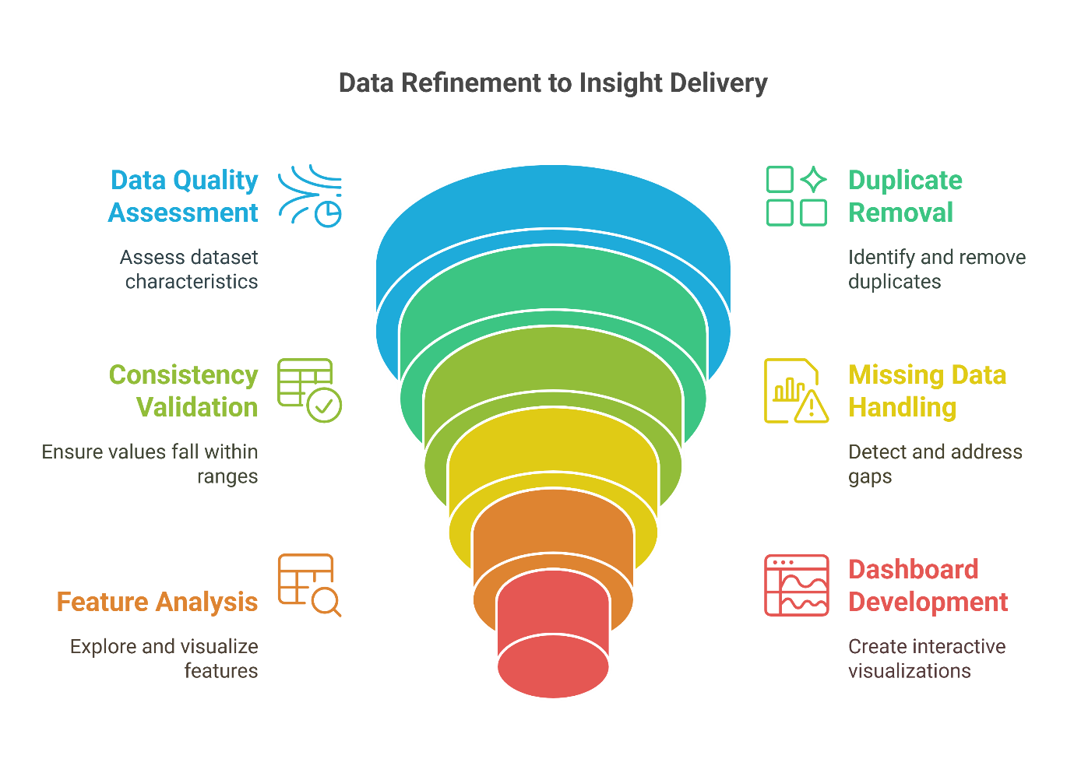
Figure 2. Illustration of the data refinement process, showcasing key steps from data quality assessment and duplicate removal to feature analysis and interactive dashboard development for delivering actionable insights.
3.0 Results
3.1 Univariate Analysis
3.1.1 Categorical Features
A. Food Category Distribution
- The dataset is dominated by Plant-Based Foods (76.74%), while Animal-Based Foods (23.26%) comprise a much smaller share.
- This imbalance suggests a stronger emphasis on plant-based sources within the data, possibly due to increased interest in sustainable diets.
B. Food Subcategory Distribution
- Among subcategories, Cereal Grains & Staples (16.28%) and Fruits (13.95%) are most prevalent, underscoring their dietary importance.
- These are followed by Vegetable Oils (11.63%), Vegetables (9.30%), and Legumes and Pulses, indicating widespread representation of core plant-based food groups.
- Animal-based subcategories such as Red Meat (9.30%) and Poultry and Seafood (4.65% each) are also represented, though less prominently.
- Less frequent categories include Beverages & Alcohol (2.33%).
C. Implications
- The dataset reflects a plant-forward dietary profile, likely shaped by a sustainability-focused analytical lens.
- The wide distribution of subcategories ensures diversity in product types, enabling more nuanced analysis in subsequent sections.

3.1.2 Numerical Features
A. General Observations
- Numerical features exhibit asymmetric distributions, with positive skewness and high kurtosis, indicating the presence of outliers and long-tailed distributions.
- Feature counts range between 26 and 43, confirming the presence of missing values across some metrics.
- The disparity between mean and median values further reinforces the non-normal nature of the data.
B. Carbon Emissions and Land Use
- Total Emissions (mean = 5.97, median = 1.60, skew = 3.62) Emissions are highly skewed, with a small group of products contributing disproportionately to the total footprint.
- Farm Stage (mean = 3.47) is the most dominant emission source among all supply chain stages.
- Land-Use Change (mean = 1.26, skew = 3.69) exhibits strong skewness and high variability, reinforcing that deforestation or land conversion contributes to emissions unevenly across food products.
- Packaging, Processing, Transport, and Retail stages have minimal contribution in comparison, indicating the primary impact lies in upstream agricultural practices.
- Land Use (mean = 29.26, skew = 3.86) The wide range in land requirements suggests that some foods (e.g., red meat) require significantly more space per kilogram.
- GHG_1000kcal (mean = 5.63, skew = 3.36) and GHG_100gP (mean = 13.52, skew = 3.12) These metrics confirm that certain protein-rich foods; notably beef, lamb, and dairy are among the highest GHG emitters per calorie and per gram of protein.
C. Water Consumption Trends
- Water_kg (mean = 36,607.42, skew = 2.18) Water consumption is unevenly distributed across products, with a few outliers (e.g., nuts, chocolate) consuming large amounts.
- Water_1000kcal (mean = 17,380.58, skew = 0.68) is less skewed, indicating that per-calorie water use is more evenly distributed.
- Water_100gP (mean = 59,196.44, skew = 3.23) shows extreme variability, highlighting that water use per protein is highly inefficient for some products, particularly fruits and nuts.

D. Eutrophication Potential
- Eutro_kg (mean = 46.14, skew = 2.76) Nutrient pollution is concentrated in a few products—primarily livestock and aquaculture—due to fertilizer use and manure runoff.
- Eutro_1000kcal and Eutro_100gP follow similar skewed patterns, though the per-protein distribution appears more balanced, suggesting that nutrient efficiency varies significantly by product.

3.1.3 Summary of Key Environmental Patterns
Category | General Trend | Key Takeaways
Land Use & Change | Right-skewed, high variability | Disproportionate land demand from a few high-impact products
Water Use | Broad spread, extreme outliers | Certain foods (e.g., nuts, fruits) are extremely water-intensive
Eutrophication | Strongly skewed | Livestock and fertilizer-intensive crops drive nutrient runoff
GHG Emissions | Heavy-tailed, high outlier impact | High emissions driven primarily by animal-based products

Key takeaways
- The univariate analysis highlights clear disparities in environmental impact across food types, especially between plant-based and animal-based products.
- The distributions of emissions, land use, and water usage indicate that a few high-impact foods significantly influence overall sustainability metrics.
- These insights set the stage for deeper comparative analysis to validate hypotheses and explore targeted sustainability interventions.

  - Bivariate Analysis
3.2.1 Environmental Impact Comparison by Food Category
A. Higher Environmental Burden from Animal-Based Foods:
- Animal Feed, Farm Emissions, and Land Use Change Emissions are significantly higher in Animal-Based Foods, highlighting the disproportionate environmental cost of livestock farming.
- Total Emissions and GHG Emissions (both per kg and per kcal) are markedly higher for animal products.
B. Resource Intensity and Efficiency:
- Water Usage (per kg and per 1000 kcal) is considerably greater for animal-based foods, particularly dairy and meat products.
- Land Use (per kg, per kcal, per 100g protein) reveals that red meats require significantly more land for the same nutritional output.
- Eutrophication Indicators show greater pollution potential from animal-based agriculture due to manure runoff and fertilizer use.
C. Supply Chain Contributions:
- Emissions from Processing, Transport, and Packaging tend to be higher in animal-based foods, reflecting energy-intensive supply chains.
- Retail emissions are low across the board but slightly elevated for refrigerated goods such as meat and dairy.

3.2.2 Top Contributors by Metric
A. Land Use Change (Emissions):
- Beef (beef herd) leads land-use change emissions (30.07%), followed by Dark Chocolate (26.38%) and Cheese (8.30%).
- This reflects the GHG emissions from deforestation or land transformation, especially in livestock grazing and tropical crop plantations like cocoa and coffee.

B. Animal Feed Emissions:
- Pig Meat (14.87%), Beef (dairy herd) and Shrimps (farmed) (both 12.82%) dominate feed-related emissions.
- Feed production is a major upstream driver of emissions in animal agriculture.
C. Farm Stage Emissions:
- Beef (beef herd) (26.41%), Lamb & Mutton (13.07%), and Beef (dairy herd) (10.52%) contribute the most.
- These values underscore the direct on-farm GHG emissions from livestock.
D. Processing, Transport & Packaging:
- Palm Oil and Beef (beef herd) lead processing emissions (11.93%).
- Cane Sugar (9.52%), Beet Sugar (7.14%), and Olive Oil (5.95%) dominate transport emissions, showing food miles matter for some plant-based goods.
- Coffee (13.79%) tops packaging emissions, likely due to multilayer storage needs.
E. Retail Emissions:
- Highest for Beer, Soymilk, Tofu, Milk, and Cheese (10%), related to refrigeration.
- Fresh meat products like Beef and Poultry show moderate but consistent retail emissions (6.67%).
F. Total Emissions (kg CO₂-eq):
- Beef (beef herd) (23.21%) remains the single largest contributor.
- High contributions from Lamb & Mutton, Cheese, Dark Chocolate, and Coffee reinforce that some plant-based items also have intensive footprints.
G. GHG per 1000 kcal:
- Coffee (27.40%), Beef (beef herd) (19.60%), and Lamb & Mutton (6.74%) top the list.
- Calorically dense yet low-efficiency foods like Tomatoes (5.92%) also appear.
H. GHG per 100g Protein:
- Dark Chocolate (25.55%), Beef (beef herd) (13.66%), and Coffee (9.77%) dominate.
- Some low-protein, high-impact foods (e.g., fruits, chocolate) show elevated GHG per protein unit.
3.2.3 Land Use Insights (m²)
A. Total Land Use per kg:
- Lamb & Mutton (33.25%) and Beef (beef herd) (29.33%) top the list.
- Plant-based products like Chocolate, Coffee, and Oil Crops also require substantial land.
B. Land Use per 1000 kcal:
- Inefficiencies highlighted for Beef (29.15%), Lamb (28.46%), and Coffee (9.42%).
- Energy yield relative to land requirement is poor for some plant-based foods too.
C. Land Use per 100g Protein:
- Lamb (23.52%), Beef (20.82%), and Dark Chocolate (17.55%) require the most land per protein.
- More sustainable options include legumes, poultry, and fish.

3.2.4 Water Use Insights (L)
A. Water Use per kg:
- Highest: Cheese (15.82%), Nuts (11.66%), Farmed Fish (10.42%), and Rice (6.34%).
- Livestock and nuts require intensive water inputs.
B. Water Use per 1000 kcal:
- Farmed Fish (13.63%) and Tomatoes (12.87%) show poor water-to-energy conversion.
- Fruits and dairy continue to feature prominently.
C. Water Use per 100g Protein:
- Apples (16.06%), Berries (11.22%), and Tomatoes (8.99%) have poor water efficiency for protein.
- Cheese and nuts are also high.

3.2.5 Eutrophication Insights (g PO₄-eq)
A. Eutro_kg:
- Dominated by Beef (dairy herd) (20.83%) and Beef (beef herd) (17.19%).
- Farmed Fish (13.41%), Coffee (6.30%), and Chocolate (4.97%) follow.
B. Eutro_1000kcal and Eutro_100gP:
- Coffee (22.00%) and Dark Chocolate (12.22%) show high eutrophication per energy/protein.
- Nutrient-intensive farming of tropical and livestock-based products is a concern.

3.2.6 Scarcity-Weighted Water Use (L)
A. Per kg of Food:
- Nuts, Cheese, and Olive Oil dominate water stress impact.
- Animal agriculture (e.g., Lamb & Mutton, Beef, Pig Meat) remains a major contributor.
B. Per 1000 kcal and 100g Protein:
- Apples, Berries, and Brassicas show poor water efficiency for nutritional return.
- Nuts and dairy remain consistently intensive across all metrics.

3.2.6 Subcategory-Level Environmental Comparison
Food Subcategory | High Impact Areas | Interpretation
Red Meat | Land Use Change, Farm, GHG Emissions, Total Emissions | High impact across multiple sustainability metrics.
Dairy | Animal Feed, Total Emissions, GHG_100gP | Significant but generally lower than red meat.
Fruits | SW_Water_1000kcal, SW_Water_100gP | Low in emissions but water-intensive per protein.
Nuts & Seeds | Water_kg, SW_Water_100gP | High water use; requires efficient irrigation.
Seafood | Animal Feed, Water Use, GHG Emissions | Environmental pressure from feed and aquaculture systems.
Cereal Grains | Balanced impact across features | Relatively sustainable.
Beverages and Alcohol | Packaging | Low emissions, some packaging-related concerns.

3.2.7 Correlation Analysis with Food Category
The table below summarizes the correlation strength between environmental metrics and Food Category (Animal-Based = 1, Plant-Based = 0):
Correlation Range | Feature | Interpretation
Strong Positive (≥ 0.55) | Animal_Feed (0.91), Farm (0.55), Retail (0.56), Total_emissions (0.55), Eutro_kg (0.64) | Strongly associated with animal-based products.
Moderate Positive (0.30–0.50) | Water_kg, Water_1000kcal, Land_kg, Land_1000kcal, Processing, SW_Water_kg, Eutro_1000kcal, GHG_1000kcal, Land_use_Change | Generally higher in animal-based foods, but with some overlap.
Weak or Negligible (≤ 0.15 or negative) | Transport, Packaging, GHG_100gP, Water_100gP, SW_Water_100gP | Not strongly tied to food origin; some water metrics skew toward plant-based foods with low protein density.
Key Takeaways
- Animal-based foods consistently show a higher environmental footprint across most sustainability metrics.
- The largest impacts arise from farm emissions, animal feed production, and eutrophication due to nutrient runoff.
- Land use, water use, and total GHG emissions are significantly greater for animal products.
- Plant-based diets offer a promising route to reducing environmental degradation.
- Some plant-based products (e.g., coffee, chocolate, and nuts) also have notable impacts when assessed per kilocalorie or per 100g protein.
- A nuanced perspective is necessary; sustainability should be assessed on multiple dimensions, not just food origin.

3.3 Multivariate Analysis
3.3.1 Strong Positive Correlations
- Total Emissions show very high correlation with:
  - Farm activities (r = 0.97)
  - Land_kg (r = 0.83)
  - GHG_1000kcal (r = 0.70)
  - Animal_Feed (r = 0.57)
Emissions are predominantly driven by on-farm activities and land use, with animal feed also playing a significant role. These processes should be the focal points for reducing the environmental impact of food systems.
- Land_kg and Land_1000kcal (r = 0.97) indicates consistent land pressure across both mass-based and energy-based perspectives.
- Water_kg and SW_Water_kg (r = 0.85) suggests that surface water use is a major component of total water use, with similar trends across food types.
- Eutro_kg has strong correlations with:
  - Farm (r = 0.77)
  - Total_emissions (r = 0.76)
  - Processing (r = 0.61)
Suggests eutrophication is influenced heavily by early production stages.

    - Weak or Negative Correlations
- Transport exhibits low or negative correlations with other features. This implies that transport emissions are relatively decoupled from the production processes.
- Packaging shows weak to negative associations with sustainability metrics
  - E.g., SW_Water_1000kcal (r = -0.27), Water_1000kcal (r = -0.29) indicates a relatively minor environmental contribution in the dataset.
- Retail is weakly correlated across all metrics
  - Highest observed correlation is with Land_1000kcal (r = 0.52). Downstream impacts such as retail have limited influence on total emissions and resource use.
3.3.3 Interesting Mid-Range Correlations
- Processing correlates moderately with:
  - GHG_1000kcal (r = 0.49)
  - Eutro_kg (r = 0.61) reflects a secondary but noteworthy contribution, particularly toward eutrophication.
- SW_Water_1000kcal is moderately correlated with:
  - SW_Water_kg (r = 0.59)
  - Water_1000kcal (r = 0.66) reinforces the reliability of using calorie-based water stress indicators.
- GHG_1000kcal and Land_1000kcal (r = 0.65). Emission-intensive foods tend to also demand more land per calorie, highlighting a shared environmental burden.

4.0 Discussion
4.1 Assessing the Environmental Impact of Animal-Based vs. Plant-Based Foods
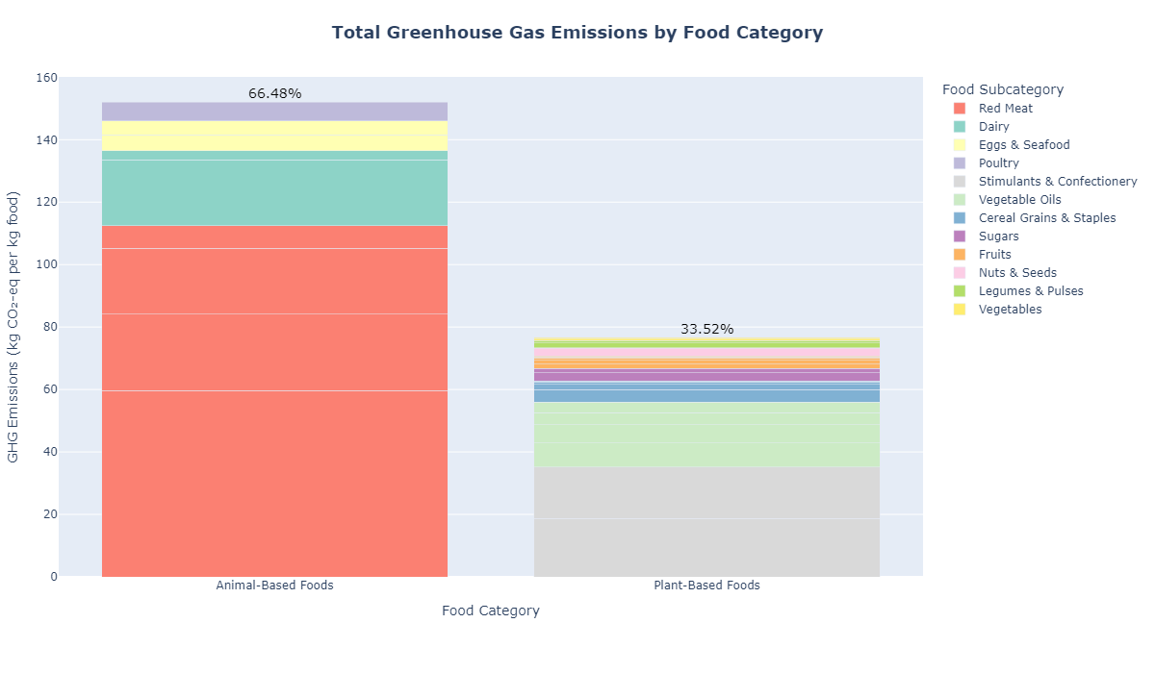
Figure 3. Comparison of greenhouse gas emissions (GHG) from animal-based and plant-based foods. The plot highlights the contribution of each food category to total emissions, emphasizing the higher environmental impact of animal-derived products, especially red meat, compared to plant-based options such as cereals, legumes, vegetables, and fruits.
The comparison between animal-based and plant-based foods reveals a stark contrast in their environmental footprints, especially concerning greenhouse gas (GHG) emissions. The analysis shows that animal-based foods account for 66.48% of total GHG emissions, more than double the 33.52% contribution from plant-based foods. This disparity underscores the disproportionately large climate burden carried by animal-derived products.
Within the animal-based category, red meat stands out as the most significant contributor, followed by dairy, poultry, eggs, and seafood. The high emissions from red meat are largely driven by methane release from ruminants, manure management, and feed production. These upstream processes intensify the climate impact associated with meat-heavy diets.
In contrast, plant-based food categories including cereal grains, legumes, vegetables, and fruits, consistently exhibit much lower GHG emissions per kilogram of product. While some plant-derived products such as nuts, chocolate, and coffee have higher impacts under specific metrics (e.g., per kcal or per gram of protein), their overall contributions to total emissions remain relatively low.
This disparity has critical implications for sustainability strategies. A transition toward plant-based diets, particularly those emphasizing legumes, grains, and vegetables can offer significant reductions in GHG emissions. Moreover, the data highlight that targeting reductions in red meat consumption alone could yield substantial climate benefits.
Observation | Implication
Animal-based foods contribute twice as much to GHG emissions as plant-based foods. | Promoting plant-forward diets can serve as a key climate mitigation strategy.
Red meat is the most intensive emitter across all food types. | Public awareness and policy should focus on reducing red meat consumption.
Legumes, vegetables, and grains have minimal climate impact. | These should be emphasized in sustainable dietary guidelines and food policies.

In conclusion, the analysis provides strong evidence supporting the environmental advantages of plant-based food systems. From a policy perspective, these findings can inform dietary recommendations, agricultural subsidies, and climate action plans aimed at reducing the carbon footprint of the global food supply.

4.2 Identifying the Highest and Lowest Greenhouse Gas Emitters
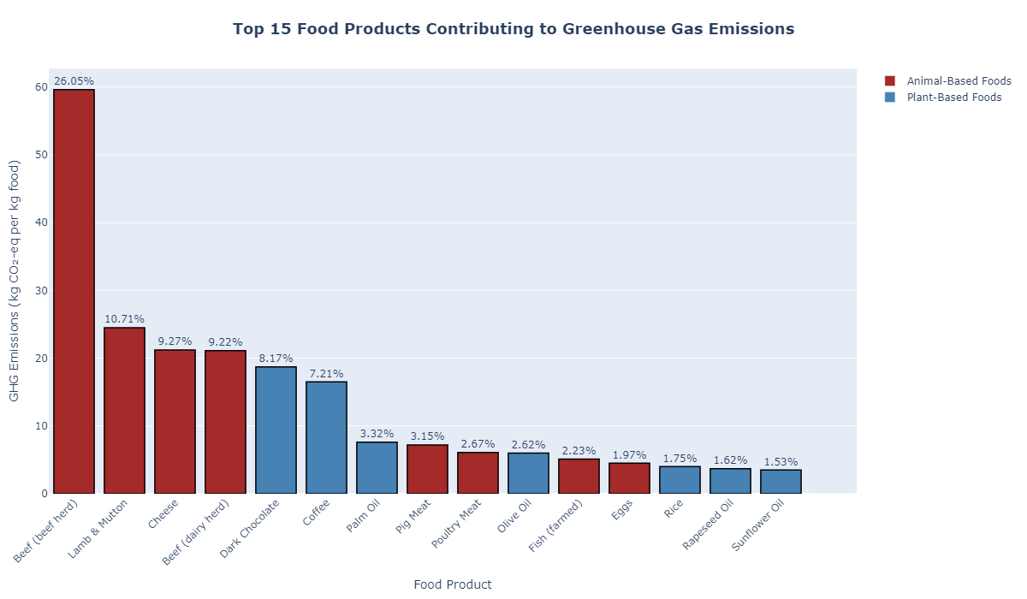
Figure 4. Top 15 Highest GHG Emitting Food Products (per kg food). This plot displays the food products with the highest greenhouse gas emissions per kilogram of food. Animal-based foods, particularly beef (from both beef and dairy herds), lamb & mutton, and cheese, dominate the rankings, with emissions ranging from ~23 to ~60 kg CO₂-equivalents per kg of food. Two plant-based products; dark chocolate and coffee, also appear among the top emitters ranging from ~16 to ~19 kg CO₂-equivalents per kg of food.
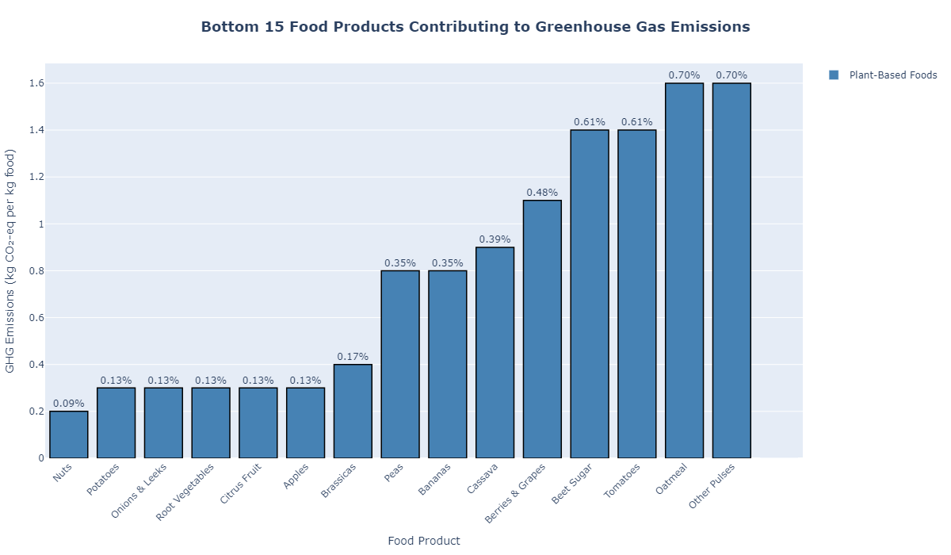
Figure 5. Top 5 Lowest GHG Emitting Food Products (per kg food). This plot highlights the lowest GHG-emitting foods per kilogram of food, all of which are plant-based. Foods like nuts, potatoes, onions, root vegetables, and citrus fruits produce less than 0.4 kg CO₂-equivalents per kg food, making them climate-efficient dietary options.
One of the central aims of this analysis was to determine which food products contribute most significantly to greenhouse gas (GHG) emissions, thereby identifying strategic targets for dietary and production-based sustainability interventions.
The findings reveal a clear dominance of animal-based foods among the highest GHG emitters. Notably, beef from the beef herd emerges as the single worst offender, contributing approximately 26% of total emissions overall. This is followed closely by lamb & mutton, cheese, and beef from dairy herds; all of which are animal-derived and intensive in terms of both feed production and methane emissions.
Interestingly, two plant-based products, dark chocolate and coffee, also feature among the top emitters, primarily due to land use change, fertilizer use, and energy-intensive processing in tropical production regions. Their inclusion reinforces the importance of assessing environmental impact on a product-specific rather than category-wide basis.
At the other end of the spectrum, the lowest GHG emitters are entirely plant-based, with foods like nuts, potatoes, onions, root vegetables, and citrus fruits emitting less than 0.4 kg CO₂-eq per kg of food. These products are nutrient-rich, calorie-efficient, and environmentally sustainable, making them optimal candidates for low-impact dietary recommendations.
Observation | Implication
Animal-based foods dominate the top GHG contributors. | Reducing intake of red meat and dairy could yield substantial reductions in carbon emissions.
Certain plant-based items (e.g., chocolate, coffee) rank high. | Life cycle emissions must be assessed holistically—not all plant-based foods are low-impact.
Low-emission foods are plant-based and nutrient-rich. | Potatoes, legumes, and vegetables offer scalable, eco-friendly alternatives.
In conclusion, this evidence strongly supports the promotion of climate-friendly diets, centred around plant-based foods. Public campaigns, supply chain restructuring, and dietary guidelines should prioritize reducing consumption of red meat and high-emission animal products, while also considering the hidden impacts of certain plant-derived commodities.

4.3 Supply Chain Emissions: Identifying Critical Stages for Intervention
Understanding where greenhouse gas (GHG) emissions originate within the food supply chain is essential to identifying intervention points for sustainability. The analysis reveals that emissions are highly concentrated in upstream processes, particularly farming and land use change, while downstream stages like transport and retail contribute minimally. The plot confirms that over 80% of total emissions are generated in the farm and land transformation stages alone, with animal-based production being the largest driver.
4.3.1 Breakdown of GHG Emissions by Supply Chain Stage
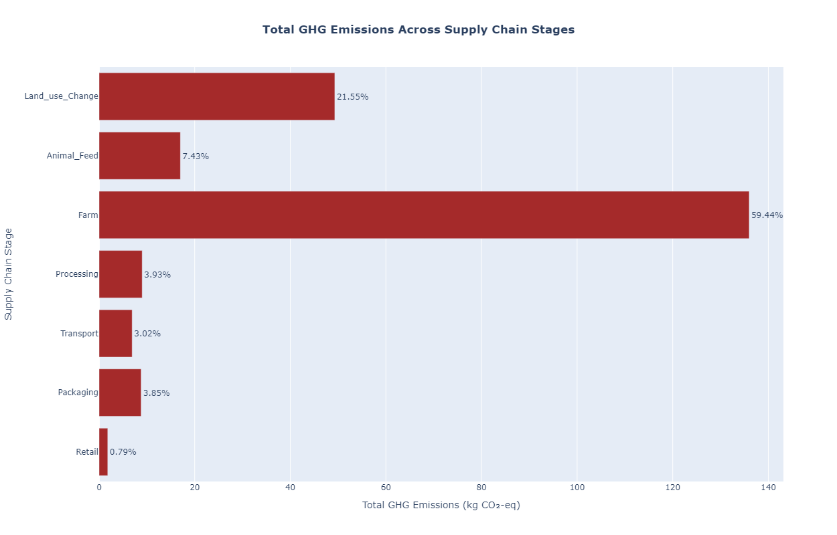
Figure 6. Proportional contribution of supply chain stages to total greenhouse gas (GHG) emissions across all food products. This chart illustrates the percentage share of each stage; farm, land use change, animal feed, processing, transport, packaging, and retail – in the total emissions footprint of the food system. The farm stage accounts for nearly 60% of total emissions, followed by land use change (21.55%) and animal feed (7.43%). Downstream processes contribute relatively minor shares, emphasizing the importance of upstream interventions to reduce environmental impact.
To reduce food system emissions effectively, targeted strategies are needed at the stages with the most impact:
- Farm Stage (59.44%) – Highest Priority
  - Encourage regenerative agricultural practices and precision farming.
  - Improve fertilizer application efficiency and manage manure more sustainably.
  - Promote low-emission livestock management techniques.
  - Land Use Change (21.55%) – Critical
  - Implement forest preservation policies and discourage agricultural expansion into natural habitats.
  - Support reforestation, agroforestry, and the protection of carbon-rich ecosystems.
- Animal Feed (7.43%) – Medium Impact
  - Focus on feed optimization, including sourcing alternatives that require less land and water.
  - Improve the sustainability of feed crop cultivation.
- Secondary Stages (Each <4%) – Efficiency Gains
  - Processing & Packaging: Streamline energy use, adopt circular packaging solutions.
  - Transport & Retail: Optimize logistics, invest in low-emission cold chains, and adopt energy-efficient retail technologies.
- To understand emissions at the product level, two heatmaps were used to analyze GHG contributions by stage for both top 15 highest and bottom 15 lowest emitting foods.

4.3.2 Top Emitting Food Products: Intensive and Complex Supply Chains
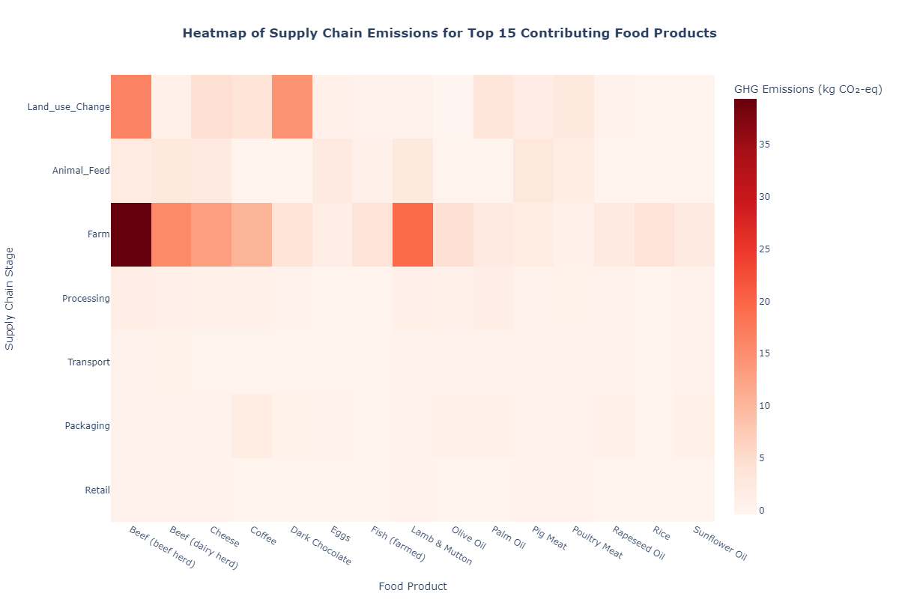
Figure 7. GHG emissions breakdown by supply chain stage for the 15 highest-emitting food products. This heatmap highlights emissions intensity across the supply chain for high-impact foods, primarily animal-based products and tropical commodities. The farm stage dominates, followed by significant contributions from land use change and animal feed. Downstream processes such as processing, packaging, and retail contribute marginally by comparison.
This heatmap shows GHG emissions across supply chain stages for the top 15 highest-emitting food products, which are mostly animal-based or tropical commodity crops. The key observations made include:
- The farm stage overwhelmingly dominates emissions, especially for ruminant meats (beef, lamb), driven by methane emissions, feed cultivation, and fertilizer use.
- Land use change is the second largest source, particularly for products associated with deforestation like beef, palm oil, chocolate, and coffee.
- Animal feed is a notable contributor for monogastric animals and aquaculture products such as pig meat, poultry, and fish.
- Processing and packaging contribute modestly for processed or shelf-stable items like coffee.
- Transport and retail remain marginal.
Supply Chain Stage | Overall Impact | Intervention Priority | Notes
Farm | Very High | Highest | Especially for beef, lamb, and cheese
Land_Use_Change | High | High | Especially for beef, palm oil, chocolate, coffee
Animal_Feed | Moderate | Medium | Pig, poultry, fish, dairy
Processing | Low | Low | Slightly relevant for cheese, chocolate
Transport | Very Low | Low | Minimal contribution overall
Packaging | Very Low | Low | Slight uptick in processed goods
Retail | Very Low | Low | Negligible impact

4.3.3 Low-Emitting Food Product: Lean and Localized Systems
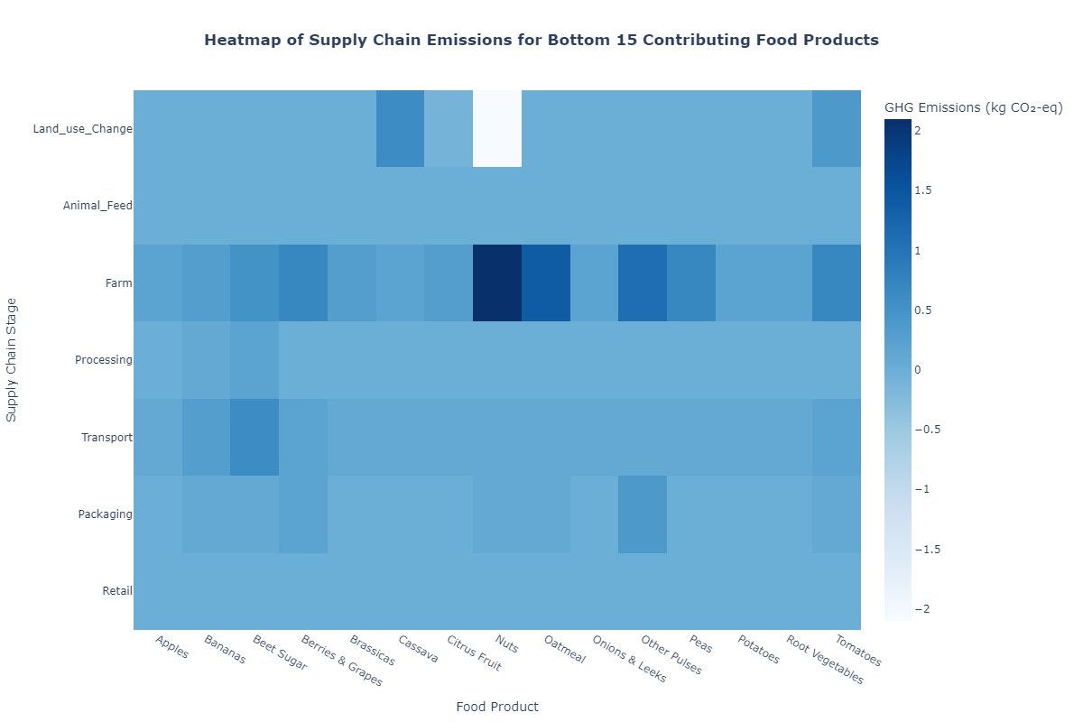
Figure 8. GHG emissions breakdown by supply chain stage for the 15 lowest-emitting food products. This heatmap visualizes the greenhouse gas contributions (kg CO₂-eq) from each stage of the food supply chain; farm for foods with the lowest total emissions. Although emissions are generally low, the farm stage remains the most significant contributor, while land use change, transport, packaging and downstream processes play a minimal role.

A separate heatmap analysis of the bottom 15 GHG-contributing food products (mostly plant-based) reveals important nuances:
- While these products are low emitters overall, the farm stage remains the dominant contributor.
- Transport emissions become slightly more relevant for perishable goods (e.g., bananas, berries, tomatoes) due to refrigeration and long shipping distances.
- Packaging and land use change are nearly negligible, and processing, and retail have almost no impact in this group.
Supply Chain Stage | Overall Impact | Intervention Priority | Notes
Farm | Moderate | Medium | Still the largest contributor, even in low-GHG foods.
Land Use Change | Very Low | Very Low | Negligible in most low-emission plant foods.
Transport | Low | Low–Medium | More relevant for imported or perishable items.
Processing | Very Low | Very Low | Minimal emissions.
Packaging | Very Low | Very Low | Slight spikes in some cases (e.g., pulses).
Retail | Very Low | Very Low | Uniformly insignificant.

The findings are clear: to significantly reduce GHG emissions in food systems, the greatest impact can be achieved by targeting upstream activities, especially farming practices and land use change prevention. While secondary stages like transport and packaging offer marginal opportunities for efficiency gains, their cumulative effect is small compared to upstream interventions.
However, even low-emitting foods are not exempt since they can still benefit from improved farm practices and optimized transport strategies, especially when dealing with fresh or globally sourced items.
This layered understanding of the food supply chain highlights the importance of tailored sustainability strategies emphasizing that not all stages, or all food types, require the same intensity of intervention.

