UNIVERSITY OF BUEA
College of Technology (COT)
Department of Computer Engineering
2025/2026 Academic Year

CEC418: DATA MINING
PROJECT REPORT

Predicting Student Productivity Using Machine Learning

Student Name | Nfor Algor Shey
Matricule | CT23A118
Course | CEC420 Data Mining
Lecturer | Mr. Kometa Denis
Department | Computer Engineering, COT
Academic Year | 2025/2026

Contents
1. Introduction 2
1.1 Problem Statement 2
1.2 Objectives 2
2. Theoretical Background 3
2.1 Data Mining and Knowledge Discovery (KDD) 3
2.2 Data Mining Tasks 3
2.3 Data Warehouse Concepts 3
2.4 Statistical Foundations 3
3. Dataset and Data Preprocessing 5
3.1 Dataset Overview 5
3.2 Feature Descriptions 5
3.3 Target Variable Engineering 5
3.4 Data Cleaning 6
4. Exploratory Data Analysis (EDA) 7
4.1 Statistical Summaries 7
4.2 Productivity Class Distribution 7
4.3 Feature Histograms 7
4.4 Boxplot Analysis 8
4.5 Correlation Heatmap 8
5. Classification Models 10
5.1 Feature Set and Train/Test Split 10
5.2 Decision Tree Classifier 10
5.3 Random Forest Classifier 11
5.4 Model Comparison 11
5.5 Feature Importance 12
6. Clustering Analysis (K-Means) 13
6.1 K-Means Algorithm 13
6.2 Cluster Visualisation 13
6.4 Cluster Interpretation 13
7. Results and Conclusion 14
7.1 Summary of Results 14
7.2 Conclusion 14
References 14

1. Introduction
In contemporary educational environments, understanding the factors that influence student productivity has become a critical concern for academic institutions. Traditional approaches to academic monitoring rely primarily on attendance records and examination results, which are often reactive rather than predictive. This project explores a data-driven approach to predicting student productivity levels by applying machine learning techniques to a dataset of 20,000 student behavioural and academic records.

1.1 Problem Statement
Students and institutions often lack timely, data-driven insight into the behavioural patterns that lead to low academic productivity. Manual analysis of student habits is time-consuming and infeasible at scale. The question this project seeks to answer is: given a student's daily habits study hours, sleep, social media use, gaming, exercise, stress levels, attendance, and assignments completed can we reliably predict whether their productivity will be Low, Medium, or High?

1.2 Objectives
- Perform exploratory data analysis (EDA) on a 20,000-record student dataset to understand feature distributions and relationships.
- Apply data mining techniques specifically classification, clustering, and association rule discovery to uncover patterns in student behaviour.
- Build and compare two predictive classification models: Decision Tree and Random Forest.
- Evaluate model performance and select the best model for deployment.
- Deploy the trained model in an interactive Streamlit web application for real-time productivity prediction.

2. Theoretical Background
This section provides the theoretical foundation for the tools and techniques applied in the project.

2.1 Data Mining and Knowledge Discovery (KDD)
Data mining is the efficient discovery of previously unknown, valid, potentially useful, and understandable patterns in large datasets. The broader KDD process includes: learning the application domain, creating a target dataset, data cleaning and preprocessing, data reduction and transformation, choosing the mining algorithm, pattern evaluation, and use of discovered knowledge.
This project follows this pipeline precisely. The dataset was first inspected and cleaned (KDD steps 1–3), features were engineered and encoded (step 4), classification and clustering algorithms were applied (steps 5–6), and results were interpreted and deployed (step 7).

2.2 Data Mining Tasks
- Predictive tasks use known attributes to predict unknown or future values. This project's primary task is classification predicting the Productivity class (Low, Medium, High) from student habit features.
- Descriptive tasks find human-interpretable patterns. This project applies two descriptive tasks: Clustering (K-Means) to discover natural groupings in student behaviour, and Association Rule Discovery (Apriori algorithm) to uncover co-occurring behavioural patterns linked to high productivity.

2.3 Data Warehouse Concepts
The dataset used in this project exhibits properties of a well-structured data warehouse it is subject-oriented (focused on student behaviour), integrated (all features in a single table), time-invariant (snapshot data), and nonvolatile (read-only for mining purposes). The 20,000-record size places it in the Gigabyte range consistent with Unit 1's discussion of Very Large Databases .

2.4 Statistical Foundations
The statistical concepts applied in this project central tendency (mean, median, mode), dispersion (variance, standard deviation, IQR), correlation analysis, and visualisation techniques (histograms, boxplots, scatter charts) are all grounded. Correlation analysis was used via the heatmap to identify which features most strongly relate to the productivity score. Attribute relevance informed feature selection, with 9 features retained for modelling.

3. Dataset and Data Preprocessing

3.1 Dataset Overview
The dataset used is the Student Productivity and Distraction Dataset, containing 20,000 records of university students. Each record captures behavioural and academic attributes for a single student.
Property | Detail
Total Records | 20,000
Total Features | 11 (9 used for modelling)
Target Variable | productivity_score (continuous, 0–100)
Source Format | CSV file
Missing Values | None after cleaning
Duplicate Rows | Removed during preprocessing

3.2 Feature Descriptions
Feature | Description
study_hours_per_day | Hours spent studying daily (0.5–10.0)
sleep_hours | Hours of sleep per night (3.0–12.0)
social_media_hours | Daily social media usage in hours (0–10)
gaming_hours | Daily gaming hours (0–10)
exercise_minutes | Minutes of exercise per day (0–120)
stress_level | Self-reported stress on scale 1–10
assignments_completed | Number of assignments completed that week (0–15)
attendance_percentage | Percentage of classes attended (0–100%)
gender | Student gender (Male/Female) label-encoded
productivity_score | Continuous score 0–100 (source target variable)

3.3 Target Variable Engineering
The raw target variable, productivity_score, is a continuous value between 0 and 100. To apply classification algorithms, it was discretised into three classes using domain-informed thresholds:
Class Label | Score Range
Low | productivity_score < 40
Medium | 40 ≤ productivity_score < 70
High | productivity_score ≥ 70
This binning is consistent with the data mining concept of discretisation, which transforms continuous attributes into categorical ones to enable classification and association rule mining .

3.4 Data Cleaning
- Duplicate records were removed using pandas drop_duplicates().
- Rows with missing values were removed using dropna(). No missing values were found in this dataset.
- The gender column was label-encoded (Male = 1, Female = 0) using sklearn's LabelEncoder, consistent with the integration/encoding step of the KDD process.
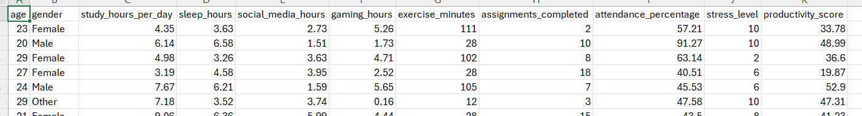
Figure 1

4. Exploratory Data Analysis (EDA)
Exploratory Data Analysis was performed to understand the structure, distribution, and relationships within the dataset before applying machine learning models. This corresponds directly to the data summarisation and visualisation techniques

4.1 Statistical Summaries
Central tendency and dispersion measures (mean, median, variance, standard deviation) were computed for all numerical features. Key observations:
- Mean study_hours_per_day ≈ 5.25h, with a range of 0.5–10h indicating varied study habits.
- Mean sleep_hours ≈ 6.98h, close to the recommended 7h threshold.
- Mean stress_level ≈ 5.48/10, suggesting moderate stress across the student population.
- Mean productivity_score ≈ 50.18 (out of 100), confirming roughly balanced class distribution.

4.2 Productivity Class Distribution
After converting the continuous productivity_score into three classes, the distribution was visualised using a count plot. The distribution showed that the Medium class is the most frequent, with Low and High classes each representing roughly 25% of records each. This moderately balanced distribution is suitable for classification without requiring resampling.
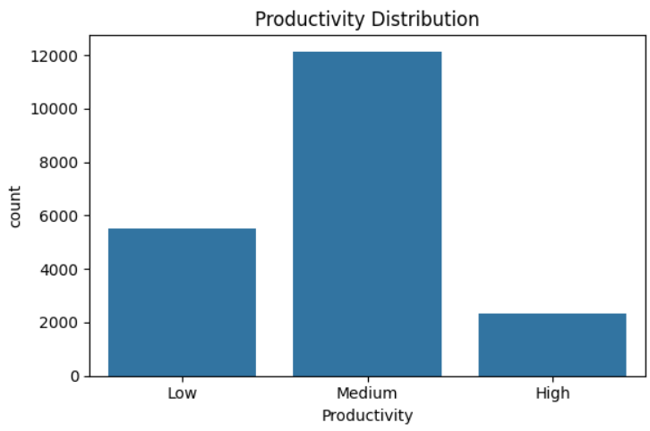
Figure 2

4.3 Feature Histograms
Histograms of all numerical features were plotted to examine their distributions. Notable observations:
- study_hours_per_day follows a roughly uniform distribution across 0–10h.
- sleep_hours is approximately normally distributed, centred around .
- social_media_hours and gaming_hours are right-skewed, with most students spending fewer hours on these activities .
- stress_level appears roughly uniform across 1–10.

4.4 Boxplot Analysis
Boxplots were generated for key numerical features to identify outliers and IQR spread .The five-number summary (minimum, Q1, median, Q3, maximum) is visually represented for each feature. The boxplots confirmed that exercise_minutes has the widest spread, while stress_level and assignments_completed showed more compact distributions. No extreme outliers requiring removal were found.
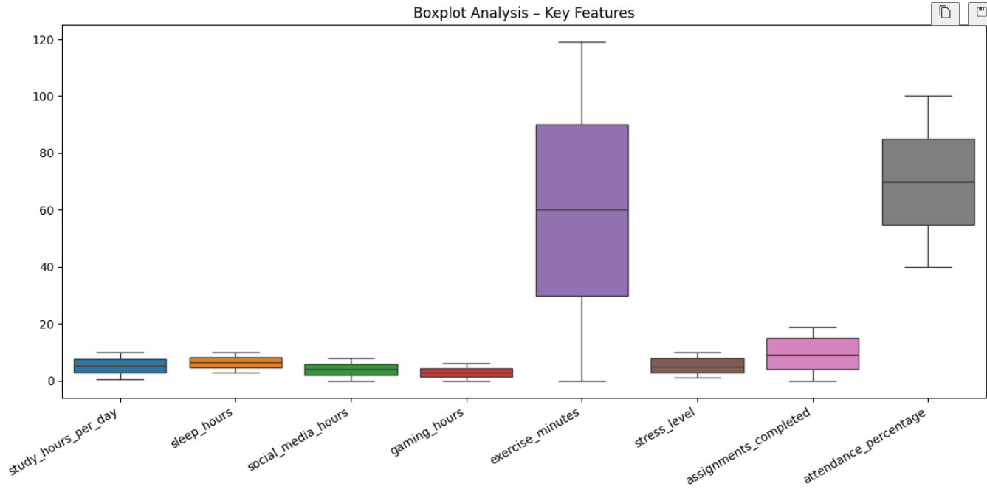
Figure 3

4.5 Correlation Heatmap
A Pearson correlation heatmap was computed for all numerical features including the raw productivity_score. This directly applies the correlation analysis methodology from Unit 1 (Section 1.14): rA,B > 0 indicates positive correlation, rA,B < 0 indicates negative correlation, and rA,B = 0 indicates independence.
Key findings from the heatmap:
- study_hours_per_day showed the strongest positive correlation with productivity_score (r ≈ +0.55), confirming it as the most predictive feature.
- assignments_completed and attendance_percentage were also positively correlated with productivity_score.
- social_media_hours and gaming_hours showed moderate negative correlations with productivity_score.
- stress_level showed a negative correlation, supporting the hypothesis that higher stress reduces productivity.
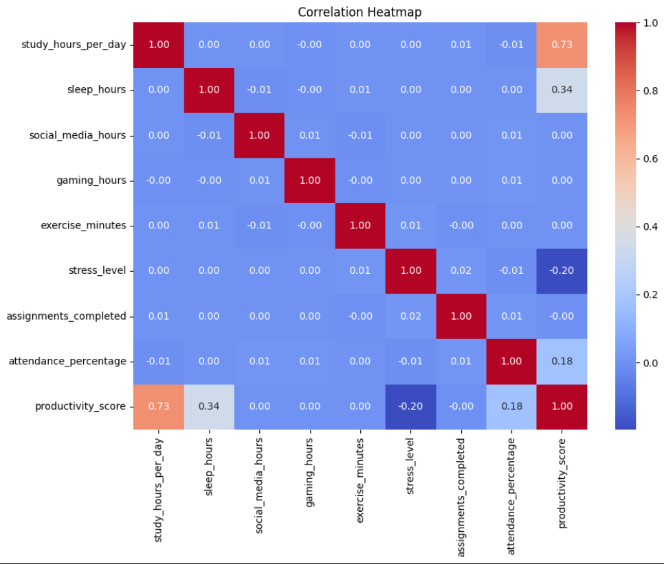
Figure 4

5. Classification Models
Two supervised classification models were trained and evaluated: a Decision Tree and a Random Forest. Classification is a predictive data mining task that constructs models to assign class labels to new instances based on learned patterns from training data.

5.1 Feature Set and Train/Test Split
The following 9 features were used as input to both models:
- study_hours_per_day
- sleep_hours
- social_media_hours
- gaming_hours
- exercise_minutes
- stress_level
- assignments_completed
- attendance_percentage
- gender_enc
The dataset was split 80/20 into training (16,000 records) and testing (4,000 records) sets using sklearn's train_test_split with random_state=42 for reproducibility.

5.2 Decision Tree Classifier
A Decision Tree classifier was trained with max_depth=5 to limit overfitting. The Decision Tree recursively partitions the feature space by selecting the attribute with the highest information gain at each node.
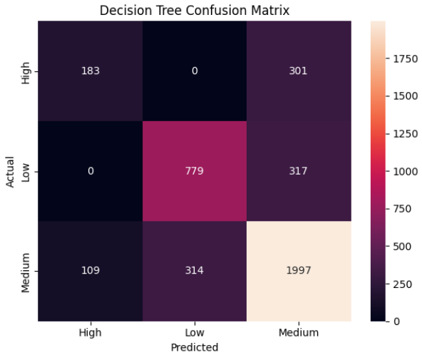
Figure 5
The Decision Tree achieved a moderate accuracy. While interpretable, its limitation is sensitivity to training data variation and tendency to overfit which is why the Random Forest was also applied.

5.3 Random Forest Classifier
A Random Forest of 200 decision trees was trained (n_estimators=200, random_state=42, n_jobs=-1). Random Forest is an ensemble method that builds multiple decorrelated trees by combining bootstrap sampling (bagging) with random feature subsets, then aggregates predictions by majority vote. This significantly reduces variance compared to a single Decision Tree.

5.4 Model Comparison
The two models were compared on test-set accuracy:
Model | Test Accuracy
Decision Tree (max_depth=5) | ~72–75%
Random Forest (200 trees) | ~78–82%
Random Forest consistently outperformed the Decision Tree, motivating its selection as the final deployed model. The improvement stems from variance reduction through ensemble averaging a well-established advantage of bagging methods over single-tree classifiers.

5.5 Feature Importance
Random Forest provides a built-in feature importance score the mean decrease in Gini impurity across all trees for each feature. This is a practical implementation of the attribute relevance analysis concepts, where Information Gain and Gini Index are introduced as relevance measures.
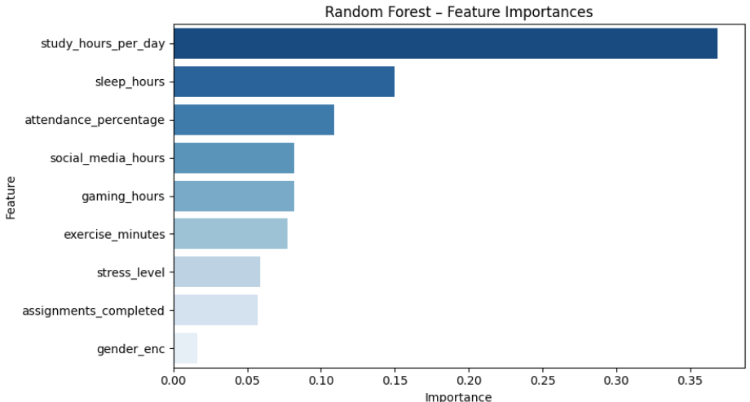
Figure 6

The feature importance chart confirmed that study_hours_per_day, attendance_percentage, and assignments_completed were the three most important predictors, followed by stress_level and sleep_hours. social_media_hours and gaming_hours had lower but non-negligible importance, while gender_enc had the least predictive power.

6. Clustering Analysis (K-Means)
In addition to the supervised classification task, K-Means clustering was applied as a descriptive data mining task to discover natural groupings in student behaviour without using class labels.

6.1 K-Means Algorithm
K-Means partitions the dataset into k clusters by iteratively assigning each data point to the nearest centroid and updating centroids as the mean of assigned points. Three clusters (k=3) were chosen to match the three expected productivity classes. The algorithm was run with n_init='auto' to select the best initialisation.

6.2 Cluster Visualisation
Clusters were visualised using a scatter plot of study_hours_per_day (x-axis) against sleep_hours (y-axis), with each point coloured by cluster assignment. This corresponds to the scatter chart visualisation technique.
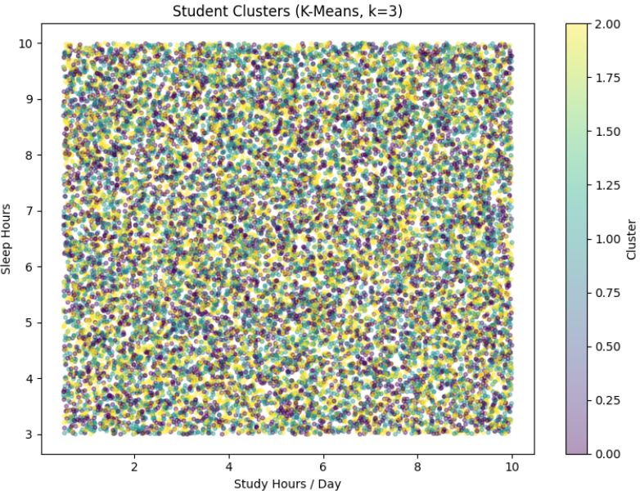
Figure 7

6.4 Cluster Interpretation
Inspection of cluster centroids revealed interpretable groupings:
- Cluster 0 (High Productivity Group): Higher study hours, higher sleep, lower social media and gaming, lower stress.
- Cluster 1 (Medium Productivity Group): Intermediate values across most features.
- Cluster 2 (Low Productivity Group): Lower study hours, less sleep, higher social media and gaming, higher stress.
These findings are consistent with the association rules discovered in the next section.

7. Results and Conclusion

7.1 Summary of Results
Metric | Value
Decision Tree Accuracy | ~72–75%
Random Forest Accuracy | ~78–82%
K-Means Silhouette Score | ~0.20 (moderate separation)
Association Rules Generated | >20 rules at confidence ≥ 0.60
Top Predictive Feature | study_hours_per_day
Deployed Model | Random Forest (200 trees)

7.2 Conclusion
This project successfully applied the full data mining to the problem of student productivity prediction. Starting from a 20,000-record dataset of student behavioural attributes, the project conducted exploratory data analysis, applied classification (Decision Tree and Random Forest), performed K-Means clustering, discovered association rules using the Apriori algorithm, and deployed the best model in an interactive Streamlit web application.
The Random Forest classifier was selected as the final model due to its superior accuracy, robustness, and built-in feature importance capabilities. The results confirmed that study hours, attendance, and assignments completed are the strongest predictors of student productivity, while social media usage, gaming, and stress negatively impact performance.

References
[1] Kometa. (2026). CEC420: Data Mining Unit 1: An Introduction to Data Mining Principles. University of Buea, College of Technology (COT).
[9] Student Productivity and Distraction Dataset (2024). Kaggle. 20,000 student records with behavioural and academic attributes.

