UNIVERSITY OF BUEA
College of Technology (COT)
Department of Computer Engineering
2025/2026 Academic Year
CEC418: SOFTWARE CONSTRUCTION AND EVOLUTION
PROJECT REPORT
Smart Study Planner Web Application (StudyFlow)
Task Management and Study Scheduling System

Student Name | Nfor Algor Shey
Matricule | CT23A118
Course | CEC418 — Software Construction and Evolution
Lecturer | Mr. Kometa Denis
Department | Computer Engineering, COT
Academic Year | 2025/2026

Table of Contents
Contents
Table of Contents 2
1. Introduction 3
2. Problem Statement 3
3. Proposed Solution 3
4. Software Construction Fundamentals 4
4.1 Minimising Complexity 4
4.2 Anticipating Change 4
4.3 Constructing for Verification 5
4.4 Reuse 5
4.5 Standards in Construction 6
5. Managing Construction 7
5.1 Construction in Life Cycle Model 7
5.2 Construction Planning 7
5.3 Construction Measurement 7
6. Practical Considerations 8
6.1 System Architecture 8
6.2 Database Design 8
6.4 Frontend Construction 8
7. Software Construction Tools and DevOps 9
7.1 Development Environment 9
7.2 Version Control — Git and GitHub 9
7.3 Containerisation — Docker 10
7.4 CI/CD — GitHub Actions 10
8. Testing and Verification 11
8.1 Unit Testing (Dynamic Verification) 11
8.2 API Testing (Postman) 11
8.3 Regression Testing 11
8.4 Verification vs Validation 11
9. Maintenance Strategy 13
10. Conclusion 14
11. References 16

1. Introduction
Software construction, as defined in the course unit, refers to the detailed creation of working software through a combination of coding, verification, unit testing, integration testing, and debugging. It forms the core of the iterative design-construct-test cycle at the heart of most software development processes.

StudyFlow was conceived as a practical demonstration of these principles, applied to a real and pressing problem experienced by students at the University of Buea. The application enables students to register study tasks, assign attributes such as deadline, importance, and difficulty, and receive an AI-generated priority study plan updated in real time. The system further notifies students via daily email and push notifications when deadlines are approaching.

The construction of this system was guided by the five major knowledge areas illustrated in Figure 1.1 of the CEC418 Unit 1 course notes: Software Construction Fundamentals (minimising complexity, anticipating change, verification, reuse, and standards), Managing Construction, Practical Considerations, Construction Technologies, and Software Construction Tools. Each of these areas is addressed in the sections that follow.

2. Problem Statement
University students at UB, particularly those in the College of Technology, face significant challenges in managing their academic workload. Common problems include:

- Forgetting assignment and exam deadlines due to the volume of concurrent courses.
- Inability to prioritise tasks effectively — students often begin with easier or more familiar work rather than the most urgent or difficult tasks.
- Absence of structured study plans, leading to last-minute cramming and poor academic performance.
- No automated reminder system to alert students when critical deadlines are approaching.

These challenges are amplified during peak periods such as coursework submission weeks and examination sessions, when students must simultaneously manage multiple high-stakes deliverables across five or more courses.

3. Proposed Solution
StudyFlow addresses the identified problems through four core functional modules:

- Task Management: Students create, edit, delete, and mark complete any number of study tasks, each carrying a title, deadline, importance rating (1–3), difficulty rating (1–3), and status (pending/in-progress/completed).
- AI Priority Scheduling: A rule-based scoring algorithm automatically ranks all pending tasks using the formula: score = (deadline_weight × 0.5) + (difficulty × 0.3) + (importance × 0.2). The deadline weight is dynamically computed from the number of days remaining, ensuring the ranking updates every day without student intervention.
- Email Reminders: A cron job executes daily at 07:00, queries the database for tasks due within three days, and dispatches a professionally styled HTML email to each affected student listing their upcoming tasks with priority scores.
- Push Notifications: Students may opt in to browser push notifications. When the daily cron job runs, it simultaneously sends a push notification to all subscribed devices, alerting students to approaching deadlines even when the application is not open in the browser.

4. Software Construction Fundamentals

4.1 Minimising Complexity
As the course notes state: 'reduced complexity is achieved through emphasising code creation that is simple and readable rather than clever.' StudyFlow addresses complexity minimisation through three architectural decisions:

- Modular Architecture: The system is divided into three entirely independent layers — a React frontend (responsible only for UI rendering), a Node.js/Express backend (responsible only for business logic and API routing), and a MySQL database (responsible only for persistence). Each layer communicates exclusively through well-defined REST API contracts.
- MVC-Like Separation in the Backend: Within the Node.js backend, code is further separated into Routes (URL mapping), Controllers (request handling and response logic), Services (email and push notification delivery), Jobs (scheduled tasks), Config (database connection), and Middleware (JWT authentication). No controller contains database logic directly; and no route contains business logic.
- Avoidable Complexity Elimination: Following the distinction between essential and avoidable complexity introduced in Section 1.2.3 of the notes, the codebase avoids deeply nested conditionals, excessive function parameters, and tightly coupled components. The AI scheduling algorithm, for instance, is contained entirely within a single 15-line function that is independently testable.

4.2 Anticipating Change
Section 1.3 of the course notes defines anticipating change as building extensible software that can be enhanced without disrupting the underlying structure. StudyFlow was designed with the following future changes explicitly anticipated:

- API-First Architecture: All functionality is exposed through versioned REST API endpoints. Adding a mobile application in the future requires no changes to the backend — the new client simply consumes the same API.
- Environment Variables: All deployment-sensitive values (database credentials, JWT secret, SMTP credentials, VAPID keys, frontend URL) are externalised into a .env file rather than hardcoded. This allows the same codebase to be deployed to development, staging, and production environments without code changes.
- Modular Notification System: The email and push notification services are implemented as independent service modules (emailService.js and pushService.js) called by the cron job. Either service can be replaced, upgraded, or disabled without affecting the other.
- Docker Containerisation: The system is containerised using Docker, meaning the entire stack can be deployed to any cloud provider (AWS, DigitalOcean, Azure) without environment-specific code changes. This directly implements the adaptive maintenance type described in Section 1.3.1 of the course notes.

4.3 Constructing for Verification
Section 1.4 of the course notes defines constructing for verification as 'building software in such a way that faults can be readily found.' StudyFlow implements this through:

- Unit Testing: A Jest test suite (planner.test.js) contains nine automated unit tests covering the core AI scheduling algorithm and authentication input validation logic. Tests verify correct scoring under various deadline, difficulty, and importance combinations, ensuring the algorithm behaves deterministically.
- API Testing: All REST endpoints are structured to return consistent JSON responses with appropriate HTTP status codes (200 for success, 201 for creation, 400 for bad input, 401/403 for auth failures, 404 for not found, 500 for server errors). This consistency makes Postman-based API testing straightforward and systematic.
- Input Validation: Every controller validates incoming request body fields before processing. Invalid or missing fields return a 400 status with a descriptive error message, preventing silent failures.
- Try-Catch Error Handling: All asynchronous operations and database queries are wrapped in try-catch blocks with structured error responses, ensuring that unexpected runtime errors are surfaced clearly rather than causing silent system failures.

4.4 Reuse
Software reuse, as described in Section 1.5 of the notes, spans multiple levels from function reuse to framework reuse. StudyFlow demonstrates reuse at each level:

- Framework Reuse (Web Application Framework): React.js serves as the frontend WAF, providing a component-based architecture aligned with the Model-View-Controller pattern described in Section 1.5.5. Express.js serves as the server-side framework, providing reusable routing and middleware infrastructure.
- Component Reuse (Intra-Project): Reusable React components — Sidebar, Layout, TaskCard, TaskModal, NotificationSettings, and ProtectedRoute — are defined once and consumed across multiple pages. The Sidebar, for example, is used identically on Dashboard, Tasks, Planner, and Profile pages.
- Middleware Reuse: The JWT authentication middleware (authMiddleware.js) is a single function applied to all four protected route groups (tasks, planner, profile, notifications) via router.use(verifyToken), rather than being duplicated in each controller.
- Library Reuse (Object and Function Level): Third-party libraries including bcryptjs (password hashing), nodemailer (email), web-push (push notifications), node-cron (scheduling), and jsonwebtoken (JWT encoding/decoding) represent COTS-level reuse, avoiding the need to implement these complex and security-sensitive functions from scratch.

4.5 Standards in Construction
Section 1.6 of the course notes identifies standards as a key mechanism for achieving efficiency, quality, and coordination. The following standards were applied throughout StudyFlow:

- REST API Standards: All API endpoints follow RESTful naming conventions — nouns for resources (/tasks, /auth, /profile), HTTP verbs for actions (GET, POST, PUT, DELETE, PATCH), and standard status codes for responses.
- Coding Standards: JavaScript code follows consistent naming conventions (camelCase for variables and functions, PascalCase for React components), consistent module export pattern (exports.functionName for all controller functions), and uniform file organisation.
- Database Standards: All MySQL tables use AUTO_INCREMENT primary keys named id, foreign keys with explicit constraint names (e.g. fk_tasks_user), and indexed columns for performance.
- Security Standards: Passwords are hashed using bcrypt with a salt factor of 10. JWT tokens are signed with a secret stored in environment variables and set to expire in 7 days. SQL queries use parameterised inputs to prevent injection attacks.

5. Managing Construction

5.1 Construction in Life Cycle Model
The project followed an iterative construction life cycle consistent with the model described in Section 1 of the course notes. Development proceeded through clearly defined phases:

Phase | Activity | Output
1 | Requirements Analysis | Problem statement, list of functional and non-functional requirements
2 | Database Design | MySQL schema with users, tasks, and push_subscriptions tables
3 | Backend Construction | Node.js/Express API with auth, tasks, planner, profile, and notification modules
4 | Frontend Construction | React application with Login, Register, Dashboard, Tasks, Planner, Profile pages
5 | Authentication Integration | JWT-based login flow with localStorage persistence and protected routes
7 | Notification System | Email cron job and Web Push notification service
8 | Testing | 9 Jest unit tests and Postman API collection
9 | Containerisation | Docker Compose stack with MySQL, backend, and Nginx-served frontend

5.2 Construction Planning
Development was decomposed into independent, testable modules. Each module was built and verified before integration with dependent modules — for example, the authentication API was completed and tested before the task management API, which depends on authenticated user IDs.

This approach aligns with the incremental development advantage described in Section 1.4.3 of the course notes: 'a testable version of the system is available at a fairly early stage, and new functionality can be checked as it is added to the system.'

5.3 Construction Measurement
Progress was measured through concrete deliverables at each phase: API endpoint availability (verified via Postman), UI page completion, passing unit test count, and Docker container health status. The final system comprises:

- 11 REST API endpoints across 4 route groups
- 6 React pages and 6 reusable components
- 3 MySQL tables with appropriate indexes and foreign key constraints
- 9 Jest unit tests all passing
- 3 Docker containers orchestrated via Docker Compose

6. Practical Considerations

6.1 System Architecture
StudyFlow follows a three-tier client-server architecture, directly implementing the ideal layered distribution model described in Section 1.3.2 of the course notes (Figure 1.11):

- Presentation Layer: React + Vite frontend served by Nginx, handling all UI rendering and user interaction.
- Application Services Layer: Node.js/Express backend providing all business logic, authentication, task management, AI scheduling, and notification dispatch.
- Database Layer: MySQL 8.0 providing persistent, relational storage of users, tasks, and push subscriptions.

6.2 Database Design
The database schema was designed to enforce referential integrity through foreign key constraints and to optimise query performance through indexed columns. The three tables are:

Table | Key Columns | Type | Purpose
users | id, name, email, password | Authentication | Stores student credentials (bcrypt-hashed passwords)
tasks | id, user_id, title, deadline, importance, difficulty, status | Core data | All study tasks with AI scoring inputs
push_subscriptions | id, user_id, subscription (JSON) | Notifications | Stores browser PushSubscription objects for Web Push delivery

6.4 Frontend Construction
The React frontend was constructed using functional components and React Hooks throughout. State management uses React Context (AuthContext) for global authentication state and component-level useState for local UI state. Axios is used for all API communication with an interceptor that automatically attaches the JWT token to every request header.

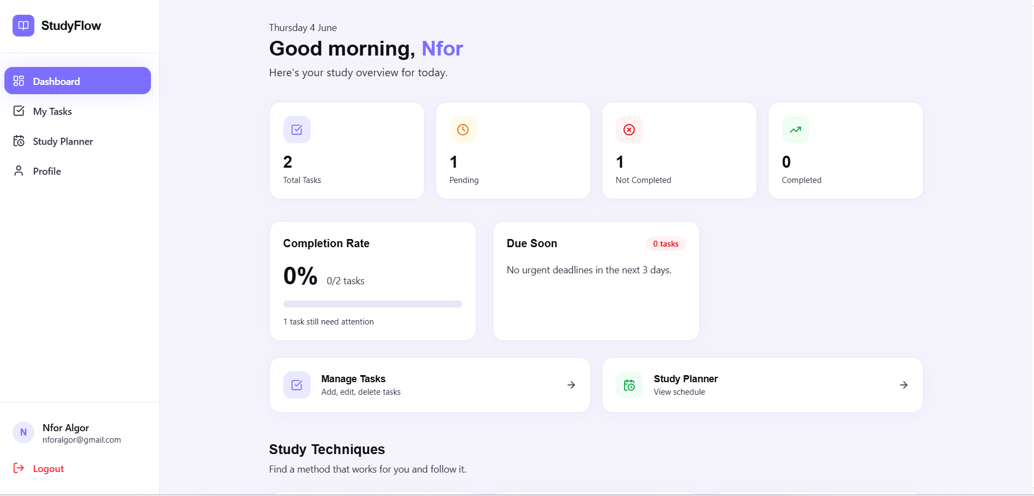
Figure 1

7. Software Construction Tools and DevOps
The Software Construction Tools branch of Figure 1.1 encompasses the development environment, GUI builders, unit testing tools, version control, and profiling tools. This section documents all tools used in StudyFlow's construction.

7.1 Development Environment
- Visual Studio Code: Primary IDE used for all JavaScript, JSX, YAML, and SQL development. Extensions used include ESLint (code quality), Prettier (formatting), and MySQL (database management).
- Node.js v18 (Alpine): Runtime environment for the backend. All npm packages were managed through package.json with explicit version pinning.
- Vite: High-performance frontend build tool used to scaffold and bundle the React application. Vite's hot module replacement significantly accelerated frontend development iteration time.
- MySQL Workbench: GUI tool used for database schema design, SQL query testing, and data inspection during development.

7.2 Version Control — Git and GitHub
Git was used for all version control throughout the project. The repository is hosted on GitHub. Key practices applied:

- Commit-based progress tracking: each major feature (auth, tasks, planner, notifications, Docker) was committed independently with descriptive commit messages.
- The .gitignore file ensures that the .env file (containing all secrets) is never committed to the repository, protecting credentials.
- The .env.example file is committed as a public template, enabling any collaborator to set up their own environment by copying and populating the template.

7.3 Containerisation — Docker
Docker is used to containerise all three application components into isolated, reproducible environments. The Docker Compose configuration orchestrates three services:

- ssp_db: MySQL 8.0 container with a named volume (db_data) for data persistence across restarts. An init.sql script mounted as a Docker entrypoint automatically creates all required tables on first run — eliminating the need for manual database setup.
- ssp_backend: Node.js 18 Alpine container built from a multi-stage Dockerfile. The production stage runs as a non-root user for security. A health check endpoint ensures the backend only starts accepting traffic after the database is confirmed healthy.
- ssp_frontend

The three containers communicate over a shared Docker bridge network (ssp_network). Container name resolution (e.g. DB_HOST=db) replaces localhost addressing, a critical difference from local development.

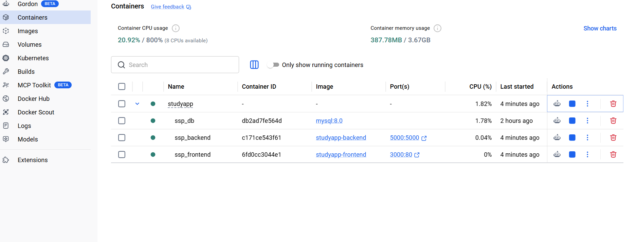
Figure 2

7.4 CI/CD — GitHub Actions
A GitHub Actions workflow (.github/workflows/ci.yml) was configured to provide continuous integration. The pipeline triggers on every push to the main or develop branch and performs two jobs:

- Test Job: Installs Node.js 18, installs backend dependencies, and runs the Jest test suite. The pipeline fails if any test fails, preventing broken code from reaching the main branch.
- Lint/Build Job: Installs dependencies for both backend and frontend, then performs a production Vite build of the frontend. This verifies that the frontend compiles successfully without errors.

8. Testing and Verification
Applying the V&V principles from Section 1.4 of the course notes, StudyFlow was verified through both static and dynamic techniques.

8.1 Unit Testing (Dynamic Verification)
The Jest test file (src/tests/planner.test.js) contains two test suites:

- Scheduling Algorithm Suite (5 tests): Verifies that tasks due sooner score higher than distant tasks; that harder tasks outscore easier tasks with identical deadlines; that higher importance produces higher scores; that generatePlan correctly sorts multiple tasks; and that a task due today receives the maximum deadline weight of 3.
- Auth Input Validation Suite (4 tests): Verifies rejection of empty fields, invalid email format, and passwords shorter than 6 characters; and acceptance of valid input.

8.2 API Testing (Postman)
Each endpoint was tested manually using Postman during construction. Tests verified correct responses for valid inputs, appropriate error codes for invalid inputs (missing fields, wrong passwords, non-existent resources), and correct JWT token rejection for unauthenticated requests.

8.3 Regression Testing
Regression testing was applied throughout development. After the implementation of each new module, previously passing API tests and unit tests were re-executed to ensure that new code did not introduce regressions in existing functionality. The GitHub Actions CI pipeline automates this regression testing on every push to the main branch.

8.4 Verification vs Validation
- Verification (Are we building the product right?): Confirmed through unit tests verifying that the scoring formula produces mathematically correct outputs, and through API tests verifying that all endpoints return specified HTTP responses. The code conforms to its specification.
- Validation (Are we building the right product?): Addressed by tracing every feature back to the original problem statement — the system successfully prevents missed deadlines, provides automated prioritisation, and sends unsolicited reminders, directly solving the identified student problems.

9. Maintenance Strategy
Maintenance Type | Definition (Course Notes) | StudyFlow Implementation
Corrective Maintenance | Repair software faults | Bug fixes are isolated to individual controller functions. The modular architecture means a fix in taskController.js cannot affect authController.js. Jest tests detect regressions after each fix.
Adaptive Maintenance | Adapt to a different operating environment | Docker containerisation allows the entire stack to be migrated to any cloud provider (AWS, DigitalOcean, Azure) without code changes. Environment variables handle all deployment-specific configuration.
Perfective Maintenance | Add or modify functionality | Planned future enhancements (mobile app, improved ML-based scheduling, SMS notifications) can be implemented by adding new Express routes and React pages without modifying existing modules.

The project's use of Git and GitHub directly implements the configuration management practice described in Section 1.3 of the course notes — tracking different versions of the software and ensuring the appropriate version of each component is used in each system release.

10. Conclusion
StudyFlow — the Smart Study Planner Web Application — demonstrates a comprehensive application of the Software Construction Knowledge Area as taught in CEC418. The system addresses a genuine problem experienced by University of Buea students and provides a practical, fully functional solution built on industry-standard technologies.

The project successfully implements all five branches of Figure 1.1:

- Software Construction Fundamentals: Complexity is minimised through strict modular separation; change is anticipated through API-first design and environment variables; constructing for verification is achieved through Jest unit tests and systematic error handling; reuse is practiced at framework, component, middleware, and library levels; and REST and coding standards are applied consistently.
- Managing Construction: An iterative nine-phase development lifecycle was followed, with each phase producing a testable, independently verifiable output.
- Practical Considerations: The three-tier architecture with a dedicated presentation layer, application services layer, and database layer directly reflects the ideal system structure described in the course notes.
- Construction Technologies: API design standards, runtime parameterisation, error handling, concurrency via the Node.js event loop, performance optimisation via database indexing and Nginx compression, and middleware reuse are all demonstrated.
- Software Construction Tools: VS Code, Git, GitHub, GitHub Actions, Docker, Jest, Postman, and MySQL Workbench collectively cover all tool categories in Figure 1.1.

The AI scheduling feature, implemented as a rule-based expert system using a weighted scoring formula, provides genuine value by removing the cognitive burden of study prioritisation from students — a burden that, as documented in the problem statement, contributes to poor academic outcomes at UB. The automatic daily reminder system through both email and push notifications further closes the gap between a smart to-do application and a genuinely useful academic support tool.

Future development directions identified under the perfective maintenance category include: integration of a machine learning model trained on task completion data to replace the rule-based algorithm; addition of SMS notifications via the Twilio API; development of a native mobile application consuming the existing REST API; and implementation of collaborative study group features allowing task sharing between students.

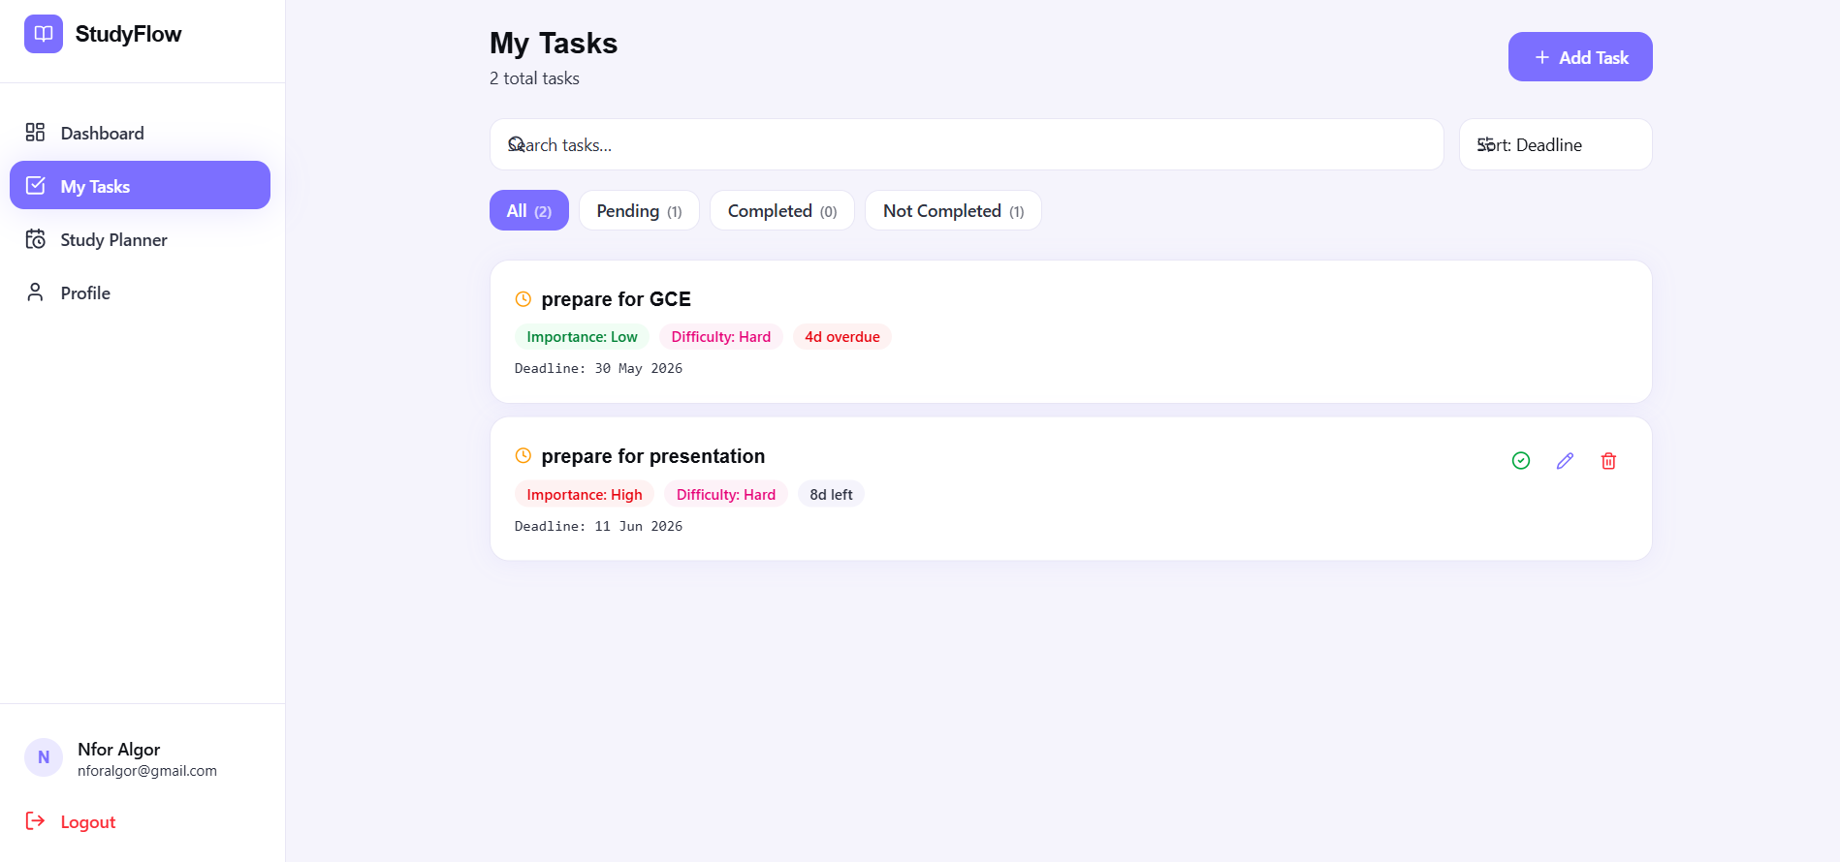
Figure 3

11. References

- Mr. Kometa D. (2026). CEC418: Software Construction and Evolution — Unit 1: Software Construction Fundamentals. University of Buea, College of Technology, Department of Computer Engineering. 2025/2026 Academic Year.
- GitHub Inc. (2024). GitHub: Let's build from here. GitHub, Inc. https://github.com — Used for remote repository hosting, version control history, collaborative development, and CI/CD pipeline integration via GitHub Actions.
- Docker Inc. (2024). Docker: Accelerated container application development. Docker, Inc. https://www.docker.com — Used for containerisation of the backend (Node.js), frontend (Nginx), and database (MySQL 8.0) services, enabling reproducible builds and simplified deployment.
- Vercel Inc. (2024). Vercel: Develop. Preview. Ship. Vercel, Inc. https://vercel.com — Referenced as a cloud deployment platform alternative for hosting the React frontend, compatible with the Vite build output.

