# Eigenfaces

## 1. Method

In this experiment, principal component analysis is used for face images.

Reference:

M. A Turk and A. P. Pentland, “Face Recognition Using Eigenfaces", Proceedings of IEEE CVPR 1991.

Data:

The data include smiling and neutral face images of 200 persons. For training, 190 neutral face images are used.

http://fei.edu.br/~cet/frontalimages_spatiallynormalized_cropped_equalized_part1. zip http://fei.edu.br/~cet/frontalimages_spatiallynormalized_cropped_equalized_part2. zip

Fig.1 shows the mean face of of the training data.

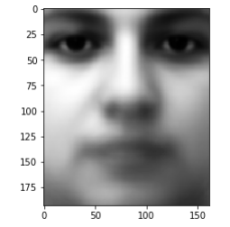

Fig.1 the mean face of the training data

## 2. Neutral face of a person in training data

Fig.2.1 shows a sample of a neutral face image of a person in the training data. Fig.2.2 shows the reconstructed images with different number of principal components. The numbers of the components are 2, 8, 32, and 64.

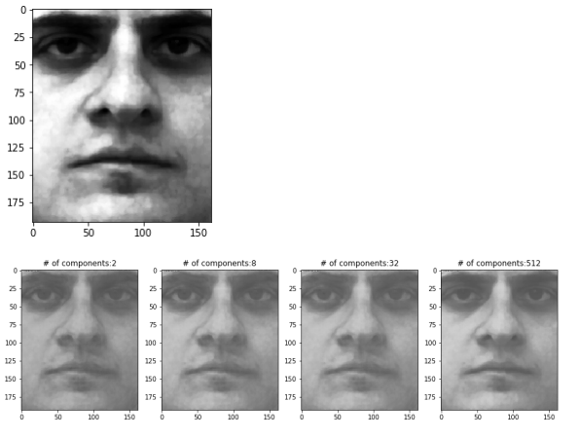

Fig.2.1 A sample of a neutral face image of a person in the training data

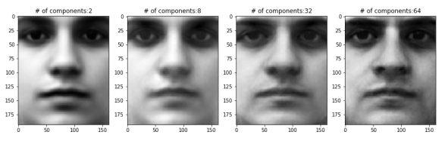

Fig.2.2 The reconstructed images with different number of principal components. The numbers of the components are 2, 8, 32, and 64.

## 3. Smile face of a person in training data

Fig.3.1 shows a sample of a smile face image of a person in the training data. Fig.3.2 shows the reconstructed images with different number of principal components. The numbers of the components are 2, 8, 32, and 64.

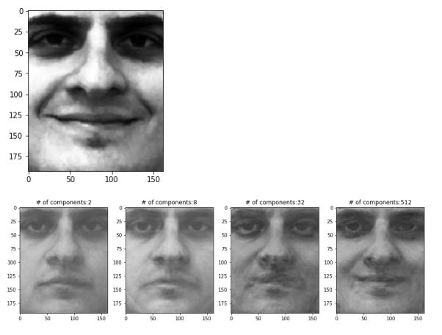

Fig.3.1 A sample of a smile face image of a person in the training data

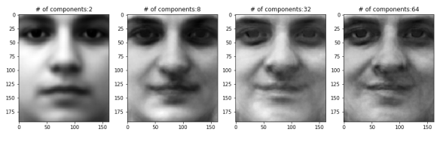

Fig.3.2 The reconstructed images with different number of principal components. The numbers of the components are 2, 8, 32, and 64.

## 4. Neutral face of a person not in training data

Fig.4.1 shows a sample of a neutral face image of a person not in the training data. Fig.4.2 shows the reconstructed images with different number of principal components. The numbers of the components are 2, 8, 32, and 64.

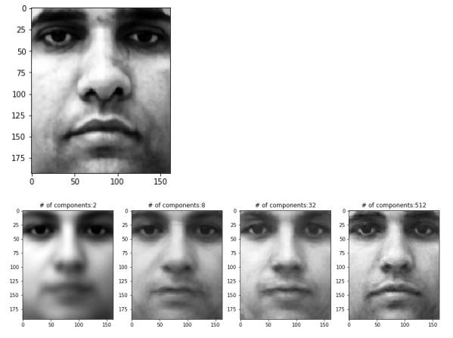

Fig.4.1 A sample of a neutral face image of a person not in the training data

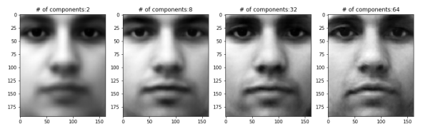

Fig.4.2 The reconstructed images with different number of principal components. The numbers of the components are 2, 8, 32, and 64.

## 5. Non-human image

Fig.5.1 shows a sample of a non-human image. Fig.5.2 shows the reconstructed images with different number of principal components. The numbers of the components are 2, 8, 32, and 190 (all components).

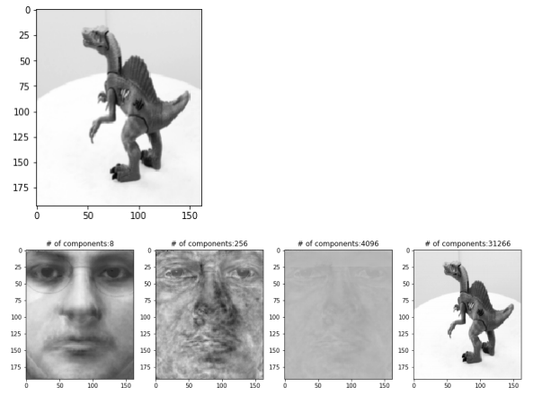

Fig.5.1 A sample of non-human image

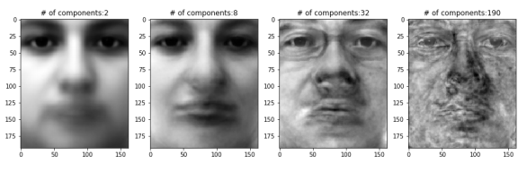

Fig.5.2 The reconstructed images with different number of principal components. The numbers of the components are 2, 8, 32, and 190 (all components).

## 6. Rotated neutral face of a person in training data

Fig.6.1, Fig. 6.3, and Fig.6.5 show samples of a rotated neutral face image of a person in the training data. Fig.6.2, Fig.6.4, and Fig.6.6 show the reconstructed images with different number of principal components. The numbers of the components are 2, 8, 32, and 190 (all components).

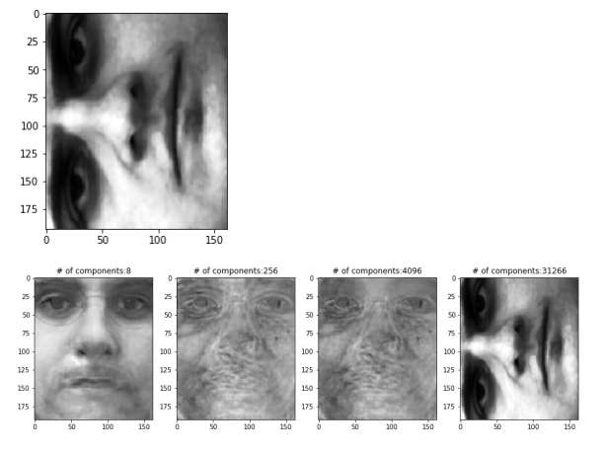

Fig.6.1 a rotated image of neutral face of a person in training data

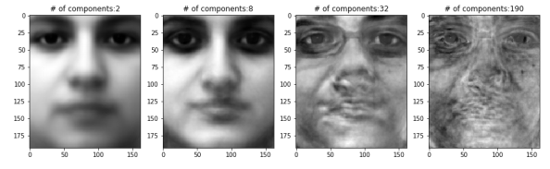

Fig.6.2 The reconstructed images with different number of principal components. The numbers of the components are 2, 8, 32, and 190 (all components).

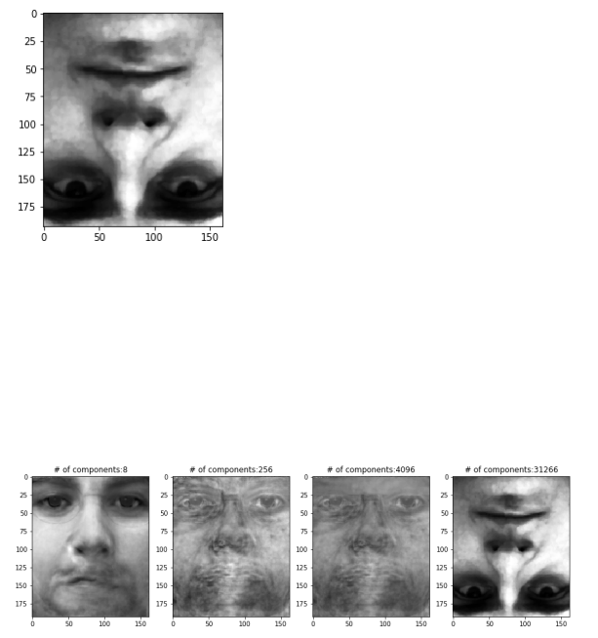

Fig.6.3 a rotated image of neutral face of a person in training data

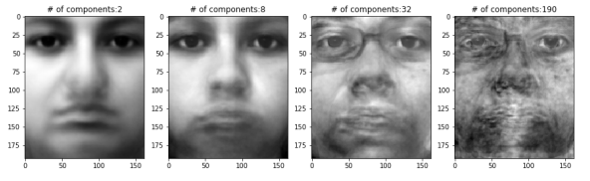

Fig.6.4 The reconstructed images with different number of principal components. The numbers of the components are 2, 8, 32, and 190 (all components).

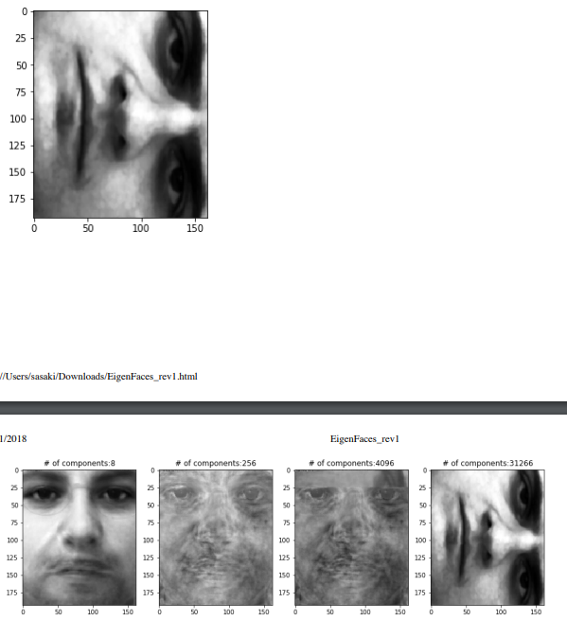

Fig.6.5 a rotated image of neutral face of a person in training data

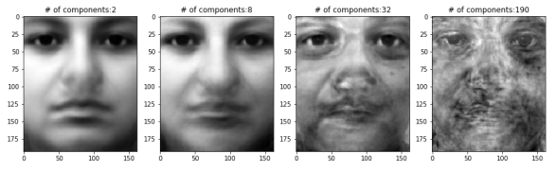

Fig.6.6 The reconstructed images with different number of principal components. The numbers of the components are 2, 8, 32, and 190 (all components).