# Bayesian BDR

# Strategy 1

The plots bellow show the results for dataset1, 2, 3 and 4 in the case of strategy 1.

## Dataset 1, Dataset 2

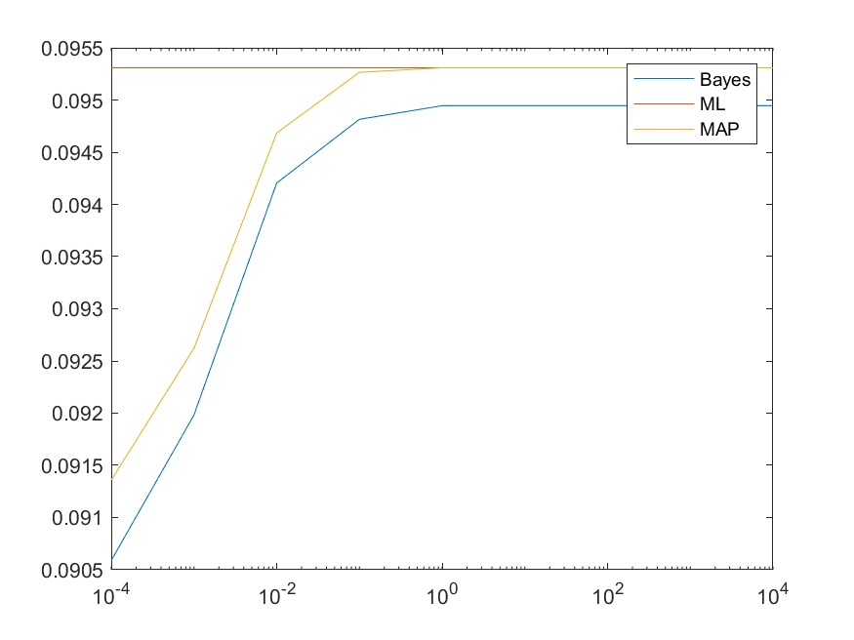 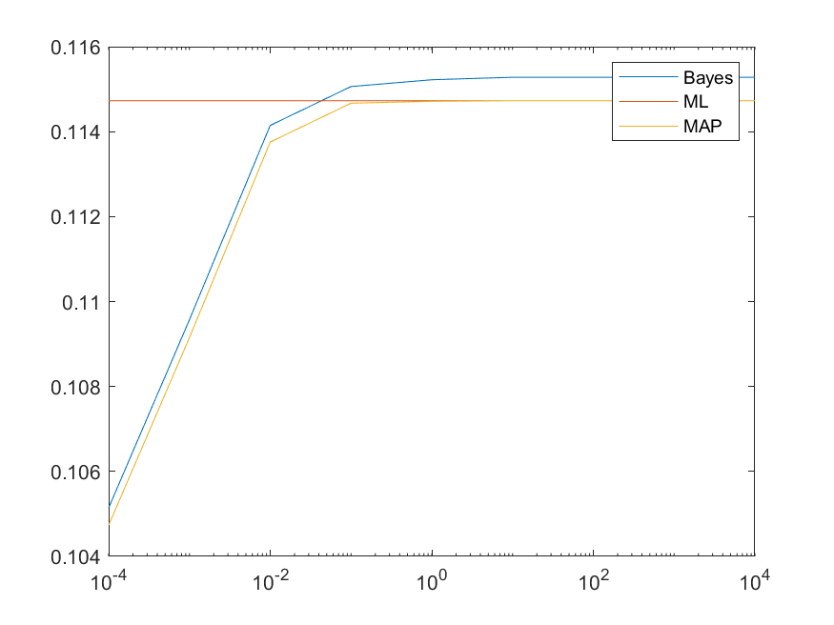

## Dataset 3, Dataset 4

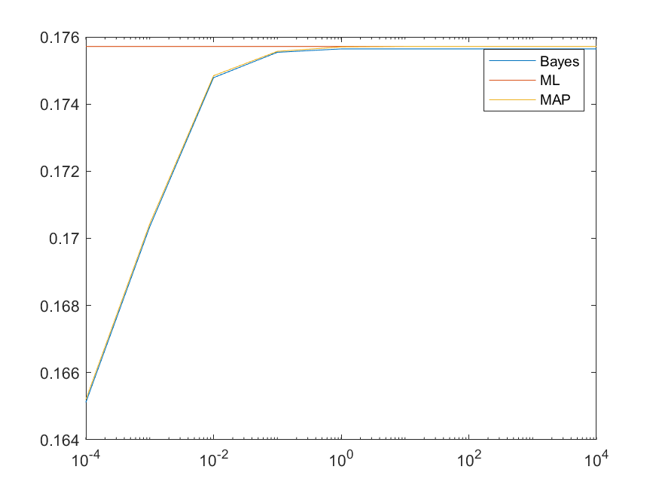 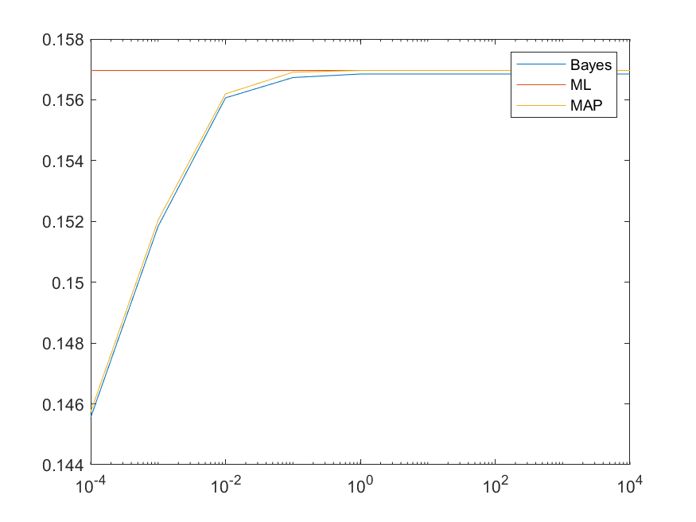

Fig1. The results for dataset1, 2, 3 and 4 (Strategy 1)

# Strategy 2

The plots bellow show the results for dataset1, 2, 3 and 4 in the case of strategy 2.

## Dataset 1, Dataset 2

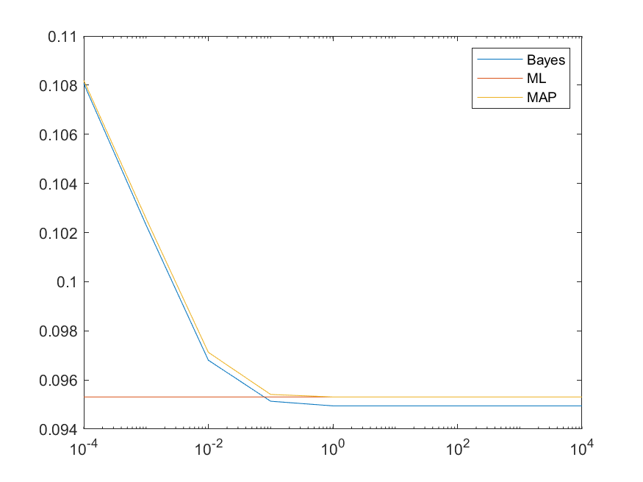 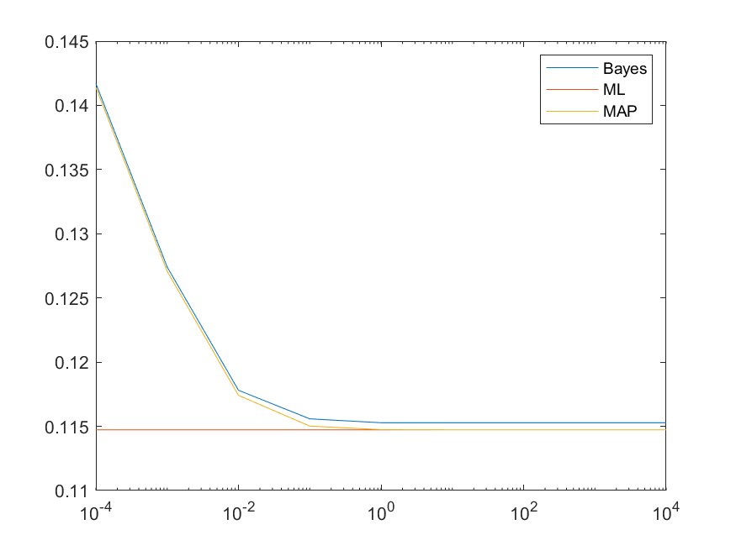

## Dataset 3, Dataset 4

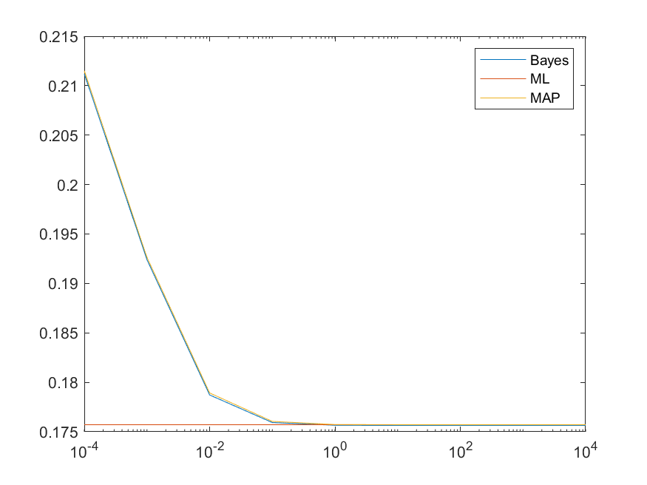 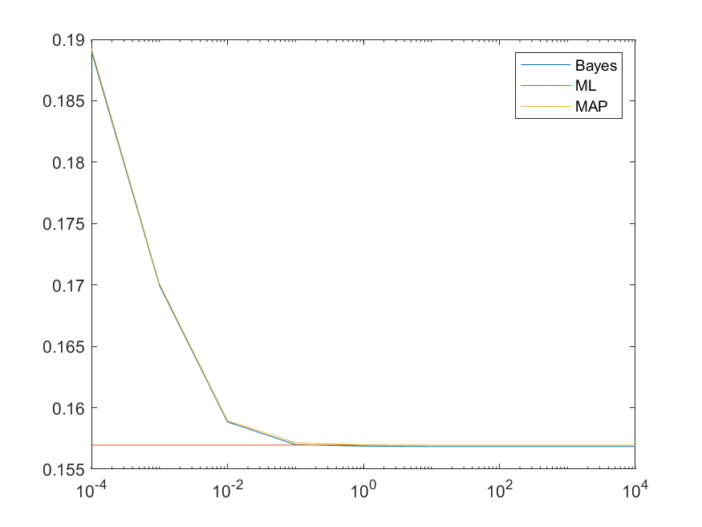

Fig2. The results for dataset1, 2, 3 and 4 (Strategy 2)

# Comments

ML BDR

Since we do not assume prior knowledge about mu, the results do not depend on alpha.

Bayesian BDR

In both strategy 1 and 2, when alpha is small, the results of Bayesian BDR heavily depend on the prior knowledge because small sigma0 means the high confidence of the prior knowledge of mu.

In the case of strategy 1 and dataset 1, the results of Bayesian BDR are better than those ML and MAP.

MAP BDR

The results by the MAP method has similar curves as those of Bayesian BDR. In other words, MAP accounts the prior knowledge into account, especially when sigma0 is small.

In the case of strategy 1 and dataset 1, the results of MAP are better than ML, especially when alpha is small. When alpha is large, the results of MAP are almost same as those of ML.

Data sets

About data sets, the results of MAP should get closer to those of ML as the number of samples gets larger. That is because as the number of samples increases, the parameters of MAP gets closer to those of ML.

Strategies

In strategy 1, we have good prior knowledge about mu0 (i.e. the cheetah is darker than grass). In this case, small sigma0s lead to good results of Bayesian BDR and MAP. In other words, these work better when we are confident in the prior knowledge.

By contrast, in strategy 2, we do not have a good prior knowledge about mu0 (i.e. we do not know if the cheetah is darker than grass or not). In this case, large sigma0s lead to good results of Bayesian BDR and MAP. In other words, these works better when we are not confident in the prior knowledge.