# Maximum Likelihood Estimate

a) Using the training data in TrainingSamplesDCT_8.mat compute the histogram estimate of the prior PY (i), i ∈ {cheetah, grass}. Using the results of problem 2 compute the maximum likelihood estimate for the prior probabilities. Compare the result with the estimates that you obtained last week. If they are the same, interpret what you did last week. If they are different, explain the differences.

$C_{1}$: the number of foreground samples.

$C_{2}$: the number of background samples.

$P_{Y}\left(cheetah\right)$ and $P_{Y}\left(grass\right)$ maximize $\frac{\left(C_{1}+C_{2}\right)!}{C_{1}! C_{2}!}P_{Y}{\left(cheetah\right)}^{C_{1}}P_{Y}{\left(grass\right)}^{C_{2}}$.

Using the results of problem2, $P_{Y}\left(cheetah\right)=\frac{C_{1}}{C_{1}+C_{2}}=0.1919, P_{Y}\left(grass\right)=\frac{C_{2}}{C_{1}+C_{2}}=0.8081.$

These are the same as the results of my previous homework. This means that probabilities proportional to sample sizes, which are often intuitive, maximize the likelihood given by binomial distribution. Using histograms, which ignore the spatial dependency among samples, these approaches assume that the samples are independent and identically distributed.

b) Using the training data in TrainingSamplesDCT_8.mat, compute the maximum likelihood estimates for the parameters of the class conditional densities $P_{X|Y}(x|cheetah)$ and $P_{X|Y}(x|grass)$ under the Gaussian assumption. Denoting by X = {X1,...,X64} the vector of DCT coefficients, create 64 plots with the marginal densities for the two classes - $P_{X_{k}|Y}(x_{k}|cheetah)$ and $P_{X_{k}|Y}(x_{k}|grass)$, k = 1,..., 64 - on each. Use different line styles for each marginal. Select, by visual inspection, what you think are the best 8 features for classification purposes and what you think are the worst 8 features (you can use the subplot command to compare several plots at a time). Hand in the plots of the marginal densities for the best-8 and worst-8 features (once again you can use subplot, this should not require more than two sheets of paper). In each subplot indicate the feature that it refers to.

The fig.1 shows the 64 plots with the marginal densities for the two classes, $P_{X_{k}|Y}(x_{k}|cheetah)$ and $P_{X_{k}|Y}(x_{k}|grass)$. For classification purposes, the more different the means of the two classes are, the better the features are (of course, the variants also affect the results, but I ignored them for simplicity after some experiments). From this viewpoint, the best features would be [1 2 3 4 5 6 26 8], and the worst ones 57-64. The fig.2 and fig.3 show the marginal densities for the best/worst features.

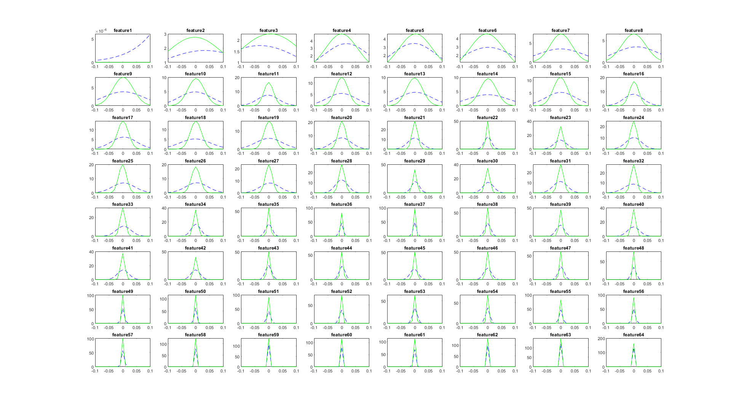

Fig. 1. The marginal densities for $P_{X_{k}|Y}(x_{k}|cheetah)$ and $P_{X_{k}|Y}\left(x_{k} | grass\right), k=1,…,64$. The blue dashed lines and the green solid lines represent $P_{X_{k}|Y}(x_{k}|cheetah)$ and $P_{X_{k}|Y}(x_{k}|grass)$ respectively.

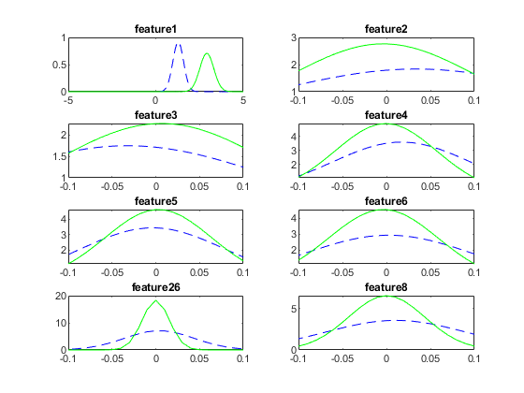

Fig. 2. The marginal densities for the best 8 features. The blue dashed lines and the green solid lines represent $P_{X_{k}|Y}(x_{k}|cheetah)$ and $P_{X_{k}|Y}(x_{k}|grass)$ respectively.

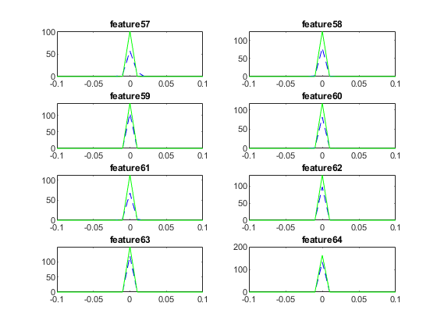

Fig. 3. The marginal densities for the worst 8 features. The blue dashed lines and the green solid lines represent $P_{X_{k}|Y}(x_{k}|cheetah)$ and $P_{X_{k}|Y}(x_{k}|grass)$ respectively.

c) Compute the Bayesian decision rule and classify the locations of the cheetah image using i) the 64-dimensional Gaussians, and ii) the 8-dimensional Gaussians associated with the best 8 features. For the two cases, plot the classification masks and compute the probability of error by comparing with cheetah mask.bmp. Can you explain the results?

i) The 64-dimensional Gaussians

The fig.4 shows the mask image predicted from the 64-dimensional Gaussians.

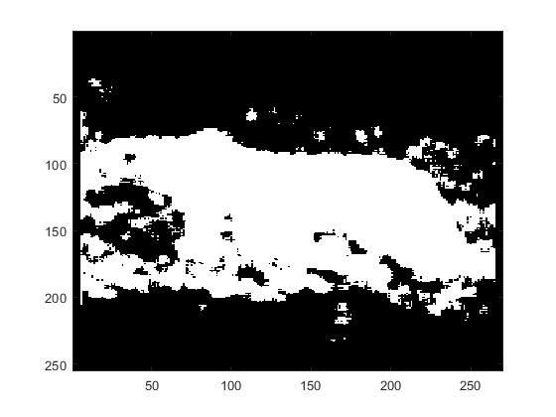

Fig.4 The mask image predicted from the 64-dimensional Gaussians

The error rate in the ground-truth cheetah pixels $e_{cheetah}$:

$e_{cheetah}$ = (# of errors at ground-truth cheetah pixels)/(# of the ground-truth cheetah pixels) = 0.0167

The error rate in the ground-truth grass pixels $e_{grass}$:

$e_{grass}$ = (# of errors at ground-truth grass pixels)/(# of the ground-truth grass pixels) = 0.1952

The overall error rate:

$P_{Y}(cheetah)$ $e_{cheetah}$* + $P_{Y}(grass)$ $e_{cheetah}$* = 0.1609

ii) The 8-dimensional Gaussians associated with the best 8 features

The fig.5 shows the mask image predicted from the 8-dimensional Gaussians associated with the best 8 features.

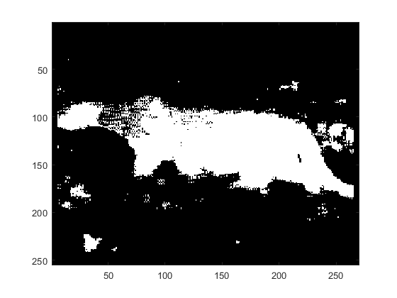

Fig.5 The mask image predicted from the 8-dimensional Gaussians associated with the best 8 features

The error rate in the ground-truth cheetah pixels $e_{cheetah}$:

$e_{cheetah}$ = (# of errors at ground-truth cheetah pixels)/(# of the ground-truth cheetah pixels) = 0.1008

The error rate in the ground-truth grass pixels $e_{grass}$:

$e_{grass}$ = (# of errors at ground-truth grass pixels)/(# of the ground-truth grass pixels) = 0.0377

The overall error rate:

$P_{Y}(cheetah)$ $e_{cheetah}$* + $P_{Y}(grass)$ $e_{cheetah}$* = 0.0498

These two results show that the mask can be predicted better from the 8-dimensional Gaussians associated with the best 8 features than from the 64-dimensional Gaussians. This is because the 64 features include unimportant information and the noise worsens the classifier. Choosing appropriate features that characterize the difference between the foreground and background lessens such noise, thereby enhancing the quality of the classifier.