# Segmentation of a Cheetah Image

a) using the training data in TrainingSamplesDCT 8.mat, what are reasonable estimates for the prior probabilities?

$P_{Y}(cheetah)$

= (# of foreground samples)/((# of foreground samples)+(# of background samples)) = 0.1919.

$P_{Y}(grass)$

= (# of background samples)/((# of foreground samples)+(# of background samples)) = 0.8081.

b) using the training data in TrainingSamplesDCT 8.mat, compute and plot the index histograms $P_{X|Y}(x|cheetah)$ and $P_{X|Y}(x|grass)$.

Fig. 1 and Fig. 2 show the conditional probabilities of $P_{X|Y}(x|cheetah)$ and $P_{X|Y}(x|grass)$ respectively.

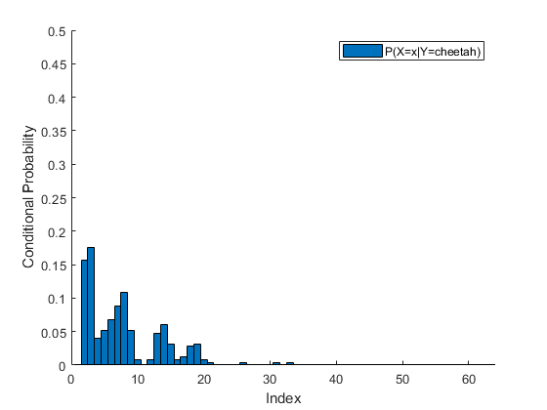

Fig. 1. Conditional probability of $P_{X|Y}(x|cheetah)$

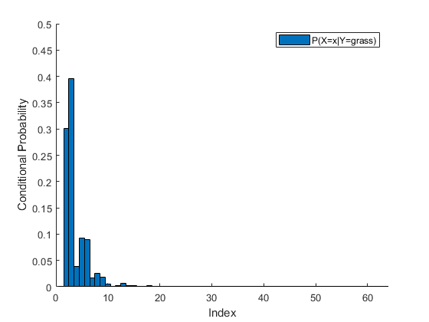

Fig. 1. Conditional probability of $P_{X|Y}(x|grass)$

c) for each block in the image cheetah.bmp, compute the feature X (index of the DCT coefficient with 2nd greatest energy). Compute the state variable Y using the minimum probability of error rule based on the probabilities obtained in a) and b). Store the state in an array A. Using the commands imagesc and colormap(gray(255)) create a picture of that array.

Fig.3 shows the mask image predicted by the training data.

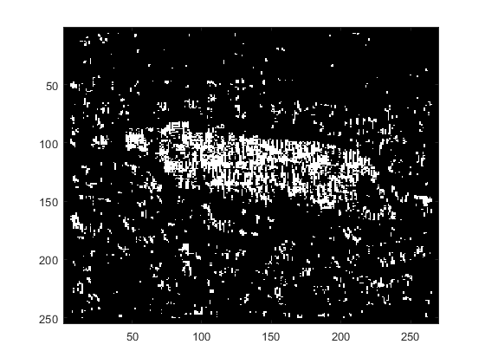

Fig. 3. The mask image predicted by the training data

d) The array A contains a mask that indicates which blocks contain grass and which contain the cheetah. Compare it with the ground truth provided in image cheetah mask.bmp and compute the probability of error of your algorithm.

The error rate in the ground-truth cheetah pixels $e_{cheetah}$:

$e_{cheetah}$ = (# of errors at ground-truth cheetah pixels)/(# of the ground-truth cheetah pixels) = 0.6736

The error rate in the ground-truth grass pixels $e_{grass}$:

$e_{grass}$ = (# of errors at ground-truth grass pixels)/(# of the ground-truth grass pixels) = 0.0502

The overall error rate:

$P_{Y}(cheetah)$ $e_{cheetah}$* + $P_{Y}(grass)$ $e_{cheetah}$* = 0.1698