1. **Stakeholder Background (Individual: 10 marks)**

Sales manager refers to the manager who is responsible for developing and analysing the companies’ sales strategies and leading the team of sales staff to formulate plans to sell the products the company is advertising to generate revenue for the company.

1. **Exploratory Questions**
2. What is the total revenue generated by my products and how profitable is each product?
3. What are some of the consumer’s preferences?
4. How am I able to formulate sales solutions to generate more revenue for the e-commerce company?
5. What are some of the goals and expectations I need to set for my team of sales representatives?
6. What can I observe by analysing customers’ spending behaviour on the various products offered by the e-commerce platform?
7. **Actionable Statements (Individual: 5 marks)**

The profit is obtained by taking the total revenue subtracted from the total cost of making each product. Additionally, they can analyse profits made by each product and determine which product is more preferred or most favoured amongst consumers. This allows them to predict consumer market trends in the e-commerce sector.

Upon analysing market trends and consumer trends, they can collaborate with suppliers or more companies to bring in more products that are in high demand by consumers to generate higher revenues for the company. To meet the targeted revenue, they would have to set performance targets for each sales representative on the number of products sold.

1. **Data Analysis and Visualisations (Individual: 25 marks)**

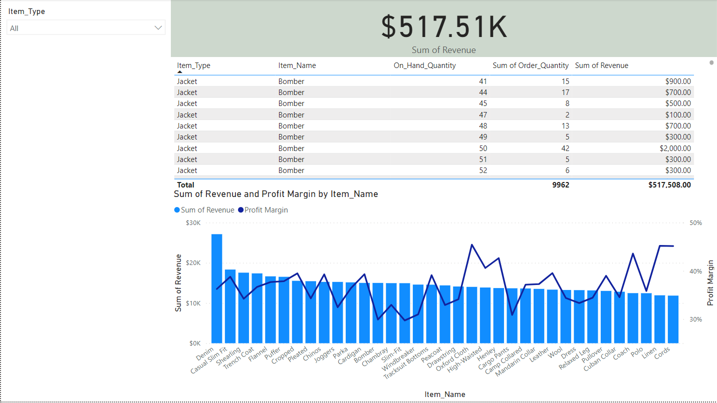

Figure i

With reference to Figure i, based on the figure the sales manager would be able to calculate the total revenue gained from each product sold by the e-commerce website. They can also utilise the Item Type slicer to categorise the charts and tables to display the view for jackets, shirts, and trousers. This chart is beneficial towards the stakeholder as from the chart the sales manager would be able to comprehend the overall revenue generated from each product and how profitable each product is by looking at the profit margin. Thus, this may lead the sales manager to formulate sales strategies that offer greater discounts on products that are more profitable. This allows them to gain more customers as products are sold at a relatively affordable price. It also encourages brand loyalty amongst its customers. Hence, this broadens its consumer base and widens its ability to market to more consumers, increasing the amount of revenue generated by the company. The table in the figure shows the comparison between the item quantity in stock and the order quantity for each product, this allows the sales manager to analyse the demand by consumers for each product. As a result, sales managers can take advantage of this insight to allocate more resources or lower the selling price of a product that is high in demand.

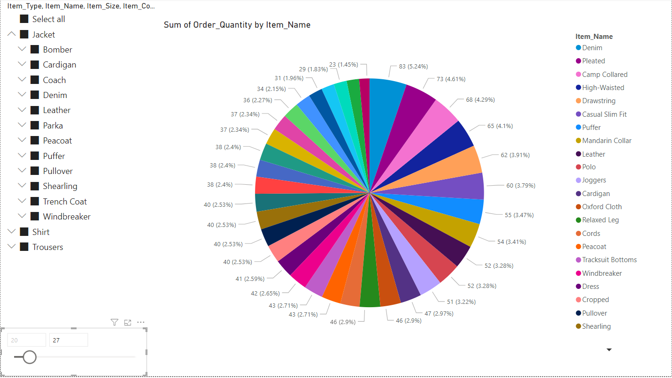

Figure ii

Figure iii

Figure ii describes a pie chart representing the sum of order quantity by item type and by consumer age. The slicer at the side allows the sales manager to further categorise the pie chart based on the product type, product name and product size. The sales manager can use this data to determine the specific products that are most popular and preferred amongst consumers of various ages. As a result, the sales manager to effectively understand their customer’s characteristics and behaviour when shopping. Allowing them to anticipate consumer trends in the e-commerce sector in Australia within a particular age group. This would allow them to collaborate with suppliers and the marketing team to bring in more products that would appeal to a certain age group and create advertisements that would promote their products that are relevant to the age group.

Additionally, the stakeholder would be able to drill through the Figure ii pie chart to display the order quantity of each product by each consumer’s state. Enabling the sales manager to comprehend the reach of their products in each consumer’s state. This allows them to prioritise advertising their products to regions that have fewer customers purchasing their products. Thus, increasing their market base and the extent of the influence of their products in Australia.

Figure iv

According to Figure iii, this visual represents the profit gained by each item, this visual can be further categorised by representing the profit gained from each item quarter-yearly and for the whole year. The items can also be further categorised based on the item hierarchy to the sizes and names based on each item type. This allows the sales manager to set KPI (Key Performance Indicators) for each sales representative using the earnings from each product in the year 2021 as a baseline for subsequent years. For instance, the total earnings produced for the item Casual Slim Fit trousers in the year 2021 is 1.7K. To avoid product earnings stagnating over time, the sales manager would anticipate each sales representative profits from 2022 to exceed the previous year’s profits for all products. Allowing the company to remain competitive in the e-commerce industry. Hence, these indicators act as a gauge of the company’s performance in terms of profits allowing the sales manager to monitor and incentivize each sales representative.

For 2022 the sales manager may expect the sales representative’s total profits from the specific item to surpass 2021 profits to not let their profits stagnate over time allowing them to stay competitive as a business in the e-commerce sector.

1. **Dashboard (Individual: 15 marks)**

This is the dashboard selected for the sales manager. This dashboard gives an overview of the main components of the report which are my total revenue for each product, my profit earned from each product and my consumer trends represented by the pie chart. This allows other stakeholders to understand the main components of the sales reports and it also allows the sales manager to justify and explain the various sales strategies implemented after analysing the report to the stakeholders.

1. **Individual Reflection (10 marks)**

Discuss any 2 key takeaways from this module (minimum 500 words), for example:

* What have you learnt from this module (i.e. concepts/theories, new knowledge)?
* Were there any technical or generic skills that you have learnt?
* Did the lab exercises provide you with a deeper appreciation of Power BI?

DSF has taught me the importance of data and its applications throughout all different types of industries such as delivery companies like Ninja Van which uses data to provide real-time tracking and shipment of products to their customers. E-commerce companies or any business that utilises data to grow their business profits, understand the landscape of the market and practice more efficient and effective methods when selling their products or marketing them. These are just a few examples that showed the cross-disciplinary uses of data in any industry. Through the lab exercises, I was able to grasp certain fundamentals that were taught in lectures such as cleaning, transforming, loading data and data modelling. For instance, I remembered in one of the exercises we had to merge certain queries and filter queries as some of the columns had null values that needed to be replaced. Additionally, in the most recent lab exercise on data modelling, I was taught to display parent-child relationships in data using a hierarchy, for instance, Employee details, Employee Name, Employee position and Employee ID. I was also taught that we could display relationships between primary and flat tables this is known as cardinality. Some of the relationships include one-to-one, one-to-many, many-to-one, and many-to-many. These relationships are modelled in a shape of a star schema. In the assignment part of the module, I was exposed to design thinking where I got to understand the various challenges and problems from the perspective of the stakeholder, I also had to come up with relevant and innovative visualizations in the report that will help the stakeholder fulfil their specific needs and goals. This would then lead to more effective and efficient implementation of solutions in the report as going through the define and empathise process paints a comprehensive analysis of the selected stakeholder which helps us visualize the big picture or see the vision in a long-term perspective. This allows us to bring our ideas into the real world. Through the various lectures and assignments, I have come to gain a greater appreciation and a greater admiration towards data analysts and data scientists as these lectures and assignments showed me the technical skills and competencies together with critical skills or transferable skills that are necessary for a data scientist or analyst to possess and be proficient in which takes a lot of time and effort. I am also grateful that my lecturer Mr Chee was able to help me grasp and understand the various fundamentals by often using personal examples to demonstrate the usage of these fundamentals he also shared his personal experience which made the lesson more insightful and interesting. I personally believe that some of the skills can be transferred to any discipline or industry I may be pursuing in the future. For instance, when making an infographic I can utilise the skills I learnt in Power Bi to create visuals for the infographics according to the data given. I am also able to incorporate the design thinking process when developing new ideas or solutions from scratch or challenging my thought process by being creative and innovative.