INTERNSHIP REPORT ON

WEB APPLICATION DESIGN AND DEVELOPMENT

**BY**

**NISHITH JAGDISH GEEDH**

This Report Presented in Partial Fulfillment of the Requirements for the Degree of Bachelor of Technology in Information Technology.



**NATIONAL INSTITUTE OF TECHNOLOGY, KURUKSHETRA**

**HARYANA, INDIA**

**JULY 2023**

# DECLARATION

I, Nishith Jagdish Geedh, hereby declare that the presented report of the internship titled **“Web Application Design and Development”** is uniquely prepared by me after the completion of one month’s work at **Toyo Engineering India Private Limited.**

I do hereby solemnly declare that the work presented in this Internship Report has been carried out by me and has not been previously submitted to any other University, College, or Organization for any academic Qualification, Certificate, or Degree.

I also confirm that the report is only prepared for my academic requirement, not for any other purpose.

# ACKNOWLEDGEMENT

I am incredibly grateful to my internship supervisor Mr. Omkar Kolwalkar Sir for their invaluable guidance and support throughout my internship. From the moment I started, he took the time to get to know me and understand my goals for the internship. They provided me with clear direction and expectations, and were always available to answer my questions and provide valuable feedback.

Throughout the internship, Mr. Pranit Pimple Sir provided me with invaluable insights and advice that helped me to grow my knowledge. I am deeply thankful for Mr. Abhishek Chavan Sir, Mr. Omkar Chavan Sir and Mr. Vaibhav Utekar Sir for their time and effort, and for their commitment to my success. Their constructive feedback helped me to improve my skills and approach to my tasks, and their encouragement kept me motivated and focused. I am also thankful for Mrs. Dhwani Ma’am for helping me out a lot during my initial days of the internship.

# ABSTRACT

The main objective of this internship was WEB DESIGN AND DEVELOPMENT. Several programming languages are used to develop a web-based application. Some are used only for the UI and the frontend of the application; some are used for the backend design of the software.

For example- HTML, CSS, Bootstrap Framework etc. are some programming languages to develop the frontend of an application. PHP, Java etc. are used at the backend.

Nowadays there are also some frameworks that are used vastly. Frameworks are basically structured programming by using Model, View, and Controller. It is also called as MVC.

If we develop a web-based application, it is very useful for us because we can access it from anywhere in the world. It is extremely helpful for our daily life.

Working in *Toyo Engineering India Private Limited* added a major experience in my upcoming career. Solving real life problems was another key issue. This report takes us through all the details, knowledge and experience of *Web Design and Development* gathered during this internship period.

|  |  |  |
| --- | --- | --- |
|  | **TABLE OF CONTENTS** |  |
| **CONTENT** |  | **PAGE NO** |
| Declaration  Acknowledge |  | 1  2 |
| Abstract |  | 3 |
| **CHAPTER** |  | **PAGE NO** |
| **CHAPTER 1: Introduction** |  | **4-6** |
| * 1.1 Objectives |  | 4 |
| * 1.2 Goals |  | 5 |
| * 1.3 Motivation |  | 5 |
| * 1.4 Report Layout |  | 6 |

CHAPTER 2: Internship Enterprise 7-8

* 2.1 About Company 7
* 2.2 Head Office 8

CHAPTER 3: INTERNSHIP ROLES AND RESPONSIBILITIES 9-16

* 3.1 Introduction 9
* 3.2 Knowledge Attained 9
* 3.3 Assigned Responsibilities 9
* 3.4 Work Environment 10
* 3.5 Performed Tasks 10
* 3.6 Web Page Details 11

CHAPTER 4: INTERNSHIP OUTCOMES 17-20

* 4.1 Problems and Solutions 17
  + 4.1.1 Problems 17
  + 4.1.2 Solutions 17
* 4.2 Learning Outcomes 18
  + 4.2.1 HTML 18
  + 4.2.2 CSS 18
  + 4.2.3 Bootstrap 18
  + 4.2.4 JavaScript 19
  + 4.2.5 SQL 19
  + 4.2.6 C# 19
  + 4.2.7 jQuery 19
  + 4.2.8 .NET Framework 19
* 4.3 Challenges 20

## CHAPTER 5: CONCLUSION AND FUTURE SCOPE 21-22

* + 5.1 Conclusion 21
  + 5.2 Future Scopes 22

**REFERENCES 23**

# Objectives

**CHAPTER 1: INTRODUCTION**

Internship is thought on addition a few encounters from the different a few associations which will encourage bounty to make a connection between the hypothetical and reasonable data. It includes profitable ability like usable working environment or pc instrumentation, taking care of a spread of things in the meantime, sorting out or dissecting learning, spending plans or rising collaboration, composing, and talking gifts. Usable work environment or pc instrumentation, composing, and talking gifts. It’s indispensable to get a hand on the best approach to impart data to outsiders, managers, and companions. While doing an Undergraduate program in Information Technology at NIT Kurukshetra, I considered a few programming courses in the past 2 years. Be that as it may, this is frequently not enough to get a good hand on Web Development because it's an extremely vast area of concern. I'm intrigued to be an intern at Toyo Engineering India Private Limited.

This internship report covers the whole internship time that I have finished with progress concerning the coding, style and improvement.

* + - Understand basic concept and structure of HTML, CSS, Bootstrap Framework, JavaScript, jQuery, MySQL and creating Databases and Websites.
    - To get awareness about the various job opportunities.
    - To perceive communicational skills and organizational dynamics.
    - To get educated about the corporate world.
    - Opportunities for technical skills.
    - Improve communication skills.

# Goals

* + - Knowing practical knowledge about programming.
    - Gain knowledge about HTML, CSS, Bootstrap Framework, JavaScript, jQuery, MySQL.
    - Increase communication skills with others.
    - Gain essential background knowledge.
    - Work well with the others.
    - Develop research skills.
    - Improve administrative skills.
    - Increase the capability for solving problems.
    - Knowledge of key professionals.
    - Improve professional ethics and values.
    - Improve technical skills.

# Motivation

For internship to induce the sensible expertise within the field of IT and Engineering. It's extraordinarily vital that knowing about hypothetical information and actualize inside the reasonable field to broaden our gifted ability in building work advertise.

The motivation of this internship actually came from the intention of learning more about the job sector and the work environment of IT farms. Before joining the internship, I knew that I am in a primary stage and a beginner in learning web development, so my first task would be to learn in order to create and be creative.

The learning curve of web development is very interesting. It is very simple to build a project fully by HTML, CSS, Bootstrap, jQuery and MySQL when you know what you are doing.

# Layout of Report

This Layout contains key points of this report as like objective details of the kind of paper selected, the margins, line spacing, pagination, and equation illustrations, and references, incorporation. Table 1 presents general page layout specifications.

I may allocate a document format for each report that I make. Through the document design, I describe the report's template attributes, like the report's page format and report’s data's number format. I am able of setting parameters for the documents when I use the functions of layout.

Once I define a document format, I explicitly specify a design for a report and I can modify a report's default layout.

* + - **Chapter 1** Describes the details of introduction of Web Development.
      * Objective. In this portion, the objective of the internship is described. It also consists of the facility, resources, how to reduce the number of employees and load of work on them. How to implement, inheriting the motivational thinking of web development.
      * Goals. Goals describes the aim of the internship. The key features of this part are to analyze the learning by the internship. It also shows the effectiveness and the choices can be made in future.
      * Report layout. It is an overview of the chapters contain in the full report.
    - **Chapter 2** This chapter is dedicated to describe the company I am doing the internship in. The motto and the goal of the company is stated in this chapter.
    - **Chapter 3** This chapter consists of the responsibilities and the roles I was given while doing the internship. This contains the training attended, work environment, assigned roles and responsibilities and the performed tasks.
    - **Chapter 4** This chapter contains the outcomes of a project and as well the internship. The outcome of a project is the result, and the problems and their solutions.
    - **Chapter 5** This chapter simply contains and describes the conclusion of the report.

# CHAPTER 2 ENTERPRISE OF THE INTERNSHIP

* 1. **Company information**

**Toyo Engineering India Private Limited (Toyo-India)**, an Engineering Consultancy & Contracting Company, is a perfect blend of Japanese technology and management practices with Indian expertise and ingenuity.

Toyo-India was established in the year 1976 by Toyo-Japan and to further consolidate its India story; started the Engineering centre in 1979.

**Group Mission**: Engineering for Sustainable Growth of the Global Community.

**Group Vision**: Global Leading Engineering Partner.

**Group Value**: Integrity, Creativity, Diversity, Learning, Team.

Toyo-India has created a niche by setting unparalleled standards in various sectors. Some of the key elements that help the company to excel include:

* Wide range of services: Toyo-India serves its customers in flexible manner under a variety of contract schemes for each project phase.
* Human Resources: The company earnestly strives to improve their engineering skills through in-house and customized training programmes.
* Engineering Tools and Infrastructure: All the engineering and project execution support departments are equipped with the latest engineering tools for smooth and timely completion of projects.
* Procurement: The procurement network testifies the superior supply chain management and our capability to source almost anything from anywhere across the globe.
* Construction: Toyo-India converts designs into realities through high quality construction and fast track project execution.
* Project Management: Their project management gives emphasis on information sharing; transparency and accountability; periodic monitoring; risk identification-analysis-mitigation and integration of advanced IT tools.
* Dynamic Work Culture: They foster our youth wing to develop and introduce latest working methodologies and tech-trends in the organization. Fresh engineers are given the opportunity to showcase their talents through challenging tasks and assignments.

# Head Office

Name: TOYO ENGINEERING INDIA PRIVATE LIMITED

Address: Toyo House, Lal Bahadur Shastri Marg, Kanjurmarg (West), Mumbai-400 078

Maharashtra, India

Tel: +91 - 22 - 5072 7000

Fax: +91 - 22 - 2573 7520 / 1

Website: <https://www.toyo-eng.com/in/en/>

## Some Programming Languages Used Here

## .NET Framework, ASP.NET, ADO.NET, C#, Razor, JavaScript, AJAX, PHP, CSS, HTML, Bootstrap, Java, MSBuild, IISExpress, Docker, jQuery, JSON

## Database Systems

## Oracle SQL Developer

## Frameworks

## .NET, Bootstrap, Flutter, Xamarin

## Cloud Platform

## Microsoft Azure

# CHAPTER 3

**ROLES AND RESPONSIBILITIES OF THE INTERNSHIP**

# Introduction

This chapter secured the approach of the internship program and gives the data about where the internship has been connected to accept the accountability of this program.

# Knowledge Attained

Bootstrap is a presentation framework, which seats on the client side of the client server architecture of web applications. It has very little to do with data storage in the backend or in the client side.

We either need a client-side language like JavaScript to fetch the data via AJAX for instance then we can use Bootstrap to style it or you need to use a server-side language/framework (PHP, Java, Python, NodeJS) to fetch the data.

The knowledge I attained at *Toyo Engineering India Private Limited* includes:

* + - HTML
    - CSS
    - JavaScript
    - Bootstrap
    - jQuery
    - Oracle SQL Developer
    - Microsoft Visual Studio
    - C#
    - .NET Framework

# Delegated Responsibilities

* + - Web design. Designing websites.
    - Frontend development.

Developing the frontend of websites based on the given UI.

# Environment of Work

**Frontend Developer:** A front-end developer is responsible for creating the user interface of a website, to ensure it looks good and is easy to use, with great focus on design principles and user experience. It's a combination of HTML, CSS and JavaScript, where HTML provides the structure, CSS the styling and layout, and JavaScript the dynamic behavior and interactivity.

**Backend Developer:** A backend developer is responsible for the development of server-side components of a web application i.e., working with databases, handling requests, creating server-side APIs that can be consumed by frontend developers to retrieve and manipulate data, ensuring the scalability of the systems. It often involves the use of programming languages such as Python, Java, PHP, JavaScript (Node.js), and .NET languages.

The job profiles for a web developer include:

* + - Frontend web Developer
    - Backend Web Developer
    - Developer of Web Applications
    - Analyst for Design and Layout
    - Senior Web Analyst.
    - Web Marketing Analyst.

# Performed Tasks

**Task 1:**

The task is the Design of the About Us Page for SquareOne. SquareOne is an in-house developed Web Application to manage mainly DXoT activities and is being maintained and enhanced by SFD department. It is a Web Platform, which is very easy to access and get the operations accomplished. The purpose is to develop the webpage according to the UI design provided. The Web Page must be completely Responsive and should be properly viewable on multiple screen sizes.

**Task 2:**

The name of the project is the Design of a Sample Portfolio Website that is completely Responsive and can be used as a basis for developing a personal portfolio website. Responsive web design is an approach to web design that aims to make web pages render well on a variety of devices and window or screen sizes from minimum to maximum display size to ensure usability and satisfaction. The webpages are static, built using Bootstrap and include some use of JavaScript to make the website a little lively. It consists of a navigation bar, the webpage content, which is different for every page, and a footer.

# 3.6 Web Pages Details :

* Home
* About
* Work
* Contact

## Home Page:

In this page, the home screen of the website is showed. Users can surf through this page to get an overview of the entire portfolio.

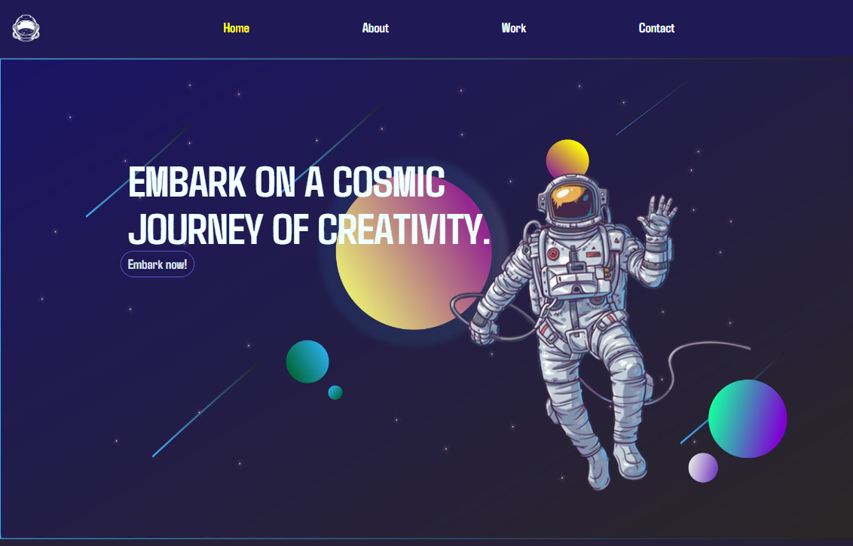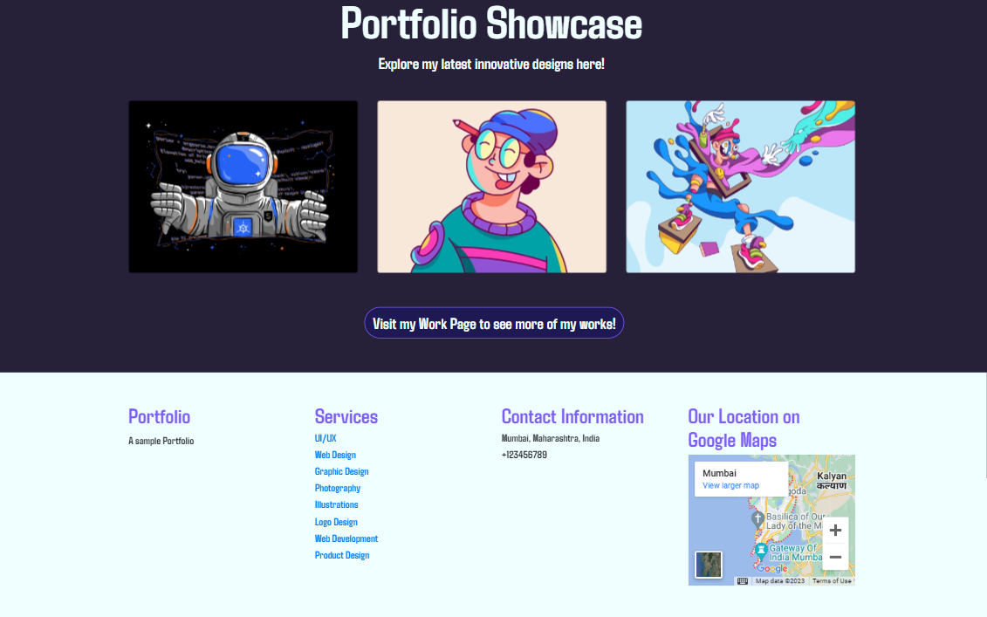

## About Page:

This page consists of a summary of information regarding the person whose portfolio is being made. It also consists of the skills of the person, experience and the services he/she offers.

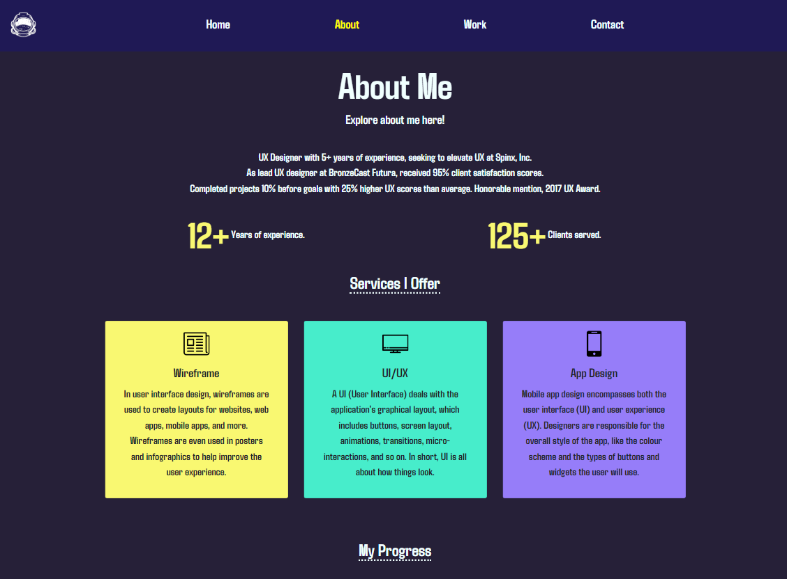

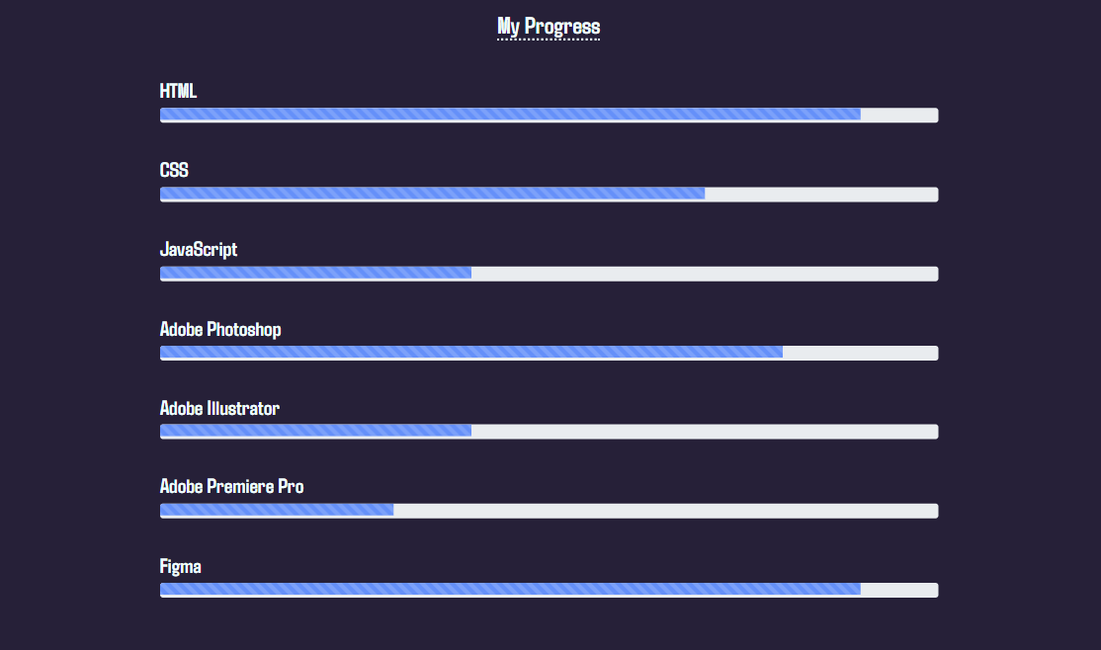

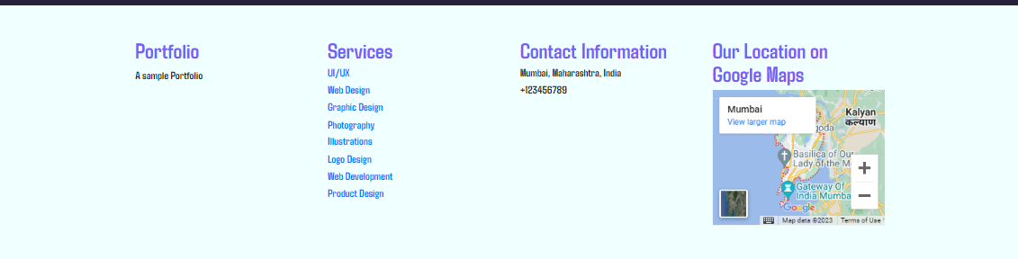

## Work Page:

This page consists of the projects done previously by the person in different fields or in the same field. It also consists of the services provided or the achievements of the person.

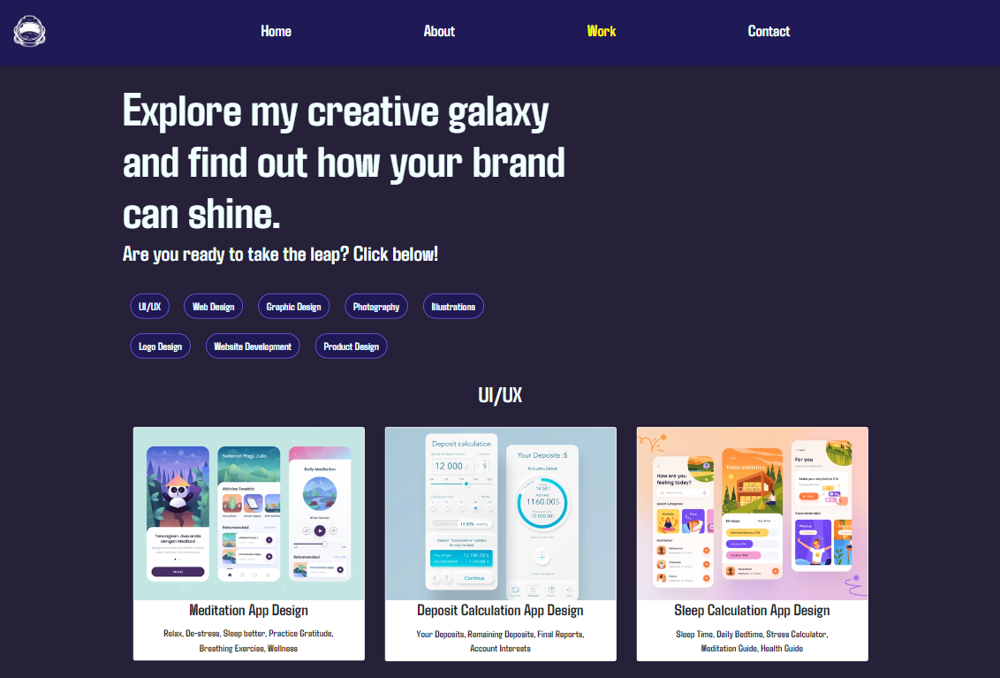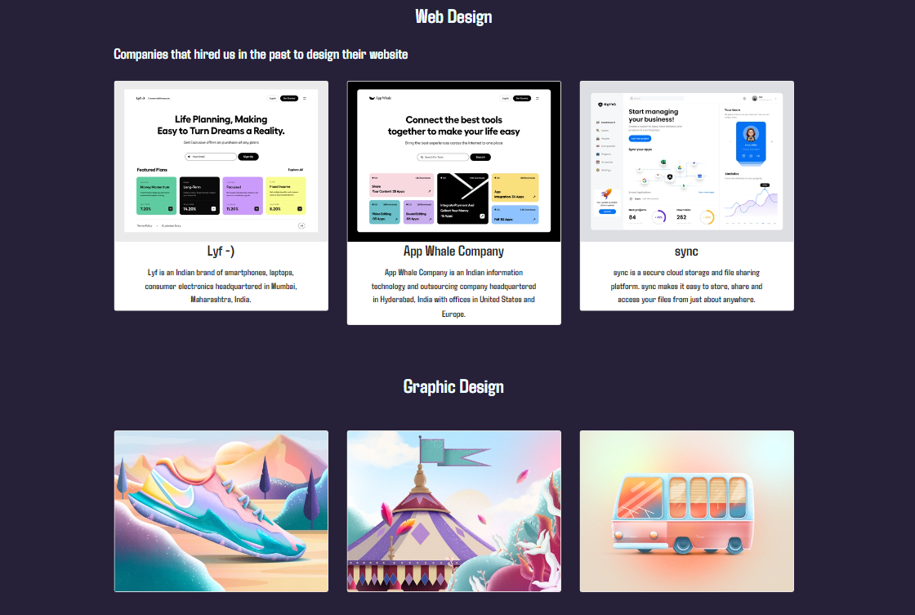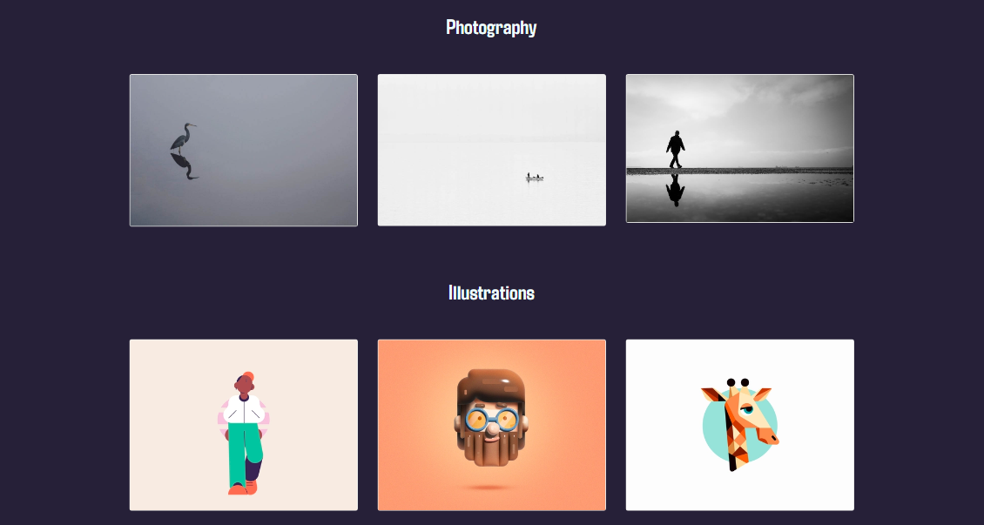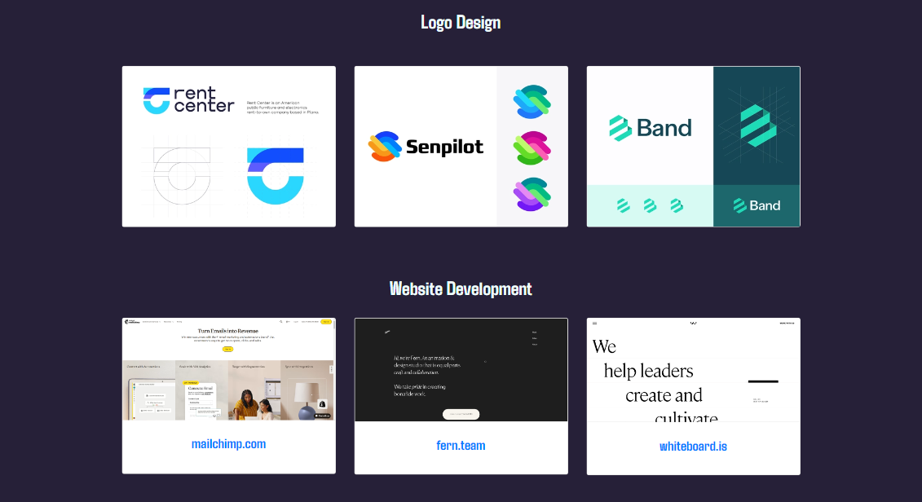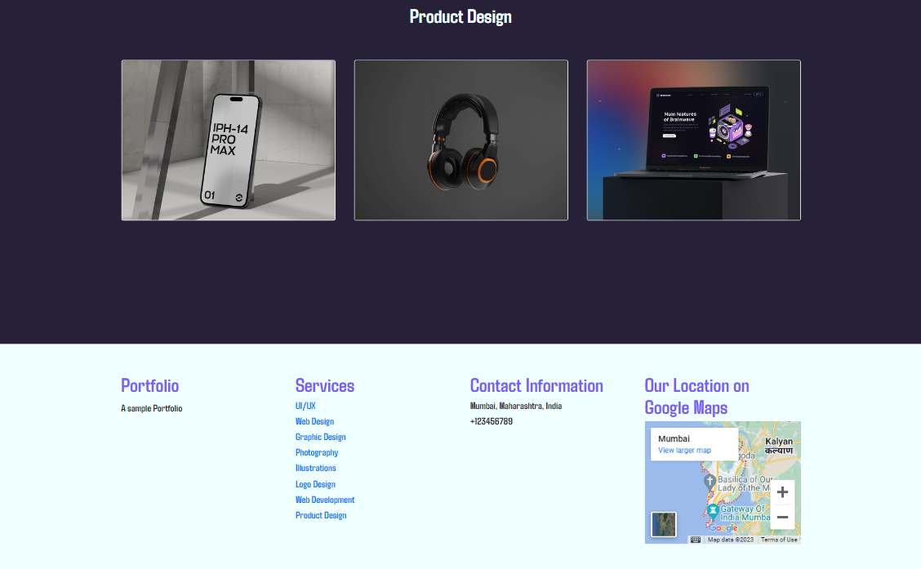

## Contact Page:

This page consists of the contact of the person. The person can get in touch with a client or an employer through this page. It may also consist of testimonials by previous clients or employers.

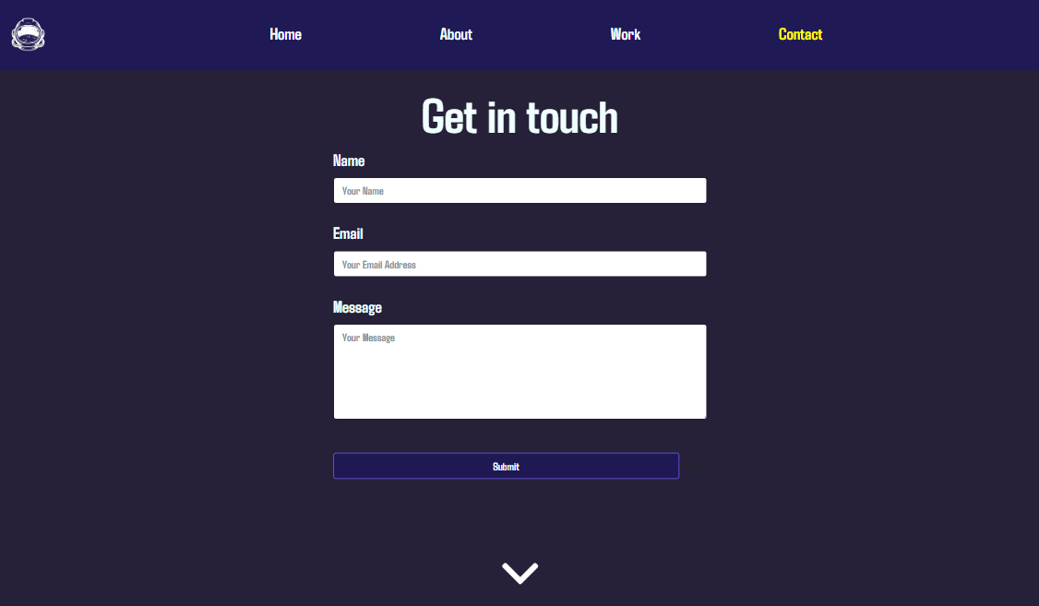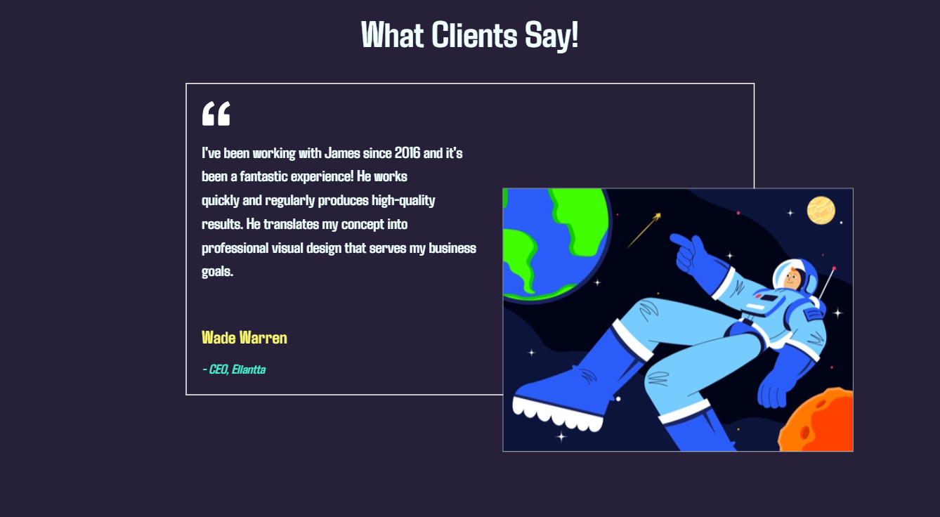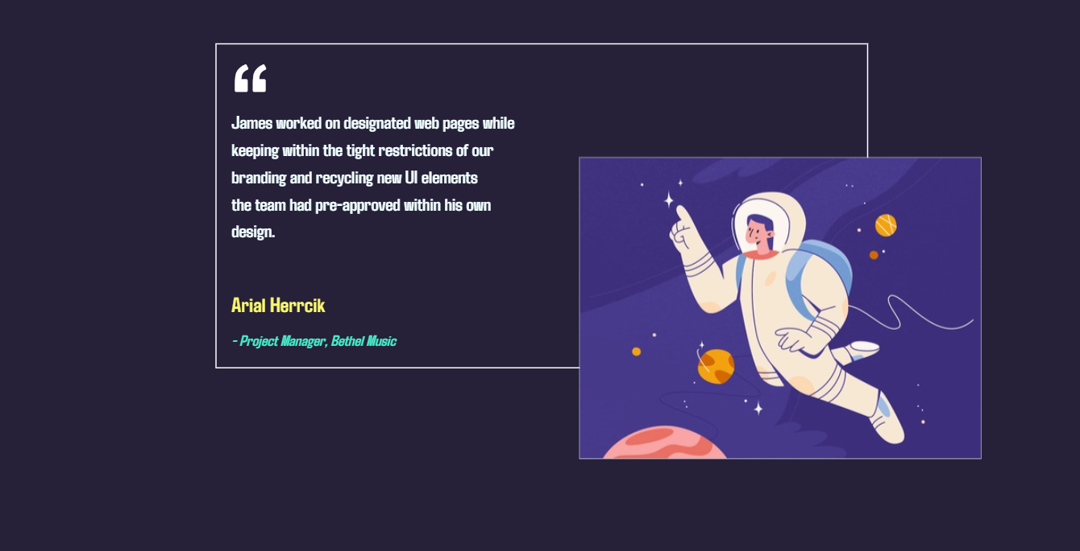

## Responsive:

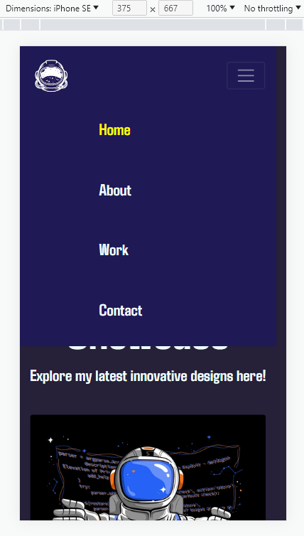 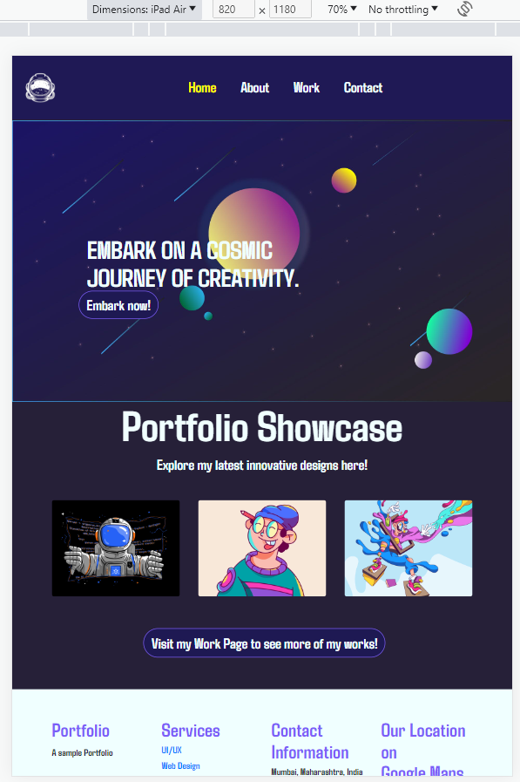

# CHAPTER 4 INTERNSHIP OUTCOMES

* 1. **Problems and their Solutions**

During Web Development, different issues can be faced as the result requires different forms of markups, methods, objects, modifiers, and many others to build an entire website. These problems require easy to understand solutions in the quickest possible time.

# Problems

I faced so many problems while working with Bootstrap. Sometimes an easy task becomes tough when it doesn't match the expectations and is not placed in the right place. Web design is not a simple task. To come up with a unique web design it takes a lot of creativity, brainstorming, the cooperation of the group and uniqueness. A web designer goes through a lot of obstacles on a regular basis. Only the web designs that were in the process of constant development and recursive thinking can satisfy the target market and clients. This creates a challenging environment for designing websites.

On the contrary, web designers also face some other hurdles. Such tasks include maintaining a website that is sensitive enough to be viewed and accessed on all phones. Such a website is called a Responsive website. Sometimes websites take time to load, so making the website load faster on different devices is one of the toughest challenges for web design to provide a better user experience.

There is another issue that occurs frequently. Clients face issues with the website and report it to the developer. But when developers check the website, it looks absolutely fine to them. These issues can be caused by outdated web servers or when clients make incorrect changes to them. Finding the sources of these issues can be time consuming and the developer has to tackle this on a daily basis.

# Solutions

Web development is so fascinating and simultaneously tough for me. During my internship period, I have faced multiple problems which I have faced by taking help from my seniors and also looked up for a solution online which has helped me gain so much knowledge.

Clean software eliminates unforeseen errors that can impact the load of the site. Automated website monitoring solutions frequently enable developers to view the websites of their customers in real time and set alerts to notify them when potential issues arise. Not only does this allow developers to recognize an issue before the customer does it, it also gives them the opportunity to address it in many situations before the problem affects the business of the customer.

# Outcomes of Learning

## HTML

* + - * Basic HTML (Tags, Element, Attributes, Paragraphs, Headings, Line Breaks, Horizontal Rule, Lists, Table, Color Codes, Font, Text Linking, Email, Images, Background, Comments, Meta, Media, Charset)
      * Basic concepts (WWW& HTTP, HTTPS, Client Server Communication)
      * HTML Forms (Input, Text Fields, Password, Checkbox, Combo Box, Radio, Text Areas, Files, Buttons)

## CSS

* + - * Basic CSS (selector, internal, external, Inline, Class, Id, Background, font, Text, Padding, Margin, Border, list CSS, hovering and elements)
      * Advance CSS (border-radius, opacity, cursor, layers, position, display, float, gradient, and multiple-column)
      * Concept of Menus (single menu, dropdown menu)
      * Template, design using CSS div.

## Bootstrap

* + - * Environment Setup
      * Grid System
      * Typography
      * Tables, Forms, Buttons, Images
      * Drop down, Button group
      * Navigation Element
      * Bootstrap plug-ins (Transition, Modal, Drop down, Tab, Tool tip, Alert, Button)

## JavaScript

## Basic JavaScript (Syntax, Enable, Location, Operators, Variables, Events, Alert, Confirm, Prompt, POP up, Date, print)

* + - * JavaScript String (Strings, Length, Split, Search, Replace)
      * JavaScript advanced (get Element by Id, Inner HTML, Get table, index, DOM, manipulation, Regular Expression)

## SQL

* + - * Databases (Create, Select, Show, Drop, Copy Database)
      * Table (Create, Alter, Show, Drop, Copy, Rename, Truncate, Describe, Drop)
      * Queries (Insert, Update, Delete, Select Record)
      * Clauses, Conditions, Joins, Aggregate Functions
    1. **C#**
       - Methods (Parameters, Overloading)
       - Classes (OOP, Inheritance, Polymorphism, Abstraction)
       - Enums
    2. **jQuery**
       - DOM Manipulation (Add, Remove, Replace Elements)
       - CSS Manipulation (CSS Classes, Dimensions, Properties)
       - Effects (Animation, Chaining, Callback Functions)
       - Traversing (Ancestors, Descendants)
       - UI (Interactions, Widgets, Theming)
       - Plugins (PagePiling.js, Flicketplate.js, Multiscroll.js, etc.)
    3. **.NET Framework**
       - ASP.NET MVC (Model, View, Controller)
       - Routing (Conventional, Attribute)
       - SQL Server (Entity Framework, CRUD Operations)
       - HTML Helpers (Textbox, DropDownList, Templated, etc.)
       - Data Annotations
       - Attributes, Action Results, Views, Filters
       - Security (Authentication and Authorization)

**Differences Between ASP.NET and ASP.NET Core**

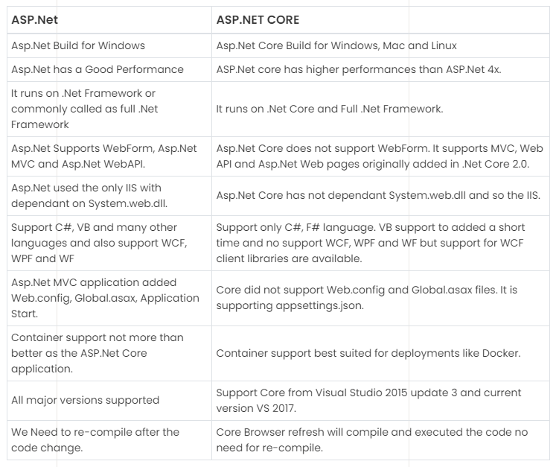

# Challenges

During the design of the code, different problems are faced. Most common problems include:

* Syntax error
* Fatal error

# CHAPTER 5 CONCLUSION AND THE FUTURE SCOPE

* 1. **Conclusion**

As we all know, our country is a developing country and it dreams to be a developed country soon. Hence the Government of India has taken many necessary projects for fulfilling the concept of Digital India. Day by day our job sector is getting more and more competitive. As a result, each and every company is searching for experienced candidates.

Finally, I can claim that this internship has helped me gain experience. Thanks to *Toyo-India*,

I gained so much in-depth knowledge of technical and personal skills. This internship has helped me gather theoretical and practical knowledge about HTML, CSS, Bootstrap, JavaScript, MySQL, C# and other programming languages.

For the students who are willing to work in Web Development, there are huge opportunities available. To give them the scope for online work and development of websites, most private and public organizations employ Web Designers. With the rapid emergence of the digital industry, the demand for web development professionals is growing, and in the coming days it has already availed so many job opportunities for freshers.

My internship company gave me a good scope to learn and discover my potentials. I am very grateful to them. Now I am able to develop completely responsive web applications from scratch. I am fortunate to get the chance to experience the real-life software development environment.

# Future Scopes

I gained so much experience during this internship. This internship will support me for my future career opportunities. In the future, I may now:

* + - Work in an IT farm.
    - Work as a Full Stack Web Developer.
    - Pursue a career in Web Design.
    - Work as a Software Engineer.
    - Pursue Mobile Application Development.
    - Work as a QA Tester.
    - Become a Web Analyst

# REFERENCES

1. <https://www.toyo-eng.com/in/en/>
2. <https://www.tutorialsteacher.com/mvc>
3. <https://www.tutorialspoint.com/jquery/index.htm>
4. <https://www.w3schools.com/cs/index.php>
5. <https://www.udemy.com/>
6. <https://www.pragimtech.com/courses/bootstrap-tutorial-for-beginners/>