**ÔN TẬP SPEAKING UNIT 8**

**FOOD**

1. What do you like to eat for breakfast?

* I like to eat bánh mì for breakfast

1. What are typical dishes in your country?

* The typical dishes in my country is Pho

1. What foreign dishes are popular in your country now? Do you like them?

* Foreign dishes are popular in my country are pizza, shushi, tokbokki, etc

1. Do you eat a healthy diet? Why or why not?

* Yes, i do. Because i eat a lot of vegetables, and I don't skip breakfast

1. Do you prefer to eat out or eat at home?

* I prefer eat at home.

1. Do you like cooking? What kind of food can you cook?

* Yes, i like cooking. I can cook rice and fried eggs

1. What food can’t you live without?

* I can’t live without rice, eggs, and instant noodles.

1. What is your favorite food?

* My favorite food is instant noodles

1. What are some traditional foods in your country?

* Traditional foods in my country are pho, banh mi, banh xeo, banh khot, etc

1. Do you like tasting new food?

* Yes, i like tasitng new food. Because i want to know many foods

1. What time do you usually have dinner?

* I usually have dinner at 19pm

**CLOTHES**

1. What is your favourite item of clothing?

My favourite item of clothing is a watch or shoes

1. Where do you often go shopping for clothes?

* I often go shopping online.

1. How do you feel about fast fashion?

* I feel that is a waste

1. Have you ever bought second-hand clothes? What did you buy?

* Yes, i have. I bought t-shirt, jeans, wide-leg pants, shoes, etc

1. Do you think that buying clothes is a waste of money?

**There are some benefits of healthy eating**

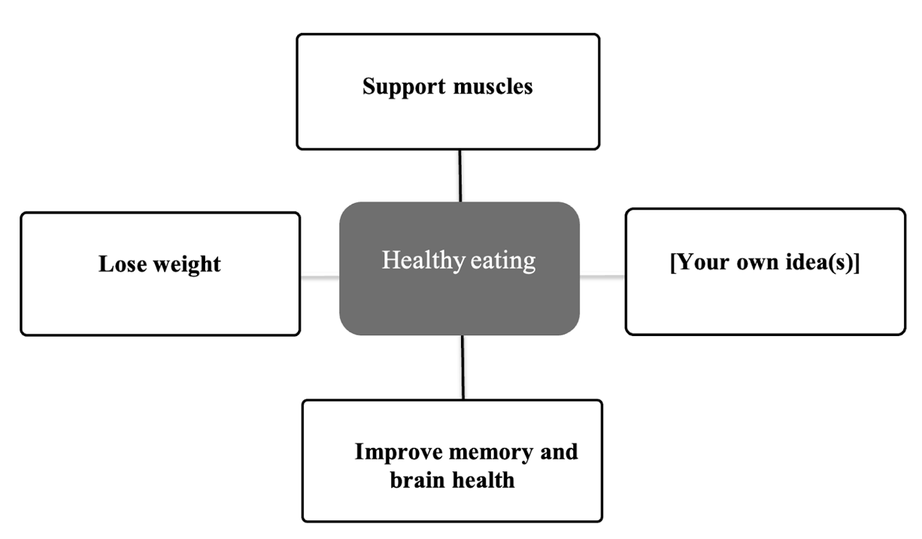

**Follow-up questions:**

1. Do you like eating vegetables?
2. What food do you not like to eat?
3. Do you eat fruit every day?
4. Do you like trying new foods?