Contents

**I.** **INTRODUCTION** 4

**II.** **DESCRIPTION OF OUR TOPIC** 4

**III.** **VISUALIZATION** 5

**1.** **FIGURE 1 : Geographic Map : Overview of vaccination process around the world** 5

**2.** **FIGURE 2 : Polar Plot : What strengths does each region have to combat the pandemic ?** 6

**a.** **GDP per capita index** 7

**b.** **Human development index** 7

**c.** **Hospital beds per thousand** 8

**d.** **Stringency index** 8

**3.** **FIGURE 3 : Sunburst Plot : Do vaccines affect death tolls ?** 12

**a.** **North America and South Asia analysis** 12

**b.** **East Asia analysis** 15

**4.** **FIGURE 4 : Bar Plot : Breaking down vaccination process based on 3 criteria** 18

**5.** **FIGURE 5 : Line plot : When did vaccines start to have effect on new cases or new deaths ?** 19

**a.** **European analysis** 20

**b.** **Middle East and North America analysis** 21

**c.** **Asia analysis** 22

**d.** **Australia & New Zealand analysis** 23

**6.** **FIGURE 6 : Heatmap : Do factors affect each other ?** 24

**7.** **FIGURE 7 : Box Plot : Overview of new vaccines, new cases, new deaths** 25

**IV.** **SUMMARY** 26

1. **INTRODUCTION**

* Originated from Wuhan (China) in the end of 2019 onwards, Covid-19 pandemic has been causing 253 million cases, 5.09 million deaths (WHO 9/11). The pandemic develops in a complicated way in 215 nations and territories. New cases have been detected everyday. America tops the list with 46,9 million cases, 761 thousand deaths, followed by India. Covid-19 is such a pressing issue that the whole world are trying to deal with. But we are living in an era that a new vaccine can be rolled out every 9 months, therefore, it becomes a turning point to terminate the pandemic. The Covid outbreak spread out in a large scale. The outbreak has been difficult to predict and it had a big impact on wide range of social economic industries. Specifically, the global supply chain of goods and services has been interrupted. Some activities such as import, export, tourism, accomodation, restaurant, health service were directly affected. Jobs have been lost, millions of workers have filed for unemployment. Corporations went into bankruptcy or halted operations and underwent a reduction in its size. Even developed nations have had a hard time curbing the rapid spread of the viruses. Although we are in difficult time, the advent of vaccines have shed a light on a solution to the end of pandemic. Numbers and figures in this analytic research will demonstrate that Covid-19 vaccinations have been working very well.

1. **DESCRIPTION OF OUR TOPIC**

* The data source is sponsored by Our World In Data a large organization and the data is updated daily and used by google search engines as a source of information for vaccine tracker.
* We look at worldwide overview, then selecting 8 particular regions with the most fully vaccinated people rate, then taking into consideration aspects that are influenced by vaccination and other factors of a country such as human development index, government response, GDP per capita , health facilities. Finally, we will answer **whether vaccines are effective in preventing infections or deaths, or both.**

1. **VISUALIZATION**
2. **FIGURE 1 : Geographic Map : Overview of vaccination process around the world**

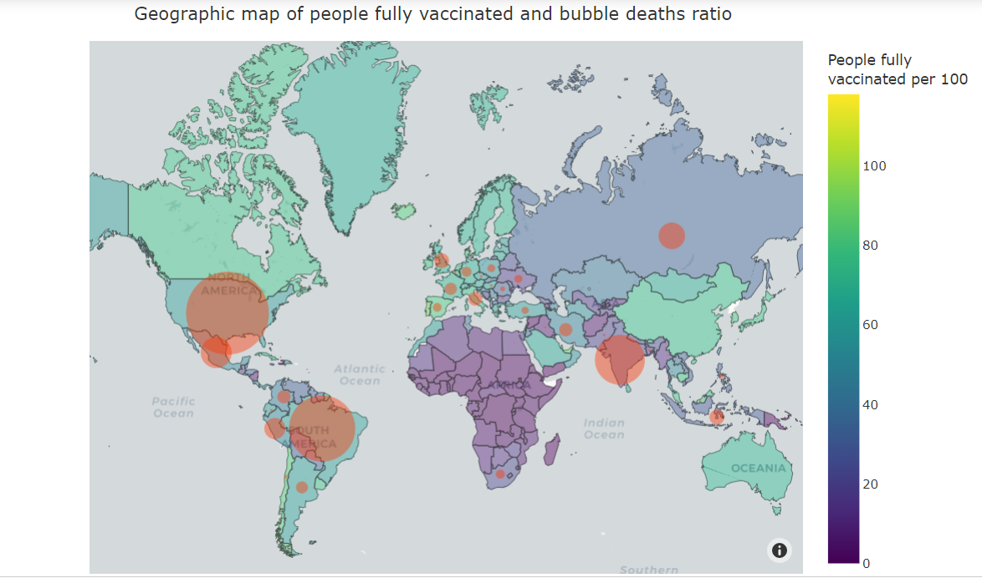

* **This geographic map shows full vaccination rate among countries in the world. People got 2 shots are consider full vaccinated.**
* As can be seen from the graph, nations in North America region, especially United States has the rate of 75%. Representatives of East Asia region, including Japan, China, South Korea has the full vaccination ratio of 75%, 74.26%, 77.96% respectively. Among countries with the highest full vaccination rate, we can take some examples with Australia 68.94%, countries in European Union such as England, France, Germany, Italia, Spain with the rate of 67.39%, 68.55%, 66.91%, 72.44%, 80.1% respectively.
* Countries with the lowest vaccination rate mainly locate on continent Africa. South Africa has just a 22.19% full vaccination rate, but this number is the highest in Africa. The rest of the region has really low rate, even under 1%. The most populous country in South Asia, India has the rate of 26%. For some nations in ASEAN, the figures in Vietnam, Laos, Myanmar are generally moderate with 33.49%, 37.63%, 15.05% respectively.
* Obviously from analysis above, regions or countries which are in the top of vaccination race, are developed economies or has produced their own vaccine to provide for citizens. For example, Moderna is a vaccine brand from American manufacturer, Astra Zeneca belongs to a England-Sweden company, Pfizer is the vaccine product from American-German corporation, Spunik of Russia, China also has their own vaccine product named Sinopharm – Sinovax.
* On the contrary, developing nations generally have lower full vaccination rate compared with developed ones. They have limited budget and technology progress to develop vaccines and therefore they are dependent on other supplies or humanitarian aid.

1. **FIGURE 2 : Polar Plot : What strengths does each region have to combat the pandemic ?**

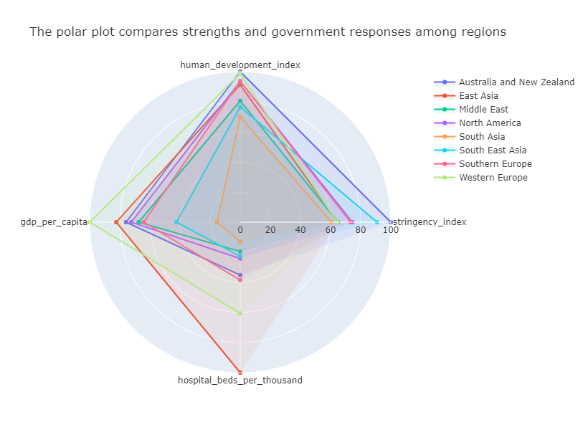

* The Polar plot indicates which aspects a particular region are strong or weak in order to deal with pandemic.

1. **GDP per capita index**

* Western Europe takes the lead in terms of GDP per capita. It consists of 9 members : Austria, Belgium, Germany, France, Liechtenstein, Luxembourg, Monaco, Netherlands and Switzerland. The main feature of this region is that its nations have relatively equal social economic development. Additionally, there are some countries having the strongest financial ability in the entire European Union.
* The region with second highest GDP per capita index is East Asia. China, Japan, South Korea has impressively high GDP per capita but discrepancy as regards development in this region such as wealthy gap between those 3 countries listed and Mongolia or North Korea, has caused it to lag behind Western Europe counterpart.
* Regions follow Western Europe and East Asia are Australia and New Zealand, Middle East, North America, Southern Europe. They have similar index and specifically in a small range (64 – 72). Middle East is politically unstable but they have a massive oil reserve so that this index are not low as expected. The index of South East Asia is quite low because major of this region are developing nations.
* The lowest index in these 8 regions belongs to South Asia (15.42). That is reasonable because this region is highly populous but the economies are not compatible with scale of population.

1. **Human development index**

* Australia and New Zealand region is at the top of the list, followed by Western Europe (98.91), Southern Europe (93.71), North America (93.65), East Asia (91.35). Of the lower part HDI in these 8 regions, Middle East and South East Asia has indices of 80.62 and 76.6 respectively. Again, South Asia has the lowest number for this criteria in these 8 regions.
* We can see that GDP per capita and HDI have a relative correlation. This totally makes sense because the rich countries would have more budget and resources to improve citizen’s living standard.

1. **Hospital beds per thousand**

* East Asia is the best region in terms of this public health facility index. Considering China as an example for East Asia, this most populous country quickly responded to the outbreak by building makeshift hospitals. Those temporary hospitals have helped China fighting against pandemic effectively.
* Western Europe has the second most hospital beds per thousand. With strong financial ablity, they can build a lot of health facilities to serve their citizens. But majority of people lacked enough caution, new cases increased so rapidly that it overloaded the health care system.
* Southern Europe region, Australia and New Zealand region both have relatively high economic strength but the number of beds did not meet patient demand.
* North America, South East Asia and Middle East has very low number of hospital beds per thousand compared to that East Asia and Western Europe, just approximately one-third.
* Finally, not surprising, South Asia has the least number of hospital beds among these 8 regions. South Asia is home to many populous countries (India, Pakistan, Bangladesh) but these countries has moderate social-economic development.

1. **Stringency index**

* As described in Our World in Data website, The stringency index is a composite measure based on nine response indicators including school closures, workplace closures, and travel bans, rescaled to a value from 0 to 100.
* The polar plot indicates that region of Australia and New Zealand have the strictest social distancing measure. It is proved that this is wise action from the two government due to shortage in number of beds available to patients.

This is polar plot of only region Australia and New Zealand :

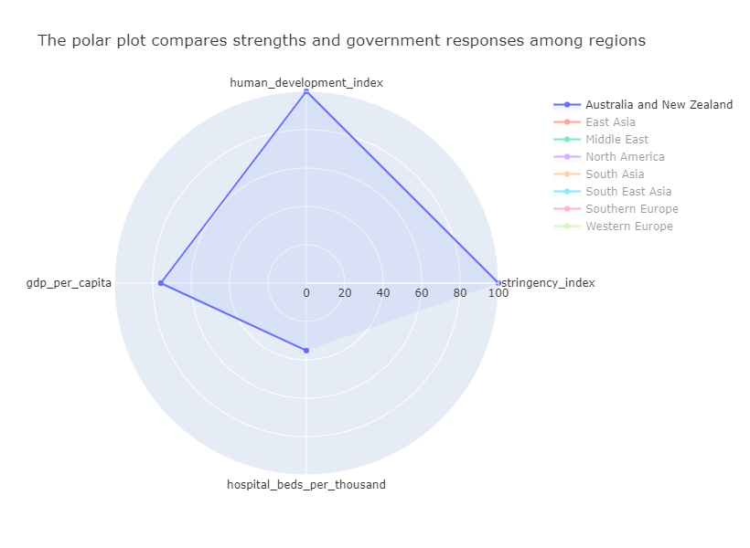

* The second strictest is South East Asia with relatively successful measure against the viruses. Not only low GDP per capita but also limited hospital beds, SEA nations need to adopt strict measures to tackle the problem For example, quick response from Vietnam’s government has contained the viruses in first 3 wave of Covid 19, which enable GDP growth to be positive during that period.

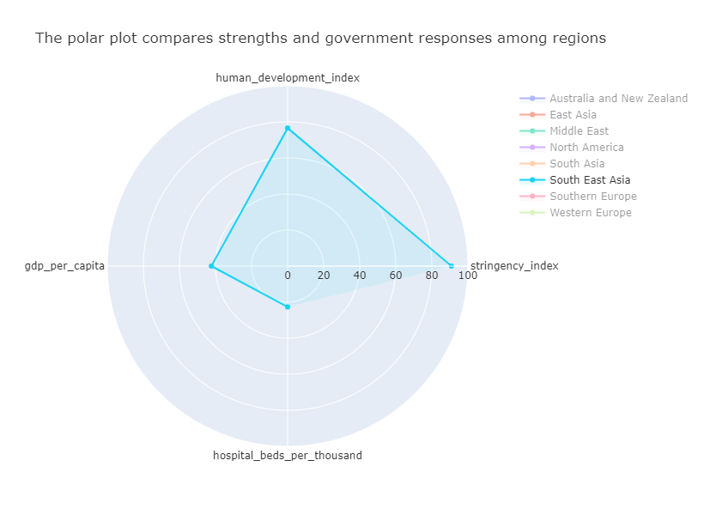

* North America and Southern Europe come next with number 75.51 and 73.2 respectively. Although the new cases were increasing at a rapid rate in America and Mexico, the two governments were still indifference in taking firm measures like Canada. Southern Europe had adopted some social distancing rule but they were still subjective with wide vaccination process. In Eastern Europe (64.43), people did not seem to concern pandemic. On special days, people still gathered in public places despite alert from local government. Governments in Middle East were moderately cautious about the complicated condition (64.98).
* The region which seems to be the most apathetic in these 8 regions is South Asia. India can be taken as an solid example for South Asia. India experienced one of the worst atrocious period of fighting against the Covid-19. Indeed, India imposed lockdown nationwide at first stage of pandemic. However, when lockdown had adverse effect on economic activities, citizen’s daily life, especially people living under poverty line. Therefore, governments did not impose another quarantine. To sum up, this region have been facing dilemma whether to shut down activities for public health concern or to open nation borders for economic priority.

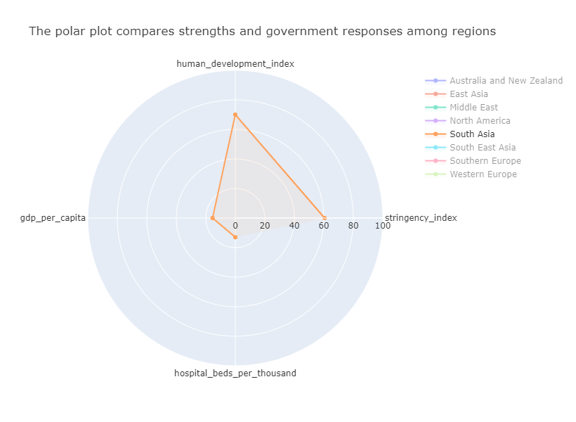

1. **FIGURE 3 : Sunburst Plot : Do vaccines affect death tolls ?**

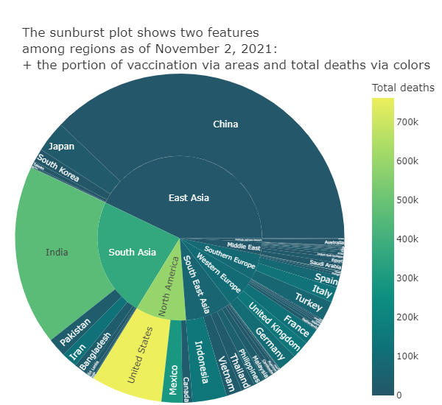

* Sunbusrt plot shows the share of vaccination and total deaths as of November 2, 2021.

1. **North America and South Asia analysis**

* Moving into more detail, North America and South Asia are considered to be the hotbed of pandemic, with really high death tolls. United States accounts for a major part of death tolls in North America, whereas India takes up large portion of number in South Asia.
* Although South Asia has shot 1 461 588 725 doses, Covid-19 has claimed 679 966 lives in this region. To account for this phenomenon, this region not only consists of many developing countries with high population, but also lacks of sufficient health facilities and proactive measures.

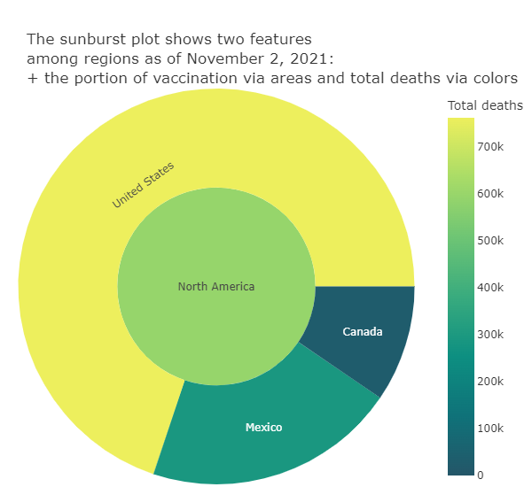

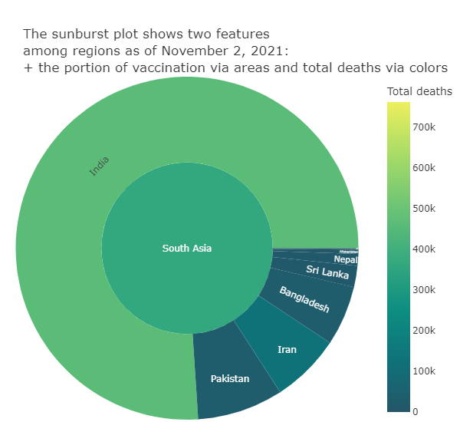

* These results can be interpreted by reusing polar plot : Both North America and South Asia have poor health facilities and did not impose strict lockdown to curb the viruses. The two regions are not performing well even we take GDP per capita and HDI into consideration. These are the most obvious evidence show why these two regions are the hotbed of Covid pandemic.

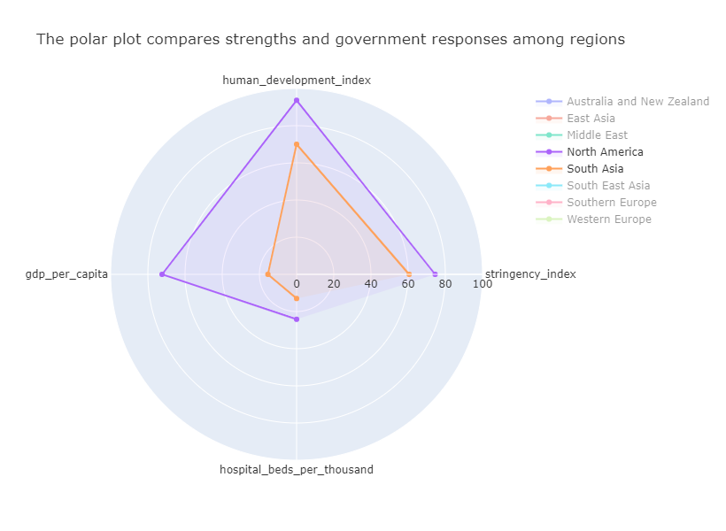

1. **East Asia analysis**

* East Asia has the most share of vaccine globally and this is one reason to show why death tolls are surprisingly low despite of biggest population. Immunization campaign had a positive impact, it was successful in containing severe cases in East Asia. China has very high vaccination rate due to the fact that this country can develop their own vaccine from early stage and number of products can meet massive demand of citizens.

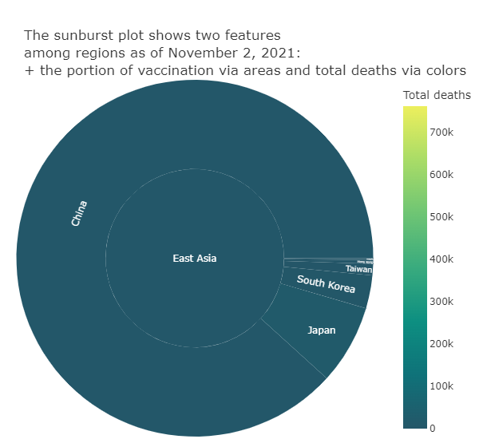

* Again, the polar plot which we mentioned can be used to explain the impressive success of East Asia in tackling the Covid problem: East Asia have impressively high index in terms of HDI, GDP per capita, hospital beds so they could deal with pandemic although they were not having strict quarantine.

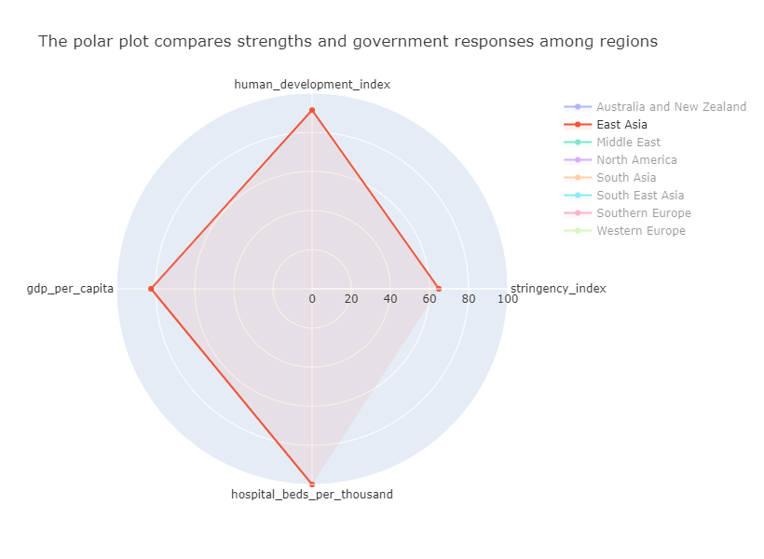

1. **FIGURE 4 : Bar Plot : Breaking down vaccination process based on 3 criteria**

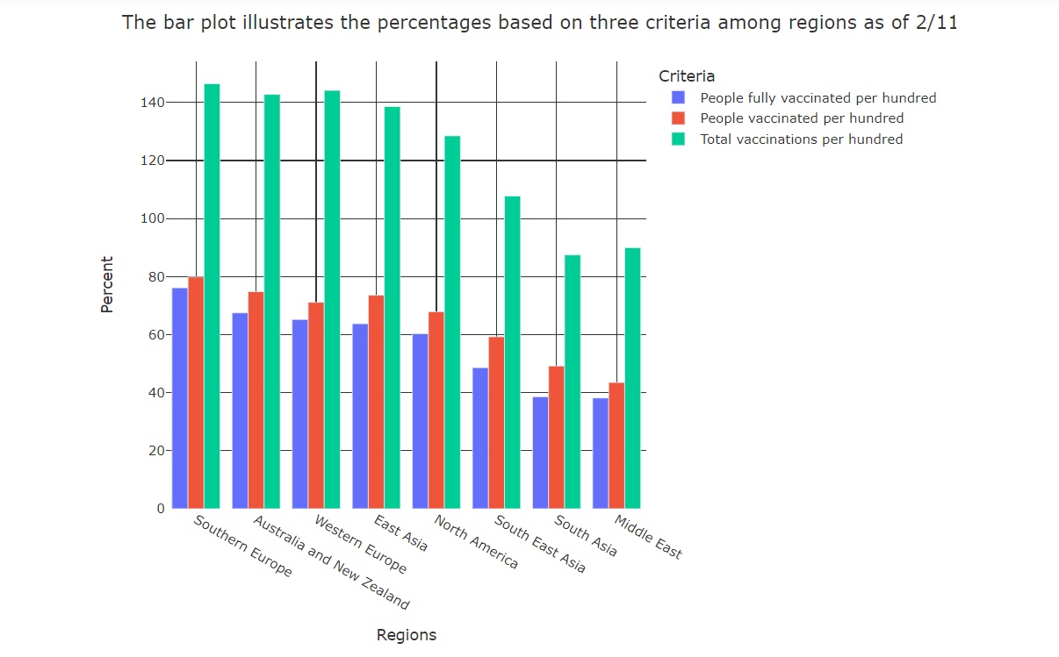

* The bar plot compares number of people per hundred who are fully vaccinated among 8 regions as of 2/11/2021.
* Generally, those numbers divided by three criteria are highly correlated. If a region has high total vaccination, it also has high rate of people vaccinated and fully vaccinated as well.
* Regions which have the highest people fully vaccinated per hundred are Southern Europe (76), Australia and New Zealand (67), Western Europe (65) and East Asia (64). These are highly developed regions and with economic and technology ability, they can buy or produce enough doses for their citizens.
* On the contrary, North America, South East Asia, South Asia, Middle East have fully vaccinated rate 60% or below. Governments in these regions are speeding up vaccination process to reach herd immunity.

1. **FIGURE 5 : Line plot : When did vaccines start to have effect on new cases or new deaths ?**

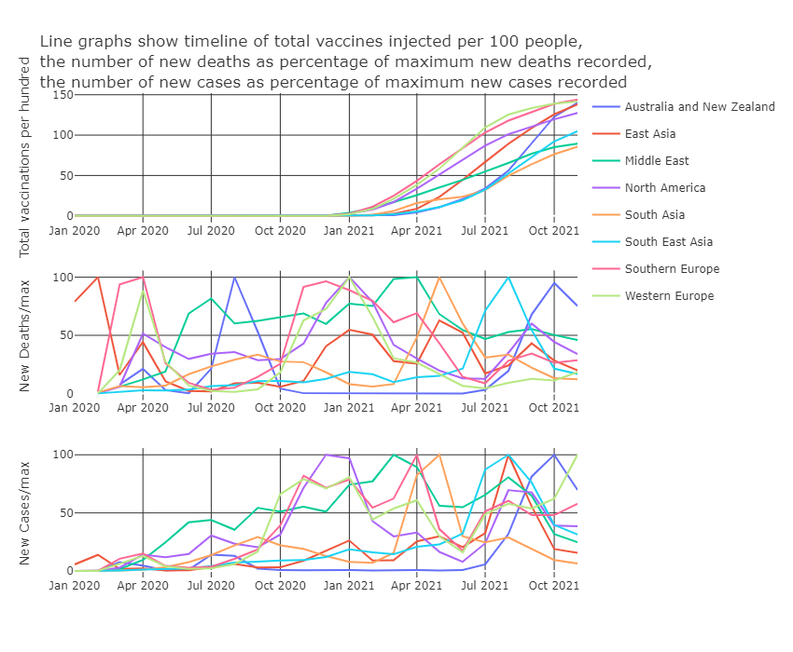

* Line charts illustrate the timeline of vaccination process, trend of new deaths and new cases (we take the new deaths and new cases as a portion of maximum new deaths and maximum new cases in the period respectively).
* As can be seen from the first of three graphs, vaccines were rolled out from the end of 2020. Countries in Southern Europe, Western Europe, North America, Middle East were among the first to start the Covid-19 vaccination process. Then, South Asia, East Asia, South East Asia, Australia & New Zealand had access to vaccines.
* Although Middle East had access to vaccines very early but they did not speed up the process like other regions. In contrast, East Asia and Australia & New Zealand have stable and quick vaccination process. South Asia and South East Asia have been fallen behind other regions in term of speeding up vaccine rate.

1. **European analysis**

* Delving into more detail, data from European nations (both Southern and Western) has proved that vaccines have been effective against new deaths. Since October 2021, European nations, especially England, have eased social quarantine. They let their citizens to participate in public events, this leads to increase in new cases. But the new deaths have not been increasing considerably.

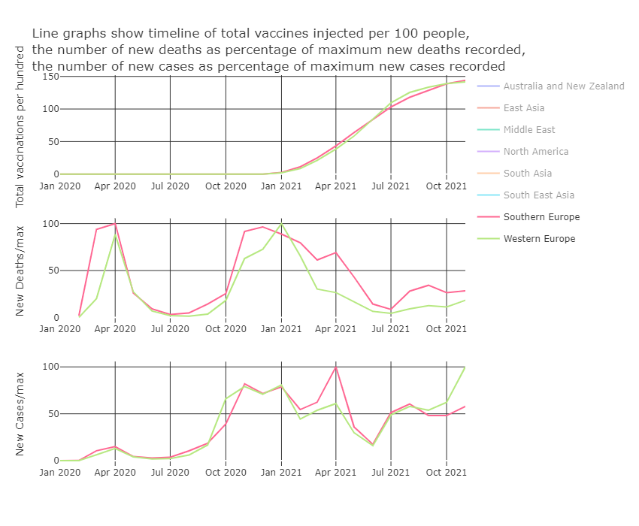

1. **Middle East and North America analysis**

* The data from Middle East and North America show the similar outcome of the effect of vaccine in prevent people to die from the disease.

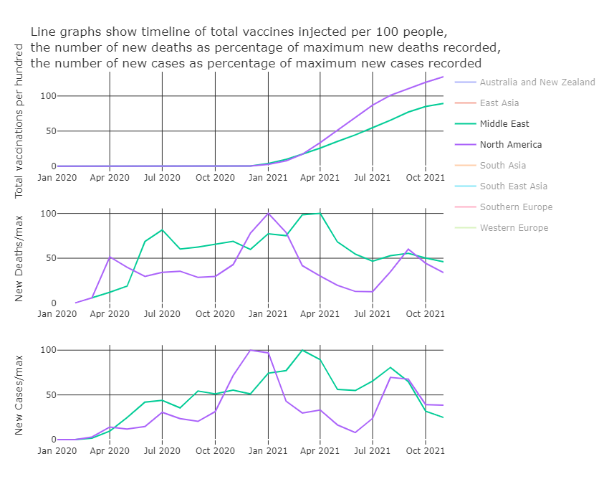

1. **Asia analysis**

* The great effect of vaccines can also be seen from Asian countries. After majority of continents have reached around 50% full vaccination rate, both new cases and new deaths show a obviously downward trend.

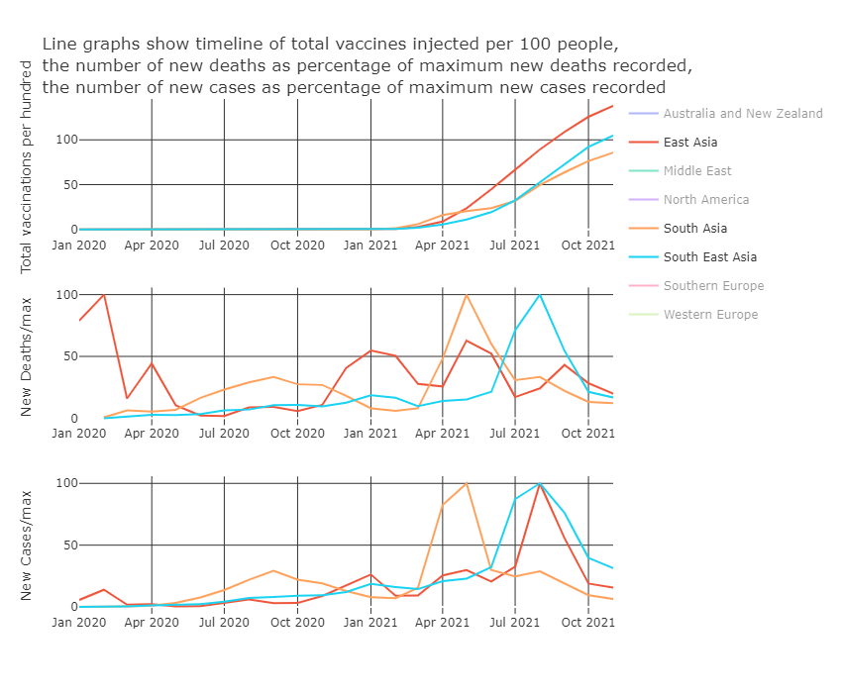

1. **Australia & New Zealand analysis**

* There is an exception in the data that new cases and new deaths have not been decreasing although vaccination process speeded up. That phenomenon occurs in Australia & New Zealand region. The new cases and new deaths before vaccination were really low that it can be negligible. This is the result of strict lockdown imposed in this region before 2021. After vaccines were widely used, goverments reopen countries and new cases and new deaths increased considerably. But since October 2021, both new cases and new deaths have gone down. This may be the time vaccines start to have effect.

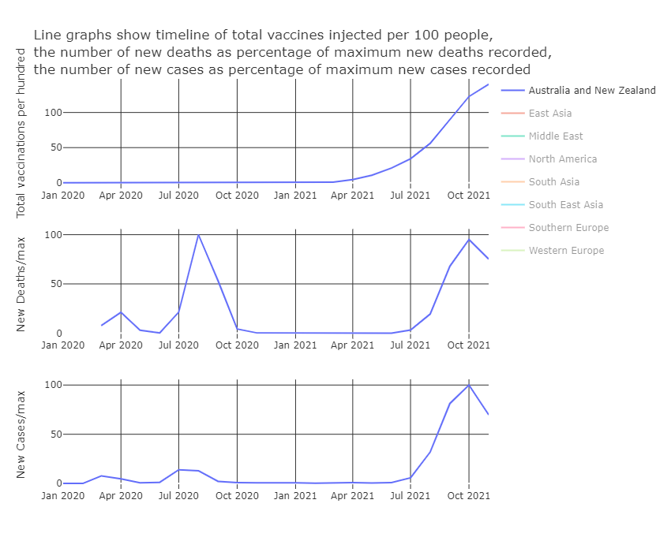

1. **FIGURE 6 : Heatmap : Do factors affect each other ?**

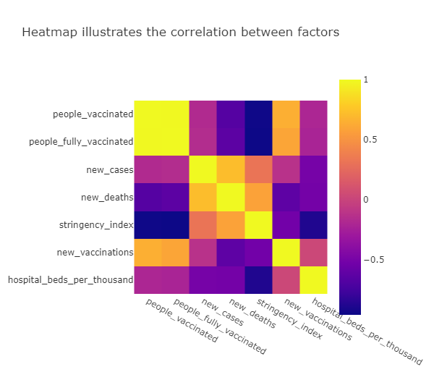

* Hospital beds per hundred and stringency index have a strong negative correlation (-0.88). It is understandable because countries which have a good health facilities tend to be more confident and therefore they usually do not maintain strict social distancing rules.
* Stringency index also has a strong negative correlation with people vaccinated and people fully vaccinated. The general approach of countries in the world : they will prioritize economic benefit after vaccination process has been conducted to some extent. Empirical study showed that production of goods and services have been recovering strongly after governments lifted strict lockdown. Those actions were necessary when community have reached herd immunity.
* Healthcare facilities also play an important role in reducing mortality rate. The heatmap shows that correlations between hospital beds per thousand and new cases or new deaths are both around -0.5.
* **The great effect of vaccination also has been illustrated in this correlation map, especially in reducing number of death tolls.** **Although new cases and people vaccinated have correlation of -0.17, the number for correlation between new deaths and people vaccinated is relatively high (-0.66).**

1. **FIGURE 7 : Box Plot : Overview of new vaccines, new cases, new deaths**

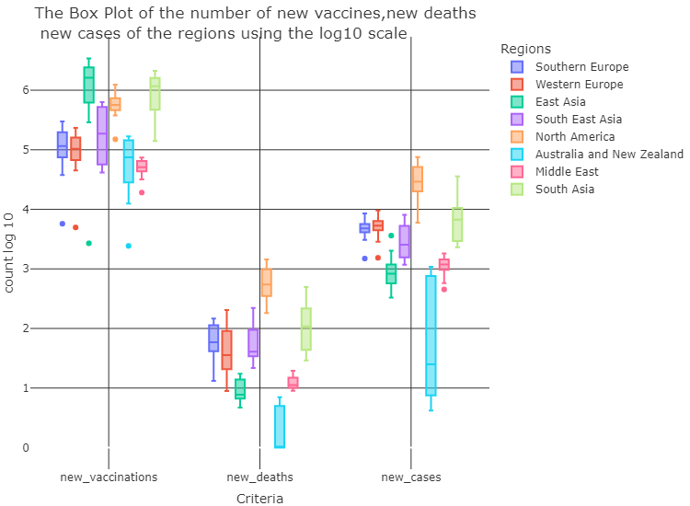

* Box plot shows the number of new vaccines, new deaths and new cases of 8 selected regions with log scale.
* Generally, regions which have high infection rate would automatically have huge new deaths and new vaccinations. But the difference is each regions have their own features relating to pandemic response, social economic development, culture, government policy so we can see the difference volatilities in three measures.
* In reference to Western Europe and Southern Europe, daily doses of vaccines have been injected stably at around 100000 doses everyday. Vaccination has not reduced new cases substantially so the distributions of new cases in both Western and Southern Europe are smooth with 3200 and 630 respectively. But the boxplot of new deaths distributions are skewed to the left and have a long interquartile range shows that there is a high volatility in new deaths recorded daily. Since vaccination process has been expanded and people have suffered from major waves, the herd immunity would be achieved. Therefore, this achievement has reduced new deaths and that is the reason why distributions are skewed to the left.
* Australia & New Zealand imposed strict lockdown at initial stage of pandemic, but they reopened borders and economic operations after when reaching specific vacccination rate. This leads to an increase in new cases detected.
* East Asia, as mentioned before, have late access to vaccines. However, with stringent policy and fast vaccination speed, East Asia have succeeded in combating the pandemic and show how effective vaccines can be.

1. **SUMMARY**

* The effect of vaccines can be various among regions in the world due to the difference in their economic ability, government response. Some regions witnessed the effect in short-term after vaccination, but there are some regions could not see the effect until at least months after herd immunity.
* **From the analysis of 7 main graphs, it can be showed that vaccines have been playing a major role in combating with the pandemic. We can say that vaccines have been an effective cure to reduce number of people suffering in pandemic, especially new deaths.**