Steps:

To generate the following:

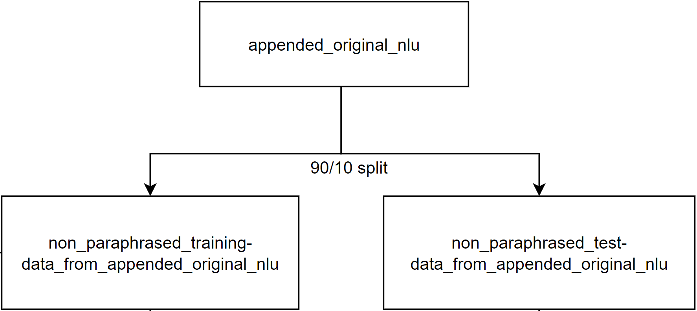

0. Install corresponding libraries, modules, and packages in requirements.txt

1. split the training data into 90/10

$ rasa data split nlu --nlu <your original nlu yaml file> --training-fraction 9

2. renamed the 10% test file to non_paraphrased_test_data_from_appended_original_nlu.yml

3. renamed the 90% train file to non_paraphrased_training_data_from_appended_original_nlu.yml

4. Train nlu model with non_paraphrased_training_data_from_appended_original_nlu.yml

$ rasa train --nlu

5. Paraphrase non_paraphrased_training_data_from_appended_original_nlu.yml by shifting the file to Pharaphraser folder, and convert it into XLSX format.

a. Convert Yaml to XLSX by using: https://www.convertcsv.com/yaml-to-csv.htm

b. Update nlu_test.xlsx by importing the converted data.

c. Run split.py to generate a new expanded.tsv file:

$ python split.py nlu_test.xlsx

e. Add "- " to nlu_examples_expanded by ="- "&<cell>

6. Run the paraphrasing python script.

$ python run RasaRephraseFull.py

7. Repeat steps 1. to 6. to create the following:

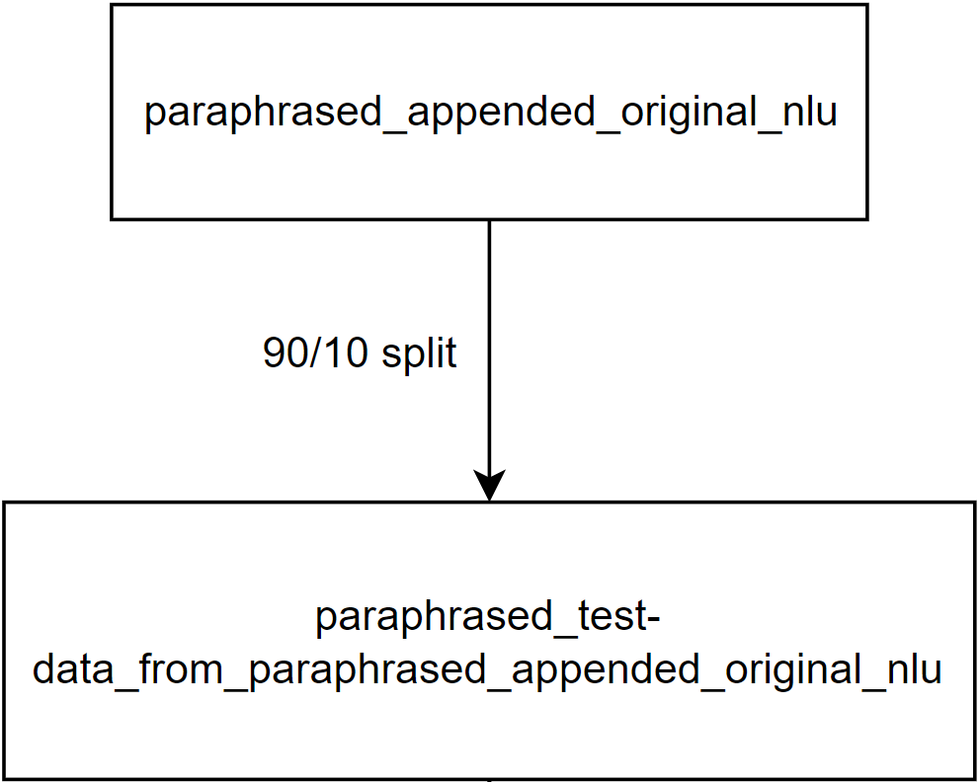

Overview Diagram:

