PUMA NUCLEI STAGE-2 RESEARCH REPORT
Debate History, Architecture Decisions, CPU Hypothesis Experiments, Performance Record, and V17 Research Plan
Consolidated through 7 September 2026
Current project status
Stage 1 is frozen and treated as strong infrastructure. v16.4 is retired as a production direction and retained only as a historical/control baseline. The research focus is a causally controlled Stage-2 semantic audit, followed by only those context, robustness, or proposal-selection components that demonstrate measurable conditional value.
Scope note
This document is a comprehensive synthesis of the technical discussion and experiments, not a verbatim transcript. It preserves the major hypotheses, counterarguments, numerical results, promotion/stop rules, and final implementation decisions.

Contents
1. Executive summary
2. Project scope, non-negotiable constraints, and evaluator realities
3. Historical Stage-2 baseline: v16.4
4. How the debate evolved
5. Experiment Set A: CPU20 hypothesis suite
6. Experiment Set B: V17 CPU surrogate audit
7. Experiment Set C: 20-epoch learning-curve rerun
8. What the experiments accept, reject, and leave unresolved
9. Final diagnostic framework for each nucleus class
10. Final evaluator-aligned causal decompositions
11. Final V17 architecture strategy
12. Statistical, checkpoint, runtime, and promotion rules
13. Exact next GPU experiment
14. Risk register and unresolved questions
15. Performance ledger
Appendix A. Full 20-epoch trajectory
Appendix B. Formula and metric glossary
Appendix C. Reproducible artifacts and source files

1. Executive summary
One-sentence conclusion
The project has moved from “make v16.4 bigger and train longer” to “freeze Stage 1, measure where Stage 2 actually loses F1, select the best real semantic anchor, and add context only as a proven rescue signal—preferably as a sparse residual that cannot freely rewrite already-strong classes.”
- Stage 1 is considered strong and is a permanent constraint: its architecture is not to be redesigned in this research program.
- v16.4 demonstrated real learning but poor scaling with complexity: early UNI2 adaptation improved semantics and PUMA, then prolonged LoRA training caused rising validation loss and declining generalization.
- The first full CPU20 proxy decisively rejected the old five-phase V17 curriculum: the simple baseline outperformed the phased design, KD hurt substantially, and a deliberate memorization test reached 1.0 training Macro-F1, reducing the likelihood of a fundamental crop/label/gradient bug.
- The later V17 CPU audit showed why controlled placebos are necessary: Cell+Context appeared to gain +0.0095 Macro-F1, but a same-information capacity placebo did even better, so the gain could not be called biological complementarity.
- The 20-epoch surrogate rerun showed that the strongest C256 branch learns clearly, but class learning is uneven: tumor and apoptosis improve strongly, while lymphocyte and histiocyte deteriorate. The main problem is now diagnostic, not optimization.
- The final research program distinguishes four class-level failure types: boundary-limited, representation-limited, interference/forgetting, and scarcity-limited.
- Real CellViT/ConvNeXt and real UNI2 must still compete fairly before any production semantic anchor is locked. The CPU C256 result makes Cell the control, not the guaranteed final base.
- Context (UNI2 and/or tissue) must prove net, unique rescue of mistakes made by the base anchor, while preserving strong classes and improving deployment/evaluator-aligned performance.
- The exact PUMA matcher is class-conditioned and score-aware, so clean semantic Macro-F1 is not enough. Class decisions, confidence ordering, duplicate selection, and centering must be causally separated.
- The final likely direction is a strong base semantic anchor plus only proven residual context, followed by the GT → Nearest-S1 → Selected-S1 and Class(old/new) × Score(old/new) evaluator audits.

2. Project scope, non-negotiable constraints, and evaluator realities

2.1 Objective
Maximize PUMA 10-class nuclei Macro-F1 while preserving a strong frozen Stage-1 detector, controlling runtime/VRAM, and avoiding architecture complexity that yields only +0.00x gains.

2.2 Non-negotiable constraint: Stage 1 is frozen
Permanent constraint
Stage 1 architecture, backbone, training objective, and detector design are not to be changed. Stage 1 may be measured, audited, and used to produce coordinates/confidence, but Stage-2 work must not redesign it.
- Allowed: measure coverage, centering residuals, duplicate behavior, OOF proposal coordinates, confidence, and structural ceilings.
- Not allowed: change detector architecture, detector loss, Stage-1 backbone, or jointly retrain Stage 1 with Stage 2.

2.3 Exact evaluator implications
The current public matcher groups predictions by predicted class. For a GT nucleus, only predictions of the same predicted class are eligible; eligible candidates are ordered by confidence first and distance second. This means class prediction changes matching eligibility, and confidence changes which duplicate is selected.
proposal -> predicted class -> class-conditioned eligibility -> confidence order -> distance -> match
- A wrong class can simultaneously create an FN for the true class and an FP for the predicted class.
- Changing Stage-2 class labels can alter the geometry of the evaluator outcome even when Stage-1 coordinates are unchanged.
- Changing confidence can change which same-class proposal wins a duplicate competition.
- The project must report both ROI-averaged fixed-10 aggregation and summed TP/FP/FN fixed-10 aggregation because they can disagree materially.
Source note: Verified against the current project public_matcher.py and aggregators.py during the debate.

3. Historical Stage-2 baseline: v16.4

3.1 Architecture and curriculum
v16.4 combined frozen/LoRA UNI2 identity features, BioMask-style identity cues, morphology, local/tissue/spatial context machinery, long-tail sampling, utility learning, and a long multi-phase curriculum. The initial schedule was approximately: semantic epochs 1–5, joint identity LoRA 6–70, context 71–120, utility 121–140.
- Identity anchor: target-centered UNI2 token pooling plus mask/morphology residuals.
- UNI2-H: 24 transformer blocks, 1536-dimensional embedding, 224×224 input, 14-pixel patch size.
- Source views were resized to 224×224, meaning source FOV and effective magnification were entangled.
- Runtime on L4 was compute-bound; context phases risked micro-batch reductions and higher cost.

3.2 Observed v16.4 learning history
Epoch | Phase | Semantic F1 | PUMA_FIXED10 | Val loss
4 | identity / frozen UNI2 | ~0.414 | ~0.261 | 0.928
5 | identity / frozen UNI2 | ~0.393 | ~0.242 | 0.984
7 | joint identity / LoRA warming | ~0.441 | ~0.277 | —
9 | joint identity / LoRA full LR | ~0.446 | ~0.268 | 1.011
12 | joint identity / LoRA | ~0.437 | ~0.257 | 1.095
15 | joint identity / LoRA | ~0.424 | ~0.257 | 1.276
18 | joint identity / LoRA | ~0.423 | ~0.259 | 1.398
Interpretation
LoRA was not simply “bad”: early adaptation improved semantic F1 from ~0.414 to ~0.446 and PUMA from ~0.261 to ~0.277. The failure was prolonged adaptation: validation loss rose sharply while generalization stopped improving. Therefore v16.4 was retired rather than extended to 50–100 more epochs.

3.3 Historical richer-view evidence
Older frozen richer-view V12 runs were not directly comparable, but they suggested that v16.4 may have discarded useful information through its FOV/pooling/fusion choices.
Historical run | Representative semantic F1
V12_05_CE_CCR_V64_V128_FROZEN | 0.4811 (E1), 0.4828 (E6), 0.4841 (E7), 0.4824 (E10)
V12_02_CONTEXT_CCR_V64_V128_V256_FROZEN | 0.4937 (E4), 0.4889 (E9), 0.4807 (E10)

4. How the debate evolved
Debate stage | Key insight | Decision
Round 1 — v16.4 diagnosis | Training was real, but complexity did not scale. Early LoRA helped; long LoRA overfit. Context/utility had not even been trained yet, so architecture failure could not be inferred from epoch 18 alone. | Stop extending the same curriculum; measure the error budget.
Round 2 — controlled C/A/B thinking | Proposed controlled branches to isolate frozen identity, LoRA, and context effects; emphasized identical sampling/loss/optimizer so only the intended factor changes. | Causal ablation over ad-hoc phase comparisons.
Round 3 — structural oracles | Recognized that semantic vs geometry/selection headroom had to be separated using the exact evaluator. | Build Ccoverage/C00/Csemantic/C01/C11 before ranking.
Round 4 — V17 CellContext | Moved toward decoupled classification: target-cell representation + local UNI2 + tissue, with Stage 1 frozen and proposal noise delayed. | Clean GT-centered semantics first; robustness later.
Round 5 — CPU20 red-team | Five-phase V17 proxy lost to a simple baseline; KD hurt; memorization reached 1.0; oversampling+CE beat Balanced Softmax. | Simplify aggressively and turn V17 into a promotion ladder.
Round 6 — Semantic Anchor Tournament | Removed the assumption that CellViT/ConvNeXt must be the semantic anchor. Real Cell and real UNI2 must compete. | C / U / CU tournament before expensive fusion.
Round 7 — placebo and capacity controls | Recognized that C+U gains may come from extra capacity, not complementary biology. | Add C+C, U+U, shuffled, same-ROI, later same-class controls.
Round 8 — evaluator audit | Verified class-conditioned, score-aware matching. | Clean semantic F1 becomes insufficient; every promoted model gets exact E2E shadow evaluation.
Round 9 — Nearest vs Selected | A single “Stage1-centered” metric mixed centering and selection. | GT → Nearest-S1 → Selected-S1.
Round 10 — Class × Score factorial | A new class and a new score had been changed together. | E00/E01/E10/E11 with E01 using p(old class), not pmax.
Round 11 — 20-epoch learning curves | C256 clearly learns but distributes gains unevenly across classes; CU/U overfit early. | Stop asking whether Stage2 trains; diagnose each class failure.
Round 12 — failure taxonomy and sparse residual context | Weak class ≠ needs context. Boundary, representation, interference, and scarcity must be separated. | Add context only as proven net/unique rescue; prefer sparse residual correction over giant fusion.

5. Experiment Set A: CPU20 hypothesis suite
A full 20-epoch CPU smoke test was run on six usable TIFF+GeoJSON ROI pairs (primary 001–003 and metastatic 100–102). This experiment was designed to kill weak hypotheses cheaply before another large GPU run.

5.1 Main result: simple baseline beat phased V17 proxy
Run | Best pooled Macro-F1 | Final Macro-F1
Simple 64-FOV baseline | 0.2538 @ E19 | 0.2506
Phased V17 CPU proxy | 0.2307 @ E12 | 0.2171
Difference | -0.0231 best | -0.0335 final
Epoch | Phased phase | Clean F1 | Miscentered F1 | Baseline same epoch
4 | A0 clean | 0.2156 | 0.2164 | 0.2020
5 | A1 + long-tail | 0.2287 | 0.2345 | 0.1972
8 | A1 + long-tail | 0.2133 | 0.2179 | 0.2281
12 | paired proposal views | 0.2307 | 0.2349 | 0.2359
16 | frozen-teacher KD | 0.2083 | 0.2113 | 0.2468
20 | EMA-KD | 0.2171 | 0.2201 | 0.2506

5.2 High-value CPU20 findings
Test | Result | Interpretation
Deliberate memorization | Training Macro-F1 = 1.000 | Strong evidence against a basic mapping/crop/gradient/data-loader failure.
KD | 0.2307 → 0.2083 | Strongly negative; EMA did not recover the loss. Remove from core V17.
Oversampling+CE vs Balanced Softmax | 0.2260 vs 0.2054 | Oversampling+CE selected as default; later true full-data BS control remains scientifically permissible.
Handcrafted cell/local/global | cell .2291; local .2093; global .1979 | Cell strongest standalone in this proxy.
Cell + local | 0.2376 | Best handcrafted fusion; +0.0086 over cell.
Cell + global | 0.2111 | Did not justify global.
Local + global | 0.2024 | Weak.
Cell + local + global | 0.2195 | Extra branches hurt; rejected “everything together” intuition.
GT polygon shape oracle | 0.1666 | Shape alone was not enough.

5.3 Representation-dependent FOV warning
Learned surrogate FOV/config | Macro-F1
64 | 0.0837
128 | 0.0887
224 | 0.0976
448 | 0.1139
cell128 | 0.0841
local224 | 0.1007
global448 | 0.1161
triple | 0.1205
Critical conclusion
This surrogate favored larger FOV, whereas a later handcrafted CPU representation favored 96px/64px. Therefore FOV cannot be chosen independently of representation.

6. Experiment Set B: V17 CPU surrogate audit
A second CPU suite used real PUMA image/annotation crops but lightweight image-descriptor surrogates instead of real CellViT/UNI2. It tested experimental mechanics: FOV sensitivity, placebo-controlled synergy, centering robustness, tissue interactions, imbalance handling, synthetic end-to-end transfer, and structural oracle code paths.

6.1 Sample distribution and limitation
Class | Count
tumor | 1667
lymphocyte | 459
apoptosis | 295
stroma | 190
histiocyte | 84
endothelium | 35
plasma | 3
neutrophil | 3
melanophage | 2
epithelium | 0
Interpretation constraint
Macro-10 is necessarily unstable/pessimistic in this six-ROI sample. Macro6 over the six reasonably supported classes is useful for mechanics, not for SOTA conclusions.

6.2 FOV screen
Source FOV | Cell-surrogate MLP Macro6 | Context-surrogate MLP Macro6
64 | 0.3686 | 0.3287
96 | 0.3810 | 0.2886
128 | 0.3697 | 0.2426
160 | 0.3371 | 0.2243
224 | 0.2953 | 0.2244
448 | 0.1843 | 0.2057
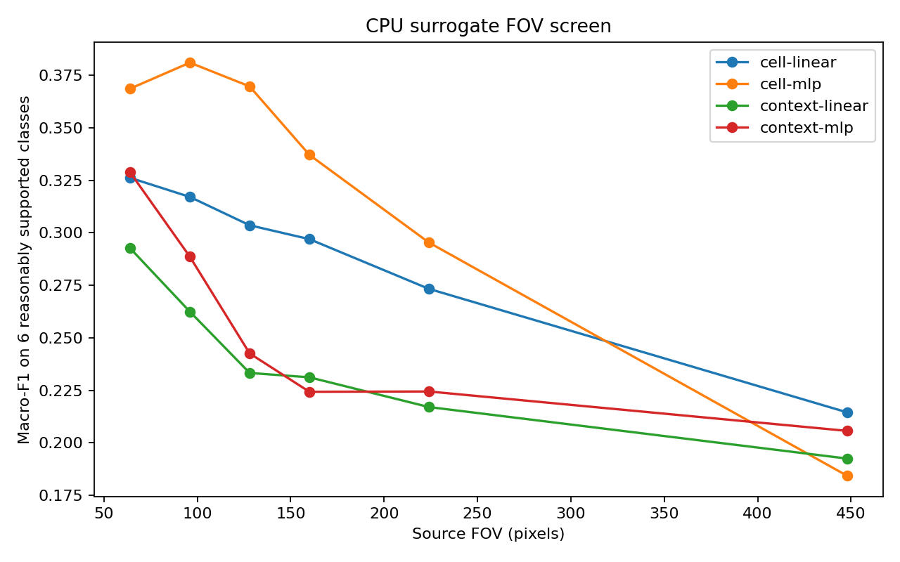
Figure 1. CPU surrogate FOV screen: local/small FOV wins for this descriptor, contradicting the earlier learned surrogate and proving FOV × representation interaction.

6.3 Placebo-controlled anchor test
Model | Macro6 | Fixed10
C | 0.2880 | 0.1728
U | 0.2818 | 0.1691
C+U | 0.2974 | 0.1785
C+C capacity placebo | 0.3124 | 0.1874
U+U capacity placebo | 0.2823 | 0.1694
C + shuffled U | 0.2747 | 0.1648
C + same-ROI shuffled U | 0.2363 | 0.1418
Raw apparent fusion gain: 0.2974 - 0.2880 = +0.0095
Against imperfect capacity placebo: 0.2974 - 0.3124 = -0.0150
Debate outcome
The +0.0095 gain cannot be called genuine biological complementarity. However, the C+C placebo duplicated the same feature representation and was not perfectly capacity matched, so the experiment also cannot prove true synergy is negative. The real GPU tournament must use independent learned projections and multiple shuffle controls.
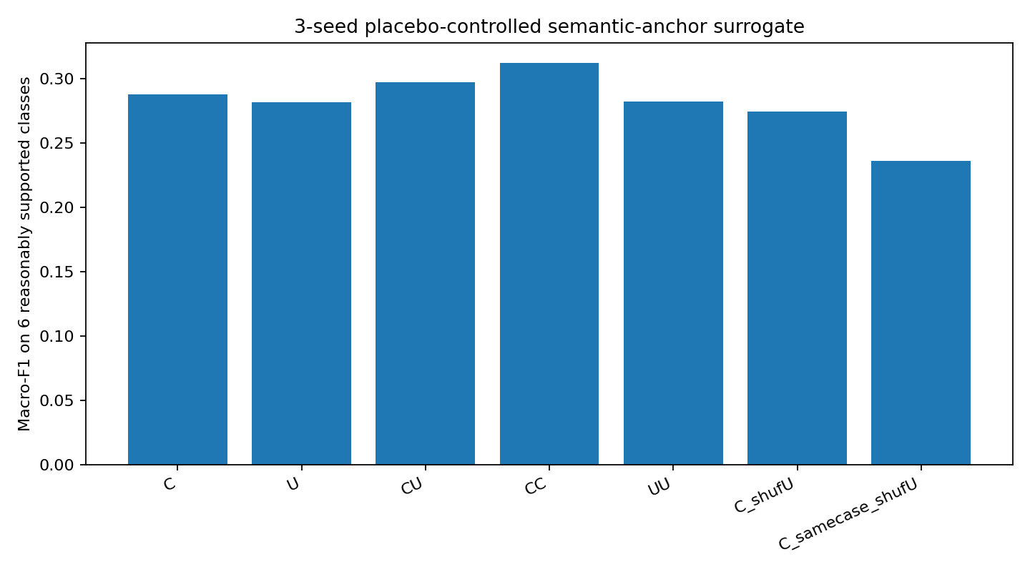
Figure 2. Three-seed placebo-controlled surrogate semantic-anchor comparison.

6.4 Paired bootstrap on surrogate fusion
Statistic | CU minus C
Mean Δ Macro6 | -0.0197
95% paired ROI bootstrap CI | [-0.0450, +0.0081]
P(Δ > 0) | 0.0695

6.5 Centering robustness experiment
Synthetic shift σ | λp=0 | λp=.25 | λp=.50
3 px | 0.3638 | 0.3604 | 0.3609
6 px | 0.3428 | 0.3429 | 0.3452
9 px | 0.3358 | 0.3464 | 0.3456
At 9 px: +0.0107 Macro6 from λp=.25 versus no proposal-view training
Decision rule produced by the debate
Proposal-view robustness is not a default phase. Measure real isolated centering loss first. If Δ_center < .015: λp=0; .015–.03: test .25; >.03: robustness becomes a serious Stage-2 problem.
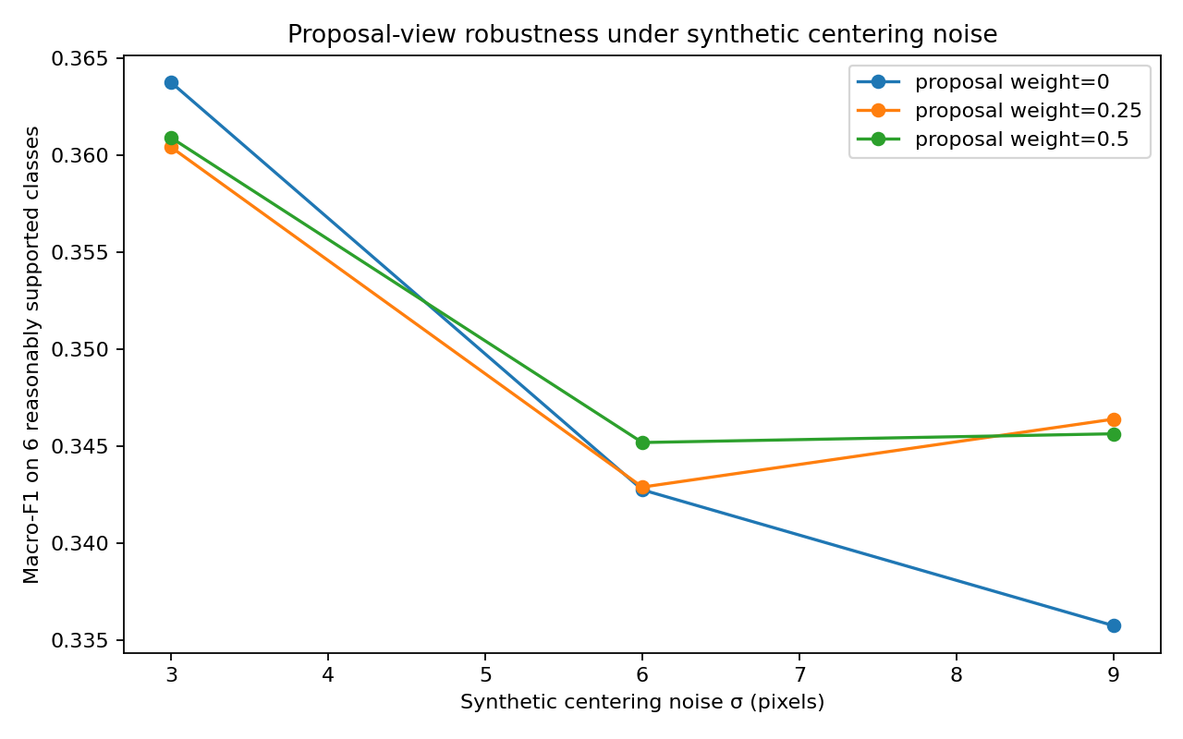
Figure 3. Proposal-view robustness only becomes useful under severe synthetic centering noise.

6.6 Pseudo-tissue factorial
Anchor | No tissue (clean) | Point pseudo-tissue | Spatial pseudo-tissue
C | 0.3684 | 0.3606 | 0.3556
U | 0.3104 | 0.2761 | 0.2891
CU | 0.3427 | 0.3514 | 0.3829
Anchor | No tissue (6px shift) | Point pseudo-tissue | Spatial pseudo-tissue
C | 0.3642 | 0.3076 | 0.3492
U | 0.2895 | 0.2929 | 0.2904
CU | 0.3594 | 0.3619 | 0.3348
Interpretation
Pseudo-tissue is not biologically interpretable. Its value was methodological: anchor × tissue × centering interactions can be large and non-additive, so the real GT-tissue oracle must be factorial and coordinate-aligned.

6.7 Imbalance experiment
Recipe | Macro6 | Macro9 | Fixed10
Capped oversampling + CE | 0.3533 | 0.2355 | 0.2120
Oversampling + prior-adjustment proxy | 0.2843 | 0.1895 | 0.1706
Decision
Capped class×case-diverse oversampling + ordinary CE remains the default. A single true Balanced-Softmax control is allowed later on full data; loss-function shopping is otherwise closed.

6.8 Synthetic end-to-end shadow evaluation
Surrogate | Semantic Macro6 | E2E fixed10 avg | E2E summed
C | 0.3726 | 0.1085 | 0.1762
U | 0.2864 | 0.1016 | 0.1440
CU | 0.3797 | 0.1177 | 0.1889
CU vs C: Δ_semantic = +0.0072; Δ_E2E_summed = +0.0127
Interpretation
Directionally encouraging: semantic improvement did not disappear in the synthetic matcher. But Δ_semantic was < .01, so the transfer ratio was intentionally not interpreted.

6.9 Synthetic structural oracle
Quantity | Fixed10 avg | Summed
C00 current | 0.1177 | 0.1889
C semantic-intervention | 0.3392 | 0.7197
C01 geometry/selection oracle | 0.1348 | 0.2175
C11 both | 0.4301 | 0.8893
Synthetic proposal coverage = 0.9998; r_selection(summed) = 0.0538
Interpretation
This is a unit test of the oracle machinery, not evidence that real Stage 1 is semantics-dominated. Synthetic coverage was nearly perfect by construction.
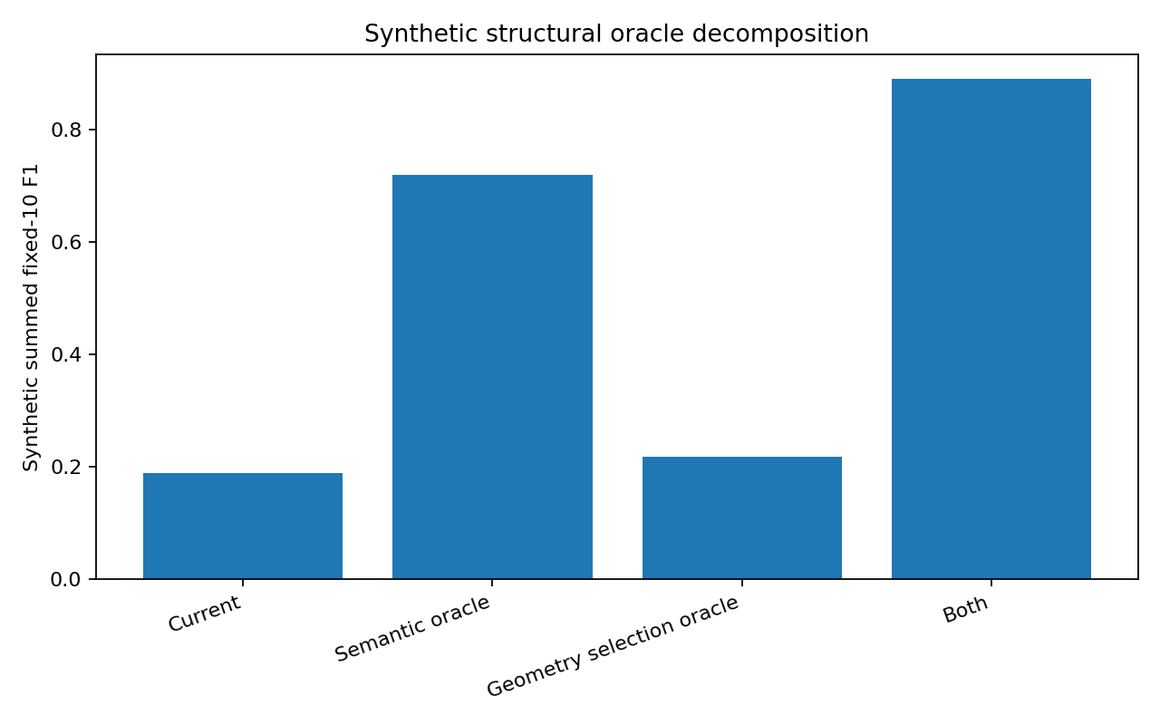
Figure 4. Synthetic structural oracle decomposition; useful for code-path validation only.

7. Experiment Set C: 20-epoch learning-curve rerun
A later 20-epoch rerun tracked the sample semantic branches every epoch. This experiment answered a different question: does the network genuinely learn, and how does learning redistribute performance across classes?

7.1 Aggregate trajectories
Model | Epoch 1 fixed10 | Best fixed10 | Best epoch | Epoch 20 | Interpretation
C256 | 0.1975 | 0.2477 | 20 | 0.2477 | Learns; essentially plateaus around E11–E20
CU | 0.1696 | 0.2363 | 7 | 0.2127 | Learns quickly, then overfits/degrades
U256 | 0.1214 | 0.1755 | 7 | 0.1634 | Weak surrogate U; early plateau/degradation
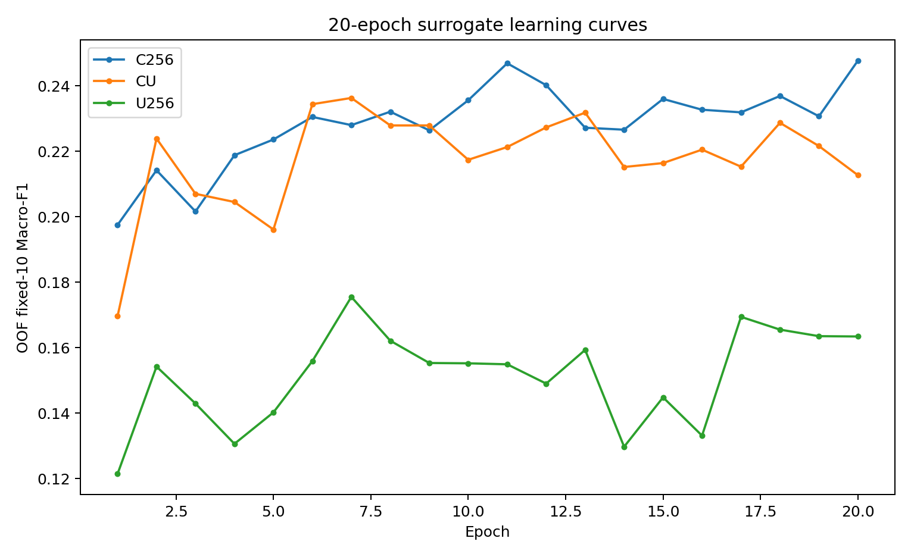
Figure 5. OOF fixed-10 Macro-F1 by epoch for C256, CU, and U256.
Critical interpretation
Stage 2 is definitely learning. The problem is no longer optimization failure. C256 becomes a valid sample control, while CU/U256 demonstrate that lower training loss does not imply better held-out F1.

7.2 C256 plateau analysis
Metric | E1 | E7 | E11 | E20 | Change E11→E20
Supported-class Macro6 | 0.3291 | 0.3799 | 0.4115 | 0.4128 | +0.0013
Fixed10 Macro-F1 | 0.1975 | 0.2280 | 0.2469 | 0.2477 | +0.0008
Checkpoint implication
E20 is numerically best, but E11 and E20 are practically tied. The later gain is noise-sized and comes with class redistribution. Future runs should use validation-based Pareto checkpointing, not “last epoch wins.”

7.3 Class-level evolution of C256
Class | Support | E1 F1 | Best F1 | Best epoch | E20 F1 | E1→E20
Tumor | 1667 | 0.501 | 0.850 | 10 | 0.847 | +0.346
Lymphocyte | 459 | 0.500 | 0.500 | 1 | 0.429 | -0.071
Apoptosis | 295 | 0.400 | 0.699 | 19 | 0.614 | +0.214
Stroma | 190 | 0.265 | 0.325 | 15 | 0.300 | +0.035
Histiocyte | 84 | 0.243 | 0.243 | 1 | 0.149 | -0.094
Endothelium | 35 | 0.065 | 0.210 | 2 | 0.138 | +0.073
Plasma | 3 | 0 | 0 | — | 0 | Not interpretable
Neutrophil | 3 | 0 | 0 | — | 0 | Not interpretable
Melanophage | 2 | 0 | 0 | — | 0 | Not interpretable
Epithelium | 0 | 0 | 0 | — | 0 | Not interpretable
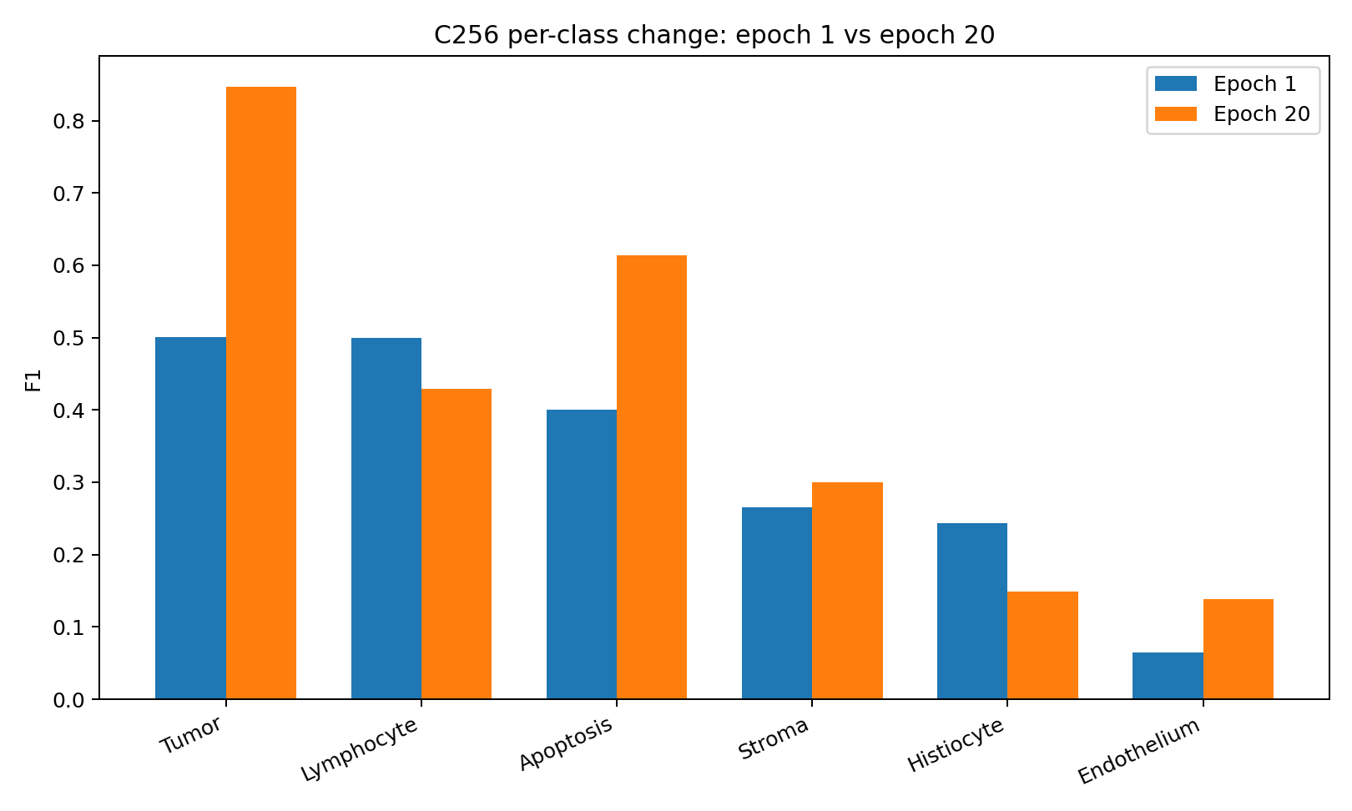
Figure 6. C256 per-class F1 redistribution from epoch 1 to epoch 20.
Most important biological/optimization finding
C256 is not uniformly “getting better at nuclei classification.” It becomes much stronger on tumor and apoptosis while lymphocyte and histiocyte deteriorate. This is the direct motivation for the class-level failure taxonomy and targeted rescue experiments.

7.4 Precision/recall clues
Class | Early behavior | Late behavior | Working interpretation
Tumor | P≈.944, R≈.341 | P≈.852, R≈.843 | Healthy broadening of a learnable morphology decision region.
Apoptosis | P≈.311, R≈.563 | P≈.527, R≈.736 | Healthy representation learning; both P and R improve.
Lymphocyte | P≈.405, R≈.656 | P≈.641, R≈.322 | Becomes conservative; likely boundary/prior issue until proven otherwise.
Histiocyte | P≈.227, R≈.262 | P≈.127, R≈.179 | Both P and R degrade; stronger candidate for representation/context/scarcity diagnosis.
Stroma | Modest | F1 peaks ~.325 then ~.300 | Possible context/tissue sensitivity or boundary competition.
Endothelium | n=35, highly volatile | Best ~.210 E2, ~.138 E20 | Insufficient evidence for architecture conclusions.

8. What the experiments accept, reject, and leave unresolved
Hypothesis | Status | Evidence / reason
Stage1 should be redesigned | REJECTED | User constraint + no Stage2 evidence requiring detector redesign.
v16.4 should keep training | REJECTED | Val loss explodes while semantic/PUMA plateau or decline.
Basic Stage2 pipeline is fundamentally broken | LARGELY REJECTED | Deliberate memorization reached 1.000 train Macro-F1.
Five-phase V17 curriculum | REJECTED | CPU proxy loses to simple baseline by -0.0231 best / -0.0335 final.
KD / EMA-KD as default | REJECTED | 0.2307 → 0.2083 in CPU proxy.
Capped class×case oversampling + CE | ACCEPTED DEFAULT | Repeatedly the strongest simple imbalance strategy in CPU screens.
Fixed 128px / 96px / any single FOV | REJECTED AS ASSUMPTION | Different surrogate representations prefer opposite FOV directions.
Cell must be the final anchor | UNRESOLVED | C256 wins surrogate control, but real CellViT/UNI2 are untested.
Real UNI2 is weak | UNRESOLVED | Only U surrogate is weak; no inference about pretrained UNI2-H.
Cell+UNI2 fusion is beneficial | UNRESOLVED / CONDITIONAL | Raw gain failed placebo proof; current placebo itself was imperfect.
Tissue helps | UNRESOLVED | Pseudo-tissue is not a biological oracle. Real GT tissue test remains mandatory.
Proposal-view robustness always helps | REJECTED | Only useful under large synthetic shift.
Selection is the main real bottleneck | UNRESOLVED | Synthetic oracle cannot answer for real frozen Stage1.
Longer training solves CU/U | REJECTED | Training loss falls while held-out F1 degrades.
Weak class automatically needs context | REJECTED | Boundary vs representation vs interference vs scarcity must be diagnosed first.

9. Final diagnostic framework for each nucleus class
The final debate explicitly rejects the shortcut “weak class = add context.” Every supported class should first be assigned to one of four failure types.
Failure type | Diagnostic signature | Primary intervention
A. Boundary-limited | Good PR-AUC / pairwise separability; large cross-fitted bias rescue; many low-margin errors; prevalence shift | Decision bias, sampling, boundary tuning; no context branch yet.
B. Representation-limited | Poor PR-AUC; small bias rescue; high-confidence wrong predictions; stable hard confuser | New FOV/encoder, real UNI2, tissue, or representation-specific adaptation.
C. Interference / forgetting | Reasonable stable earlier F1 followed by repeated decline across seeds/folds while separability remains | Earlier Pareto checkpoint, regularization, frozen-base residual context; do not train longer.
D. Scarcity-limited | Too few nuclei and/or too few independent ROIs/cases; wide bootstrap uncertainty | Full data, case-balanced sampling, no architecture conclusion from that class yet.
Predicted prevalence: rho_k = #(predicted class k) / #(true class k)
Boundary rescue: B_k = F1_k(bias-optimized, cross-fitted) - F1_k(base)
Stable forgetting: D_k(stable) = max_t smoothed/seed-averaged F1_k(t) - late F1_k
Hardest-confuser margin: d_k = z_k - z_h(k), where h(k) is the dominant confusion class
Current provisional interpretation from the surrogate run
Lymphocyte looks more boundary/prior-limited because precision rises while recall collapses. Histiocyte looks more representation/context/scarcity-limited because both precision and recall fall. These labels are provisional until full-data confusion, PR-AUC, margin, and bias-rescue analysis.

10. Final evaluator-aligned causal decompositions

10.1 GT → Nearest-S1 → Selected-S1
The earlier single “Stage1-centered” metric mixed coordinate noise with proposal selection. The final decomposition separates them.
F_R = represented nuclei evaluated at GT centers
F_N = same nuclei evaluated at geometry-valid nearest Stage1 proposal centers
F_S = same nuclei evaluated at frozen current Stage1-selected proposal centers
Delta_center = F_R - F_N
Delta_selection = F_N - F_S
Centering loss | Selection loss | Action
Low | Low | Focus semantics/context only.
High | Low | Train V17-R centering robustness.
Low | High | Fix deterministic dedupe/selection; do not over-augment.
High | High | Fix selection first, then train residual robustness on realistic remaining errors.
- Nearest-S1 must use an assignment-valid geometry oracle; one proposal should not be independently assigned to multiple GT cells.
- Selected-S1 must use a frozen pre-semantic selection rule, not the new classifier, otherwise the diagnostic mixes semantics and selection again.

10.2 Class(old/new) × Score(old/new)
c0 = old predicted class; c1 = argmax_k p_k from new semantic model
Cell | Class | Score | Meaning
E00 | c0 | old Stage1 score | Baseline
E01 | c0 | p(c0) or composite using p(c0) | Pure score intervention; must not use pmax
E10 | c1 | old Stage1 score | Pure class intervention
E11 | c1 | p(c1)=pmax | Class + semantic score
Delta_class = E10 - E00
Delta_score = E01 - E00
Interaction = E11 - E10 - E01 + E00
Why this matters
The exact matcher is class-conditioned and score-aware. This factorial tells whether a Stage-2 gain comes from better class identity, better duplicate ordering, or their interaction.

10.3 Structural oracle framework
Oracle quantity | Definition
Ccoverage | Fraction of GT nuclei recoverable by existing frozen Stage1 proposals.
C00 | Actual current pipeline.
C_semantic-intervention | Perfect classes for existing proposals, then rerun the exact class-conditioned matcher.
C01_geo | Current predicted classes unchanged; geometry/objectness/duplicate selection is improved without true-class access.
C01_semrank | Current semantic outputs retained; ranking oracle may exploit semantic usefulness. Measures semantic×selection interaction.
C11 | Perfect semantic class + perfect selection among existing frozen proposals.
r_selection = (C01_geo - C00) / (C_semantic-intervention - C00 + eps)

11. Final V17 architecture strategy

11.1 Base semantic anchor: still a real tournament
The surrogate C256 result makes Cell the control, not the guaranteed production base. Real frozen/pretrained CellViT or ConvNeXt and real UNI2-H must still compete under matched probes and deployment populations.
- Cell bank: candidate source FOVs 64/96/128/160/224 px; frozen linear and tiny-MLP screens first.
- UNI2 bank: candidate biological FOVs ~14/28/49/99 µm; coordinate-local pooling variants such as CLS, 3×3 local, 5×5 local, CLS+local.
- Representation screen should use raw standardized probes, PCA/whitened common dimension, and several fixed random/orthogonal projections so PCA does not become the sole comparison bottleneck.
- Only finalists receive learned source-specific projections and fine-tuning.

11.2 Corrected synergy controls
S_true = F_CU - max(F_C, F_U, F_CC, F_UU, F_placebo)
- C and U standalone controls with matched downstream capacity.
- C+C and U+U with independent learned projections, not literal feature duplication.
- Multiple global-shuffle, same-ROI shuffle, and same-class shuffle controls.
- Production promotion should consider S_true on Nearest-S1/deployment conditions, not GT centers only.
S_true range | Interpretation
≤0 | Reject fusion
0–.005 | Practically redundant
.005–.015 | Confirm with seeds/folds
≥.015 | Meaningful
≥.02 + paired CI > 0 + positive E2E | Strong production-grade evidence

11.3 Rescue and damage analysis
Rescue U<-B: R_k^U = P(U correct, Base wrong | y=k)
Damage U<-B: D_k^U = P(U wrong, Base correct | y=k)
Net correction: N_k^U = R_k^U - D_k^U
Unique UNI2 rescue vs tissue: U_k(unique) = P(U correct, Base wrong, Tissue wrong | y=k)
Unique tissue rescue vs UNI2: T_k(unique) = P(T correct, Base wrong, U wrong | y=k)
Context is promoted only when it rescues mistakes that the current base systematically makes, does not destroy strong classes, and contributes unique information that another context source does not already provide.

11.4 Tissue ladder
Tier | Implementation | Purpose
T0 | No tissue | Baseline
T1 | GT point/spatial tissue queried at the same coordinate as the semantic crop | Oracle headroom without coordinate leakage
T2 | OOF tissue log-prior | Cheapest production realization
T3 | Learned OOF tissue embedding | Only if T2 leaves meaningful headroom
T4 | Spatial-FiLM / denser tissue modulation | Only if substantial oracle headroom remains
Tissue prior example: z'_k = z_k + beta_k * sum_t p(t) log P(k|t)
Deployment tissue realizability: R_S1 = (F_OOF,S1 - F_none,S1) / (F_GT,S1 - F_none,S1)
- In GT-center condition, query the GT tissue map at the GT coordinate.
- In Nearest-S1 or Selected-S1 conditions, query the perfect GT tissue map at that Stage1 coordinate—not at the hidden GT coordinate.

11.5 Sparse residual context: preferred fusion if rescue is proven
The late debate moved away from a giant “Cell + UNI2 + tissue → fusion MLP” design. If context rescue is real, the safer architecture is a frozen/strong base logit model plus a limited residual correction.
z_final = z_base + m ⊙ r_context
- m can initially be fixed to zero for strong classes and one only for established weak/context-benefiting classes.
- However, freezing strong-class residuals alone does not guarantee preserving strong-class predictions: raising a weak-class logit can still steal the argmax.
- Therefore add a simple high-confidence strong-class bypass first: if the base predicts a strong class with margin above threshold τ, return base logits unchanged.
- Train the residual branch with the base encoder/classifier frozen first. Only consider joint fine-tuning after residual value is proven.
- Do not introduce an instance-adaptive learned gate until a simple class-limited residual fails to capture proven context rescue.
Conceptual final path
FROZEN STAGE 1
|
x, y, score
|
REAL BASE ANCHOR AUDIT (CellViT/ConvNeXt vs UNI2)
|
base 10-class logits
|
+-- real UNI2 rescue audit
+-- GT/OOF tissue rescue audit
|
keep only unique/net rescue
|
optional sparse residual context
|
GT -> Nearest-S1 -> Selected-S1
|
Class(old/new) x Score(old/new)
|
optional R / deterministic D / QO-QD / H / Lane B only if diagnostics justify

12. Statistical, checkpoint, runtime, and promotion rules

12.1 Fold discipline
- Fold0: broad development/screening.
- Fold1: finalist selection / second development fold.
- Fold2: one-shot architecture confirmation. If architecture changes after Fold2, Fold2 is development and confirmation must move.
- Folds3–4: locked evaluation.
- Final 5-fold CV/ensemble may be reported after architecture is frozen, but must be distinguished from architecture-selection-free confirmation.

12.2 Statistical reporting
- Broad screens: one seed.
- Finalists: 3 seeds.
- Paired cluster bootstrap at patient/case level if available, otherwise ROI; approximately 2,000 bootstrap replicates.
- Report mean Δ Macro-F1, 95% paired CI, P(Δ>0), seed SD, 10 class F1s, TP/FP/FN/support, per-case scores, CE/NLL, runtime, VRAM.

12.3 Checkpoint selection
Candidate epochs T = {t : F_macro(t) >= F* - delta}, delta ≈ .003–.005
- Within the near-best band, prefer stronger weak-class macro / net rescue.
- Then fewer severe class regressions / lower stable forgetting.
- Then lower validation CE/NLL.
- Then the earlier checkpoint.
- Do not choose the checkpoint from training loss or from a noise-sized last-decimal advantage.

12.4 Training schedule
- Frozen representation probes first.
- Max ~25–30 epochs for real anchor training as a starting budget, validating every epoch.
- Patience ~6–8 validation checks.
- Model-specific early stopping: the surrogate CU/U256 peaked around E7 while C256 plateaued around E11–E20; one fixed epoch schedule for all branches is rejected.
- No KD module, no EMA teacher, no KD phase in core V17.

12.5 Promotion thresholds
Quantity | Rule of thumb
Generic Δ Macro-F1 | <+.003 ignore unless free; +.003–.008 minor; +.008–.015 confirm; +.015–.030 strong; >+.030 architectural discovery
Fusion S_true | ≥.015 meaningful; ≥.02 + paired CI>0 + positive E2E = strong
Centering loss Δ_center | <.015 no robustness; .015–.03 test λp=.25; >.03 major robustness problem
Tissue realizability | Prefer production OOF tissue to capture ≥~60–70% of GT oracle gain
Aggregator disagreement | |Δ_avg-Δ_sum| > .01 → inspect ROI×class decomposition, not automatic rejection
Semantic→E2E transfer ratio | Interpret only when |Δ_semantic| ≥ .01; always report absolute Δ_E2E too

12.6 Runtime discipline
Every component should report Δ Macro-F1, seconds/ROI, peak VRAM, and parameter/model-size cost. A branch that gains +.004 F1 while adding ~70% runtime should normally be deleted.

13. Exact next GPU experiment
- Freeze Stage 1 architecture/checkpoints/OOF outputs permanently and freeze v16.4 as historical control.
- Export real OOF Stage1 proposal UID, x/y coordinate, confidence, ROI/case, and fold information.
- Run real structural oracle: Ccoverage, C00, C_semantic-intervention, C01_geo, C01_semrank, C11.
- Audit exact-centroid duplicates, same-class/cross-class duplicates, reused selected UIDs, and centroid collisions.
- Build assignment-valid GT → represented → Nearest-S1 → Selected-S1 mapping.
- Cache real frozen CellViT/ConvNeXt feature banks across cell FOV candidates.
- Cache real frozen UNI2-H feature banks at ~14/28/49/99 µm and pooling variants.
- Run raw standardized, PCA/common-dimension, and random-projection representation screens.
- Train learned equal-capacity finalists and run corrected C/U/CU/CC/UU + global/same-ROI/same-class shuffle placebos.
- Select the real tissue-free base/S0; evaluate GT-all, represented-GT, Nearest-S1, and Selected-S1.
- On full development data, compute confusion matrices, prevalence, PR-AUC, pairwise hardest-confuser separability, margins, and cross-fitted safe bias rescue.
- Assign supported classes to boundary / representation / interference / scarcity categories and freeze strong/weak/uncertain sets prospectively.
- Compute real UNI2 rescue, damage, net rescue, and unique rescue relative to the base.
- Run GT point/spatial tissue oracle at coordinate-aligned GT/Nearest/Selected positions; compute tissue rescue/damage/unique rescue.
- Choose production S1: base only, base+residual UNI2, base+residual tissue, or sparse residual UNI2+tissue only if unique rescue is real.
- Replace GT tissue with true OOF tissue and quantify deployment realizability.
- Run exact E00/E01/E10/E11 Class × Score factorial; tune semantic bias and evaluator bias separately with cross-fitting.
- Use Δ_center and Δ_selection to choose robustness (R) vs deterministic duplicate cleanup (D) vs proposal-quality work (Q) vs neither.
- Run every promoted model through both evaluator aggregations and end-to-end transfer analysis.
- Only afterward permit one true Balanced-Softmax control, hard-pair auxiliary, tiny UNI2 adaptation, learned QD/QO, or dense Lane B.

14. Risk register and unresolved questions
Unresolved question / risk | Why it matters | Required evidence
Real CellViT/ConvNeXt vs real UNI2 anchor | Surrogate rankings are not trustworthy for pretrained pathology representations. | Real feature banks + matched probes + fold discipline.
True tissue value | Pseudo-tissue cannot support biological conclusions. | GT point/spatial tissue oracle and OOF production tissue.
Real Stage1 centering vs selection losses | Synthetic proposal generator was near-perfect coverage. | Real OOF proposal mapping; GT→Nearest→Selected.
Class-boundary vs representation failures | Lymphocyte and histiocyte show different failure signatures. | Confusion, PR-AUC, margins, safe bias rescue, full case support.
Tail-class evidence | Plasma/neutrophil/melanophage/epithelium are absent/nearly absent in CPU sample. | Full dataset + case-level support and bootstrap.
Fusion complementarity | Current CPU placebo was imperfect. | Independent projection capacity controls + multiple shuffles.
Semantic score usefulness | Matcher confidence ordering may help or hurt duplicate selection. | E00/E01/E10/E11 + within-class duplicate ranking AUC.
Exact-centroid matcher quirks | Cheap deterministic dedupe may create or remove evaluator gains. | D0/D1/D2 intervention audit through exact matcher.
SOTA comparability | Local evaluator aggregation may not equal leaderboard protocol. | Lock evaluator version; report both fixed10-average and summed; do not infer hidden-test SOTA from local values alone.

15. Performance ledger
This section consolidates the key numerical checkpoints that drove design changes. Values from different experiments are not directly comparable unless explicitly stated; their role is to document evidence and direction.
Experiment/checkpoint | Performance | Design consequence
v16.4 frozen identity | Semantic ~0.414; PUMA ~0.261 @ E4 | Meaningful baseline.
v16.4 early LoRA | Semantic ~0.446 @ E9; PUMA ~0.277 @ E7 | Adaptation initially helps.
v16.4 late LoRA | Semantic ~0.423; PUMA ~0.259; val loss 1.398 @ E18 | Overfit; retire long curriculum.
CPU20 simple baseline | Best 0.2538; final 0.2506 | Beats phased V17 proxy.
CPU20 phased V17 | Best 0.2307; final 0.2171 | Stacked curriculum rejected.
CPU20 KD | 0.2307 → 0.2083 | KD rejected.
CPU20 memorization | 1.000 train Macro-F1 | Basic learnability path works.
CPU20 oversampling+CE | 0.2260 | Default imbalance recipe.
CPU20 Balanced Softmax | 0.2054 | Lost in proxy; one future real control remains allowed.
CPU20 cell/local/global | cell .2291; local .2093; global .1979 | Cell primary in proxy.
CPU20 cell+local | 0.2376 | Conditional local context promising.
V17 CPU FOV | Cell MLP best .3810 @ 96px; context best .3287 @ 64px | Contradicts earlier large-FOV surrogate; proves representation dependence.
V17 CPU C/U/CU | C .2880; U .2818; CU .2974 | Raw fusion +.0095 only.
V17 CPU C+C placebo | 0.3124 | Raw fusion gain not proven as biological complementarity.
V17 CPU centering 9px | no robust .3358; λp=.25 .3464 | Robustness useful only under severe shift.
V17 CPU pseudo-tissue CU | none .3427; spatial .3829 clean | Methodological interaction only; not real tissue evidence.
Synthetic E2E CU vs C | Δ_sem +.0072; Δ_E2E summed +.0127 | Directionally transfers; ratio not interpreted.
Synthetic oracle | C00 .1889 summed; semantic .7197; geo .2175; C11 .8893 | Unit-test of structural oracle only.
20-epoch C256 | Fixed10 .1975 → .2477; Macro6 ~.3291 → .4128 | Strong sample learning, plateau ~E11.
20-epoch CU | Peak .2363 @ E7 → .2127 @ E20 | Overfit / noisy redundant context proxy.
20-epoch U256 | Peak .1755 @ E7 → .1634 @ E20 | Weak surrogate U; no conclusion about real UNI2.

15.1 Master dashboard template for the real V17 audit
Model | GT all | GT repr. | Nearest S1 | Selected S1 | E00 | E01 | E10 | E11 | Avg | Summed | Dagg | sec/ROI
v16
Cell
UNI2
CC
UU
CU
best + GT tissue
best + OOF tissue
+ robustness
Sidecar for every promoted row: TP/FP/FN/support/F1 × 10 classes; CE/NLL/ECE; 3-seed SD; paired case bootstrap; S_true; Delta_center; Delta_selection; R_transfer; Dagg; parameters; peak VRAM; seconds/ROI.

Appendix A. Full 20-epoch fixed-10 Macro-F1 trajectory
Epoch | C256 | CU | U256
1 | 0.1975 | 0.1696 | 0.1214
2 | 0.2142 | 0.2239 | 0.1542
3 | 0.2016 | 0.2070 | 0.1429
4 | 0.2188 | 0.2045 | 0.1306
5 | 0.2236 | 0.1961 | 0.1402
6 | 0.2305 | 0.2344 | 0.1559
7 | 0.2280 | 0.2363 | 0.1755
8 | 0.2321 | 0.2279 | 0.1621
9 | 0.2264 | 0.2279 | 0.1553
10 | 0.2356 | 0.2174 | 0.1552
11 | 0.2469 | 0.2213 | 0.1549
12 | 0.2402 | 0.2273 | 0.1490
13 | 0.2272 | 0.2318 | 0.1593
14 | 0.2266 | 0.2152 | 0.1297
15 | 0.2360 | 0.2164 | 0.1448
16 | 0.2327 | 0.2205 | 0.1331
17 | 0.2319 | 0.2153 | 0.1694
18 | 0.2369 | 0.2287 | 0.1655
19 | 0.2307 | 0.2216 | 0.1635
20 | 0.2477 | 0.2127 | 0.1634

Appendix B. Formula and metric glossary
Symbol / term | Meaning
S_true | Fusion conditional information gain after same-information capacity/placebo controls.
F_R / F_N / F_S | Represented-GT / nearest valid Stage1 / frozen selected Stage1 semantic evaluations.
Delta_center | F_R - F_N: isolated centering sensitivity.
Delta_selection | F_N - F_S: proposal-selection/interface loss.
E00/E01/E10/E11 | Old/new class × old/new score exact-evaluator factorial.
Ccoverage | Fraction of GT nuclei recoverable by existing frozen Stage1 proposals.
C_semantic-intervention | Perfect proposal classes followed by rerunning the exact matcher.
C01_geo | Geometry/objectness/duplicate selection oracle with current semantic classes preserved.
R_transfer | Delta end-to-end F1 / Delta semantic F1; interpret only for meaningful semantic gains.
R_tissue / R_S1 | Fraction of GT tissue-oracle gain realized by production OOF tissue, preferably under Stage1 coordinates.
B_k | Cross-fitted class-bias rescue for class k.
D_k(stable) | Smoothed/multi-seed class forgetting from stable peak to late checkpoint.
R_k / D_k / N_k | Context rescue, damage, and net correction relative to the base anchor.
H_clean / H_represented | Clean and deployment-relevant semantic oracle headroom over v16.
Dagg | Absolute disagreement between ROI-averaged and summed evaluator gain.

Appendix C. Reproducible artifacts and source files
Artifact | Role
PUMA_Nuclei_Pipeline_updated.zip | Earlier code overlay for the project.
03_Train_Stage2_Hypotheses.ipynb | Current/earlier Stage2 training notebook used during v16.4 diagnosis.
public_matcher.py | Exact class-conditioned, score-aware matcher clone inspected during the evaluator debate.
aggregators.py | Fixed10 ROI-averaged and summed aggregation implementations.
puma_v17_cpu_fast_results/01b_fov_screen_repro.csv | Reproducible CPU FOV screen.
puma_v17_cpu_fast_results/11_anchor_placebo_all3seeds.json | Three-seed placebo-controlled anchor surrogate.
puma_v17_cpu_fast_results/03_centering_robustness.csv | Synthetic centering/robustness experiment.
puma_v17_cpu_fast_results/09_anchor_x_pseudotissue_x_center.csv | Anchor × pseudo-tissue × centering factorial.
puma_v17_cpu_fast_results/05_imbalance.csv | Imbalance strategy screen.
puma_v17_cpu_fast_results/07_synthetic_e2e.json | Synthetic semantic→E2E shadow evaluation.
puma_v17_cpu_fast_results/08_synthetic_structural_oracle.json | Synthetic structural oracle validation.
v17_real_feature_audit.py | Generic real-feature audit harness, smoke-tested on the surrogate cache.
puma_v17_01_fov_screen.py | Fast CPU FOV screen script.
puma_v17_anchor_placebo_3seed.py | Three-seed capacity/placebo script.
puma_v17_cpu_suite_continue.py | Centering/imbalance/E2E/oracle continuation suite.
puma_v17_anchor_tissue_factorial_cpu.py | Anchor × pseudo-tissue × centering factorial script.

Appendix D. External references discussed during the debate
The debate used several contemporary publications/repos as strategic context. Their quoted performance figures were discussion-time reference points and are not re-verified in this report. They should not be treated as directly comparable to the project’s local fixed-10 evaluator without protocol matching.
- DeNuC (MICCAI 2026): used as evidence for decoupling detection from pathology-foundation-model classification and querying nucleus-specific UNI2-H features after localization.
- TAND / Tissue-Aware Nuclei Detection (ISBI 2026): used as evidence that explicit tissue conditioning can materially help PUMA ten-class nuclei classification.
- PUMA Grand Challenge 2025 Track 2: discussion referenced an averaged Macro-F1 around 0.2707 and a summed Macro-F1 around 0.4897 for the winning entry, illustrating aggregation/protocol sensitivity.
- PUMA dataset/baseline literature: used to contextualize the difficulty of rare classes and annotation disagreement.

