PUMA Stage 2 / V17
Research Debate, Architecture Decisions, CPU Audit and Performance Report
Consolidated record through 7 September 2026

Scope: This report consolidates the architecture debate, experimental logic, code/audit design, surrogate CPU experiments, epoch-by-epoch performance, classwise behavior, rejected hypotheses, and the final proposed real-GPU V17 research plan. The CPU numbers are diagnostic—not SOTA estimates—because real CellViT/ConvNeXt, UNI2-H, OOF Stage1 proposal caches, and production tissue maps were not available in the sample run.

1. Executive Summary
The project converged from a complex multi-phase Stage2 design toward a causal, evidence-gated architecture search. Stage1 is permanently frozen as a high-recall proposal generator. The central research question is no longer whether Stage2 can train—it can—but which additional signal can rescue nuclei that a morphology anchor systematically misses without damaging classes it already handles well.
Question | Current answer
Is Stage2 learning? | Yes. Closed question in the surrogate experiment.
Is C256 a valid control? | Yes. Best current morphology-like surrogate baseline.
Is C256 the final architecture? | No. Learning is highly class-dependent.
Should C256 be trained 50–100 epochs? | No. Aggregate learning essentially plateaus around epoch 11.
Should CU/U256 simply train longer? | No. Both peak near epoch 7 and then degrade.
Does weak surrogate U imply real UNI2 is weak? | No. Real pretrained representations must decide.
Should KD return? | No. CPU phased test showed clear degradation; remove from primary V17.
Should context be mandatory? | No. It must prove conditional/unique rescue.
Current architecture direction | Morphology-first base + only proven sparse residual context.

The strongest 20-epoch surrogate branch, C256, improved fixed-10 OOF Macro-F1 from 0.1975 to 0.2477 and supported-six Macro-F1 from about 0.329 to 0.413. However, this improvement was driven mainly by tumor and apoptosis. Lymphocyte and histiocyte deteriorated, revealing class redistribution rather than uniform ontology learning.

2. Starting Point and Non-Negotiable Constraints

2.1 Frozen Stage1
Stage1 is a high-recall nuclei detector/proposal generator and must remain architecturally and checkpoint frozen.
Stage1 Fold0 metric | Value
F1@15px | 0.6695
Precision | 0.5160
Recall | 0.9530
TP | 21,671
FP | 20,329
FN | 1,069
Mean match distance | 3.254 px
Proposals | 42,000
GT nuclei | 22,740

Interpretation: proposal coverage is excellent, but Stage1 overproduces candidates. Stage2 should primarily solve semantic identity; selection/ranking is added only if structural oracles prove it is a major bottleneck.

2.2 v16.4 historical baseline
- Semantic Macro-F1 during prior development was roughly 0.414–0.446; a full local PUMA figure around 0.277 was also observed under a different evaluation setting.
- Architecture used 64/128/256 crops resized to 224, a 64-pixel identity branch, UNI2-h, multiple phases, LoRA/context/utility logic.
- Early LoRA gave slight gains, followed by stagnation/degradation.
- Decision: retire v16.4 as a historical baseline; do not rescue it by doubling epochs, batch size, or optimizer tuning.
Metric caution: the PUMA challenge has both ROI-averaged and summed TP/FP/FN Macro-F1 variants. Previously discussed official Track2 winner figures were approximately 0.2707 averaged Macro-F1 and 0.4897 summed Macro-F1. Local numbers must not be compared to leaderboard values unless split and evaluator semantics align.

3. CPU Hypothesis Experiment Before V17
A six-ROI labeled subset was recovered and used for diagnostic experiments. Total labeled nuclei: 2,738.
Class | Count
Tumor | 1,667
Lymphocyte | 459
Apoptosis | 295
Stroma | 190
Histiocyte | 84
Endothelium | 35
Neutrophil | 3
Plasma | 3
Melanophage | 2
Epithelium | 0

Three grouped folds were used: F0 held primary001+metastatic100, F1 held primary002+metastatic101, and F2 held primary003+metastatic102. The imbalance is extreme, so these results are mechanics/screening evidence only.

3.1 What the early CPU tests established
Experiment | Result | Decision
Memorization sanity | Train Macro-F1 reached 1.0 | Basic image→crop→label→loss→gradient path can learn.
Integral FOV proxy | 64px best (~0.243), larger FOVs worse | Local morphology looked useful under handcrafted proxy.
Learned surrogate FOV | 448px best (~0.114) | FOV preference was representation-dependent.
3-source factorial | Cell+local ~0.238 best | Cell+local became a provisional minimal hypothesis.
Long-tail control | Oversampling+CE beat Balanced Softmax in both proxies | Default capped oversampling + ordinary CE.
GT polygon shape oracle | Macro-F1 ~0.167 | Morphology features alone insufficient; no standalone handcrafted shape branch.
Phased V17 proxy | Best ~0.231 vs simple baseline ~0.254 | Full multi-phase proxy not validated.
KD phases | Clear degradation | Remove KD from primary V17.

The key lesson was that global/local preference changed with representation. Therefore real frozen UNI2 and real cell encoders—not surrogate intuition—must decide the final FOV and fusion design.

4. Evolution of the Architecture Debate

4.1 From architecture-first to information-first
The debate gradually replaced 'Which fashionable branch should we add?' with one promotion question:
What new information does this branch contribute that the current best model cannot already extract?
Every candidate branch is now evaluated by conditional gain, variance, runtime, parameter cost, and engineering complexity.

4.2 Key decisions that became locked
- Stage1 remains frozen permanently.
- KD is removed from the primary V17 code path; revisit only if a clearly superior teacher exists.
- Generic EvidenceFusion, graph modules, and mandatory global context are not defaults.
- CellOnly, LocalOnly, CellLocal, or Cell/Tissue variants are all allowed outcomes.
- Context must prove complementarity rather than merely standalone F1.
- Real OOF proposal robustness is delayed until isolated centering loss justifies it.
- Ranking is separated from semantic class logits and delayed until structural oracle evidence warrants it.
- Fold discipline is strict: broad development, secondary selection, one-shot confirmation, then locked evaluation.

4.3 Causal decompositions introduced during debate
Two decompositions became central.
GT → Nearest-S1 → Selected-S1
Using a one-to-one geometry-only assignment and a common GT population:
Δ_center = F_GT/common − F_Nearest
Δ_selection = F_Nearest − F_Selected
This separates crop miscentering from proposal selection/interface effects.
The second decomposition isolates class identity from confidence ordering:
Cell | Class | Score
E00 | Old class c0 | Old Stage1 score
E01 | Old class c0 | New semantic probability p(c0)
E10 | New class c1 | Old Stage1 score
E11 | New class c1 | New semantic probability p(c1)

Δ_class = E10 − E00
Δ_score = E01 − E00
Interaction = E11 − E10 − E01 + E00
A critical correction was that E01 must use p(c0), not pmax; otherwise the score-only intervention would leak the new class decision.

5. V17 Causal Audit Implementation
A runnable audit was built to operationalize the debate. It includes:
- one-to-one geometry-only Nearest-S1 assignment;
- frozen Stage1-score Selected-S1;
- common-support comparisons;
- raw, PCA/whitening, and random-projection representation screens;
- C256, U256, CC, UU, CU capacity controls;
- label-free global-shuffle and same-group/ROI shuffle placebos;
- class×case-diverse oversampling + CE;
- class-conditioned confidence-first evaluator shadow;
- both ROI-averaged fixed-10 and summed TP/FP/FN Macro-F1;
- structural oracle decomposition and paired ROI bootstrap.
The sample cache used real PUMA annotated nuclei but lightweight surrogate Cell/Context features and synthetic Stage1 proposals. Therefore the audit validates mechanics and causal interpretation—not real encoder quality.

6. Sample Audit Results
Representation | View | Macro10 fixed | Observed/present macro
Cell | raw | 0.2233 | 0.2481
Cell | pca | 0.2238 | 0.2487
Cell | random_projection | 0.2223
UNI2 | raw | 0.1236 | 0.1373
UNI2 | pca | 0.1357 | 0.1508
UNI2 | random_projection | 0.1372

6.1 Capacity/placebo-controlled anchor tournament
Model | Macro10 | Present macro | CE
C256 | 0.2330 | 0.2589 | 1.217
CC | 0.2287 | 0.2541 | 1.250
CU | 0.2146 | 0.2384 | 1.155
C_global_SHUF | 0.2198 | 0.2442 | 1.253
C_same_group_SHUF | 0.1652 | 0.1835 | 1.336
U256 | 0.1856 | 0.2062 | 1.367
UU | 0.1712 | 0.1902 | 1.512

Production placebo-adjusted synergy S_prod = -0.0184. CU versus the best single source had mean Δ = -0.0100, bootstrap interval [-0.0241, 0.0050], P(Δ>0) = 0.237.
Decision: do not promote fusion in this sample. This does not reject real Cell+UNI2 fusion; it rejects an unsupported surrogate fusion claim.

6.2 Centering and selection decomposition
Metric | C256 value
GT/common | 0.2330
Nearest-S1 | 0.2240
Selected-S1 | 0.2235
Δ_center | 0.0090
Δ_selection | 0.0005

With Δ_center ≈ 0.009 < the provisional 0.015 robustness gate, the sample does not justify proposal-view robustness training. Selection loss is almost zero.

6.3 Class × score evaluator factorial
Metric | Avg fixed10 | Summed macro
E00 | 0.11134 | 0.17495
E01 | 0.11133 | 0.17535
E10 | 0.10520 | 0.17665
E11 | 0.10516 | 0.17671

In the short surrogate run, the new semantic classes hurt ROI-averaged E2E F1 while score-only intervention was nearly neutral. The summed metric moved differently. This demonstrated why semantic accuracy cannot be assumed to translate directly into PUMA evaluator gain.

6.4 Structural oracle smoke test
Oracle | Fixed10 avg | Summed macro
C00 | 0.1113 | 0.1749
Semantic intervention | 0.3096 | 0.5183
C01_geo | 0.1906 | 0.3105
C01_semrank | 0.1114 | 0.1750
C11 | 0.4333 | 0.9000

The synthetic structural oracle produced r_selection ≈ 0.395 under summed Macro-F1. Because proposal generation was synthetic with 100% coverage, this value is not a real Stage1 bottleneck estimate; it only validates the decomposition code.

7. Twenty-Epoch Learning Experiment
Model | Best epoch | E1 Macro10 | Best Macro10 | E20 Macro10 | Final train loss
C256 | 20 | 0.1975 | 0.2477 | 0.2477 | 0.1787
CU | 7 | 0.1696 | 0.2363 | 0.2127 | 0.1333
U256 | 7 | 0.1214 | 0.1755 | 0.1634 | 0.2347

Interpretation: all three branches optimize, but generalization differs. C256 continues to improve/plateau; CU and U256 peak around epoch 7 and then degrade despite falling training loss. That is evidence of overfitting/redundancy rather than undertraining.
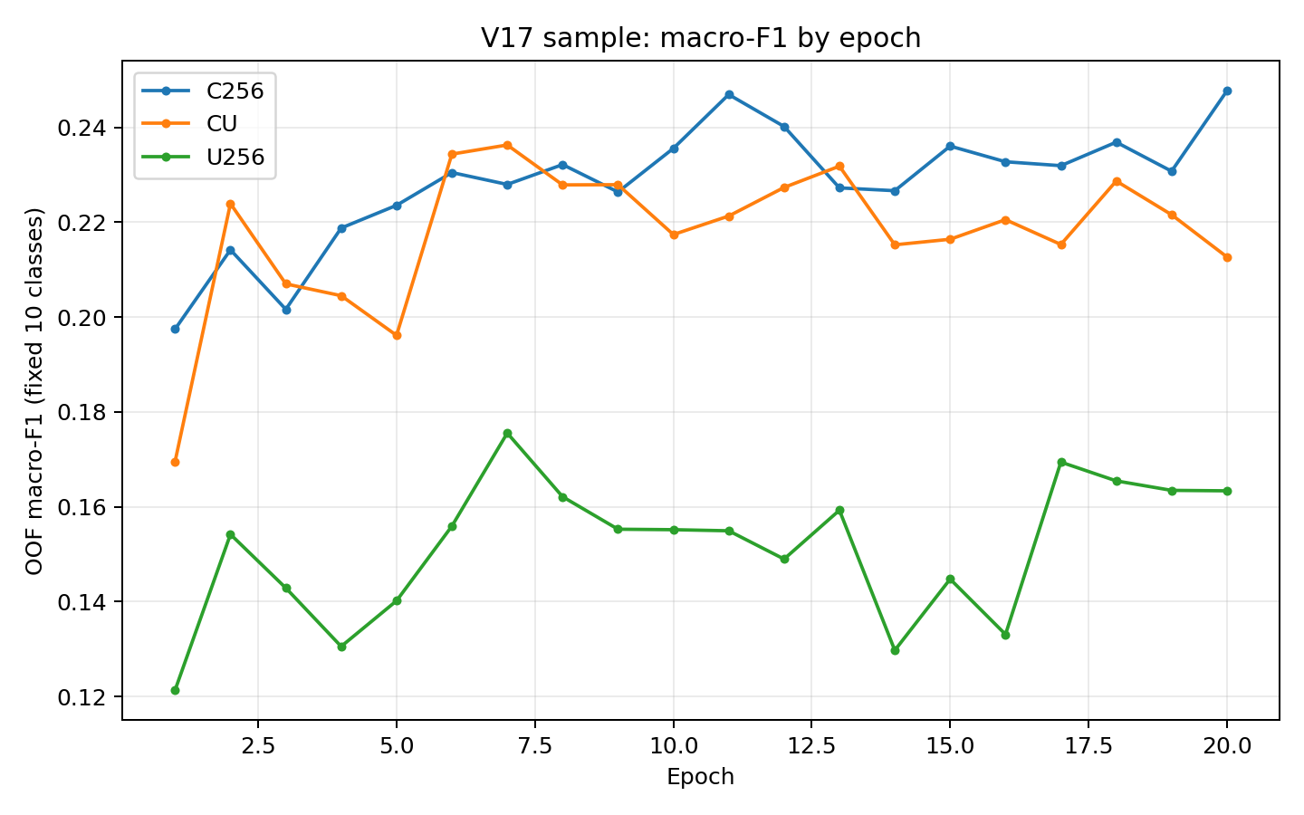
Figure 1. OOF fixed-10 Macro-F1 by epoch for C256, CU and U256.

7.1 C256 plateau interpretation
For the six reasonably supported classes, Macro-F1 was approximately 0.3291 at E1, 0.4115 at E11, and 0.4128 at E20.
E1 → E11 = +0.0824
E11 → E20 = +0.0013
Therefore E20 is not scientifically meaningfully better than E11. The late epochs mainly redistribute class performance. A Pareto/tolerance checkpoint rule is preferable to selecting the highest fourth decimal.

8. Per-Class Learning and Failure Modes
Class | Support | E1 F1 | Best ep. | Best F1 | E20 F1 | E1→E20
tumor | 1667 | 0.501 | 10 | 0.850 | 0.847 | +0.347
lymphocyte | 459 | 0.500 | 1 | 0.500 | 0.429 | -0.071
plasma | 3 | 0.000 | 1 | 0.000 | 0.000 | +0.000
histiocyte | 84 | 0.243 | 1 | 0.243 | 0.149 | -0.095
melanophage | 2 | 0.000 | 1 | 0.000 | 0.000 | +0.000
neutrophil | 3 | 0.000 | 1 | 0.000 | 0.000 | +0.000
stroma | 190 | 0.265 | 15 | 0.325 | 0.300 | +0.035
endothelium | 35 | 0.065 | 2 | 0.210 | 0.138 | +0.073
epithelium | 0 | 0.000 | 1 | 0.000 | 0.000 | +0.000
apoptosis | 295 | 0.400 | 19 | 0.699 | 0.614 | +0.213

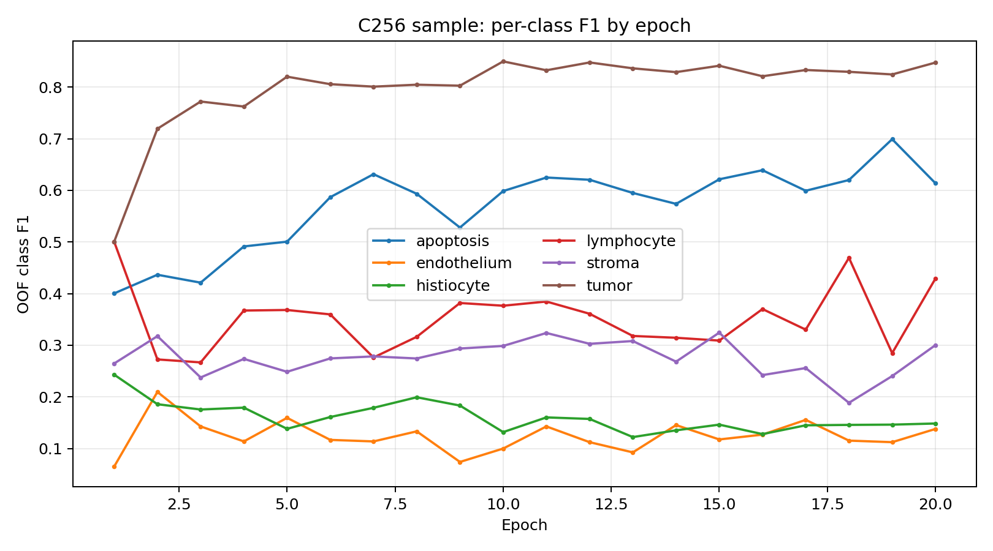
Figure 2. C256 per-class F1 trajectories across 20 epochs.

8.1 Healthy learning
- Tumor: F1 ~0.501 → 0.847, peak ~0.850. This is the clearest healthy learning trajectory in the sample.
- Apoptosis: F1 ~0.400 → 0.614, peak ~0.699. Strong learnable morphology, but some late-epoch forgetting.
- Stroma: modest gain ~0.265 → 0.300, peak ~0.325. Suggests incomplete morphology signal and possible contextual value.

8.2 Boundary-like vs representation-like failures
Lymphocyte became more conservative: precision increased while recall fell substantially. This pattern is compatible with a decision-boundary/prior problem and should be tested with cross-fitted class-bias rescue before adding context.
Histiocyte deteriorated in both precision and recall. This is more consistent with missing representation/context, difficult hard-pair structure, scarcity, or interference. It is a higher-priority target for real FOV/UNI2/tissue rescue tests.
Endothelium has only 35 examples and is too unstable for architectural conclusions. Plasma, neutrophil and melanophage have only 2–3 examples; epithelium is absent. Their zero F1 values are data limitations, not evidence of impossible classification.

8.3 Macro-F1 naming correction
At E20 the three reported macro values are largely rescalings of the same six supported-class information:
macro6_supported ≈ 0.4128
macro10_fixed ≈ 0.4128 × 6/10 = 0.2477
macro9_observed ≈ 0.4128 × 6/9 = 0.2752
For the CPU sample, macro6 is the most useful learning-mechanics diagnostic; full real evaluation must return to the exact 10-class PUMA metrics.

9. Final Diagnostic Framework
Before adding context, each class should be assigned to one of four failure types.
Failure type | Evidence pattern | Preferred response
Boundary-limited | Good PR-AUC; large bias rescue; low-margin errors | Class bias/calibration/sampling; no new branch yet.
Representation-limited | Poor PR-AUC; small bias rescue; high-confidence wrong errors | FOV, real Cell encoder, UNI2, tissue.
Interference/forgetting | Reasonable stable peak; later decline | Checkpointing, regularization, frozen-base residual context.
Scarcity-limited | Very low support; unstable F1 | More/full data, case-balanced sampling; avoid architecture conclusions.

Required diagnostics at E1/E7/E11/E20: 10×10 confusion matrices, TP/FP/FN, precision/recall/F1, predicted prevalence ρk, PR-AUC, top1−top2 margin, confidence when correct/wrong, and confusion destinations.
ρ_k = number predicted as class k / number truly class k

9.1 Boundary-rescue oracle
z'_k = z_k + b_k
B_k = F1_k(bias-cross-fitted) − F1_k(base)
A large Bk means recoverable decision signal exists, but does not prove the representation is sufficient. It must be interpreted together with PR-AUC and margin distributions.

10. How Real UNI2 and Tissue Should Be Tested

10.1 Rescue, not standalone competition
R_k^(U←C) = P(U correct, C wrong | y=k)
R_k^(C←U) = P(C correct, U wrong | y=k)
Real UNI2 earns entry by rescuing nuclei that the morphology anchor systematically misses, especially in weak classes, while preserving strong morphology classes.

10.2 Tissue oracle
Run point and spatial GT tissue at the same coordinate used by the semantic crop (GT, Nearest-S1, or Selected-S1). This avoids hidden oracle leakage.
G_T = F_GT,T − F_GT,0
R_C = (F_GT,0 − F_Near,0) − (F_GT,T − F_Near,T)
R_S = (F_Near,0 − F_Selected,0) − (F_Near,T − F_Selected,T)
After the GT oracle, replace it with true OOF tissue and measure how much oracle gain is realizable in production.

10.3 Unique rescue
U_unique,k = P(U correct, C wrong, T wrong | y=k)
T_unique,k = P(T correct, C wrong, U wrong | y=k)
If UNI2 and tissue rescue the same mistakes, keep the stronger/cheaper signal. If both have meaningful unique rescue, only then test both.

11. Proposed V17 Architecture After the Debate
The preferred direction is morphology-first with sparse residual context, conditional on real rescue evidence.
Frozen Stage1
│
x,y
▼
Real morphology anchor (CellViT / ConvNeXt)
│
Base 10-class logits z^C
│
┌───┴───────────────┐
│ │
Real UNI2 GT/OOF tissue
│ │
Rescue test Rescue test
└───────┬───────────┘
▼
Keep only unique, validated context
│
Sparse residual correction on weak classes
▼
Final 10-class logits
│
Class/score evaluator audit
│
Optional R or D/Q only if diagnostics demand

11.1 Residual context form
z_k = z_k^C + α_k r_k^ctx
Initially, αk should be fixed to zero for strong classes and learnable only for prospectively defined weak/context-benefiting classes. Context must earn the right to modify a phenotype.

11.2 Residual tissue prior
z'_k = z_k^C + β_k Σ_t p(t) log P(k|t)
Again, βk is zero for classes with no tissue oracle gain. This is simpler and safer than forcing all classes through a large fusion MLP.

12. Promotion, Stopping and Checkpoint Rules

12.1 Fusion/context promotion
- Production conditional gain: S_prod^deploy around +0.015 or a statistically convincing smaller gain.
- Weak-class rescue: positive ΔF_W across multiple prospectively defined weak classes.
- Strong-class preservation: approximately ΔF_S ≥ −0.01 unless E2E gain is exceptionally large.
- Unique rescue: the context signal must correct some errors not already corrected by other sources.
- Paired case/ROI bootstrap should support Δ>0; no catastrophic rare-class damage.

12.2 Checkpoint selection
T = {t : F_macro(t) ≥ F* − δ}, δ ≈ 0.003–0.005
Among near-tied checkpoints choose: (1) stronger weak-class macro, (2) fewer severe class regressions, (3) lower validation CE, (4) earlier epoch. On the surrogate C256 curve, an E11-like checkpoint is scientifically preferable to calling E20 superior based on ~0.0008 fixed-10 gain.

12.3 Training schedule
- Max roughly 25–30 epochs for real anchor screens.
- Validate every epoch; save best checkpoint.
- Patience roughly 6–8 validation checks.
- Model-specific stopping: do not force C, U and CU to train for the same duration.
- No KD, no mandatory robustness phase, no 100-epoch curriculum.

13. Exact Next Real-GPU Execution Plan
- Freeze Stage1 architecture, checkpoints and OOF predictions permanently.
- Lock v16.4 historical reference and both evaluator aggregation variants.
- Export real OOF Stage1 UID/x/y/score/ROI data and compute structural oracle.
- Build GT→represented→Nearest-S1→Selected-S1 mapping with one-to-one geometry assignment and common-support evaluation.
- Finish C256-style diagnostic audit: confusion matrices, prevalence, margins, PR-AUC and cross-fitted class-bias rescue.
- Extract real CellViT/ConvNeXt feature banks over candidate cell FOVs; select the real morphology anchor.
- Define and freeze the weak-class set W using full development data and a minimum support rule.
- Extract real UNI2-H feature banks across candidate biological FOVs and pooling variants.
- Measure per-class Cell-wrong/UNI2-correct and reverse complementarity.
- Run corrected capacity controls and label-free placebos; promote UNI2 only if conditional gain survives.
- Run GT point/spatial tissue oracle on the real morphology anchor at GT/Nearest/Selected coordinates.
- Compare UNI2 rescue, tissue rescue and their unique rescue overlap.
- If neither rescues enough: keep Cell-only. If one rescues: keep only that residual. If both uniquely rescue: test sparse residual UNI2+tissue.
- Replace GT tissue with true OOF tissue and measure realizability.
- Run the immutable E00/E01/E10/E11 class×score factorial.
- Use isolated Δ_center and Δ_selection to decide robustness (R) versus deterministic dedupe/ranking (D/Q) versus neither.
- Only after these gates consider one Balanced Softmax control, hard-pair auxiliary loss, tiny UNI2 adaptation, or dense Lane B.

14. Ideas Explicitly Rejected or Deferred
Idea | Status | Reason
KD / EMA distillation | Rejected from primary V17 | CPU phased test degraded held-out F1.
Mandatory global branch | Rejected | Must prove conditional gain like any other signal.
Generic giant Cell+UNI2 fusion MLP | Deferred | Surrogate CU overfit and failed placebo-adjusted synergy.
EvidenceFusion / attention / graph | Deferred | No evidence they add unique information yet.
Proposal robustness by default | Rejected | Only Δ_center should trigger it.
Learned ranking by default | Rejected | Structural oracle + deterministic dedupe/score tests come first.
Balanced Softmax as default | Rejected | Oversampling+CE won the CPU long-tail screen.
50–100 epoch rescue | Rejected | Plateau/overfitting evidence; problem is not simply training duration.

15. Limitations of the Recorded Experiments
- Only six labeled ROIs and 2,738 nuclei were used in the CPU sample.
- Four classes were absent or nearly absent; fixed-10 Macro-F1 is therefore depressed and unstable.
- Cell and context features were surrogates, not real pretrained CellViT/ConvNeXt and UNI2-H representations.
- Stage1 proposals in the audit smoke test were synthetic; structural oracle numbers are mechanics checks only.
- True OOF tissue maps were unavailable.
- Some reported historical v16/local metrics used different evaluation settings; they must not be directly compared without evaluator alignment.
- Per-class peak F1 at a single epoch can be noisy; forgetting claims should be confirmed across folds/seeds or smoothed trajectories.

16. Consolidated Research Conclusion
The project has moved from architecture accumulation to causal diagnosis. Stage2 is demonstrably trainable. The C256 surrogate provides a valid morphology control, but it does not learn the PUMA ontology uniformly. The strongest gains are concentrated in tumor and apoptosis, while lymphocyte and histiocyte expose different failure modes. Therefore the next V17 should not be a larger all-purpose fusion network.
Preferred principle: strong morphology base + only the proven residual context needed by weak classes
The decisive real-GPU question is: which additional signal—real UNI2, tissue, or neither—rescues nuclei that the morphology anchor systematically misses, while preserving its strong classes and improving the exact PUMA evaluator? Only after that is answered should robustness, deduplication/ranking, hard-pair losses, adaptation, or a dense contextual lane be considered.

Appendix A. Recorded Experiment Artifacts
- v17_real_audit_v4.py — causal audit implementation
- build_v17_sample_cache.py — sample cache builder
- v17_sample_audit_final/master_table.csv — GT/Nearest/Selected and E00–E11 results
- v17_sample_audit_final/representation_screen.csv — raw/PCA/random projection screen
- v17_sample_audit_final/anchor_summary.csv — capacity/placebo tournament
- v17_sample_audit_final/synergy.json — placebo-adjusted fusion result
- v17_sample_audit_final/structural_oracle.json — structural oracle smoke test
- v17_epoch_curves/epoch_macro_f1.csv — epoch-by-epoch macro F1
- v17_epoch_curves/epoch_per_class_f1.csv — epoch-by-epoch class F1
- v17_epoch_curves/C256_class_summary.csv — per-class summary

Appendix B. Core Equations and Gates
Δ_center = F_GT/common − F_Nearest
Δ_selection = F_Nearest − F_Selected
Δ_class = E10 − E00
Δ_score = E01 − E00
I_class,score = E11 − E10 − E01 + E00
S_prod = F_CU − max(F_C, F_U, F_CC, F_UU, label-free placebos)
R_tissue = ΔF1_OOF / ΔF1_GT
B_k = F1_k(bias-cross-fitted) − F1_k(base)
R_k^(U←C) = P(U correct, C wrong | y=k)
z_k = z_k^C + α_k r_k^ctx

