**DANANG VOCATIONAL TRAINING COLLEGE**

**FALCUTY OF INFORMATION TECHNOLOGY**

**2ND YEAR INTERNSHIP REPORT**

**Mentor: Vo Cong Dinh**

**Student: Nguyen Hong Quan**

**Class: PNV 22B**

**Major: Information Technology**

***Danang, 9 / 2021***

**ACKNOWLEDGEMENT**

*First of all, I would like to say thank you to Passerelles numériques Vietnam and all the lecturers and staff who have taught, supported, and imparted valuable knowledge to me during my last study period. This will definitely be valuable knowledge, luggage for me to be able to step firmly in the future.*

*I would like to express my gratitude to* ***Skytech*** *Company for enabling me to learn and professional development during the past 2 months of my internship. This is a great opportunity for me to gain exposure to the working environment in the information technology company.*

*I would also like to extend my mentor's thanks to my mentors at Skytech company, Mr Ho Xuan Vinh, as his accompaniment and support throughout my internship period.*

*Finally, I would love to express my acknowledgement to Mr Vo Cong Dinh, my mentor at Passerelles Numériques Vietnam who has always accompanied, followed and supported me during this internship.*

*Once again I sincerely thank you.*

**TABLE OF CONTENTS**

1. Company presentation: 1

2. Internship Presentation: 2

2.1. Internship training plan: 2

2.2. Internship project : 3

3*.* Working environment 6

3.1. Day to day work and analysis 6

3.2. 02 Soft skill-related experiences 6

4. Conclusions: 7

4.1. Achievements / successes : 7

4.2. Conclusions / What I learned : 7

4.3. Career path impact / How will this experience affect my future? 7

1. Company presentation:

* Company name: **Skytech Infomatics Solutions for Business**
* Director: Ms. Nguyen Thi Hong Loan
* Established date: 2018
* Address: 320 2/9 street, Hai Chau, Da Nang
* Phone: (+84) 941.300.639
* Email: [sales@skytechkey.comcom](mailto:tung@webmtp.com)
* Website: <https://www.skytechkey.com/>
* Services:
  + Design web
  + Hosting – domain – personal email, enterprise
  + Outsourcing
  + Deploy smarthome - iot solutions
  + Network infrastructure consulting
* 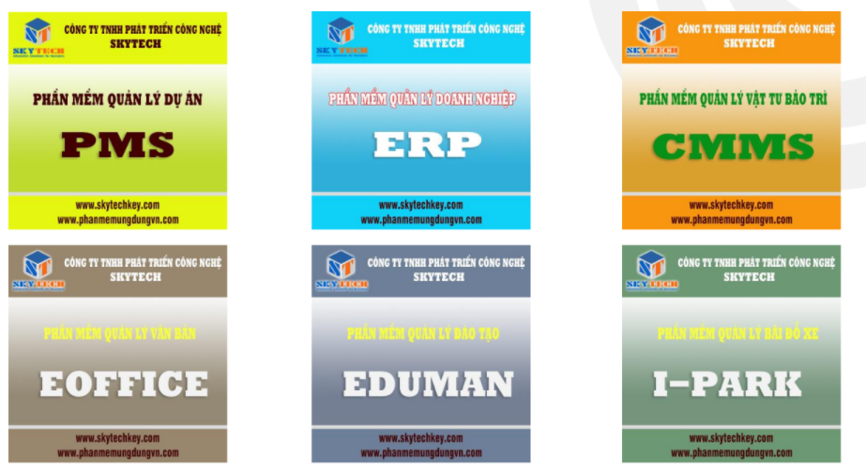Products:

1. Internship Presentation:
   1. Internship training plan:

* 1. Internship projects:
* Information about student web project:
  + Laravel projects name: (02 projects)
    - *Manage media files*
    - *Assets Management*
  + Scope of use: Internal company
  + Team members: Nguyen Hong Quan, Nguyen Dinh Kha, Tran Van Phat
  + Time: 1 month / project
  + Technologies:
    - Laravel framework
    - HTML, CSS, JavaScript
    - JQuery
  + Tools:
    - Visual Studio Code
    - Xampp
    - Miro, Skytechkey ERP, Github
* Detail about *Manage media files* project:
  + Purpose: Create a website to manage media files
  + Main Features:
    - Upload multiple files
    - Decentralize users
    - Manage files in department
    - Preview media (pictures, music, video)
  + Description:

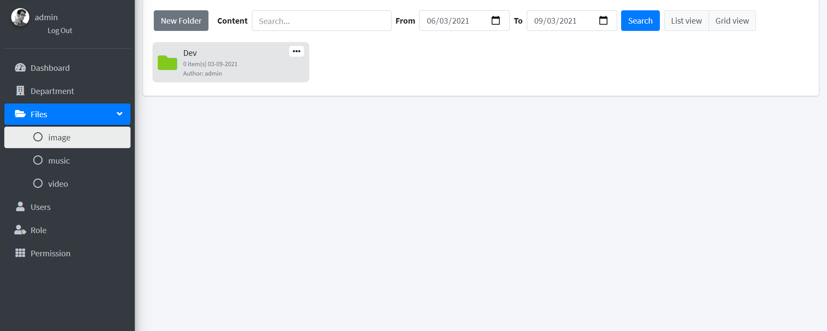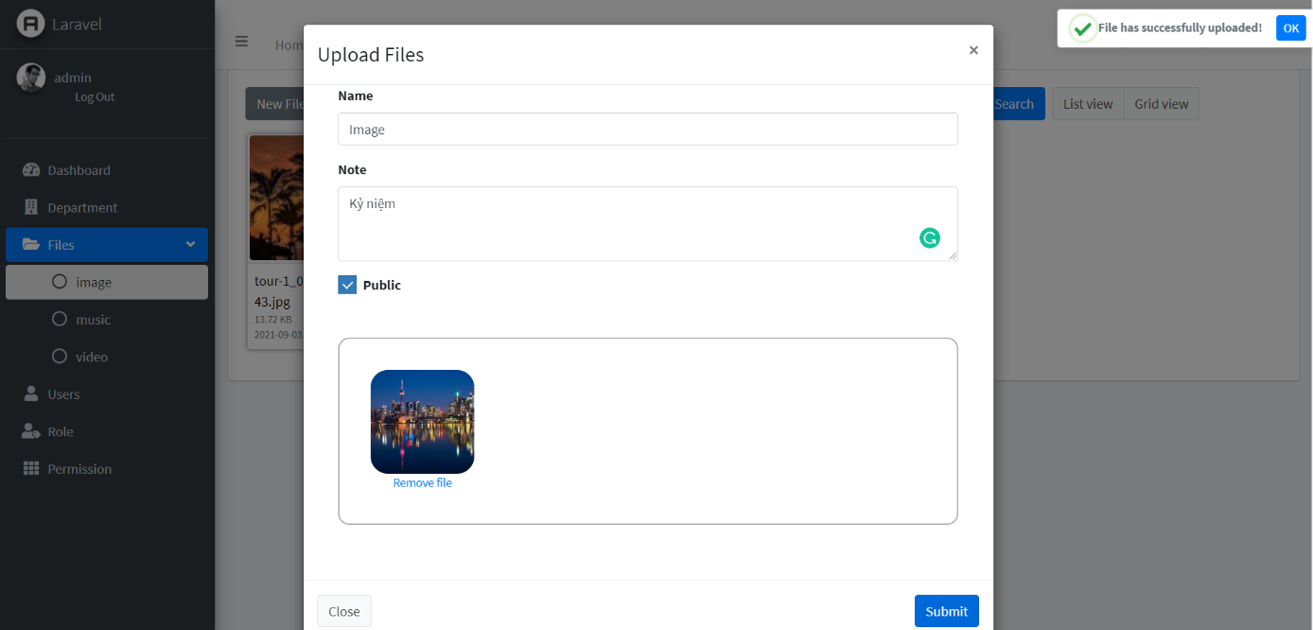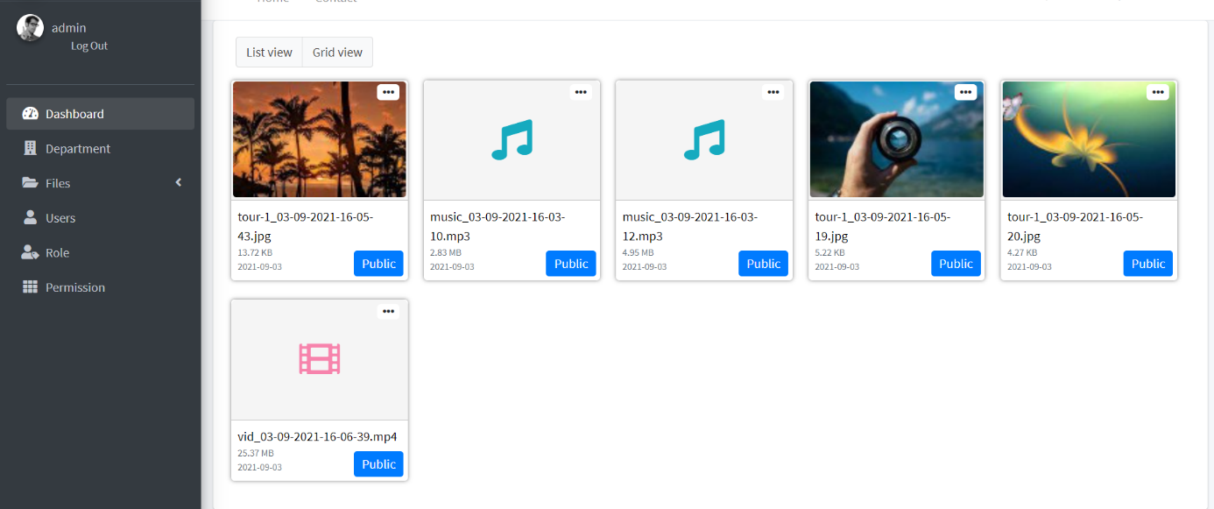

*Picture 1: Manage folder*

*Picture 2: Manage media files*

*Picture 3: Manage media files*

* Detail about *Assets Management* project:
  + Purpose: Create a web to manage assets
  + Main Features:
    - Manage company/organization, branches, departments
    - Login user (staff in company)
    - Decentralize users, manage users
    - Manage assets (add new, update, view detail, upload related files, repair fee)
    - Manage import, export assets
    - Asset statistics
  + Description:

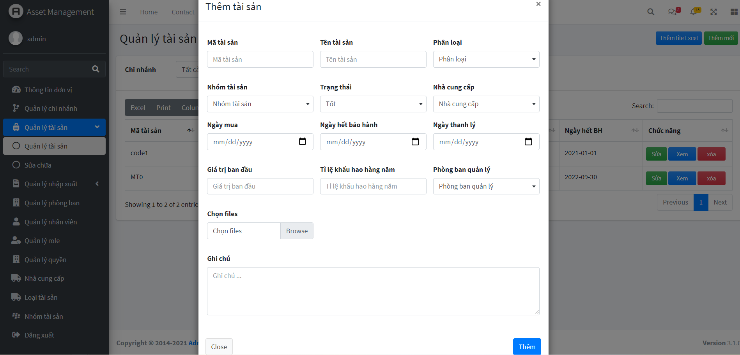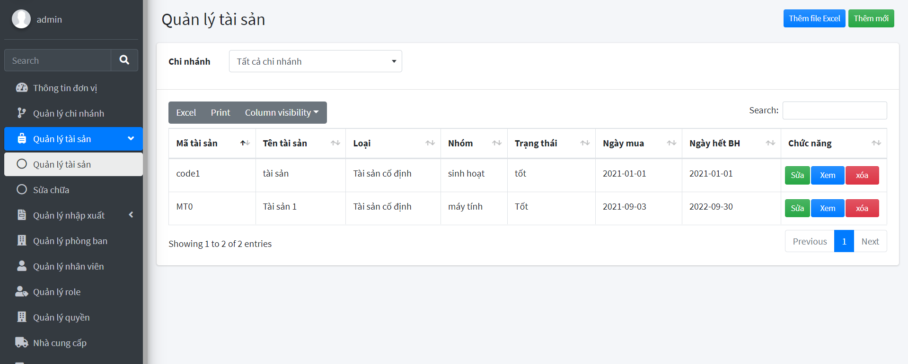

*Picture 5: Add new asset*

*Picture 4: Manage assets*

1. Working environment
   1. Day to day work and analysis

* My daily work routine:
  + 8:00 am: Attend and check new tasks on ERP app.
  + 9:00 am: Have a meeting or not
  + 12:00 pm: End of working hours
  + 13:30 pm: Attend and check new tasks on ERP app.
  + 16:30 pm: Report and get feedback
  + 17:30 pm: End of working hours
* Did not understand the task assigned by the mentor:
  + Asking the mentor again at the time he assigns the task
  + After completing a task to confirm with the mentor for early adjustment.
* Tool documentation not available:
  + Searching for information in English
  + Documents provided by the mentor
  + Laravel document, Stackoverflow website, …
* Self-study and do tasks that take a lot of time:
  + Breaking down the task into smaller tasks
  + Using some free time in the day to learn more about that knowledge.
  1. 02 Soft skill-related experiences
* Skill 1 : Problem solving
  + Get all required information clearly.
  + Research information or use suitable tools to solve the problem.
  + Make a plan and set a deadline for it.
  + If don’t have solution, quickly ask mentor to get advice.
* Skill 2 : Teamwork
  + After receiving the task, together analyze and separate the task into smaller tasks to make it easier and save more time.
  + Respond quickly when any member has problem.
  + The team leader is responsible for dividing the work and adjusting the work accordingly.

1. Conclusions:
   1. Achievements / successes :

* As an intern at Skytech company, though most of the time is online intern but this is an opportunity for me to interact with the working environment at the company.
* Regarding
  1. Conclusions / What I learned :
* Regarding my expertise in the web development, my programming thinking improved. I realize that quality is more important than quantity and I gained more knowledge, wrote code more and more logical, I learn how to managed the code better.
* I reviewed the knowledge of Laravel, and learned new knowledge about decentralization, middleware and upload files.
* I learned how to organize folders in the project and how to divide the layout to make the base for the development project.
  1. Career path impact / How will this experience affect my future?
* During my internship, I learned how to apply my knowledge to projects, and was introduced to many tools for better project management. At the same time, with the help of someone with experience, I have realized many of my defect so I can improve them.
* I realize there is a lot of demand for jobs on Laravel framework, knowing more about it will be an advantage for me.

Comments/Evaluation of mentor at PNV: (attach with this report)