

**DMS Renovation**

**Software Requirement Specification**

**Project Code: DMS1**

**Document Code: DMS1_SRS_DefectManagement_v1.0**

**Ho Chi Minh, May 2014**

**RECORD OF CHANGE**

*A - Added M - Modified D - Deleted

| **Effective Date** | **Changed Items** | **A* M, D** | **Change Description** | **New Version** |
| --- | --- | --- | --- | --- |
| 01-May-14 | First release | A |  | 1.0 |
|  |  |  |  |  |
|  |  |  |  |  |
|  |  |  |  |  |
|  |  |  |  |  |
|  |  |  |  |  |
|  |  |  |  |  |
|  |  |  |  |  |
|  |  |  |  |  |
|  |  |  |  |  |
|  |  |  |  |  |
|  |  |  |  |  |
|  |  |  |  |  |

**SIGNATURE PAGE**

**ORIGINATOR:** Vo Quoc Bao 01-May-14

**REVIEWERS:**

**APPROVAL:**

**TABLE OF CONTENT**

**TABLE OF CONTENT 4**

**1.** **DEFECT MANAGEMENT 5**

**1.1.** **Add Defect** 5

**1.2.** **Attachment screen** 12

**1.3.** **Defect List screen** 17

**1.4.** **Defect View Or Edit screen** 24

**1.5.** **Batch Update Defect screen** 31

**1.6.** **Export Defect** 34

**1.7.** **Defect lifecycle** 37

**2.** **OTHERS REQUIREMENT 39**

**2.1.** **Header of page** 39

**2.2.** **Data Format** 41

**2.3.** **Order of reference data** 41

**2.4.** **Timeout requirement** 47

1. **DEFECT MANAGEMENT**

Defect management is the heart of DMS. It contains following functionalities:

* Add Defect
* Attachment
* Defect List
* Defect View Or Edit
* Batch Update Defect
* Export Defect

* 1. **Add Defect**
     1. **Overview**

This screen is used to add new defect to DMS

* + 1. **Actors**

All project members can add defect to DMS

* + 1. **Use-case diagrams**



* + - 1. **Pre-condition**

User must be logged in

* + - 1. **Post-condition**

New defect was added into database.

* + - 1. **Triggers**
* Clicks on the “Add New” button on the Defect View or Edit screen
* Go to menu Manage Defect from page header of any page, click on the hyper-link “New Defect”
  + 1. **Workflows**

| **Scenario** | **Actor** | **System** |
| --- | --- | --- |
| 1. User successfully add new defect | 1.1. Go to this screen | 1.2. Display “Add defect” screen. |
| 1.3 At any time, user can attach file by clicking “Attach file” button  Attachment is optional | 1.4 Submit to “Attach file” screen.  After user attached file, return to “Add new defect” screen with current status and values of all fields and control except change in attachment area. |
| 1.5 Fill in mandatory fields and optional fields (not required) and click “Save” button | 1.6 Validate mandatory fields and valid format.  All fields are valid, new defect will be saved into database and continue to display “Add defect” screen for the next new defect |
| 2. User inputs invalid data | 2.1 Refer to step 1.1 | 2.2 Refer to step 1.2 |
| 2.3 Refer to step 1.3 | 2.4 Validate mandatory fields and valid format  If there are still errors, dialog error messages of invalid fields will be displayed at the center of screen |

* + 1. **External interfaces**
       1. **Prototype:**

Add Defect

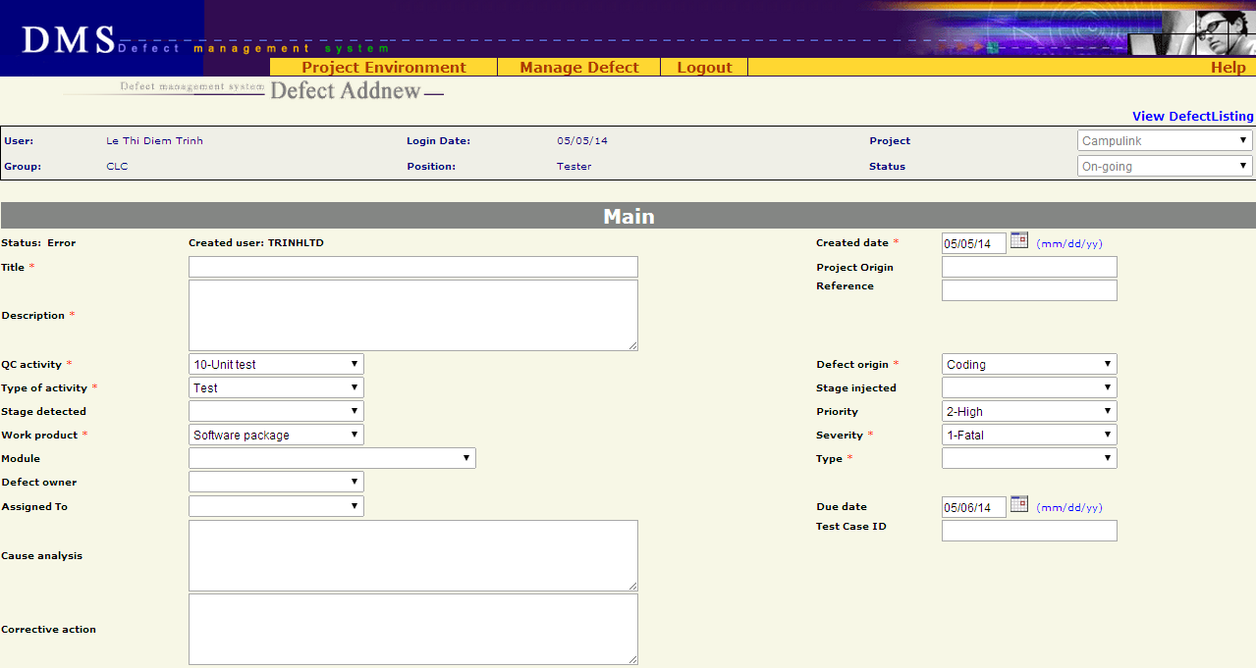

Button



Attachment

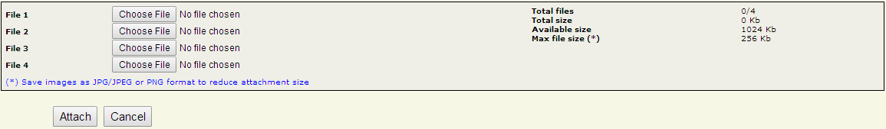

* + - 1. **Screen description**

| **No** | **Field name** | **Control type** | **Required** | **Data type** | **Default value** | **Description** |
| --- | --- | --- | --- | --- | --- | --- |
| **Defect detail** | | | | | | |
| 1 | Status | Label | Yes | Text | Error | Status of the defect. |
| 2 | Created user | Label | Yes | Text | Logged-in user | Member who created the defect and all other members of project |
| 3 | Created Date | Text field | Yes | Date | Today | Date when the defect was recorded in DMS  Date format mm/dd/yy |
| 4 | Title | Text field | Yes | Text | Blank | A short & brief description of the defect for quick recognition  Maximal 150 characters |
| 5 | Project Origin | Text field | No | Text | Blank | Maximal 50 characters |
| 6 | Description | Text area | Yes | Text | Blank | Full description of the defect, often the steps to reproduce the defect |
| 7 | Reference | Text field | No | Text | Blank | Maximal 30 characters |
| 8 | QC Activity | Combo box | Yes | Text | 10-Unit test | QC activity in which the defect is found |
| 9 | Defect Origin | Combo box | Yes | Text | Coding | Process of defect |
| 10 | Type of activity | Combo box | Yes | Text | Test | Defect type of current project |
| 11 | Stage Injected | Combo box | No | Text | Blank | Stage injected of current project |
| 12 | Stage Detected | Combo box | No | Text | Blank | Stage detected of current project |
| 13 | Priority | Combo box | No | Text | 2-High | Indicate how urgent the defect needs to be fixed |
| 14 | Work Product | Combo box | Yes | Text | Software package | Work product in which the defect is found. It is high level CI |
| 15 | Severity | Combo box | Yes | Text | 1-Fatal | Severity of defects in current project |
| 16 | Module | Combo box | No | Text | Blank | Module of defect in current project |
| 17 | Type | Combo box | Yes | Text | Blank | Type of defect |
| 18 | Defect Owner | Combo box | No | Text | Blank | List all members of the project. |
| 19 | Assigned To | Combo box | No | Text | Blank | List all members of the project. |
| 20 | Due Date | Text field | No | Date | Today+1 | Deadline of defect fixing.  Date format mm/dd/yy |
| 21 | Cause Analysis | Text area | No | Text | Blank | Description of the cause of defect |
| 22 | Test Case ID | Text field | No | Text | Blank | ID of test case in which the defect was found  Maximal 50 characters |
| 23 | Corrective Action | Text area | No | Text | Blank | Actions/steps to correct the defect |
| **Button** | | | | | | |
| 24 | Save | Button | Yes | N/A | N/A | Save new defect to database and go to “Add Defect” screen |
| 25 | Defect List | Button | Yes | N/A | N/A | Return to “Defect List” screen corresponding to previous selected query (All defects / All Open Defects / All Leakage Defects / Public or Private Query) |
| 26 | Attach file | Button | Yes | N/A | N/A | Go to “Attach file” screen |

* + 1. **Business descriptions**

| **No** | **Name** | **Control Type** | **Description** |
| --- | --- | --- | --- |
| **Defect detail** | | | |
| 1 | QC Activity | Combo box | When “QC Activity” changes, appropriate values of “Type of Activity” will be automatically generated |
| 2 | Type of Activity | Combo box | This information won’t be inputted by user.  System will add Type of Activity information according to QC Activity |
| 3 | Stage Detected - Injected | Combo box | Information of 2 stages will come from FI accordant to “today” |
| 4 | Priority | Combo box | Priority of defect |
| 5 | Work Product | Combo box | Work product in project |
| 6 | Severity | Combo box | Severity of defect |
| 7 | Module | Combo box | Available values are automatically got from another Project management tool  From this available values, list all appropriate “Modules” of “Work Product” |
| 8 | Type | Combo box | List all defect types of system |
| 9 | Created user | Combo box | User can choose any member of project |
| 10 | Assigned to | Combo box | User can choose any member of project |
| 11 | Defect Owner | Combo box | User can choose any member of project |
| 12 | Defect ID | Text | This number is automatically generated whenever a new defect is added. Defect ID counter will not be reset. |
| 13 | Re-opened | N/A | This property is not displayed in screen. It will be automatically set to 0 each time a new defect is created. |
| 14 | Translation status | Hidden | Available values are: Not translated, Translated, Reviewed  This field is automatically set to “Not translated” whenever a new defect is created |
| 15 | Due Date | Text | Default value is today + 1 |
| 16 | Defect Title | Text | Focus on Defect Title item at the first load |
| **Button** | | | |
| 17 | Defect list | Button | Return to “List Defect” screen of previous chosen query (All Defects, All Open Defects, …) |
| 18 | Attach file | Button | Go to attachment screen |

* + 1. **User-validation rules**

| **No** | **Validation rule** | **Message Code** |
| --- | --- | --- |
| 1 | Combo box is required | ERR_REQUIRED_QC_ACTIVITY  ERR_REQUIRED_ORIGIN  ERR_REQUIRED_TYPE_ACTIVITY  ERR_REQUIRED_WP  ERR_REQUIRED_SEVERITY  ERR_REQUIRED_TYPE |
| 2 | Date format mm/dd/yy | ERR_FORMAT_DATE_CREATED  ERR_FORMAT_DATE_DUE |
| 3 | Text field/text area is required | ERR_REQUIRED_CREATED_DATE  ERR_REQUIRED_TITLE  ERR_REQUIRED_DESCRIPTION |
| 4 | Created date is greater than current date | ERR_CONSTRAINT_DATE_CREATED_TODAY |
| 5 | Created date is greater than Due Date | ERR_CONSTRAINT_DATE_CREATED_DUE |
| 6 | Length of input fields are over limitation | No message, auto trim string |

* + 1. **Related use-cases**
* List defect
* Attach file

* 1. **Attachment screen**
     1. **Overview**

This function is described for the updating/attaching some files to a defect while user creates a new defect or updates an existing defect. In this screen, user will have information on attachments of the defect, including: total number of attached file(s), total size of attached file(s) and available size for next attachment.

* + 1. **Actors**

All users who have permission to attach files to a defect.

* + 1. **Use – case diagram**



* + - 1. ***Pre-condition***

- The actor has successfully logged into the system.

- There’s enough available space for attachment

* + - 1. ***Post-condition***

N/A

* + - 1. ***Triggers***

From Add Defect, Defect View Or Edit screen, user clicks on the Attach file button to view Attach files screen.

* + 1. **Workflows** 
       1. ***Scenario 1 – Valid Attachment***

| **Actor** | **System** |
| --- | --- |
| 1. From Add Defect, Defect View Or Edit screen, user clicks on the **Attach File** button | 2. Display Attach files screen |
| 3. User choose some files by clicking on the Choose file button to open Choose File dialog |  |
| 4. After choosing file, User clicks on **Attach** button | 5. Validate all inputs  - If all inputs are valid  🡺 Upload files to server and display Upload Attachment Result screen with successful message |
| 6. On Upload Attachment result screen, user clicks on **Done** button. | 7. Return to the Add Defect, Defect View Or Edit screen |

* + - 1. ***Scenario 2 – Invalid Attachment***

| **Actor** | **System** |
| --- | --- |
| Step 1, 2, 3 – refer to scenario 1 | |
| Step 4 – refer to scenario 1 | 5. Validate all inputs  - If any input is invalid  🡺 Go to Upload Attachment Result screen with fail message |
| 6. On Upload Attachment result screen, user clicks on **Done** button. | 7. Return to the Add Defect, Defect View Or Edit screen |

* + 1. **External interfaces**
       1. ***Prototype***

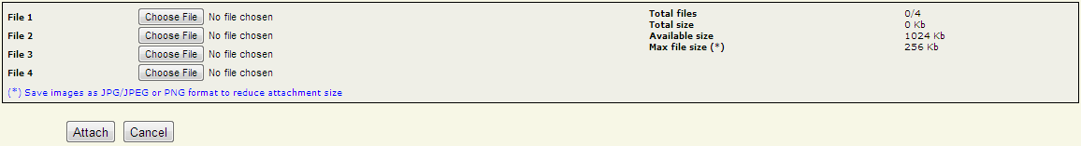

**Figure: Attach file screen**



**Figure: Upload attachment result screen**

* + - 1. ***Screen Description***

This function uses two screens: Upload Attachment screen, Upload Attachment result screen

* + - * 1. ***Attach file screen***

| **No** | **Field name** | **Control type** | **Data type** | **Default Value** | **Require** | **Functional Description/(*) Tool tip** |
| --- | --- | --- | --- | --- | --- | --- |
| 1 | File X | Label Area | Text | Blank | Yes | There are always 4 file browsing item in this screen |
| 2 | Total files, Total size, Available Size, Max file size (*) | Label Area | Text | N/A | Yes | Information includes:   * Total uploaded files, * Total size of attached files * Available size for next attachment * Maximum uploaded file size |
| 3 | Attach | Button | Control | N/A | Yes | Upload the chosen file(s) to server. |
| 4 | Cancel | Button | Control | N/A | Yes | Reset and close the dialog to return to Add Defect, Defect View Or Edit screen |

* + - * 1. ***Upload Attachment result screen***

| **No** | **Field name** | **Control type** | **Data type** | **Functional Description/(*) Tool tip** |
| --- | --- | --- | --- | --- |
| 1 | File(s) attached successfully | Label Area | Text | Incase success when attaching file   * New files = number of attached file * New size = Total size of attached files * Total files = <number attached file>/4 * Total size = Total size (old & new) Kb * Available size = <1024 – Total size> Kb |
| 1 | Attach failed due to error | Label Area | Text | Incase fail when attaching file   * New files = 0 * New size = 0 Kb * Total files = 0/4 * Total size = 0 Kb * Available size = 1024 Kb |
| 2 | Done | Button | Control | Return to Add Defect, Defect View Or Edit screen with the new attachment list |

* + 1. **Business Description**
       1. ***Upload Attachment screen***

| **No** | **Name** | **Business rules** |
| --- | --- | --- |
| 1 | Upload/ Attachment screen  **General constraints** | * Limitation for file size = 256 Kb * Limitation for number of file = 4 * Total size of all attachments doesn’t exceed 1024 Kb * To reduce size of attachment, save images as JPG, JPEG or PNG format * In addition, attachment can be any format such as .doc, .xls, .txt, .zip, .rar… |

| **No** | **Name** | **Business rules** |
| --- | --- | --- |
| 1 | From Add Defect, Defect View Or Edit screen, user clicks on **Attach File** button. | Display Upload Attachment screen 🡺  open Choose file dialog to browse the required file to attach |
| 2 | In Upload Attachment screen:  User clicks on **Cancel** button | Reset and close the dialog to return to Add Defect, Defect View Or Edit screen |
| 3 | * User clicks on **Attach** button - If all the file paths are valid, the file size is not bigger than the limitation of attachment for a defect and the available space is enough   🡺 The chosen file(s) uploaded to server. If upload run successfully  🡺 Display **Upload Attachment screen – result** | |
| 4 | File name | File name of the attachment must be different to old attachments’ name |

* + - 1. ***Upload Attachment result screen***
* **Control area**

| **No** | **Name** | **Business rules** |
| --- | --- | --- |
| 1 | User clicks on **Done** button | Return to Add Defect, Defect View Or Edit screen with the new attachment list |

* + 1. **User validation rules**

| **No** | **Error type** | **Message Code** |
| --- | --- | --- |
| 1 | user did not select any file for attachment when clicking Attach button | ERR_REQUIRED_ATTACHMENT_FILE |
| 2 | Total size is over the limitation (1024 Kb) | ERR_FILE_OVER_AVAILABLE_SIZE |
| 3 | file size is over the limitation (256 Kb) | ERR_FILE_OVER_MAX_FILE_SIZE |
| 4 | File name is same to old attachment’s name in the project | ERR_EXISTED_FILE_NAME |

* + 1. **Related use-cases**
* Defect View Or Edit
* Add new Defect

* 1. **Defect List screen**
     1. **Overview**

This screen displays a list of defects matching a previously chosen query and specific search criteria if filter was applied.

* + 1. **Actors**

All users can view defect list

* + 1. **Use-case diagram**



* + - 1. **Pre-condition**

User must be logged-in.

* + - 1. **Post-condition**

List of suitable defects was displayed.

* + - 1. **Triggers**
* User selects a query of listing in homepage
* User clicks Defect List button in Add Defect and Update Defect screens
  + 1. **Workflows**
       1. **Scenario 1 (Fixed Query - Filter)**

| **Actor** | **System** |
| --- | --- |
| 1. User click on a fixed query (All Defects, All Open Defects, All Leakage Defects) | 2. The corresponding list defect is displayed with the set of criteriaas follows:   * Defect Owner * Status * Module Code * Assigned To * Severity * Type * Created By * Reference * Defect Origin * Stage Detected * Stage Injected * QC Activity * Created From * Created To * Work Product * Fixed From * Fixed To * Priority * DefectID * Test Case ID * Title |
| 3. User enters information related to searching defects in the **Filter** section. |  |
| 4. User click on the button “Search” | 5. The corresponding list defect is displayed on a table |

* + 1. **GUI**
       1. **Prototype**

Filter:

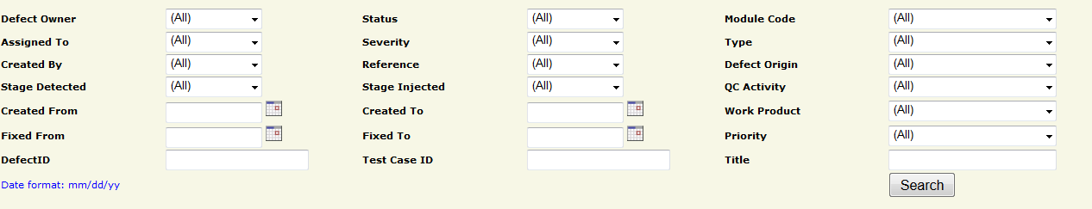

List defects:

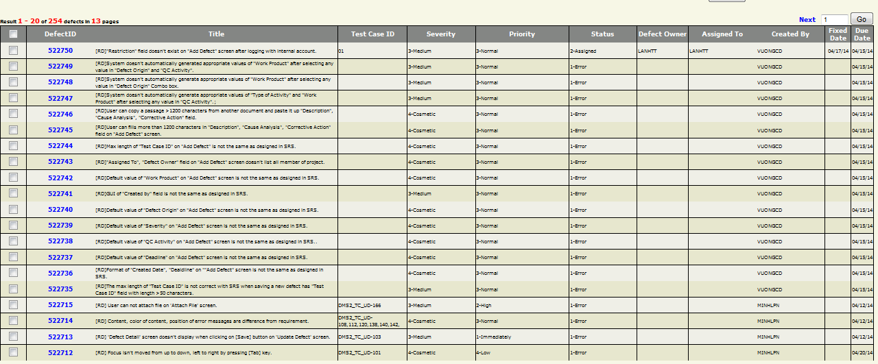

Control area:

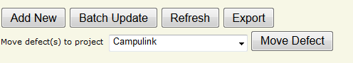

* + - 1. **Screen Description**
         1. **Zone 1 - filter**

| **No** | **Field  Name** | **Control Type** | **Data Type** | **Default Value** | **Required** | **Functional  Description/(*)ToolTip** |
| --- | --- | --- | --- | --- | --- | --- |
| 1 | Defect Owner | Combo box | Text | All | No | Owner of defects searching. List all members of the project. Besides, it has 2 more items: (All) and None |
| 2 | Status | Combo box | Text | All | No | Status of defect. Depend on project model. Besides, it has 1 more item: (All) |
| 3 | Module Code | Combo box | Text | All | No | Module which contain defects user wants to search. Besides, it has 2 more items: (All) and (None) |
| 4 | Assigned To | Combo box | Text | All | No | List of all members of the project. Besides, it has 2 more items: (All) and (None) |
| 5 | Severity | Combo box | Text | All | No | Severity of defects in current project, similar to current DMS values. Besides, it has 1 more item: (All) |
| 6 | Type | Combo box | Text | All | No | Defect type of the defects searching, similar to current DMS values.  Besides, it has 1 more item: (All) |
| 7 | Created By | Combo box | Text | All | No | Member who creates the defect is selected in the list of all members of the project... Besides, it has 2 more items: (All) |
| 8 | Reference | Combo box | Text | All | No |  |
| 9 | Defect Origin | Combo box | Text | All | No | Indicates the actual process that caused the defect, similar to current DMS values.  Besides, it has 1 more item: (All) |
| 10 | Stage Detected | Combo box | Text | All | No | Stage of project when defect is detected |
| 11 | Stage Injected | Combo box | Text | All | No | Stage of project when defect is resolved |
| 12 | QC Activity | Combo box | Text | All | No | QC Activity of defects searching, similar to current DMS values.  Besides, it has 1 more item: (All) |
| 13 | Created From | Text field | Date | Blank | No | Minimal creation date of the defects searching  Current date format of project |
| 14 | Created To | Text field | Date | Blank | No | Maximal creation date of the defects searching  Current date format of project |
| 15 | Work Product | Combo box | Text | All | No | Work Product in which found the defects, similar to current DMS values.  Besides, it has 1 more item: (All) |
| 16 | Fixed From | Text field | Date | Blank | No | Minimal fixed date of the defects searching  Current date format of project |
| 17 | Fixed To | Text field | Date | Blank | No | Maximal fixed date of the defects searching  Current date format of project |
| 18 | Priority | Combo box | Text | All | No | List priority that the defect need to be resolved. Besides, it has 2 more items: (All) and None |
| 19 | Defect ID | Text field | Text | Blank | No | The beginning value that the defects searching contains |
| 20 | Test Case ID | Text field | Text | Blank | No | The Test Case ID which found the defects |
| 21 | Title | Text field | Text | Blank | No | The title that defects searching contains |
| 22 | Search | Button | Control |  | No | Button allows user to search defects by selected criteria |
| 23 | Date format | Text | Text | mm/dd/yy | Yes | Date format of displayed date value |

* + - * 1. **Zone 2 - Paging area**

| **No** | **Field name** | **Control Type** | **Data Type** | **Default Value** | **Required** | **Functional  Description/(*)ToolTip** |
| --- | --- | --- | --- | --- | --- | --- |
| 1 | Go | Button |  |  |  | Go to selected page in paging mode |
| 2 | Selected page | Text field | Text | 1 | Yes | Selected page value in paging mode |
| 3 | Prev | Link | Image |  |  | Go to previous page in paging |
| 4 | Next | Link | Image |  |  | Go to next page in paging |

* + - * 1. **Zone 3 – Defects listing area**

| **No** | **Field  Name** | **Control Type** | **Data  Type** | **Default Value** | **Required** | **Functional Description/ (*)ToolTip** |
| --- | --- | --- | --- | --- | --- | --- |
| 1 | Check | Check box | Boolean | False | No | Selected defects will be used for batch update functionality |
| 2 | Defect ID | Link | Text |  | No | Link to “Defect View Or Edit” page |
| 3 | Title | Text | Text |  | No | Short description of content of defect |
| 4 | Test Case ID | Text | Text |  | No | ID of test case that found the defect |
| 5 | Severity | Text | Text |  | No | Severity of defect |
| 6 | Priority | Text | Text |  | No | Priority of defect |
| 7 | Status | Text | Text |  | No | Status of defect |
| 8 | Defect owner | Text | Text |  | No | Owner of defect |
| 9 | Assigned To | Text | Text |  | No | Who is assigned to fix defect |
| 10 | Created By | Text | Text |  | No | Who created defect |
| 11 | Fixed Date | Text | Date |  | No | Date when defect was fixed  Current date format of project |
| 12 | Due Date | Text | Date |  | No | Deadline for defect fixing  Current date format of project |

* + - * 1. **Zone 4 – Control area**

| **No** | **Field Name** | **Control Type** | **Data  Type** | **Default Value** | **Required** | **Functional Description/(*)ToolTip** |
| --- | --- | --- | --- | --- | --- | --- |
| 1 | Add New | Button | Text | N/A | N/A | Link to create new defect page |
| 2 | Batch Update | Button | Text | N/A | N/A | Submit selected defects to batch update page |
| 3 | Refresh | Button | Text | N/A | N/A | Refresh the page |
| 4 | Export | Button | Text | N/A | N/A | Permit user to export defects to excel file |
| 5 | Move defect(s) to project | Combo box | Text | N/A | N/A | Destination projects for moving defects |
| 6 | Move Defect | Button | Text | N/A | N/A | Permit QA to move defects to selected project (visible with QA only) |

* + 1. **Business description**
       1. **Zone 1 - Filter**

| **No** | **Field Name** | **Business Rules** |
| --- | --- | --- |
| 1 | Assigned To, Created By, Defect Owner | - Combo box contains all users assigned to the project |
| 2 | Status | - Combo box contains a list of defect status |
| 3 | Severity | - Combo box contains a list of defect severity values |
| 4 | Module Code | - Combo box “Module Code” contains a list of module code values  - At the first load, Module code combo box contains all modules |
| 5 | QC Activity | - Combo box contains a list of QC Activity values |
| 7 | Priority | - Combo box Priority contains a list of Priority values |
| 9 | Type | - Combo box contains a list of defect type values |
| 10 | Defect Origin | - Combo box contains a list of Origin values |
| 12 | Work Product | - Combo box contains a list of Work Product values |
| 13 | DefectID | - Search all defects that begin with inputted value |
| 14 | Defect Owner | - Combo box contains all members of the selected project |
| 16 | Title | Search all defects which have relative value with inputted value |
| 17 | Test Case ID | Search relative value |

* + - 1. **Zone 2 – Defects listing area**

| **No** | **Field Name** | **Business Rules** |
| --- | --- | --- |
| 1 | Check | - Used for “Batch Update” - If user clicks the check icon on the header row, all check boxes will be checked |
| 2 | DefectID | - Link to “Defect View Or Edit” page - Refer to use-case “Defect View Or Edit”  - If user clicks the icon “DefectID” on the header row , all values of the result table will be sorted by this field |
| 3 | Title | - If user clicks the icon “Title” on the header row , all values of the result table will be sorted by this field |
| 4 | Test Case ID | - If user clicks the icon “Test Case ID” on the header row , all values of the result table will be sorted by this field |
| 5 | Severity | - If user clicks the icon of this field on the header row , all values of the result table will be sorted by this field |
| 6 | Priority |
| 7 | Status |
| 8 | Defect Owner |
| 9 | Assigned To |
| 10 | Created By |
| 11 | Fixed Date |
| 12 | Due Date |

* + 1. **User – validation rules**

| **No** | **Validation rule** | **Message Code** |
| --- | --- | --- |
| 1 | Date format mm/dd/yy | ERR_FORMAT_DATE_CREATED_FROM  ERR_FORMAT_DATE_CREATED_TO  ERR_FORMAT_DATE_FIXED_FROM  ERR_FORMAT_DATE_FIXED_TO |
| 2 | Created From Date > Created To Date | ERR_CONSTRAINT_DATE_CREATED_FROMTO |
| 3 | Fixed From Date > Fixed To Date | ERR_CONSTRAINT_DATE_FIXED_FROMTO |
| 4 | Input data that is characters/specific characters/negative number is filled in “DefectID” | ERR_DEFECT_ID_INVALID |
| 5 | Selected page is out of range or not a positive number | ALT_PAGE_INVALID |
| 6 | No defect is checked to batch update | ALT_REQUIRED_DEFECT |

* + 1. **Related use-cases**
* Add defect
* Defect View Or Edit
* Batch update
* Export defect

* 1. **Defect View Or Edit screen**
     1. **Overview**

With this function, user can update existed defect and save the modification. All members of project can update the defect.

* + 1. **Actors**

All project members can update defect.

* + 1. **Use-case diagram**



* + - 1. **Pre-condition**

User must be logged-in the system.

* + - 1. **Post-condition**

N/A

* + - 1. **Triggers**
    - User clicks on Defect ID in defects list screen
    1. **Workflows**

| **Actor** | **System** |
| --- | --- |
| 1. Go to “Defect View Or Edit” screen | 2. Display “Defect View Or Edit” screen with all available data fields related to a specific actor  Display current values of defect for user to update |
| 3. Update value of data fields & click “Save” button | 4. Validate data fields  If all fields are valid, defect will be updated in database and go to the page “Defect List” |

* + 1. **External interfaces**
       1. **Prototype**

Defect View Or Edit

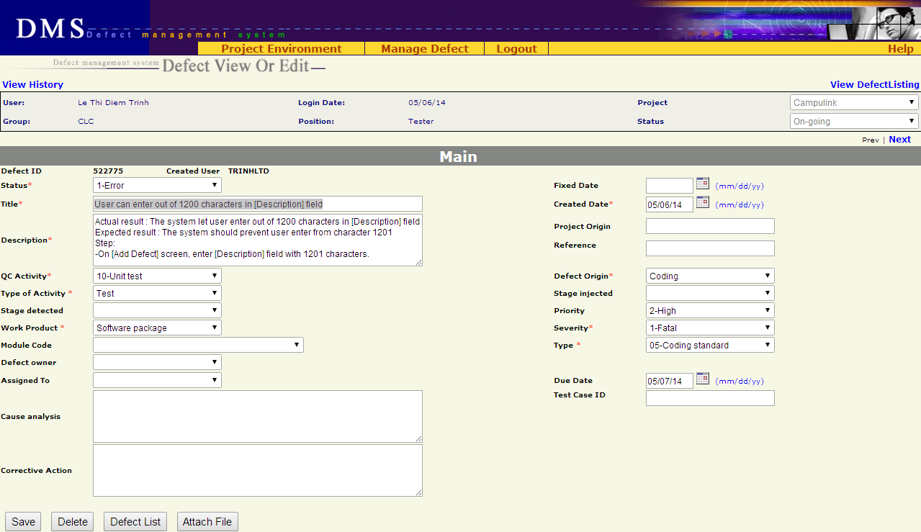

* + - 1. **Screen descriptions**

| **No** | **Field name** | **Control Type** | **Required** | **Data type** | **Default value** | **Description** |
| --- | --- | --- | --- | --- | --- | --- |
| **Defect detail** | | | | | | |
| 1 | Status | Label | Yes | Text | Current Value | Status of the defect. |
| 2 | Fixed Date | Text field | No | Date | Blank | Date when the defect was fixed  Date format mm/dd/yy |
| 3 | Title | Text field | Yes | Text | Current Value | A short & brief description of the defect for quick recognition |
| 4 | Created Date | Text field | Yes | Date | Current Value | Date when the defect was recorded in DMS  Date format mm/dd/yy |
| 5 | Description | Text area | Yes | Text | Current Value | Full description of the defect, often the steps to reproduce the defect |
| 6 | Project Origin | Text field | No | Text | Current Value |  |
| 7 | Reference | Text field | No | Text | Current Value |  |
| 8 | QC Activity | Combo box | Yes | Text | Current Value | QC activity in which the defect is found |
| 9 | Defect Origin | Combo box | Yes | Text | Current Value | Process of defect |
| 10 | Type of activity | Combo box | Yes | Text | Current Value | Defect type of current project |
| 11 | Stage Injected | Combo box | No | Text | Current Value | Stage injected of current project |
| 12 | Stage Detected | Combo box | No | Text | Current Value | Stage detected of current project |
| 13 | Priority | Combo box | No | Text | Current Value | Indicate how urgent the defect needs to be fixed |
| 14 | Work Product | Combo box | Yes | Text | Current Value | Work product in which the defect is found. It is high level CI |
| 15 | Severity | Combo box | Yes | Text | Current Value | Severity of defects in current project |
| 16 | Module Code | Combo box | No | Text | Current Value | Module of defect in current project |
| 17 | Type | Combo box | Yes | Text | Current Value | Type of defect |
| 18 | Defect Owner | Combo box | No | Text | Current Value | List all members of the project. |
| 19 | Assigned To | Combo box | No | Text | Current Value | List all members of the project.  If combo box “Assigned To” is chosen, status will be changed to Assigned by system |
| 20 | Due Date | Text field | No | Date | Current Value | Deadline of defect fixing.  Date format mm/dd/yy |
| 21 | Cause Analysis | Text area | No | Text | Current Value | Description of the cause of defect |
| 22 | Test Case ID | Text field | No | Text | Current Value | ID of test case in which the defect was found  Maximal 50 characters |
| 23 | Corrective Action | Text area | No | Text | Current Value | Actions/steps to correct the defect |
| **Button** | | | | | | |
| 24 | Save | Button | N/A | N/A | N/A | Save current defect to database and return to “List defect” screen |
| 25 | Delete | Button | N/A | N/A | N/A | Delete current defect |
| 26 | Defect list | Button | N/A | N/A | N/A | Return to “Defect List” screen corresponding to previous selected query (All defects / All Open Defects / All Leakage Defects / Public or Private Query) |
| 27 | Attach file | Button | N/A | N/A | N/A | Submit the defect to “Attach file” screen |

* + 1. **Business descriptions**

| **No** | **Name** | **Description** |
| --- | --- | --- |
| **Defect detail** | | |
| 1 | Assigned To | User can choose any member of project |
| 2 | Module Code | Available values are automatically got from another Project management tool  From this available values, list all appropriated “Modules” of “Work Product” |
| 3 | Type | List all defect types of system |
| 4 | Title | Can be updated by all members of project |
| 5 | Description | Can be updated by all members of project |
| 6 | Defect Owner | List all members of team that are assigned to project |
| 7 | Due Date | Default value is today+1 if there is no value for this field |
| 8 | Title | Focus on Defect Title item at the first load |
| 9 | Corrective Action | If Status is changed to “3-Pending”, “4-Tested”, “5-Accepted” or “6-Cancelled” then “Corrective Action” must be filled. |
| **Button** | | |
| 10 | Save | Validate all fields  If all fields are valid, save the defect in database and go to “Add Defect” screen. Save all information in Update screen including comment (if any) |
| 11 | Delete | Delete the defect from database and go to “Defect List” screen. |
| 12 | Defect List | Move to “Defect List” screen |
| 13 | Attach file | Only Created user, Assignee and full-right users (PM, PTL, QA) can use this functionality  Submit the defect to “Attach file” screen |

* + 1. **User-Validation rules**

| **No** | **Validation rule** | **Error message ID** |
| --- | --- | --- |
| 1 | Combo box is required | ERR_REQUIRED_STATUS  ERR_REQUIRED_QC_ACTIVITY  ERR_REQUIRED_DEFECT_ORIGIN  ERR_REQUIRED_TYPE_ACTIVITY  ERR_REQUIRED_WP  ERR_REQUIRED_SEVERITY  ERR_REQUIRED_TYPE |
| 2 | Date format mm/dd/yy | ERR_FORMAT_DATE_CREATED  ERR_FORMAT_DATE_FIXED  ERR_FORMAT_DATE_DUE |
| 3 | Text field/text area is required | ERR_REQUIRED_TITLE  ERR_REQUIRED_CREATED_DATE  ERR_REQUIRED_DESCRIPTION |
| 4 | Created date is greater than current date | ERR_CONSTRAINT_DATE_CREATED_TODAY |
| 5 | Fixed date is greater than current date | ERR_CONSTRAINT_DATE_FIXED_TODAY |
| 6 | Created date is greater than fixed date | ERR_CONSTRAINT_DATE_CREATED_FIXED |

* + 1. **Related use-cases**
* List defect
* Attach file

* 1. **Batch Update Defect screen**
     1. **Overview**

This function permit user to update concurrently some defects of the same batch. User must select defects from List Defect screen before using Batch Update.

* + 1. **Actors**

All users who have permission on Batch update functionality (defined in RMS)

* + 1. **Use - case diagram**



* + - 1. ***Pre-condition***

- The actor has successfully logged into the system.

- User has selected at least one defect to update

* + - 1. ***Post-condition***

N/A

* + - 1. **Triggers**

From List Defect screen, user selects some necessary defects for updating and clicks on Batch Update button.

* + 1. **Workflows** 
       1. ***Scenario – Batch update***

| **Actor** | **System** |
| --- | --- |
| 1. From List Defect screen, user selects some necessary defects for updating |  |
| 2. User clicks on **Batch Update** button. | 3. Display Batch Update screen |
| 4. User change some necessary fields of the selected defects |  |
| 5. User clicks on **Save** button | 6. Save all modifications and return to List Defect screen. |

* + 1. **External interfaces**
       1. ***Prototype***

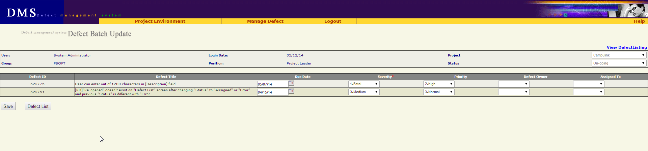

* + - 1. ***Screen Description***

Each defect is listed here with following information:

| **No** | **Field name** | **Control type** | **Data type** | **Default value** | **Require** | **Functional Description/(*) Tool tips** |
| --- | --- | --- | --- | --- | --- | --- |
| 1 | Defect ID | Label | Text | Copy from previous | N/A | ID number of defect  Cannot be edited |
| 2 | Defect Title | Label | Text | Copy from previous | N/A | This is a brief description about defect  Cannot be edited |
| 3 | Due Date | Text box | Text | Copy from previous | No | This is the date on which the defect should be fixed  - Associated with a date picker calendar  - format dd/mm/yy |
| 4 | Severity | Combo box | Text | Copy from previous | Yes | Severity of defect |
| 5 | Priority | Combo box | Text | Copy from previous | No | Priority of defect |
| 6 | Defect Owner | Combo box | Text | Copy from previous | No | This field indicates who is owner of the defect  List all members of the project |
| 7 | Assigned to | Combo box | Text | Copy from previous | No | This field indicates who will be responsible for fixing the defect  List all members of the project |

* + 1. **Business Description**
       1. ***Data fields***

| **No** | **Name** | **Business rules** |
| --- | --- | --- |
| 1 | Defect Owner | User can assign owner for defect to any member of project |
| 2 | Assigned To | User can assign defect to any member of project |

* + - 1. ***Control area***

| **No** | **Name** | **Business rules** |
| --- | --- | --- |
| 1 | From List Defect screen, user clicks on **Batch Update** button | Go to Batch Update screen with the list of selected defects |
| 2 | At Batch Update screen, user clicks on **Defect List** button | Return to List Defect screen without saving any thing |
| 3 | User clicks on **Save** button | Save all changes and return to List Defect screen |

* + 1. **User validation rules**

| **No** | **Error type** | **Message Code** |
| --- | --- | --- |
| 1 | Due date is in invalid format | ERR_FORMAT_DATE_DUE |

* + 1. **Related use-cases**
* Defect List

* 1. **Export Defect**
     1. **Overview**

This screen allows user to export defects list retrieved from “Defect List” screen.

* + 1. **Actors**

All users who has permission on Export functionality

* + 1. **Use-case diagram**



* + - 1. **Pre-condition**

User must be logged-in.

* + - 1. **Post-condition**

Defects were exported to a file.

* + - 1. **Triggers**

In “Defect List” screen, user click “Export” button.

* + 1. **Workflow**

| **Actor** | **System** |
| --- | --- |
| 1/ Click “Export” button from “Defect List” screen | 2/ Defect which are being displayed in “Defect List” is exported  The exported file is saved in download link of browser.  Type of file: excel |

* + 1. **External interfaces**
       1. **Prototype**

Defect is exported to excel file

* + - 1. **File description**

| **No** | **Field name** | **Description** |
| --- | --- | --- |
| 1 | # |  |
| 2 | DefectID |  |
| 3 | Title |  |
| 4 | Test Case ID |  |
| 5 | Severity |  |
| 6 | Priority |  |
| 7 | Status |  |
| 8 | Defect Owner |  |
| 9 | Assign To |  |
| 10 | Created By |  |
| 11 | Create Date |  |
| 12 | Fixed Date |  |
| 13 | Due Date |  |
| 14 | Description |  |
| 15 | Project Origin |  |
| 16 | Reference |  |
| 17 | QC Activity |  |
| 18 | Defect Origin |  |
| 19 | Activity Type |  |
| 20 | Stage Injected |  |
| 21 | Stage Detected |  |
| 22 | Work Product |  |
| 23 | Module |  |
| 24 | Defect Type |  |
| 25 | Corrective Action |  |
| 26 | Closed Date |  |
| 27 | Cause Analysis |  |

* + 1. **User – validation rules**

| **No** | **Name** | **Message Code** |
| --- | --- | --- |
| 1 | Export list is empty | ALT_REQUIRED_EXPORT_LIST |

* + 1. **Related use-cases**
* Defect List

* 1. **Defect lifecycle**

**Defect lifecycle:**

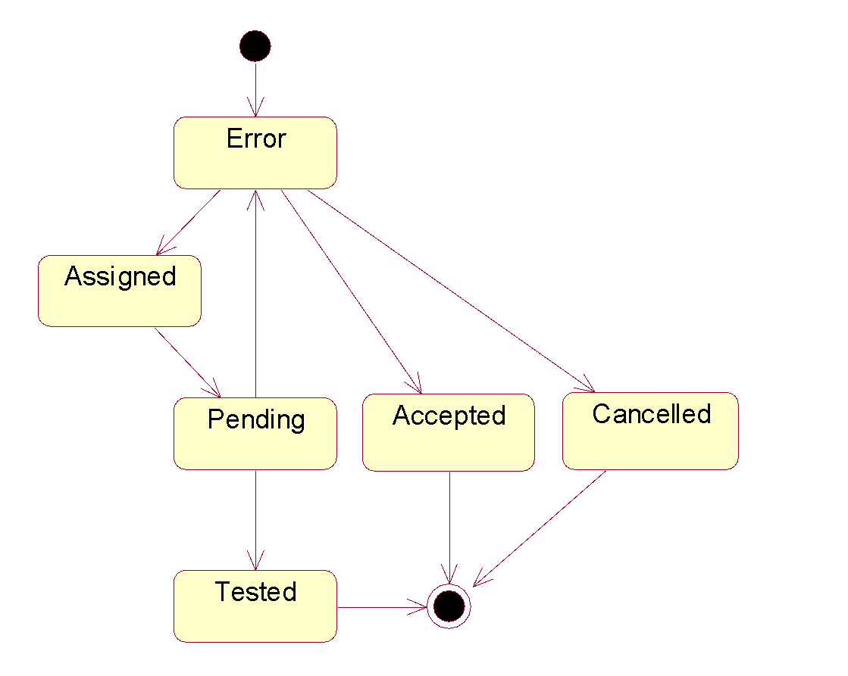

**Figure 2.1.1: Defect life cycle**

**Description:**

1. A problem is logged into DMS -> status = Error
2. PM/PTL verify the logged problem
   1. It’s really a bug - assign to Developer fix -> change status = Assigned
   2. It’s NOT a bug -> change status = Cancelled
   3. It’s really a bug but no need fix at this project (by any reason) -> change status = Accepted
3. Developer fix bug -> change status = Pending
4. Tester verify bug again
   1. Bug is really fixed -> change status = Tested
   2. Bug is NOT fixed yet -> change status = Error again

| Current status |  | | Next status | | | | |  |
| --- | --- | --- | --- | --- | --- | --- | --- | --- |
| Relationship | 1-Error | 2-Assigned | | 3-Pending | 4-Tested | 5-Accepted | 6-Canceled | End |
| 1-Error |  | x | |  |  | x | x |  |
| 2-Assigned |  |  | | x |  |  |  |  |
| 3-Pending | x |  | |  | x |  |  |  |
| 4-Tested |  |  | |  |  |  |  | x |
| 5-Accepted |  |  | |  |  |  |  | x |
| 6-Cancelled |  |  | |  |  |  |  | x |

1. **OTHERS REQUIREMENT**
   1. **Header of page**
      1. **Overview**

Always display Header in all screens.

* + 1. **External interfaces**
       1. **Prototype:**

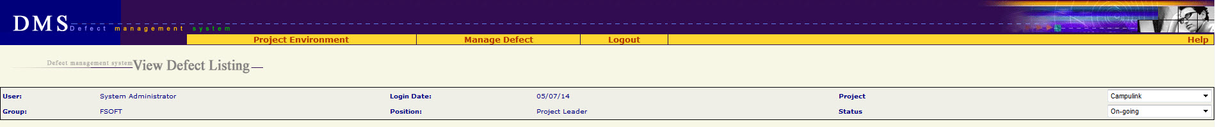

* + - 1. **Screen description**

| **No** | **Field name** | **Control type** | **Data type** | **Description** |
| --- | --- | --- | --- | --- |
| 1 | Project Environment | Menu | Text |  |
| 2 | Assign User | Menu | Text | Submenu of “Project Environment” menu |
| 3 | Work Product | Menu | Text | Submenu of “Project Environment” menu |
| 4 | Module | Menu | Text | Submenu of “Project Environment” menu |
| 5 | Setup Environment | Menu | Text | Submenu of “Project Environment” menu |
| 6 | Mange Defect | Menu | Text |  |
| 7 | Manage Views | Menu | Text | Submenu of “Mange Defect” menu  Go to Home page |
| 8 | New Defect | Menu | Text | Submenu of “Mange Defect” menu  Go to Add New defect screen |
| 9 | Manage Planned Defect | Menu | Text | Submenu of “Mange Defect” menu |
| 10 | Project Summary | Menu | Text | Submenu of “Mange Defect” menu |
| 11 | Import Defect | Menu | Text | Submenu of “Mange Defect” menu |
| 12 | Logout | Menu | Text | Logout system, go to Login screen |
| 13 | Help | Menu | Text | Download & open file “Guideline_Defect Management System.doc” |
| 14 | Defect management system <screen name> | Label | Text |  |
| 15 | User | Label | Text | Value = type of login user |
| 16 | Group | Label | Text | Value = group of login user |
| 17 | Login Date | Label | Text | Value = today  Date format = mm/dd/yy |
| 18 | Position | Label | Text | Role of login user |
| 19 | Project | Combo box | Text | List of project which login user is assigned  Default value = the current project |
| 20 | Status | Combo box | Text | Status of project  Default value = the current status of project |

* 1. **Data Format**
     1. **Date/Time Format**

Default date format is mm/dd/yy For example: 05/29/14

Default time format is hh:mm:ss For example: 07:23:55

* + 1. **Number Format**

No zero at prefix

File size: xx.x KB For example: 192.3 KB

Available size: xx KB For example: 456 KB

Order number has no comma separated For example: 12345

Decimal places of % is 1 For example: 25.7%

* 1. **Order of reference data**
     1. **QC Activity**

10-Unit test (Type of Activity = Test)

11-Integration test (Type of Activity = Test)

12-System test (Type of Activity = Test)

13-Acceptance test (Type of Activity = Test)

14-Regression test (Type of Activity = Test)

15-After release test (Type of Activity = Test)

16-Other test (Type of Activity = Test)

17-Prototype test (Type of Activity = Test)

20-Document review (Type of Activity = Review)

21-Code review (Type of Activity = Review)

22-After release review (Type of Activity = Review)

23-Prototype review (Type of Activity = Review)

24-Other review (Type of Activity = Review)

30-Quality gate inspection (Type of Activity = Inspection)

31-Final inspection (Type of Activity = Inspection)

32Other inspection (Type of Activity = Inspection)

33-UT inspection (Type of Activity = Inspection)

40-Baseline audit (Type of Activity = Audit)

41-Other audit (Type of Activity = Audit)

* + 1. **Defect Origin**

Administration

Coding

Collaborator Management

Configuration Management

Contract Management

Correction

Customer Support

Deployment

Design

Document Control

Facility Management

IS Management

Internal Audit

Management Review

Other

Prevention

Process Improvement

Project Management

Quality Control

Quality Planning

Recruitment

Requirement

Retirement

Staff Management

Student Management

Subcontract Management

Technology management

Test

Training

* + 1. **Type of Activity**

1. Review

2. Test

3. Inspection

4. Audit

* + 1. **Stage Injected / Stage Detected**

<blank>

1-Initiation

2-Definition

3-Solution

4-Construction

5-Transition

6-Termination

Definition&Solution

Initiation&Definition

Release 1

Release 2

Release 3

Release 4

Release 5

Release 6

Solution&Construction

* + 1. **Priority**

<blank>

1-Immediately

2-High

3-Normal

4-Low

* + 1. **Work product**

Acceptance note  
Architectural design  
Audit program  
Audit record  
Audit report  
Baseline Audit  
Baseline report  
CM Plan  
Change request  
Coding convention  
Configuration Status Report  
Contract  
Customer Satisfaction Survey  
DAR Report  
DP Plan  
DP report  
Database  
Deployment package  
Design prototype  
Detailed design  
Final inspection  
Handover note  
IP  
IP database  
Installation manual  
Integration test case  
Integration test plan  
Integration test report  
Meeting minutes  
Others  
PCB  
PQA report  
Pilot plan  
Pilot record  
Pilot report  
Plan  
Process assets  
Process database  
Program  
Project assests  
Project database  
Project plan  
Project record  
Project report  
Proposal  
Prototype  
QA report  
QA review record  
QDS  
Quality control report  
Quality gate record  
Record  
Release note  
Report  
Requirement prototype  
Resource and environment  
Review TestCase  
Review record  
SQA report  
SRS  
Service Level Agreement  
Software module  
Software package  
Support Diary  
System description  
System test case  
System test plan  
System test report  
Test data  
Test plan  
Test script  
Traceability matrix  
Training course  
Training material  
Training records  
URD  
Unit test case  
Unit test plan  
Unit test report  
Use case  
User manual and WO

* + 1. **Severity**

1-Fatal

2-Serious

3-Medium

4-Cosmetic

* + 1. **Module / Module Code**

<Blank>

<List of module which got from another Project management tool>

* + 1. **Type**

01-Functionality (Other)  
011-Req misunderstanding  
012-Feature missing  
013-Coding logic  
014-Business logic  
02-User Interface  
03-Performance  
04-Design issue  
05-Coding standard  
06-Document  
07-Data & Database integrity  
08-Security & Access Control  
09-Portability  
10-Other  
11-Tools

* + 1. **Defect owner, Assigned To,**

All member of project are ordered by alphabet :

<Blank>

<Member 1>

…..

<Member n>

* + 1. **Status**

1-Error

2-Assigned

3-Pending

4-Tested

5-Accepted

6-Canceled

* 1. **Timeout requirement**

All screens have timeout of 1 hour

After timeout, user has to re-login, and does his/her previous step by step once again.

* 1. **Message list**

| **Message Code** | **English Content** |
| --- | --- |
| ERR_FORMAT_DATE_CREATED | Created Date is invalid |
| ERR_FORMAT_DATE_CREATED_FROM | "From Created Date" is invalid. |
| ERR_FORMAT_DATE_CREATED_TO | "To Created Date" is invalid. |
| ERR_FORMAT_DATE_FIXED | "Fixed Date" is invalid. |
| ERR_FORMAT_DATE_FIXED_FROM | "From Fixed Date" is invalid. |
| ERR_FORMAT_DATE_FIXED_TO | "To Fixed Date" is invalid. |
| ERR_FORMAT_DATE_DUE | "Deadline" is invalid. |
| ERR_REQUIRED_SEVERITY | "Severity" is required |
| ERR_REQUIRED_TYPE | "Type" is required |
| ERR_REQUIRED_TYPE_ACTIVITY | "Type of Activity" is required |
| ERR_REQUIRED_QC_ACTIVITY | "QC Activity" is required |
| ERR_REQUIRED_ORIGIN | "Defect Origin" is required |
| ERR_REQUIRED_WP | "Work Product" is required |
| ERR_REQUIRED_CREATED_DATE | "Created Date" is required |
| ERR_REQUIRED_TITLE | "Title" is required |
| ERR_REQUIRED_DESCRIPTION | "Description" is required |
| ERR_REQUIRED_STATUS | Ignore this message because status cannot be blank |
| ERR_REQUIRED_DEFECT_ORIGIN | Ignore this message because defect origin cannot be blank |
| ERR_DEFECT_ID_INVALID | Defect ID must be positive number |
| ERR_REQUIRED_ATTACHMENT_FILE | Please select at least one file to attach |
| ERR_FILE_OVER_AVAILABLE_SIZE | Attachment size exceeds available space |
| ERR_FILE_OVER_MAX_FILE_SIZE | Attach size exceeded |
| ERR_EXISTED_FILE_NAME | The attached file already exists! |
| ERR_CONSTRAINT_DATE_CREATED_FROMTO | "From Created Date" cannot be later than "To Created Date" |
| ERR_CONSTRAINT_DATE_FIXED_FROMTO | "From Fixed Date" cannot be later than "To Fixed Date" |
| ERR_CONSTRAINT_DATE_CREATED_TODAY | "Created Date" cannot be later than today |
| ERR_CONSTRAINT_DATE_CREATED_DUE | "Created Date" cannot be later than "Deadline" |
| ERR_CONSTRAINT_DATE_CREATED_FIXED | "Created Date" cannot be later than fixed date |
| ERR_CONSTRAINT_DATE_FIXED_TODAY | "Fixed Date" cannot be later than today |
| ALT_PAGE_INVALID | Your number is out of range |
| ALT_REQUIRED_DEFECT | Defect(s) is required |
| ALT_REQUIRED_EXPORT_LIST | Some items must be selected |