**ASSIGNMENT 01 FRONT SHEET**

|  |  |  |  |
| --- | --- | --- | --- |
| **Qualification** | **BTEC Level 5 HND Diploma in Computing** | | |
| **Unit number and title** | Unit 09: Software Development Life Cycle | | |
| **Submission date** | 7/6/2022 | **Date Received 1st submission** |  |
| **Re-submission Date** |  | **Date Received 2nd submission** |  |
| **Student Name** | Nguyen Tran Nam Khanh | **Student ID** | GCH210731 |
| **Class** | GCH1003 | **Assessor name** | Michael Omar |
| **Student declaration**  I certify that the assignment submission is entirely my own work and I fully understand the consequences of plagiarism. I understand that making a false declaration is a form of malpractice. | | | |
|  |  | **Student’s signature** |  |

**Grading grid**

|  |  |  |  |  |  |  |  |
| --- | --- | --- | --- | --- | --- | --- | --- |
| P1 | P2 | P3 | P4 | M1 | M2 | D1 | D2 |
|  |  |  |  |  |  |  |  |

|  |  |  |
| --- | --- | --- |
| **❒ Summative Feedback: ❒ Resubmission Feedback:** | | |
| **Grade:** | **Assessor Signature:** | **Date:** |
| **Internal Verifier’s Comments:** | | |
| **Signature & Date:** | | |

# Table of Contents

Table of Contents 1

Introduction 1

P1. Describe two iterative and two sequential software lifecycle models. 2

1. SDLC models 2

2. Prototyping model 3

3. Two iterative and two sequential SDLC models 4

A. Two Sequential software life circle model 4

a. Waterfall 4

b. V-Shaped 5

B. Two Iterative software life circle model 7

a. Scrum 7

b. Spiral 8

A. Discuss the suitability of the model 9

P2. Explain how risk is managed in the Spiral lifecycle model. 10

1. How risk is managed in the spiral lifecycle. 10

A. Risk Management process with clear illustrations and explanations. 10

B. Identify some risks and discuss an approach to manage them 12

P3. Explain the purpose of a feasibility report. 13

1. Discuss the purpose of conducting a feasibility study for the Tune Source project. 13

2. Discuss how the three feasibility criteria 14

A. Technical feasibility 14

B. Economic feasibility 14

C. Organizational feasibility 15

3. The feasibility of the project 15

4. Discuss alternative technical solutions using the alternative matrix 16

5. Explain the components of a feasibility report. 17

P4. Describe how technical solutions can be compared 17

Conclusion 18

References 1

1. Prototype model (Duyen, 2019) 3

2. waterfall model (existek, 2017) 5

3. V-shaped (existek, 2017) 6

4. Agile (Ta, 2020) 7

5. Spiral (existek, 2017) 8

# Introduction

* To be able to understand the requirements of the projects for Tuna Source, we first need to look at the wide view of the context as well as the task given.
* Tuna Source is the brainchild of three different entrepreneurs from California. Their business is to find and offer rare audio recording includes jazz, rock, country, folk. Tuna Source were quickly found themselves in the household name for getting rare audio recording in the market. Their annual sales last year were $40 million and yearly growth at 3% - 5% per year. Additionally, they currently have a website for customers to search and buy their CD.
* The project is requested so that the company can expend their income in digital format through kiosks in their store or over the Internet. As a result, the requirements of this project need to consist of these functions as following:
  + Search for music in our digital music archive.
  + Listen to music samples.
  + Purchase individual downloads at a fixed fee per download.
  + Establish a customer subscription account permitting unlimited downloads for a monthly fee.
  + Purchase music download gift cards
* As for the business value, new customers can find this method as a result of enabling purchasing digital tracks. In addition, this system is requested by loyal customers so this is a good way to keep them satisfied and be close to the brand for years to come. It is crucial for the system to meet to market as soon as possible.
* For the tasks, this section will be derived directly from assignment brief:

**“Task 1 – SDLC model**

As a project manager of a company named ABC. My company has been hired by Tune Source to carry out a project that helps them develop a software for the requirements specified in the system request. As the first step, I need to:

1. Describe the following SDLC models: waterfall, v-model, prototyping, scrum and spiral. Choose one that you think suitable for the project and explain why.

Discuss the suitability of each of the SDLC models for the project. For each model, specify whether it is most, moderately or least suitable.

Discuss the merits of applying the waterfall model to a large software development project.

1. Identify some risks and discuss an approach to manage them.

**Task 2 – Feasibility study**

1. Discuss the purpose of conducting a feasibility study for the project.
2. Discuss how the three feasibility criteria (technical, economic, organizational) are applied to the project. Discuss whether the project is feasible.

Discuss alternative technical solutions using the alternative matrix.

1. Explain the components of a feasibility report.

Discussion economic feasibility study on Tune Source project (NPV, Cashflow, Break-Even Point)

Discussion organizational feasibility study on Tune Source project

1. Assess the impact of each feasibility criterion on a software investigation.

Discussion and represent as feasibility alternatives matrix for Tune Source project.”

# P1. Describe two iterative and two sequential software lifecycle models.

## SDLC models

* It is known that SDLC outlines many tasks that are required to ultimately become a software application. The method vastly increases the efficiency as well as avoid any wastage of resource and time.
* The following will explain the general model with many 7 phases of the process:
  + Planning: in this phase, the team leaders will analyze and define the project. Some aspects will come to consideration are the costs, labors, making project teams and timetable and schedule for each goal. Another aspect is feedback from the stakeholders as well as experts, developers, potential customer, etc. In short, this phase is important for setting the scope of the program.
  + Define requirements: this is a simple phase but also crucial when testing the projects which is the latter phase. Simply put, the requirements set must be appropriate with the purpose of the program.
  + Design and Prototyping: According to Goran Jevtic (2019), the design phase models the way a software application will work. Some aspects of the design include:
    - Architecture: Specifies programming language, industry practices, overall design, and use of any templates or boilerplate
    - User Interface: Defines the ways customers interact with the software, and how the software responds to input
    - Platforms: Defines the platforms on which the software will run, such as Apple, Android, Windows version, Linux, or even gaming consoles
    - Programming: Not just the programming language, but including methods of solving problems and performing tasks in the application
    - Communications: Defines the methods that the application can communicate with other assets, such as a central server or other instances of the application
    - Security: Defines the measures taken to secure the application, and may include SSL traffic encryption, password protection, and secure storage of user credentials.
  + Software Development: This is the phase where the program is written. The developing phase includes many departments like IDE, database design, debugging, FAQ, troubleshooting guide, etc.
  + Testing: the program can not be introduced without any testing. There are many tests that can be used to get the desired result like testing in a specific environment or general testing of the functions in many cases.
  + Deployment: the program is made available for the users. This phase can be deployed for a specific client requested or made public by download links or mobile store.
  + Operations and Maintenance: when users find errors that were not discovered in the testing phase, those need to be fixed as soon as possible. In addition, when fixing these bugs, other errors might occur as well as new features need to be added.

## Prototyping model

* The prototype model is a method of developing a system in which a prototype is built. The prototype must go through many stages of developing and testing to meet the requirements and come out as a working system.
* According to Sarah Lewis (2019), this model works best in scenarios where not all of the project requirements are known in detail ahead of time. She also stated that it is an iterative, trial-and-error process that takes place between the developers and the users.
* The model also utilized the feedback of the customer by giving small part of the product and fix or rework the prototype. The process will be repeated until the final product that meet all the requirements is developed.
* The diagram will illustrate the prototype model:

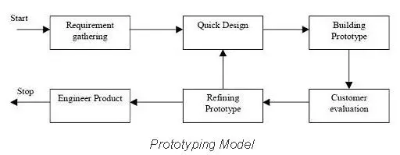

. Prototype model (Duyen, 2019)

* There are some advantages when using this model:
  + Customers can experience the product early which increase the satisfaction.
  + Any errors or malfunction can be detected easily.
  + Better understanding for users.
  + The prototype can be reused.
  + Better vision of customer’s need.
* Despite that there are some downsides when it comes to prototype model:
  + Cost more time and money.
  + Rapid feedbacks from customers can be overwhelmed at times and some of them can be conflicted. In addition, keeping pace with all the demands will make the work more challenging
  + After the first prototype, the customers can become uninterested or even demand quicker product release, putting the stress on the team.
* In order to fully utilize this model, the main point to look out for is whether the requirements are clear, unstable or not. The prototype model is made to be able to survive the rapid changes in the requirements whether that from the clients or the environment of technology. In addition, the model is also proven to produce high quality products in the fields of algorithms, UI/UX, etc. The prototype model is based on the client’s feedback as the samples will be sent to them, the technical feasibility is cleared for this particular project.

## Two iterative and two sequential SDLC models

* In the process of developing a program, different methods should be considered in the making with each is used in different situations, requirements.
* There are 2 methods that are popular:
  + Iterative: this model is known as agile in which the documentation is limited in order to push the release to be early. This requires flexibility as it is common for the requirements to be changed. Some of the iterative models are:
    - Scrum
    - Spiral
    - eXtreme Programming
  + Sequential: this method provides a big resource of information for the sustainability of the project. This model can still be active upon release due to factors like maintenance, update features, etc. Some of the sequential models are:
    - Waterfall
    - V-model
    - Incremental

### Two Sequential software life circle model

#### Waterfall

* The waterfall is an SDLC model that works like it sounds which is the procession of a flow. As such this model is the most effective when dealing with complex projects.
* There are many phases of waterfall model:
  + Requirement analysis
  + Designing the system
  + Development
  + Testing
  + Deployment
  + Maintenance

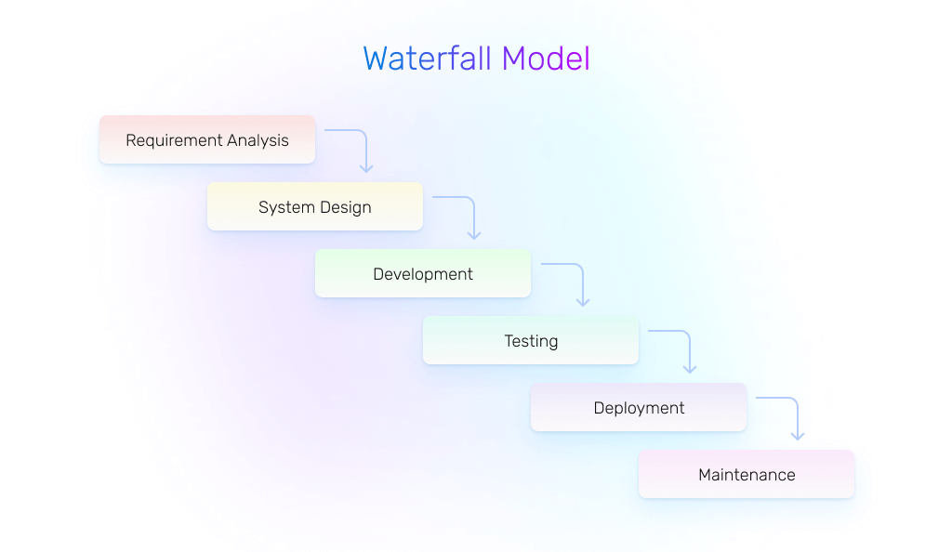

. waterfall model (existek, 2017)

* There are some advantages and disadvantages when it comes to this particular SDLC model:
  + Advantages:
    - Simple to understand (prioritize tasks, main points, etc)
    - A structure is available for newer staff to follow
    - Different goals at different times that are easy to understand
    - Development goes through stages
    - Good for monitoring project for manager since tracking and planning are eaiser
  + Disadvantages:
    - High risks
    - Progression is only continued when the previous step is done
    - Not good for long-term project
    - Not flexible especially when the requirements change
    - There are no customers review, feedback during the developing stage.
  + In order to maximize the potential of the waterfall model, these requirements should be met beforehand:
    - Requirements are clear and known beforehand
    - A consistent plan for the development.
    - Good understanding and familiarity of the technology.
    - When porting an existing product into a new platform.

#### V-Shaped

* The V-shaped model is called like this because of its appearance. Moreover, it also prioritizes Validation and Verification.
* According to Existek (2017), the goal of verification is to determine whether the software is consistent with the initial technical requirements, validation, in turn, should confirm whether the product corresponds to the business needs, whether it serves its intended purpose, whether it acts as planned.
* V-shaped model is an expansion of the classic waterfall model since it relies on the test stage to be able to develop.
* V-model will have double the steps that needs to be fulfilled, they are:
  + Verification:
    - Business requirements
    - System requirements
    - Software design
    - Module design
    - Coding
  + Validation:
    - Acceptance testing
    - System testing
    - Component testing
    - Unit Testing
    - Coding

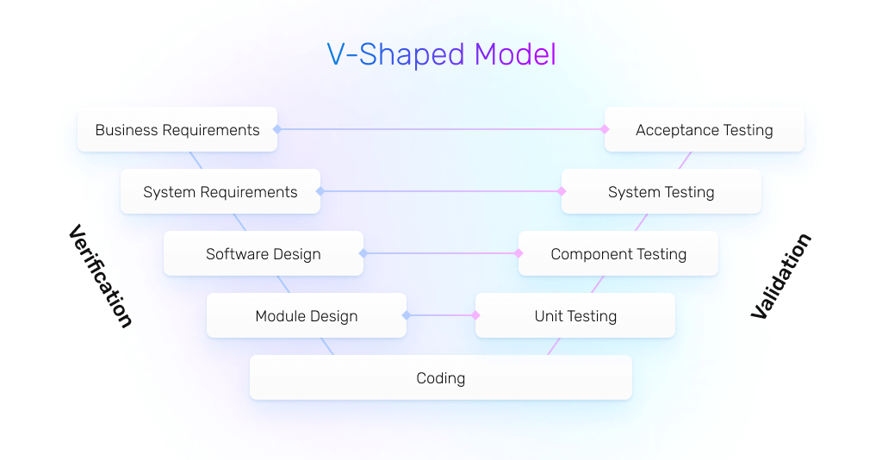

. V-shaped (existek, 2017)

* There are some advantages and disadvantages when it comes to this particular SDLC model:
  + Advantages:
    - Easy to control for its strict results since in order to getting to the next stage, testing must be passed. This will make sure when moving to the latter step, the quality meet the requirements.
    - Verification and testing take place early in the process since it is based on validation and verification. This ensures the quality when finished
    - Easy to control for the manager by the simplicity in the tracking.
  + Disadvantages:
    - This method is inconsistent when the requirements are not static. Changing the requirements mean the whole process will be repeated.
    - This does not contain risk analysis activities.

### Two Iterative software life circle model

#### Scrum

* Scrum is a model that emphasizes teamwork, iterative progress of the main goals.
* Scrum or agile model prioritize the customer satisfaction and make changes to the requirements of the clients. As a result, the products will be divided into different parts that different teams will work on. These team will work at the same time to produce the final products. There are 5 areas that need to be done:
  + Planning
  + Requirements Analysis
  + Design
  + Coding
  + Unit Testing and Acceptance Testing
* Since the work is separated into different sections, every feature of the program will be fulfilled by the teams.
* This model is mainly for customers or stakeholders. The presentation will be a working product. At this point, the clients will make changes to the requirements which can be either more additional features or changes in the system.

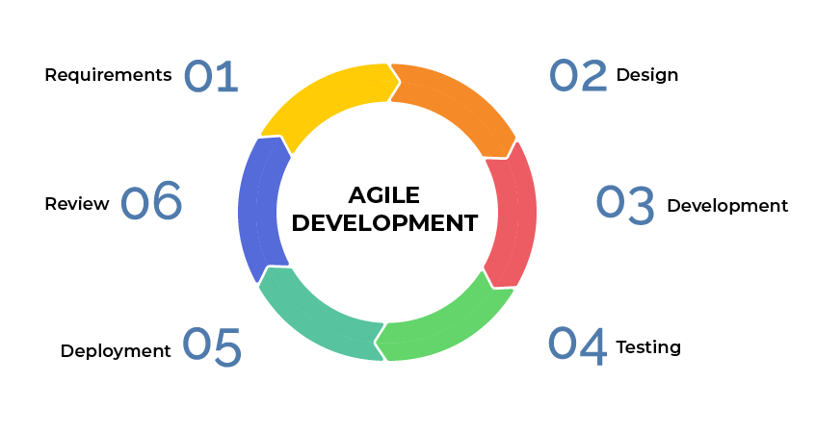

. Agile (Ta, 2020)

* Benefits of scrum:
  + Quality products: the process build around feedback and improvement.
  + Teamwork: create cohesive team of developer that communicate well, solve problem and finish the deadlines together.
  + Flexibility: the team have to adapt with new tools as well as new requirements. In addition, unfortunate turn of events might occur and the team needs to find a solution as soon as possible to ensure the quality and the pace of the work.
  + Fast pace for the first release.
* Downsides of the model:
  + High risks due to the model does not rely on planning. As a result, maintenance is needed after the release.
  + The team need to be highly regarded as a professional
  + The project is highly client-orientated
  + New requirements may be conflicted with existing design.
* Use cases for the Agile model (existek, 2017):
  + The users’ needs change dynamically
  + Less price for the changes implemented because of the numerous iterations
  + It requires only initial planning to start the project

#### Spiral

* Spiral is a combination of waterfall and iterative model with an addition of risk analysis. The model is called spiral because of its shape like a spiral curve. There is no fixed phase and there are a number of loops to be applied.
* The main point of the spiral model is to find the right moment to move to the next step.
* Sometimes, the shift will be active as the plan even if the previous step is not done.

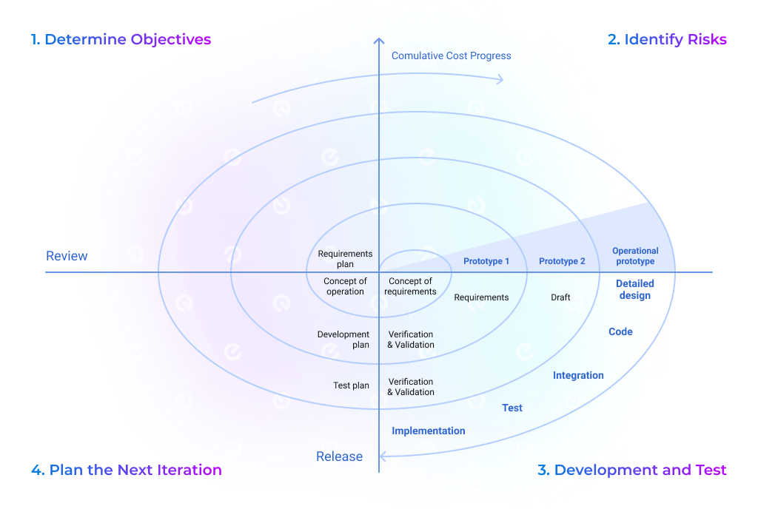

. Spiral (existek, 2017)

* Some of the advantages of spiral as well as the disadvantages:
  + Advantages:
    - The risk concentration can be addressed since the phase can be finished early.
    - The development is well documented with scalable to changes
    - This means additional features and changes can be made in last stages.
    - The users can give feedback as soon as the prototype is done.
  + Disadvantages:
    - High cost
    - Involve high-level professionals to handle the risk management.
    - Not suitable for small projects
    - Requirement high amount of document.
* Use cases for the Spiral model (existek, 2017):
  + The customer isn’t sure about the requirements
  + Significant edits are expected during the software development life cycle
  + Risk management is highly essential for the project

# Discuss the suitability of each of the SDLC models for the project.

* With the given model and their explanation, the discussion of the suitability of each of the SDLC models for the Tuna Source project will be display by the following table:

|  |  |  |  |
| --- | --- | --- | --- |
| Alternative models | Least suitable | Moderate | Most suitable |
| V - Model | X |  |  |
| Waterfall | X |  |  |
| Spiral |  | X |  |
| Scrum |  |  | X |

### Discuss the suitability of the model

* The most effective model to amply for the Tuna Source project is Scrum (Agile) since the existence of rapid changes to meet the requirements of the customers. Additionally, the loyal customer asked for this particular system of buying niche market of rare audio online that the system should be available as soon as possible. The scenario mentioned above fits the Scrum model the best with its changing requirements and fast deadline.

# P2. Explain how risk is managed in the Spiral lifecycle model.

## How risk is managed in the spiral lifecycle.

* It is crucial for the project to identify the risks in the lifecycle before moving to the stage of managing them. Risk can be understanded is the unfortunate events that can occur during or after the developing phase.
* There are low to high risks depend on the consequence of the result. This can be low level that can be resolved quickly or sometimes ignore due to its insignificance or high-level risks that can have negative effects on the project that if the developers are unable to find the solution in time can sabotage the whole project.
* Some examples of risks are miscalculation in the budget, limited resource, deadlines too early, unclear timetable, etc.
* The risk management is important for the project to operate in a friendly cost and after the release to determine whether it is profit or not.
* Despite the planning of risks beforehand, there will be unexpected risks that occur. With the spiral model, the risks control is proven to be effective in such situation.
* According to TechTarget Contributor (2019), the spiral model enables gradual releases and refinement of a product through each phase of the spiral as well as the ability to build prototypes at each phase, the most important feature of the model is its ability to manage unknown risks after the project has commenced; creating a prototype makes this feasible.
* The most important aspect is to be ready when the risks are starting to show sign by doing what has been planned or improvise and adapt based on the current situation. The goal is to minimize the risks or even resolve it as soon as possible so the project can progress.

### Risk Management process with clear illustrations and explanations.

* The process of risk management is to recognize the risks as well as the opportunities that are presented and define the suitable solution and respond. This is to maintain the stability for the project and foresee the possibility of the final result.
* Risk management also have its own set of steps that need to be followed for the best result. These steps are:
  + Risk Identification: it is important to know what events might happen that will affect the project in an either positive or negative way. Aspects like legal problem, market risk and environment should all be considered in the development phase. Having options to deal with these can be crucial for the preparation. In addition, all the people involve should identify R&O or Risks and Opportunities with the risk manager have to make sure to plan the response. There are a feel tools to help identify R&O (Marie BELGODERE, 2021):
    - Analysis of existing documentation
    - Interviews with experts
    - Conducting brainstorming meetings
    - Using the approaches of standard methodologies – such as Failure Modes, Effects and Criticality Analysis (FMECA), cause trees, etc.
    - Considering the lessons learned from R&Os encountered in previous projects
    - Using pre-established checklists or questionnaires covering the different areas of the project (Risk Breakdown Structure or RBS).
  + Risk Analyze: After identify the risks, it is important to understand the risks. These include the elements that related to the risks, find the right solution and the level of the damage that it might cause. In addition, prioritize should be consider for more damaging ones rather than insignificant risks.
  + Risk Assessment: After the analyzing, the risks need to compare to each other to determine which one is more important and need the initial attention first. There are 2 types of risk assessment which is qualitative and quantitative.
    - Qualitative Assessment: the risk manager will rank the risks based on how severe the impact and how likely the event might occur.
    - Quantitative Assessment: the risk manager and the risk owner will carry out a financial evaluation of the risk or an opportunity’s benefits to determine the ranking for each risk.
  + Risk Treatment: the next step is to treat the risks and in order to do so there is a treatment plan needed. The main goal is the reduce the likeliness how the risk occurrence and lower the damage. The role of the risk owner is to monitor the progress of the treatment plan. There are 7 steps for response strategies (Marie BELGODERE, 2021):
    - Accept: Do not initiate any action but continue to monitor.
    - Mitigate/Enhance: Reduce (for a risk) or increase (for an opportunity) the probability of occurrence and/or the severity of impact.
    - Transfer/Share: Transfer responsibility of a risk to a third party who would bear the consequences of the problem (share the benefits of a realized opportunity).
    - Avoid/Exploit: Entirely eliminate uncertainty / take advantage of the opportunity.
  + Risk Monitoring and Reporting: It is important to monitor and report the treatment plan. By developing a monitoring and reporting structure it will ensure there are appropriate forums for escalation and that appropriate risk responses are being actioned. (Marie BELGODERE, 2021).

### Identify some risks and discuss an approach to manage them

* Risk management matrix table:

|  |  |  |  |  |  |
| --- | --- | --- | --- | --- | --- |
|  | Insignificant | Minor | Moderate | Major | Catastrophic |
| Almost certain |  |  |  |  |  |
| Likely |  |  | Productivity |  | Hardware malfunction |
| Possible |  |  | Stakeholders |  |  |
| Unlikely |  |  |  | Cyber attack |  |
| Rare |  | Deadlines |  |  |  |

* With the all risks in mind, there will be a table for managing risks. The following table is a risk management table:

|  |  |  |  |  |  |
| --- | --- | --- | --- | --- | --- |
| Risk | Description | Probability | Severity | Overall + Priority | Managing |
| Deadlines | The time that the project needs to be finished set by the client. The chance of not deliver the product in time is likely and will cost delay. | 10% | 20% | 15%  Low | Having a good plan and timetable will keep this problem in check. In addition, monitoring the progress in important in making adjustment, |
| Stakeholders | Low communication and understanding between stakeholders and developers causes the product to be unwanted | 50% | 60% | 55%  Medium | More meeting to have more communication, better plan and expectation from both sides. |
| Productivity | The loss in productivity is sometimes we can not avoid. This can be from many aspects whether it is the workplace or personal problem. | 60% | 60% | 60%  Medium | A good plan and timetable for the team to avoid burning out and having stress. Creating good working environment is always a good way to boost productivity. That includes good communication, good relationship between members |
| Cyber attack | Hackers steal information in the database whether it is the user information or the music library. | 40% | 80% | 60%  Medium-High | A good cyber security is necessary to any online website. This involve having good hardware as well as expert in the field. This matter is serious and worth the investment especially when the company got bigger. |
| Hardware malfunction | The hardware can overheat or out of order. This can cause the loss in the database. | 50% | 85% | 70%  High | Have good devices is important since having a big website will need a big machine to run. In addition, having a good staff that can control tough situation and familiar with these events is crucial |

# P3. Explain the purpose of a feasibility report.

## Discuss the purpose of conducting a feasibility study for the Tune Source project.

* A feasibility study is an analysis of the determine the likelihood of the project’s success based. This is based on 4 different aspects of the development:
  + Economic feasibility
  + Technical feasibility
  + Legal feasibility
  + Scheduling feasibility
* In addition, when making a feasibility study, possible alternatives can be found. This is need to be discussed to agree on the best possible solution to be applied to the project.
* In short, a feasibility study should provide enough data and information for the manager to make a decision on:
  + The Assessment of the practicality of a proposed plan or project and the cost and return on the investment.
  + Having several alternative solutions and find the most suitable option.
* Given the Tuna Source project, the feasibility study will help the manager decide whether the project is practical or not based on the system request and the cost and profit that this investment will have. An example of this might be the security of the website where the hackers can gain access to the library and stream the music for free or users might use tool to illegally download the music in the website itself. A potential problem like this needs to be discussed when it comes to making a feasibility of the Tune Source project.

## Discuss how the three feasibility criteria

### Technical feasibility

* Technical feasibility is the process of deciding whether it is technically possible to make a product or service with current status of development. Things to come to consider when analyze the study are the tools, technology, labor and logistics. For example, with the given requirements, will the current technology be able to come to practice and whether the team can have it available or utilize such tool. Sometimes, technology can be so advance that the current staff is unable to make use and cost for expert will need to be consider.
* In short, technical feasibility study will help answer some of these questions (Team, 2021):
  + Is it possible to develop the product with the available technology in the company?
  + Is the organization equipped with the necessary technology for project completion?
  + Are there technically strong employees who can deliver the product on time and within budget using the available technology?
  + Is there scope in the company's budget to add more technical resources?
  + Is the available technology the right choice to help the product team save time and complete development within budget?
  + Does the client require specific technology, or is the client open to developing the product, irrespective of the technology?
* Regarding the Tuna Source project, it is considered to be feasible in terms of technology for this new technology of online marketing of rare audio distribution which is requested by loyal customers. This is not a new technology since music streaming online has been around for decades and many companies has the same model when building their websites. With the current developers in the team, this project might not need extra expert involve unless the manager wants to make sure of the quality.

### Economic feasibility

* An economic feasibility is a calculation of whether the project is worth the investment or not. With the given requirements and solutions on previous steps, the team should be able to assess the cost as well as the benefits for each solution. The goal of this is to find out:
  + Which alternatives make the best ROI (Return on Investment)?
  + Will the goods be able to compensate the drawbacks?
  + How long until the benefits happen?
* The formula for ROI usually be the following

ROI = Total Profit/Total Cost

= (Lifetime profit – lifetime cost) / lifetime cost

* With the Tuna Source project, the first thing to consider is the company has a profound background of being a long-time household in terms of having and distributing rare audio recording. This project is an expansion of their already successful business to a digital format of selling which is requested by loyal customers. This project will have a high chance of being sustainable for long-term since having an online market is a great advantage in today for its many benefits. Customer will have more options to purchase their products will the online website grants the ability to listen first as well as shipping for customers who do not have time to visit the shop. In addition, the ability to buy tracks instead of the whole collection will draw more customers into buying since not every track is in their cup of tea. Additionally, they have also estimated the value of the company sell, which is the following:
  + $757,500 in sales from individual music downloads.
  + $950,000 in sales from customer subscriptions.
  + $205,000 in additional in-store or website CD sales.
  + $153,000 in sales from music download gift cards.
  + In total of $2,065,000 in sales.
* In spite of the specific profit on the brief, little to no information on how much the desirable website would cost as well as how much the Tuna Source project willing to spend. There are many contents to be considered in making a website like creation cost, design cost, building cost, setup cost, training cost, etc. According to a Web Design Calculator by Webfx (2022), the costs of running a website per month are from $390,000 to $831,000
* With that, we have the following ROI calculation:

(2,065,000 - 390,000)/390,000 * 100% = 429%

(2,065,000 - 831,000)/831,000 * 100%=148%

* With the calculation, we can see the ROI of the project can be from 148% to 429%.

### Organizational feasibility

* Organizational feasibility study will reveal the sufficient management expertise of the company project.
* Organizational feasibility can be referred as the feeling of the client about the system, the final product that has been developed. This can be the problem that you have identified and your solutions to such. In addition, they will look for alternatives that you have explored and your decision to that.
* So, at the end, the team must ask the question not just whether the system can work or rather will it work. This implies that the practicality of the system when the risks are implied. Will the system be able to handle in such condition or will it just function well under normal circumstances.

## The feasibility of the project

* With all the requirements met, the Tuna Source project is considered to be feasible.

## Discuss alternative technical solutions using the alternative matrix

* The following table will display the relevance of the three technical solutions or three different programming languages. The test will reveal their performance based on several aspects. The final result will prove why JavaScript is the option that the project should follow:

|  |  |  |  |  |
| --- | --- | --- | --- | --- |
| Feasibility Criteria | Weight | Alternative 1: PHP | Alternative 2: JavaScript | Alternative 3: C# |
| Technical  Feasibility | 40% | PHP is mostly used to develop website. In this case, we are rather developing an application/system so PHP is not a good option  Score: 20 | JavaScript is well familiar with developers for a long time for its versatile uses. JavaScript also supports Windows servers and the source is commercially known.  Score: 90 | C# is a good tool for developing application with full support for Windows servers.  Score: 70 |
| Economic  Feasibility | 40% | PHP is free to use and has been utilized widely for the past few years.  The server can be reuse from the previous website  Score: 70 | Java SE costs $2.5 per month for one user. In addition, pricing of servers and cloud developing usually cost $20-$25 per month  Score: 50 | C# is developed by Microsoft and it is free to use. The server can be reuse from the previous website.  Score: 70 |
| Organizational Feasibility | 20% | Since PHP is a web-design tool, it is considered to be harder to find a reliable developer and manager with sufficient result as well as a good tester.  Score: 40 | Easier to find a senior developer as well as a well- trained manager and a reliable tester  Score: 80 | Easier to find a senior developer as well as a well- trained manager and a reliable tester  Score: 80 |
| Total of Weight | 100% | 44 | 72 | 72 |

* As the result of the table suggest, the best options are JavaScript and C# with both ties at 72 points. While both options are exellent choices, I will personally choose JavaScript because of its variety in the resource. While the disadvantage of having to pay for month subscription, the benefits are surely outweight that drawback.

## Explain the components of a feasibility report.

* Feasibility reports vary from each companies. However there are a few elements to includes:
  + Executive summary:
    - Brief description of the report
    - the main ideas of the research
  + Introduction:
    - Explains the problem and the approaches.
  + Background and context
    - Description of present situation
    - Current settings.
  + Evaluation criteria:
    - Financial costs
    - Tax impacts
    - Environmental effects
    - Public perception
    - Etc.
  + Evaluation of solutions:
    - description of each alternative
    - Feasibility report
  + Conclusion:
    - summarize your report
  + Final recommendation:
    - recommendation for the best path forward

# P4. Describe how technical solutions can be compared

|  |  |  |  |  |
| --- | --- | --- | --- | --- |
| Baseline | | Alternative Solution | | |
| Criteria | **Current Solution** | **PHP** | **Java** | **C#** |
| Feasibility | 5 | -1 | 1 | 1 |
| Cost | 4 | 1 | 1 | 1 |
| Long-term Benefit | 1 | -1 | 1 | -1 |
| Maintainability | 3 | 1 | 0 | 0 |
| Resources Availability | 2 | 1 | 1 | 1 |
| Sum of all Positives |  | 9 | 12 | 11 |
| Sum of all Negatives |  | 6 | 0 | 1 |
| Total of alternative solutions’ mark |  | 3 | 12 | 10 |

* The discussion is focusing on the technical compatibility on the technical feasibility. This provides the familiarity of the team with the application and the tools used in the project. With everything calculated, the score with show the best option amongst the solutions given.
* Regrading Tuna Source project, the task is to develop a website that help customers buy audio recordings thus increase the sale through digital. It is reasonable to argue the best option to use for this project is PHP for its best compatibility. JavaScript is optimized for making websites. In addition, JavaScript is good for long-term since the cost for it is cheap and the developer had made an effort in making maintenance and running the program fairly easier.

# Conclusion

* The Tune Source project is an ambitious potential for expending an already successful business. The company wanted to have an application where users can listen and purchase songs from a CD of their collection.
* With that in mind the project will need to have a model to follow. I have explained some of the useful model in the making a project and have come in a conclusion of using scrum model for it is the most suitable regarding the scenario of this project.
* All the projects will face some risks. There are a number of steps in managing risks and making an illustration of such is proven to be cleared for understanding the matter. Prioritizing and arranging the risks based on the urgency as well as the consequence’s mass is an effective way to minimize to damage.
* A study of feasibility is necessary for the project to be able to start in the first place. There are some feasibility studies like economic, technical and organizational and the Tuna Source project is passed all those tests.
* Finally, there are alternatives for the solutions and those will be taken to account to see which one is the best for the project. In this case, JavaScript is the one that will be operated on in the Tune Source project.

# References

Contributor, T., 2019. *spiral model.* s.l.:s.n.

Duyen, D. T., 2019. Tìm hiểu về prototype model.

existek, 2017. SDLC Models: Agile, Waterfall, V-Shaped, Iterative, Spiral.

Jevtic, G., 2019. What is SDLC? Phases of Software Development, Models, & Best Practices.

Lewis, S., 2019. Prototyping Model.

Marie BELGODERE, J. C. C. C. A. D. E. L. J. M. I. N. P. P. L. S. C. W., 2021. The Risk Management Process:.

Ta, K., 2020. Traditional vs Agile SDLC: How To Skyrocket Your Project With Agile Model.

Team, I. E., 2021. What Is Technical Feasibility? (Process and Best Practices).

Webfx, 2022. *How Much Should a Website Cost in 2022?.* s.l.:s.n.