**ASSIGNMENT 2 FRONT SHEET**

|  |  |  |  |
| --- | --- | --- | --- |
| **Qualification** | **BTEC Level 5 HND Diploma in Computing** | | |
| **Unit number and title** | **Unit 3: Professional Practice** | | |
| **Submission date** |  | **Date Received 1st submission** |  |
| **Re-submission Date** |  | **Date Received 2nd submission** |  |
| **Student Name** | Nguyen Tran Nam Khanh | **Student ID** | GCH210731 |
| **Class** | GCH1003 | **Assessor name** |  |
| **Student declaration**  I certify that the assignment submission is entirely my own work and I fully understand the consequences of plagiarism. I understand that making a false declaration is a form of malpractice. | | | |
|  |  | **Student’s signature** |  |

**Grading grid**

|  |  |  |  |  |  |  |  |
| --- | --- | --- | --- | --- | --- | --- | --- |
| P5 | P6 | P7 | P8 | M4 | M5 | D3 | D4 |
|  |  |  |  |  |  |  |  |

|  |  |  |
| --- | --- | --- |
| **❒ Summative Feedback: ❒ Resubmission Feedback:** | | |
| **Grade:** | **Assessor Signature:** | **Date:** |
| **Internal Verifier’s Comments:** | | |
| **Signature & Date:** | | |

**Table of Contents**

I. Introduction 4

II. Discuss the importance of team dynamics in the success and/or failure of group work 5

1. Definition of team dynamics 5

2. The importance of team dynamics in the success and/or failure of group work, then taken in account to our group 6

3. In my group 7

III. Work within a team to achieve a defined goal 8

1. Introduction of my group work 8

2. My role in the group work 9

IV. Define and discuss the importance of CPD and its contribution to own learning 10

V. Produce a development plan that outlines responsibilities, performance objectives and required skills, knowledge and learning for own future 12

2. Three skills need to develop 13

3. Strengths, weaknesses, development progress on them 14

5. Development plan 16

VI. Conclusion and critical evaluation 17

1. Conclusion 17

References 18

# Introduction

* Followed the brief of the assignment, there will be no case study or any particular situation that need to be solved. Instead, there are several aspects that need definition as well as analyzing. I will have to take to account to decide various style of learning to find the most fitting. This will involve a lot of self-evaluate, self-reflection and critically recognizing my own skill and knowledge.
* This assignment will discuss some issues related to learning styles, self-managed learning, the role of lifelong learning, personality reflection and time management. Understanding all of these and figure a way to take these to practice will lead to a huge advantage in not just myself but anyone life for the matter.
* Finally, the assignment will display some goal setting, personality as well as style of learning of myself in order to help in the future in the matter of controlling life and problem.

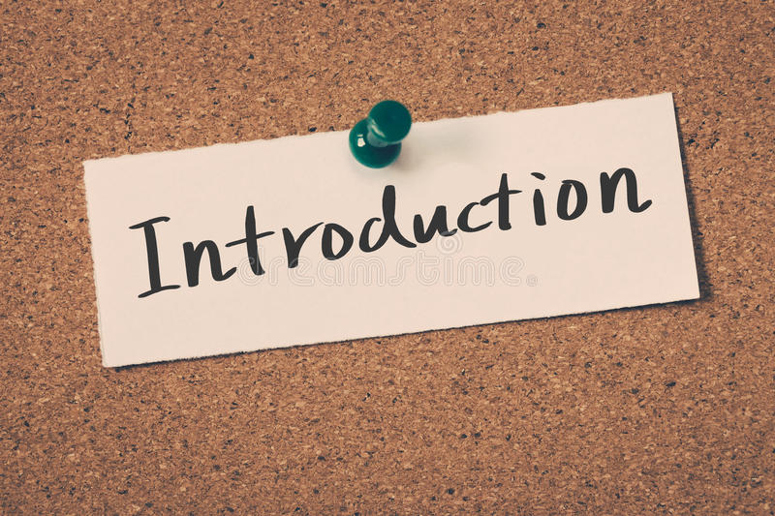

. Introduction

# Discuss the importance of team dynamics in the success and/or failure of group work

## Definition of team dynamics

* The truth is everyone has their own personality, weaknesses and strengths. So, a team or group is made up by all these different individuals. Team dynamics lie on their daily interactions, collaborative effort and having the same goal. It is no surprise that if the team has positive dynamics, the members will handle their work more smoothly, generate more innovative ideas and perform better with higher chance of succeed.
* The truth is understanding team dynamics is a big part of a good leader. Knowing how to generate positive environment to create positive team dynamics is essential to make a great leader. In addition, members should also know how to encourage the good work and be positive as well.
* In short, team dynamics refer the overall chemistry of the team with all the differences in the individual how it affects their mind in performing, this goes to both the team and the members. A good leadership can resolve this in a friendly fashion by given suitable roles as well as generating good behaviors.



. Team dynamics

## The importance of team dynamics in the success and/or failure of group work, then taken in account to our group

* As I stated before, team dynamics affect the overall performance of the group one way or other. Team dynamics play an undeniable role of the final product, whether that product is a success or failure is all depends on how the team function.
* The truth is there are positive and negative impacts on team dynamics:
* Benefits of good team dynamics:
  + Powerful results: as mentioned, a team with good dynamics will perform better. Enhancement of the team effectiveness is influenced by good encouragement, healthy conflict, shared mindset, friendly behaviors.
  + Engagement: establishing trust and loyalty all across the team help each and everyone to rely on each other. When members show respect with exchanging ideas, they will feel valued. This result in members be more optimistic, remain royal and stay motivated in challenging times.
  + Enhance Decision-Making and Problem-Solving Skills: open communication encourages constructive criticism. This allows members to feel less pressure to agree with sake of agreement but express their own concerns and ideas. Teams like these do not afraid to try out different path to come up with better solutions.
* Negative Impacts on Team Dynamics:
  + Groupthink: this is when the members will not find their way to explore more alternative. This kind of behavior is often found in members that are quiet and shy and only agreeing. This result in the lacking communication and anxiety.
  + Weak leadership: A weak leader often weaken the team as well. This allows conflicts to be unresolved, no direction to be found.
  + Block behaviors: Being overly critical, not participating, disagreeing with everyone's ideas, etc.



. Team dynamics (Kulakov, 2021)

## In my group

* My group consists of 6 members. In beginning, there was no leader assigned because that is left for the members to decide. Our goal was given and we were told to solve that with the most effective way.
* After having a short discussion, we made the decision to make Vu the leader. We found him to be the most fitting as well as the capability to execute the role. In addition, we also focused on the task and analyze the problem.
* Vu after this split the work evenly for everyone with the work he believed to be the most fitting for each person. This is crucial to avoid any conflicts and a welcoming atmosphere. Our team was be able express our ideas freely throughout the course of many meetings. In the end, the task was executed and with any remaining problems we quickly found a solution for them.
* Vu:
  + Task roles: Initiator/Contributor: Vu started discussion on group works on the event’s timetable, dividing the common works on everyone and some tasks problem presented in the situation as well.
  + Personal role: Observer/Commentator: Even though Vu, of course, have contributed ideas to the group, but he mainly constantly giving feedback on others’ ideas.
* Tran Anh & Minh Nhat
  + Task roles: Recorder + Co-ordinator: both Tran Anh & Minh Nhat has not just actively recorded the ideas of the groups during several meetings, but also have given their opinions sometimes on whether idea A harmonize with idea B or not.
  + Personal role: Follower: I clarified them as a follower since they don’t contribute in terms of original idea much, but rather getting the given tasks done and giving their opinion on others’ point of views.
* Khiem:
  + Task roles: Orienter: Khiem has always been someone to utilize the ideas noted by Tran Anh & Minh Nhat to take that in account in terms of reviewing the overall progression as well as fixing how the group’s heading so that we can get back on target during the reviewing process.
  + Personal role: Encourager: With his built-in cheerleader personality, there is no doubt that he’s someone who is capable of giving everyone a boost in terms of mental. This is more true because of the fact that he’s an orienter himself too.
* Duy Anh:
  + Task roles: Evaluator/Critic: Contrast to that of other people tasks (in which it’s about giving opinion and criticize it) Duy Anh is constantly analizing the tasks (or the problems) we were given to done (solve) so that we can have a great start at given opinion
  + Personal role: Compromiser: This but not much, he offered to do any tasks he is given since he’s flexible in terms of what to do.
* Nam Khanh:
  + Task roles: Elaborator: Since the start, I have been constantly developing more ideas of others’ ideas whenever one has reached a unanimous agreement, that also include one of my opinions too, which is about the timetable
  + Personal roles: Follower: Based on the elaborator one, it’s safe to assume that he’s a follower himself.

# Work within a team to achieve a defined goal

## Introduction of my group work

* The group that I was a part of was my latest working group. We were assigned to complete the assignment 1 tasks.
* The main goal was to plan a training event. The aim was to meet the solution of an e-commerce problem (improve the customer service on online or offline). The event would take place in 5 days and everything else was up to us to decide whether that was the hotel we rent or the content of the meeting.

## My role in the group work

* My role in the group is a normal member with a given work that need to done in a given time. In my vision, the leader Vu has split the work in a fairly equally fashion with the discussion of everyone. This is to make sure no one work is overlapped and utilized fully everyone strength.
* There are some works in the group includes:
  + Coming up with agenda.
  + Determine what kind of event it is and where to host it.
  + Design the slide for the presentation.
* My work is to come up the estimate budget of the overall work. For this given task I had to do a market-research of particular activities in the given area (Hoi An) to see the suitable price for each. For example, the plane ticket can be fluctuated at times depends on the time of year. I tried pick the cheapest days that the price dropped so that we can have more money for other areas.
* While the truth is I have done my given work in time, I feel like I had relied too much on other work and did not raise my own idea since I just agreed with the common idea. I find this action of mine to be deficient and will affect my work in the future.

1. **The result of the group works**

* As for the result, I feel like the team works effectively with good team dynamics. The given tasks were fitting to the members and we executed successfully. In addition, we had a good attitude and friendly manners to each other which contributed to how we performed
* In the end, we were finished solving the problem by successfully meeting all of the given requirements. These includes considering potential problems (what to expect and what to do to solve it) or estimating budgets, as well as meeting the deadlines before moving on to executing.



, Group work (Byrne, 2019)

# Define and discuss the importance of CPD and its contribution to own learning

1. **Definition of CDP**

* CDP stands for Continuing Professional Development. It is the act of tracking the progress of your professional skill, knowledge that you gain on an ongoing development. It is what you learn and how you apply that to practice.
* These skills can be gained formally by taking courses, training or by watching and learning from others. According to SkillsYouNeed (n.d), some professions use the term 'continuing professional development' formally, and require a certain amount of development activity to be carried out and documented each year as a condition of maintaining your membership of, or registration with, a professional body, or a license to operate in that field.

1. **Why CDP importance**

* CDP helps you control your own development. It is as a record or review of your own performance so that you can reflect and learn from experience.
* One thing about CDP is that it is different for different people. Everyone has their own definition of what they need, different ways of planning their trainings and different ways of receiving and processing information. Being a professional means taking your own development to your own responsibility and know when and what to improve.
* As stated before, it is a responsibility for one self to taken to their own development. CDP helps us to become more conscious about learning and more active to learn. It is true that CDP unlocks one potential to be more committed to the enhancement of the professional skills.

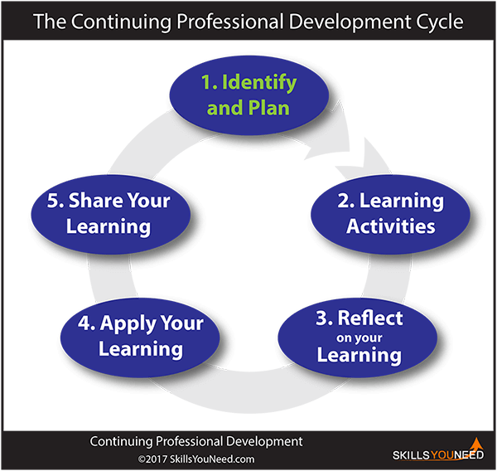

. CDP (SkillsYouNeed, n.d)

1. **CDP contribution to own learning**

* I use CDP to identify my needs of development. I can achieve by either performing and evaluate myself or colleague’s feedback. Additionally, I can develop new skill that I have interest. For an example, I choose communication skill to demonstrate.
* The next is to have a plan which can be either formal or informal learning. For formal learning, I will take a course for communication in workplace. This will not only help me in training many skills but also provide opportunities. As for informal way, I watch online video for lessons, communicate with friends and take feedback and minoring people with good skill in such area.
* Next, I need to reflect on my learning and apply that the practice. This is done by doing interview, talk in more professional manner.

# Produce a development plan that outlines responsibilities, performance objectives and required skills, knowledge and learning for own future

1. **Setting goals**

* When setting goals, one should come in consider that there are 2 types of goal, short-term and long-term goals.
* As for short term goals, these goals are usually achievable in the course of days to months or even at the end of the year. Goals like these could be a foundation for the future or just temporary satisfaction. Moreover, these could just a stop for bigger goals as we need a certain skill to progress more in curtain aspects.
* In terms of long-term goals, these refers to broader, up-scale destination, usually require a couple of short-term goals to be achieved. As for such high scale targets, we could be taking about pursuing a career, buying an expensive item, etc. Building a good foundation require a long amount of time of learning, investing to gain skills, knowledge.
* As for myself, I have made a list of short-term and long-term goals. These include professional and personal purpose that I want myself to achieve.
* Short-term goal:
  + Finishing all my current subjects with passing or more.
  + Finish a short-term teaching job in 2 months and get a better salary job.
  + Being able to bench press 10 reps of 80kg in 3 months (gym related).
  + Getting close to 10% body fat when cutting (workout term).
  + Be a good assistant for my brother when I stay with him for 1 month in July.
  + Get into a healthy romantic relationship.
* Long-term goals:
  + Graduate from university of Greenwich.
  + After graduating, get a job either related to education field of mine which is IT or have a decent job related to my hobbies.
  + Sustain a long-term relationship with a reliable partner.
  + If I have a good job in 10 years, pursue a music career as a part time either in production or a band.

## Three skills need to develop

* First skill I want to develop more is more or less the skill of completing the mind. This means learning to remain calm to think straight in tough situation, stay focus in work, remain a healthy relationship with my mental health, etc. There are times when I feel extreme under pressure and get overwhelmed by a lot things in life that I feel no desire to do anything in the day. Although I have learned over the year the ability the control my feeling and desire so that I will not affect my life negatively, sometimes I still feel like something inside someday will snap. In addition, I worry about my future and that I do not think about it enough. Finally, I want to be level-headed and calm in challenging scenario.
* Secondly, I want to improve my communication and social skill. I was not advised much about how to communicate and express my feeling when I was younger. However, growing up I learned the importance of such skills and that lacking of them had me lost many advantages. Although I find it difficult learning to show people all of my thoughts, I always try my best to be better at this despite lacking of foundation. Bad communication had costed my many opportunities in life but I am still young and there are many opportunities ahead.
* Finally, I want myself to be better at soft-skills. These are essential when I eventually out in the workplace. While this matter is being taught in university, real life practice is more important and more likely to transform into permanent skill.

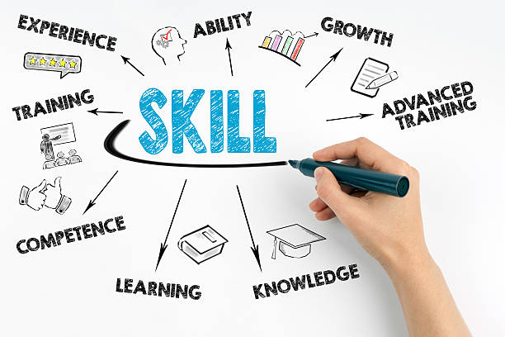

## Strengths, weaknesses, development progress on them

* It is true that everyone has their own strengths and weaknesses. I am a human being with a lot of flaws and goods similar the anyone else. Ultimately, the goal is to level up your set of skills and overcome your bad side. This will ensure my overall quality as an individual and brighten my future.
* I have made a list of some of my strengths and weaknesses and explain some description and planning for them in future.
* Strengths:
  + English: This might be the most important skill consider the need for such in the moment. English is the globally means of communication. We not only need English to study at school and do research online but we also use English to communicate online, consume content online in English. The truth is I used to think English is not as necessary since I surrounded myself in people with good English skill but now, I realize not everyone can have such level of languages. Since I apply English to my everyday life, I am able to keep my skill to be consistent and avoid decrease in the skill. For development plan, I will try to use this advantage to make money out of it either in teaching or selling that involves English.
  + Generation of technology: I am born in the generation where technology is advanced. Being able to be familiar with many devices give me advantage ahead of many people. In addition, I use computer every day and I am able perform various tasks in such device. However, there are a lot more knowledge and skill regrading this field. I am planning to develop more on this skill by studying in school and do research at home.
* Weaknesses:
  + Communication: I find myself still lacking in this aspect despite seeing improvement over the years. The truth is communication is so important in not just workplace but for your own good since it is a crucial way to get your image out to the people. We need communication to express ourselves, our feelings, ideas, concerns and not expressing only give you disadvantages. Furthermore, this skill is heavily required when working in a professional office. I am planning to fix this problem by the smallest like talk more to the people I know in a more comfortable way to the bigger like taking a course.
  + Groupthink: this is the matter that I have discussed before as groupthink is the behavior of not participate much in the working of generate more ideas as I tend to agree to the common idea. I am planning to avoid this by not avoiding communication and be more active in the communicating.

1. **Rating development needs**

* As for the English skill, I see it as not very urgent as well as important since my English skill has already more than what I use. I use English everyday in both personal needs and educational purpose. However, with the previous IELTS score of 7.5, I want to try harder for the next time I take part in another test with the goal of 8.0.
* In term of technology, I also find this not urgent and important since I have yet to find any challenging tasks current that requires more of what I have already know. However, I will still learn about technology as a side project for it will give a big advantage when I eventually need to use such knowledge.
* For communication, I rate this as important but not urgent. Even though my communication is so much to be desired, I find it enough to get what I need for the day. I will still try my best to stick to the development plan and make improvement.
* Finally, groupthink is rated as important and urgent. I always think of this as my biggest weakness since it is very important when working in a team. To be able to improve this I also need to improve communication skill. This is urgent because I will need that for future team work which might not be far in the future.

## Development plan

|  |  |  |  |
| --- | --- | --- | --- |
| Objectives | Development plans | Time period | Monitor and review |
| Finishing all my current subjects with passing or more. | Attend all the classes with exceeding 25% absent  Do all the assignment carefully to get P or more | Until 30/4/22 | So far, I have not exceeded the allowed absence.  Do the best assignment, if fail evaluate on the mistake and fix for second chance |
| Finish a short-term teaching job in 2 months and get a better salary job. | Try to be patient and hardworking in the current teaching job  Either through connection or interview, get a decent part time job | Until 1/8/22 | Evaluate based on the pupil score in the test.  Evaluate on how long until I get a new job and the quality of the job |
| Being able to bench press 10 reps of 80kg in 3 months (gym related). | Eat more.  Consistence of training hard.  Keep track of the gain. | Until 1/8/22 | Evaluate on the work ethic and the consistence of each training session.  Evaluate based on the performance when hitting the desire weight. |
| Getting close to 10% body fat when cutting (workout term). | Eat less and healthier.  Keep track of the calories intake and the food consumed.  Train consistently and do cardio every day. | From 1/6/22 to 1/9/22 | Evaluate on the work ethic and the consistence of each training session.  Evaluate on the finish physique. |
| Be a good assistant for my brother when I stay with him for 1 month in July. | Spend less time on phone and more on doing chores and learning.  Focus when doing the job.  Make more connection given the opportunities. | From 1/7/22 to 1/8/22 | Based on the connection I make and the quality of the work.  Based on the satisfaction of my brother.  Based on how much I learn and change for the better. |
| Get into a healthy romantic relationship. | Meet more people.  Surrounded myself with likeminded people.  Improve on myself physically and mentally. | Until the end of 2022 | Based on the quality of the partner, the quality of the relationship. |
| Mind | Meditate  Focus on improving myself physically and mentally.  Meet more people | Until 26/4/23 | Evaluate based on the general feel and motivation throughout the course of a year |
| Graduate from Greenwich | Attend all the classes  Passing all the assignments | by 8/2024 or more | Evaluate based on the score and the status of the subjects |
| Soft skills | Taking courses  Find a part time job | By 8/24 | Evaluate the performance |
| Communication skill | Talk more to known people, make small talk with strangers with appropriate scenarios.  Taking courses | By the end of 2022 | Learn from awkward situation.  See if I feel comfortable in the given time |
| Sustain a long-term relationship with a reliable partner. | Be liable yourself  Take courses for relationship.  Have more deep conversation with partner to express current feeling and concerns as well as happiness. | Until the day I die | Evaluate based on the satisfaction of both parties. |
| After graduating, get a job either related to education field of mine which is IT or have a decent job related to my hobbies. | After graduating, I will send CVs to different companies and taking part in interviews.  Find opportunities for hobbies related jobs. | After graduation 8/24 or more for  10 years | Learn from failed interviews, learn from experience and keep trying until I find one. |
| If I have a good job in 10 years, pursue a music career as a part time either in production or a band. | Have a good career first.  Find a community of music and make connection.  Practice at home first then record. | After 15 years to 20 years for as long as I can. | Evaluate based on the job I have that time.  Evaluate based on the positive energy doing music. |

# Conclusion and critical evaluation

## Conclusion

* In CDP is crucial in both professional and personal life as it helps people to grow as a person and own to their development. As for the team work, I thought I did somewhat fine but there are still more room for improvement and I know with my current status I can do more to the team. In the future I will use CDP as a main tool for my development in the future.

1. **Critical evaluation**

* When doing this assignment, I think my biggest strength is my researching skill. The truth is from the previous assignment of different subjects, I was able to learn how to do research effectively. This not only ensure the quality of the material but also save a lot of time.
* In addition, with previous history of taking writing courses, I am confident in my writing since I know appropriate words as well as the structure so the writing can be cohesive.
* On the other hands, I would say the downside of my ability in this assignment is the information in some place can be lacking. Additionally, the weakness of working in the group has been mentioned with the development plans.
* For the weaknesses, I will reflect on the feedback the teacher will eventually give and re-evaluate to be a better writer in future assignments. In addition, watching writing lessons on the internet will help me learn and improve upon my current skill. I will keep reflecting and practicing at home to make sure the skills are sharpened.
* Although this is not the perfect report, I have tried my best to make sure it is as good as possible. With that in mind, I would want my grade to be from P to M.

# References

Byrne, G. (2019). When your course schedule says ‘group work’ and you think ‘hard work’. Retrieved 04 25, 2022, from https://rcni.com/nursing-standard/students/nursing-studies/when-your-course-schedule-says-group-work-and-you-think-hard-work-149701

Kulakov, M. (2021). How to Manage and Improve Team Dynamics. Retrieved 04 25, 2022, from https://everhour.com/blog/team-dynamics/

SkillsYouNeed. (n.d). Continuous Professional Development. Retrieved 04 26, 2022, from https://www.skillsyouneed.com/ps/continuing-professional-development.html