**ASSIGNMENT 1 FRONT SHEET**

|  |  |  |  |
| --- | --- | --- | --- |
| **Qualification** | **BTEC Level 5 HND Diploma in Computing** | | |
| **Unit number and title** | Unit 13: Computing Research Project | | |
| **Submission date** | 24/02/2023 | **Date Received 1st submission** | 24/02/2023 |
| **Re-submission Date** |  | **Date Received 2nd submission** |  |
| **Student Name** | Nguyen Tran Nam Khanh | **Student ID** | GCH210731 |
| **Class** | GCH1003 | **Assessor name** | Nguyen The Lam Tung |
| **Student declaration**  I certify that the assignment submission is entirely my own work and I fully understand the consequences of plagiarism. I understand that making a false declaration is a form of malpractice. | | | |
|  |  | **Student’s signature** |  |

**Grading grid**

|  |  |  |  |  |  |  |  |  |  |
| --- | --- | --- | --- | --- | --- | --- | --- | --- | --- |
| P1 | P2 | P3 | P4 | P5 | M1 | M2 | M3 | D1 | D2 |
|  |  |  |  |  |  |  |  |  |  |

|  |  |  |
| --- | --- | --- |
| **❒ Summative Feedback: ❒ Resubmission Feedback:** | | |
| **Grade:** | **Assessor Signature:** | **Date:** |
| **Internal Verifier’s Comments:** | | |
| **Signature & Date:** | | |

Table of Contents

Tables of contents 4

I. Introduction the purpose of the research 6

1. Introduction to the research 6

2. The main aim and objectives 7

II. Literature review 7

1. Research Methodologies 8

A. Primary Research 8

B. Secondary research 10

C. Qualitative and Quantitative Research 12

a. Qualitative Research 12

b. Quantitative Research 13

c. Comparison 14

D. Scientific method 15

E. Research process 16

F. Population in research 19

G. The research methods that will be used to carry out the research 20

2. Secondary Research 20

A. Definition 20

B. History 21

C. Advantages and disadvantages 22

D. Effects on the environment 22

a. Battery production 22

B. Material and recycle battery 24

c. Driving 25

E. Future 27

3. Conclusion 28

III. Primary research 28

1. Method 28

2. Survey 29

A. Questions 29

B. Results and Analyze Data 35

3. Interview 46

4. Conclusion 49

IV. Research Proposal Form 49

V. Research Ethics Approval Form 51

References 53

# Tables of contents

1. Electric car 2022 Lucid Air (Lekach, 2023) 6

2. Literature review (Kramer, 2022) 8

3. Primary research (pollfish, n.d.) 9

4. Secondary research (pollfish, n.d.) 11

5. Qualitative research (questionpro, n.d.) 13

6. Quantitative research (Shenmare, n.d.) 14

7. Scientific methods (Chiechi, 2022) 15

8. Research process (questionpro, n.d.) 16

9. Population in research (bccampus, 2020) 19

10. Different types of electric cars (windsor, n.d.) 20

11. Electric car battery (Alternative Fuels Data Center, n.d.) 23

12. Electric and conventional vehicle test-cycle and upstream fuel cycle emissions in (Lutsey, 2017) 25

13. Life-cycle emissions (over 150,000 km) of electric and conventional vehicles in Europe (The international council on clean transportation, 2018) 26

14. Comparison of life-cycle greenhouse gas emissions in conventional, electric, and plugin hybrid vehicles in various European markets. (The international council on clean transportation, 2018) 26

15. Comparing the CO2eq emissions over the lifetime of two similar cars in grams/km (Hoekstra, 2020) 27

16. Survey question 1 29

17. Survey question 2 29

18. Survey question 3 30

19. Survey question 4 30

20. Survey question 5 30

21. Survey question 15 34

22. Survey question 16 34

23. Survey question 17 34

24. Survey question 18 34

25. Chart for name 35

26. Age chart 35

27. Gender chart 36

28. Electric car own chart 36

29. Cost question 37

30. User cost satisfaction chart 38

31. Favorite features 38

32. Least favorite features. 39

33. Comfortability chart 40

34. Challenges in charging 40

35. Schedule affection 41

36. Changes opinion 42

37. Support on charging stations 43

38. Electric cars on service 44

39. Rural area chart 44

40. How supportive chart 45

41. Improvement suggestion 46

# I. Introduction the purpose of the research

## 1. Introduction to the research

Compared to the past, humankind has successfully normalized many technologies to the extends of daily use and widely use. These are smart phones, laptops, desktop computers, etc … In addition, businesses and governments are also applying technologies so the management job can be easier and more effective. This also works two ways as the customers or citizens are also benefited from these as well.

The most alarming problem in the world right now is the carbon emissions level in a high level. This problem has been around for a while now since the main energy source is still fossil feud and this release carbon emissions to the earth and damaging the environment. Cleaner sources of energy have been always developed and they have been trying to implement in real life.

While there are still skeptical when this first launched but electric cars have been improved every year and the benefits are proven to be effective despite some downsides. In general, using electric instead of gasoline or diesel is more eco-friendly. Even when considering the cost for electric plants, the emissions will still be less harmful. In addition, here are some benefits of electric cars:

* Zero greenhouse emissions
* Less harmful battery to discard
* Easier to management in traffic control.

As a result, the title of this research paper will be: “How can electric cars benefit the environment as well as the quality of life and will be replacing fossil fuel cars in the future”.

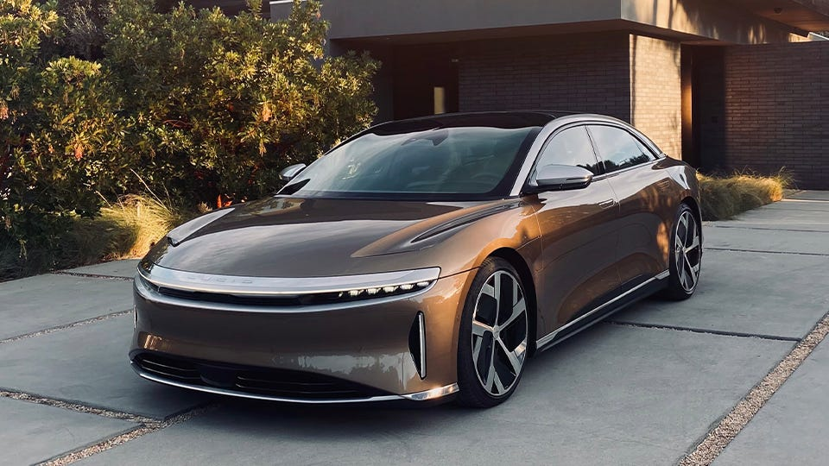

1. Electric car 2022 Lucid Air (Lekach, 2023)

## 2. The main aim and objectives

The main aim of the project is to conduct researches to prove that electric cars is beneficial for the environment compare the normal cars and that there might be more advantages of that in the future.

The following is the study’s objectives:

* Current greenhouse gases of fossil fuel cars and electric cars.
* Conduct an interview/survey to see how satisfied or otherwise of the electric cars’ owners are with the products.
* Analyze the data submitted by users.
* Provide solutions that meet the demands of the users as well as improve the future products.

The research will do:

* Research about electric cars history and its effect on the environment.
* Conduct a survey to see how satisfied or otherwise of the electric cars’ owners are with the products.
* Conduct an interview to ask professionals about in depth information

The research will not do:

* Survey will not ask people who own fossil fueled cars.
* Research will not show how the fossil fueled cars effect the environment but only the amount.
* Research will not go in depth in the evolution of electric cars and how that evolve but only briefly mention

# II. Literature review

A literature review covers information that has been published in a specific field of study, and occasionally information that has been published within a specific time frame. Although a literature review might just be a list of the sources, it often follows an organizational structure and combines summary and synthesis. A synthesis is a reorganization or reshuffle of the material in a summary, which is a recap of the key points from the source. It could provide a fresh interpretation of dated information or blend fresh and outdated perspectives. Perhaps it could outline the field's intellectual history, including significant arguments. The literature review may also assess the sources and advise the reader on which are the most topical or relevant, depending on the circumstances. (writingcenter, n.d.)

The primary goal of an academic research paper is to create a fresh argument, and a literature review is frequently included in research papers as one of their sections. In a research paper, you draw on the body of literature to lay the groundwork and provide evidence for an original idea you present. Yet, the goal of a literature review is to synthesize and summarize the claims and theories of others without making any original additions. You can use literature reviews as a convenient reference for a certain subject. Reviews of the literature can serve as a starting point or overview for your investigation if you are short on time. These are helpful papers that keep professionals abreast of the most recent developments in their industry. The breadth and depth of the literature review highlight the author's authority in their subject for academics. Literature reviews also give a research paper's investigation a strong foundation. Most research papers require extensive knowledge of the relevant literature. (writingcenter, n.d.)



2. Literature review (Kramer, 2022)

## 1. Research Methodologies

### A. Primary Research

According to (thehartford, n.d.), primary research is analysis carried out by you (or hire someone to do for you.) It entails speaking with a source directly to collect information, typically clients and potential customers in your target market. Primary research cases include:

* Interviews (telephone or face-to-face) (telephone or face-to-face)
* Surveys (online or mail) (online or mail)
* Questionnaires (online or mail) (online or mail)
* Focus sessions
* visits to the locations of rivals

Two types of information are commonly gathered when conducting primary research:

* Exploratory. In-depth interviews with a single person or a small group are frequently conducted as part of this wide and open-ended research project.
* Specific. Exploratory study highlighted the problem that is being addressed by this more focused research. More formal, structured interviews are part of it.

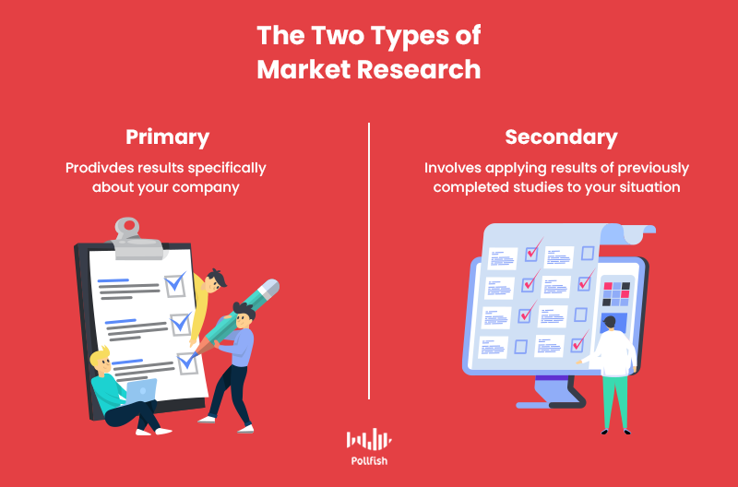

3. Primary research (pollfish, n.d.)

Advantages of primary research:

* A focused approach to market research is provided by primary research methodologies which makes it possible to address certain problems, keeping the study entirely relevant to the project's aims and scope.
* Primary research focuses on niche markets rather than the general public
* The marketing professional has full control over the sampling procedure, representative sample size, and methodology.
* Primary research ensures that the data gathered is current and pertinent.
* This makes it possible to identify precise patterns.
* Primary research gives an individual or organization ownership of the data.
* They can decide to divulge the details in order to solidify their reputation as an industry expert.
* To prevent providing competitors an advantage, they can decide to keep the information private.

Disadvantages of primary research:

* More expensive than secondary research
* More time-consuming than secondary research
* Demands more preparation, execution, and data analysis
* Due to possible prejudice on the part of respondents or misinterpretations of the questions, accuracy must be taken into account.

### B. Secondary research

According to (thehartford, n.d.), research that has already been prepared, gathered, organized, and published by others is referred to as secondary research. It comprises research and reports from government organizations, industry trade groups, and other companies. Most research is often secondary for small organizations with tight resources because it can be acquired more quickly and cheaply than primary research.

By just typing in search terms and phrases for the kind of material you're looking for, you may easily find a lot of secondary research on the Internet. A reference library visit, reading articles in periodicals, trade journals, and industry publications, as well as contacting trade associations or organizations, are other options for getting secondary research. Government organizations are a great place to find secondary research data, which is frequently available for free. On the other hand, accessing data made available by private companies may require your consent and occasionally include a price. In addition, public libraries, educational institutions as well as commercial sources can also be method of secondary research.



4. Secondary research (pollfish, n.d.)

Advantages of secondary research:

* Data is readily available, especially online and from established sources like libraries or official archives.
* Affordable because no direct data collection from a cohort is necessary.
* Before beginning a more extensive study and the acquisition of primary data, it identifies knowledge gaps and possible data availability.
* Reduces the need for time-consuming, expensive primary research.
* Since the data is frequently already in the public domain, participants' permission or consent is not necessary.
* If the secondary data is used properly, there will be fewer ethical issues.

Disadvantages of secondary research:

* Lack of control over data quality: When using secondary data, researchers have no influence over how the data were gathered or how high-quality they are. The accuracy of the research conclusions may be impacted by the use of data that is insufficient, out-of-date, or unreliable.
* Restricted scope: Secondary research may not address the specific research questions or hypotheses of the current study and is restricted to the data that has already been gathered.
* Lack of customization: While employing secondary data, researchers are unable to alter the data collection procedure to suit the particular requirements of their research. This may make it more difficult to get in-depth information or ask follow-up questions to get more information on certain data points.
* Accessibility issues: Certain data sources may be difficult to use or cost money to access. Finding the data that researchers require for their study may become difficult as a result.
* Bias: Depending on the techniques of collection or the initial goal of the data gathering, the information used in secondary research may be prejudiced. Data must be extensively analyzed by researchers in order to spot any biases that can have an impact on the findings of their work.

### C. Qualitative and Quantitative Research

#### a. Qualitative Research

According to (Streefkerk, 2019), the results of qualitative research are written up. It aids in understanding ideas, experiences, or concepts. You can gain comprehensive knowledge about poorly understood subjects by the type of research you are doing. Typical qualitative techniques include open-ended interview questions, written descriptions of observations, and literature reviews that examine ideas and theories. Research biases like the Hawthorne effect, observer bias, recollection bias, and social desirability bias can also affect qualitative studies.

The methods that qualitative research uses are:

* Interviews
* Documents
* Cultural records
* Personal accounts or papers
* Focus groups
* Observation

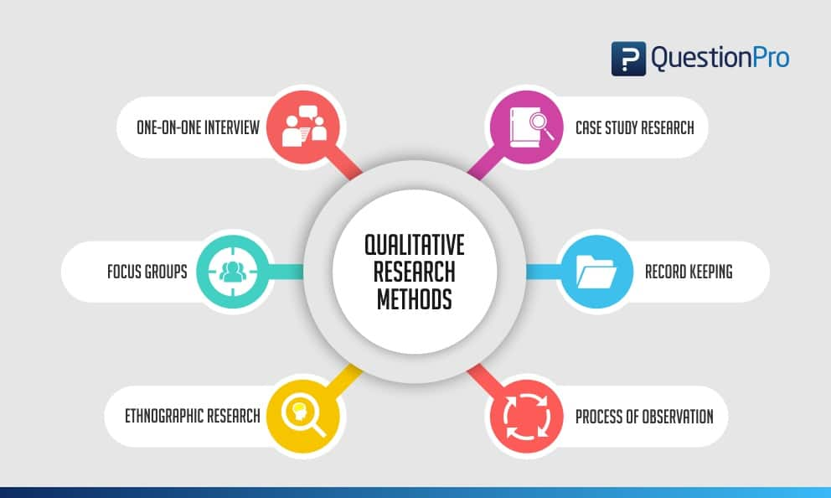

5. Qualitative research (questionpro, n.d.)

Qualitative researchers, often known as their informants, aim to acquire specifics from the accounts of persons they are investigating. Conclusions are reached through gathering, contrasting, and assessing the feedback and input from the informants throughout the course of a study. In qualitative research, the "why" behind a phenomena, correlation, or behavior is frequently the main focus. (Hoover, 2021)

#### b. Quantitative Research

According to (Streefkerk, 2019), graphs and numbers are used to represent quantitative research. It is used to validate or put to the test beliefs and presumptions. A topic's generalizable facts can be established through this kind of study. Experiments, observations that are quantified, and surveys with closed-ended questions are examples of common quantitative procedures. Quantitative research is at risk for research biases like information bias, omitted variable bias, sample bias, or selection bias.

The methods that quantitative research uses are:

* Surveys
* Experiments
* Database reports
* Questionnaires

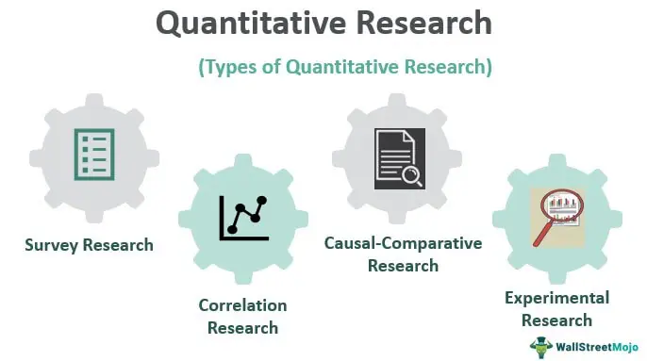

6. Quantitative research (Shenmare, n.d.)

To create a statistical representation of a trend or connection, quantitative data are numerically evaluated. These statistical findings might clarify the causal connections. These might support or contradict the initial hypothesis of the study. The result, whether favorable or unfavorable, can prompt awareness and action. The "what" and "how" of a phenomena, correlation, or behavior are frequently the subjects of quantitative research. (Hoover, 2021)

#### c. Comparison

Both quantitative and qualitative research allow you to address many types of research issues by using various data collection and analysis techniques. (Streefkerk, 2019)

|  |  |
| --- | --- |
| Quantitative research | Qualitative Research |
| Focuses on testing hypotheses and theories | Focuses on exploring ideas and formulating a theory or hypothesis |
| Analyzed through math and statistical analysis | Analyzed by summarizing, categorizing and interpreting |
| Mainly expressed in numbers, graphs and tables | Mainly expressed in words |
| Requires many respondents | Requires few respondents |
| Closed (multiple choice) questions | Open-ended questions |
| Key terms: testing, measurement, objectivity, replicability | Key terms: understanding, context, complexity, subjectivity |

### D. Scientific method

According to (Wright, 2023), through testing and experimentation, the scientific method establishes facts in an unbiased manner. Making an observation, formulating a hypothesis, making a prediction, carrying out an experiment, and then evaluating the findings are the fundamental steps. The scientific method's principles can be used in various contexts, including business, technology, and scientific study.

He also stated that a set of steps are used in the scientific process to establish facts or generate knowledge. The general procedure is generally known, but depending on what is being examined and who is performing it, each step's specifics may alter. Only questions that can be tested and either proven true or false can be answered using the scientific method:

* Make an observation or ask a question.
* Gather background information
* Create a hypothesis
* Create a prediction and perform a test
* Analyze the results and draw a conclusion
* Share the conclusion or decide what question to ask next

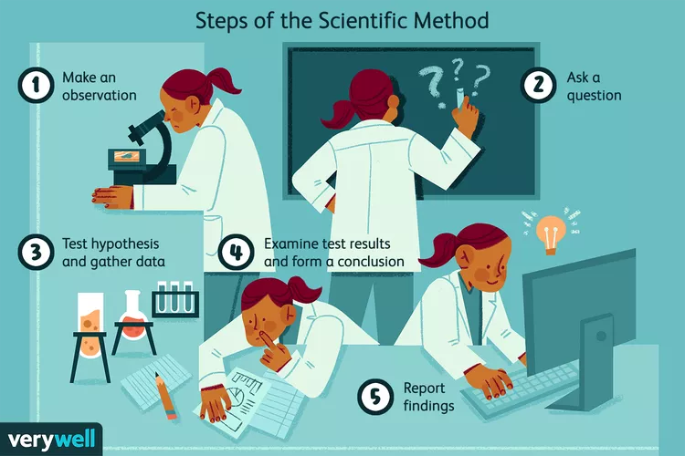

7. Scientific methods (Chiechi, 2022)

### E. Research process

There are various approaches when conducting researches and with each research comes different methods. However, the process should follow the more or less same process provided in the following illustration which is an 8 steps process: (questionpro, n.d.)

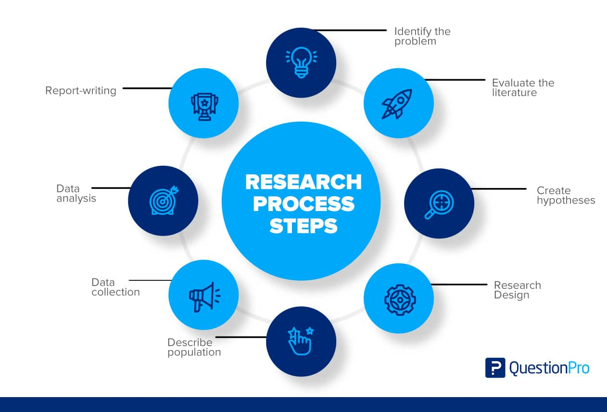

8. Research process (questionpro, n.d.)

**Step 1: Identifying the Research Problem**

The initial step is to identify a problem or create a research question. The researcher will be guided by a well-defined problem through every step of the research process, from formulating objectives to selecting a technique. There are several ways to gain comprehension of a subject and get insight into it. Such as:

* A preliminary survey
* Case studies
* Interviews with a small group of people
* Observational survey

**Step 2: Reviewing of Literature**

The research procedure requires a careful review of the pertinent studies. It makes it possible for the researcher to pinpoint the particular elements of the issue. The investigator or researcher needs to learn more about a problem after they have identified it.

This stage provides context for the problem area. It teaches the researcher about earlier study, how it was carried out, and its findings. With a literature study, the researcher can establish consistency between his work and other works. Such a review exposes the researcher to a larger body of information and aids in his effective execution of the research procedure.

**Step 3: Setting Research Questions, Objectives, and Hypotheses**

The next logical step after defining and condensing the research issue is to develop an original hypothesis. The logical relationships between variables are resolved by a belief. A researcher needs to be an expert in their field in order to formulate a hypothesis.

When developing a hypothesis, it is crucial for researchers to keep in mind that it must be founded on the subject of their study. As they create theories to direct their work, researchers are better able to focus their efforts and remain dedicated to their goals.

**Step 4: Choosing the Study Design**

The strategy for achieving goals and responding to research questions is known as research design. It describes where to find the necessary data. Its objective is to plan studies that will test hypotheses, respond to research inquiries, and offer guidance on making decisions.

The research plan seeks to reduce the amount of time, money, and effort needed to gather useful data. Four categories best describe this strategy:

* Experimentation
* Surveys
* Data Analysis
* Observation

**Step 5: Deciding on the Sample Design**

Research studies frequently focus on a particular population, a facility, or how technology is applied in the workplace. The phrase "population" in research refers to this subject matter. The study group is chosen in part based on the research topic and objectives.

Let's say a researcher wants to look into a particular community's population. In that situation, the study might concentrate on a certain age bracket, gender, region, or ethnic group. To enable generalization of the findings, the sample or population of a study must be determined as the last step in its design.

**Step 6: Collecting Data from The Research Sample**

In order to get the knowledge or information needed to respond to the research question, data collecting is crucial. Every research project gathered information, either from the literature or the subjects. The two groups of researchers must provide data. These resources might offer original data.

* Experiment
* Questionnaire
* Observation
* Interview

Secondary data categories are:

* Literature survey
* Official, unofficial reports
* An approach based on library resources

**Step 7: Process and Analyze the Collected Research Data**

Data analysis is planned by the researcher during research design. The researcher evaluates the data after gathering it. Based on the method used in this stage, the data is analyzed. Review and reporting of the research results.

Establishing categories, applying these categories to raw data through coding and tabulation, and then deriving statistical inferences are only a few of the closely connected steps involved in data analysis. Many statistical techniques can be used by the researcher to analyze the data they have collected.

**Step 8: Writing Research Report – Developing Research Proposal, Writing Report, Disseminating and Utilizing Results**

The researcher next needs to write a report outlining his findings after finishing these processes. The following points must be carefully considered when composing the report:

* The Layout: The report's title, date, acknowledgements, and prologue should all be on the first page. If there are any, a list of tables, graphs, and charts should come after the table of contents.
* Introduction: The objective and methodology of the research should be stated in the introduction. The study's boundaries and scope should be described in this section.
* Summary of Finding: The findings and suggestions are summarized in a straightforward manner after the introduction. If the findings are long, they should be condensed.
* Principle Report: The report's main body should be logically organized and comprised of understandable sections.
* Conclusion: At the end of the main text, the researcher should reiterate his conclusions. That is the outcome.

### F. Population in research

According to (explorable, n.d.), a research population is typically a sizable group of people or things that serve as the principal subject of a scientific inquiry. Research is carried out to benefit the general populace. However, because population sizes are so huge, it is sometimes impractical and expensive for researchers to examine every member of the community. Researchers use sampling strategies because of this. The term "research population" also refers to a well-defined group of people or things that are recognized to share common traits. Typically, every person or thing within a population shares some sort of unifying quality.

**Relationship of Sample and Population in Research:**

As stated by (explorable, n.d.), simply said, a sample is a portion of the population. The difficulty of the researchers to test every member of a particular population gives rise to the idea of a sample. The sample must be enough in size to support statistical analysis and representative of the population from which it was taken.

The primary purpose of the sample is to enable the researchers to perform their research on members of the population in order to draw generalizable conclusions from the study's findings. That is very similar to a give-and-take exchange. The sample is "given" by the population, which then "takes" inferences from the sample's findings.

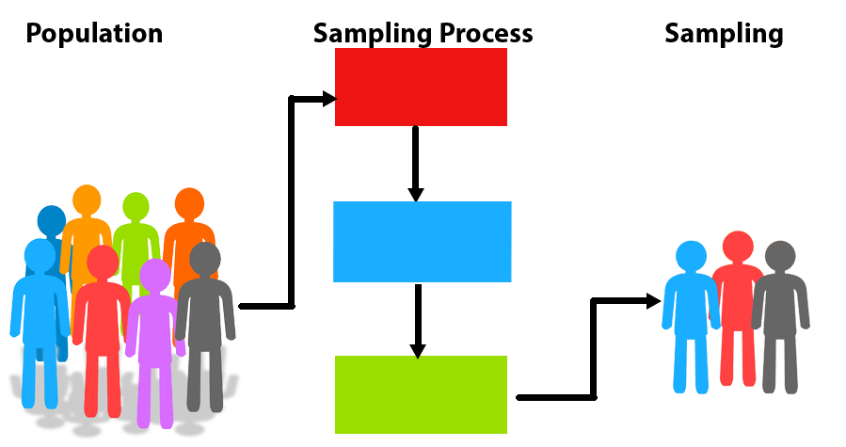

9. Population in research (bccampus, 2020)

### G. The research methods that will be used to carry out the research

Finding appropriate methods is crucial for the study as it allows collecting and analyzing data much easier and more effective. In this project, I choose the research methods interview and survey.

## 2. Secondary Research

### A. Definition

According to (windsor, n.d.), An electric motor powers an electric car (EV), which is essentially an automatic vehicle. A purely electric vehicle is one without a gasoline or diesel engine. When an electric vehicle is in "drive" mode, it accelerates similarly to an automatic vehicle. Electric and hybrid vehicles lack gears. They are all completely automatic vehicles. Power is transmitted from the battery to the electric motor when the accelerator is depressed. The drive shafts turn the wheels when the motor is powered. When the car brakes, it starts to slow down and the motor turns into an alternator, producing power. The battery receives this power and uses it again.

Here are some types of different electric cars and their comparison:

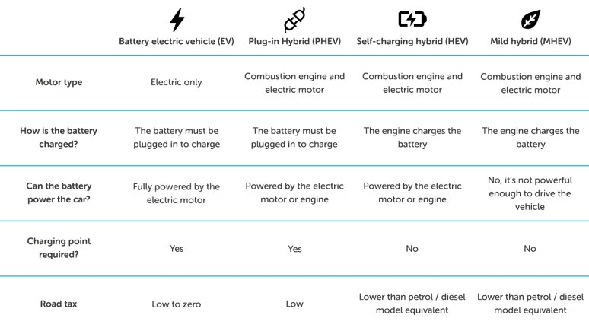

10. Different types of electric cars (windsor, n.d.)

Electric vehicles work by being plugged into a charging station. It then starts charging the car by using electricity from the grid, just like all electrical gadgets. Rechargeable batteries in the car are used to store the electricity, which powers an electric motor that turns the wheels as a conventional fuel engine would. As there are no gears to shift through, electric automobiles feel lighter to drive since they accelerate more quickly than vehicles with conventional fuel engines. (windsor, n.d.)

Another type of car that utilize electric is hybrid cars. A hybrid vehicle combines an electric motor and an additional propulsion source, such as a gasoline or diesel engine. The main benefits of a hybrid car are its lower fuel consumption and CO2 emissions compared to a comparable petrol or diesel-engined vehicle. A traditional engine, an electric motor, and a battery are all present in hybrid vehicles. Depending on how much battery power they have, hybrids can be classified as powerful or mild. Strong hybrids may travel further on electric power alone than mild ones since they have larger batteries. (windsor, n.d.)

### B. History

According to (BARLINGEN, 2022), here are the brief history of electric cars:

* **The early pioneers of electric mobility (1830-1880):** Inventors in Hungary, the Netherlands, the UK, and the US began concentrating their efforts on fusing these technological advancements to produce a powered motor vehicle as early as the 1830s. Many claim that the first small-scale electric automobiles were created between 1828 and 1832, albeit this is a contentious subject.
* **The transition to motorized transport (1880-1914):** A large number of individuals started switching from using horses and carts to motorized vehicles at the turn of the 20th century. As a result, the popularity of the car quickly increased and the competition for the future of transportation began. The choices? Electric, fuel, or steam. On American roadways at the time, there was an approximately equal distribution of the three types of propulsion: about 40% of cars were propelled by steam, 38% by electricity, and just 22% by gasoline.
* **The return of electric vehicles (1970-2003):** Fast-forward to the 1970s, when interest in reducing society's reliance on oil increased as oil prices and gasoline shortages reached a new high—peaking with the 1973 Arab Oil Embargo. Automakers began looking into solutions for alternative fuel vehicles, including electric cars, as they sensed this social upheaval. For instance, when their electric Lunar rover became the first manned spacecraft on the moon, NASA helped increase awareness by developing a prototype for an urban EV. General Motors also produced a similar vehicle. But, compared to gasoline-powered cars, electric vehicles still had a number of problems, such as a limited range and modest top speeds, and buyers remained uninterested.
* **The rEVolution (2003-2020):** Eberhard and Marc founded Tesla Motors in 2003 after observing the expansion of lithium-ion battery capacity in their previous business. In 2006, a Silicon Valley start-up stated it will begin building a high-end electric sports automobile with a range of more than 320 kilometers. New battery technologies also started to become available, which helped to lower the price of EV batteries and increase range. This is seen by the 97% decrease in lithium-ion battery costs since 1991. As a result, the cost of electric vehicles as a whole has decreased, making them more accessible to consumers.
* **The tipping point (2021 and beyond):** Electric mobility, and particularly passenger electric vehicles, have experienced significant growth. It is undeniable that governments, society, and consumers see electric mobility playing a significant role in the future, regardless of the metric used to measure it: EV sales, EVs on the road, government EV mandates, EVs as a percentage of all vehicle sales, or simply vehicle manufacturers making electric mobility pledges.

### C. Advantages and disadvantages

Benefits of electric vehicles over conventional fuel-powered vehicles:

* As they don't emit any emissions while driving, electric cars are more environmentally friendly.
* Due to their lower fuel costs and minimal maintenance requirements, electric vehicles are more affordable to operate.
* Due to the lack of a conventional combustion engine, driving an electric automobile is quieter and more comfortable.
* As production prices fall and technology advances, electric cars are becoming more accessible.

Compared to conventional fuel-powered cars, electric cars have the following drawbacks:

* Electric vehicles have a constrained range and need to be charged more frequently.
* Compared to conventional petrol stations, charging infrastructure is not as extensively available.
* The price of the battery and electric engine technology may make electric automobiles more expensive up front.
* Due to the energy needed to create the automobile and its parts, as well as the disposal of batteries at the end of their useful lives, the production of electric cars might still have a negative environmental impact.

### D. Effects on the environment

#### a. Battery production

The production of EVs battery can be a big concern as it is a major contribution of the overall emissions of EVs. The truth is EVs is still a new technology so the energy sources used to manufacture batteries are not in accordance with industry norms, which increases carbon footprints. But things are starting to change in this regard.

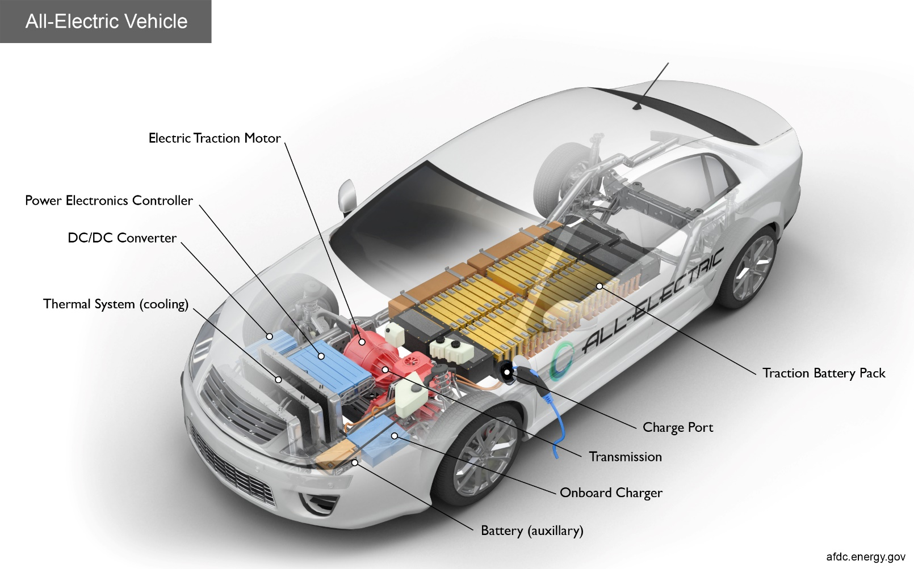

11. Electric car battery (Alternative Fuels Data Center, n.d.)

According to (Mathieu, 2019), the carbon footprint of the most common type of battery for electric cars is estimated to be 61-106kg of CO2 emissions equivalent per kilowatt hour of battery capacity, according to the latest data compiled and modelled by battery researchers at IVL Sweden. This is 2 to 3 times lower than the 150-200kg of CO2eq estimate measured by the same researchers back in 2017. However, there are three reasons why the production of the battery has improved so rapidly. First, the manufacturing of battery cells has become more efficient thanks to commercialization and scaling up, requiring less energy per cell and resulting in a decrease in CO2 emissions. Second, rather than depending on obsolete information and outmoded assumptions, more recent and accurate data are now available to populate the model. In order to decarbonize the grid and lower industrial emissions, particularly in Europe, the US, and China, an increasing amount of renewable energy is being used to generate electricity in important manufacturing zones.

In a paper published by (Hoekstra, 2020), he stated that batteries will likely last longer than 500,000 kilometers (310,000 miles); research indicates that gasoline and diesel emit more pollutants than previously believed; and the energy required to produce batteries has already decreased as the amount of electricity generated from renewable sources rises.

It is clear to see through those researches is that the car battery production used to by high and even higher than fossil fueled car at the moment. However, the reason for this is because the technology was inferior. The truth is electric cars technology is evolving fast and it is the key the CO2 problem that human is having while fossil fueled is going to a dead end. It is no doubt that we will see better production in car battery in the near future that it might be less than fossil fueled cars in terms of emissions.

#### B. Material and recycle battery

Another aspect to look at is the material when manufacturing. One of the most problematic in the production of an EVs is using raw materials. Most EVs use lithium battery which reply on raw materials like cobalt, lithium and rare earth elements. Hazardous tailings and slags from cobalt mining can contaminate the environment (Kaniki, 2019). The process of extract the metals itself can be harmful for the environment as well.

The answer to this can be to recycle the battery. But the truth is only 5% of lithium battery are recycled in the United State (Jacoby, 2019). According to (Hiroko Tabuchi, 2021), battery waste contains valuable metals and other components that can be salvaged and used again, according to experts. Battery recycling may also require a lot of water or create air pollutants, depending on the procedure employed.

According to (Hoekstra, 2020), recycling can cut down on GHG emissions, but it's not a guarantee. The amount by which second life will reduce GHG emissions is difficult to estimate. In our study, we adopt a cautious stance and disregard both. How to count recycling and second life is a topic of debate as well. Our first step is recycling. Simply put, you save material but not energy if you have to melt the battery to get the contents. Hence, if you recycle on energy that is heavy in carbon, CO2 emissions can potentially increase. Yet, significant energy savings are conceivable if the materials can be utilized again without having to melt the entire battery.

It's still unclear whether second-life use will be effective, but it could be a smart method to stabilize electricity systems that use a lot of solar and wind energy. Although it is difficult to put a number on it, we have already cited another study that predicts future batteries would be used as grid storage for 20 years after being used as car batteries25. Naturally, a second use would have the potential to reduce GHG emissions, but because there are numerous ways to calculate this, it has proven difficult to come up with a reliable, tenable estimate. Instead, this has mostly resulted in subjective debates that have the potential to undermine the already reliable conclusion that an electric vehicle emits significantly less CO2 over its lifetime. In this report, we will not quantify this advantage. (Hoekstra, 2020)

However, with the time goes on and the technology progress, the chance of lithium battery being recycled is high. EVs drawbacks are displaying at the moment but this is only the beginning of the chapter where human use EVs and innovative technology comes with it.

#### c. Driving

Regarding the using stage, EVs has a major benefit when they use no tailpipe emissions. The figure below shows how electric vehicles and conventional vehicles compare in CO2 emissions. (Lutsey, 2017)

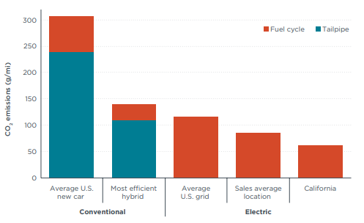

. Electric and conventional vehicle test-cycle and upstream fuel cycle emissions in (Lutsey, 2017)

As seen in the figure 1, the overall CO2 emissions of conventional cars is far higher than that of electric cars. While the fuel cycle CO2 emissions produced by electric cars are up to more than 100g/mi in average U.S grid and are majorly comparing to that of conventional, the tailpipe emissions in conventional cars are the differences. With electric cars only counted in fuel cycle, gas fueled cars produced heavily with the production from tailpipe

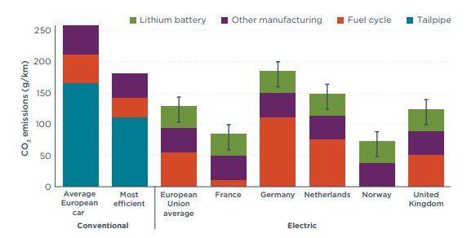

. Life-cycle emissions (over 150,000 km) of electric and conventional vehicles in Europe (The international council on clean transportation, 2018)

Similarly, the study of the life cycle emissions in Europe produced the same argument. As seen in the figure 2, the tailpipe in conventional cars is the major reason why electric cars are far better for the environment. The only exception was in Germany where the emissions from fuel cycle witnessed an alarming amount. However, the other countries produced the emissions which are far more advantageous.

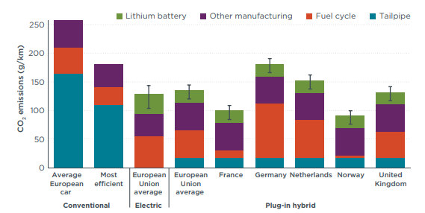

. Comparison of life-cycle greenhouse gas emissions in conventional, electric, and plugin hybrid vehicles in various European markets. (The international council on clean transportation, 2018)

Here is a comparison of electric cars versus fossil fueled cars. In this example, there will be 3 groups of cars that are similar in grams/km: (Hoekstra, 2020)

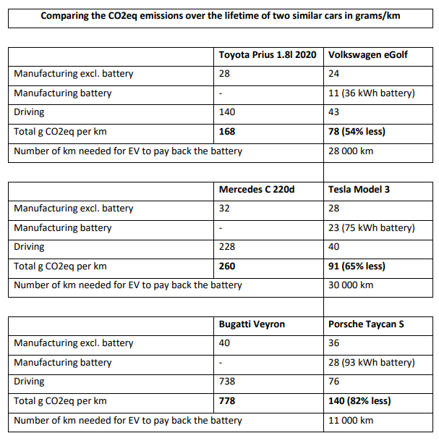

. Comparing the CO2eq emissions over the lifetime of two similar cars in grams/km (Hoekstra, 2020)

Likewise, this table proves the same result. Despite the CO2 emissions in the production stage was slightly higher, it was minor comparing to the amount in the driving stage of the fossil fueled cars. The most remarkable part of the table was the last group: the Porsche Taycan S was 54% less that the CO2 emission of Bugatti Veyron.

### E. Future

According to (DALY, 2021), The Biden administration unveiled a bold federal plan on Monday to construct 500,000 electric vehicle charging stations nationwide and reduce the price of electric automobiles with the intention of revolutionizing the American auto sector.

This means the US is already ambitious about introducing electric cars into people daily lives, slowly replacing fossil fueled cars in the future. They want to make electric cars accessible for everyone as well as ensure the necessary charging stations is spread nationwide for every region.

In Vietnam, VinFast has already introduced themselves in the foreign market as well as popularize themselves domestically. VinFast reported last week that Autonomy had placed its largest corporate order to date—2,500 electric vehicles—with them. According to VinFast, it has almost 65,000 orders worldwide and anticipates selling 750,000 EVs annually by 2026 (Nguyen, 2022). There will be no doubt that electric cars leading by VinFast will dominate the market of cars in Vietnam in the near future when electric cars will soon replace fossil fueled cars.

## 3. Conclusion

Electric cars are a greener option to conventional fuel-driven vehicles since they employ electric motors that are powered by rechargeable batteries to turn the wheels. Purely electric and hybrid vehicles are the two primary categories of electric cars. While hybrid vehicles combine an electric motor with a gasoline or diesel engine, pure electric vehicles run entirely on electricity. Although electric vehicles have been around since the 19th century, it wasn't until the 21st century that they became a more practical and affordable choice because of improvements in battery technology and falling prices. Nonetheless, there is still a large carbon footprint associated with the manufacture of electric vehicle batteries.

By providing a cleaner alternative to conventional fuel-powered vehicles, electric cars have become more widely available to consumers thanks to advances in battery technology. Yet, there is still potential for improvement in terms of the energy sources utilized to produce electric car batteries, and the creation of these batteries still has a substantial environmental impact.

# III. Primary research

## 1. Method

The first stage of the primary research is collecting data. In this study, I choose survey and interview to be my methods of collecting data. My survey will have some short, easy multiple-choice questions and opened, longer questions for a deeper understanding and easier to analyze. My interview will have more sophisticate questions which require more knowledge in the fields and as a result the answer will be more impactful.

The population of the study is people who are related to electric cars. This group of people is specific in the subject of the study which is electric cars and its impact on the environment.

## 2. Survey

### A. Questions

I have created a survey form and collect the opinions of 20 electric car users in Hanoi who have more than a year of using the product. This survey will have closed as well as opened questions to learn more about their perspective

For this survey I use Google Form to make and collect data: <https://forms.gle/ApqT6fJM8vE34LyJ6>

Here are the questions included in the survey:



16. Survey question 1



17. Survey question 2



18. Survey question 3



19. Survey question 4



20. Survey question 5

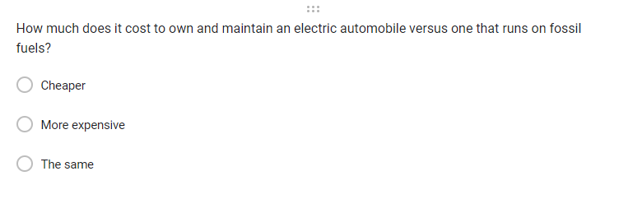

13. Survey question 6



14. Survey question 7



15. Survey question 8



16. Survey question 9

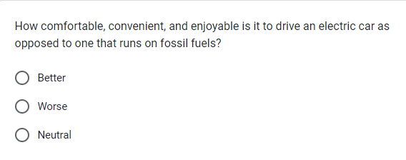

17. Survey question 10

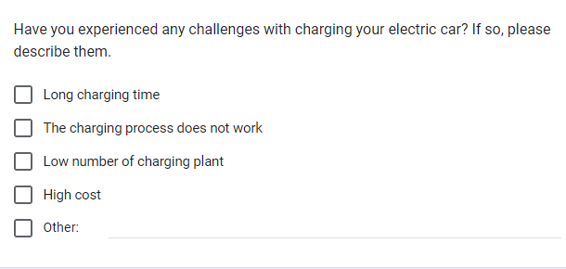

18. Survey question 11



20. Survey question 12

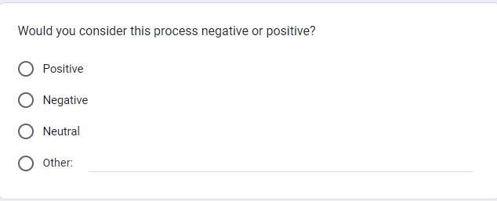

21. Survey question 13

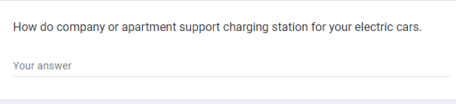

22. Survey question 14

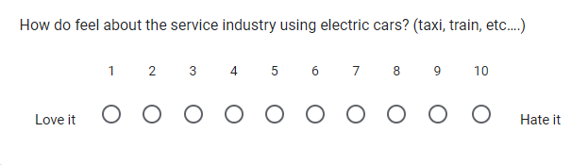

. Survey question 15



. Survey question 16

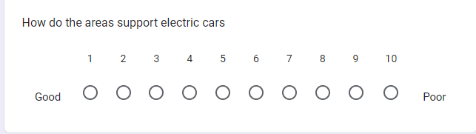

. Survey question 17



. Survey question 18

### B. Results and Analyze Data

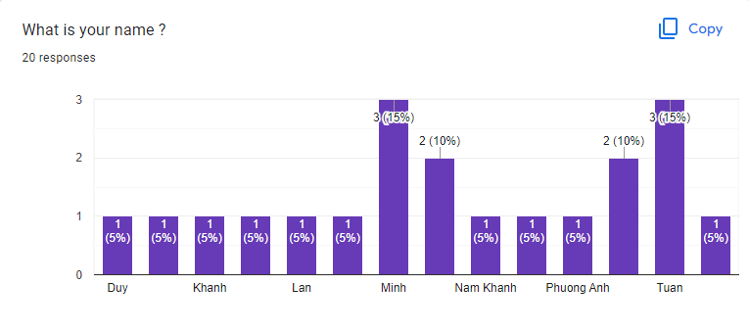

. Chart for name

This is only the different in people’s name that take the survey. There is nothing special in this chart.

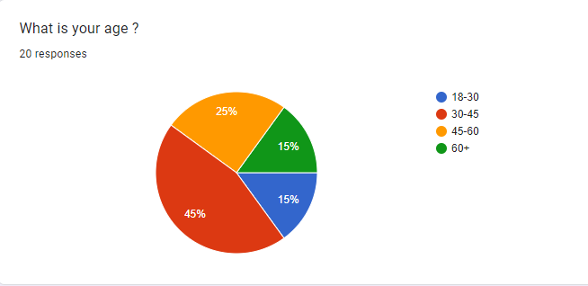

. Age chart

As we can see here, the age group is divided in 4 groups. The first group is from 18-30 years old which along with 60+ are the smallest with only 15%. This is because people from that age are either too young to be financial stable and too old to drive a new generation car. The in between are the most occupied group with the majority are 30-45 years old with 45% followed by 25% of 45-60 years old.

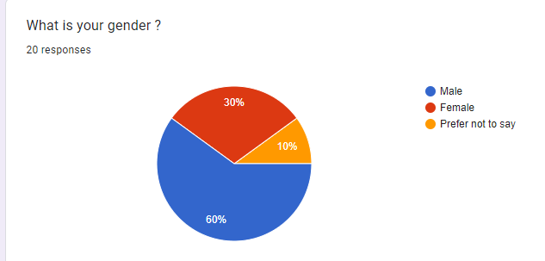

. Gender chart

The gender chart shows the majority of electric cars buyer are male. This shows that the automobile market is more appearing to men as the percentage of that is 60% while that of women is only 30%. The rest of the pie chart is the figure of people whose genders are sensitive.

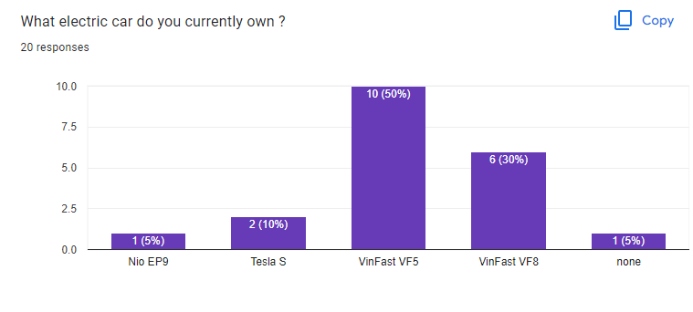

. Electric car own chart

As we can see in the chart, more than haft of the survey takers own a VinFast especially the VinFast VF5 with half of the users owned. This is because VinFast is a local company and there for more accessible to the population. The minority of the users own a foreign car which can be more expensive.

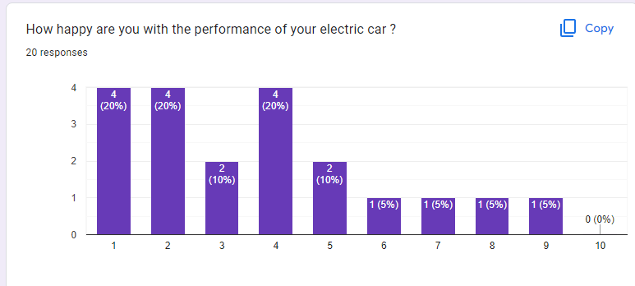

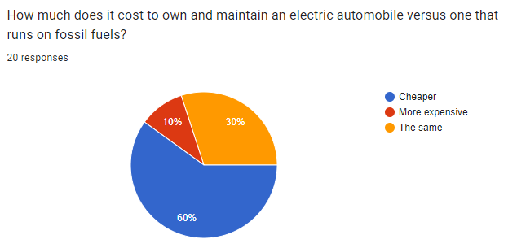

. Cost question

This question is to know how different the cost of the electric cars compares to fossil fueled cars. It is evidenced that electric cars are cheaper in the cost to maintain. This is proved because energy of electric cars is easier to produce and as pointed out more suitable for the environment. As a result, it is shown here with 60% said cheaper. 30% of the users said it is the same and 10% said it is more expensive. There could be several reasons for this. Firstly, depends of the model of their electric cars that the cost can be vary. Older generation electric cars are less advance and will cost more. In addition, owning an electric car that is larger in volume will cost more compare to a smaller fossil fueled car.

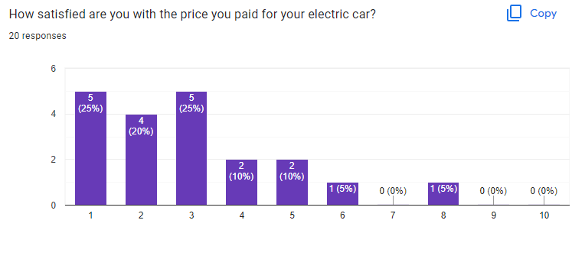

Good

Bad

. User cost satisfaction chart

This is the chart that reflects satisfactory of the user about the price of their cars. As seen in the chart, The majority of them are happy with the affordable price of what I assume is the VinFast car. However, one person said otherwise and he/she was not happy which can be explain as the high price of foreign cars.

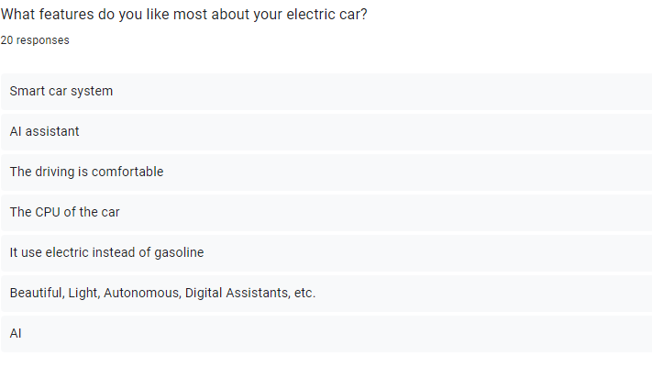

. Favorite features

With the collected response, it can be seen that there are various features that people like: AI, CPU, gasoline, etc… The most noticeable feature that an electric car has to offer is that an AI assistant. This allows multitasking in the car much easier without distracting the driver. More so, many electric cars even have auto pilot mode, which makes the experience and efficiency even higher.

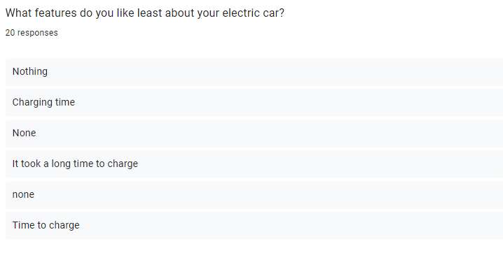

. Least favorite features.

There are no a lot of complaint regarding electric cars except for charging time. It is true that an electric car would take longer to fill up the energy. This will change the way people schedule their time and with the transition time like this, people will find it hard to adapt to this process.

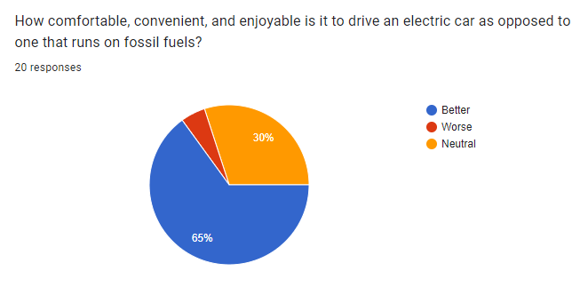

. Comfortability chart

Most electric cars nowadays use latest technology. That means those will have the latest features, the most comfortable design and the driving is smoother. As a result, the chart shows the same outcome with 65% of users said better. Only 5% said worse and 30% said neutral.

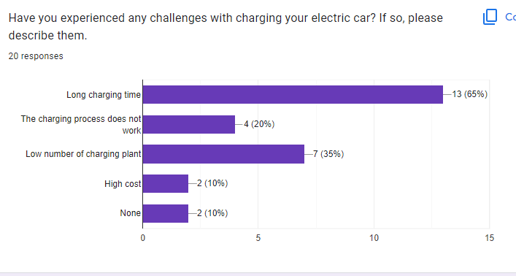

. Challenges in charging

This question asks people about their experience with charging their electric cars. Most people have the same issue of the charging time which takes too long. As explain before, this is a transitional time that people need to adapt but it could be the reason why people choose not to buy. Another problem is the low number of charging plant. Electric cars are still new in Vietnam and the only supplier is VinFast. This cause people to be extra cautious about their charging time and place. There are also problems like the charger does not work or the cost of charging. While there are some model of electric cars that will cause more to charge, future products will improve this.

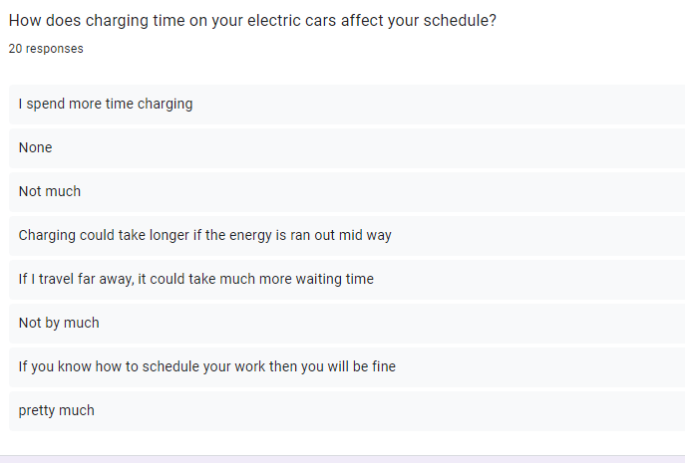

. Schedule affection

People generally find it harder to deal with the charging time and find struggle in it. For people with high workload, they might find the charging time something they can not stand while for other they either feel fine with it or find a way to work it around.

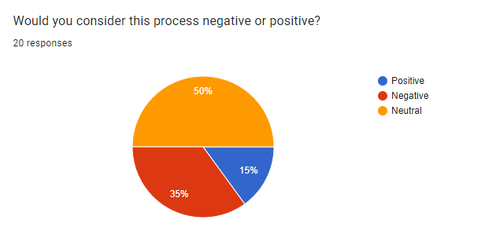

. Changes opinion

This is a follow up question of the last one, which is their opinion on this matter. Half of the people think it is neutral and that it is simply not good or bad about this. However, 35% of people find this to be negative which suits their previous answers. Only 15% of people find the changes helpful. We can say that charging time is the most noticeable flaw of electric cars that users concern.

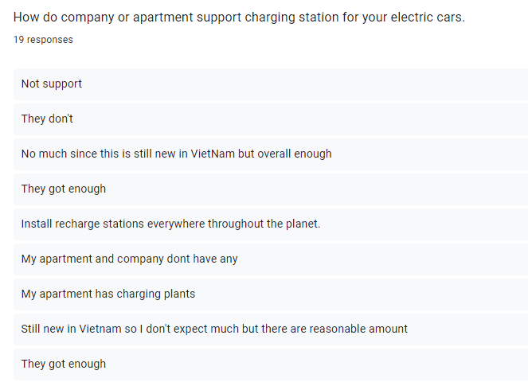

. Support on charging stations

This question concern of the users’ experience on the charging stations in their work and home. This will depend on where their home is and where they work. Almost all of Vin properties have charging stations in them and so if an user lives or works in a Vin building, he/she will not have to worry about this matter. However, not many people are fitted in that category and finding a charging plant might come off as difficult to them.

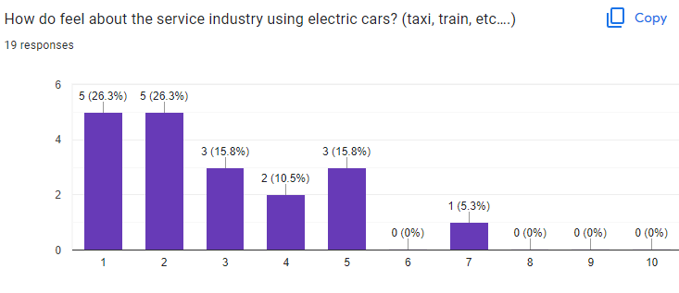

. Electric cars on service

People that take this survey have positive feelings about the idea of applying electric cars into the service industry. Taxi, train or even service like grab, uber are very popular amongst people who do not have a vehicle or need travel far away. The number for these industries can be very high can electric cars will help in improving the environment.

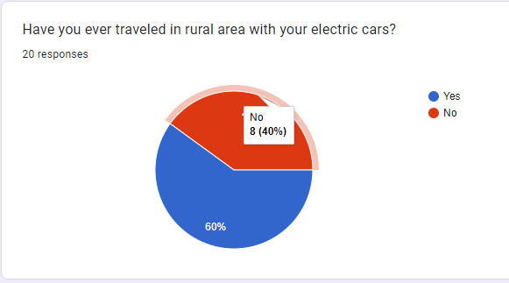

. Rural area chart

We know that the cities are more popular with car users. Electric cars’ charging plant will be more to support that. However, rural area tend to be less supportive in these facilities due to their low and budget and needs. The people here are very evenly divided for the sense that some people do not want to go there for their low support of the vehicles and other might have work or family issue to travel there.

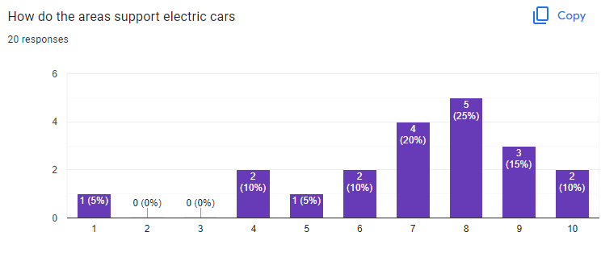

. How supportive chart

As a result, most people will have negative feelings about this issue and only a small percentage have good feeling about it.

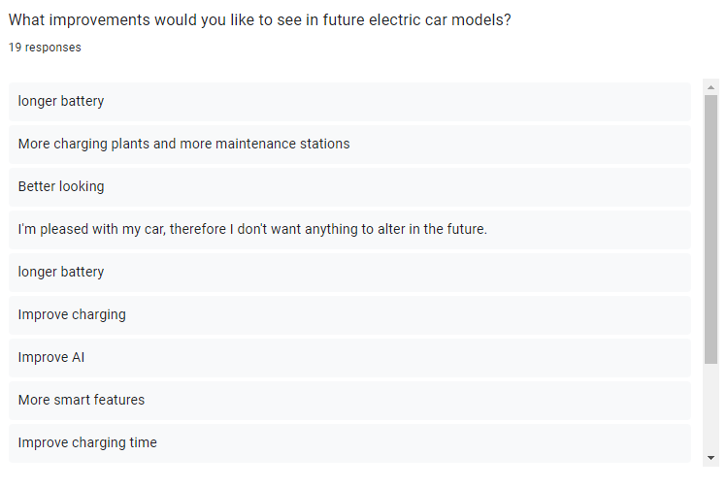

. Improvement suggestion

Finally, users give improvement for future products. Firstly, people will request a longer battery since electric cars need to charge faster than gas cars and this could be a problem for time consuming. As for such, charging time is an issue when people find it hard to fit that into their schedule. The truth is this technology is still new and will be improved in the future. Another thing people find helpful is the AI improvement. AI in electric cars is now a helpful tool for users whenever they are on the road. Improving this will bring benefits and draw users into buying the products.

## 3. Interview

The interview is used to collect data from 3 professional people at VinFast and ask their opinion on their products. Here is the questions and their answer:

1. What do you think the environmental effects of gas- and electric-powered vehicles are?
   * Electric vehicles are a significant way to address environmental issues because they emit fewer greenhouse gases and pollutants than gasoline-powered vehicles.
   * Compared to gas-powered vehicles, electric vehicles have a substantially smaller environmental impact. Electric vehicles have no harmful emissions from their tailpipes, which means they don't contribute to smog, air pollution, or climate change. On the other side, gas cars significantly increase the quantity of carbon dioxide and other air pollutants released into the atmosphere, which causes global warming and other environmental issues.
   * At VinFast, we consider electric vehicles to be a vital component of the solution to the problem of climate change and other environmental issues. Electric vehicles emit much fewer greenhouse gases and air pollutants than gas-powered vehicles. Further lowering their environmental impact, electric automobiles can also be fueled by renewable energy sources like solar and wind.
2. How do you respond to worries about how the manufacture and disposal of batteries affect the environment?
   * We are dedicated to minimizing the effects of battery production and disposal on the environment. To lessen the carbon footprint of our batteries, we use cutting-edge production processes and materials. Our batteries are made to be recycled, and we're always looking for methods to make recycling more efficient and less harmful to the environment.
   * We are dedicated to minimizing the effects of battery production and disposal on the environment. Our batteries have a smaller carbon impact since we produce them with environmentally friendly materials and methods. In order to further increase their sustainability, our batteries are made to be easily recyclable, and we are investigating cutting-edge recycling techniques.
   * Our batteries have a lower carbon footprint thanks to the use of sustainable materials and production methods, and we're investigating cutting-edge recycling strategies to increase their sustainability.
3. What efforts is your business taking to cut emissions during the manufacturing of electric vehicles?
   * To lower emissions during the manufacturing process of electric vehicles, we have put in place a variety of initiatives. They include adopting efficient production methods to limit waste and energy consumption, relying on renewable energy sources to power our manufacturing facilities, and working with suppliers who share our commitment to sustainability.
   * We cut emissions from transportation by optimizing our logistics and using renewable energy sources to run our factories.
   * Our electric car production process includes a number of environmental controls. For instance, we power our facilities with renewable energy sources like solar and wind, and we recycle materials whenever possible. In order to cut down on transportation-related emissions, we also decrease waste and improve our operations.
4. Could you describe the components required to make electric automobiles and how they differ from conventional gas vehicles?
   * We aim to employ materials with less negative influence on the environment, and the materials used in electric automobiles are often more sustainable than those used in gas cars.
   * The materials used to make electric cars are very different from those used to make conventional gas cars. Aluminum, carbon fiber, and high-strength steel are used in electric cars to make them lighter and more efficient. Compared to the materials used in conventional cars, these materials are also more environmentally friendly and more environmentally sustainable.
   * On general, the materials used in electric cars are more environmentally friendly than those in gas-powered vehicles. For instance, we lighten the weight of our cars and increase their energy efficiency by using aluminum and other lightweight materials. We also try to choose materials that, over the course of their lifetime, have little negative environmental impact.
5. How does your business intend to enhance the battery recycling process for electric vehicles?
   * We are always looking for innovative ways to make the battery recycling procedure for electric cars better. In order to create new technologies that can extract valuable elements from spent batteries and repurpose them in new batteries or other uses, we collaborate with recycling partners.
   * We're working to create a reliable recycling infrastructure for batteries used in electric vehicles, and we design our batteries to be simple to disassemble for recycling.
   * We are dedicated to creating a reliable recycling method for batteries used in electric vehicles. We collaborate with reputable recycling businesses that employ cutting-edge technology to remove essential components from batteries and repurpose them in new products. Also, we make sure that our batteries are simple to disassemble for recycling.
6. Can you explain the approach your business is taking to get more people using electric cars?
   * Offering a variety of models at various price ranges, expanding the infrastructure for charging, and funding marketing and awareness-raising initiatives are all part of our approach for getting more people to use electric cars.
   * Making electric cars more accessible, inexpensive, and convenient for consumers is the main goal of our plan for bringing them to more people. To cater to a wide spectrum of consumers, we provide a variety of electric cars at various price points, and we are investing in charging infrastructure to make it simpler for people to charge their electric cars while they are in motion.
   * Our approach to introducing electric vehicles to more people is varied. To cater to a wide spectrum of customers, we provide a variety of models at various pricing ranges. In order to develop the infrastructure for charging and make it simpler for consumers to charge their cars, we also collaborate with utilities, charging network providers, and other stakeholders. Finally, we are funding marketing and educational initiatives to spread the word about the advantages of electric vehicles.
7. What upcoming technology developments do you think will help electric automobiles' environmental impact?
   * We are always looking at new breakthroughs and technology that could reduce the negative environmental effects of electric vehicles. In order to power our production facilities and charging infrastructure, this entails creating more effective batteries, investigating novel materials, and making investments in renewable energy sources.
   * There will be less pollution and better air quality as more people move to electric vehicles. There will also be less reliance on foreign oil and more use of renewable energy sources.
   * Electric vehicles, in our opinion, will become a more significant part of transportation in the future. There will be less pollution and better air quality as more people move to electric vehicles. There will also be less reliance on foreign oil and more use of renewable energy sources.

Based on the result of the interview, there are some points that the company made very clear. Through lowering greenhouse gas emissions and fostering sustainability, the corporation is dedicated to lessening the environmental effect of its products as they are very aware of the current situation regarding the environment. The company is dedicated to reducing the environmental impact of battery manufacture and disposal, and it is researching cutting-edge recycling methods to increase the sustainability of battery production. By implementing effective production techniques and relying on renewable energy sources to power its manufacturing facilities, the company is also taking steps to cut emissions during the creation of electric vehicles. The business is also working to improve consumer access to, affordability with, and convenience with electric vehicles. Last but not least, the corporation is dedicated to researching new technologies that will lessen the harmful effects of electric vehicles on the environment, such as developing more efficient batteries and putting money into renewable energy sources. In general, the corporation is dedicated to lessening the negative effects of its products on the environment and encouraging sustainability. All and all, the answer provides the view and the responsibility of the manufacturer in the process of lower emissions.

## 4. Conclusion

The interview conducted shows the understanding of people inside the matter about the current circumstance and their explanation of the industry. Furthermore, their ambition and their strategy in expanding the market taken into consideration as well as the future improvement of the products.

The survey conducted illustrated the users experience about the products they use. This will give us a more personal view of the user and with their suggestion to make changes to future improvement. As proven that electric cars are better for the environment and will be better in doing so in the future, finding a strategy to implement that to a wider market will not only bring more profits but also and most importantly lower the emissions of vehicles.

# IV. Research Proposal Form

Student name: Nguyen Tran Nam Khanh Student number: GCH210731

Tutor: Nguyen The Lam Tung Date: 23/2/2023

Unit: Computing research project

Proposal title: How can electric cars benefit the environment as well as the quality of life and will be replacing fossil fuel cars in the future?

|  |
| --- |
| **Section One: Title, objective, responsibilities** |
| **Title research project:**  How can electric cars benefit the environment as well as the quality of life and will be replacing fossil fuel cars in the future?  **Objective:**   * Current greenhouse gases of fossil fuel cars and electric cars. * Conduct an interview/survey to see how satisfied or otherwise of the electric cars’ owners are with the products as well as in depth information from professional. * Analyze the data submitted by participants. * Provide solutions that meet the demands of the users as well as improve the future products. |
| **Section Two: Reasons for choosing this research project** |
| Reasons for choosing the project:   * The alarming stage of CO2 emissions and cars are one of the reasons * Electric cars are evolving in are the key to solve to the problem with car emissions * Electric cars are the future |
| **Section Three: Literature sources searched** |
| Key literature sources to support my research question, objective or hypothesis:   * <https://theicct.org/sites/default/files/publications/EV-life-cycle-GHG_ICCT-Briefing_09022018_vF.pdf> * <https://www.transportenvironment.org/discover/ev-batteries-are-getting-cleaner-and-cleaner-2-3-times-better-2-years-ago/> * <https://www.avere.org/wp-content/uploads/2020/09/englisch_Studie-EAuto-versus-Verbrenner_CO2.pdf> * <https://theicct.org/wp-content/uploads/2021/06/Integrating-EVs-US-EU_ICCT_Working-Paper_22062017_vF.pdf> |
| **Section Four: Activities and timescales** |
| 1. Find resources related to the topic 2. Get feedback and guidance from tutor on research proposals 3. Plan the project 4. Write a literature review and find hypothesis 5. Plan the primary research 6. Get feedback on the literature review and research plan by the tutor 7. Do primary research 8. Do secondary research 9. Present finding to the tutor 10. Write assignment 1 11. Submit assignment 1 |
| **Section Five: Research approach and methodologies** |
| * Research process: sequential * Research classes: quantitative * Research methods: survey/interview |
| **Comments and agreement from tutor** |
| Comments (optional):  I confirm that the project is not work which has been or will be submitted for another qualification and is appropriate.  Agreed: …………………………………………..(Name) ………………………………………………….. (Date) |
| **Comments and agreement from project proposal checker (if applicable)** |
| Comments (optional):  I confirm that the project is appropriate.  Agreed: …………………………………………..(Name) ………………………………………………….. (Date) |

# V. Research Ethics Approval Form

|  |
| --- |
| **Section One: Basic details** |
| Project title: How can electric cars benefit the environment as well as the quality of life and will be replacing fossil fuel cars in the future?  Student name: Nguyen Tran Nam Khanh  Student number: GCH210731  Major: IT  School: University of Greenwich  Intended research start date: 02/02/2023  Intended research end date: 24/02/2023 |
| **Section Two: Project summary** |
| Please select all research methods that you plan to use as part of your project:   * Interviews Yes * Questionnaires Yes * Observations No * Use of personal records No * Data analysis Yes * Action research No * Focus groups No * Other (please specify): No |
| **Section Three: Participants** |
| Please answer the following questions, giving full details where necessary.  Will your research involve human participants? Yes  Who are the participants? Tick all that apply: Owners of electric cars and professionals  Children aged 12–16: □  Young people aged 17–18: □  Adults: □  How will participants be recruited (identified and approached)?  Describe the processes you will use to inform participants about what you are doing:  We will schedule an interview to ask about related topic.  Survey on the internet provide information.  How will you obtain consent from participants? Will this be written? How will it be made clear to participants that they may withdraw consent to participate at any time?  We will ask for consent of the participant before interviewing. This include recoding the interview in audio  **Studies involving questionnaires:**  Will participants be given the option of omitting questions they do not wish to answer?  Yes: □ No: □  If, No please explain why below and ensure that you cover any ethical issues arising from this:  **Studies involving observation:**  Confirm whether participants will be asked for their informed consent to be observed.  Yes: □  No: □  Will you debrief participants at the end of their participation (i.e. give them a brief explanation of the study)?  Yes: □  No: □  Will participants be given information about the findings of your study? (This could be a brief summary of your findings in general.)  Yes: □  No: □ |
| **Section Four: Data storage and security** |
| Confirm that all personal data will be stored and processed in compliance with the Data Protection Act (1998):  Yes: □  No: □  Who will have access to the data and personal information? People who involved in collecting and using the data  **During the research:**  Where will the data be stored? Local desktop and cloud  Will mobile devices (such as USB storage and laptops) be used?  Yes: □  No: □  If yes, please provide further details:  **After the research:**  Where will the data be stored? The same as during research  How long will the data and records be kept for and in what format? A year  Will data be kept for use by other researchers?  Yes: □  No: □ |
| **Section Five: Ethical issues** |
| Are there any particular features of your proposed work which may raise ethical concerns? If so, please outline how you will deal with these:  Since this research only concern with the amount of electric vehicles waste. There is no ethical concern  It is important that you demonstrate your awareness of potential risks that may arise as a result of your research. Please consider/address all issues that may apply. Ethical concerns may include, but are not limited to the following:   * Informed consent. * Potentially vulnerable participants. * Sensitive topics. * Risks to participants and/or researchers. * Confidentiality/anonymity. * Disclosures/limits to confidentiality. * Data storage and security, both during and after the research (including transfer, sharing, encryption, protection). * Reporting. * Dissemination and use of your findings. |
| **Section Six: Declaration** |
| I have read, understood and will abide by *[insert centre name]* Research Ethics Policy:  Yes: □  No: □  I have discussed the ethical issues relating to my research with my Unit Tutor:  Yes: □  No: □  **I confirm that to the best of my knowledge:**  The above information is correct and that this is a full description of the ethics issues that may arise in the course of my research.  Name: Nguyen Tran Nam Khanh  Date: 12/2/2023  **Please submit your completed form to: Nguyen The Lam Tung** |

# References

Alternative Fuels Data Center, n.d. *How Do All-Electric Cars Work?.* [Online]   
Available at: https://afdc.energy.gov/vehicles/how-do-all-electric-cars-work  
[Accessed 23 2 2023].

BARLINGEN, J. D. S. W. V., 2022. *The history of electric cars.* [Online]   
Available at: https://blog.evbox.com/electric-cars-history  
[Accessed 22 2 2023].

bccampus, 2020. Chapter 7: Sampling Techniques. In: *RESEARCH METHODS FOR THE SOCIAL SCIENCES: AN INTRODUCTION.* s.l.:s.n.

Chiechi, T., 2022. *Steps of the Scientific Methods.* [Art].

DALY, M., 2021. *Harris unveils plan for electric vehicle charging network.* [Online]   
Available at: https://apnews.com/article/joe-biden-technology-business-electric-vehicles-ee21590eee61025fa149549b61e19433  
[Accessed 23 2 2023].

explorable, n.d. *Research Population.* [Online]   
Available at: https://explorable.com/research-population  
[Accessed 21 2 2023].

Hiroko Tabuchi, B. P., 2021. *How Green Are Electric Vehicles?.* [Online]   
Available at: https://www.nytimes.com/2021/03/02/climate/electric-vehicles-environment.html  
[Accessed 8 2 2023].

Hoekstra, A., 2020. *Comparing the lifetime green house gas.* [Online]   
Available at: https://www.avere.org/wp-content/uploads/2020/09/englisch_Studie-EAuto-versus-Verbrenner_CO2.pdf  
[Accessed 23 2 2023].

Hoover, L., 2021. *What Is Qualitative vs. Quantitative Study?.* [Online]   
Available at: https://www.gcu.edu/blog/doctoral-journey/what-qualitative-vs-quantitative-study  
[Accessed 21 2 2023].

Jacoby, M., 2019. *It’s time to get serious about recycling lithium-ion batteries.* [Online]   
Available at: https://cen.acs.org/materials/energy-storage/time-serious-recycling-lithium/97/i28  
[Accessed 8 2 2023].

Kaniki, A. T., 2019. *Management of mineral processing tailings and metallurgical slags of the Congolese copperbelt: Environmental stakes and perspectives.* [Online]   
Available at: https://www.sciencedirect.com/science/article/abs/pii/S0959652618335340  
[Accessed 8 2 2023].

Kramer, L., 2022. *How to Write a Stellar Literature Review.* [Online]   
Available at: https://www.grammarly.com/blog/literature-review/  
[Accessed 21 2 2023].

Lekach, S., 2023. *Best Luxury Electric Cars For 2023.* [Online]   
Available at: https://www.forbes.com/wheels/best/luxury-electric-cars/  
[Accessed 21 2 2023].

Lutsey, N., 2017. *Integrating electric vehicles within.* [Online]   
Available at: https://theicct.org/wp-content/uploads/2021/06/Integrating-EVs-US-EU_ICCT_Working-Paper_22062017_vF.pdf  
[Accessed 8 2 2023].

Mathieu, L., 2019. *EV batteries are getting cleaner and cleaner: 2-3 times better than 2 years ago.* [Online]   
Available at: https://www.transportenvironment.org/discover/ev-batteries-are-getting-cleaner-and-cleaner-2-3-times-better-2-years-ago/  
[Accessed 8 2 2023].

Mathieu, L., 2019. *EV batteries are getting cleaner and cleaner: 2-3 times better than 2 years ago.* [Online]   
Available at: https://www.transportenvironment.org/discover/ev-batteries-are-getting-cleaner-and-cleaner-2-3-times-better-2-years-ago/  
[Accessed 8 2 2023].

Nguyen, P., 2022. *Vietnam's VinFast ships first electric vehicles to U.S. customers.* [Online]   
Available at: https://www.investing.com/news/stock-market-news/vietnams-vinfast-ships-first-electric-vehicles-to-us-customers-2951604?utm_source=google&utm_medium=cpc&utm_campaign=19277875882&utm_content=641713888556&utm_term=dsa-1463805041937_&GL_Ad_ID=641713888556&GL  
[Accessed 23 2 2023].

pollfish, n.d. *The Complete Guide to Market Research Techniques.* [Online]   
Available at: https://resources.pollfish.com/survey-guides/the-complete-guide-to-market-research-techniques/  
[Accessed 21 2 2023].

questionpro, n.d. *Qualitative Research Methods: Types & Examples.* [Online]   
Available at: https://www.questionpro.com/blog/qualitative-research-methods/  
[Accessed 21 2 2023].

questionpro, n.d. *Research Process Steps: What they are + How To Follow.* [Online]   
Available at: https://www.questionpro.com/blog/research-process-steps/  
[Accessed 22 2 2022].

Shenmare, K., n.d. *Quantitative Research.* [Online]   
Available at: https://www.wallstreetmojo.com/quantitative-research/  
[Accessed 21 2 2023].

Streefkerk, R., 2019. *Qualitative vs. Quantitative Research | Differences, Examples & Methods.* [Online]   
Available at: https://www.scribbr.com/methodology/qualitative-quantitative-research/  
[Accessed 21 2 2023].

The international council on clean transportation, 2018. *Effects of battery manufacturing.* [Online]   
Available at: https://theicct.org/sites/default/files/publications/EV-life-cycle-GHG_ICCT-Briefing_09022018_vF.pdf  
[Accessed 8 2 2023].

thehartford, n.d. *Types of Research: Primary vs Secondary.* [Online]   
Available at: https://www.thehartford.com/business-insurance/strategy/market-research/primary-second-research#:~:text=Primary%20research%20is%20research%20you,or%20face%2Dto%2Dface)  
[Accessed 21 2 2023].

windsor, n.d. *Electric Vehicles Explained.* [Online]   
Available at: https://www.windsor.ie/electric-hybrid/electric-vehicles-explained/  
[Accessed 22 2 2023].

Wright, G., 2023. *scientific method.* [Online]   
Available at: https://www.techtarget.com/whatis/definition/scientific-method#:~:text=The%20scientific%20method%20is%20the,and%20finally%20analyzing%20the%20results.  
[Accessed 21 2 2023].

writingcenter, n.d. *Literature Reviews.* [Online]   
Available at: https://writingcenter.unc.edu/tips-and-tools/literature-reviews/#:~:text=A%20literature%20review%20discusses%20published,combines%20both%20summary%20and%20synthesis.  
[Accessed 21 2 2023].