**Results**

The performance of various agents for ***20 matches*** are as follow:

|  |  |  |
| --- | --- | --- |
| Agent | Performance | Rank |
| ID_Improved | 60.54 | 8 |
| Student1 | 61.07 | 7 |
| Student2 | 63.39 | 3 |
| Student3 | 58.93 | 10 |
| Student4 | 59.64 | 9 |
| Student5 | 62.68 | 6 |
| Student6 | 63.21 | 5 |
| Student7 | 63.39 | 3 |
| Defensive2Offensive | 63.75 | 1 |
| Offensive2Defensive | 63.75 | 1 |

*Table 1*

The performance of various agents for ***20 matches*** are as follow:

|  |  |  |
| --- | --- | --- |
| Agent | Performance | Rank |
| Defensive2Offensive | 64.29 | 2 |
| Offensive2Defensive | 65 | 1 |

*Table 2*

In *Table 1*, both the custom heuristics agents that have created (**Defensive2Offensive** and **Offensive2Defensive**) perform better than the agents such as, ID_Improved and Student(s) by a reasonable margin.

**Offensive2Defensive** performs better than Defensive2offensive as stated in *Table 2*.

The raw evaluation result stated in *Table 1* is stated below:

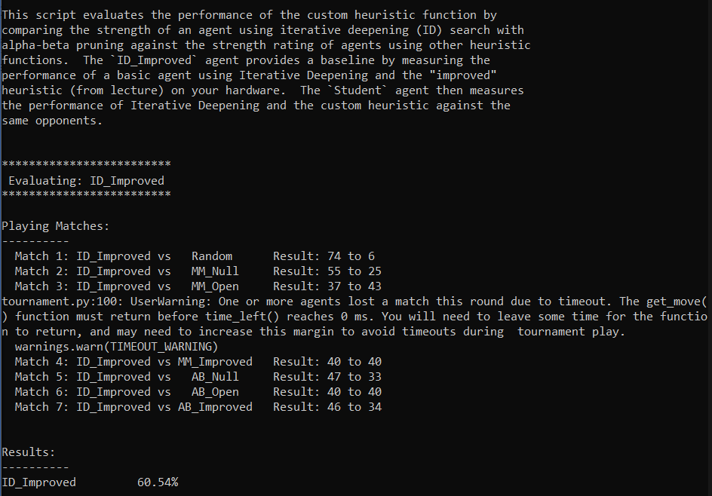

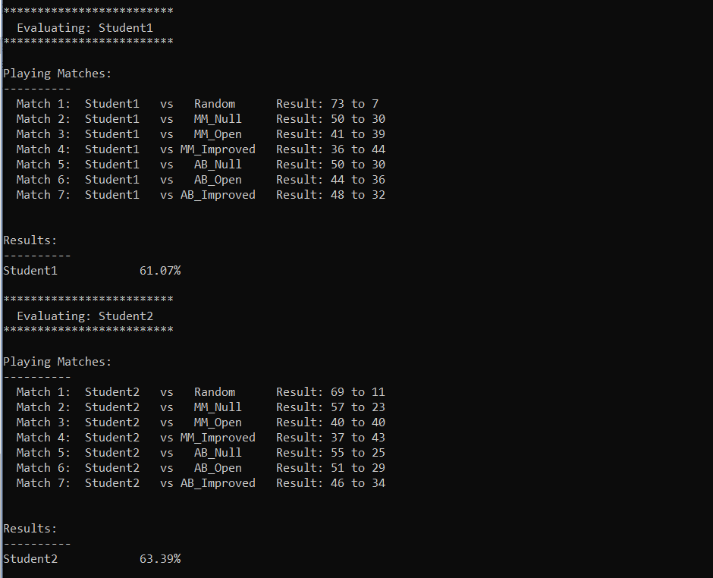

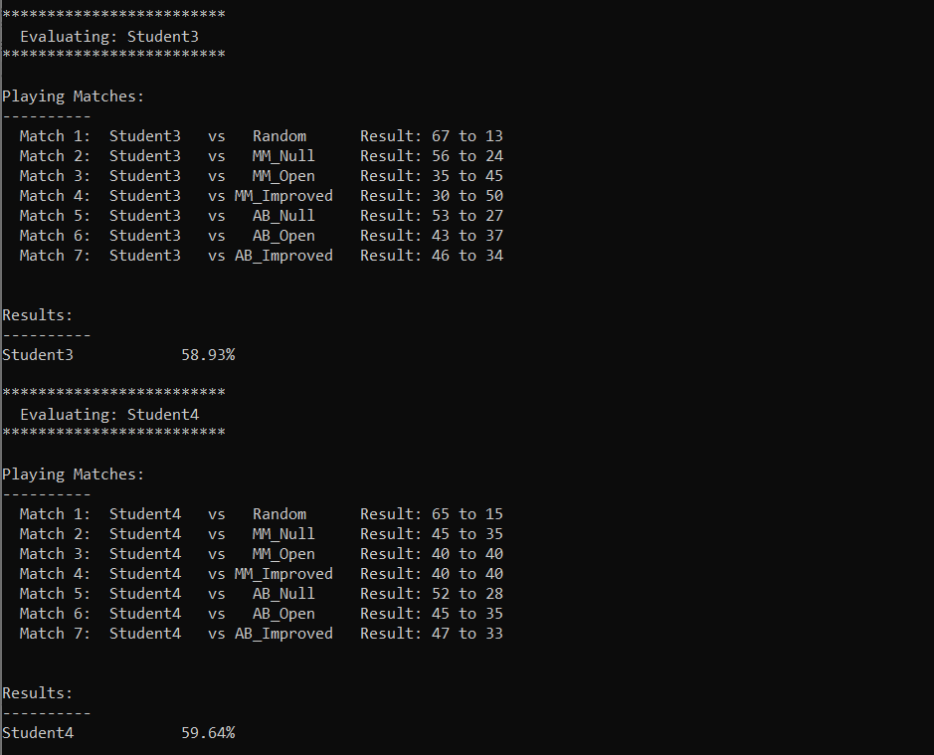

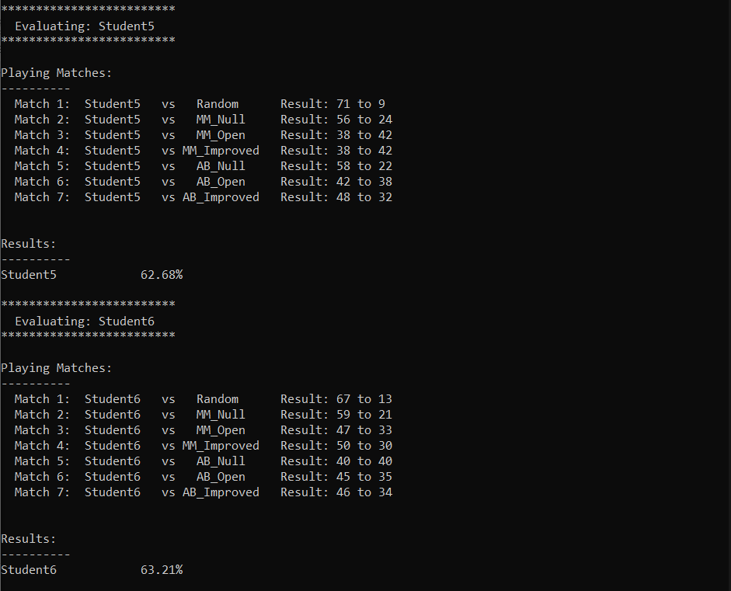

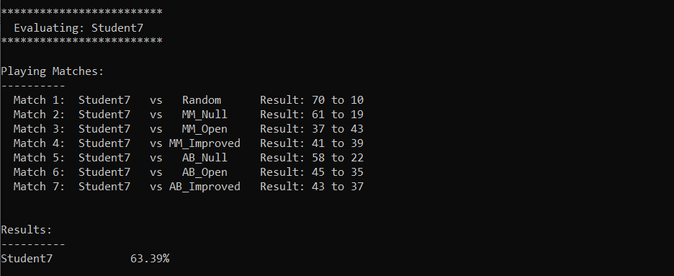

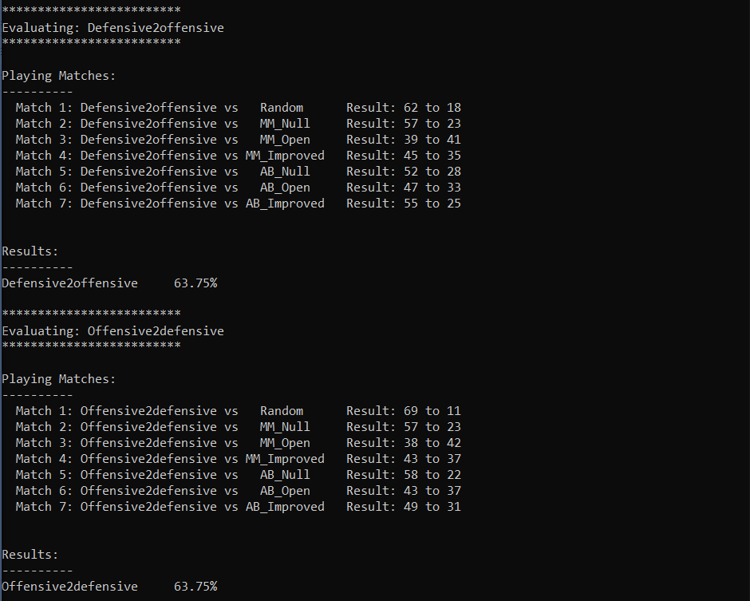

The raw evaluation result stated in *Table 2* is stated below:

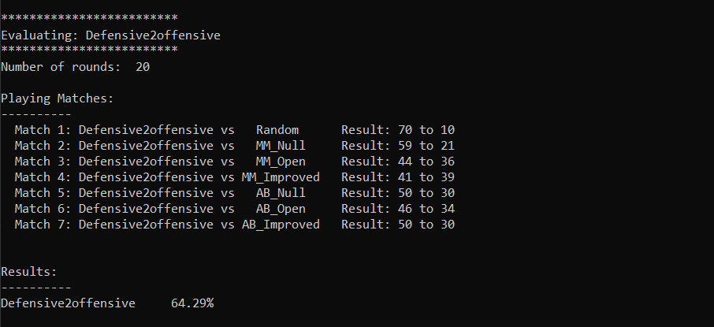

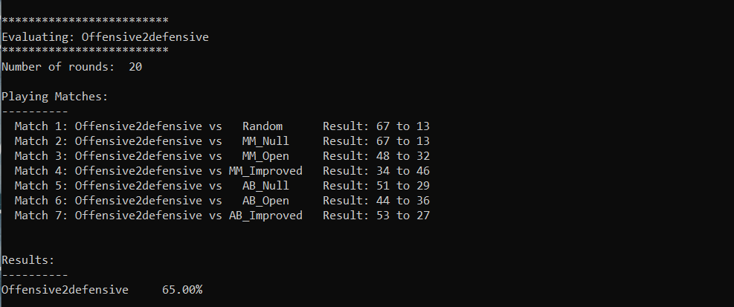

Conclusion: The custom_score function will implement **Offensive2defensive** as it outperforms all other heuristics with win-rate **65%** which is the highest among all.