

**Group 5**

**High-five Biz Gp 5**

**High-five**

**Business Plan**

**Created on December 6, 2020**

Table of contents

**Ⅰ. Company Overview4**

1. Brief Introduction

2. Average Customer

3. Existing Problems

4. Solutions to Existing Problems5

5. Legal Structure6

6. Mission Statement

7.Things Needed to Run the Business

8. Location

9. Future Goals7

**Ⅱ. Our service8**

1. In a Nutshell

2. Content Creator’s Videos/Contents Translation Service

3. Translation Service9

4. Interpretation Service10

5. Pictorial Overview of our Services ...............................................................................................................................11

**Ⅲ. The Market12**

1. The 2 Competitors....…..………………………………………………………………………………………………13

2. Barriers to Entry.............................................................................................................................................................15

**Ⅳ. Marketing Strategy17**

1. Product

2. Price18

3. Place

4. Promotion19

**Ⅴ. Advertising20**

**Ⅵ. Operations22**

1. Staff Titles and Roles

2. Facilities, Supplies and Equipment23

3. Daily Actions and Tasks

**Ⅶ. Financial Planning25**

1. Income Statement

2. Investments-worthy Business

3. Break Even Calculation

4. Break Even Point Graph.…………………………………………………………...............................................……26

5. Possible Adjustments

**Ⅷ. Risk Analysis28**

1. General-specific Risk

2. Industry-specific Risk

3. Company-specific Risk

**Ⅸ. Launch29**

1. Gnatt Chart

**Ⅰ. Company Overview**

**Brief Introduction**

High-five is a translation service company which is under the translation industry. Our company primarily offers 3 types of translation services.

Firstly, the company aims to help social networks such as Facebook and online video platforms such as YouTube’s content creators translate their videos or any other form of contents.

Secondly, the company focuses on helping companies and educational institutions translates newsletters, documents, notices, videos, websites, advertisements and so on into another language that our company offers.

Thirdly, the company provides translators to companies and schools to assist in translation needs such as overseas video conferences, business meetings, business trips, international trades and deals and foreign visitors to school or company.

For a start, our company will be only offering translation services in languages namely, English, Chinese, Russian, Vietnamese and Hindi.

**Average Customers**

Our company’s target customer groups are online content creators, schools and companies. Basically, any staff within a school; or employees or executives within a company are our primary customers. Any online content creators who wish to get their digital contents subtitled/translated into several languages are also our targeted audiences.

**Existing Problems**

Firstly, a lot of times, if one is to look through the comments section of a YouTube video, for example. There are many comments whereby people say that they cannot understand what the video is saying because it is in a language that he or she does not understand. Also, there are many comments that hopes for anyone to help translate the video into the language he or she can understand.

Secondly, in schools or companies, non-Korean websites, newsletters, notices and so on are either poorly translated or parts of it are not translated at all when compared to the Korean version. For example, comparing a Korean webpage to the exact webpage, in English, one can clearly see that the Korean one is flooded with updates and notices but the English barely have anything.

Thirdly, a first world and international-trade-dependent like South Korea, there will be times where one needs to strike a deal or have an important meeting with another country. However, given that Korean is only used in Korea and there may not be a common language between the Korean school or company and its counterpart, this will cause a serious language barrier and potential loss in the deal.

The reason why the problems exist is simply because, for the first issue, most online content creators only translate or subtitle their video into English if the main language in the video is not in English. It is understandable from the creator’s perspective because the general crowd should probably be able to understand English. However, there are always people that do not.

With regards to the second problem, the school or company lacks a translator. For example, in the first problem, a school or company may not have enough manpower to translate the documents or videos. On top of the manpower issue, the person may not be proficient enough to translate the documents or videos. Thus, due to the lack of manpower which is equivalent to the lack of time and the proficiency of the person, it results in poor to zero translation.

As for the second problem, schools and companies may not want to hire someone who simply only do translation as his or her job. From the schools and companies’ perspective, it may be a waste of money and it is difficult to find someone who is able and qualified to translate multiple languages. In the end, the language barrier problem arises when there needs to be communication with another party who is unable to speak a common language.

**Solutions to the Existing Problems**

Our company have the perfect solutions and services to solve the above problems.

Regarding the first problem, our company have a range of languages which can be translated or subtitled into the video which can be an advantage for the content creator because, by having more languages for the video, it will mean that more people will view the video; even those whom cannot understand English nor the language in the video. In return, the content creator will be able to earn more revenue through his or her videos.

As for the second problem, schools and companies can hire qualified and proficient translators to help translate needed documents, webpages, newsletters and so on; be it full-time or periodically.

Lastly, for the third problem, if the company or school do not want to hire a full-time employee to purely do translation but rather someone who can help in the translation just for a period of time, our company have such a service too. Our qualified and proficient translators can be hired for just a period such as during an overseas video conference or business trip.

**Legal Structure**

Our company’s legal structure will be Limited Liability Company(LLC). All 4 members are co-owners in our company. Profits and losses are shared based on financing capital percental.

**Mission Statement**

To ensure reliable, right and quality translation anytime, on time, every time.

**Things Needed to Run the Business**

Apart from basic office furniture and fixtures, the key for the business to run is our translators. We aim to only hire qualified and proficient translators who have passion to work in the translation industry. In order to ensure the proficiency of our translators, non-local language certifications are a must and renewal of the certifications soon before expiration are a must too. For example, if a Korean wants to work as a English translator, he or she must minimally hold certifications such as Test of English for International Communication(TOEIC) and Test of English as a Foreign Language(TOEFL) certifications.

**Location**

Our company will be at Yeouido Business District(YBD) area, 1 of the top 3 Central Business District areas in Seoul. The reason why we chose YBD area to establish our company is because, through researches, YBD area have the greatest number of companies that do international businesses. Thus, by placing our company is YBD area, we hope to be able to reach out those companies more easily.

**Future Goals**

Our company’s goals are split into 2 parts. Firstly, our company will be located in Seoul; in other words, most of our customers will probably be from the Seoul area. However, given enough capital and reputation, we will hope to open our business in other regions of Korea such as Busan and Incheon which also have a good number of companies that do international trades and businesses.

Secondly, as a start-up company, we are only offering translation services in 5 different languages. However, as time passes, we will want to expand the number of languages our company can offer so to appeal and attract different and more customers.

**Ⅱ. Our Services**

**In a Nutshell**

As High-five is a start-up company, we may lack the expertise of translation skills compared to other major translation companies. However, language contains the sense of the society’s flow which means that it changes over time. High-five consists of young workers from various countries to get the sense of language flow which is changing or newly-built by the young. This is the competitive aspect of High-five; world trendy. It matches with the Internet property that is going worldwide. The increasing number of YouTube creators and social network service(SNS) influencers are trying to promote themselves to the world by social media. Thus, for a start, world trendy characteristic of High-five will prioritize work for the individual workers for their profit and also for their comfort rather than providing translating services to the major companies as we hope to first gain some reputation and reliability, in order for the major customers to trust us and work with us.

High-five is providing three types of translating service. Firstly, we translate visual media into subtitles for SNS users such as YouTube creators. Secondly, we translate the documents for the general public and students too. Thirdly, we provide simultaneous interpretation services for conferences or for schools in 5 different languages.

**Content Creator’s Videos/Contents Translation Service**

High-five offers accurate and high-quality multilingual subtitles through 1-to-1 customized translation. We are able to provide native-like translation in various languages compared to simple and sloppy translation provided by open-source websites. Our translators are young and trendy people; thus, we are confident that we can provide accurate translated subtitles or contents with humor for the viewers.

First of all, we will have meeting with customers to get their prior request such as what or how they want to convey their message in a specific scene.

Secondly, we will make optimal translation for each scene’s subtitles using appropriate memes and trendy buzzwords in the target country and explain why the translation is so and what nuances it is. If the customer wants to revise or change something, we will reflect the customer’s feedback and will be reconfirmed. In rare cases, if the deadline is not met, we will refund a portion of the translation fee(maximum full amount) back to the customer. If the customer is satisfied, subtitles will be provided after checking the time code of subtitles on the screen.

YouTube and SNS are borderless platform used by over 2 billion people around the world. There are many different advertisers all around the world who want to advertise their business. Creators can earn advertising revenues as advertisements that will appear on the creator’s content on YouTube or SNS. Our service will be needed for creators who want to effectively advertise their content in various countries.

Below is a typical workflow on how our content creator customers can request for our service to the point they receive our service.

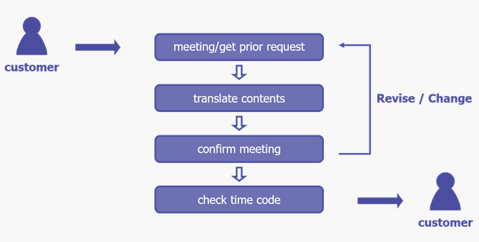

**Translation Service**

Our company’s second service is our translating service. We cover various kinds of translations such as letters, news, articles, books and thesis, etc. Unlike other major translating companies, our company will want to focus more on individual’s tasks rather than large-scale business tasks. Reason being, usually people hesitate using major translation company for small-scale translations due to its price. Thus, we want to give these people an opportunity to translate their things in an affordable price.

For example, students who want to translate their thesis into another language or people who want to news or magazines into another language. Such cases may be too costly to get it translated in a major translation company yet translating them using an open-source translator may be ineffective too. Thus, our company is the middle point for a reliable and cheap translation. Our company can handle such cases at a lower cost than any other translation companies in Korea and most importantly, still maintaining its translation quality. Customers can first send a summary of what they want to translate, allowing us to access whether or not we are able to translate it properly. It is because we want to give customers the assurance that we can do a perfect job before actually entrusting us with the full work. When both the customer and our company agree to the service, we will send a message to the customer for his or her payment. In a digital world that we are living in, customers are able to contact us via the internet or any calling platforms but of course, customers can also fell free to drop by to consult us face to face.

**Interpretation Service**

Our third and final service is our interpretation service. As globalization continues to be a critical part of life, meeting with someone who does not speak one’s language is never a strange thing. Having said that, communication without a common language is also a challenge. It is perfectly fine if both oneself and the other party can speak a common language but, as reality it is, it is often not the case especially between 2 people from different countries. Not to worry because our company is the solution. We have qualified interpreters who can help in the interpretations, not only during a meeting or business deal, but also even for a more 1-to-1 cases. Moreover, similar to our other services, we always aim to be charging at a lower price compared to other interpretation companies. We provide interpretations in the 5 different languages we offer and the charges are on a subscription basis.

**Pictorial Overview of our Services**

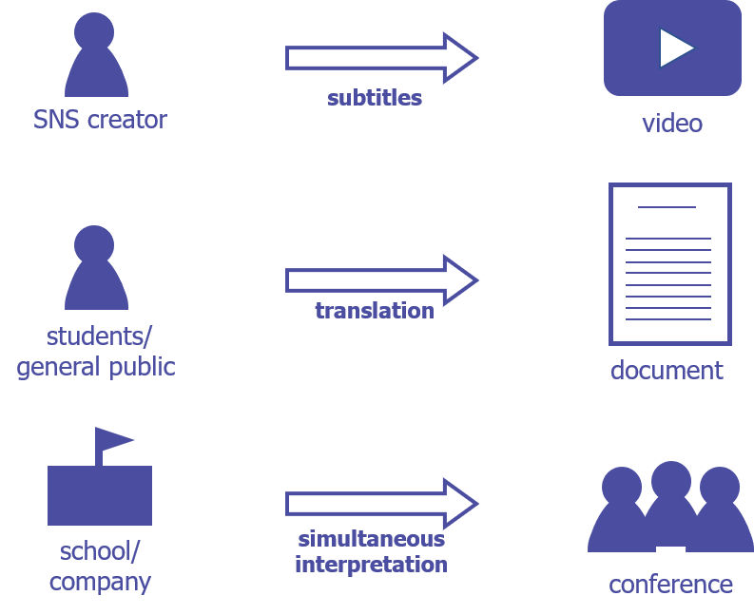

**Ⅲ. The Market**

Nowadays, the amount of interaction with people from foreign countries increases as globalization continues to be of vast importance. However, not everyone has the ability to speak a foreign language. Thus, in order to help these group of people, many translating and interpreting companies have been established. Normally, such companies are not hard to enter as long as one is proficient in the language. However, the truth is, the translating and interpretating market is not that easy. The 2 most important aspects for such a market are professionalism and preciseness. To achieve proper interpretation and translation, the interpreter and translator should first understand the contents they are going to translate or interpret with precision. Also, it is important for them to have sufficient knowledge regarding the contents they are tasked to.

For example, for a tourism interpreter, he or she have to understand the culture and custom of the country. For business-to-business interpretation, vast knowledge of the content which the interpreter is crucial. Also, at times, some business deals may have technical words too. Thus, having a great range of more industrial or technical words are needed and critical too. Therefore, major translation and interpretation companies have a wide range of professional and skilled translators and interpreters to handle kinds of tasks.

It is inevitable for newly-built companies like ours to be overwhelmed by the professionalism by larger and more reputable translation and interpretation companies. Thus, it is hard for us to stay competitive against our industry opponents. Worst still, in the event of having mistranslation mistakes, the company’s reputation will be worsened and other customers may withdraw from their transactions. Thus, we felt that it may be challenging and unreasonable for us to immediately deal with official documents or business-to-business cases from the get go. Thus, for a start, we decided to shift our prioritize. As a start-up company, we decided to focus on trend, price, convenience and accessibility. Also, immediately having big clients is always good, but we want to focus on individuals first so to gain experience and goodwill. We would like to grab all opportunities even if the translations are minimum because to us, every translation counts and every reputation counts. We felt it is possible to gain more individual customers because, normally, if an individual has little to translate, he or she may not go to large translation companies due to its hefty cost. In addition, we decided to focus our attention in managing YouTube and SNS translation service which is a good direction to start with as most people nowadays have SNS and access YouTube frequently.

High-five mainly targets the market for content creators from social media. Here is an example of a happening that commonly happens in YouTube. An individual media creator who wants to expand his or her work worldwide made subtitles from his or her own language into other language. Then, people from that country or people who studies that language came to watch his or her video and started to make fun of him or her mistakes. This happens every time. The problem is that the creator may feel hurt but, more importantly, the creator is unable to deliver what he or she wants to his or her viewers. High-five can help these people with difficulties of translating the media through our translation service at a reasonable price.

This market also has a property that there is no limit to become a creator. Anyone, regardless of age, sex or nationality, can become one. However, the limitation always exists. Elderly who did not get enough education about language will face problem delivering their intention of the project that they are doing. Moreover, there are some statistics that the videos in YouTube with English subtitles get much more hits compared to the ones that does not have English subtitles. Due to this fact that hits are directly connected with the profit for the creator, the one who wants to earn money or wants his or her thoughts to be shared with a large number of people should use our service.

Therefore, High-five’s translating services are targeted to individual creators from SNS or YouTube corresponding to their desire to get what they want to do on a global scale.

**The 2 Competitors**

DayTranslations:

DayTranslations is an international translation company which have branches all around the world. They are a very reputable translation company, not only in Korea, but on the global stage. They were ranked 5th in Best Reviewed Language Companies and in Korea, they are 1 of the top and located in Seoul.

Although this company’ services can be mainly classified into 2; namely, translation and interpretation, what is special and made this company reputable is that they have translators and interpreters that are specialized in different fields such as travel, retail, healthcare and so on. This is a big strengthen of this company as it is extremely difficult for 1 translator to know well about each field especially when it comes to the technical words. Thus, this company provides a wide range of fields with specialized translators in the particular field. Also, they offer an exact total of 50 languages, which is 10 times more than what we offer. Lastly, they are a 24-hour operation business. This is another huge advantage of the company as this ensure that anyone can sure get a translator or interpreter at any time.

However, like there are always 2 sides to a coin, as reputable and professional the company it may be, the downside is that the charges are extremely expensive. For example, translating of documents. They charge at a rate of USD $0.12 per word. Assuming that there are about 500 words per page on average, that is USD $60 per page which is extremely expensive.

Elite Asia:

Elite Asia is another reputable and elite translation and interpretation company based all around Asia. The main branch is in Singapore but it has companies all over Asia such as Korea, Japan and Vietnam. Similar to DayTranslations, Elite Asia is yet another translation and interpretation company with strong goodwill and have won several awards along its way such as the “Work-life Achiever Award” in 2014 and the company is ranked the 20th largest translations, interpretations and localization vendor in Asia.

Similar to DayTranslations, Elite Asia too do provide translation and interpretation services but what made them stand out is that, unlike typical translation and interpretation companies, they provide proofreading and copywriting services too. Also, like DayTranslations, they have specialized translators and interpreters for different field of works such as academic translations, business translations, software translations and website translations. Having specialized translators for specific areas will give their translations an edge compared to their competitors when it comes to the right terms and words to be use for a certain field.

However, there are 2 downsides to Elite Asia. Firstly, the languages they provide are only languages from Asia such as Korean, Japanese, Vietnamese and Malay which means that clients who want to venture out of Asia and need translations in other languages such as Russian or French will not be able to get any help from the company. Thus, the company may indirectly lose customers as they are very restricted to Asia only. Secondly, unlike DayTranslations, Elite Asia is not a 24-hours operation business which means that if a customer or businessmen needs a interpreter urgently during at the night, Elite Asia will lose out in the deal and customers will go to its competitors such as DayTranslations.

**Barriers to Entry**

There are 2 barriers to entry that may stop us from entering the business. Firstly, when we, co-owners, have no experience in the specific field. Secondly, when we cannot reliably assess the quality of our work.

For the first barriers to entry, it basically means that if we, co-owners, have no experience in the translation industry, we may not be able to open up a business in such an industry. As for the second barriers to entry, if we do not have proof to show that we can translate work of great quality or show that we have the manpower to translate work professionally then we may be rejected to enter the industry.

However, having said that, we still strongly believe that we can do well and be successful in the industry and gain a good reputation in our business just like our 2 competitors. It is true that we may not have the experience just yet but we, co-owners, coming from a country that can speak at least 2 languages, we had a lot of opportunities, be it in school or workplace, to interpret and discuss work or tasks in the various languages. Although we may not have any practical or hands-on experiences in translating, being able to switch between languages is also a form of translation and quick interpretation. Thus, arguably, it is not entirely true that we have no experience.

Secondly, for the fact that we have yet to open up the business; thus, it is indeed difficult to prove that we have the ability to be as for professional translating standards. However, having the ability or not, time will only tell. Instead, we acknowledge that we may not be as good as reputable as those companies in the translation industry for a long time, but we do have other strong points too that may attract customers too. For example, our low charges which may be good for students whom have financial difficulties to go to a large company to give their work translated for an extremely expensive price. Also, unlike companies like Elite Asia, we do not only stick to Asia but we are venturing out of Asia, providing languages not in Asia too. Also, we are going to be a 24-hours business as times pass.

Thus, despite the lack in experience and ability to proof how good our translations actually are, we do have other strong points that even reputable companies do not have. Thus, we believe that we can be successful in this industry still.

**Ⅳ. Marketing Strategy**

**Product**

Practically, it is difficult to play fair for professionality with conglomerates. High-five will take low cost, convenience and familiarity as our advantages. We provide translation services for individual cases such as books, magazines, webpages, letters and thesis. We also provide interpretation services for 5 different languages; namely, English, Chinese, Russian, Vietnamese and Hindi. Besides these services, High-five have several unique features compared to most interpretation and translation companies in Korea.

24-hour operation:

Running our business as a 24-hour business is one of our aim when our business starts to gain strong reputation. It is so that interpreting and translating orders can come in at anytime around Korea. Some customers may suddenly need an interpreter in the middle of the night but most to all translation companies do not have a 24-hour operation which means that customers will have problem finding an interpreter. However, our company runs 24-hours which means that customers can disregard time factor and reach us anytime they want.

1-to-1 meeting with the translator:

Whenever customers have questions about the translated contents or have extra requests, we can also liaise the customer with the translator-in-charge to talk about it. High-five will allows strive to provide accurate and quality translations by reflecting and listening to our customers’ opinion actively.

SNS translation:

We handle translation of SNS professionally for customers who are curious about the meaning of foreign YouTube channels and other SNS such as Facebook and Instagram. We manage localization of foreign YouTube channels and social network accounts for Korea. High-five is made up of experts of latest trends in SNS such as memes for a more smooth and natural translation.

**Price**

|  |  |
| --- | --- |
| **Services** | **Prices and Rates (in USD)** |
| Document translations | $20 / page |
| Video translations | $22.50 / min |
| Meeting/Conference translator services | $25 / hr |
| Company/School attachment translator services | $30 / hr |

(USD $1 = KRW 1100won approx.)

Our prices were determined after comparing the prices of the respective services from various translation companies in Korea. We looked up on several translation companies in Korea, identify the similar services they offer to what we offer and then, look at how much it costs for the services. After comparing several companies, our pricings were by the average pricing of the respective services and then, slightly lowering the averaged amount.

However, our prices may still be steep for some people such as students. Thus, we decided that we cannot lower the prices any further but we decided to adopt a discount scheme through membership. Basically, customers are able to sign a monthly or yearly membership to get discounts on our services. On top of that, as a member of our company, members will be able to accumulate points whenever they use our services; in which the points can be used for future promotions and benefits.

Like most companies that provide services in Korea, advance payments are normally made. Thus, we too will be using the advance payment method for our payment terms. However, refunds and deduction in costs are possible in events such as wrong translations and not meeting the deadlines.

**Place**

Customers can either visit our company or contact us via phone, our webpage or email for inquiry. Customers can then send us abridgment of contents for translation. Then after, we will notify them if we are able to proceed or not. If it is possible, we will take the documents and redeliver them back to customer upon completion.

**Promotion**

In order to promote our business, we will be using 2 forms of promotion methods; namely advertising and sales promotion. As for advertising, firstly, we will be advertising our business through social medias such as Facebook and Instagram. Most people get information through social media nowadays and most people have social media. Thus, we thought that it will be a good way to promote our business. Also, we will create channels such as a Facebook page for our company whereby we will use it further promote our services and update our customers on any benefits or promotions.

Secondly, we will also want to do a partnership with advertising companies to help us advertise our business through platforms such as television advertisements, posters and banners and also, try to help us reach out to other companies and schools who are our primary customers.

Also, we will want to promote our discounts, benefits and promotions our company is having. Be it through social medias, advertisements or banners, we want to attract customers by telling them that we have sales going on. Everyone loves sales! Thus, through sales promotion with the help of advertisements, we hope to attract as many customers as possible.

**Ⅴ. Advertising**

High-five’s advertising strategy is to stress the importance of translation and subtitles. People use translation system to understand the context better or to deliver their messages to others with other countries. Misunderstandings of the context or having no skills to translate a certain language into another makes people feel frustrated. The advertisement was made to give people that sense of frustration which ultimately, we hope that people can feel the need of subtitles.

A couple of our advertising examples will be as follows below. The top image is for English users and the bottom image is for Korea users.

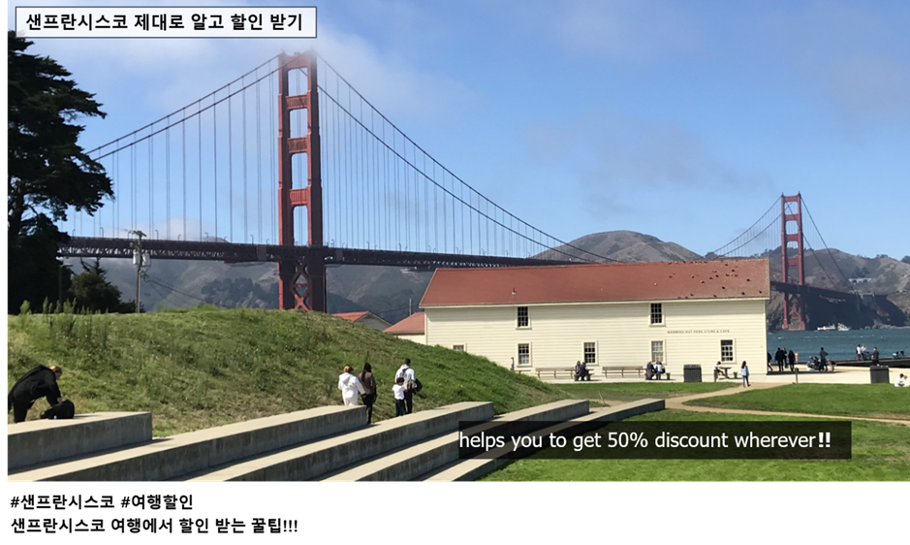

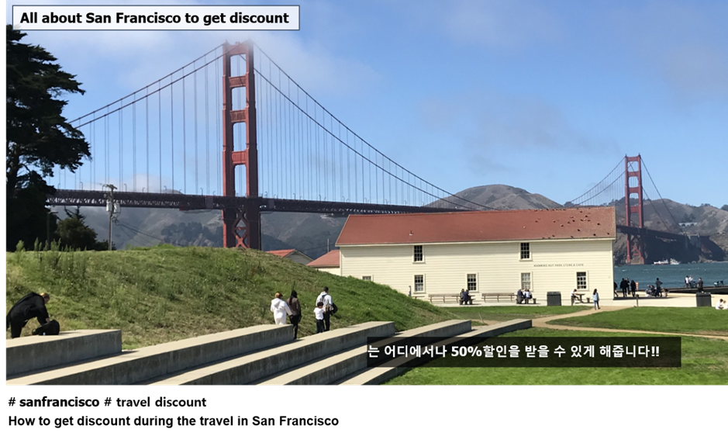

This advertisement can be an outdoor banner or a short video advertisement. It managed the situation that there is a lack of the most important information which makes people curious about what it is. By putting subtitles on the right side, where there are no subtitles on the left, the most important information which is how or where is missing. Therefore, people will feel that the video or an image is not fully done and feel uncomfortable. The person who is operating their own media will notice that the lack of subtitles in another language will make people uncomfortable. Knowing the importance of translating or putting subtitles through their own experience by this advertisement will make them use High-five services.

**Ⅵ. Operations**

**Staff Titles and Roles**

Apart from the 4 of us, co-owners, we are looking at hiring 10 to 15 employees for a start. Since our business is starting with 5 languages, we will want to have ideally 2 to 3 employees per language. Thus, the 2 to 3 employees will form a department. For example, in the English department, all 2 to 3 employees must be highly proficient in English or English as their native tongue. On top of English, among the 2 to 3 employees, there should have a good mixture of second languages such as Chinese, Hindi and so on. Basically, the employee first language will probably be the determining factor to which department he or she will go. Similarly, for the other departments; taking the Chinese department as another example. It could be 2 to 3 employees from China and they have 1 employee who is proficient in English, 1 employee who is proficient in Vietnamese and 1 employee who is proficient in Russian. On top of each employee having their own departments, there will be a department leader within each department. Thus, to summarize the hierarchy of our company, on the top, there are the 4 of us, co-owners, followed by the department leaders from each department and then, followed by the translators who are under each of their department leaders. Below are the roles and responsibilities of a department leader and translator.

Department leader:

* Assign tasks to translators
* Attend company/department meetings
* Do translation tasks (Documents/Videos translations, Video conference translations)
* Report department’s tasks-for-the-day to co-owners daily
* Report what the department done for the day to co-owners daily
* Research on language terminologies, taboos and culture trends

Translator:

* Attend company/department meetings
* Do translation tasks (Attachments, Documents/Videos translations, Video conference translations)
* Report to department leader what is done for the day
* Report to department leader what is to be done for the day
* Research on language terminologies, taboos and culture trends

**Facilities, Supplies and Equipment**

Facilities:

* Customer waiting reception area
* Main working office area
* Meeting rooms
* Refreshment area
* Video conference rooms

Supplies / Equipment:

* Computers and laptops
* Dictionaries and thesaurus
* Files
* Papers
* Projectors and projector screens
* Snacks and drinks
* Stationeries
* Tables and chairs

**Daily Actions and Tasks**

As for now, the operating hours for our company will be from KST 08:30 to 17:30 with an hour lunch break from KST 12:00 to 13:00. However, as our business starts to get busier and prosper, we will want to have employees who can do night shifts. This will be 1 of our business’s unique areas whereby we do cater translation services during the night too. For example, if a customer needs a translator to join him/her on a business trip whereby he/she needs to depart during the night. This is when our 24-hour business comes into play. Just like our mission statement suggests, we are always available anytime and every time. Thus, apart from the standard working hours, we may go into a 24-hour business in the future. Nevertheless, below are the daily actions and tasks of a department leader and translator on a typical day.

For the translator, the first thing he or she needs to do when he or she steps into the office is to report what needs to be done for the day, together with the deadlines, to his or her department leader. Then after, he/she can start any translation works that need to be done such as translating of documents or video conference translations. If the translator is attached to a company or school, it is up to the company or school’s judiciary to task the translator. However, daily reporting on the progress to the department leader needs to be done. Also, during his or her less busier times, as a member of our company, he or she is required to do research on the language terminologies, taboos and culture trends of the country of the respective language. We felt that this is important for our translators as different countries may have different ways of expressing things and ways things should be expressed in. For example, even in the same language, English, British and American English spells the word colour/color differently. Thus, it is important to research and know such differences to avoid unnecessary mistakes. Especially, taboos. If a certain country has some words that may be a taboo to them, a good translator will definitely want to know and avoid using it when translating. Lastly, before knocking off work, the translator is required to report what was done for the day to his or her respective department leader. Also, not daily but if needed, he or she may need to attend company meetings or department meetings too.

Similar to a translator, a department leader daily routine is pretty much similar; except he or she only reports to any of the co-owners, daily, after all the translators have reported to him or her during the start and end of work. Similarly, a department leader will also have to research on language terminologies, taboos and culture trends of the country of the respective language during his or her less busy times and do translation tasks too. However, the difference with a translator is that he or she will not be tasked an attachment as the department leader needs to be in the office to oversee the whole department. Also, he or she may need to attend company meetings or carry out a department meeting whenever needed. Furthermore, he or she is responsible in managing his or her manpower and assigning jobs to the translators whenever work comes in.

**Ⅶ. Financial Planning**

**Income Statement**



**Investments-worthy Business**

Investing into our business is definitely worthwhile because, just judging from the income statement above, one can see that there will be an increasing trend in the revenues earned as months pass while the expenses incurred on the variable costs will show a decreasing trend. This implies that the net income will show an increasing trend as time passes. As seen in the income statement above, our business is expected to take a turn for the better during May. Thus, investing into our business will ensure profit in the long run.

**Break Even Calculation**

Variable Cost per Unit = ($120,000 + $4,200 + $10,080 + $60,000 + $420,000) / 76785 = $8

Document translations = $20 / page

Video translations = $22.50 / min

Meeting/Conference translator services = $25 / hr

Company/School attachment translator services = $30 / hr

Price per Unit = ($20 + $22.50 + $25 + $30) / 4 = $24 (approx.)

Total Fixed Expenses = $1800 + $650 + $400 = $2850

Break Even (units) = Total Fixed Expenses / (Price per Unit – Variable Cost per Unit)

= 2850 / (24 – 8)

= 178 units (approx.)

Break Even ($) = 178 x 24 = $4272 (approx.)

**Break Even Point Graph**



**Possible Adjustments**

As of now, in terms of the prices for each of our services such as $20 / page for translating of documents, we try to keep it as low and reasonable as possible given that we are just a newly built business. Also, when we anticipate the budget for each area of our expenses, we gave a decent markup margin just in case we overspend. Thus, judging from our income statement, if everything goes as planned, there would not be any adjustments for the first year.

However, moving on to the near future or the future, we hope to increase the cost of our services bit by bit as we get more reputable. This is so that we can generate more revenue but, of course, our services must be on par or even better than what we are charging.

Also, there are 3 variable costs that we hope to reduce as years pass; namely, training, advertisement and equipment. We believe that we can reduce these 3 costs as time passes. For training, when we have enough trained employees and no new translators enter our company, there would not be a need to send anyone for training. Thus, we can save the training expenses for other things. As for advertisement, for the first year, we decided to put a large sum of money into advertisement so to publicize our company more and gain reputation in the translation industry. However, when time passes, if things goes well and people knows us even if we do little to no advertisements, then we can cut the advertisement expenses. Lastly, for equipment, when we start a new company, a lot of money will go into buying of equipment such as tables, chairs, workstations and so on. However, such fixed assets do not depreciate so quickly nor need to be changed monthly or yearly. Thus, at the start, a lot of money will go into equipment but as time passes, we are certain that lesser and lesser money will be spend on it.

**Ⅷ. Risk Analysis**

For a more stable business operation, we need to consider and prepare for several risks in our business. We have listed the possible risk and analysis how we can minimize these risks. The risks can be grouped into three categories; namely, “General-specific Risk”, “Industry-specific Risk” and “Company-specific Risk”.

**General-specific Risk**

There are already several translation, subtitle and interpretation company in the market. This is a very common risk for companies entering the market for the first time because customers using other companies’ translation service are more likely to receive services through same company rather than unverified and new company. Therefore, it is considered, of great importance, to have price competitiveness. We will have unconventional marketing for a certain period after our grand opening to attract customers. Then, we will give more discounts when they bring in other customers and advertise that using paid memberships will be their long-term benefit.

**Industry-specific Risk**

Nowadays, Internet browsers such as Chrome and Microsoft Edge as well as YouTube provides free services that translate pages or create subtitles internally. These translations are used by individuals who do not consider mistranslations as a major drawback. To attract those individual costumers, during advertisement targeting individuals through social medias, we will include advertisements that show how unnatural translations can distort the meaning of what should be the right translation.

**Company-specific Risk**

As High-five is a start-up company, it can be tough to obtain start-up capital which will affect operations greatly. It is especially likely for our company as we will be running promotions to get a lot of customers early on. To minimize the difficulty of obtaining working capital, we will take advantage of government start-up subsides for young people. By using the government subsides, we will take a long-term profit after getting a large number of customers with our initial advertising expenses.

**Ⅳ. Launch**

We have decided to hold our company’s grand opening on the 15th of December 2020, slight just before the end of the year; which is also the reporting period for various results and plans of many companies.

Before launching, we will make an advertisement and decide which channel to advertise through. To reduce rent, we will get facilities, supplies and equipment a month in advance before launching our opening day. After bring in the facilities, we will have essential training about our company’s systems for each of our positions. Then after, when we are ready, we will start advertisement through social medias a few weeks before the grand opening.

After the grand opening, we will start our price reduction promotions for a limited period of time. Whenever we get customers, we will try to persuade them to sign-up for our memberships. Since there is a lot of initial expenditure early on in our business, we will get additional financing through business loan if needed.

**Gantt Chart**

The table below shows the Gantt chart of our company.

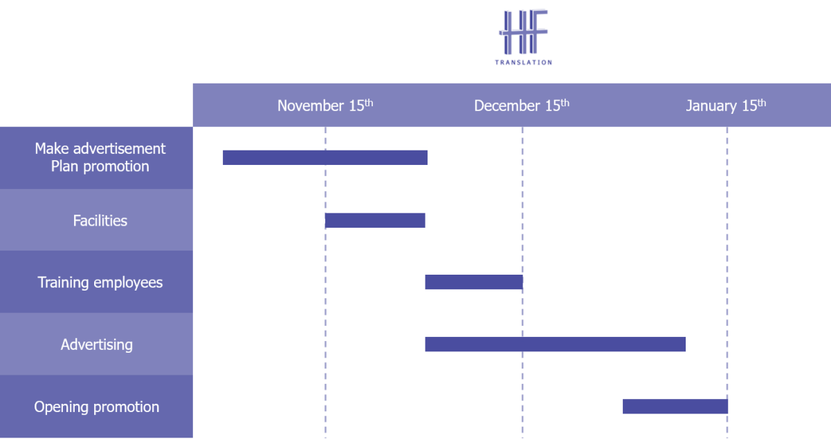

|  |  |  |  |  |  |
| --- | --- | --- | --- | --- | --- |
| **Criterion** | **4  A-level qualities** | **3  B-level qualities** | **2  C-level qualities** | **1 or 0  D- or F-level qualities** | **Score** |
| **Overview / Summary Description** | Effectively answers questions on homework, goes beyond section by including components discovered through research, and shows realistic depth of understanding. | Effectively answers questions on homework and goes beyond section by including components discovered through research. | Satisfactorily answers to questions on homework. Does not show further development. | Does not fully answer questions from homework, and/or shows lack of effort and understanding. | 4 |
| **Product/Service** | Effectively answers questions on homework, goes beyond section by including components discovered through research, and shows realistic depth of understanding. | Effectively answers questions on homework and goes beyond section by including components discovered through research. | Satisfactorily answers to questions on homework. Does not show further development. | Does not fully answer questions from homework, and/or shows lack of effort and understanding. | 3 |
| **Marketing Plan** | Effectively answers questions on homework, goes beyond section by including components discovered through research, and shows realistic depth of understanding. | Effectively answers questions on homework and goes beyond section by including components discovered through research. | Satisfactorily answers to questions on homework. Does not show further development. | Does not fully answer questions from homework, and/or shows lack of effort and understanding. | 3 |
| **Operations** | Effectively answers questions on homework, goes beyond section by including components discovered through research, and shows realistic depth of understanding. | Effectively answers questions on homework and goes beyond section by including components discovered through research. | Satisfactorily answers to questions on homework. Does not show further development. | Does not fully answer questions from homework, and/or shows lack of effort and understanding. | 3 |
| **Financial Plan/Funding** | Effectively answers questions on homework, goes beyond section by including components discovered through research, and shows realistic depth of understanding. | Effectively answers questions on homework and goes beyond section by including components discovered through research. | Satisfactorily answers to questions on homework. Does not show further development. | Does not fully answer questions from homework, and/or shows lack of effort and understanding. | 4 |
| **Risk Analysis** | Effectively answers questions on homework, goes beyond section by including components discovered through research, and shows realistic depth of understanding. | Effectively answers questions on homework and goes beyond section by including components discovered through research. | Satisfactorily answers to questions on homework. Does not show further development. | Does not fully answer questions from homework, and/or shows lack of effort and understanding. | 3 |
| **Launch** | Effectively answers questions on homework, goes beyond section by including components discovered through research, and shows realistic depth of understanding. | Effectively answers questions on homework and goes beyond section by including components discovered through research. | Satisfactorily answers to questions on homework. Does not show further development. | Does not fully answer questions from homework, and/or shows lack of effort and understanding. | 3 |

**Other:**

**Total Points __23__ / 28**

Very well done. Please take note that earning a 3 for each section is what is considered good. That means that the business plan has been completed to a degree that would be expected for this class, and all sections were completed to the level required. Earning a 4 on a section shows you have gone above what was expected, and earning below a 3 means there are areas missing or in need of great effort and explanation.

Your group has done well, especially in the overview and financial sections. Please see above.

Thank you all for your hard work and effort!