

**D&B Burger Shop**

**Business Group 8**

**Business Plan**

|  |  |  |
| --- | --- | --- |
| **Entrepreneurship English Business Group 8** | | |
| **Name & Student ID:** |  |  |
|  |  |
|  |  |

**Created on November 28, 2021**

Table of Contents

**1. Company Overview** 4

**Brief Introduction** 4

**Average Customers** 4

**Existing Problems** 4

**Solution to the Existing Problems** 4

**Legal Structure** 4

**Things Needed to Run the Business** 5

**Location** 5

**Future Goals** 5

**2. Our Products/Services** 6

**Overview of Our Products/Services** 6

**Our Products/Services (in detail)** 6

**Pictorial Overview** 7

**3. The Market** 8

**Our Target Market** 8

**2 Competitors** 8

**Barriers to Entry** 8

**4. Marketing Strategy** 10

**Products/Services** 10

**Price** 10

**Place** 11

**Promotion** 11

**5. Advertising** 12

**6. Operations** 14

**Staff Titles and Roles** 14

**Facilities, Supplies, and Equipment** 14

**Daily Actions and Tasks** 15

**7. Financial Planning** 16

**Income Statement** 16

**Investments-worthy Business** 16

**Break Even Calculation** 16

**Break Even Point Graph** 17

**Possible Adjustments** 17

**8. Risk Analysis** 18

**General-specific Risk** 18

**Industry-specific Risk** 18

**Company-specific Risk** 18

**9. Launch** 19

**Launch Date** 19

**Things to Do Before Grand Opening** 19

**Things to Do After Grand Opening** 19

**Gantt Chart** 20

# **1. Company Overview**

## **Brief Introduction**

D&B Burger Shop is hamburger shop that sells hamburger for people who are on a diet and workout (bulk-up) without servers. D&B Burger Shop is under the food industry and it is a fast food (hamburger) business.

## **Average Customers**

The average customers are people who are on a diet or do workout (bulk-up).

## **Existing Problems**

1. There are people who like hamburgers but cannot enjoy hamburgers because of their enormous calories and imbalance of nutrients.
2. People who are on workout (bulk-up) need hamburgers specialized in bulking up because the balance of nutrients in hamburgers is inappropriate.
3. There are people who do not come to the hamburger shop because they are afraid of infection of COVID-19 due to contact with employees in the COVID-19 pandemic.

## **Solution to the Existing Problems**

Our hamburger shop provides healthy hamburgers suitable for diet by replacing the ingredients of existing hamburgers with healthier ingredients. Also, we offer hamburgers that are more suitable for bulking up for people who is on bulk-up. Also, in order to reduce unnecessary contact with servers, we will serve hamburgers without servers using ‘sliding down serving’.

## **Legal Structure**

General partnership. It is because there are three members in our group and operating Limited Liability Company (LLC) or Corporation takes too much money. Thus, General partnership (partnership) is suitable for our group.

**Mission Statement**

To make hamburgers that anyone in the world can enjoy.

## **Things Needed to Run the Business**

Money needed to run the hamburger shop and employers who make hamburgers. Also, the place where the hamburger shop will be located and food distribution companies which provide ingredients for the hamburger shop.

## **Location**

Haeundae, which has a large floating population.

## **Future Goals**

Our goal is to expand our business to chain stores around the world. This will allow us to provide unique burgers and environment to people who are on diet or bulk-up on a more global stage.

# **2. Our Products/Services**

## **Overview of Our Products/Services**

Products

We have 2 main products for our hamburger shop; hamburgers for diet and hamburgers for bulking up.

Services

Serving by a serving slide. Food that are ready will slide down a slide to the customers. Thus, we do not have or need servers.

## **Our Products/Services (in detail)**

Products

Firstly, details about our hamburgers. By health-boom culture in Korea right now, we are going to serve 2 types of burgers. One, for people who want to lose weight, we prepared diet-focused hamburger. With whole-wheat bread on both top and bottom, we replaced greasy meat patties with pea-meat patties which has rich proteins. Also, we used sriracha sauce, for more healthy diet, sprinkled on fresh vegetables like lettuce, tomato and so on.

Bulk-up hamburgers are similar with the diet one but certainly different in their ingredients and nutrition. Meal for bulk-up should supply more calories than a person's basal metabolism. Thus, we need to create the burger with many carbohydrates and proper amount of fat for efficient weight gaining, naturally with lots of proteins for muscle growth. Between the whole-wheat bread, there are two bulky beef patties with two slices of cheese and fresh vegetables like the one above. Also, for those who wants to eat cleaner bulk-up burger, there are options to change beef patties to chicken breast.

Services

Secondly, details about our services. Because of the COVID-19 situation, we came up with Korea’s first sliding down serving. Cooking and making of burgers and meals are done on the 2nd floor and, when ready, the food will slide down to the first floor where the customers are.

This method will help us reduce costs of hiring employees for the eating area. Also, it will be a form of entertainment for our shop and also, an identity for our shop.

## **Pictorial Overview**

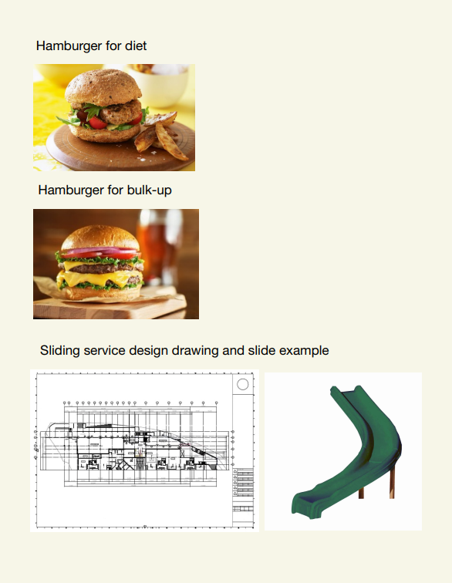

# **3. The Market**

## **Our Target Market**

We chose Haeundae as our target market because there are many floating populations who come to enjoy the attractions with beach. Also, there are efficiency apartments and apartments around the sights so there are many the resident population too.

We target two types of customers. Firstly, those who want to go on a diet or bulk-up. We call this group of people as our “exercising customers”. As our food is focused on healthy bulk-up and diet, we can attract the group with this strong point of concept. Secondly, the floating population who comes to the place for traveling. With our sliding down serving, which cannot be found in other burger restaurant, this will be an interesting point for the travelers who visit our restaurant.

## **2 Competitors**

In the main street of Haeundae, there are two main competitors; “Burger King” and “Subway”. Both the two restaurants are franchise and has similar menu. Against the two franchise restaurants, we thought of some concepts that can lead to competition. Most franchise restaurants have the same quality and kind of menu. This point is their strength and also their weakness. To seize the opportunity of this point, we decided on specialized menus with concepts such as “clean burger” for diet and bulk-up. Also, “Burger King” is infamous because of their high price, with common quality of burgers by franchised menu and ingredients. We selected fresh ingredients and handmade cuisine to have advantages against that point. Also, “Subway” has self-ordering system, selecting each of the ingredients by telling the employee, which is the marketing point of them. However, it is too inconvenient and not accessible for people who are shy. Thus, we changed the marketing point from ordering process to delivering (serving) process, our sliding down serving. These points will make us successful among our competitors.

## **Barriers to Entry**

There is one main barrier and one price-wise barrier that we thought are important. The main barrier that blocks us from entering the market is “Brand”. Since we are an unfamiliar individual brand, we need more effort and cost for marketing. Thus, we thought of two main points of our burger restaurant which can differentiate us from others to attract people. Also, Haeundae’s high rental cost is in proportion to accessibility of customers and travelers.

# **4. Marketing Strategy**

## **Products/Services**

What differentiates our product from other companies is that our hamburgers are healthy and suitable for bulk-up and diet. Usually, hamburgers are not suitable for people who is on diet because they are too calorie-rich for people to eat hamburgers or people who is on bulk-up because the nutrition in hamburgers is not balanced for people who bulk up. However, because our hamburgers are specialized for diet and bulk-up, people who is on diet or bulk-up would be interested in our hamburgers.

Furthermore, ‘No server’ is another special point about our product. In COVID-19 pandemic, people who are afraid of COVID-19 infection will want to minimize contact with others. Thus, our ‘no server’ service can make these people come without worries and impress people by giving them a notable experience.

Our Unique Selling Proposition (USP) is “The only hamburger that make your body better”. It implies that our burger can make you be healthier and bulk up too.

## **Price**

Diet burger: $6, Bulk-up burger: $8, side dishes: $3, drinks: $1.

Diet burger set: $9, Bulk-up burger set: $11.

According to pricing formula, Materials + Labor (Hourly rate x Time) = Cost. We expect the price of the materials needed to make the diet burger to be $2. Also, we expect to be able to make 10 of them per hour. Assuming that hourly rate is $10, Cost is $2+$10/10=$3. Therefore, since we are going to sell burgers directly to our customers, assuming that the markup is 2, the price of our diet burger is cost x markup = $3 x 2 = $6.

In case of bulk-up burger, since it contains more meat, it is expected to be more expensive than diet burger. Therefore, we can expect the price of the materials needed for bulk-up burger to be $3. Thus, the cost of bulk-up burger is $3 + $10/10 = $4 and the price of bulk-up burger is $4 x 2 = $8.

In the case of side dishes and drinks, they do not take much time to make so the cost of side dishes and drinks is $1.05 (materials) and $0.50 (materials) and the price of side dishes and drinks is $1.50 x 2 = $3 and $0.50 x 2 = $1.

The set menu must be cheaper than the sum of the members' prices to have a promotional effect. Therefore, we decided the price of Diet burger set is $9 and the price of Bulk-up burger set is $11.

## **Place**

We sell our products directly to customers at our hamburger shop. Thus, our distribution channel includes only producer and consumer.



## **Promotion**

We will run sales promotion. No matter how delicious and healthy our burgers are, it is useless if customers do not come to eat because of the relatively high price. Therefore, it is important to have access to our hamburgers through sale promotion when opening the store for the first time. Also, people who are on diet or bulk-up often need something to eat regularly. Thus, we will have membership discount so that we encourage people to buy our products regularly. Moreover, we will also run eating burger challenge to attract people's attention.

Lastly, we will also advertise through social network. Advertising through social network is relatively cheaper and more effective than promotions in other ways. If we spread the strengths of our products through social network, we can make many people come to the store.

# **5. Advertising**

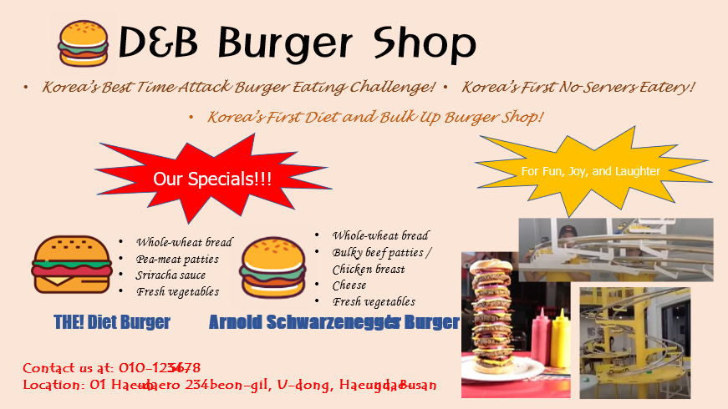

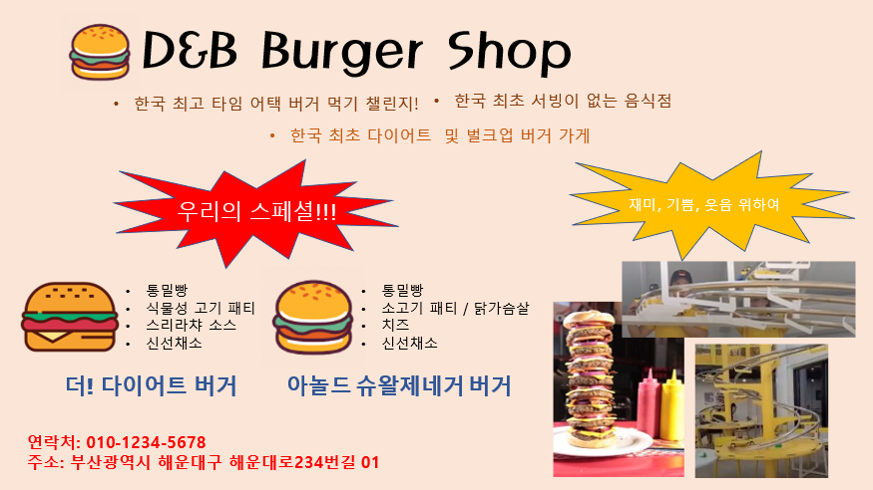

The advertisement really shows us in a nutshell. The general idea of the advertisement is not to show our menu but to bring out what we have but another burger restaurant does not. Right on top, we introduced that we are the first diet and bulk-up burger restaurant, first ever no serving restaurant in Korea and we have an eating challenge too. Also, the theme of our restaurant is diet and bulk-up so we showed our main menu that will put us on the map. Apart from the food, we also introduced distinct features of our restaurant like the serving slide and eating challenge.

Given the uniqueness of our restaurant and laying it out all in an advertisement, this will allow potential customers to know the uniqueness of our restaurant in a glance. Given the uniqueness and “diet and bulk-up” culture that Korea has, the restaurant will sure attract customers as the entire experience will not only be on the burger but also, the eating challenge and no server’s slide too.

Lastly, the advertisement ends off with our shop’s contact details and address at the bottom because we want to ensure that people who are interested in this whole new experience can find us.

# **6. Operations**

## **Staff Titles and Roles**

Apart from the three of us, co-owners, we are looking to hire approximately 4 to 5 cooks (including part-time cooks) for a start. Also, we are going to hire 1 general manager cum cleaner at the front of the house. The general idea would be that the cooks will be at level 2 preparing the food and sending the food down by the slider. The general manager would be at level 1 ensuing the tidiness of the place and also, assisting customers if should they need any help. Another role of the general manager is to convey any further requests by customers to the cooks if should there be any. As for us, co-owners, we can help out in both the cooking area at level 2 or host our customers, tidy up the place, and assist the general manager at level 1. Below are the roles and responsibilities of the cooks and general manager.

Cooks:

* Ensure that the ingredients are fresh
* Prepare the ingredients
* Prepare the meals as ordered
* Tidy up the cooking area after closing hours

General manager:

* Ensure the tidiness of the eating area
* Assist customers if needed
* Covey customer’s requests to cooks
* Greet and suggest table or seats to customers

## **Facilities, Supplies, and Equipment**

Facilities:

* Cooking area / kitchen (level 2)
* Eating area (level 1)

Supplies / Equipment:

* Self-ordering machine
* Food delivery slide
* Ingredients
* Tables and chairs
* Drinks
* Culinary tools
* Utensils

## **Daily Actions and Tasks**

The first thing the general manager does in the morning is to tidy up the eating area and get the self-ordering machine started. Whenever there are customers, the general manager must greet the customers and try to find a table for them. If any customers need help in the self-ordering machine, the general manager is expected to help too. If should there be any special requests from the customers, the general manager will need to convey the request to the cooks. During the end of the day, the general manager will need to check the total sales from the self-ordering machine and send the amount to the co-owners before closing the machine and the restaurant. Also, at times, the general manager should report any issues or complaints by customers to the co-owners.

As for the cooks, the first thing to do is to wash and get the culinary tools ready for use. When the fresh ingredients arrive, they need to check the quality and quantity of the ingredients. Then after, they will need to wash, cut, slice, or prepare the ingredients. Whenever an order come in, they will need to prepare the meal as requested. Also, they need to check if the manager comes up to the cooking area to notify them about any special requests. At the end of the day, they need to empty the trash, wash and tidy up the kitchen and ensure everything is in an orderly manner before they end work.

# **7. Financial Planning**

## **Income Statement**

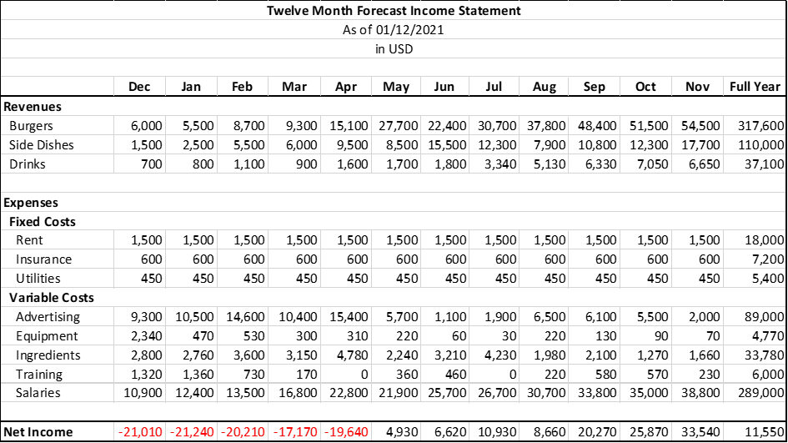

## **Investments-worthy Business**

Investing in our business is worthwhile as, judging from the income statement above, there will be an increasing trend in the revenues earned as months pass while the expenses incurred on the variable costs will gradually decrease. This implies that the net income will increase as time passes. As seen in the income statement above, our business is expected to take a turn for the better around May. Thus, investing into our business will ensure profit in the long run.

## **Break Even Calculation**

Variable Cost per Unit = (89,000 + 4,770 + 33,780 + 6,000 + 289,000) / 140,850 = 3

Burgers = $6 / burger (avg.)

Side dishes = $5 / side dish (avg.)

Drinks = $3 / drink (avg.)

Price per Unit = (6 + 5 + 3) / 3 = $5 (approx.)

Total Fixed Expenses = 1,500 + 600 + 450 = $2,550

Break Even (units) = Total Fixed Expenses / (Price per Unit – Variable Cost per Unit)

= 2550 / (5 – 3)

= 1,275 units

Break Even ($) = 1,275 x 5 = $6,375

## **Break Even Point Graph**

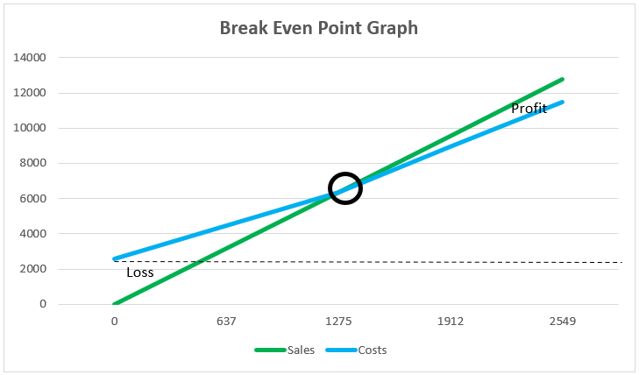

## **Possible Adjustments**

A possible adjustment will be on the advertising cost. As seen in our forecasted income statement, we kept our advertising high as we believe that it is important to keep our business advertise especially during our first year. However, nowadays, instead of the typical means of advertising through a advertisement company, social media like Facebook and Instagram are used for advertisement. Thus, if we shift our means of advertising to social media, we believe that we can save a lot of money on our variable costs. Furthermore, apart from us, customers will also use their social media to advertise our food and restaurant. Thus, we are certain that the advertising cost can be much lower than forecasted.

# **8. Risk Analysis**

## **General-specific Risk**

As we are a start-up restaurant and are unfamiliar to the industry, we need required experience in cash flow and marketing. For cash flow, we should carefully manage our capital, not to waste under reasoning that we are only in the start of our business and marketing for customers. Also, the quality maintenance problem in making delicious hamburger is important for us to manage our restaurant.

## **Industry-specific Risk**

As we are in a restaurant business, there are many common risks that we share. Stable condition of ingredients, training part-time workers, determining recipes and so on.

## **Company-specific Risk**

Among the risks that were mentioned, because we selected handmade hamburgers for our main menu, producing good and stable quality of food is the most important part. Also, the location that we are in, Haeundae, is a fierce battleground of restaurant business in attracting tourists and citizens. Thus, managing marketing strategy is also a big risk for us while running our business too.

# **9. Launch**

## **Launch Date**

Winter is a good season to diet or bulk up so there will be many people who want our products. Also, because there is a big floating population at the beginning of the new year, it is appropriate to launch the shop in the first week of January.

## **Things to Do Before Grand Opening**

Before launching our hamburger shop, we should research the market around the place where our shop will be located. It is necessary to investigate what stores are nearby, what people here want, and whether our shop is suitable for entering here. Also, we should find out the distributor that will provide the ingredients for our store. By comparing several distributors, we can find the best distributor for us. Furthermore, we need to analyze the cost and the benefit. It is necessary to figure out how much money we can spend and how much we can earn. Lastly, we need to hire and educate employees to work in our shop. If we are ready to open our hamburger shop, we have to start advertising through social media.

## **Things to Do After Grand Opening**

On the opening day, we will run opening sales promotion for two weeks. This is because it is important to attract a lot of people on the opening day and this can lead to a lot of regular customers. Then, we will also run eating burger challenge to attract people’s attention.

After the opening, we should also find out the problems of our business by checking which products sold well or not through sales analysis. Lastly, through customer feedback, we must accurately understand the needs of customers visiting our shop.

## **Gantt Chart**

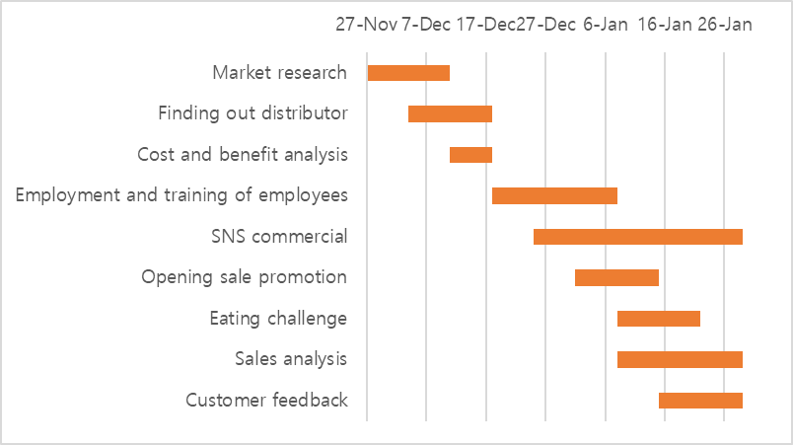

|  |  |  |  |  |  |
| --- | --- | --- | --- | --- | --- |
| **Criterion** | **4  A-level qualities** | **3  B-level qualities** | **2  C-level qualities** | **1 or 0  D- or F-level qualities** | **Score** |
| **Overview / Summary Description** | Effectively answers questions on homework, goes beyond section by including components discovered through research, and shows realistic depth of understanding. | Effectively answers questions on homework and goes beyond section by including components discovered through research. | Satisfactorily answers to questions on homework. Does not show further development. | Does not fully answer questions from homework, and/or shows lack of effort and understanding. | 3 |
| **Product/Service** | Effectively answers questions on homework, goes beyond section by including components discovered through research, and shows realistic depth of understanding. | Effectively answers questions on homework and goes beyond section by including components discovered through research. | Satisfactorily answers to questions on homework. Does not show further development. | Does not fully answer questions from homework, and/or shows lack of effort and understanding. | 3 |
| **Marketing Plan** | Effectively answers questions on homework, goes beyond section by including components discovered through research, and shows realistic depth of understanding. | Effectively answers questions on homework and goes beyond section by including components discovered through research. | Satisfactorily answers to questions on homework. Does not show further development. | Does not fully answer questions from homework, and/or shows lack of effort and understanding. | 3 |
| **Operations** | Effectively answers questions on homework, goes beyond section by including components discovered through research, and shows realistic depth of understanding. | Effectively answers questions on homework and goes beyond section by including components discovered through research. | Satisfactorily answers to questions on homework. Does not show further development. | Does not fully answer questions from homework, and/or shows lack of effort and understanding. | 3 |
| **Financial Plan** | Effectively answers questions on homework, goes beyond section by including components discovered through research, and shows realistic depth of understanding. | Effectively answers questions on homework and goes beyond section by including components discovered through research. | Satisfactorily answers to questions on homework. Does not show further development. | Does not fully answer questions from homework, and/or shows lack of effort and understanding. | 3 |
| **Risk Analysis** | Effectively answers questions on homework, goes beyond section by including components discovered through research, and shows realistic depth of understanding. | Effectively answers questions on homework and goes beyond section by including components discovered through research. | Satisfactorily answers to questions on homework. Does not show further development. | Does not fully answer questions from homework, and/or shows lack of effort and understanding. | 3 |
| **Launch** | Effectively answers questions on homework, goes beyond section by including components discovered through research, and shows realistic depth of understanding. | Effectively answers questions on homework and goes beyond section by including components discovered through research. | Satisfactorily answers to questions on homework. Does not show further development. | Does not fully answer questions from homework, and/or shows lack of effort and understanding. | 3 |

**TOTAL SCORE 21 /28 Points**

**NOTES:** To begin with, an average score for each section is 3 points. If you earn 4 points for any section, this means that section had gone above and beyond expectation. And anything lower than a 3 means that section is lacking information or is inadequate in some way. Therefore, if your total score is 21 or above, you have done quite well.

Overall, your plan performed as expected. Good job, and I would like to say that I appreciate your groups hard work and effort this semester.

Cal ^^