|  |
| --- |
| HW6. (Array of Structures)  (Open Source Programming 2019, Spring English class) **Class number: 060**  부산대학교 전기컴퓨터공학부 정보컴퓨터공학전공  201524582  HeeSeok Jeong(정희석)  Submission date: 2019-05-19 |

# Explanation for your codes (50 Points)

(1) Explain of key variables: extern and static variables must be explained.

A. This Program has two Key variable : typedef Struct Contact PB PhoneBook[MAX=50], int size. This variables are global variable, use all of source code such as register, search, delete, print. I define this global variable with extern variable in header file, can use all of source code that if include phone.h.

And each Program has static variable. Register.c has static int try that check user’s password input trial count, this variable shared in inside of register.c but another source code cannot access this variable. This is static variable’s characteristic. Search.c, Delete.c has static char array temp that store name that compare with Phonebook’s name, static int I that store search index number information. Finally main(phoneBookMain.c) has static variable int count_service, and implementation of extern variables size, password, PhoneBook.

(2) Describe the main data structure

A. I use structure type array structure, that named PhoneBook[MAX=50]; I consider using linked list, pointer, but this assignment require fixed number of Array(but not say only use array). This array is composed of this structure.

**[**Name[10byte]**|**PhoneNumber[15byte]**]**|…|**[**Name[10byte]**|**PhoneNumber[15byte]**]**

(3) Explain how to implement functions.

1. 스크린샷, 텍스트이(가) 표시된 사진

   자동 생성된 설명phone.h

* this header file contain basic variable of this Program.

Implement PhoneBook’s base structure Contact,

Define PB array PhoneBook with extern variable, can store 50 Contacts. Char array password,

int size store current array size

and define several Constant with number for easily change number of elements

1. 텍스트, 스크린샷이(가) 표시된 사진

   자동 생성된 설명phoneBookMain.c

* This code include main function, and role of Selection Service and UI.

Input selection from user, and execute matched function. While user input exit select.

1 : register

2 : print

3 : search

4 : delete

5 : exit

others : wrong selection.

Line 20’s getchar() role flush buffer.

1. register.c

* this code role register.

And assignment require check password process, I append checkPassword function, devide password checking process from registration process

* I use fgets function instead of gets function because of checking string size.

And append Line 15, Line 18 -> prevent print \n charactor.

* Use while loop and if condition, compare password and check trial count

1. 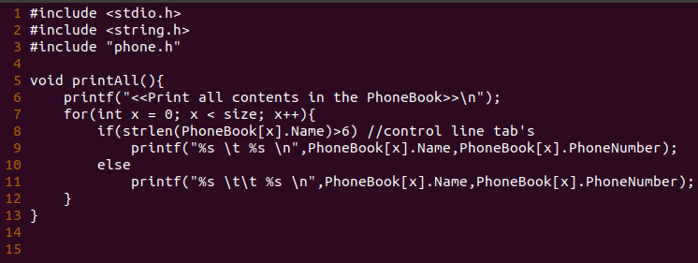print.c

I use if-else condition for controlling tab size with name string length.

1. search.c

- I use static variable for store string name for comparing name in PhoneBook, and index (originally I define static int index but string.h has char index -> crash!).

- Using fgets store name for search, compare with strcmp function in string.h

If find same string in phonebook, break loop and then index not same with size -> matched case!

- All loop complete –> index same with size -> that case mismatch

1. 텍스트이(가) 표시된 사진

   자동 생성된 설명delete.c

<same with search.c>

- I use static variable for store string name for comparing name in PhoneBook, and index (originally I define static int index but string.h has char index -> crash!).

- I devide delete and sort section from search and delete

- Deletebyname -> search name same with input name

- If find name on phonebook -> execute deletensort , Else -> exit.

- deleteNSort() use strcpy’s copy feature and remove previous data

* search matched index on static variable i, from that index to end of array, strcpy from next element to previous element and finally decrease size.

1. service.h

* 텍스트이(가) 표시된 사진

  자동 생성된 설명this code define function of main feature that register, print, search, delete for main source file.

(4) Describe makefile

This is my makefile based on last homework5’s makefile.

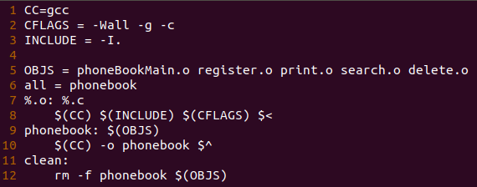Macro variable :

CC, CFLAGS, INCLUDE -> Setting of gcc

OBJS -> Object Files

All -> select main

%.o: %.c -> compile each c source code to same name of object file.

phonebook : link all OBJS to executable file named phonebook

clean : remove all object file and executable file.

# Program Execution (20 points)

1. Types of operating systems and compilers used
2. OS : Ubuntu 18.04.2 LTS based on debian linux

GCC : gcc (Ubuntu 7.3.0-27ubuntu1~18.04) 7.3.0

=> I can check Ubuntu version with ‘cat /etc/*release’ and gcc version with ‘gcc –version’ command

1. How to compile and execute the program //create makefile, make,
2. I can compile with gcc and make makefile & use make command -> make executable file(named phonebook) -> execute ./phonebook

* Make execute compile to c -> object file, link all object file -> executable file and

make clean execute remove all object file and executable file.

1. Include a screen capture for illustrating how the program works

* Register & Print
* Execute Program, first user register password -> execute register service check correction of password

* After check password right -> add User Name & PhoneNumber
* Can check added information with print all service

* This is password error case. We can try maximum 4 times, and if password incorrect, escape this function.
* Search

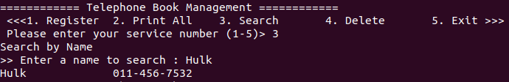

* Input name and same name exist on PhoneBook, print information of name.

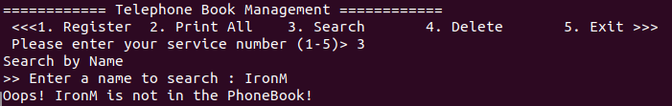

* If input name not in the phone book -> error message print.
* Delete

<Correct case>

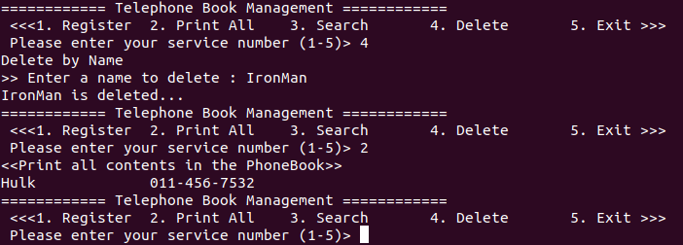

* Input name, can delete information of name -> this can check on print all service

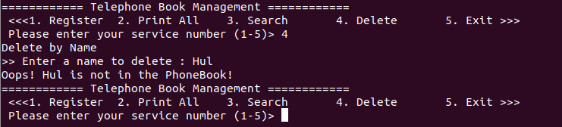

* If input name not in the phone book -> error message print.

# Github repository(20 points)

1. include github commands for cloning, adding, committing and pushing

* 1st I can check my status with ‘git status’ command

* 2nd then I can add my files for push with ‘git add *’ command(use * wild card)
* 3rd and commit added file to local repository for push with command ‘git commit’ and add comment with -m option.

* 4th check my status with ‘git status’ command,
* Finally use ‘git push’, I can push my files from local repository to remote repository.

1. After pushing the source code and the makefile to your github directory, include the screen capture image of the Github repository

* After my commit, push all activity, I can check my comment “19/05/17 Complete

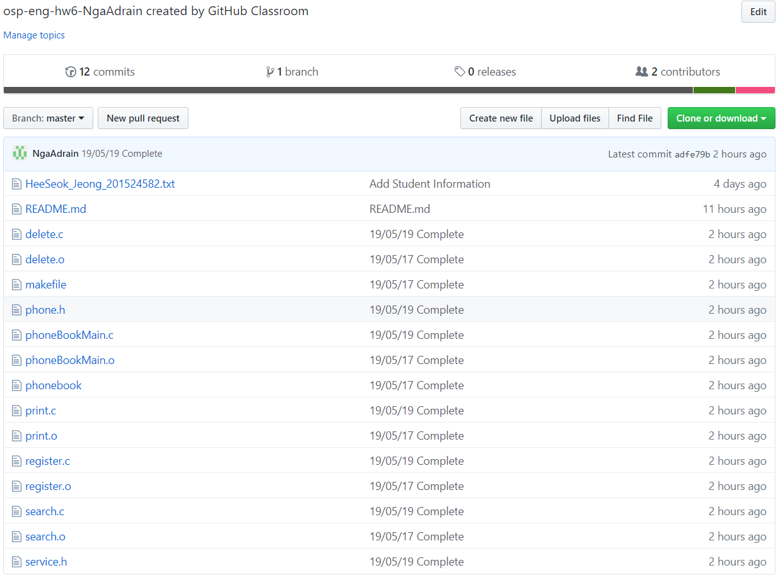

* This is result.

# Discussion (10 points)

- What you learned while doing your homework (contents other than class hours),

A. I can practice using github include clone, add, commit, push, and process of git that <1st. clone from remote repository to local repository(include pull) 2nd. After modify, create, delete add file to track 3rd. commit tracked file to local repository, finally push from local repository to remote repository.> , know concept of extern variable and static variable, how 2 use that variable with header file, and review making and using makefile.  
- Describe difficulties during homework

A. I have some difficulties with extern variable that how can I use that variable?(usage) and that solved with google search. And gets has security problem(with buffer overflow) I use fgets but problem occurred from fgets includes \n character -> that invoke printall function show weird result. Because of this problem I spend a lots of time to debug for solving this problem, and I can resolve this problem temporary that increase phonenumber’s size, and when register data add process that remove last \n character. And tab size occur uncomfortable view on print function that over 6 character on name, print length set different. -> this problem also resolve temporary that make condition when over 6 character, same or less than 6 character, append \t character once vs twice.

So. This assignment quite simple problem, but it was good chance to practicing what we learned.

Thanks for reading my report.