AUTOWASH PRIORITY BOOKING ENGINE
Course: Data Structures and Algorithms (CSD201)
Semester: SU2026

STUDENT INFORMATION
Field | Details
Full Name | Ngô Gia Long - SE190732
 | Nguyễn Anh Kiệt - SE190095
 | Ngô Hoàng Thái Dương - SE190177
Instructor | Huỳnh Công Việt Ngữ
Report Number | Report 3
Class | SE2019
Project Topic | AutoWash Priority Booking Engine

REPORT 3 — UML Modeling, Conceptual Framework & AI Audit
Objective: Finalize system architecture using UML. Design performance experiments. Maintain and analyze the AI Audit Log.

3.1 UML Diagrams — Finalized Architecture
3.1.1 Use Case Diagram
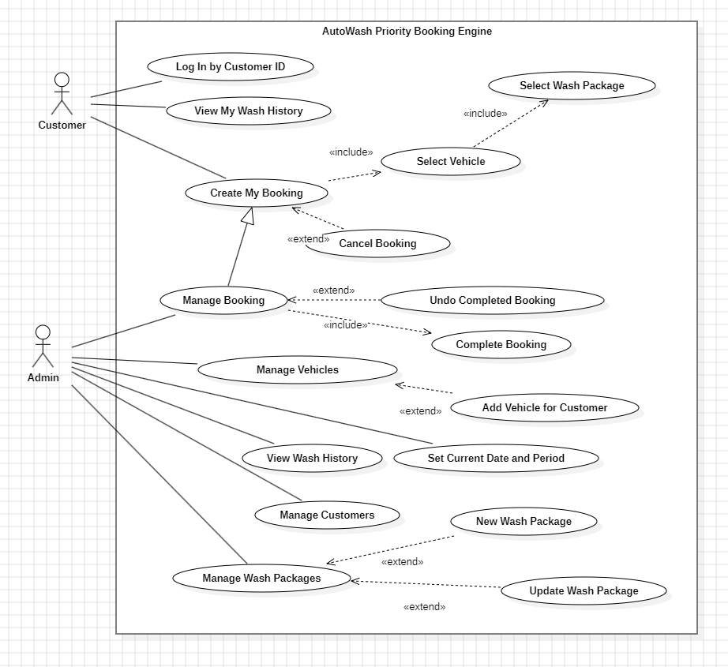
Figure 1. Use Case Diagram of the AutoWash Priority Booking Engine, showing Customer and Admin interactions with core system functions.
3.1.2 Sequence Diagram
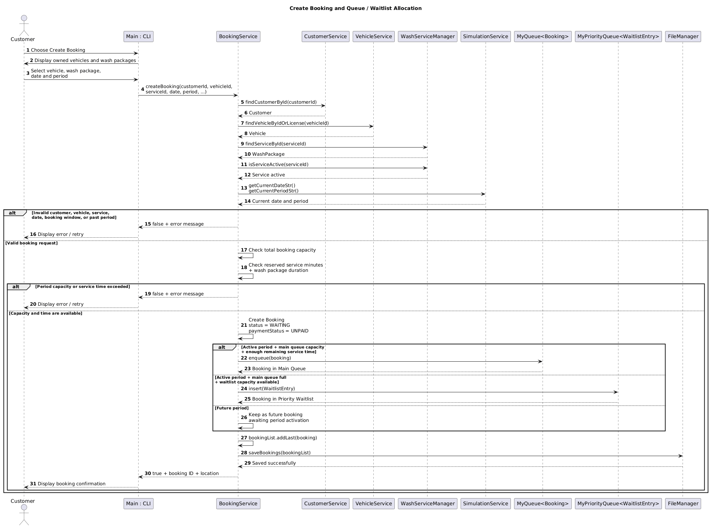
Figure 2. Sequence Diagram for the Create Booking and Queue/Waitlist Allocation flow.
3.2 Conceptual Framework
Framework Summary:
The AutoWash Priority Booking Engine applies abstract data type and algorithm-complexity principles to manage bookings without using a database. MyLinkedList is used to store dynamic collections such as customers, vehicles, wash packages, bookings, periods, and history records. MyQueue preserves FIFO order for the main booking queue, while MyPriorityQueue uses a max-heap to select the highest-priority waitlisted customer. MyStack supports undo because only the most recently completed booking can be restored. These choices balance predictable service order, membership-based priority, and simple implementation for a CLI system.
Framework Diagram / Table:

Concept | Theory Applied | Impact on Design
Data Abstraction | Abstract Data Type | Service classes encapsulate data and provide operations such as createBooking() and processNextBooking().
Dynamic Data Storage | Linked-list organization | MyLinkedList<T> stores customers, vehicles, services, bookings, periods, and history.
Main Queue Processing | FIFO Queue principle | MyQueue<Booking> serves bookings in first-come-first-served order.
Waitlist Priority | Max-Heap Priority Queue | MyPriorityQueue<WaitlistEntry> selects higher membership tiers before lower tiers.
Undo Operation | LIFO Stack principle | MyStack<CompletionRecord> stores the latest completion for rollback.
Service Sorting | Selection Sort, O(n²) | Wash packages can be sorted by price or duration for display.
Customer Search | Linear Search | The current implementation searches through MyLinkedList; using get(i) makes it O(n²).
Booking-window Lookup | Array-backed Map | MyMap<String, Integer> stores allowed booking days for membership levels.
Capacity and Time Constraint | Resource-constrained scheduling | A booking is accepted only when the selected period has both an available slot and enough remaining wash-service minutes.
3.3 Performance Experiment Design
Research Question (from Report 1):
How does using a priority queue instead of a standard FIFO queue affect booking fairness and processing efficiency when a car-wash waitlist contains customers with different membership tiers?
Experiment Setup

Parameter | Value
Input Sizes (n) | 100, 500, 1,000, 5,000, and 10,000 waitlist entries
Algorithm(s) Tested | MyPriorityQueue<WaitlistEntry> versus MyQueue<WaitlistEntry>
Metric Measured | Average insertion time, average next-customer selection time, and priority-compliance rate
Hardware/Environment | Java JDK 8, Apache NetBeans IDE, Windows 11 Home (10.0.26200),  AMD Ryzen 7 8745HS with Radeon 780M Graphics, 14 GB RAM
Number of Trials | 5 trials for each input size; use the average result
Test Data | Same booking arrival order and membership-tier distribution for both structures. Each entry includes a membership tier, booking creation time, and wash-package duration.
Fairness Metric | Percentage of cases in which a higher-tier customer is selected before a lower-tier customer
Expected Results (Hypothesis)
The priority queue is expected to provide better membership-priority compliance than a standard FIFO queue because MyPriorityQueue<WaitlistEntry> uses a max-heap to select the highest-tier waitlisted customer first. When customers have the same membership tier, the earlier booking creation time is expected to receive higher priority. The priority queue insert and poll operations are expected to grow approximately O(log n), while FIFO enqueue and dequeue remain O(1) but preserve only arrival order. Therefore, FIFO is expected to be faster for simple first-come-first-served processing, whereas the priority queue is expected to better satisfy the system's membership-priority requirement. In the updated system, a booking is also expected to be rejected when either slot capacity or the remaining service time of the selected period is insufficient.
Results Table (to be filled in Report 4)
Input Size (n) | Algorithm MyQueue<Booking> Time (ms) | MyPriorityQueue<WaitlistEntry> (ms)
100 | 0.0267 | 0.1116
500 | 0.0618 | 0.3041
1000 | 0.1000 | 0.3597
5000 | 0.1293 | 1.0196
10000 | 0.1956 | 2.3566

3.5 Independent Development Evidence
Provide evidence that your problem statement and Research Question were developed independently, without relying on AI for the core concept.
Evidence Provided:
- [ ] Screenshots of initial handwritten notes / sketches (attach below)
- [x] Git commit history showing early drafts before AI tools were used
- [x] Timestamp of first document draft
- [x] Other: (describe)
[INSERT EVIDENCE SCREENSHOTS / IMAGES]
The original Smart Car Wash requirements and decomposition were documented by the team on 14 June 2026 and committed to Git on 17 June 2026. The CSD201 AutoWash Priority Booking Engine adapts this earlier PRJ301 concept, with a narrower focus on custom data structures, priority queue allocation, FIFO processing, and stack-based undo.
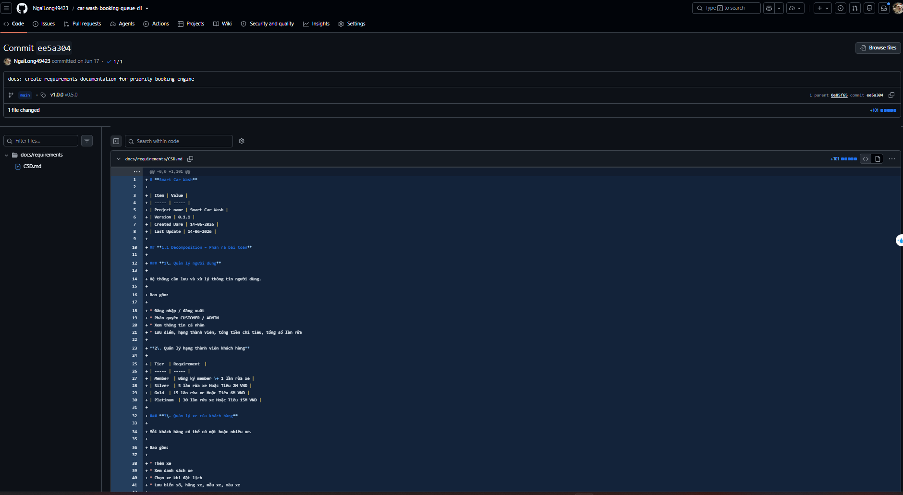
Figure 4. Early repository initialization commit (0e83f65), showing the initial project structure, documentation, diagrams, and requirement artifacts.
Link: https://github.com/NgaiLong49423/car-wash-booking-queue-cli/commit/ee5a3043ed47b199afd85b1eb00fc3d67af7cf3f
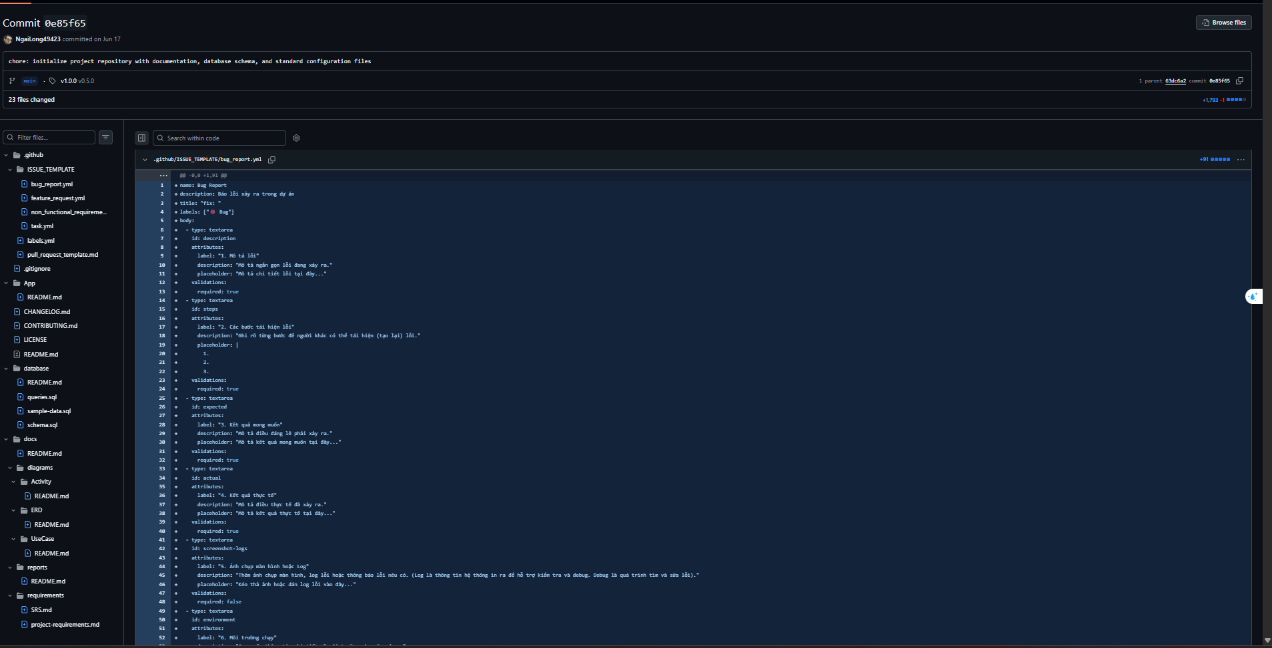
Figure 5. Early requirements documentation commit (ee5a304), containing the initial Smart Car Wash problem decomposition and booking requirements.
Link: https://github.com/NgaiLong49423/car-wash-booking-queue-cli/commit/0e85f65b72e24f20e9a77de90799821ae1c21dbc

